Project Title: Polymers Derived from Biodiesel Waste for Road Dust Control
Principal Investigator: James A. Bahr, North Dakota State University

Situation Statement
Road dust is a common problem in rural areas throughout the United States as well as in mining areas and can lead to health issues to those living and working in these dusty environments. At the same time, the rapidly growing biodiesel industry is faced with an excess of crude glycerin that is expensive to purify and expensive to dispose of. This research focused on the conversion of cheap, crude glycerin (from biodiesel waste) into a non-toxic, biodegradable and non-corrosive dust suppressant material that is dispersible in water for application onto gravel roads as a “drop-in” replacement for chloride based dust palliatives. The development of a dust control product derived from soy based biodiesel waste should create a new market for the soy based biodiesel industry. Over $400 million is spent annually in the US alone on dust control. As a result, revenue generated from this new market should decrease the overall cost of biodiesel production through the utilization of its primary waste stream as well as from the new application for the soy biodiesel itself.
Goals/Objectives
The primary objective of the project was to investigate the utility of combining waste glycerin with soybean oil (or soy biodiesel), in a chemical process, to generate high concentrations of mono and diglycerides that could then be applied to gravel roads as a dust mitigation agent. The benefit of the mono and diglycerides are threefold. First the presence of hydroxyl groups on the glycerin end of the molecule allows it to be dispersed in water while the long chain fatty component compatiblizes the triglycerides present allowing them to be emulsified in water without the need for additional surfactants. Second, the unsaturated fatty chain (from the soy based biodiesel) allows the molecules to cross-link with each other and cure into a sticky semi-solid material producing a web-like polymeric structure that binds the dust suppressant agent to the fine particles within the gravel matrix. This matrix is not water soluble and consequently won’t be washed away into the ground water. Thirdly, the hydroxyl groups on the mono and diglycerides are free to absorb moisture from the air making it hygroscopic and wet. The cross-linked molecules and water absorption sites are shown in figure 1. This hygroscopic mechanism is the mode of action of current road dust suppression salts such as magnesium chloride. Additionally, the soy based polymeric glyceride blend will not be corrosive like the salt based dust suppressants currently in use today. Finally, the ester bonds present in the fatty acid structure make it biodegradable so that it does not accumulate in the environment over time.
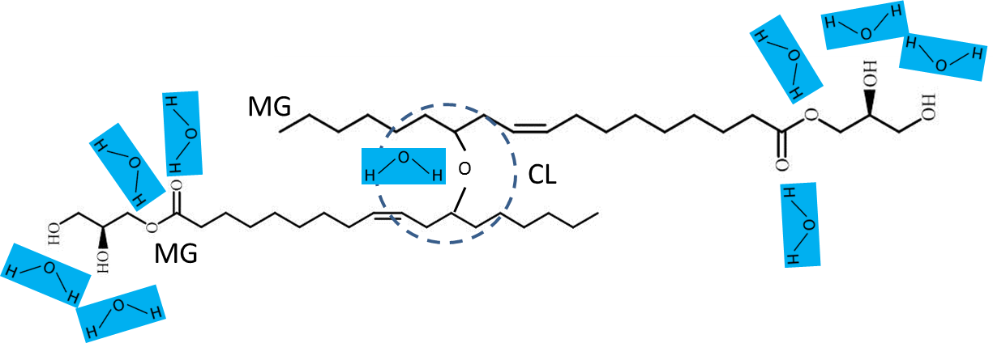
Figure 1 The fatty acid chains from the soy bean oil will crosslink (CL) naturally between their unsaturated double bonds. Two cross-linked monoglycerides (MG) are depicted above but this crosslinking will also occur between di and triglycerides as well resulting in a larger network and higher molecular weight structure. The presence of hydroxyl groups (-OH) attract moisture from the air resulting in a dampness that aids in dust reduction.

To maximize the chances of developing a successful dust control agent, we would like it to have the best properties of existing dust control agents but lack their negative aspects. For example, the ability of this material to be dispersed in water is essential for the application industry because they can simply apply the water based material with their existing equipment as they would apply a chloride based brine solution to a road bed. This is extremely important since road maintenance crews are unlikely to purchase specialized equipment just to apply a new type of dust control agent even if it is better. Therefore, our material needs to be a “drop-in” replacement for magnesium and calcium chloride brines but without their corrosive properties. Chlorides work through deliquescence by sequestering moisture from the air thereby making the gravel damp and dust free. Our material also has this quality due to the presence of hydroxyl groups on the mono and diglycerides.
Vegetable oil soapstock, a by-product from the edible oil purification process, is another dust control agent that is similar the one developed under this research in that it also has triglyceride oils. This material works by coating the dust particles with oil and agglomerating them into a stable amalgam. Soapstock is not dispersible in water and must be heated to above 35 deg C and applied on warm days followed by a waiting period of 6-8 hours for it to penetrate the gravel. It is often covered with sand in order to allow vehicle traffic the same day it is applied without excessive vehicle splatter. Our product possesses the oily agglomeration aspect of the soapstock but since it is dispersed in water, it penetrates the gravel faster and can be applied without heating. The goals of this research were as follows:

- Generate crude glycerin waste product from biodiesel synthesis
- Optimize the reaction of glycerin waste product with soy based biodiesel to generate a high percentage of mono and diglycerides
- Study the drying/curing of the soy based dust control agent with/without crosslinking agents
- Emulsify the soy based dust control agent with water and apply to class 5 gravel
- Test the treated class 5 gravel for leaching behavior due to simulated rainfall
- Measure the dust control properties in the lab and compare them to magnesium chloride treated gravel
- File a provisional patent application
- Pursue additional funding for scale up and commercialization

Description of the Research Conducted:
The first month of the project involved an extensive literature review and study into the “state of the art” in dust control materials and methods as well as the chemical synthesis techniques used to synthesize biodiesel and glycerides. The knowledge learned from this review gave us a better understanding of the road dust control problem and set the constraints that we must operate within while revealing the problems that our dust control agent must overcome. It also gave us great insight on how to approach the problem of the synthesis and analysis of our materials as well as the best application techniques to use. Throughout this process, we also learned who the major players in this industry are as well as the names of critical governmental agencies that can assist in the future development and widespread testing of this product.
Work in the lab began with the synthesis of biodiesel from soybean oil (purchased from Costco). Twenty batches of biodiesel (10 kg each) were synthesized in our 10-liter glass reactors in order to provide an ample supply of waste glycerin and crude biodiesel for use throughout the project. The biodiesel and crude glycerin were separated from each other and used as-is without further washing or purification. This was done to ensure a consistent and reliable supply of these starting materials.
With plenty of starting material on hand, we then began the synthesis trials for making the dust control agent. Variables such as time, temperature, pressure, sweep gas flowrate, stir speed catalyst concentration and the ratio of glycerin to biodiesel were explored over several months. A generalized chemical reaction scheme is shown in figure 2. The reaction vessel was fitted with a sampling port that allowed for periodic sampling of the reactants (every 30 minutes) in order to optimize the reaction time within a single batch.

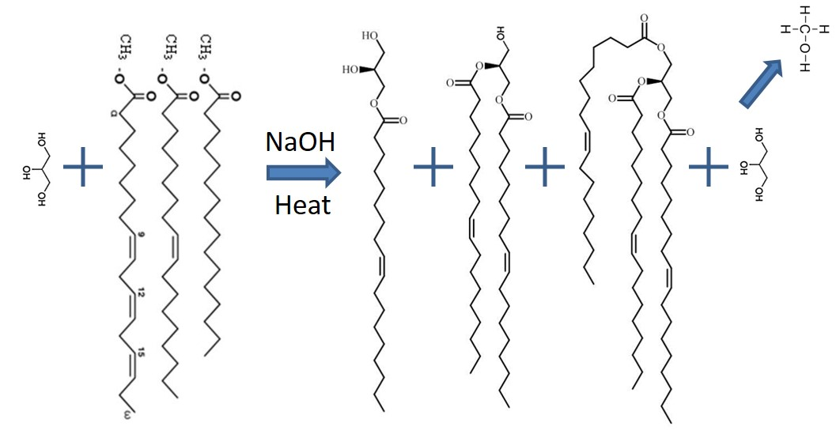
4
2
Figure 2 Generalized synthesis scheme to make glycerides from glycerin and biodiesel. This approach resulted in a mixture of mono, di and triglycerides with some residual glycerin. Methanol was stripped off in order to drive the reaction forward.

We also developed a high performance liquid chromatography (HPLC) method that allowed us to analyze the samples and determine the relative amounts of mono, di and triglycerides present in each sample. Unfortunately, we were unable to analyze the amount of glycerin present with the HPLC and had to use the data from the HPLC combined with mass balance calculations in order to determine its concentration in the samples.
After a few months of laboratory synthesis, we chose a set of reaction conditions that gave the optimal combination of; high glycerin usage, shortest reaction time and highest percentage of mono and diglycerides in the final product to use going forward. Several more batches where synthesized using the optimal conditions in order to generate enough material to perform the gravel treatments and testing.
The next step in the research was to generate water emulsions from this material. Several water emulsions of various concentrations where made and allowed to stand for several days to monitor their stability and viscosity. No additional surfactants or emulsifiers were needed for this step. The wetting characteristics of the gravel with the emulsions were studied as well as the drying characteristics of the emulsions in air on flat surfaces.
Class 5 gravel was purchased from a local landscaping company and was sieved to remove the rocks larger than 0.5 inch. This was done in order to minimize the error associated with performing tests that are weight based on a relatively small scale. For example, a few large rocks can make up most of a small sample but have very little surface area related to an equal amount of dust forming fines. Some of the class 5 gravel was further sieved to remove particles greater than 2.4 mm to further reduce error from sample to sample.
Restaurant style sheet pans and holding rack were purchased to facilitate the drying and storage of the treated class 5 gravel. Ten pounds of gravel was placed on each tray and treated with a set amount of dust control agent and then allowed to dry in the lab prior to testing. Both soy based dust control agents and magnesium chloride agents were used to treat the gravel trays.
A small concrete mixer (3 cubic feet) was purchased from Northern Tool & Supply and modified in-house for use as a dust generation/collection apparatus. The modifications involved the creation of a sealed lid outfitted with a receptacle for mounting bag type filter elements as well as a swivel joint for the introduction of a known amount of air (0.4 scfm) while it was rotated. The internal baffles were replaced with smooth plastic baffles that ensured the loaded gravel would experience a free fall with every turn of the drum. These modifications allowed for sufficient agitation of the gravel so that free dust would be generated and swept out of the drum for collection onto the filter bag (1 micron rating). The filter bag was weighed before and after the 5-minute test to quantify the amount of dust present. The entire workflow used in our lab is depicted in figure 3 below.

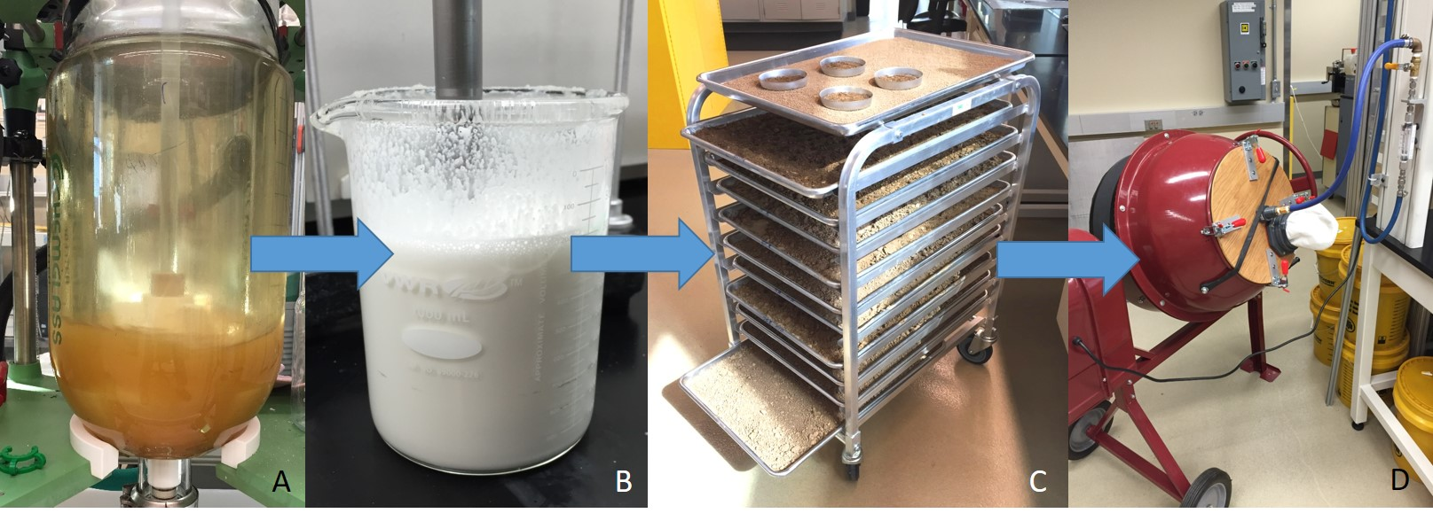
Figure 3 Depiction of the workflow used for the synthesis and testing of soy based dust control agents. A) 10-liter reactor for synthesis of glycerides from glycerin and biodiesel, B) Emulsification of raw product with water at a1:3 ratio, C) Application of emulsion to class 5 gravel followed by drying/curing, D) Testing of treated gravel for dust particle retention.

The modified concrete mixer worked well to characterize the various dust control treatments but collected a wide range of dust particle sizes and did not discriminate by size. In an effort to better understand the level of the very fine dust that is especially damaging to human health, we purchased a hand held aerosol meter (DustTrak II from TSI) that was able to give the mass concentration of respirable dust particles of less than 4 microns in size. This device is shown in the figure below.
Figure 4 Hand held aerosol/dust monitor (DustTrak II) for measuring the concentration of respirable dust particles (<4 microns) in mg/m³. This device features an onboard air pump that and size exclusion inlet that deliver dust particles of a specific size to an internal laser light scattering detection cell.

In order to verify the assumption that our cross-linked dust control agent does not wash away in the rain, we performed testing on several samples of treated gravel and compared them to magnesium chloride treated gravel. This test involved the combination of 200 grams of finally sieved treated gravel with 300 ml of distilled water. The mixture was gently mixed for 5 minutes and allowed to stand overnight. The mixture was then filtered and the washed gravel was dried completely overnight. The mass difference from the prewashed, treated gravel to the post washed and dried gravel indicated the amount of treatment that was removed by the water. This test was performed in order to simulate the effect of rain water leaching of a dust control agent from a road bed.
Unsaturated vegetable and seed oils are known for their drying characteristics through the crosslinking of the unsaturated double bonds present in the fatty acid chains (i.e. linseed oil wood finish). We expect that this same mechanism will be present in the soy based dust control agent that we have developed. In an attempt to detect the occurrence of crosslinking within our treated gravel, samples of the treated gravel were washed with tetrahydrofuran (THF) solvent for 4 hours. The THF was then filtered and dried to isolate any cross-linked (and non cross-linked) material that was extracted from the treated gravel. These samples were then prepared for analysis by Gel Permeation Chromatography (GPC) to determine if any higher molecular weight molecules had formed due to the crosslinking mechanism described above. Samples of treated and aged gravel with and without drying promoters as well as an unaged sample where analyzed.
Finally, in order to protect the technology and allow us to discuss it with outside agencies, we filed a provisional patent application with the assistance of the NDSU Technology Transfer Office that protects the composition and use of this material. A Venture grant proposal was also submitted to the North Dakota Department of Commerce, that if awarded, will pay for the conversion of the provisional patent to a full utility patent. In addition, the money will be used to perform a market analysis study and further advance the technology through additional field testing and private industry partnership formation.

Findings:

Two approaches to the synthesis of a soy based product with high concentrations of mono and di glycerides were explored. The first involved the use of soy bean oil and glycerin and proved to be more difficult with longer reaction times and high temperatures. The final composition also had higher levels of triglycerides than was desired. The second synthesis approach involved the use of crude, soy-based biodiesel and crude glycerin without additional catalyst. This approach gave favorable results with reasonable temperatures (150 C) and reaction times of around an hour. This approach required that the methanol formed during the reaction be stripped off either by vacuum and/or a sweep gas of nitrogen to drive the reaction forward.
Several synthesis reactions were performed while samples were taken every 30 minutes for analysis. The data from these tests showed that the maximum levels of mono and diglycerides were achieved at around 1 hour. At this time, 100% of the starting biodiesel was consumed and running the reaction longer resulted in the increased formation of triglycerides and decreased formation of monoglycerides which is undesirable for good water dispersion. A photograph of the 30 minute samples as well as their relative concentrations of biodiesel, mono, di and triglycerides is shown in figure 5. The white precipitate visible in the sample photos is made up of the mono and diglycerides.
The catalyst used for these reactions was sodium hydroxide. It appeared that the residual amount of sodium hydroxide catalyst left over from the biodiesel synthesis was sufficient enough to catalyze the reaction. Crude biodiesel and crude glycerin were used to ensure that the catalyst was not washed out by prior purification of these materials. We ran a few synthesis reactions where additional catalyst was added, but the final product distribution did not change significantly and the resulting material became more difficult to emulsify in water as it had a gel like consistency. Also, the final water emulsions were highly basic compared to the materials made without additional catalyst which were more neutral (pH~7.5).

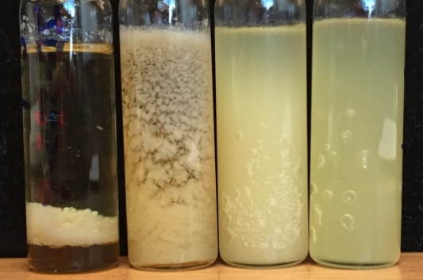
Time= 0 Minutes 30 Minutes 60 Minutes 90 Minutes
Figure 5 Conversion of glycerin and biodiesel into glycerides as a function of reaction time. Samples were taken at time 0 min, 30 min, 60 min and 90 min and analyzed for biodiesel (BD), soy bean oil triglyceride (SBO), diglyceride (DG) and monoglyceride (MG) content by HPLC. The photo above the graph depicts the corresponding time samples after they cooled down. MG and DG appear as the white cloudiness in the vials. The 60-minute sample was chosen as the optimal composition for this work.

With the basic reaction conditions now optimized, we then used these conditions as our standard reaction scheme and focused on the effect of biodiesel to glycerin ratio on the final product distribution. The experimental design for this round of testing started with a biodiesel to glycerin molar ratio of 1:1 and ended at 1.8:1 with biodiesel increments of 0.1. The results of these experiments are shown in figure 6 and indicate that as the starting concentration of biodiesel is increased, the final concentration of triglyceride also increases. This make sense since the reaction favors the formation of triglyceride if given enough time. Essentially, if we started with a biodiesel to glycerin ratio of 3:1, with enough time only triglyceride would remain. Our goal was to limit the reaction to form only the intermediate compounds of mono and diglyceride before they were fully converted to the triglyceride. This was attempted by “starving” the reaction with insufficient amounts of biodiesel from the start and stopping the reaction before all the biodiesel was converted to the triglyceride. In reality, the reaction kinetics are such that mono, di and triglyceride formation overlap with each other and the final composition is always a blend of mono, di, and triglyceride with some remaining glycerin. The biodiesel is completely consumed however.

Figure 6 Final product composition as the ratio of biodiesel to glycerin was increased. These samples were taken at 60 minutes after the start of the reaction from each batch and analyzed by HPLC. The molar ratio of 1.2 parts biodiesel to 1 part glycerin was chosen as the best candidate for this work.

Based on these results the ratio of 1.2:1 biodiesel to glycerin was chosen as the optimal starting concentration for this application due to the relatively high levels of mono and diglycerides as well as the high level of starting glycerin utilized. A high level of glycerin is desirable since it is very inexpensive and as such, we wanted to maximize its use. This ratio also gave a final product distribution that was easy to emulsify with water. This starting ratio of 1.2:1 biodiesel to glycerin along with the optimized reaction condition of 1 hr at 150 C became the standard for the remaining work and several batches where then synthesized for the treatment and testing of class 5 gravel.
The detection of triglyceride, diglyceride and monoglyceride for each sample was determined after separation on an Agilent/HP 1100 series HPLC using an evaporative light scattering detector. Identification of compounds in each chromatogram was determined by comparison to individual standards. Calibration curves, the relationship between peak area and concentration, for triglyceride and monoglyceride standards were produced using three concentrations (mg/mL) for each compound. Concentrations of tri and monoglycerides for each sample were derived from the calibration curves and that of diglyceride and glycerin were extrapolated by mass balance and initial reactant mole ratio equations. A chromatogram for the starting ratio of 1.2:1 biodiesel to glycerin (our standard material) is shown in figure 7. The chromatogram shows good separation of the products and little if any by-product formation.

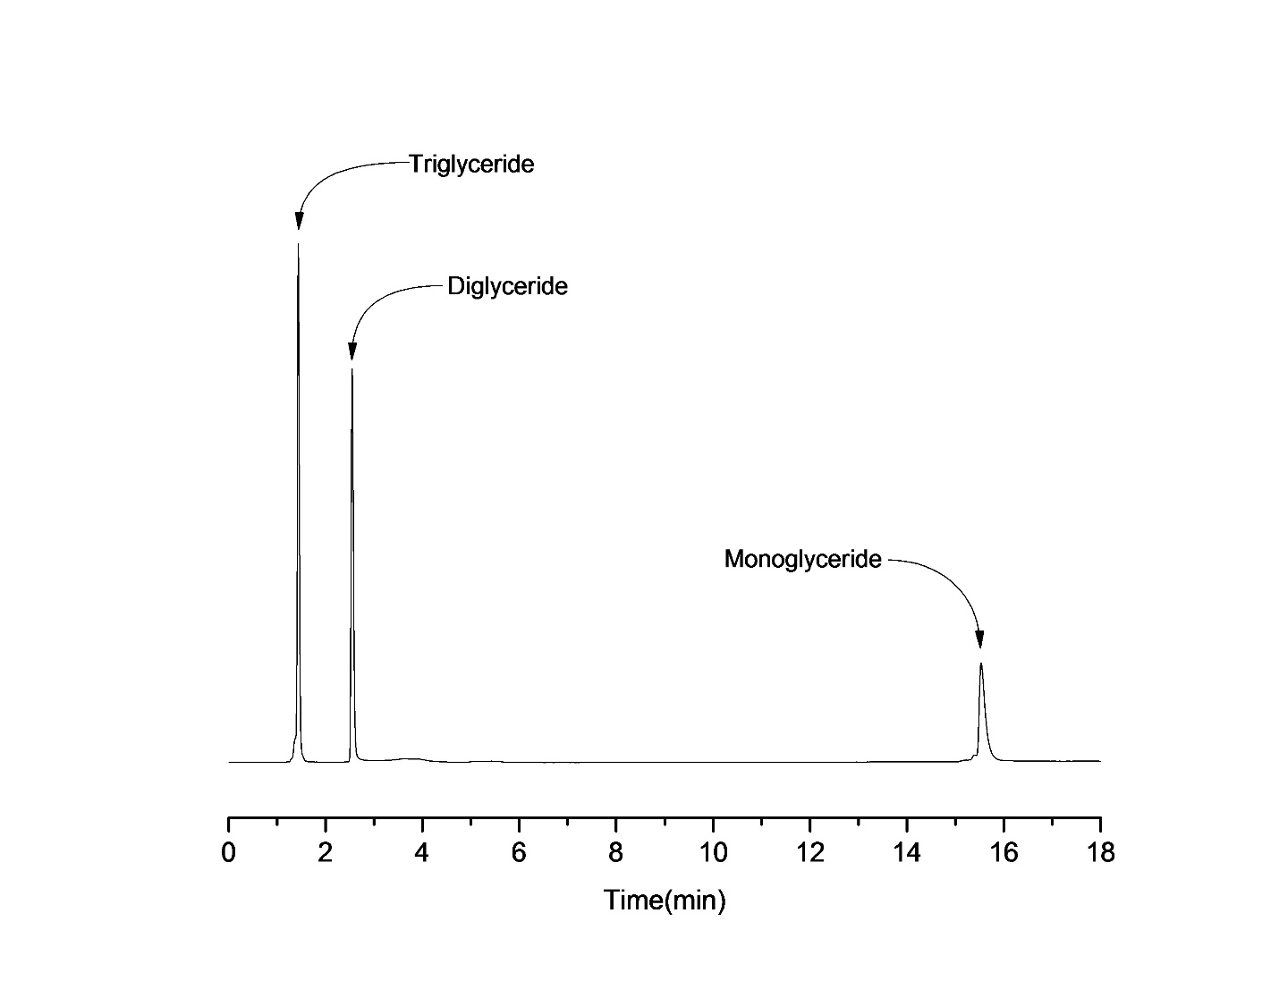
Figure 7 HPLC chromatogram from an optimal sample (1.2:1 biodiesel to glycerin) showing the 3 major components of the soy based dust control agent with minimal impurities. Glycerin concentration was determined offline using mass balance calculations.

Drying/Curing Study

Water emulsions of the 1.2:1 product were made by adding the warmed material to water in a hi shear mixer running at 10,000 rpm. The maximum concentration of product dispersible in the water was 25 weight %. Higher concentrations produced emulsions of high viscosity that were still liquid but deemed too “thick” to be applied to a road bed with standard application equipment. Trays containing 10 lbs. of class 5 gravel were treated with the emulsified material at various concentrations relative to the standard application of magnesium chloride of 0.3 gal/yd². A portion of the emulsion was also applied directly to a clean tray containing no gravel and allowed to dry in the open air. Manganese was also added to some of the emulsions as a drying promoter.
Once applied to the gravel the emulsion was allowed to soak in for 10 minutes then mixed by hand to achieve a uniform coating. Three samples were then mixed with THF solvent in order to extract the organic soy based dust control agent from the inorganic gravel in order to determine if any measurable amount of crosslinking had occurred. The three samples included treated gravel that had aged 2 months, the same treatment aged 2 months on a clean tray and treated gravel that had aged 2 days. The extracted THF was filtered, purified and analyzed by GPC to determine the average molecular weight of the extracted material. The GPC results for the three samples are shown in table 1 below.

Table 1: Molecular weight (Mw) of cross-linked dust control agent extracted from soil
Material | Average Mw (gr/mol)
Treated Gravel- Aged 2 Months | 1,974
Treated Gravel- Aged 2 Days | 870
Same Treatment Aged 2 Months in a Dish | 6,981

The results indicate that there was a significant level of crosslinking in the air dried non-gravel sample. The actual levels are likely to be higher than this, but the THF was unable to extract very highly the cross-linked material present in the sample. This was evident in the liquid samples by the presence of a solid precipitate that was removed by the filtering of the sample prior to GPC measurement. The same treatment extracted from the 2-month old gravel sample also showed crosslinking (increased molecular weight compared to the unaged sample) but it was not easily removed from the gravel and was likely caught on the filter along with the fine particles of gravel. The material extracted from the 2-day old treated gravel did not show an increase in molecular weight and was essentially the molecular weight of the mono, di, and triglycerides. These test results indicated qualitatively that the material does form crosslinks with itself resulting in the formation of a high molecular weight structure. This is also evident from the visual inspection of the air dried material that was applied to the clean tray as it had formed a sticky, viscous semisolid material over the 2-month period. The samples treated with the manganese drying promoter did not show an increase in crosslinking. A GPC chromatogram from the tray dried material is shown in figure 8. The broad, multi-peaked data indicates that there is a mixture of molecular weight material present in the soil extract.
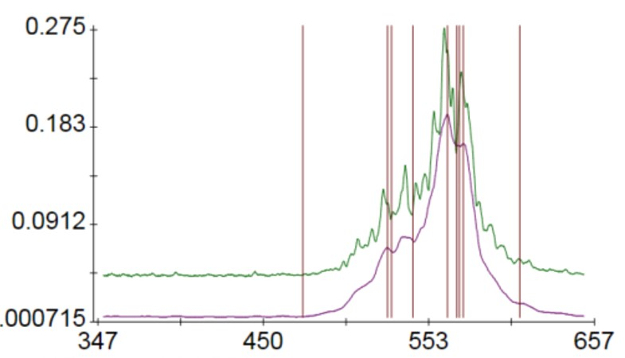
Figure 8 Gel Permeation Chromatograph (GPC) result from tray cured soy-based dust control agent. The broad range of molecular weights (>8,000 grams/mol) indicates that there is crosslinking of the fatty acid chains during curing resulting in a sticky semi-solid material that assists with fines retention of the road gravel. The green line is the raw data while the purple line is the smoothed data.

Rain Water Leaching Study
A portion of the treated gravel used for the drying study were washed with DI water to simulate the effects of rain water. The goal was to determine if the soy based material would be washed away by the rain as compared to gravel treated with magnesium chloride. Gravel samples were first sieved to remove particles larger than 2.4 mm and then washed with water and allowed to settle overnight. The settled samples prior to filtering are shown in figure 9. From the picture it is apparent that the treatment on the gravel aged 2 months has bound the fine particles together because the particles settle out much faster than the untreated control and unaged samples. The water was then filtered off and the gravel dried. The mass of the gravel before and after the water wash was used to determine how much of the treatment was removed by the water. The filtered gravel was not further washed with water.

Figure 9 Treated gravel samples after washing with water (simulated rain) after settlement. The sample on the far left settled quickly indicating that the soy based dust control agent, once cured, bound the fine dust particles into larger agglomerations that settled out faster. Gravel was sieved to remove particles larger than 2.4 mm prior to testing.
The results from the simulated rain leaching study are shown in table 2 below. As expected, the soy based material was not significantly removed by the exposure to water due to the fact that it is not water soluble. The small amount of mass lost from the 2-month old sample may be due to the mechanism of biodegradation which will cleave the glycerin from the glyceride molecules. The glycerin is water soluble and can be removed by water. The fact that only 3% mass loss occurred over a 2-month period is promising since the treatment needs to last the entire summer and fall. The magnesium chloride sample lost over 70% of its initial treatment in just one water exposure.
Table 2: Amount of dust control agent removed from treated gravel (soy based and magnesium chloride) by washing with water.
Material (200 gr Sieved Class 5 Gravel) | Weight Loss After Washing | Treatment Loss %
Soy Treated- Aged 2 Months | 0.1 gram | 3.03
Soy Treated- Aged 2 Days | <0.1 gram | 1.21
Magnesium Chloride Treated | 6.94 gram | 71.82
Untreated Gravel* | 0.3 gram | N/A
*0.3 grams lost as fines passing through the filter

Measurement of Dust Control Properties
The modified concrete mixer was used to measure the dust retention properties of the treated gravel as a function of treatment level. The goal of this test was to determine the appropriate application rate of the soy based materials relative to the magnesium chloride treated sample. Four different levels of soy based treatment were tested against one standard treated with magnesium chloride. An untreated gravel sample was measured as a control for comparison as well. The results of these test are shown in figure 10. All the samples were tested the same day under the same conditions of temperature and humidity for consistency. The relative humidity was actually quite high the day of the test at 58% and the magnesium chloride sample was visibly damp. As a result, the magnesium chloride treated sample performed quite well. The results indicated that the soy based dust control agent can perform as well as the magnesium chloride, even on a humid day when magnesium chloride is at its best. The treatment level for the soy based material required to achieve the same level of dust control was around 140 grams per tray compared to the 111 grams per tray for the magnesium chloride.
Magnesium Chloride
Figure 10 Total dust collected from treated and untreated gravel samples as a function of treatment amount. 1.5 lbs. of gravel samples were tumbled in the sealed concrete mixer for 5 minutes while an air stream was introduced at 0.4 scfm. The “dusty” air escaped the mixer through a 1-micron filter bag which collected the entrained dust for weight measurements. Gravel samples were exposed to 58% R.H. and 72 deg F prior to testing.
The modified concrete mixer test method gave an indication of the total dust generated, but did not differentiate by particle size. In order to measure the amount of respirable dust (particles smaller than 4 microns) generated during the testing we used a handheld aerosol monitor to sample the dust cloud created inside the concrete mixer at the end of 5-minute tumble. The results are shown below in mg/m³ of air and correspond well to the filter bag mass measurement method. This data indicated that the same treatment level of 140 grams per tray was sufficient to bind the very small particles as well. This equates to a road application rate of 0.45 gal/yd² which is more than the 0.3 gal/yd² typically used for magnesium chloride brines, but 50% less than the equivalent amount of soapstock that is typically applied (for an equal mass of treatment not including the water).

Untreated Gravel = 47 mg/m³
Figure 11 Respirable dust levels as a function of gravel treatment amount. Measurements were taken with the DustTrak IITM Photometer at the end of each 5 minute tumble in the modified concrete mixer. Gravel samples were acclimated to 58% R.H. and 72 deg F prior to testing.
In order to understand the effect of low humidity on the performance of the dust control treatments, treated samples of gravel were dried in an oven for two days prior to testing in the modified concrete mixer. Magnesium chloride and the soy based treatments representing the best performing samples from the previous testing group were tested under dry conditions and compared to the high humidity data based on the fine dust generation. The results of these test are shown in figure 12. Essentially, there was little change in the soy based dust control agent when the treated gravel was dried. It still possessed an oily appearance even though it is dry to the touch and was still able to wet and bind the dust particles. However, the magnesium chloride treated material no longer appeared to be wet and had much higher dust generation when tested under dry conditions.
Figure 12 Effect of low Relative Humidity (RH) on dust suppression ability. Data from the magnesium chloride and the soy based treatment (140 g/tray) are shown above. Non-treated gravel and the OSHA exposure limit are shown for reference

Conclusions:
We successfully developed and tested a soy based dust control agent that performed as well as other common dust control agents. This research required the optimization of the chemical synthesis conditions, the development of lab scale testing methods and the determination of appropriate application rates required for its use. Lab testing has shown that this soy-based material can be dispersed in water and applied to gravel surfaces using standard application equipment at rates comparable to brines and soapstock, it is also noncorrosive, biodegradable and performs well in dry conditions. Furthermore, this material has been shown to be water stable and resists being washed away in the rain. Finally, lab results indicate that it forms cross-linked networks that bind the dust particles to both minimize fugitive road dust and reduce the loss of fines from the gravel. The latter of which will reduce road maintenance costs associated with periodic re-gravelling and grading operations.

