Developing High Performance “Green” Tires using Soy Hull based Cellulose Nanofibers -- Final Report

Long Jiang and Dilpreet Bajwa
Department of Mechanical Engineering, North Dakota State University

- Research Goal and Rationale
The goal of this research is to create a new rubber material (e.g. tires) that uses soy hull-based cellulose nanofibers (CNFs) instead of traditional carbon black as the main reinforcing and functional agent. CNFs are expected to outperform carbon black in reinforcing rubber because of the former’s very high tensile strength/stiffness, large aspect ratio, and strong chemical bonding with the rubber matrix. This research is important to ND soybean farmers mainly because of the following two reasons. First, rubber, as an indispensable product to modern society, represents a huge market - 317.3 million tires were sold in the U.S. alone in 2010. A rubber product contains about 30 wt% carbon black and replacing it with CNFs would create an important new use for soybean and a new income stream for soybean growers and processors. Second, replacing carbon black will have positive environmental impacts. Production of carbon black consumes unsustainable resources (i.e. natural gas and fossil oil) and generates greenhouse gas (GHG) and hazardous air pollutant (HAP) emissions. By replacing it with CNFs, this research can increase the eco-friendliness of rubber goods through conserving nonrenewable natural resources and cut GHG and HAP emissions.

- Research Methods and Results
- Optimization of the microfluidizer
We improve the microfluidizer and significantly increase its production rate and ease of use. One person can operate the machine after the upgrade. The main drawbacks of the initial system include open-loop manual feeding, slow heat dissipation, and excess vibration. Minor issues are poor hose/cable management and work surface organization. We designed an auto-feeding system using a peristaltic pump and a switch system; heat dissipation was increased by adding an ice water bath and a submersible pump; vibration was attenuated by adding EVA pad underneath the microfluidizer, bolting the apparatus on the work surface, and adding steel reinforcement to the work surface. For the minor issues, mounting hooks were used to manage the hoses/cables and a gooseneck mount was used to support a digital pressure sensor display. Figure 1 shows the system before and after the improvement.

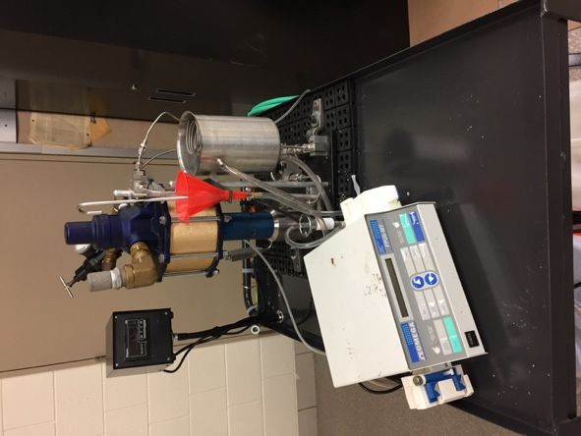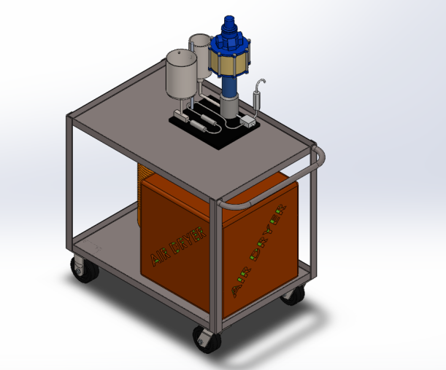
A
B
Figure 1. Microfluidizer before (A) and after (B) the improvements.

- Production of soy-based cellulose nanofibers from two soy products
We used two soy products as the feedstock to produce soy-based cellulose nanofibers and compared their production process and the properties of the obtained nanofibers. The first soy product was raw soybean hull acquired from local source and the second one is a commercial grade purified dietary cellulose fiber (FI-1 Soy Fibre®) derived from soybean hulls.

Raw soybean hull fines were first soaked in 2% w/w sodium hydroxide solution at 80 °C for 2 hours, followed by extensive washing. The resulting pulped biomass was then hydrolized by 1M of HCL at 80 °C for 2 hours, followed again by washing. The biomass was then soaked in sodium hydroxide solution of 2% w/w at 80 °C for 2 hours, followed by extensive washing. All solutions were prepared at a soybean hull biomass to soluton ratio of 1:10. The chemically purified cellulose (1 g) obtained from the process above, was added to a solution containing distilled water (100 mL), TEMPO (0.016 g), and sodium bromide (0.1 g). 2.5% NaOCl (14.88 g) solution was then added and the mixture was stirred at room temperature. 0.5 M NaOH solution was then added to maintain the solutions pH between 10 and 11. The instantaneous pH was monitored using an Oakton 11-series pH probe. Upon pH stabilization, the surface treated hull was collected via filtration (Whatman Qualitative 413) and washed successively with DI water until pH neutral.

The TEMPO-treated cellulose from soybean hull was prepared in aqueous suspensions with a 1.5% - 2% w/w cellulose content. This suspension was then cycled through the microfluidizer approximately 5-6 times to produce soy-based cellulose nanofiber suspension. Interaction chamber pressure of the apparatus ranged from 8,000 to 20,000 Psi during the nanofibrillization process. The viscosity of the suspensions increased with increasing number of cycles, indicating that the cellulose particles were progressively broken apart. Following the fibrillization, sodium azide was added to the nanofiber suspension at 0.01% to prevent mold growth. For the commercial FI-1 Soy Fibre®, TEMPO treatment was directly applied without prior chemical purification.

The yield of the chemical purification of the raw soybean hull is 22.1%. The rest of the material, i.e. lignin and hemicellulose, has mostly been removed by the acid and alkali washing. The soy-based cellulose nanofibers were produced after microfluidization and their transmission electron microscopy (TEM) micrographs are compared in Figure 2.

A
B
Figure 2. TEM micrograph of soy-based cellulose nanofibers derived from (A) raw soybean hull and (B) FI-1 Soybean Fibre®.

FTIR spectroscopy was used to study and confirm surface modification after the TEMPO treatment. Figure 3 compares the FTIR spectra taken from the samples before and after TEMPO mediated oxidation. The absorbance at approximately 1650 cm⁻¹ represents the carbonyl group present in the carboxylate acid functional group that is introduced to the surface of the cellulose during the treatment. The significant increase in the magnitude of this peak shows that TEMPO treatment is successful for both raw soybean hull and FI-1 Soy Fibre®.

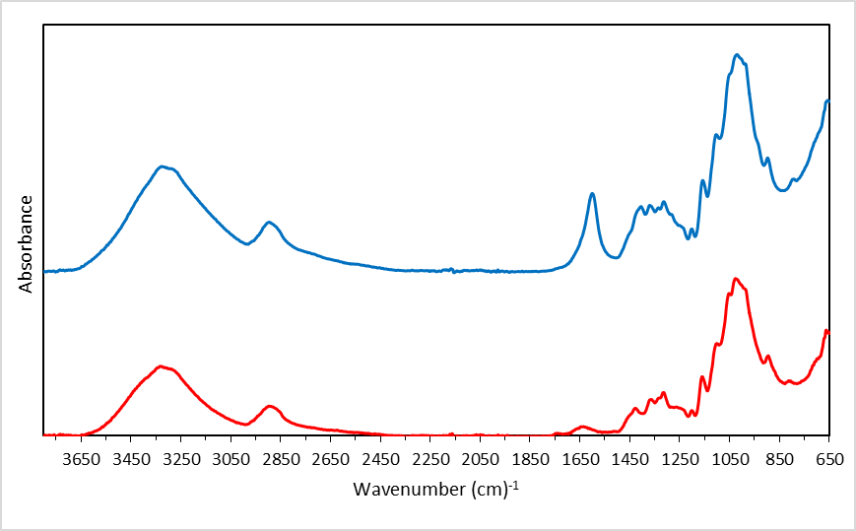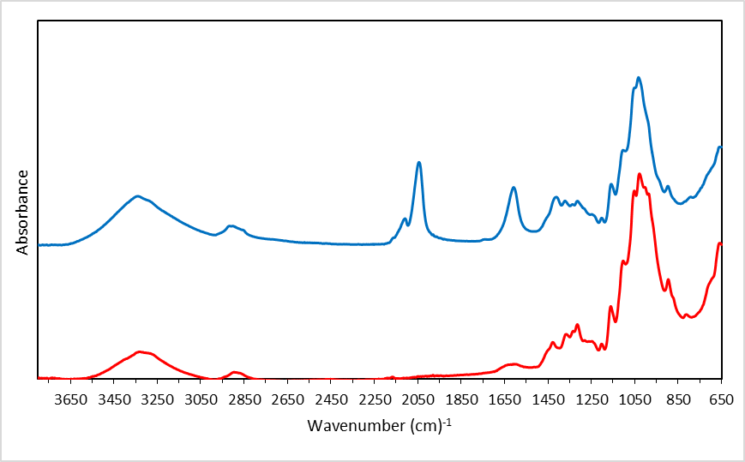
TEMPO Modified Soybean Hull
Un-Modified Soybean Hull
TEMPO-Modified FI-1 Soy Fibre
Un-Modified Fl-1 Soy Fibre
Figure 3. FTIR spectra of the soy-based cellulose nanofibers before and after the TEMPO treatment. (A) Raw soybean hull, (B) FI-1 Soybean Fibre®.
A
B

- Preparation and property testing of soy-based cellulose nanofiber composites

Nanocomposite films containing the cellulose nanofibers were prepared per the following procedure. Polyethylene oxide (PEO) (3g) was dissolved in DI water to form a 4% w/w solution. The solution was stirred at 60 °C under magnetic stirring for at least 1 hour to ensure full dissolution. The two soy-based cellulose nanofibers were then added at 1%, 3%, 5%, and 7% w/w with respect to dissolved PEO. The cellulose nanofibers produced by USDA Forest Service Laboratory using soft wood pulp were also added in the same manner for comparision. The mixture was then homogenized using an Ultra Turrax® Homogenizer equipped with an IKA® 25N 25F dispersing element at 6000 RPM for 5 minutes. Air bubbles were removed via centrifugation at 500 RPM for 3 minutes followed by solution casting on a glass plate. The cast film was then placed in a vacuum oven at 60 °C for 12 hours. Tensile properties of the nanocomposite films were examined in accordance with ASTM D882-12.

As shown in Figure 4, cellulose nanofibers show profound effects on the mechanical properties of the composites. For all three types of cellulose nanofibers, the strength of the films increase with increasing concentration of the nanofibers (Figure 4A). The nanofibers derived from FI-1 Soybean Fibre® lead to the highest film strength at 5% fiber content while the nanofibers from raw soybean hull produce the highest strength at 7% content. The highest strength (7% FI-1 Soy) is two times of that of neat PEO. Both soy-based nanofibers perform better than those produced by USDA using soft wood pulp. Modulus of the films shows a similar increasing trend with increasing nanofiber content, and the two soy-based cellulose nanofibers perform better than the USDA nanofibers.

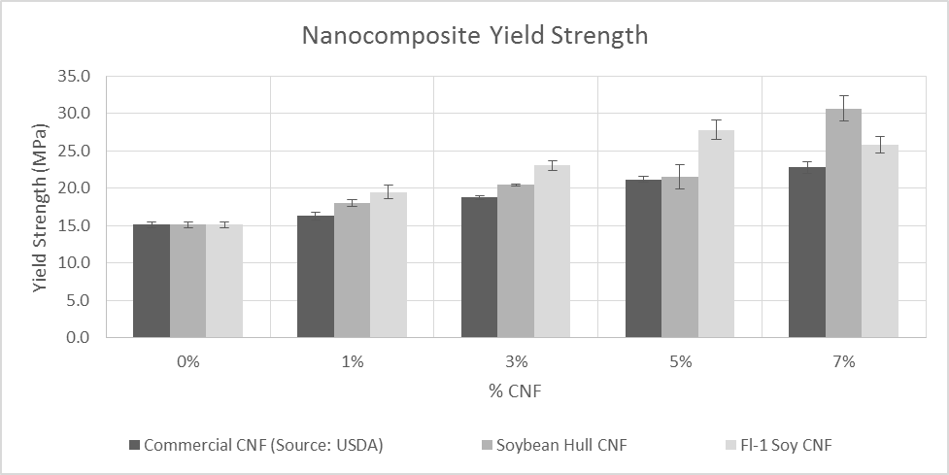
A
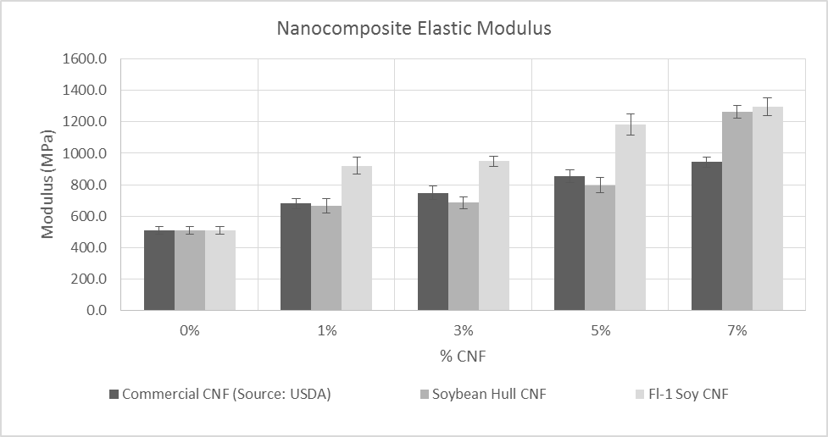
Figure 4. Strength (A) and modulus (B) of the PEO films reinforced by three types of cellulose nanofibers.
B

- Cellulose nanofiber surface modifications
We tried different chemical agents to modify the surface of the cellulose nanofibers. These agents have one functional group at each end of their molecular chains, with one end capable of reacting with the hydroxyl groups (-OH) of the nanofibers and the other end capable of reacting with rubber chains. The chemicals that we have tried so far include cysteine, 5-aminopentane-1-thiol, 6-Mercaptohexanoic acid, (3-mercaptopropyl) trimethoxy silane, and triethoxy (oct-7-enyl) silane. We have achieved different degrees of success with these chemicals and we are still optimizing the chemicals and their reaction conditions. This part of research is time consuming and will continue into the second-year of the project.

- Rubber compounding and testing
Natural rubber and styrene-butadiene rubber (SBR) have been used as the rubber materials to test the nanofibers’ reinforcing effect. The cellulose nanofibers with and without surface modifications were blended with the rubbers in a torque rheometer, mixed with sulfur crosslinking agent using a two-roll mill, and cured in a compression mold. The compressed rubber sheets were cut into dumbbell shaped samples for tensile tests. Every new nanofiber modified in Section 4 underwent this process and its reinforcement effect was investigated. The results were analyzed and were used to optimize the reaction conditions in Section 4. This part of research will also continue into the second-year of the project.

Overall, adequate progress has been made on this project so far. The future focus will be on the fine tune of surface modification method of the nanofibers and determine the properties of the final rubber products.

