Project Title: Field Testing of Soy Based Dust Control Agents
Principal Investigator: James A. Bahr, North Dakota State University
- Utilize stationary and mobile dust collection equipment to study the performance of the applied dust control agents over time.
In addition to visual inspection of the treated test section the primary metric of the overall performance of our material will be the measurement of road dust generation compared to that of the calcium chloride treated road. We will perform this measurement utilizing a dust monitoring device from TSI Inc. called the DustTrack IITM. This device was purchased during our previous project and was utilized for our laboratory assessment of dust generation. The device features a laser detection cell that operates on the principle of light scattering and outputs the total mass concentration of dust in mg/m³. The DustTrack IITM is a handheld device that was used without modification in the laboratory setting, but required an additional apparatus for use in the field. Essentially, we needed to create a device that would sample the road dust that is typically generated behind a moving vehicle and introduce that dust to the sampling port in such a manner that would not overload the laser detection cell and that could be controlled from inside the moving test vehicle.
The photos below show the dust collection device that we built in use mounted to the receiver hitch of the test vehicle. The sampling device features dual inlet ports with adjustable configuration to ensure that the samples are collected from the best location within the vehicle generated dust cloud. A suction blower draws a portion of the dust through the two inlet ports. This dust sample is then presented to the sampling port of the DustTrack IITM which is mounted in the rear of the vehicle. This apparatus provides versatility in our dust plume measurements and protects the device from the harsh environment within the dust cloud itself. Dust generation measurements are made by simply driving the road at a set speed while collecting real time data. The advantage of this system over stationary dust collection methods is that we can measure the road on specific days of varying humidity and weather conditions in real-time without the need to maintain stationary devices that typically sample over longer periods of time and tend to average out the data over several weeks. Photos of the custom built sampling device are shown below.
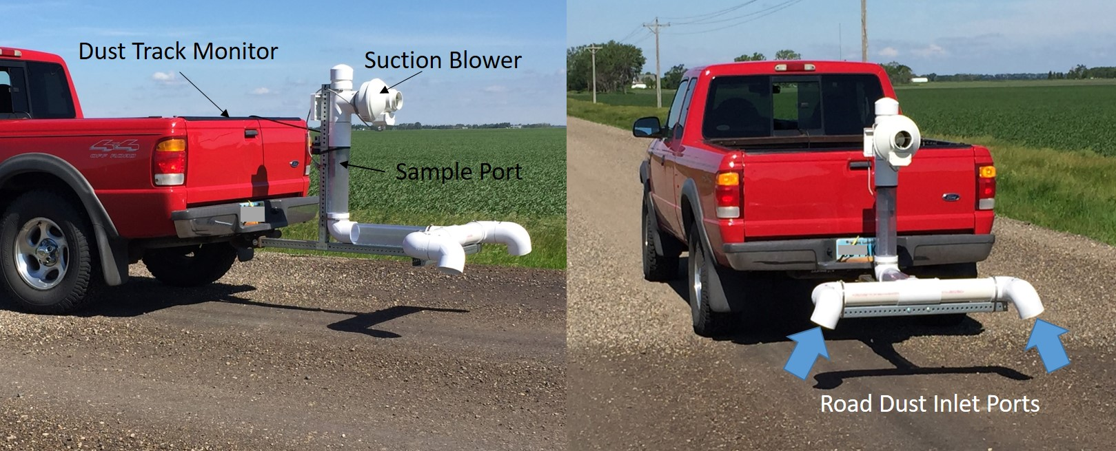
Figure 8 Vehicle mounted road dust sampling apparatus required to feed the dust meter with a well-controlled sample of vehicle-generated dust. The device is quickly assembled and features adjustable inlet ports that can be extended in order to sample closer to the road.
Preliminary data collected from this apparatus is shown in the figure below. The test method consisted of a 3 minute sampling time during which the vehicle was driven at 30 mph across the treated section of road followed by an untreated section of road for a total distance of 1.5 miles. The data shown in the following figure is the direct output of the instrument and shows that the soy treated section of Cass County 22 has no discernable dust generated after 8 days from application. A dramatic spike in the dust level occurs when the vehicle leaves the treated section and travels into the untreated section for the reminder of the measurement. This was expected as visual observations indicated the same result. We plan to continue the use of this dust measurement apparatus throughout the year to better understand how the material performs over time. Once the remaining section of 22 is treated with calcium chloride, we will only be able to make comparison measurements between our material and the calcium chloride as an untreated section will no longer exist. Due to the adjustability of our collection device, we will be able to position the dust inlet ports deeper into the dust plume in order to increase the sensitivity of the measurement as required to see the subtle differences between the two sections of treated road.
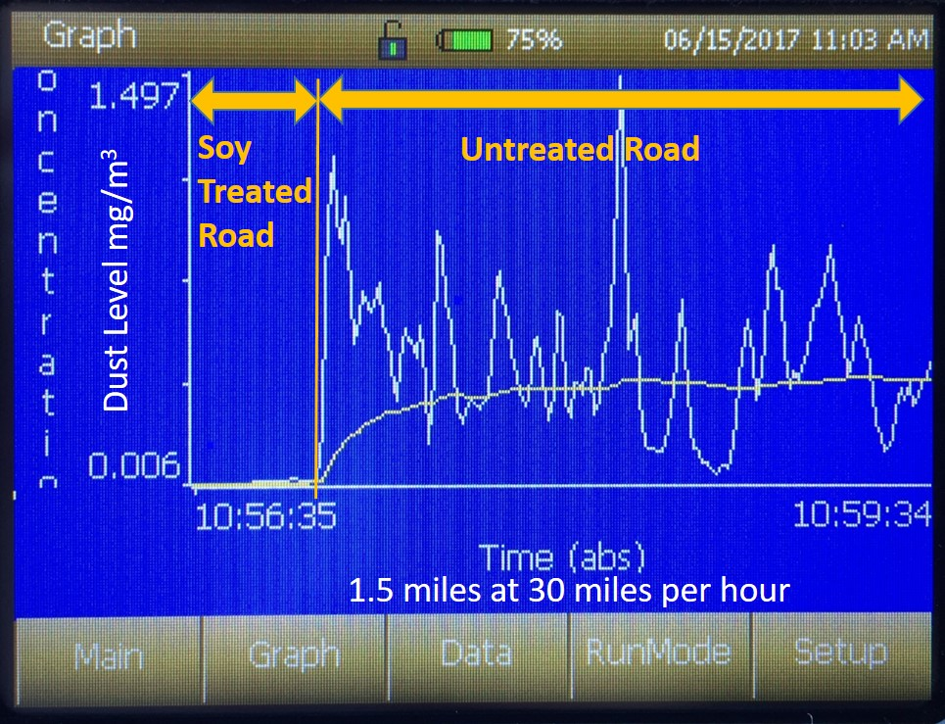
Figure 9 Vehicle generated dust measurement taken with the DustTrack IITM monitor. The vehicle was driven over the soy treated section first followed by an untreated section of road. No discernable dust was measured from the soy treated area 8 days after application. This data was collected over 3 minutes as the vehicle drove 30 mph for 1.5 miles.
Our stationary measurement method will consist of a test called loss-of-fines measurement. Essentially, a 1 meter by 1 meter test section will be marked off and hand swept to collect the loose surface gravel. This gravel sample is then taken back to the lab and separated by size through a process called classification that utilizes a series of smaller and small screens to determine the amount of fine particles present on the road surface.
- Monitor the treated road surface periodically for durability and erosion
The surface of the treated roadbed will be inspected routinely throughout the duration of the test (12 months) in order to gain an understanding of the overall performance of the product. Characteristics such as tackiness, compactness, potholes, wash boarding and surface migration will be photographed and documented along with the dust generation and loss-of-fines data. These factors will also be collected from the calcium chloride treated section of the road. At the time of this report, the Cass County DoT was not able to treat the road with calcium chloride due to rain and contractor scheduling. We anticipate that the remainder of the road will be treated within the next few weeks and the results will be reported on in the follow-on project funded by the NDSBC.
The photographs below are of the soy treated roadbed one week after application. They indicate that the soy treated gravel surface forms a firm and well consolidated surface that is stable and resistant to erosion. The region experienced heavy rains prior to theses photographs, yet the surface of the road is still intact and dust free. The darker photograph is from a portion of the road that was both very hard and free of loose gravel prior to application. This likely limited the penetration depth of the material and resulted in an area that was over saturated. The result is that the roadbed in this area is firm, but has been softened slightly. We will continue to monitor this region as the material cures and slowly penetrates deeper into the roadbed. The lighter colored photo appears to have the ideal amount of material applied as it penetrated the gravel fully leaving a firm, compact and stable surface. It also appears that in the darker region there may be some interaction between the soy based liquid and the recycled asphalt within the road surface causing the surface to look and act like asphalt. We will continue to monitor this area over the summer.
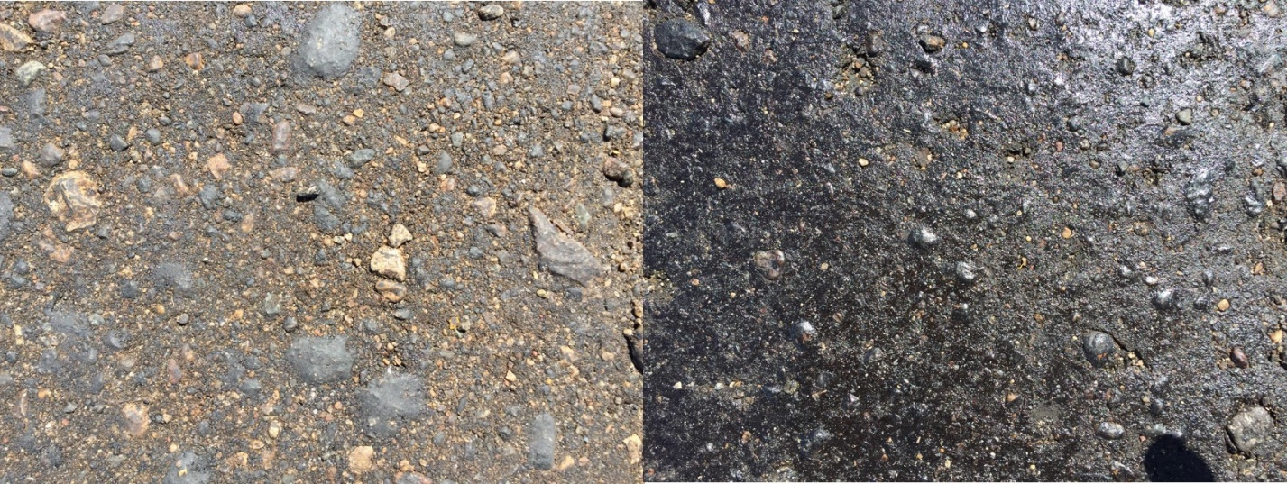
Figure 10 Photographs of select regions of treated roadbed 1 week after application. Prior to these photos being taken the region received ~2 inches of rainfall yet the material appears to have stayed in place. The darker photo on the right was an area of road that was very hard prior to application, which limited the penetration of the material and resulted in a higher surface concentration.
- Analyze soy based material for environmental toxicity
Working with Professor Kirk Howatt of NDSU Weed Sciences, we designed a crop test matrix to evaluate the plant toxicity of the soy based dust control material in the event of road run off during application and wind-borne overspray that could reach adjacent crops. A total of 32 test plots were seeded with soybeans, wheat, oats, lentils, sunflower and canola half of which were used for pre-emergent toxicity testing with the remaining 16 plots planned for post emergent toxicity testing once the plants have reached sufficient height to be sprayed. At the time of this report, the plots for post emergent testing were not tall enough for application, but will be sprayed in early July with the results being reported on in the follow-on project funded by the NDSBC.
The crop test matrix used is shown in the figure 11. The dimensions of the 16 individual plots are 10x30 ft with a sprayed width of 7 ft. Each plot has 4 replicates and 4 of the plots were left unsprayed as controls. Although, the matrix in figure 11 is shown in systematic order, the actual pattern of test plots was randomized to minimize the effect of natural variations within the testing field site as a whole. The maximum rate of application was 0.20 gal/yd², which represents 40% of the rate that would typically be applied to a roadbed. Application rates of 0.10 gal/yd² and 0.05 gal/yd² were used on the remaining plots. Application rates for the post emergent trials will be 0.10, 0.05 and 0.01 gal/yd². The post emergent test rates are lesser as they are intended to mimic wind carried overspray, which should be much less than the amount applied to the roadbed.
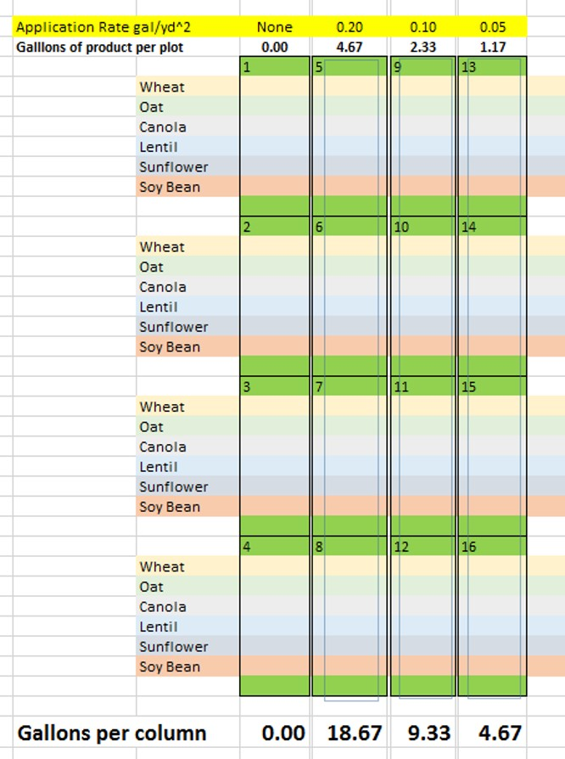
Figure 11 Crop toxicity test matrix used for pre-emergent growth inhibition studies. Six different crop varieties were planted in rows perpendicular to the spray application of soy based dust control agent. A total of approximately 35 gallons of material was applied for the pre-emergent toxicity study to 16 test plots each measuring 10x30ft.
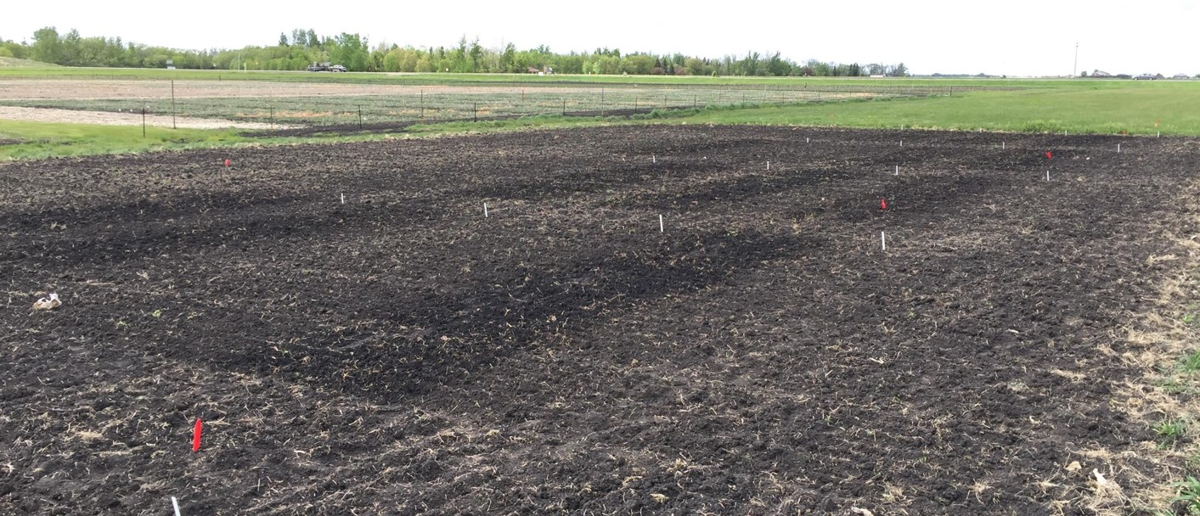
Figure 12 Photograph of the 16 plots after seeding and application of soy based dust control agent. The darker regions indicate the areas that were sprayed. Three different application rates were applied with 4 replicates of each while 4 plots were left unsprayed as controls.
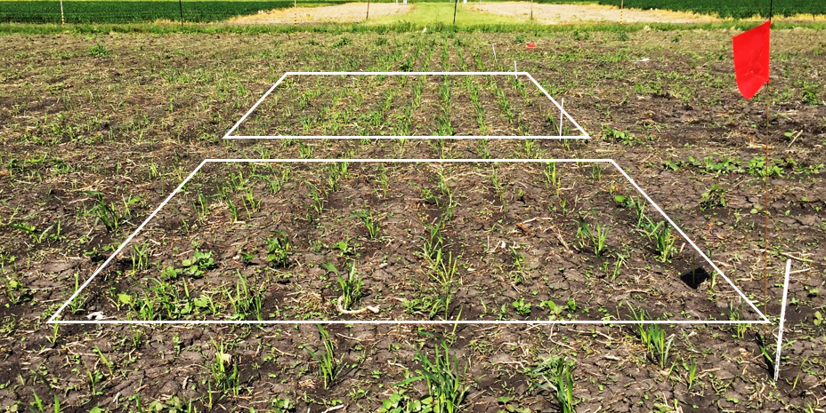
Figure 13 Eight rows of wheat spanning all 4 concentrations of pre-emergent treatment 4 weeks after seeding. Early indications suggest that the application of our soy based dust control agent to seeded crops does not hinder the growth of wheat or oats. The remaining crops have not yet attained sufficient growth to ascertain the effect of the spray.

Conclusions:
This project has the added benefit of a $100k Venture Grant from the ND Department of Commerce that has allowed us to expand the scope of work and extend the monitoring phase of this project. With these addition funds we have filed for patent protection on the technology, (the patent application published in May of 2017), we also hired a market analyst to study the feasibility of turning this technology into a new business for the State of ND as well as to expand the size of the scale up and field study area. In addition, the NDSBC has funded this work for another year allowing us to track the performance of this field study for 12 more months.
To date, we have met all of the goals of this project and the initial results look very promising. The key metrics that we will focus on going forward will be the performance over time of the test section and through our market analysis, gain a better understanding of the cost to manufacture the material and determine how this new technology will be viewed by the public and local DoT units. The initial results from our market survey indicate that a chloride free dust control agent is desirable and people would be willing to pay slightly more for it if the performance can match that of the chloride salts. We have also learned that the chloride salts are gradually being banned in many areas, which will help with the acceptance of this soy based dust control product in the future.
We will continue to seek out funding streams that will allow us to perform additional field trials where we can investigate the performance on various gravel types, different locations and optimize the application rates. We would also like to work on lowering the cost of manufacture by investigating different synthesis processes and conditions. Finally, the apparent interaction between the soy material and the recycled asphalt pavement of the current test site is very interesting and is worthy of further investigation.

