Final Technical Report
Impact of drainage water management on soil and water quality and crop production
Xinhua Jia and Thomas Scherer
Department of Agricultural and Biosystems Engineering
North Dakota State University, Fargo, ND 58108
June 30, 2017
Situation statement
Robust soybean production needs good soil, water, and climate conditions to produce the highest yield possible for the growing season. Following the wet weather cycle of the last two decades, subsurface drainage, commonly called tile drainage, has become an important farm management practice. It can remove excess water from the root zone, reduce soil salinity, and provide timely field access for planting and harvest. However, highly soluble salts, including nitrate, phosphorus, and sulfate, are found in the tile outflow. These dissolved salts are valuable crop nutrients if they remained in the field. However, if they leave the field and enter a receiving stream, they are contaminants and can cause water quality problems. To balance the need of tile drainage with the control of soluble salts lost from fields, a new practice called controlled drainage can be used. Controlled drainage uses a structure at the tile outlet that contains adjustable boards to control when and how much water leaves the field. If an adequate water source is available in July and August, a tile system with controlled drainage structures can be used for subirrigation. The combination of controlled drainage and subirrigation can reduce the nutrient loss from the field, maintain optimum soil moisture for the crop, and result in a higher crop yield. However, the effects of controlled drainage and subirrigation on water and soil qualities needs further study in the Red River Valley.
Objectives
- To continuously evaluate water quality differences among different drainage water management (DWM) practices (surface drainage, tile drainage with gravity outlet, tile drainage with flow control, and subirrigation) using measureable parameters, including nutrients and salt contents in surface and subsurface outflow.
- To assess the soil quality changes due to DWM and subirrigation (SI) practice via soil salinity mapping and soil chemistry, infiltration, and conductivity measurements.
- To measure crop response to DWM practices via leaf chlorophyll changes.

Description of the research conducted
Six fields at two existing sites to study the impact of drainage water management on soil and water quality were used in 2016-17. The Clay County, MN site has four fields with four water management practices, untiled (UD), free subsurface drainage (FD), controlled drainage (CD), and CD+ subirrigated (SI). Site descriptions and past reports can be found at USDA SARE website (http://mysare.sare.org/sare_project/lnc11-332/). The Richland County, ND site has two fields with two water management practices, UD and CD+SI, the site description can be found from a previous report and publication (http://www.ndwatermonit.org/2016_Conference/2_Wednesday/1_Jia_TileDrainageWQ.pdf, Jia et al. 2012). Water samples from surface runoff, tile drainage outflow, subirrigation water, and the surface drainage ditch were collected on a weekly schedule (when possible) from four fields in Clay County, MN and chemical constituents were analyzed. For the two fields in Richland County, ND, when possible, water samples were collected on a biweekly schedule and sent to the ND Department of Health for analysis of a suite of dissolved minerals. The results can be found at ND State Water Commission website (http://mapservice.swc.nd.gov/) for the last five years. We also measured the drainage outflow, subirrigation inflow, water table, rainfall, snowfall, soil moisture and temperature profiles, relative humidity and air temperature using various instruments. At the end of the season, soil samples across the field were collected and chemical analysis conducted for these soils. On each field, we also constructed a soil salinity map for the top 1.0 m soil layer using a Geonics EM38 Ground Conductivity Meter. Soil samples were taken during the mapping for conductivity calibration purpose. Crop responses to different water management were observed from leaf chlorophyll changes. In 2016, corn and soybean were planted in the six fields and we estimated the yield for each field.

Findings
This project, which centered on soil and water quality and crop yield responses due to different drainage water management, is an important component in a multi-state project funded by National Institute of Food and Agriculture, U.S. Department of Agriculture, under award number 2015-68007-23193, “Managing Water for Increased Resiliency of Drained Agricultural Landscapes” (http://transformingdrainage.org). With most of the results found in this report on the transforming drainage website, we will report the results that are directly related to the objectives of this project and most important to ND soybean growers, e.g., the nutrient and salinity changes in soil and water as well as crop yield responses due to tile drainage, and drainage water management.

Nitrate nitrogen (NO₃-N) was measured in water samples from surface runoff, the tile outlets, controlled drainage outlets, and the legal surface drainage ditches, which represented a mixture of surface and subsurface flow from upstream. Figure 1 shows the NO₃-N measurements at the Clay County, MN site and Figure 2 shows the results at the Richland County, ND site. In 2016, due to sufficient moisture content in the soil, subirrigation was only applied for a few hours on 9/2-9/6 at the Clay County site, while the control drainage began on 5/2/16. Due to the dry conditions, no water samples were available from the surface runoff and free drainage field. Water samples were also collected in 2017, but the chemical analysis in the lab takes time and the data are not available for this report.
Figure 1. Nitrate-Nitrogen concentrations from the drainage ditch upstream and downstream of the monitoring fields, and the control drainage structures of the control drained and controlled drained plus subirrigated fields at the Clay County, MN site in 2016.

From Figure 1, we can see clearly that the NO₃-N in the control drainage outlets were much higher than the NO₃-N in the surface drainage ditch (downstream and upstream), which was a mixture of surface and subsurface runoff flow. With the drainage control operating ever since 5/2/2016, however, none of the NO₃-N rich water flowed into the surface water, but instead, it was used in the field for potential crop uptake. Subirrigation was not applied because the soil had sufficient moisture in the root zone, nevertheless the system was tested from 9/2 to 9/6 for a few hours. Theoretically, the NO₃-N at the outlet from the CD and SI fields should be uniform, however, they were different in the spring time before 8/1/16. The NO₃-N difference could be caused by the difference in soil properties, while the CD field had less Bearden silt loam than that the SI field. This type of soil has a parent material of fine-silty glaciolacustrine deposits.

Figure 2. Nitrate-Nitrogen concentration from the drainage ditch, upstream and downstream from the field, and two controlled drained plus subirrigated fields (Sump_west and Sump_east) at the Richland County, ND site in 2016.

From Figure 2, we can see that NO₃-N was higher in spring/fall drainage mode, but during subirrigation period in the summer, the NO₃-N was low, similar to the surface drainage ditch water. A slightly higher NO₃-N was found in the ditch water downstream from the field, possibly affected by the drainage outflow of the study field because in the fall, the study field was the only field with a running drainage.

Ortho Phosphorus (P) is another important parameter affecting the surface water quality. Figure 3 shows the P monitoring at the Clay County, MN site and figure 4 shows the P at the Richland County, ND site.

Figure 3. Ortho phosphorus concentration in upstream and downstream ditches from the field, controlled drained, and controlled drained plus subirrigated fields at the Clay County, MN site in 2016.

The P results showed a similar pattern as the NO₃-N concentration, high in the field and low in the surface water. As with the NO₃-N concentrations, the P levels were held in the field due to controlled drainage and water in the structure were residue flow or static water from the field. That is why it is different from the findings in 2015 when drainage was flowing. However, the P was different from the two fields though the management in 2016 were almost identical except few hours on 9/2-9/6 when subirrigation system was tested. Beside the soil difference, the topography is also different in the two fields, while the CD has high elevation and the SI has low elevation. The elevated higher P concentration in the downstream ditch water was not associated with drainage water from the field because the entire region was dry till early July. The P values in the ditch was similar in 2012-2013. After 2013, the P levels are different, of which some P in the downstream ditch water are significant higher than the remaining like the six dates in 2016. If using the 0.02 mg/L as the threshold for surface water quality, then both surface and subsurface flow exceeded the ND water quality standard for surface water.

Figure 4. Ortho-phosphorus concentration from the drainage ditch, upstream and downstream from the field, and two controlled drained plus subirrigated fields (Sump_west and Sump_east) at the Richland County, ND site in 2016.

The P concentrations were found similar to what was reported in Jia et al. (2012), higher during the subirrigation period, due to the P introduction from the groundwater. That means the SI system provided P benefits to the crop growth.

Salts in water samples were analyzed at the both sites. Figure 5 and 6 show the electrical conductivity, a parameter representing total dissolved salts in a water sample at the MN and ND locations.

Figure 5. Electrical conductivity in upstream and downstream ditches from the field, controlled drained and controlled drained plus subirrigated fields at the Clay County, MN site in 2016.

Since the board was closed and drainage outflow was held in the field from May 2, the high salts in the CD and SI fields were not released from the field, and might be potentially harmful to the crops (4 dS/m as the threshold). However, the EC in the two fields were highly different in the spring, indicating that the soil properties were different. Even though the SI system was tested for few hours on 9/2-9/6, the EC spiked up immediately at the outlet, implying that salts from the field were leached out.

Figure 6. Electrical conductivity in upstream and downstream ditches from the field, and two controlled drained plus subirrigated fields (Sump_west and Sump_east) at the Richland County, ND site in 2016.

The ND site has a much higher EC level than that at the MN site, and the EC in the drainage outflow were around the 3.4 dS/m limiting delineation. This indicated that without tile drainage, the field would have suffered from a high soil salinity and crop yield would be limited. As the landowner indicated, before the tile drainage was installed, the lower quarter of the field was implantable. During the SI period in the summer, the EC was low because SI water has a lower EC. In the fall, when tile drainage was running again, the EC was higher than that in the summer, but lower than that in the spring, implying the mixture between drainage and irrigation water was beneficial. Also, the EC level and pattern were similar between 2015 and 2016. The high EC in the surface water indicated that more fields were tile drained and the EC level was not affected by the single testing field.

Soil quality

Soil nutrient and salts concentrations were analyzed from soil samples taken in the fall after harvesting for the top soil layer (0 -6 inch) and the bottom soil layer (6 – 18 inch). At the Clay County site, the soils were taken from the top, middle and bottom section of the fields along the drainage flow direction. At each location, the samples were also taken above the tile and in the middle of two tile lines to indicate the chemical differences due to different water management practices. The results are shown in Figure 7 for nitrate nitrogen, Figure 8 for phosphorus, and Figure 9 for electrical conductivity, respectively, for the Clay County, MN site.
Figure 7. Soil Nitrate-N concentrations at different sampling locations, UA = upper section of the field above the tile, UM = upper section of the field in the middle between two tiles, MA = middle section of the field above the tile, MM = middle section of the field in the middle between two tiles, BA = bottom section of the field above the tile, BM = bottom section of the field in the middle between two tiles in the undrained, free drained, control drained, and subirrigated fields at the Clay County, MN site in fall 2016. The white bars represent the top soil (0-6 inch) and the grey bars represent the bottom soil (6 – 18 inch).

Differences in NO₃-N were observed among the fields, with SI the highest and UD the lowest concentrations. Within the same field, a higher NO₃-N difference was found between the surface and the bottom soil layers, but less difference at different locations along the flow path. Without previous soil analysis on NO₃-N, it is challenge to conclude if the difference was caused by water management or soil properties or crop management difference.

Figure 8. Soil phosphorus concentrations at different sampling locations, UA = upper section of the field above the tile, UM = upper section of the field in the middle between two tiles, MA = middle section of the field above the tile, MM = middle section of the field in the middle between two tiles, BA = bottom section of the field above the tile, BM = bottom section of the field in the middle between two tiles in the undrained, free drained, control drained, and subirrigated fields at the Clay County, MN site in fall 2016. The white bars represent the top soil (0-6 inch) and the grey bars represent the bottom soil (6 – 18 inch).

Comparing to the NO₃-N difference, the P concentrations were even more difficult to summarize. It seems obvious that the top soil had a higher P concentration than that the bottom soil regardless of the fields. In the CD field, the P concentrations were higher at the bottom or downstream of the drainage flow, and over the tile drainage locations than the middle between two tiles. This was associated with a higher soil moisture as well along the tile lines.
Figure 9. Soil electrical conductivity at different sampling locations, UA = upper section of the field above the tile, UM = upper section of the field in the middle between two tiles, MA = middle section of the field above the tile, MM = middle section of the field in the middle between two tiles, BA = bottom section of the field above the tile, BM = bottom section of the field in the middle between two tiles in the undrained, free drained, control drained, and subirrigated fields at the Clay County, MN site in fall 2016. The white bars represent the top soil (0-6 inch) and the grey bars represent the bottom soil (6 – 18 inch).

Even with tile drainage for six years, the soil salinity level in the four fields were relatively the same, with the top soil layer had a slightly higher salts than the bottom layer. Overall, the soil salinity level was low and below the threshold of concern.

Soil samples were randomly taken in the fields for the four quadratic sections for the top and bottom soil layers. The results are shown in Figure 10 for NO3-N, Figure 11 for P, and Figure 12 for EC, respectively, at the Richland County, ND site in fall 2016.
Figure 10. Soil nitrate-nitrogen concentrations at eight quadrat sampling locations in the undrained, and subirrigated fields at the Richland County, ND site in fall 2016. The white bars represent the top soil (0-6 inch) and the blue bars represent the bottom soil (6 – 18 inch).

The NO₃-N concentrations were similar between the undrained and tile drained + control drained + subirrigated fields, with the NO₃-N in the SI slightly lower than that in the UD field. However, the top soil had a consistently low NO₃-N than that in the bottom soils, 9 mg/L vs. 15 mg/L in the SI field, and 9.4 mg/L vs. 20 mg/L in the UD field. This results were different from the findings at the Clay County site.

Figure 11. Soil phosphorus concentrations at eight quadrat sampling locations in the undrained, and subirrigated fields at the Richland County, ND site in fall 2016. The white bars represent the top soil (0-6 inch) and the blue bars represent the bottom soil (6 – 18 inch).

The P concentration in the tile drained + control drained + subirrigated field was higher than that in the undrained field. The top soil also had a higher P than that in the bottom soil. Though SI brings additional P to the field, when averaging the P levels for the entire field, the P concentrations in the SI field were 1.76 mg/L and 3.25 mg/L higher than that in the UD field for the top and bottom soil layers, respectively.

Figure 12. Soil electrical conductivity at eight quadrat sampling locations in the undrained, and subirrigated fields at the Richland County, ND site in fall 2016. The white bars represent the top soil (0-6 inch) and the blue bars represent the bottom soil (6 – 18 inch).

The EC level at the Richland County, ND site was much higher than that at the Clay County, MN site. Though the average values were about the same, the SI field had a higher EC (0.91 dS/m) than that in the UD field (0.57 dS/m), possibly due to enhanced evaporation from a slightly wetter soil in the SI field. For the bottom soil layer, the average values were about the same, 1.35 dS/m vs. 1.39 dS/m, in the SI and UD fields, respectively. Compared to the MN site, the salt level at the ND site was 65% and 78% higher in the SI and UD fields for the bottom soil layer. However, for the top soil layer, the salt level at ND site was 10% and 28% lower in the SI and UD fields.

Soil salinity map is a visual way to show the spatial distribution of the soil salts. A soil salinity mapping up to 1 m soil depth was conducted using EM38 with soils samples taken to calibrate the readings. The results are shown in Figures 13 – 16.
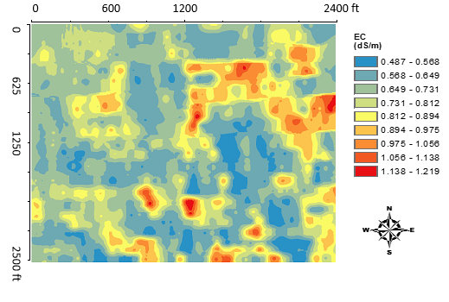
Figure 13. Soil salinity map for the control drained (south 1/3), and control drained plus subirrigated (middle 1/3) fields at the Clay County, MN site in fall 2016.
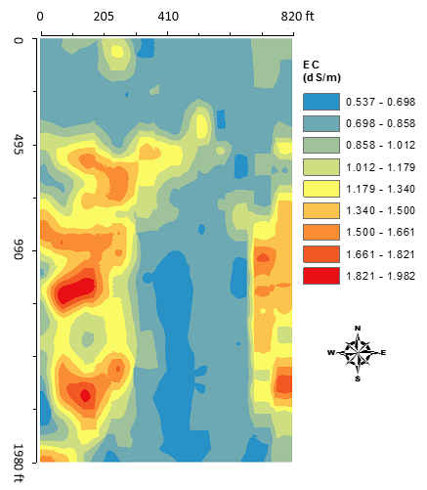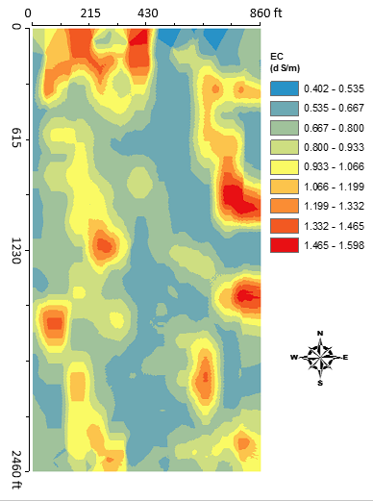
Figure 14. Soil salinity maps for the undrained (left) and free drained (right) fields at the Clay County, MN site in fall 2016.

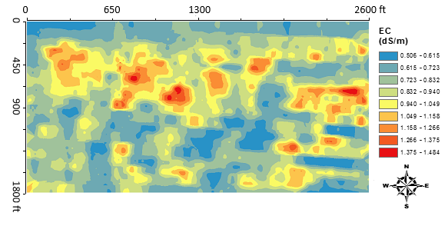
Figure 15. Soil salinity map for the control drained plus subirrigated field at the Richland County, ND site in fall 2016.

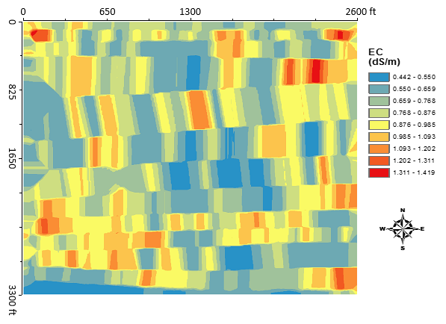
Figure 16. Soil salinity map for the undrained field at the Richland County, ND site in fall 2016.

From the salinity maps, we can see that the soil salinity was lower at the MN site, and higher at the ND site. However, the west side of the UD field had visual saline seeps as shown in the soil salinity map as well. For the fields at the MN site, this is the first time we conducted soil salinity maps, but for the ND site, we have done soil salinity maps three times since fall 2007. A clear trend of soil salinity decrease can be seen for the north half of the field since the tile drainage was installed in 2011. For the south half of the field, the soil salinity was stable around 1 dS/m, which is a good benefit derived from continuous tile drainage and subirrigation in the field.

Crop yields in 2016 were listed in Table 1, with the county average yield for that crop listed in the table as well.

Table 1. Comparison of crop yields in 2016 for undrained (UD), conventional tile drained (FD), control drained (CD), and CD and subirrigated (SI) at the Clay County, MN and Richland County, ND sites.

Location | Practice | Crop type | Yield (bu/ac or tons/ac) | County Average Yield (bu/ac or tons/ac) | Difference (bu/ac) | Difference (%)
MN site | UD | Soybean | 54 | 44.4 | 9.6 | 21.6
 | FD | Soybean | 56 | 44.4 | 11.6 | 26.1
 | CD | Corn | 197 | 181.7 | 15.3 | 8.4
 | SI | Corn | 197 | 181.7 | 15.3 | 8.4
ND site | UD | Corn | 190.9 | 184.6 | 6.3 | 3.4
 | SI | Corn | 200.3 | 184.6 | 15.7 | 8.5

The SI field in Richland County, ND has been providing steady and consistent higher yield in the last five years and one of the most important reasons was the good understanding of how to manage the water. However, in 2016, due to a sump pump failure, a high water table was kept for an extended time, the corn yield was slightly higher than the County average corn yield. This was a disappointment, however, we all learned again that a short duration of waterlogging created more damage to the crop than a long duration of drought conditions. Detailed procedures were developed to help the landowner manage the crops, especially with soybeans in 2017.

