Technical Report 2017

Project Title: Use of exogenous enzymes to improve nutritive value of soybean hulls

Principal Investigator: Uchenna Anele, Animal Scientist, NDSU Carrington Research Extension Center, 663 Hwy. 281 NE, PO Box 219, Carrington, ND 58421-0219, 701-652-2951, uchenna.anele@ndsu.edu
Co-investigators: Chanda Engel, NDSU-CREC, Animal Science Research Specialist

Introduction
With an increase in the adoption of drylot system by cow/calf operators in the US, more calves will be placed on creep in the coming years. Creep feeding is a common management practice of providing supplemental feed to calves before weaning. Weaning weight is a big profit-driver of any cow/calf enterprise. Creep feeding can be a profitable practice if the expected increase in weaning weight out-weighs the cost of feeding creep. One of the factors to consider in creep feeding is feed prices as feed is the single largest variable input cost in any livestock enterprise and improvement in feed efficiency can be a significant multiplier. The use of co-products will help lower the cost of feed. One of such co-products that have been used over the years is soybeans hulls. Increased fiber digestion of soybean hulls and other co-products by using feed enzyme additives will improve feed efficiency and reduce manure production, which allows cattle producers to use crop by-products in an environmentally responsible manner. We hypothesize that feed efficiency of preweaned calves can be improved, resulting in reduced feed costs and manure handling by using exogenous enzymes. This can be accomplished through identifying specific exogenous enzymes that target fiber digestion of co-products in calves’ diets.

Project goal:
To increase the use of soybean hulls in livestock rations (by using enzyme technology to improve feed efficiency in creep-fed calves).

Objectives:
- Identify specific enzyme additives that can be used to improve fiber digestibility of soybean hulls using the in vitro gas and in situ bag techniques.
- Evaluate the effects of enzyme additive on dry matter in take and digestibility, average daily gain, and feed efficiency of preweaned calves fed a creep ration under a drylot system.

Studies conducted
Study 1. Initial evaluation study using the in vitro batch culture
The in vitro batch culture technique was used to evaluate and identify enzyme additives that can increase fiber digestibility of soybean hulls. The enzymes were obtained from industry collaborators and key enzyme activities of cellulase, xylanase and mannanase were considered in choosing enzyme products. Ten enzyme treatments (NSPase, ABM, DYX, AMA, CUL, Mix1, Mix2, Mix3, Mix4 and Mix5) were evaluated using the in vitro gas incubation technique. Approximately 0.5 g of creep feed (Table 1) was weighed into filter bags and sealed. Sealed bags were placed in serum bottles. Ruminal fluid was collected 2 h after feeding from three ruminally fistulated steers fed a high forage diet. Whole ruminal contents were obtained from the rumen, composited, and immediately transferred to the laboratory and held at 39ºC in a water bath. Each serum bottle received 45 mL of McDougall’s buffer (artificial saliva) and 15 mL of strained ruminal fluid. Bottles were flushed with CO₂, capped with a 14-mm butyl rubber stopper, and crimp sealed. Sealed bottles were incubated in an oscillating shaker at 39ºC for 6, 12, and 24 h. After incubation, bags were removed from bottles, washed and dried in an oven for 48 h. Dry matter (DM) disappearance was determined by subtracting the loss of DM from the bags from the initial DM incubated.

Table 1. Ingredients and chemical composition of diet.
Ingredients Composition (% DM)
Rolled corn | 20.5
Modified DGS | 20.0
Soybean hulls | 55.0
Mineral supplement | 1.85
Vitamin supplement | 2.60
Chemical composition¹ | Composition (% DM)
Dry matter, % | 89.3
Crude protein | 18.1
Ether extract | 2.14
eNDF | 1.10
Neg, Mcal/lb | 65.1
Calcium | 0.79
Phosphorous | 1.08
Potassium | 1.07
¹Values for the experimental diets were calculated from NRC (1996) feed library table based on the ingredient composition.

Study 2. In situ ruminal digestibility of DM and fiber
The best two enzymes (NSPase and ABM) were further evaluated using the in situ bag technique. The in situ study was conducted with the same steers from the in vitro study and fed the same high forage diet. Ruminal DM and NDF degradability was determined using polyester bags. Quadruplicate samples of each enzyme treatment were incubated in the rumen of three steers. About 5 g of the same diet used in the in vitro study was incubated for 6 12 and 24 h. Immediately after removal from the rumen, bags were immersed in ice-water to stop or minimize microbial activity and then washed with cold water in a washing machine for 35 min. Ruminal DM and neutral detergent fiber (NDF) disappearance was calculated by subtracting the loss of DM and NDF from the bags from the initial DM and NDF incubated.

Study 3. Creep feeding of pre-weaned calves
Based on the data generated from the in situ study, NSPase was selected for the creep feeding study. The study evaluated the effectiveness of an exogenous enzyme (NSPase) to increase fiber digestibility of soybean hulls leading to improvement in feed efficiency of pre-weaned calves. Ninety red Angus cross calves (approximate initial body weight = 263 lb) was used in a completely randomized design with either diet supplemented with or without NSPase. Calves were blocked by body weight into light vs. heavy and fed over a 111-d period to determine growth and feed efficiency. Dietary treatments (with or without enzyme; Table 1) were replicated in two pens with about 23 calves per pen. The enzyme was sprayed on the creep ration, and then mixed before feeding.
Calves were weighed at the start and the end of the trial, and for a single day every 28-d during the remainder of the trial. The calves were fed once daily and intake of DM, digestibility, daily gain and feed efficiency were determined within each weigh period and for the total trial. Feeds and orts were sampled weekly for chemical analysis. Acid insoluble ash was used as the internal marker to determine digestibility. To control the effect of pen, fecal grab samples from 10 calves per pen were collected and calf was used as the experimental unit. The use of individual animals as experimental unit was only applied to the digestibility estimates. Actual DM intake and G:F were analyzed using the pen data. Data were analyzed using the Mixed procedure of SAS (SAS Institute Inc., Cary, NC). The model included the effect of pen nested within the treatment.

Results
The in vitro batch culture technique is used to determine the nutritive value of different diets. Gas is produced when carbohydrates in the diets are fermented to short-chain fatty acids (SCFA) like acetate and butyrate. Gas production reflects the generation of SCFA and microbial mass. Higher (P<0.05) asymptotic gas volume was noted for NSPase, ABM and DYX treatments compared with the other enzymes (Table 2). Enzyme treatments did not result in higher DM disappearance but NSPase and ABM treatments had numerically higher (3% or more) DM disappearance values compared with the control (Figure 1). The implication is that these enzymes will result in improved DM and fiber digestibility.
Table 2. Effects of exogenous enzymes on in vitro gas production kinetics of creep diet.
Enzymes | M | c (h⁻¹) | Lag time (h)
NSPase | 200 | 7.85 | 2.69
ABM | 199 | 7.08 | 1.50
DYX | 194 | 6.95 | 1.33
AMA | 151 | 6.85 | 0.10
CUL | 162 | 7.57 | 1.36
Mix1 | 158 | 7.96 | 2.22
Mix2 | 146 | 8.21 | 2.52
Mix3 | 133 | 9.58 | 2.97
Mix4 | 148 | 10.2 | 3.40
Mix5 | 140 | 10.7 | 3.36
Control | 139 | 8.49 | 2.67
SEM | 22.3 | 0.769 | 0.537
LSD at P<0.05 | 21.2 | 3.9 | 3.3
M = asymptoptic gas volume (ml/g DM); c = rate of fermentation.

Figure 1: Effects of enzymes on in vitro dry matter disappearance after 24 h of fermentation.

Compared with the control (no enzyme), both NSPase and ABM resulted in higher effective DM digestibility at low, medium and high feeding levels (Table 3). Differences in DM digestibility as a result of enzyme inclusion ranged from 4 to 9%. Additionally, enzyme treatments resulted in 32 and 29% increase in NDF digestibility for NSPase and ABM, respectively (Figure 2). Overall, these two
(in vitro and in situ) techniques were utilized to identify an exogenous enzyme (NSPase) that can potentially increase DM and fiber digestibility of soybean hulls used in a creep feed.

Table 3. Non-linear estimates and effective degradability coefficient of the creep diet.
 | ABM | NSPase | Control | SEM | P value
a | 0.241^{b} | 0.244^{b} | 0.243^{ab} | 0.0005 | 0.036
b | 0.406^{b} | 0.433ª | 0.399^{b} | 0.0051 | 0.003
k | 0.132ª | 0.116^{b} | 0.097^{c} | 0.0036 | <0.001
Lag | 0 | 0 | 0.157 | 0.0564 | 0.130
ED (2%) | 0.594^{b} | 0.614ª | 0.573^{c} | 0.0031 | <0.001
ED (5%) | 0.536^{b} | 0.547ª | 0.505^{c} | 0.0018 | <0.001
ED (8%) | 0.494^{b} | 0.500ª | 0.459^{c} | 0.0015 | <0.001
Undegraded | 0.352ª | 0.323^{b} | 0.358ª | 0.0054 | 0.003
^{abc} Means in the same column with different superscripts differ (P < 0.05).
a = The portion of DM solubilized at initiation of incubation; b = the fraction of DM insoluble
but degradable in the rumen; k = the constant rate (percentage per hour) of disappearance of
fraction b; Lag = lag phase, (hours) prior to the commencement of degradation of fraction b;
ED = Effective degradability at three rumen solid outflow rates of 2, 5 and 8% per h, which is
representative for low, medium and high feeding levels.

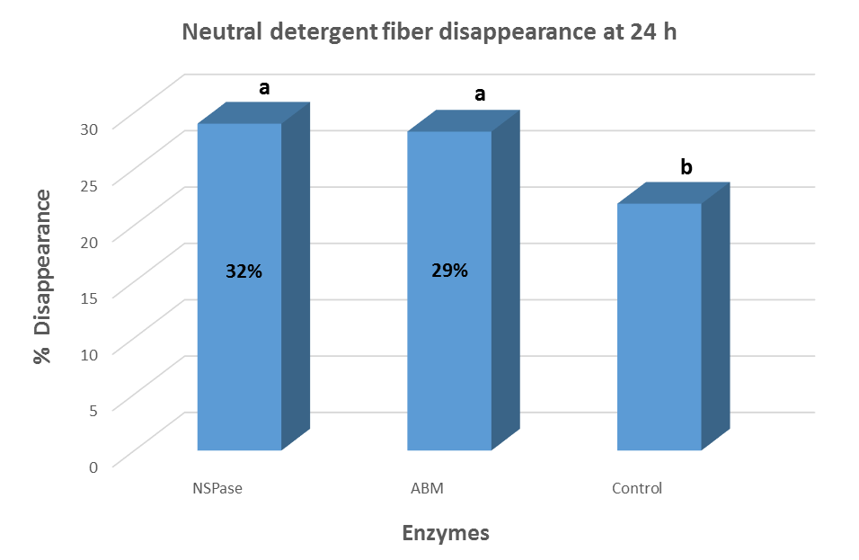
Figure 2: Effects of enzymes on in situ ruminal neutral detergent fiber digestibility. Bars with different letters differ (P<0.05).
Inclusion of the exogenous enzyme had no effect on the final BW, average daily gain, G:F and DM digestibility (Table 4). Differences in dry matter digestibility between the two treatments were similar to values observed with the cannulated steers. Dry matter intake was greater (P<0.001) for the control treatment. Lower dry matter intake in calves supplemented with the enzyme treatment did not affect their performance as they have similar average daily gain with the control treatment. The lack of difference on the effect of pen nested within the treatments for final BW, average daily gain, and G:F was expected because of the small pen number used in this study. It was based on this premise that we asked and received funding for another year of research to increase the number of replicates for statistical analysis.

Table 4. Effects of exogenous enzyme on performance and apparent DM digestibility pre-weaned red angus calves
Item | Control | Enzyme | Standard Error | P value
Initial BW¹, lb | 263 | 263 | 5.2 | 0.964
Final BW, lb | 678 | 667 | 10.2 | 0.451
ADG, lb | 3.74 | 3.62 | 0.063 | 0.191
DMI, lb | 9.90 | 9.48 | 0.049 | <0.001
Gain:Feed | 0.378 | 0.382 | 0.0061 | 0.599
Digestibility, DM % | 73.9 | 76.9 | 1.43 | 0.146
¹BW, body weight; ADG, average daily gain; DMI, dry matter intake.

Overall, inclusion of exogenous enzyme resulted in lower dry matter intake without affecting animal performance in calves fed soybean hull-based creep feed.

