**North Dakota Soybean Council – Technical Report**

**Title:** Utilizing soybean maturity class, planting date, and plant population to increase soybean production in West and Central ND

**Principal Investigator**: Jasper M Teboh, Soil Scientist, Carrington Research Extension Center

North Dakota State University. P.O. Box 219 / Carrington, ND 58421-0219 Tel: 701-652-2951; Fax: 701-652-2055; [Jasper.Teboh@ndsu.edu](mailto:Jasper.Teboh@ndsu.edu)

**Co-Investigators:** John Rickertsen, Hettinger Research Extension Center; Eric Eriksmoen, North Central Research Extension Center; Szilvia Yuja, Carrington Research Extension Center Mike Ostlie, Carrington Research Extension Center

**Situation Statement:**

Because of growing interest in soybean production among producers in Western North Dakota (ND), and Central ND, expansion of research to support the farmers with information that serves their production needs is imperative. Historically, maturity group, planting date, and plant population, have been vital for soybean production. Despite the singular importance of each of these factors, the impact of one factor on soybean yields sometimes would depend on one or more of these deciding factors for the producers, who select their seeds based on how early their planted seeds attain maturity (type of cultivar), or if the crop will do as well if planted early or late (as susceptibility to late frost in spring or early frost in fall may cause damage. They also want to know what would be the best plant population from the seeds they plant. These are of interest to producers, especially the non-traditional ND soybean producers who, because of their unfavorable climatic and soil conditions, have not until recently, been enthusiastic about growing soybeans. This is the case of several producers (in drought-prone) west of the Missouri River, and in central ND who until recently, are starting or willing to expand production. The goal of this project is to enhance farmer’s understanding and decision making on how each factor or a combination of factors such as soybean cultivars of different maturity groups (MG), planting dates, and plant population (seeding rate) affect soybean performance. Maturity is a first important consideration for choosing a cultivar that is suitable to a given geographical location. Some of the cultivars farmers grow are sometimes not suitable to the climatic conditions in western ND, thus a few producers have experienced setbacks from low yields, thereby retarding expansion of soybean production in these areas. Seeding rates to achieve higher plant population may increase yield due to increased light interception of the canopy during grain-filling.

**Goal**:

To increase soybean production and productivity from current levels in Western and Central North Dakota

**Research Objectives**

1. Determine optimum yielding maturity groups and seeding rates of soybeans for dryland production in Western and Central ND
2. Determine the impact of early and late planting on yields of early and late maturing soybean

**Description of the research conducted**

This research was conducted at Hettinger (HREC), Carrington CREC), and Minot (NCREC). Four soybean cultivars of maturity groups (MG- 0.4, 0.6, 0.8) were seeded on three dates at two week intervals (early, normal, late), at three seeding rates, 80K, 120K, 160K/ac, where K means a thousand. All trials were established under dryland conditions in addition to an irrigated (pivot) site at CREC. The four cultivars planted included two conventional cultivars, Ashtabula (MG-0.4) and Prosoy (MG-0.8), and two Round Up Ready cultivars, Proseed 50-60 (MG-0.6) and Proseed 30-80 (MG-0.8). The planting dates were May 4th, 19th, and June 2nd at Hettinger, May 6th, 17th, and June 3rd at Minot, and May 6th, May 20th, and June 2nd at Carrington. The experimental design was a Randomized Complete Block with a split-plot arrangement. The main plots consisted of three planting dates and subplots consisted of the maturity groups (MGs) and plant population. Each treatment was replicated four times. Seeds were planted at 14-inch row spacing. Statistical analysis was conducted using the Mixed Model in SAS. Mean differences were tested at 95% confidence level when effects of treatments were significant, following an analysis of variance.

**Results:**

Record yields observed in many parts of the state were not observed in this study. At Carrington, there was some hail damage in June that affected seed yields at the irrigated site, meanwhile drought conditions also affected yields on dryland. Ashtabula was destroyed by Round Up herbicide.

Effect of maturity group (MG) on seed performance: Comparing yields of MGs (cultivars) revealed that there was a significant interaction between MG and planting date at Hettinger, CREC-irrigated site, and Minot (Table 1). When the early MG cultivar (Ashtabula 0.4) was planted early or late, the yields were significantly (p<0.05) less than when planted on the normal planting date (mid-May). This was also true for the later cultivar (Prosoy-0.8), which produced about 9 bushels more, when seeded on the normal planting date. There were no interaction effects on seed protein and oil at Hettinger. Prosoy had significantly greater protein (>1%) than the other cultivars, but significantly, the lowest oil content. Oil content was significantly different for each cultivar, decreasing in the order Ashtabula > Proseed 50-60 > Proseed 30-80 > Prosoy. At the CREC-dryland site, yield was impacted by MG and population but not planting date, even though there was obvious numerical increase in yields from early to late planting. At the CREC irrigated site, planting Proseed 50-60 (MG 0.6) in early May or during normal planting date (May 20th) increased yields significantly compared to late (June 3rd) planting. At Minot, it was not evident why yields of Proseed 50-60 decreased when seeded on the later dates; meanwhile, the yields of Prosoy were significantly higher by planting early, compared to normal and late planting.

A comparison of seed protein and oil showed that ProSoy (late-MG) contained significantly more protein than the rest of the cultivars, but significantly less oil than each of the other cultivars planted at Hettinger. At CREC-dryland, within cultivar protein differences were not significant by date except for Prosoy, which produced significantly less protein by planting on May 20th but not different from June 2nd planting. It is probable that the lack of differences between the early (May 3rd) and late planting was due to lower yields produced by the late planting, resulting in greater protein concentration in the seed. At the irrigated site, grain protein increased significantly for Ashtabula and Proseed 30-80 when planted late but rather, decreased significantly with late seeding of Prosoy. At Minot, cultivar differences had significant protein effect, increasing in the order, Ashtabula = Proseed 30-80 < Proseed 50-60 < Prosoy.

Oil content was significantly different among cultivars at Hettinger and the CREC irrigated site. Population had no significant effect on yields, seed protein, and oil at Hettinger. Meanwhile there were obvious cultivar differences in protein and oil production.



Effect of planting date on seed performance: Besides the significant interaction effects of planting date and MG (discussed in the preceding section), planting date had no significant singular effect on seed yield and quality at all sites except on seed oil content at the CREC-irrigated site. Seed oil content decreased significantly from 15.6% at early planting to 15.1% at normal planting period, further decreasing significantly from normal to 14.4% at late planting. At Hettinger, planting on May 19th produced the highest yields consistently for every cultivar. Looking back at the 2015 results of this study, planting on June 1 produced the highest yields at Carrington on dryland. The highest yields were recorded for Proseed 0.6 and 0.2 compared to Prosoy (0.8) and Ashtabula (0.4), suggesting that inherent higher yielding traits of some cultivars could lessen the magnitude of difference in the effects produced by planting date of an early or late cultivar. Planting a late cultivar like Proseed 30-80 (MG 0.8) as late as June suggested higher risk of significant yield loss as observed in Carrington where, yields were consistently greater for later MG cultivars planted early. Average yield of all sites following early, normal, or late seeding were, 36, 37, 33 bu/ac, respectively. Meanwhile, the best yields were recorded on May 20th at Hettinger in 2015. The difference between response to early planting and late planting at a given site very likely depends on available soil moisture during the growth and seed production sensitive period (flowering to seed fill) of the crop.

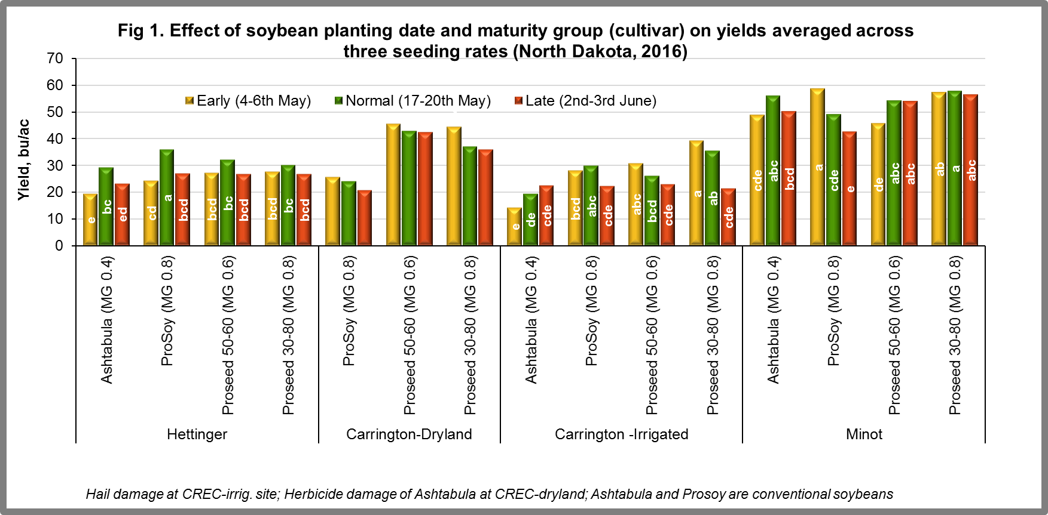

Effect of plant population on seed performance: Population has significant yield effects, generally increasing yields with population (figure 2). The impact of population was tested at the three planting dates to determine if there were treatment interaction effects. There were no significant interactions at all sites except for protein, at the CREC irrigated site and on TWT at Hettinger, where difference between populations showed greater seed TWT at 160K (160,000) compared to 120K. At the CREC dryland site, plant population significantly increased yields from 30 bushels at 80K plants, and 34 bushels at 120K plants, to 38 bushels at 160K and 200K, respectively. Yields were not significantly different between the two lowest populations. Seed protein content increased progressively from early to late planting, and from 80K to 200K when planted on May 19th and June 2nd. But when planting was done early (on May 6th), seed protein declined as population increased from 80K to 160K. At Minot, population had significant impact on seed yield, protein, and oil content. Yield (55.7 bu) at 160K seeding rate was not statistically different from 200K seeding rate, but significantly greater than seeding at 120K (50.9 bushels) and 80K (46.6 bushels). Seed protein was significantly greater at 160K compared to 80K. seed oil content at 160K was not statistically different when compared at higher seeding rates, but statistically less than at 80K rate.

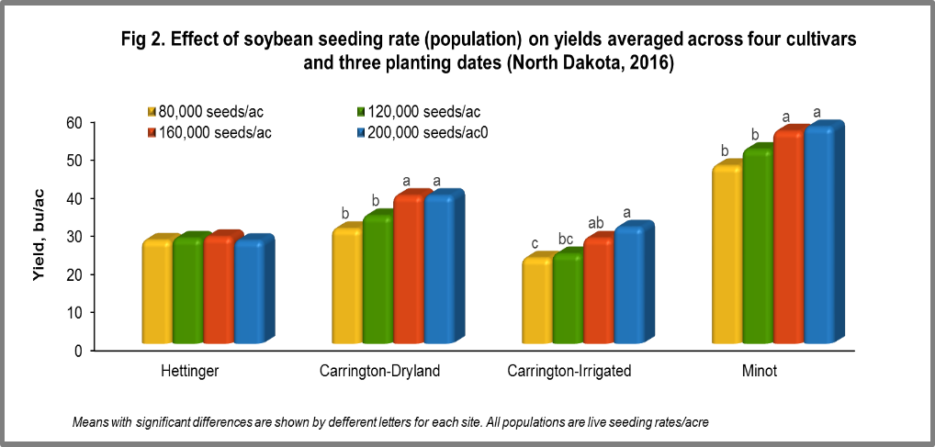

**Conclusion:** The main conclusions from this study are that, planting during the normal planting time around May 20th remains a more productive time when compared to the three dates assessed. Maturity group 0.6 and 0.8 are better suited for the Hettinger and Carrington growing regions, compared to a 0.4 or less MG. Seeding at a rate of 160,000 live seeds/ac produced as much yields as 200,000 seeds/ac, and more than at 120,000 or less seeds/ac, thus would be more economical and recommended for these sites. In deciding which maturity group to plant, it is important for the producer to have an idea of what the yield potentials are, of the cultivars available since the inherent yield capabilities may be more important than the maturity class.