Project Title: Optimizing fungicide applications for management of Sclerotinia in soybeans

Situation statement:
Management of Sclerotinia stem rot (white mold) in soybeans with fungicides is limited by a poor understanding of the optimal timing for fungicide applications and by difficulties achieving satisfactory fungicide coverage to the interior of the canopy where infections begin.

The current recommendation of making applications at the R1 growth stage was developed from studies in which only applications at R1 and R3 were tested. Data from the first two years of this project (2014 and 2015) suggest that fungicide applications at the early to full R2 growth stage improved Sclerotinia control and soybean yield, but additional multi-location data was needed to generate rigorous recommendations.

Because Sclerotinia develops in the interior of the canopy where it is difficult to deposit fungicides, even optimally timed fungicide applications rarely confer more than 50 percent disease control in soybeans. Current methods for improving fungicide coverage are primarily limited to nozzle selection, application pressure and water volume, but a new commercially available drop-nozzle has high potential to significantly improve fungicide deposition within the soybean canopy. The drop nozzle, manufactured by the 360 Yield Center, is equipped with multiple ports for optimizing pesticide delivery within the canopy and has a design that enables it to simultaneously serve as an effective canopy opener. However, this drop nozzle has not been rigorously evaluated for its ability to facilitate improved control of Sclerotinia diseases, and the application methods (nozzle selection, nozzle orientation, and spray droplet size) that optimize fungicide delivery and Sclerotinia control are poorly understood.

Objectives:
- Identify optimal fungicide application timing for control of Sclerotinia in soybeans planted to narrow, intermediate, and wide rows.
- Quantify fungicide coverage, Sclerotinia disease control, and soybean yield responses associated with conventional methods of improving fungicide coverage (higher application pressure and higher water volume) versus the use of drop nozzles to deliver fungicides directly into the lower soybean canopy.
- Optimize the use of drop nozzles to improve fungicide coverage, Sclerotinia disease control, and soybean yield by quantifying the impact of drop-nozzle height within the canopy and the impact of nozzle type, nozzle placement, and fungicide application pressure on drop nozzle performance.

Description of the research conducted:
Field trials evaluating fungicide application timing were established at the NDSU Carrington and Langdon Research Extension Centers and at the NDSU Robert Titus Research Farm in Oakes. A non-treated control was compared to 5.5 oz/ac of the fungicide Endura (boscalid; BASF Corp.) applied at the late R1 growth stage and early, mid and late R2 growth stage. Field trials were established as randomized complete block designs with 6 replicates, with separate experiments established to test fungicide application timing in soybeans seeded to narrow, intermediate and wide row spacing. In Langdon, testing was conducted on soybeans seeded to rows 15 and 30 inches apart. In Oakes, testing was conducted on soybeans seeded to rows 14 and 28 inches apart. In Carrington, testing was conducted on soybeans seeded to rows 7, 14, 21, and 28 inches apart. Field trials were planted May 9 in Carrington, May 17 in Oakes, and May 19 in Langdon. Fungicides were applied in 15 gal/ac at 40 psi with a 60-inch hand boom equipped with XR80015 flat-fan nozzles. A severe hail storm on July 9 in Carrington defoliated the soybeans at bloom initiation, precluding disease development, but studies at the other locations were successful. End-of-season Sclerotinia incidence and severity was assessed at the late R6/early R7 growth stage by individually evaluating every plant in the middle two rows of each four-row plot (12- and 14-inch row spacing) or in an arbitrarily selected row of each two-row plot (28- and 30-inch row spacing). Sclerotinia severity was assessed on each plant with the 0 to 3 scale developed by Craig Grau (Grau and Radke 1984; Plant Disease 68: 56-58): 0 = no symptoms, 1 = lesions on lateral branches only, 2 = lesions on main stem, no wilt, and normal pod development, 3 = lesions on main stem resulting in wilting, poor pod fill, and plant death. Contamination of the harvested grain with sclerotia was assessed by manually removing all sclerotia from a 200-gram subsample of grain from each plot, assessing the weight of the sclerotia, and calculating the percent weight of the sclerotia in the sample. Data were analyzed with analysis of variance (ANOVA) in PROC GLM of SAS (version 9.4; SAS Institute, Cary, NC). Data were evaluated to confirm that they met the distributional assumptions of ANOVA; when data did not meet the assumptions of ANOVA, a systematic transformation resolving the distributional problems was applied to the data whenever possible; otherwise, the data were not analyzed. Single-degree contrasts were performed for all pairwise comparisons of treatments utilizing the Tukey multiple comparison procedure.

Field trials evaluating fungicide application methods were established at the NDSU Carrington Research Extension Center and at the NDSU Robert Titus Research Farm in Oakes. The field trials were planted May 10 (Carrington) and May 17 (Oakes). Row spacing was 21 inches, seeding rate was 165,000 pure live seeds/ac, and experimental design was a randomized complete block with 6 replicates. In Oakes, fungicides were applied July 15 when 100% of plants were at the R2 growth stage, the first pods were less than 0.25 inches long, and canopy closure was 97%. Sclerotinia incidence and severity were assessed at the early R7 growth stage, and seed yield and quality were evaluated. In Carrington, a severe hail storm on July 9 in Carrington defoliated the soybeans at bloom initiation, and fungicide applications were made after the canopy had recovered at the R5 growth stage. The hail damage in Carrington precluded Sclerotinia disease development, and only fungicide deposition – not disease levels or yield – was assessed in the Carrington trials. The experiments assessing (1) nozzle spray pattern, application pressure, and droplet size and (2) water volume and spray boom height were conducted on August 15 and 16, respectively, when canopy closure was 99% and the canopy averaged 23.4 inches tall; the experiment evaluating different drop nozzle configurations was conducted on August 22.

In the fungicide application studies, applications were made with nozzles mounted 20 inches apart on a tractor-mounted boom or with nozzles mounted to the side and lower rear ports of Undercover 360 drop nozzles (Yield 360; Morton, IL). The drop nozzles were spaced 21 inches apart (the same as the dry bean row spacing), and the tractor was driven such that the drop nozzles passed half way between each row. The spray mixture was pressured with CO₂. The boom was situated such that the boom-mounted nozzles were 20 inches above the top of the average canopy height for 110-degree nozzles and 30 inches above the top of the canopy for 80-degree3 nozzles. The drop nozzles were oriented such that the nozzles were at the midpoint of the canopy. In all studies, the fungicide Endura (boscalid, 70% by weight; BASF Corp.) was applied at 5.5 oz/ac.

Spray deposition within the canopy was assessed with water-sensitive paper (5 cm x 7.5 cm) for monitoring spray distribution (Syngenta Corp.; Basel, Switzerland). Paper tabs were taped to the back of the water-sensitive paper such that they extended slightly beyond the water-sensitive paper, and the water-sensitive paper was fastened onto brackets attached to aluminum rods (to assess leaf deposition) or onto paper tabs attached to wooden stakes (to assess stem deposition) with paper clips on the paper tab. The brackets on the aluminum rods were situated such that the lower bracket (to assess deposition to leaves in the lower canopy) and the upper bracket (to assess deposition in the upper canopy) faced in opposite direction such that placement of a spray card mounted on the upper bracket did not interfere with spray deposition to a spray card mounted on the lower bracket. After mounting the water-sensitive paper, the aluminum rods and wooden stakes were driven into the ground within the plot, with care taken to ensure that leaf placement around and above the rods/stakes was representative of a fully closed canopy. Assessment of spray deposition to lower leaves was conducted by paper-clipping water-sensitive spray cards to a 90-degree bracket fixed to a wooden stake, with the stake driven into the ground within the soybean row such that the paper was upward-facing and was placed one-third of the height up the canopy. Spray deposition to upper leaves was assessed in the same manner except that the spray card was placed at two-thirds the height of the canopy, and, where applications were made with drop nozzles, pairs of downward- and upward-facing spray cards. Assessment of spray deposition to stems was conducted by mounting water-sensitive paper to a stake; the stake was driven into the seeding row such that the paper was centered at one-quarter and/or one-half of the height of the canopy. In the drop nozzle study conducted in Carrington, fungicide residues were assessed 2 days after application. From each plot, 30 plants were evaluated; from an arbitrarily selected location within the middle row of the plot, the next 30 plants within the row were uprooted. From each plant, the lowest pod and the pod closest to the mid-point of the height of the plant were removed along with the surrounding 2.5 cm of stem tissue from the plant’s main stem and from one of the plant’s outermost branches (for a total of four pods per plant). The tissue samples from all 30 plants were bulked into a single sample and shipped overnight to Environmental Micro Analysis, Inc. (Woodland, CA) for fungicide residue analyses; Environmental Micro Analysis received the samples in less than 24 hours after they were shipped and approximately 72 hours after fungicides were applied and froze the samples upon receipt.

Findings:
In soybeans seeded to 14- and 15-inch row spacing, Sclerotinia control was maximized when fungicides were applied when 85 to 100% of plants were at the R2 growth stage (Tables 1 and 2). In soybeans seeded to wide rows (28- or 30-inch), optimal fungicide timing for the control of Sclerotinia could not be rigorously assessed due to high levels of variability in disease pressure across the footprint of the studies; note the high coefficient of variation for the disease data.

The results from the fungicide timing studies conducted in Langdon and Oakes in 2016 and previous studies conducted in Carrington, Langdon, Oakes and Williston in 2014 and 2015 strongly suggest that the standard recommendation of applying fungicides at the R1 growth stage when targeting Sclerotinia is sub-optimal (Figures 1 and 2). Sclerotinia disease control was improved in 16 out of 16 field trials and soybean yield under Sclerotinia pressure was increased in 12 out of 16 field trials when applications of the fungicide Endura (5.5 or 8.0 oz/ac) were delayed from the R1 growth stage (60-90% of plants with at least one open blossom) to the early R2 growth stage (80 to 98% of plants with at least one open blossom at one of the two top two nodes on the plant). Sclerotinia disease control was increased in 9 of 11 trials and soybean yield under Sclerotinia disease pressure was improved in 10 of 11 trials when fungicide applications were delayed until the full R2 growth stage (100% of plants at R2).

Disease control conferred by different fungicide application methods could not be assessed. Sclerotinia disease pressure was very low in the field trial conducted in Oakes (Table 3), and the hail storm that occurred on July 9 in Carrington that defoliated the soybeans at bloom initiation precluded disease development. In Carrington, fungicide applications were made at the R5 growth stage, when the canopy had recovered but after the growth stages at which soybeans exhibit maximum susceptibility to Sclerotinia.

The application of fungicides through drop nozzles resulted in sharp increases in fungicide deposition to lower soybean stems, the location where most Sclerotinia infections begin. In Oakes, applying fungicides through drop nozzles resulted in a 15- to 30-fold increase in fungicide coverage, a 25- to 100-fold increase in the number droplets deposited per unit area, and a 15- to 25-fold increase in the estimated volume of fungicide deposited (Table 3). Equipping the side ports of the drop nozzles with flat-fan nozzles conferred similar levels of fungicide coverage and fungicide deposition as equipping the drop nozzles with hollow-cone nozzles. In field trials conducted in Carrington, applying fungicides through drop nozzles conferred similar increases in fungicide residual (Figure 3), fungicide coverage and fungicide deposition (Table 4). Equipping the side ports of the drop nozzles with flat-fan or hollow-cone nozzles was more effective than using twin-jet nozzles.

When fungicides were applied with nozzles mounted directly to the spray boom, fine and medium spray droplets generally resulted in better fungicide deposition to the interior of the canopy than coarse droplets (Table 5). Lowering the boom such that the recommended boom height was measured from a point 25% below the top of the canopy rather than from the top of the canopy also improved fungicide deposition within the canopy (Table 6).

Table 1. Impact of fungicide application timing on management of Sclerotinia in soybeans; Langdon, ND (2016). In all treatments, the fungicide Endura (boscalid; BASF Corp.) was applied at 5.5 oz/ac.
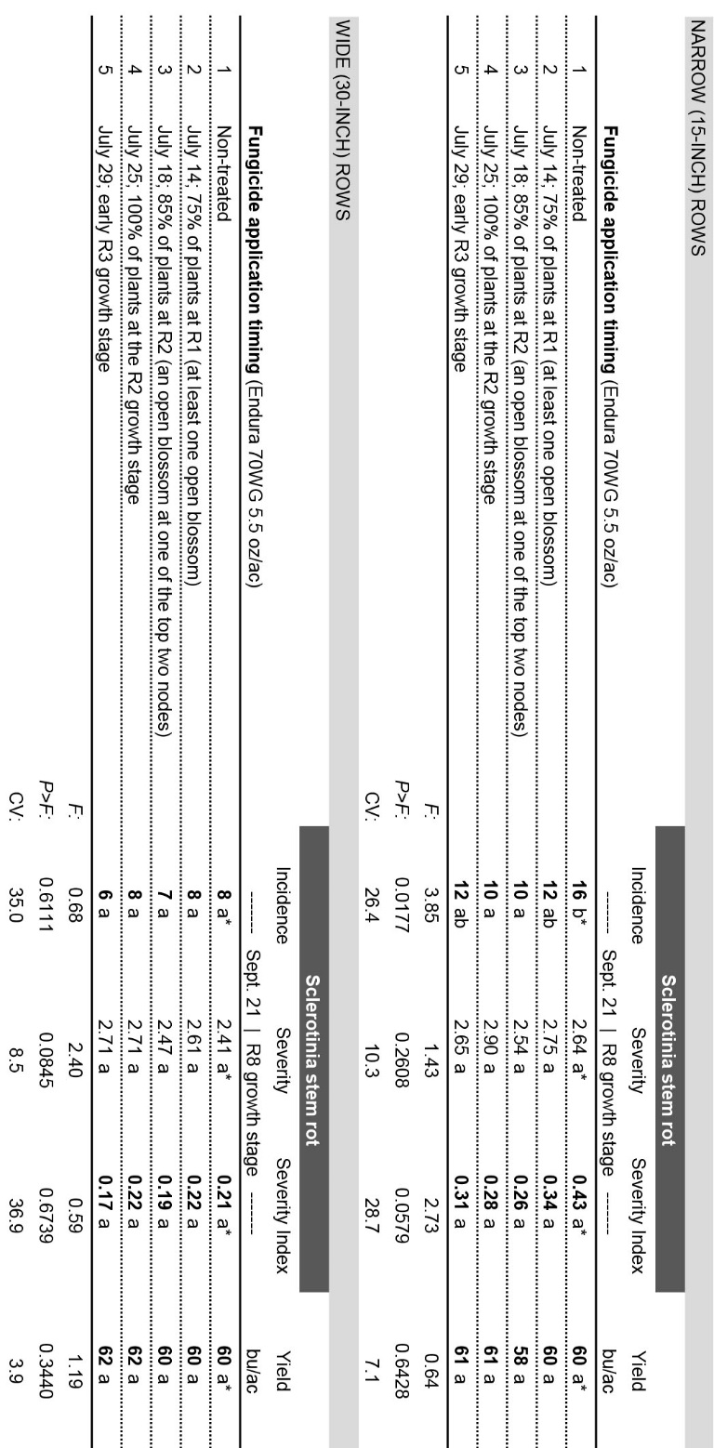
Table 2. Impact of fungicide application timing on management of Sclerotinia in soybeans; Oakes, ND (2016). In all treatments, the fungicide Endura (boscalid; BASF Corp.) was applied at 5.5 oz/ac.
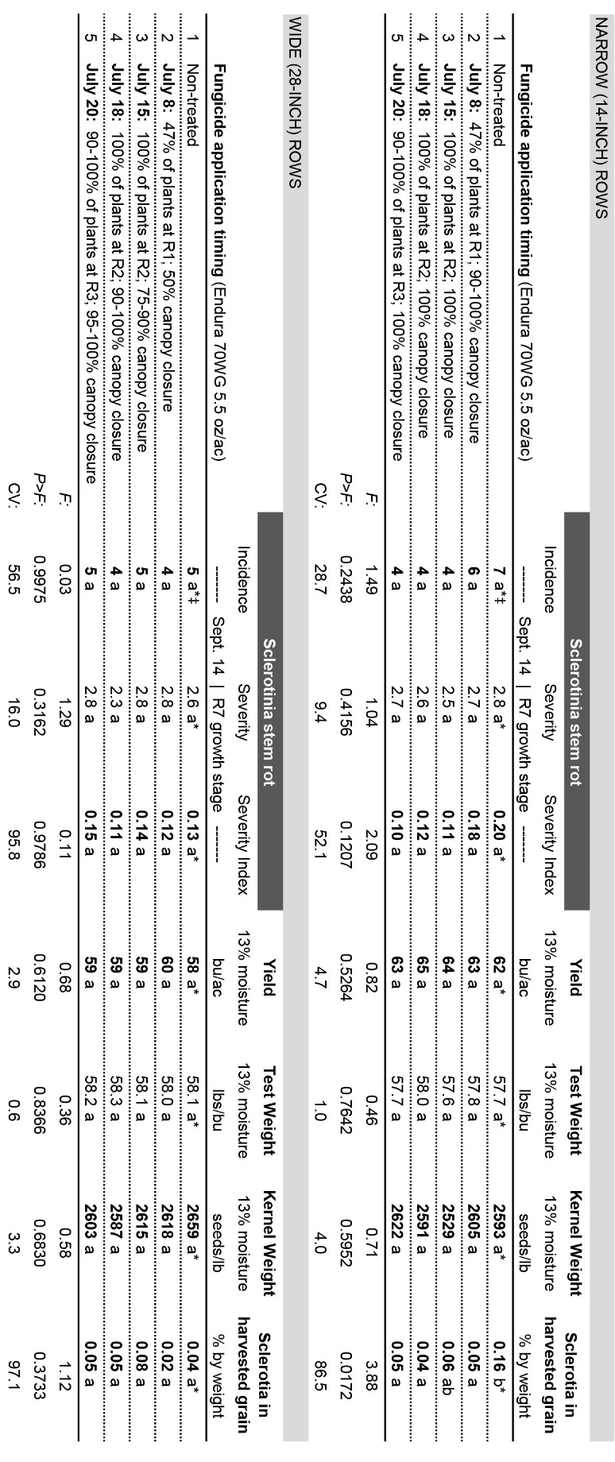
Figure 1. Impact of delaying fungicide applications from the R1 to R2 growth stage in field trials conducted in Carrington, Langdon, Oakes, and Williston, ND in 2014, 2015, and 2016. The fungicide Endura (boscalid; BASF Corp.) was applied at 5.5 or 8.0 oz/ac. Bars represent the number of field trials a specific magnitude of response.
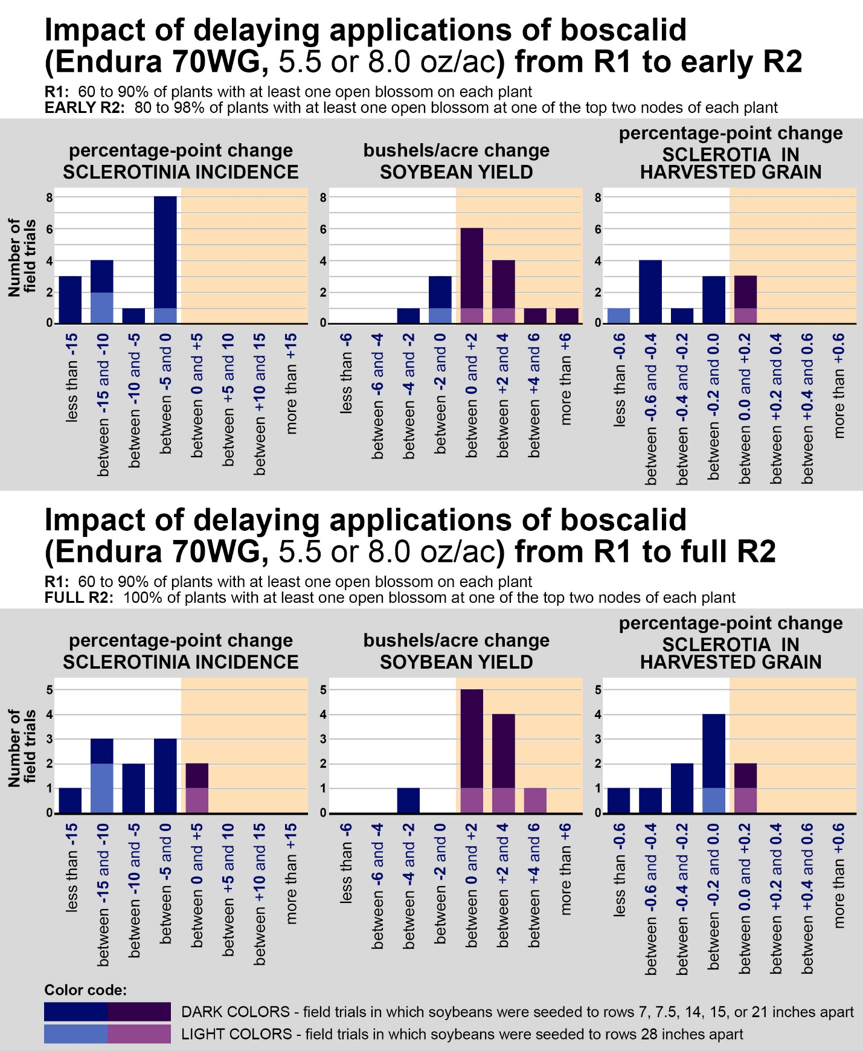
Figure 2. Impact of delaying fungicide applications from the R1 to R2 growth stage in field trials conducted in Carrington, Langdon, Oakes, and Williston, ND in 2014, 2015, and 2016. Within-column bars followed by different letters are significantly different (P<0.05), and pink coloration denotes bars that are significantly different from the control (dark blue).
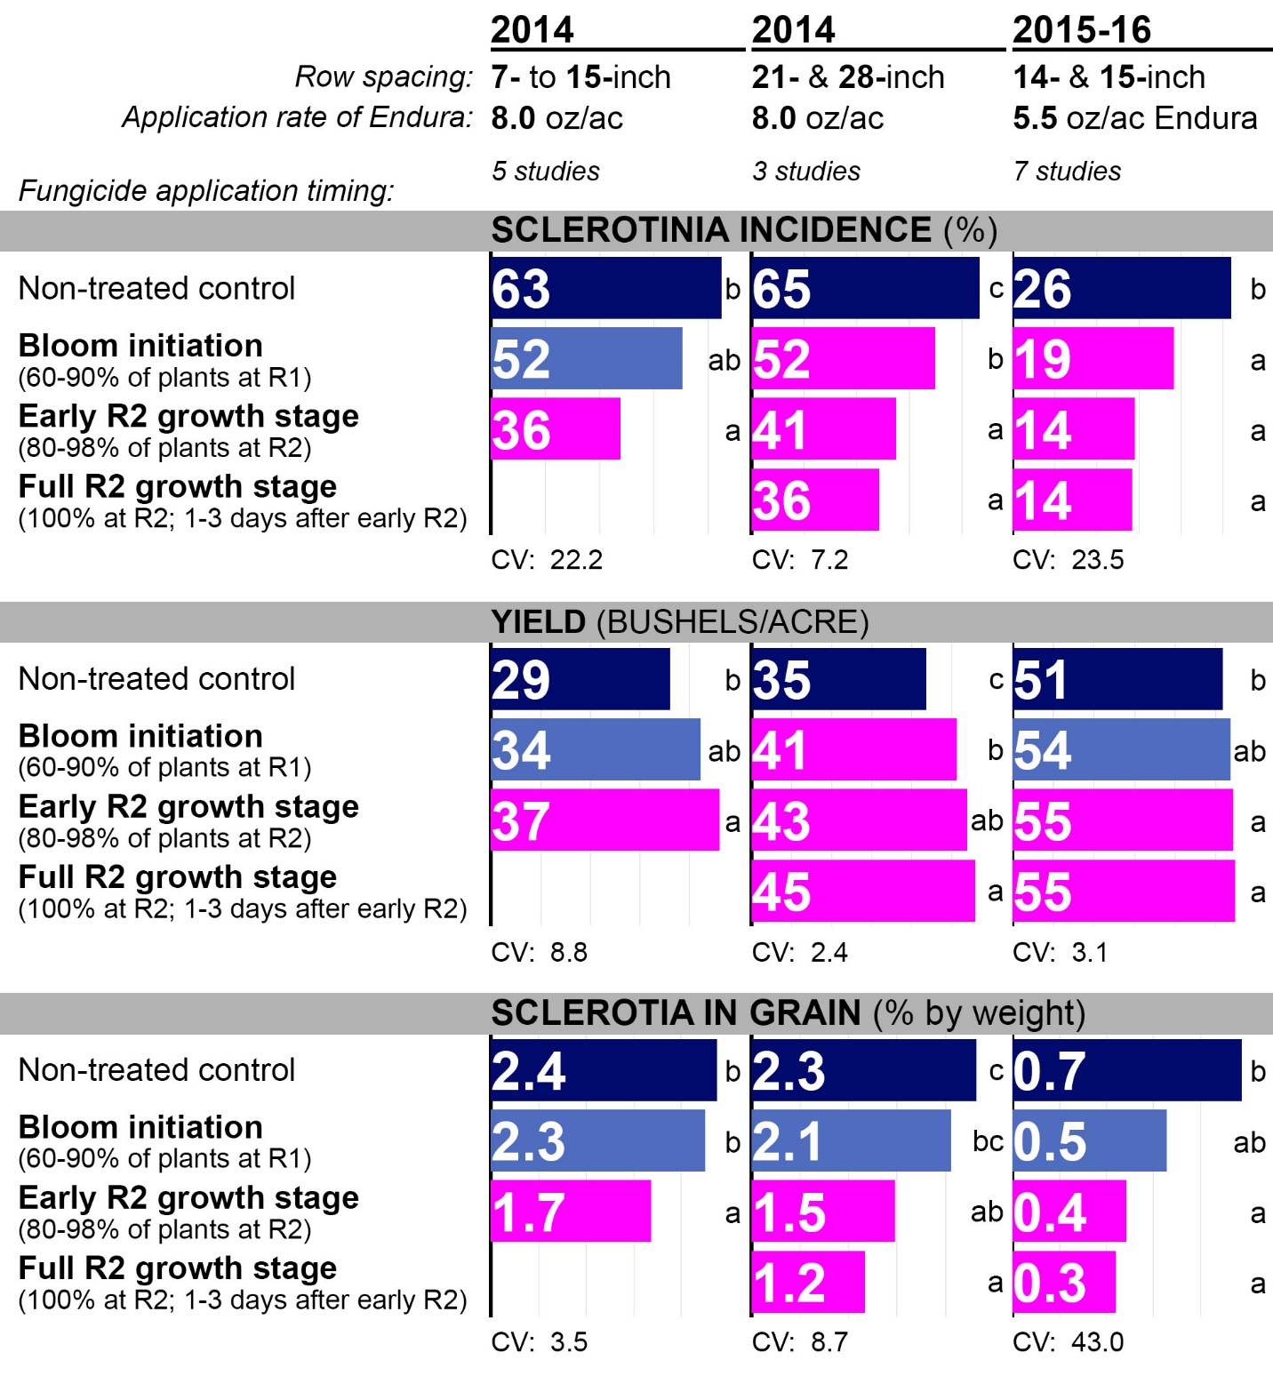
Table 3. Impacts of spray nozzle selection, adjuvants, spray droplet size, spray volume, and nozzle placement on fungicide deposition and agronomic outcomes in soybeans; Oakes, ND (2016). The 360 Undercover drop nozzle (360 Yield Center; Morton, IL) was utilized. The fungicide Endura (boscalid; BASF Corp.) was applied at 5.5 oz/ac to soybeans seeded to 21-inch rows when 100% of plants were at the R2 growth stage and canopy closure was 97%. Within-column means followed by different letters are significantly different (P<0.05).
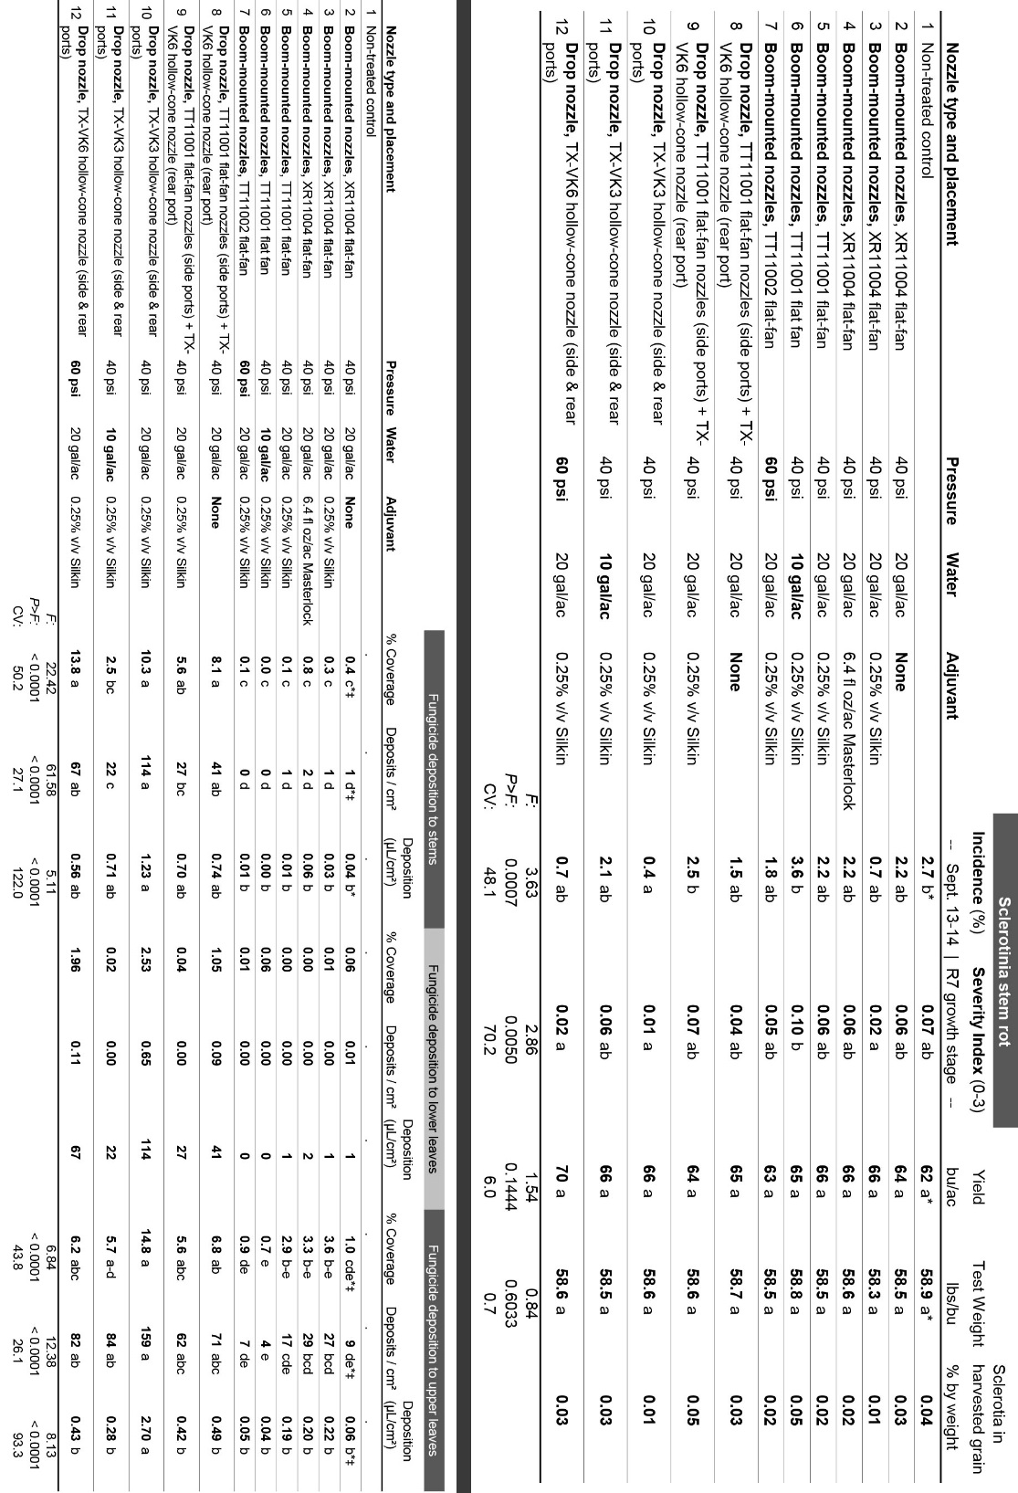
Figure 3. Impacts of spray nozzle selection, adjuvants, spray droplet size, spray volume, and nozzle placement on fungicide residues in soybeans; Carrington, ND (2016). The 360 Undercover drop nozzle (360 Yield Center; Morton, IL) was utilized. A severe hail storm that defoliated the soybeans at bloom initiation precluded making applications targeting Sclerotinia, and the fungicide Endura (boscalid; BASF Corp.) was applied at 5.5 oz/ac when the soybean canopy had recovered. Soybeans were at the R5 growth stage, and canopy closure was 97%. Fungicide residues were assessed by collecting pods and surrounding stem tissue from the bottom and the mid-point of the center stem and one of the outermost branches of 30 soybean plants per plot. Within-column bars followed by different letters are significantly different (P<0.05), and pink coloration denotes bars that are significantly different from the control (dark blue).

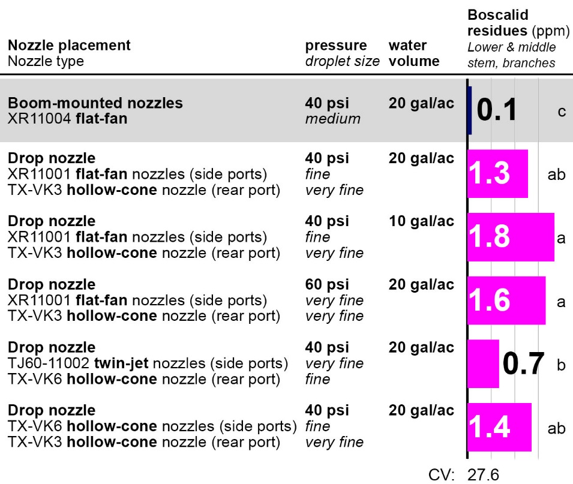
Table 4. Impacts of spray nozzle selection, spray droplet size, spray volume, and nozzle placement on fungicide deposition in soybeans; Carrington, ND (2016). The 360 Undercover drop nozzle (360 Yield Center; Morton, IL) was utilized. A severe hail storm that defoliated the soybeans at bloom initiation precluded making applications targeting Sclerotinia, and the fungicide Endura (boscalid; BASF Corp.) was applied at 5.5 oz/ac when the soybean canopy had recovered. Soybeans were at the R5 growth stage, and canopy closure was 99%. Within-column means followed by different letters are significantly different (P<0.05).

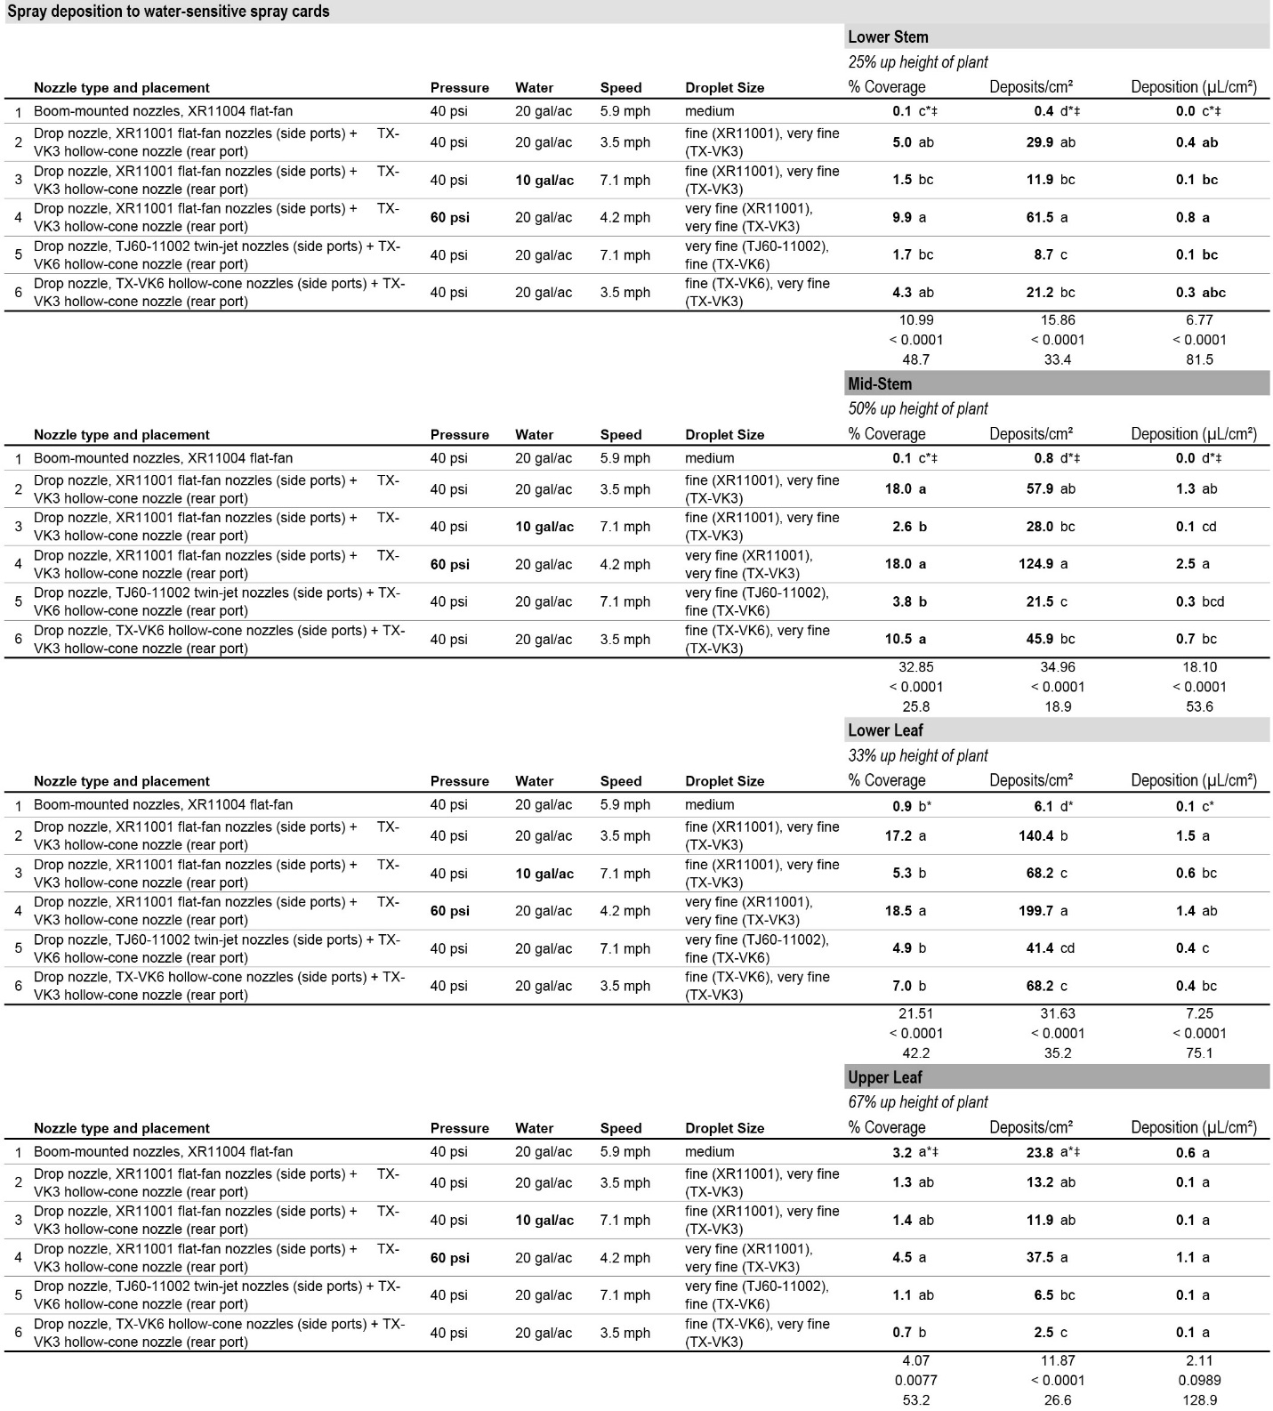

Table 4. Impacts of nozzle spray pattern and spray droplet size on fungicide deposition in soybeans; Carrington, ND (2016). All nozzles were directly mounted on the boom, and boom height was consistent with the manufacturer recommendations: 20 inches above the soybean canopy for 110-degree nozzles and 30 inches above the canopy for 80-degree nozzles. A severe hail storm that defoliated the soybeans at bloom initiation precluded making applications targeting Sclerotinia, and the fungicide Endura (boscalid; BASF Corp.) was applied at 5.5 oz/ac when the soybean canopy had recovered. Soybeans were at the R5 growth stage, and canopy closure was 99%. Within-column means followed by different letters are significantly different (P<0.05).
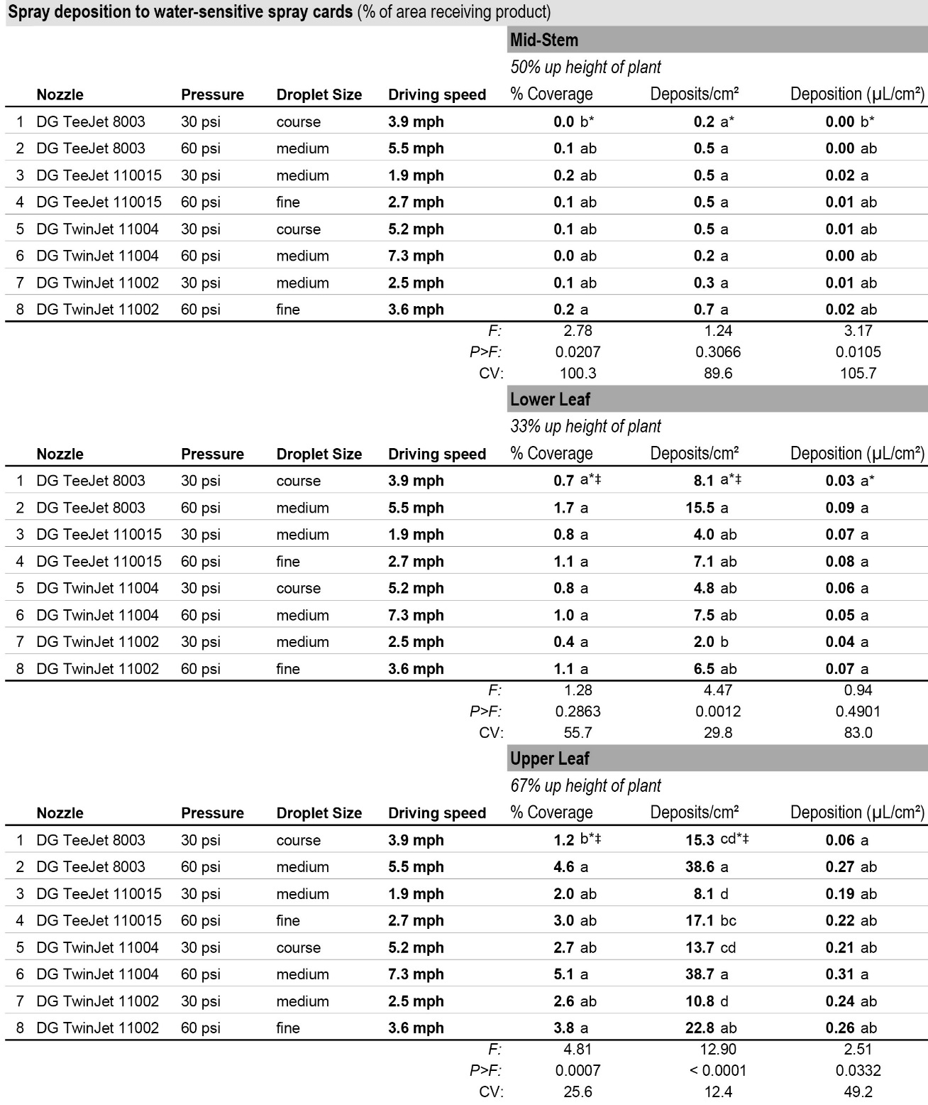
Table 5. Impacts of spray boom height and spray volume on fungicide deposition in soybeans; Carrington, ND (2016). All nozzles were directly mounted on the boom. A severe hail storm that defoliated the soybeans at bloom initiation precluded making applications targeting Sclerotinia, and the fungicide Endura (boscalid; BASF Corp.) was applied at 5.5 oz/ac when the soybean canopy had recovered. Soybeans were at the R5 growth stage, and canopy closure was 99%. Within-column means followed by different letters are significantly different (P<0.05).

