Project Title: Optimizing row spacing and plant populations for management of Sclerotinia in soybeans

Situation statement:
In fields where white mold is a significant concern, producers often seed soybeans to wide rows. The use of wide rows results in delayed canopy closure, which increases drying of the soil between rows, thereby reducing the production of the mushroom-like apothecia of the Sclerotinia fungus which produce the spores of the Sclerotinia pathogen, and increases airflow within the canopy during early bloom, facilitating more rapid drying of the canopy and reducing infection events. However, while seeding soybeans to wide rows reduces white mold, it does not always maximize soybean yield even under high white mold disease pressure. The expected relationship of decreased white mold and increased soybean yield under high Sclerotinia pressure was observed in only one (Grau and Radke 1984) of three previous studies evaluating the impact of row spacing on soybean performance under Sclerotinia pressure. In the other two studies (Buzzell et al. 1993; Lee et al. 2005), seeding soybeans to wide rows reduced soybean yield under high Sclerotinia disease pressure. None of the studies evaluated the impact of row spacing on contamination of grain with sclerotia, the black resting structures of the Sclerotinia fungus, which can be an important determinant of soybean market grade. Development of rigorous recommendations for soybean row spacing in fields where Sclerotinia is a concern requires information on (1) when the use of wide rows will be expected to maximize soybean yield under white mold disease pressure and on (2) the relationship between row spacing and contamination of soybean grain with sclerotia in soybeans grown under white mold disease pressure.

Goals:
- Quantify the impact of row spacing on Sclerotinia disease levels, soybean yield, and soybean quality at each of three seeding rates representing the full range of commonly employed seeding rates in North Dakota.
- Quantify the impact of low, intermediate, and high seeding rates (representing the full range of commonly employed seeding rates in North Dakota) on Sclerotinia disease levels, soybean yield, and soybean quality.
- Evaluate how the timing of Sclerotinia disease development influences the impact of row spacing and plant population on soybean performance and Sclerotinia disease levels.
- Evaluate whether soybean architecture type (upright vs. bush-type) influences the impact of row spacing and plant population on soybean performance under Sclerotinia pressure.

Description of research conducted:
Field trials evaluating the impact of seeding rate and row spacing on the agronomic performance of soybeans under white mold pressure were established at the North Dakota State University Langdon Research Extension Center (1 mile east of Langdon, ND), NDSU Williston Research Extension Center’s Nesson Valley Irrigation Research Site (approx. miles east of Williston, ND), NDSU Robert Titus Research Farm (4 miles south of Oakes, ND) and NDSU Carrington Research Extension Center (3 miles north of Carrington, ND). All trials were conducted under overhead irrigation; microsprinkler irrigation systems were utilized in Carrington and Langdon, and overhead linear irrigators were utilized in Williston and Oakes. A completely randomized split-split block design with six replicates (main factor, soybean variety; sub-factor, seeding rate; sub-sub-factor, row spacing) was utilized. Three soybean varieties of 0.05-0.09 maturity were evaluated in Langdon, two soybean varieties of 0.1-0.2 maturity were evaluated in Williston, four soybean varieties of 0.6-0.7 maturity were evaluated in Carrington, and four soybean varieties of 0.7-0.8 maturity were evaluated in Oakes. Three seeding rates (132,000; 165,000; and 198,000 pure live seeds/ac) and four row spacings (7, 14, 21 and 28 inches in Carrington, Langdon and Oakes; 7.5, 15, 22.5 and 30 inches in Williston) were evaluated. The studies were planted on May 12 (Carrington), May 16 (Oakes), May 23 (Williston), and May 24 (Langdon); evaluated for soybean population at the VC (Williston) or V2 (Carrington, Langdon, Oakes) growth stage, assessed for Sclerotinia incidence and severity at the late R6/early R7 growth stage on Sept. 8-12 (Oakes); and harvested Sept. 26 (Oakes), Oct. 3 (Langdon, Williston). In Carrington, a severe hail storm on July 9 completely defoliated the soybeans at the R1 growth stage (bloom initiation), precluding Sclerotinia disease development, and the Carrington trial was not harvested. Sclerotinia incidence and severity were assessed by evaluating every plant in rows 2, 3, 5, and 6 of seven-row plots (7- and 7.5-inch row spacing), every plant in rows 2 and 3 of four-row plots (14- and 15-inch row spacing), every plant in row 2 of three-row plots (21- and 22.5-inch row spacing), and every plant in one arbitrarily selected row of each two-row plot (28- and 30-inch row spacing); the same rows were assessed for soybean establishment at early vegetative growth, and the end-of-season disease notes also served to assess end-of-season soybean population. Sclerotinia severity was assessed on each plant with the 0 to 3 scale developed by Craig Grau (Grau and Radke 1984; Plant Disease 68: 56-58): 0 = no symptoms, 1 = lesions on lateral branches only, 2 = lesions on main stem, no wilt, and normal pod development, 3 = lesions on main stem resulting in wilting, poor pod fill, and plant death. Contamination of the harvested grain with sclerotia was assessed by manually removing all sclerotia from a 200-gram subsample of grain from each plot, assessing the weight of the sclerotia, and calculating the percent weight of the sclerotia in the sample. Data were analyzed with analysis of variance (ANOVA) in PROC GLM of SAS (version 9.4; SAS Institute, Cary, NC), with F-tests for the main factor (variety) conducted utilizing replicate-by-main-factor interaction for the error term, F-tests for the sub-factor conducted utilizing replicate-by-main-factor-by-sub-factor interaction for the error term, and F-tests for main-factor by sub-factor interaction conducted utilizing replicate-by-main-factor-by-sub-factor interaction for the error term. Data were evaluated to confirm that they met the distributional assumptions of ANOVA; when data did not meet the assumptions of ANOVA, a systematic transformation resolving the distributional problems was applied to the data whenever possible; otherwise, the data were not analyzed. Single-degree contrasts were performed for all pairwise comparisons of treatments utilizing the Tukey multiple comparison procedure.

Findings:
Sclerotinia disease pressure was moderate at all sites: 4 to 13% incidence (averaged across row spacings and seeding rates), depending on the soybean variety, in Langdon; 3 to 9% incidence in Williston; and 2 to 21% incidence in Oakes.
- In Oakes, where hot weather during early bloom and cool weather during mid to late pod-fill resulted in late disease onset, wide row spacing conferred a decrease in end-of-season Sclerotinia incidence in upright soybean varieties exhibiting delayed canopy closure but not in bushy soybean varieties, and seeding rate had no impact on Sclerotinia disease levels. The adoption of narrow (7-inch) or intermediate (14- or 21-inch) rows conferred a 7 to 10 bu/ac, 9 to 10 bu/ac, 8 bu/ac, or 8 to 11 bu/ac increase in soybean yield, depending on variety. Increasing seeding rate from 132,000 to 198,000 pls/ac resulted in a loss of 1 bu/ac in one variety and gain of 3 or 4 bu/ac in three varieties. In soybean varieties with upright architecture, sclerotia contamination of the grain was 0.01% (one variety) and 0.27% (second variety) by weight when wide row spacing was utilized and 0.01 to 0.02% and 0.23 to 0.33%, for each respective variety, in narrow and intermediate row spacings. In soybean varieties with bushier architecture, contamination of the grain with sclerotia was0.09% (one variety) and 0.16% (second variety) when wide row spacing was utilized and 0.05 to 0.10% and 0.11 to 0.17%, for each respective variety, in narrow and intermediate row spacings. Increasing seeding rate from 132,000 to 198,000 pls/ac increased sclerotia contamination of grain from 0.23 to 0.32% by weight in one variety and had no impact in three varieties.
- In Langdon, wide row spacing was associated with increased Sclerotinia incidence in one variety and had no impact on Sclerotinia disease levels in two varieties; seeding rate had no impact on Sclerotinia disease levels. The adoption of narrow (7-inch) or intermediate (14- or 21-inch) rows conferred a 1 to 6 bu/ac, 4 to 6 bu/ac, or 6 to 8 bu/ac increase in yield, depending on variety. Increasing seeding rate from 132,00 to 198,000 pls/ac resulted in no change in yield for one variety and a gain of 3 bu/ac in two varieties. Contamination of grain with sclerotia was negligible (less than 0.03%) across row spacing and seeding rate treatments in all varieties assessed.
- In Williston, wide row spacing (30 inches) conferred a statistically significant decrease in end-of-season Sclerotinia disease levels (P<0.05) in a soybean variety with upright architecture but not in a bushier variety. Increasing seeding rate from 132,000 to 198,000 pls/ac had no impact on disease levels in either variety. The adoption of narrow (7.5-inch) or intermediate (15- or 22.5-inch) rows conferred a -1 to +1 bu/ac or -2 to 0 bu/ac change in soybean yield, depending on variety. Increasing seeding rate from 132,000 to 198,000 pls/ac resulted in a loss of 1 bu/ac in one variety and no change in yield in one variety. In the soybean variety with upright architecture, sclerotia contamination of the grain was 0.06% by weight when wide row spacing was utilized and 0.04 to 0.09% by weight in narrow and intermediate row spacings. In the soybean variety with bushier architecture, contamination of the grain with sclerotia was 0.25% when wide row spacing was utilized and 0.24 to 0.31% in narrow and intermediate row spacings. Seeding rate had no impact on contamination of grain with sclerotia.

Results from field trials conducted 2016 were combined with results from field trials conducted in 2015 (the first year of this project) and from related field trials conducted in Carrington, ND in 2013 and 2014. The combined analysis facilitated a preliminary identification of thresholds at which wide row spacing (28 and 30 inches) conferred increased soybean yield and improved market grade relative to intermediate row spacing (14-15 inch rows and 21-22.5 inch rows) under Sclerotinia disease pressure.
- Impact of row spacing on Sclerotinia: Except when Sclerotinia incidence was low (< 13%), changing from wide (28 to 30-inch) to intermediate (14 to 15-inch or 21 to 22.5-inch) row spacing consistently increased Sclerotinia incidence (Figure 1).
- Impact of row spacing on soybean yield in soybeans grown under Sclerotinia disease pressure: With very few exceptions, when Sclerotinia incidence was less than 50% in soybeans seeded to intermediate row spacing (14 to 15-inch or 21 to 22.5-inch), yields were maximized when soybeans were seeded to intermediate row spacing. When Sclerotinia incidence exceeded 50% in soybeans seeded to intermediate row spacing, yields were often (but not always) maximized by seeding soybeans to wide (28 to 30 inch) rows (Figure 2).
- Impact of row spacing on contamination of soybean grain with sclerotia in soybeans grown under Sclerotinia disease pressure: When Sclerotinia incidence in soybeans seeded to intermediate row spacing (14 to 15-inch or 21 to 22.5-inch) was below 40%, contamination of the grain with sclerotia (resting structures) of the Sclerotinia fungus never increased by more than 0.5 percentage points relative to soybeans seeded to wide (28 to 30-inch) rows. It rarely increased by more than 0.1 percentage points and the increased contamination was never sufficient to result in a change in soybean market grade (Figure 3). However, when Sclerotinia incidence in soybeans seeded to intermediate row spacing exceeded 40%, use of intermediate row spacing often conferred a reduction of soybean market grade due to increased sclerotia contamination of the grain. Market grade was reduced from U.S. grade 1 (in which foreign material cannot exceed 1.0% by weight) to U.S. grade 2 (in which foreign material cannot exceed 2.0% by weight) or from U.S. grade 2 to U.S. grade 3 (in which foreign material cannot exceed 3.0% by weight).
- Impact of seeding rate on soybean performance under Sclerotinia pressure: Increasing seeding rate from 132,000 to 198,000 modestly increased the risk of white mold but was also associated with slightly higher yields (Figure 4). The increased Sclerotinia pressure associated with the higher seeding rate reduced soybean market grade due to increased sclerotia in the grain once out of 23 soybean varieties evaluated.

Figure 1. Change in Sclerotinia incidence as row spacing was narrowed from 28 or 30 inches to 14 or 15 inches (upper graph) and from 28 or 30 inches tp 21 or 22.5 inches (lower graph).  Each dot represents a soybean variety tested at one location in one year in a replicated, completely randomized design. Data are from Carrington, ND (2013, 2014, 2015); Langdon, ND (2015, 2016); Oakes, ND (2015, 2016); and Williston (2016). At Langdon, 00-maturity soybeans were evaluated; at other locations, 0-maturity soybeans were evaluated. |  | 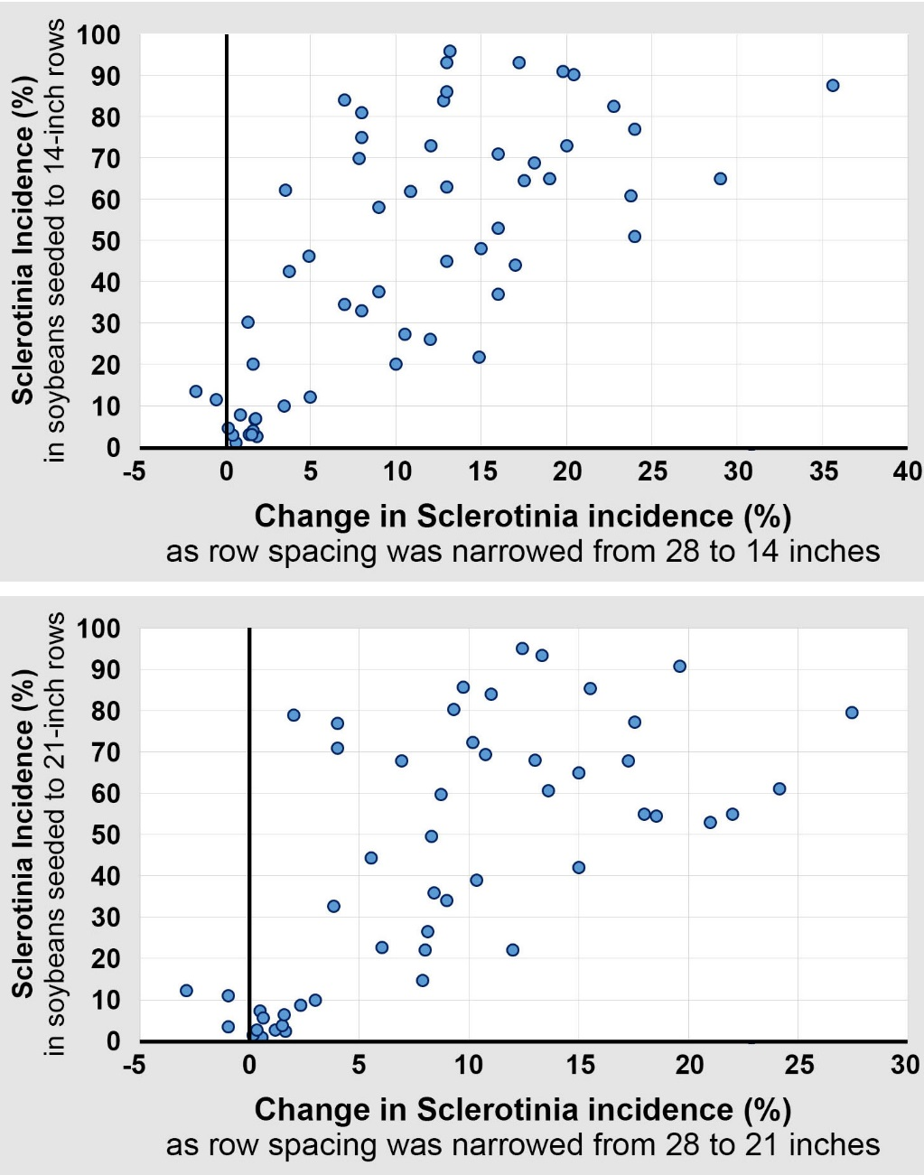
Figure 2. Change in soybean yield as row spacing was narrowed from 28 or 30 inches to 14 or 15 inches (upper graph) and from 28 or 30 inches to 21 or 22.5 inches (lower graph).  Each dot represents a soybean variety tested at one location in one year in a replicated, completely randomized design. Data are from Carrington, ND (2013, 2014, 2015); Langdon, ND (2015, 2016); Oakes, ND (2015, 2016); and Williston (2016). At Langdon, 00-maturity soybeans were evaluated; at other locations, 0-maturity soybeans were evaluated. | 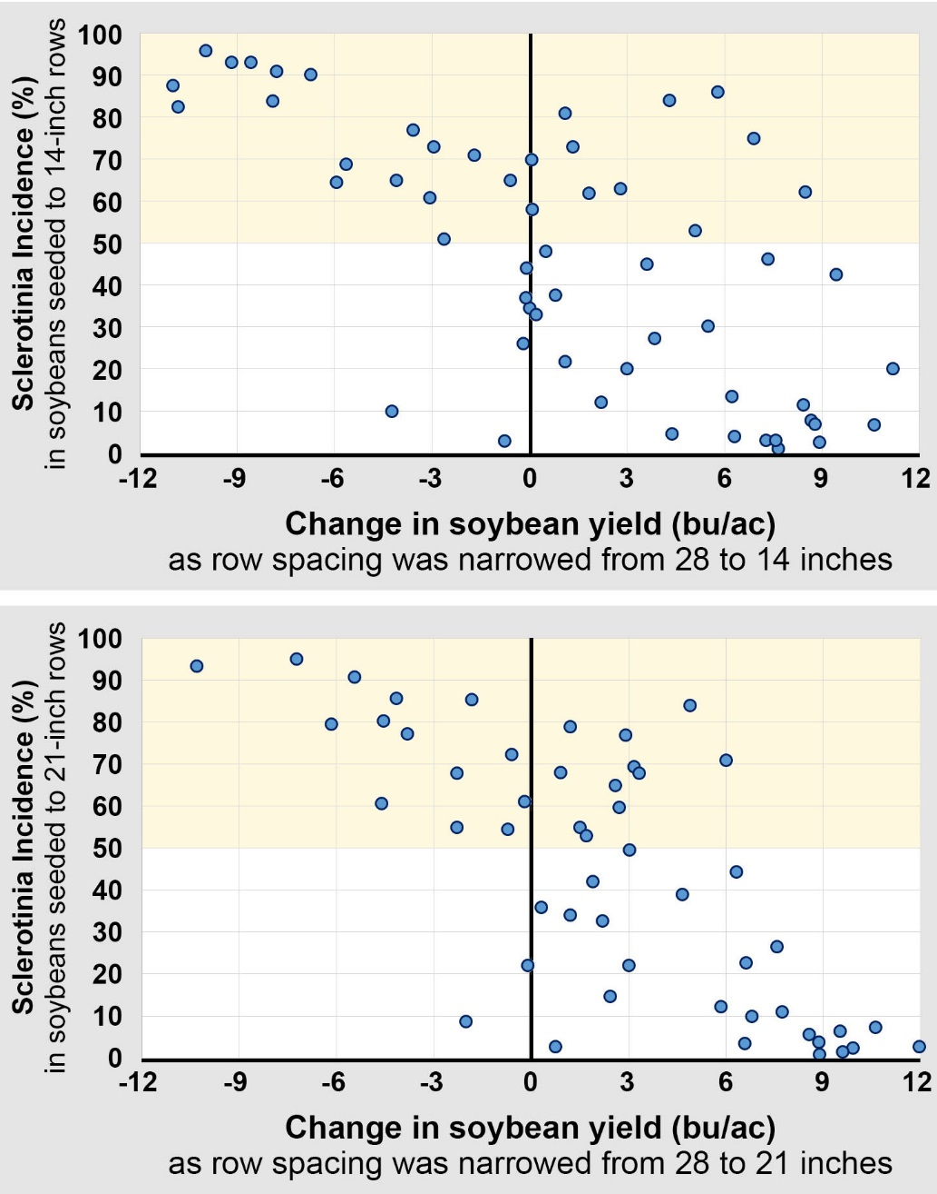

Figure 3. Change in contamination of soybean grain with sclerotia as row spacing was narrowed from 28-30 inches to 14-15 inches (upper graph) and from 28-30 inches to 21-22.5 inches (lower graph). Pink dots denote a reduction in U.S. market grade due to increased contamination of grain with sclerotia.  Each dot represents a soybean variety tested at one location in one year in a replicated, completely randomized design. Data are from Carrington, ND (2015); Langdon, ND (2015, 2016); Oakes, ND (2015, 2016); and Williston (2016). At Langdon, 00-maturity soybeans were evaluated; at other locations, 0-maturity soybeans were evaluated. | 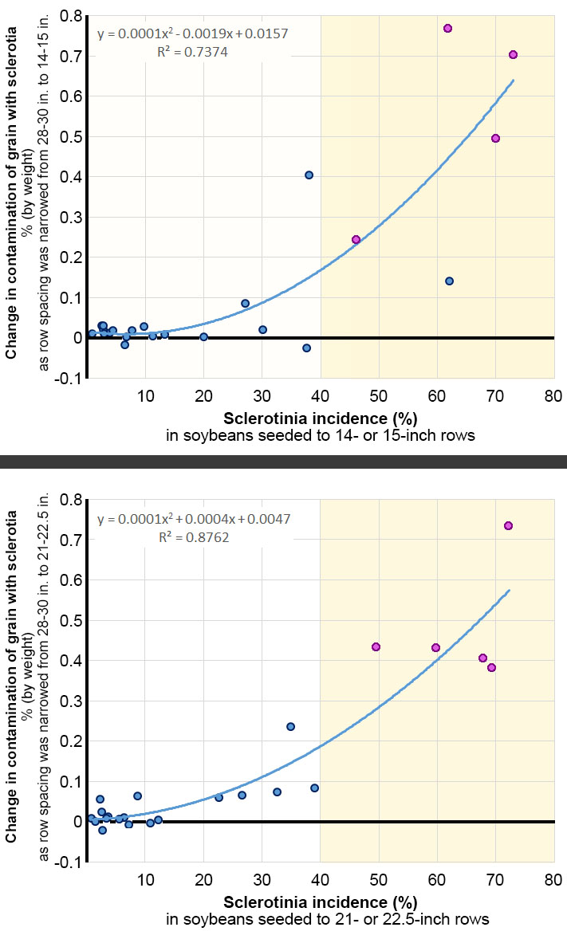

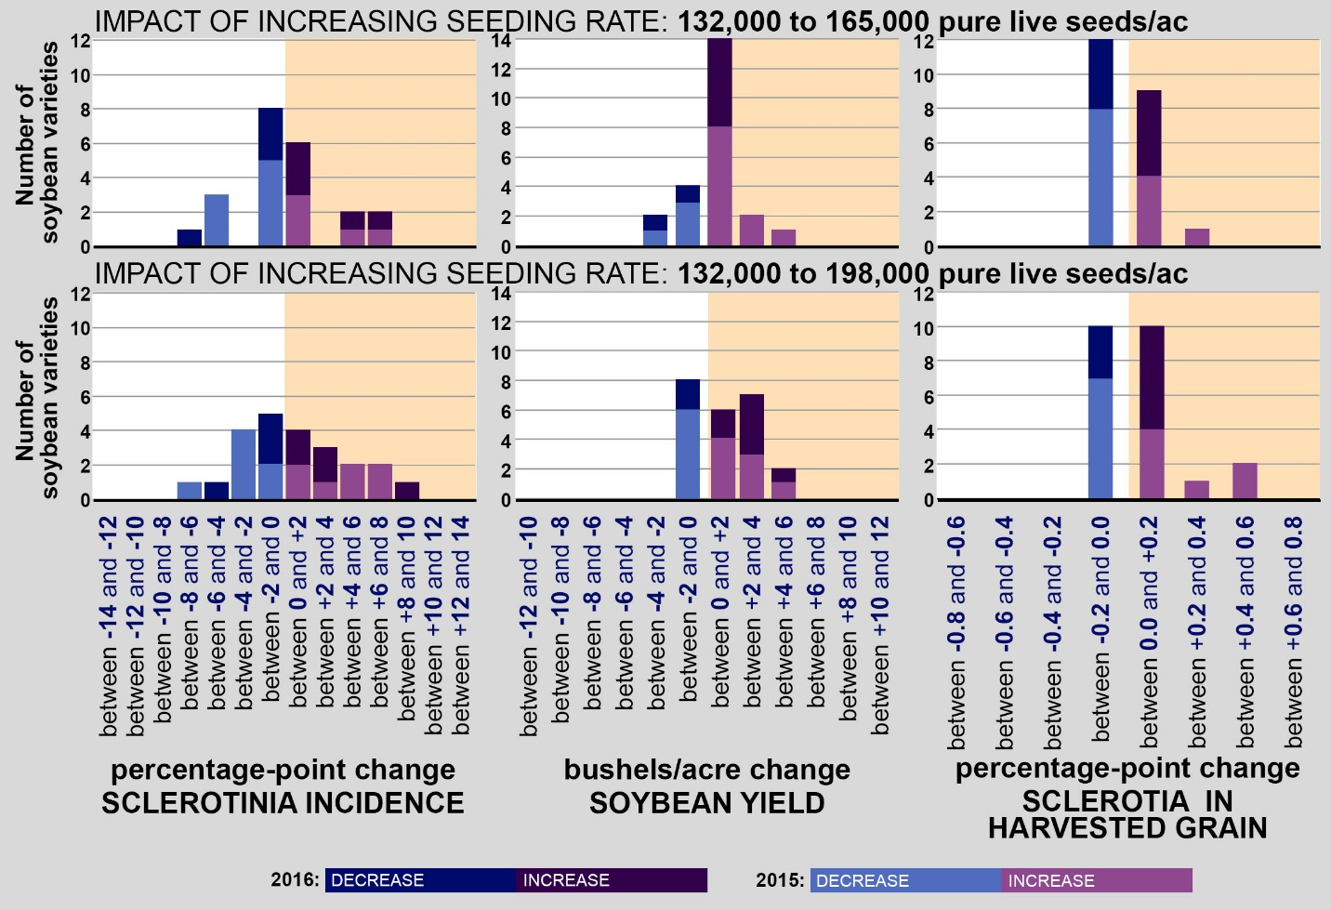

Figure 4. Impact of increased seeding rate on Sclerotinia incidence, soybean yield, and contamination of harvested grain with sclerotia.
Bars denote the number of soybean varieties exhibiting different magnitudes of responses. Data are from soybean varieties evaluated at each seeding rate in completely randomized, replicated designs in Carrington, ND (2015), Langdon, ND (2015, 2016), Oakes, ND (2015, 2016), and Williston, ND (2016). Each seeding rate was evaluated in soybeans seeded to 7, 14, 21, and 28-inch rows (Carrington, Oakes, and Langdon) or 7.5, 15, 22.5, and 30-inch rows (Williston); the response to seeding rate did not differ by row spacing, and the combined results across all row spacings are presented.

Literature cited:
Buzzell et al. 1993. Can. J. Plant Sci. 73:1169-1175
Grau and Radke 1984. Plant Dis. 68(1):56-58
Lee et al. 2005. Weed Technology 19:580-588.

