Technical Report
Soil and Water management for Soybean Production under Fargo Clay
Principal Investigators: Dr. A. Chatterjee, Dr. A. Daigh, Soil Science, NDSU
Situation Statement:
Conservation tillage practices improve the soil health but it has been a challenge for growers to adopt no-till or strip till for the field with high clay. Subsurface-tile drainage system favors drainage of excess soil moisture and offers an opportunity to adopt conservation tillage practices. Conservation tillage practices like, strip and no-till, maintain and enhance water movement through soil profile and increase the amount of drain flow. Higher disturbances under chisel plough during early spring can result into early nitrogen loss through tile before crop can use it. Deciding on tile depth and spacing also influences nutrient loss, closer drain spacing results in fast removal of excess water but also involves increased cost of installation. Wider tile spacing could reduce the cost but also significantly could reduce the yield due to prolonged water stress condition. Installation of control structures in tile drainage system provide an opportunity to control.
Goals/Objectives:
(1) Compare soybean production under different tillage practices and tile drained conditions
(2) Determine the influence of different tile spacing and depth combinations on soybean production
Description of the research conducted:
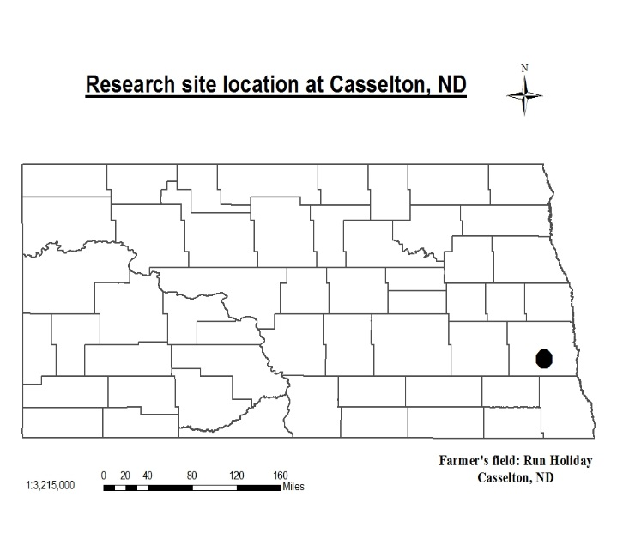
This on-farm experiment is located at Casselton, North Dakota (N 46°49’23.7972”, W 97°13’ 4.949”) (Figure 1). Soil type is Fargo silty clay. Basic soil properties are presented in table 1. Tile drain was installed in June 2013.
Figure 1. Location of tile-tillage and tile depth experiment
Table 1. Basic soil properties of the experimental site
Soil properties
pH | 6.4
EC (mmhos/cm) | 0.70
NO₃-N (lb/ac)-2 feet | 19
Olsen-P (ppm) | 48
K (ppm) | 470
Ca (ppm) | 4720
Mg(ppm) | 900
Na (ppm) | 14
CEC (Meq/100g) | 29.6

Experiment-I: Tile drainage and tillage effect on soybean production

For this experiment, we followed strip-split-split design with four replications (Table 2). Three drainage system, (1) check (surface drained only), (2) open-tile (without control box), and (3) control-tiled (with control box) are placed in strip as main plot and under each strip, three tillage practices, (1) chisel, (2) strip-till, and (3) no-till practices are randomized as sub-plot, and under each sub-plot, two rotations, (1) continuous-corn and (2) corn-soybean are randomized with four replications. Corn and soybean are planted every year. Three drainage treatments are 30-feet apart. Individual plot size is 30-feet by 11 feet wide with 22-inch row spacing. Soybean yield was determined.
Table 2. Experimental layout in strip-split-split design with tile as main-plot, tillage as sub-plot and rotation as sub-sub plot factor
Main plot-treatment-Drainage | Sub-Plot treatment-Tillage | Sub-sub plot treatment-Rotation
1. Control (Surface-drained) | 1. Chisel (CT) | 1. Continuous corn (CC)
2. Open-drained | 2. Strip-tillage (ST) | 2. Corn-Soybean(CS)
3. Control-tiled | 3. No-tillage (NT)
Experiment II: Soybean production as influenced by tile depth and spacing
We followed corn-sugarbeet-soybean rotation. Three strips of corn, soybean and sugarbeet were planted. Under each strip, we have 4 replications of six rows. Two tile lines were installed at three tile spacing, 30-, 40-, and 50-feet and at two depths, 3-feet and 4-feet at each level of tile spacing along with 50-feet long plot of only surface-drained. Soybean yield was recorded.
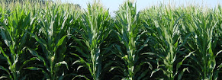
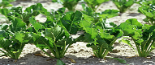
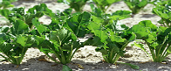
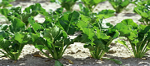
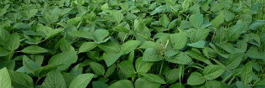
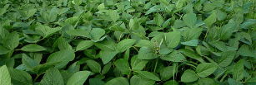
Figure 2. Experimental layout of plot to determine the influence of tile depth and spacing combinations on soybean yield
30 ft
3 ft
30 ft
4 ft
40 ft
3 ft
40 ft
4 ft
50 ft
3 ft
50 ft
4 ft
Sugarbeet
Soybean
Corn
Surface drained only
(50 ft wide)
Findings:
Soybean yield from 1st and 2nd experiment are presented in figure 3 and 4, respectively for the 2016 growing season. The highest yield (58.6 Bu/ac) was observed under chisel plough with control-drained and lowest yield (51.8 Bu/ac) under strip-till with open tile (Fig. 3). Tillage has significant effect on soybean production, chisel plough yield highest followed by no-till and strip-till. Control tile yielded higher soybean followed by surface drain and open tile. There was no significant interaction effect of tile and drainage on soybean yield.

During 2016 growing season, the highest (57.5 Bu/ac) and lowest yield (42.8 Bu/ac) were observed under surface drained (check) and 40 feet tile spacing placed at 3 feet depth, respectively (Fig 4). Results indicate benefit of tile drainage on soybean production is not available every year and it depends on rainfall intensity and distribution (Fig. 5).
Figure 3 Effect of tile drainage (surface-drained, open- and control-tiled) and tillage practices, chisel (CH), no-till (NT), and strip-till (ST) on soybean yield (Bu/ac) during 2016 growing season.

Figure 4 Effect of different tile spacing (30, 40 and 50 ft) and placement depth (3 and 4 ft) combinations on soybean yield during 2016 growing season.

Figure 5. Maximum and minimum air temperature, rainfall during entire growing season of soybean in field

