Interpretation and Sharing of Information from Soybean and Pest Pressure Response to Salinity (Year 4)

Principal Investigators:
Abbey Wick, Dept. of Soil Science; Tom DeSutter, Dept. of Soil Science; Jason Harmon, Dept. of Entomology

Technical Support:
Kirsten Butcher, Graduate Student, Dept. of Soil Science
Jackie Eichele, Graduate Student, Dept. of Entomology

FY Year End Report: June 30, 2017; Technical Report

Situation Statement:
Soil salinity continues to be a serious problem to North Dakota soybean farmers. Salinity directly reduces soybean yield while creating additional problems such as increased soybean pests that cause additional damage. Over the past four years we performed numerous research studies to evaluate and refine interactions among salinity, soybean and arthropod pests (spider mites and soybean aphids) in both the field and the greenhouse. In 2016-2017, it was an opportune time to get information to growers and also in peer-reviewed scientific publications.

Objectives:
1) Provide information to ND soybean producers about soil salinity, how it influences their plants, and what they can do about it. We used the NDSU Soil Health webpage (www.ndsu.edu/soilhealth) as an outlet for information for videos, fact sheets and circulars. We also used extension programming, for example café talks, field tours and workshops to reach farmers with valuable information.
2) Complete research on salinity effects, including analyzing all data, using information to create larger economic and biological models of salinity effects, and preparing information for use by scientific audiences and production stakeholders.

Description of Research Conducted:
Both greenhouse and field research have been conducted as part of this study and all information was included in an online economic model found on the NDSU Soil Health webpage (ndsu.edu/soilhealth). The research component of this project was conduced from 2013 thru 2016, with 2016 to 2017 being focused on sharing information with growers using extension events and also finalizing data sets for publication.

Soybean Response to Salinity:
In the greenhouse studies conducted from 2013-2014, we saw a 27% decrease in leaf area and 21% in root mass, indicating a crop response at low salt levels (figure below). As leaf area decreases, there is less surface shading resulting in more evaporative demand. As root mass decreases, there is potentially less water uptake. Both of which can lead to additional salts moving towards the soil surface with repeated stunted crops or failure to establish a crop.

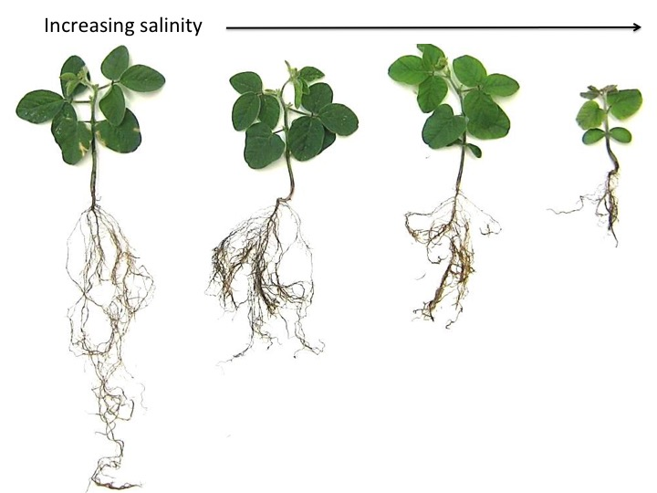

Soybean yields were also evaluated in field-conditions on three quarters dominated by sandy loam soils and three quarters dominated by silty clay loam soil textures in Richland County. Veris salinity maps were completed for each field and samples were collected along identified gradients with relatively low levels of salinity where the plant is still growing, but may be showing signs of stress.
Soybean grown in sandy loams soils were found to be considerably more sensitive to soluble salts than previous studies suggest. We found soybean yields began to decline at a soluble salt level of 1.1 mmhos/cm, instead of 1.9 mmhos/cm originally identified in other studies not conducted in North Dakota. Fifty percent yield reductions occurred at soluble salt contents of 2.2 mmhos/cm (figure below).
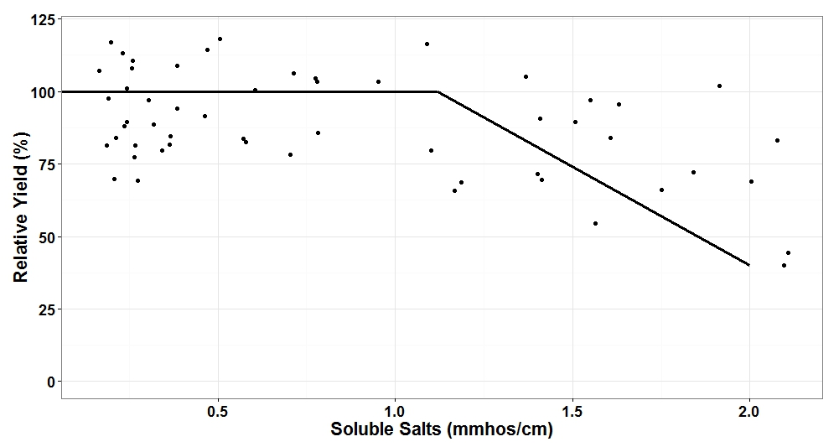
These results are extremely important for soybean growers in North Dakota experiencing yield reductions as a result of salinity. Crop selection is key when managing saline areas in a field. However, even the more salt-tolerant crops (like wheat, barley and sugar beet) can become affected by salinity if soluble salts are not effectively managed.
Salinity is a water management issue, so management practices that reduce evaporation and promote water movement thru soils are ideal for salinity management. Dilution of salts can also be important, so using residue to keep moisture in the soil can help dilute salts and provide an opportunity for crops to germinate. As soon as a yield reduction as a result of salinity is noticed, use tools like crop selection (use barley or wheat versus soybean in higher salt areas), cover crops (decreased surface evaporation thru cover and residue building, improve drainage with root channels), reduced tillage (decreased surface evaporation, improve water movement), mulching (decreased surface evaporation), and drainage (surface drainage to move water off the field and subsurface drainage to lower the water table).

Pest Response to Salinity:
The pests in this study are the two-spotted spider mite (below left) and the soybean aphid (below right). Both are occasional pests that can damage plants and cause yield reductions when populations are high. Mites feed on many crops including corn and soybean, while the aphid specializes on soy.

Our greenhouse research has continuously shown that when plants are grown in saline soil, pests do better compared to when the plants are grown in less saline soils (two examples below and broader list of results in the box to the left). We have seen that this is a continuously positive relationship, the more saline the soil, the better the pests do. Even at fairly low salt concentrations, pests can get a boost compared to healthier soils without salts. We have included both soybean and corn results below.

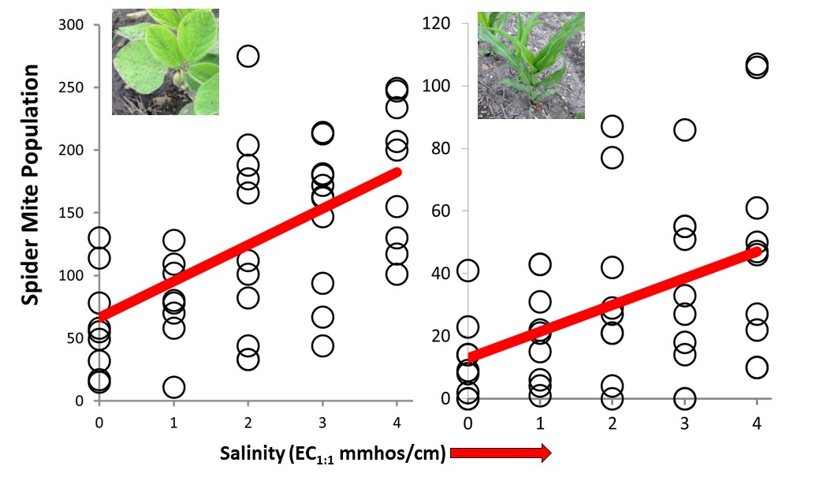

Our field research has agreed with the predictions made in the greenhouse, pests can perform better on plants grown in saline soils (example below). However, our field results have gotten different results in different fields. This suggests that there are other conditions that can alter how strongly pests respond.

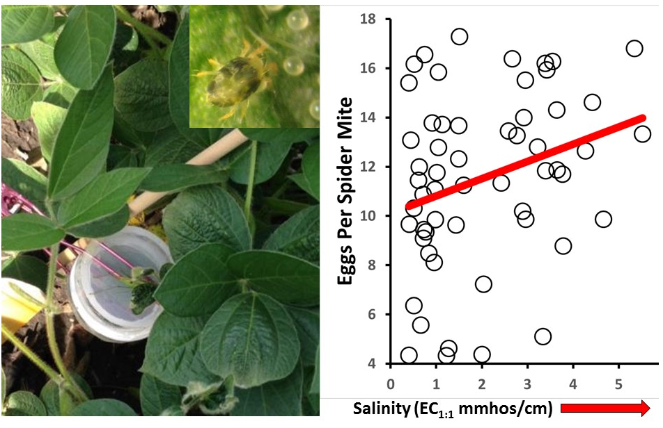
Extension and research objectives were successfully achieved, here is a list of accomplishments:
- Developed 16 educational videos addressing both soil health and salinity management with accompanying fact sheets. Research results and management recommendations developed from the salinity-soybean-pest research was included in video topics and fact sheets. These are posted on the NDSU Soil Health Webpage (ndsu.edu/soilhealth).
- Started the Soil Health Minute series with AgWeek TV, filming seven episodes with seven accompanying 500-word columns in AgWeek Magazine. This provides an outlet for reaching 40,000 viewers and subscribers in the region and is sponsored by the ND Soybean Council and ND Corn Council. Information from the Soil Health Minute is also posted on the NDSU Soil Health Webpage (ndsu.edu/soilhealth).
- Held 15 Soil Health Café Talks January through February of 2017. These were held in Nelson, LaMoure, Ransom, Richland, Sargent and Stutsman counties. Three meetings per location were held, drawing between 15 – 35 attendees. A summary article of information discussed was written for the Soybean Grower Magazine.
- Hosted 20 field days and workshops, where salinity management was part of the discussion. Many topics were covered, including inter-seeding cover crops to help manage salinity in corn, planting soybean into living cereal rye to help reduce IDC and salinity effects on soybean and crop response to salinity. These field days drew just over 1,000 attendees. Included in these field days was the 2016 Soil Health Bus Tour, where we highlighted commodity funded research projects related to soil health.
- Continued evaluation of research results. One manuscript was accepted for publication in Environmental Entomology, one manuscript in Agronomy Journal and we have two additional manuscripts ready to submit. The two graduate students funded by this project have successfully completed their degrees.

