Technical Report: Detecting Chlorosis Regions and Predicting Yield of Soybean by Large Scale UAV Principle Investigator: John Nowatzki, Agricultural and Biosystems Engineering, NDSU

Situation
This project is leveraging a ND Department of Commerce project funded to the NDSU Agricultural and Biosystems Engineering Department during 2016-17. The “Large-scale UAS Data Collection, Processing and Management for Field Crop Management” is using a large UAV to collect 1.2 – 2.6 inch spatial resolution color and infrared imagery over 100,000 acres in eastern North Dakota once each week from mid-May through mid-July both in 206 and 2017. Hyperspectral imagery was also collected using a small UAAS over selected fields in the image collection corridor. All of the imagery collected from the Large UAS project is available for use in this project at no cost. However, the imagery from the Large-scale UAS Imagery Project in 2017 was not delivered to this project’s personnel in time to be included in this report. Project personnel will analyze the Large-scale UAS Project imagery when it is received in July, 2017, and file an addendum to this report later in 2017. Instead of using the imagery described above, information included in this report was from imagery collected with a small UAV (rotocopter) over the variety trials (23rd June, 1st July, 22nd July, 29th July of 2016).

Research Objectives
- Evaluate the use of various spatial resolution and imagery types at various each crop growth stages to predict soybean yield.
- Evaluate specific VI from normal RGB or NIR imagery to predict soybean yield.
- Evaluate types of imagery and vegetative indices to detect chlorosis regions in soybean fields.
- Determine the relationship between VIs and soil PH, EC, Carbonates, P, and N.

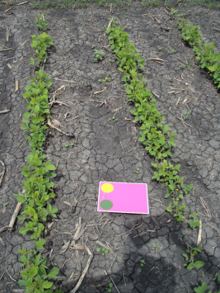
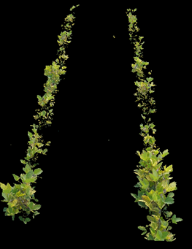
Procedure
This study was conducted on Dr. Ted Helms IDC yield trials. The trial was not harvested at the Galesburg location because the IDC was too severe. The other three locations were, Leonard, Colfax, Amenia. There were 40 soybean varieties, with four replications in three locations. We used Dark Green Color Index (DGCI) to assess the greenness of the soybean plots. The higher the DGCI, the greener the plots are. Similarly low values of DGCI indicates chlorosis in soybean plots.
DGCI is calculated from HSV color space (Hue, Saturation, and Value)

$$DGCI=\frac{\left[\frac{Hue-60}{60}\right]+\left(1-Saturation\right)+(1-Value)}{3}$$

We used ArcGIS software to identify spots in the fields with low vegetative indices to identify areas of chlorosis in soybean fields. We walked fields to identify chlorosis areas in these fields.

Results
Project personnel are now correlating soil properties to identified area of chlorosis in the imagery. We also determining the best spatial resolution for the images. We have been able to identify areas of chlorosis in soybean fields. We extracted the number of pixels for each plot and multiplied that by the DGCI value to account for both canopy size and greenness.

Figure 1: Visual Rating vs. DGCI Rating - Colfax

Figure 2: Visual Rating vs. DGCI Rating- Leonard

The following graph shows the correlation between yield and the new value for all of the 4 dates. The following results are related to the July 29th which were closer to harvest season than the other dates.

Figure 3: Yield vs. DGCI Value

