CONTROL OF SOYBEAN DISEASES

TECHNICAL REPORT
NORTH DAKOTA SOYBEAN COUNCIL
JUNE 2017

Dr. Berlin D. Nelson Jr. Principal investigator, Dept. Plant Pathology, NDSU
Cooperator: Dr. Ted Helms, Soybean Breeder, Dept. Plant Sciences, NDSU

Diseases are a persistent problem in soybean production in North Dakota. Our primary diseases are those that affect the roots of this important crop. A primary focus of this project was to work with the soybean breeder to incorporate host resistance to major diseases into public soybean cultivars and germplasm. The two soilborne diseases where sources of resistance are available are Phytophthora root rot and soybean cyst nematode (SCN). Also, we test a selection of commercial cultivars for resistance to SCN to provide growers additional information on the level of resistance. In addition to that primary focus, a secondary aspect to the research was to investigate changes in pathogen populations that would affect soybean production. The last few years we have placed emphasis on changes in the races of Phytophthora sojae, the cause of Phytophthora root rot, a major disease during periods of high soil moisture or flooded conditions.

In cooperation with Dr. Helms, we continued to incorporate resistance into soybean breeding lines. We maintain a variety of races of P. sojae in storage and each year the races we use for screening are grown in the laboratory, inoculated onto a set of plants with known resistance and susceptibility, and then re-isolated from infected plants to make sure they have maintained their known virulence. In addition we maintain other races that are used to determine which resistance genes are involved in the resistant reaction of plants, and those are occasionally grown from storage and run through the same process to make sure they maintain their virulence. Cultures that are kept too long in storage can lose virulence.
Only when we have verified the virulence of a particular race, is it used in the screening process. At present races 3 and 4 are the most common but other races exist in growers fields. During 2016 to 2017 we screened 53 breeding lines for resistance to race 4 and 40% of those lines were resistant. Another 15 lines were screened for resistance to race 3 and 43% were resistant. All the screening is conducted in our greenhouse laboratory by injecting the pathogen into the stem of 9 day old plants and then placing the plants in a humid chamber for 48 hours. Susceptible plants usually wilt within 6 days. Many of the public varieties released by Dr. Helms have resistance to various races of P. sojae. ND Bison soybean, an NDSU release in 2016, has resistance to races 3 and 4 and had been through our screening process in previous years. Drs. Helms and Nelson have been cooperating on this research for the past 30 years.

ND Bison is a conventional soybean variety released by NDSU in 2016. This release was tested for SCN resistance in cooperation with Dr. Helms and found to have a moderate level of resistance to SCN HG type 0. To improve the resistance level to SCN, Dr. Helms collected seed from 80 Bison plants in the field and we grew one seed from each of the 80 plants and screened each plant for SCN resistance. From those 80 plants, 17 seed sources were identified with greater resistance than the bulk seed of Bison. These 17 sources are now being screened a second time against HG 0 and from those results seed sources will be selected to start a new source of Bison seed with greater resistance to SCN HG 0. In addition to the screening of Bison soybean, 16 advanced breeding lines were screened for resistance to HG 0 and are currently being evaluated and 40 commercial soybean varieties that we tested last year are being retested.

We completed our recent study on new races of P. sojae in North Dakota. Soils from 81 soybean fields were sampled and P. sojae was baited from the soil, identified, and then the isolates were tested for virulence. A selection of isolates were tested for virulence on 8 standard resistance genes (Rps 1a, 1b, 1c, 1d, 1k, 3a, 6, and 7) and within the population of the pathogen in this area there are isolates that can defeat each of those resistance genes. Examples of those isolates were reported in 2016. A selection of 47 isolates were evaluated for virulence on three of the most common resistance genes used in commercial soybean cultivars in this region, Rps 1c, 1k and 6. Our results showed 57% of the isolates were virulent on Rps 1c, 45% virulent on Rps 1k and 4% virulent on Rps 6. The high percentage virulent on Rps 1k is of concern since this is the most common resistance gene used in commercial cultivars in this area. This increase in the number of isolates of P. sojae that can attack resistance genes 1c and 1k is due to the wide spread use of those genes over the past 20 years. The results suggest that new genes or gene stacking, or other management techniques will be needed in the future to control this disease in some fields. We are cooperating with the genotyping center in their efforts to develop detection tools for diseases of soybean. We supplied 15 isolates of P. sojae to them for their research. All these isolates had to be grown from isolates in long term storage and then evaluated to be sure they were pure cultures.

During the growing season of 2016 we established a field experiment to examine the effect of Fusarium solani and F. tricinctum on growth of soybean. Less inoculum compared to that used in the field studies in 2015 was used to infest soil and allow plants develop into reproductive stages before developing high amounts of root rot. Emergence and plant height each week was recorded along with the number of plants with the first trifoliate leaves opened. At three weeks, subsamples were taken to record root biomass and plant weight. Unfortunately, high levels of disease developed by four weeks after planting and the majority of the infected plants died and we were unable to measure the effect of Fusarium on plants in reproductive stages. That study was followed by a greenhouse study to test inoculum density on development of root rot caused by Fusarium solani. This information will allow us to fine-tune the inoculum levels in future field trials. In May 2017 another field experiment was initiated to further study Fusarium root rot on soybean.

In our efforts to understand the development of Fusarium root rot we developed a molecular technique to identify a specific strain of Fusarium solani that is the principal strain pathogenic in soybean roots. This strain is FSSC 11 (FSSC= Fusarium solani species complex). There are other strains found in soybean roots, but they are not the principal pathogens involved in root rot by this species. This tool will allow identification of this strain in soybean roots and soil and will aid in research on this disease. Part of these field studies with Fusarium are partially supported by research funded by the United Soybean Board through a multistate cooperative research grant managed by Southern Illinois University.

Figure 1. Evaluating virulence of Phytophthora sojae isolates from ND soybean fields. Susceptible soybeans inoculated on the stem die within 6 days while resistant plants survive. This is isolate 2-6-1 inoculated onto soybean varieties with and without a resistance gene. Insert shows inoculation with a hypodermic needle placing mycelium in the stem.

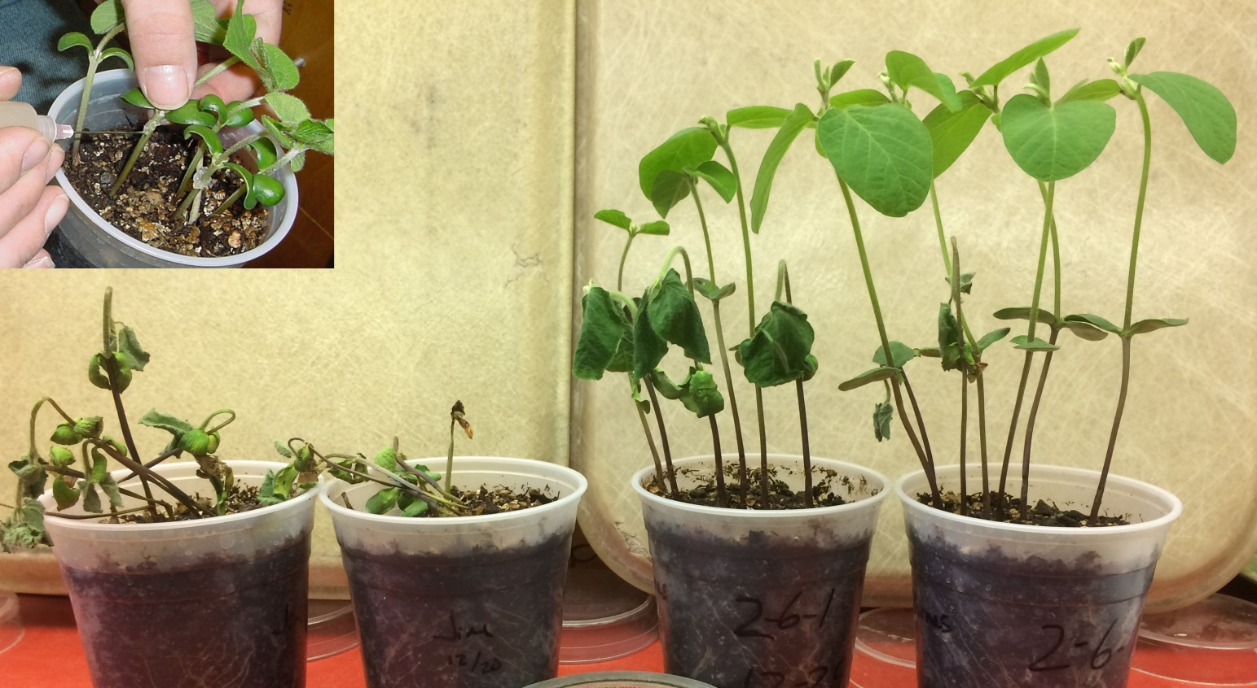

Figure 2. Evaluating soybean breeding lines and varieties for resistance to soybean cyst nematode (SCN). Plants are grown in a greenhouse system using a water bath to maintain favorable temperature in the root zone to promote growth of SCN. Water heater is shown in upper left side. The pots are immersed in the water.

