2016 – 2017 Technical Report June 30, 2016

Soybean Cyst Nematode Sampling Program: 2016

PI: Sam Markell, Ph.D.
Co-PI’s Guiping Yan, Ph.D.
Collaborators: Berlin Nelson, Ph.D., and NDSU County Extension Agents

What is the objective of this project?

The goals of this project is to provide an incentive to growers to sample for SCN and to create a map of SCN distribution. Both objectives are designed to increase awareness about SCN.

Why is this research is important to farmers?

Soybean Cyst Nematode (SCN) is the most important yield-limiting disease threat to soybean production in the United States and was first identified in North Dakota in 2003. SCN can cause very high levels of yield loss but reasonably effective management tools are available. However, management tools are most effective if SCN is identified shortly after entering a field (or region) and before egg levels reach epidemic levels; this can be done by soil sampling.

In order to encourage growers to sample for SCN, NDSU and the NDSC began a sampling program in 2013. The program covers the cost of the SCN laboratory tests, gets the growers SCN egg level data and facilitates the development of a distribution map with ‘anonymous’ data. Distribution of cost-free SCN sampling bags has had great buy-in among North Dakota growers. Additionally, secondary benefits of this program have occurred, including the increased coffee-talk about SCN, many press interviews and importantly, a significant amount of positive press for the NDSC and its mission to serve the ND growers.

How is this project conducted?

Soybean Cyst Nematode sample bags were obtained from Agvise in July 2016. Bags were labeled with distinct yellow tags containing funding and identification numbers. Bags and accompanying instruction/submission forms were distributed to every Extension County office in early August. The number of bags distributed was roughly proportional to acreage (i.e., Richland County received more bags than Divide County). Bags were also distributed though the NDSU Plant Pathology Department, the NDSC Research Directors office, field days, NDSU Research Extension Centers and any other means appropriate. To advertise the availability of the program, multiple radio interviews were delivered, NDSU Crop and Pest Reports were written and other advertising was done.

Upon receipt, Agvise processes the samples and sends results thought the U.S. mail back to the submitter. Dr. Markell receives geographic data points and egg levels and construct a map of SCN egg levels and distribution in the state. No personal information will be used.

What are the results?

In 2016, 531 SCN samples were submitted through the North Dakota sampling program. Samples were received from 36 North Dakota counties (Figure 1). Of submitted samples 153 were called ‘positive’, having an egg level of at least 50 eggs/100cc. Low level positives accounted for approximately half of the samples received. Twenty samples had an egg level in excess of 10,000 egg/100cc and the highest egg level found in 2016 was 51,650 egg/100cc from a location in Traill County (Figure 2). Since the in beginning of the sampling program in 2013 over 2,000 samples have been submitted from the majority of counties in North Dakota, of which approximately 1/3 have been identified as positive (at least 50 eggs/100cc) (Figures 3 and 4).

Important additional information about the results:

- How egg counts are determined.
Data points are nematode egg counts, presented as eggs/100cc of soil. Egg counts are determined by extracting eggs from the soil and visually counting eggs through a microscope.

- Low egg counts could be false positives.
It is nearly impossible to differentiate SCN eggs from the eggs of other closely related nematode species. Consequently, a soil sample positive for low egg counts (50, 100) could be reflective of other nematodes in the soil, and doesn't necessarily mean the sample positive for SCN eggs.

- Zero’s could be false negatives.
During the extraction process nematode eggs can be lost, which may result in a false positives. Additionally, SCN is notoriously patchy in a field and may be missed in the sampling process.

Figure 1. State wide distribution and egg level of soybean cyst nematode in North Dakota received though the NDSC / NDSU sampling program in 2016.

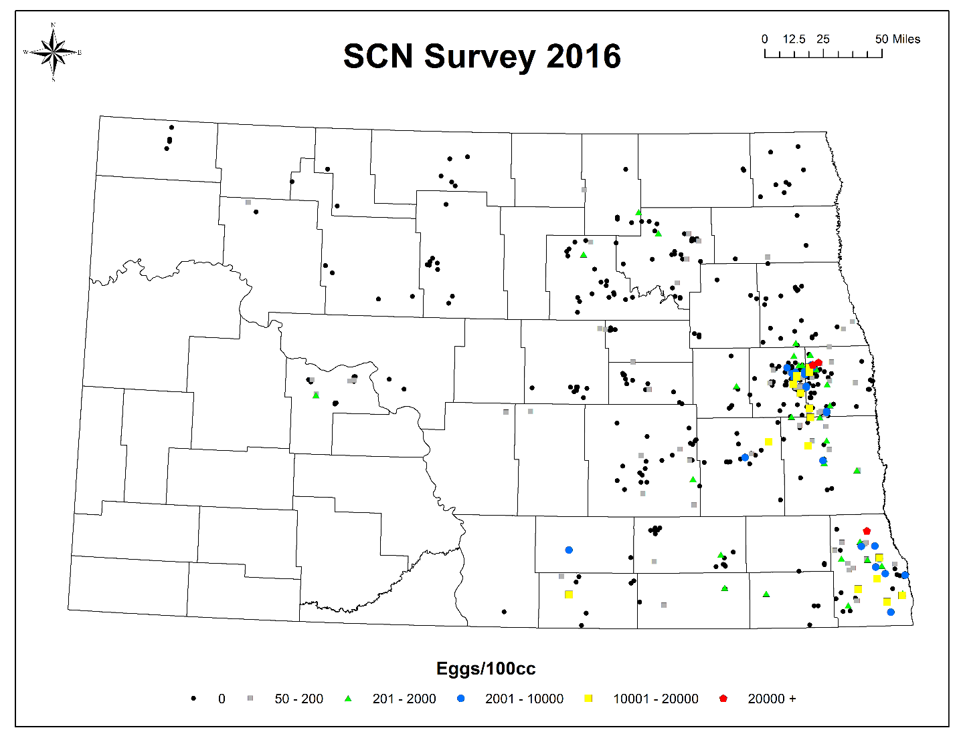

Figure 2. Regional distribution and egg level of soybean cyst nematode in North Dakota received though the NDSC / NDSU sampling program in 2016.

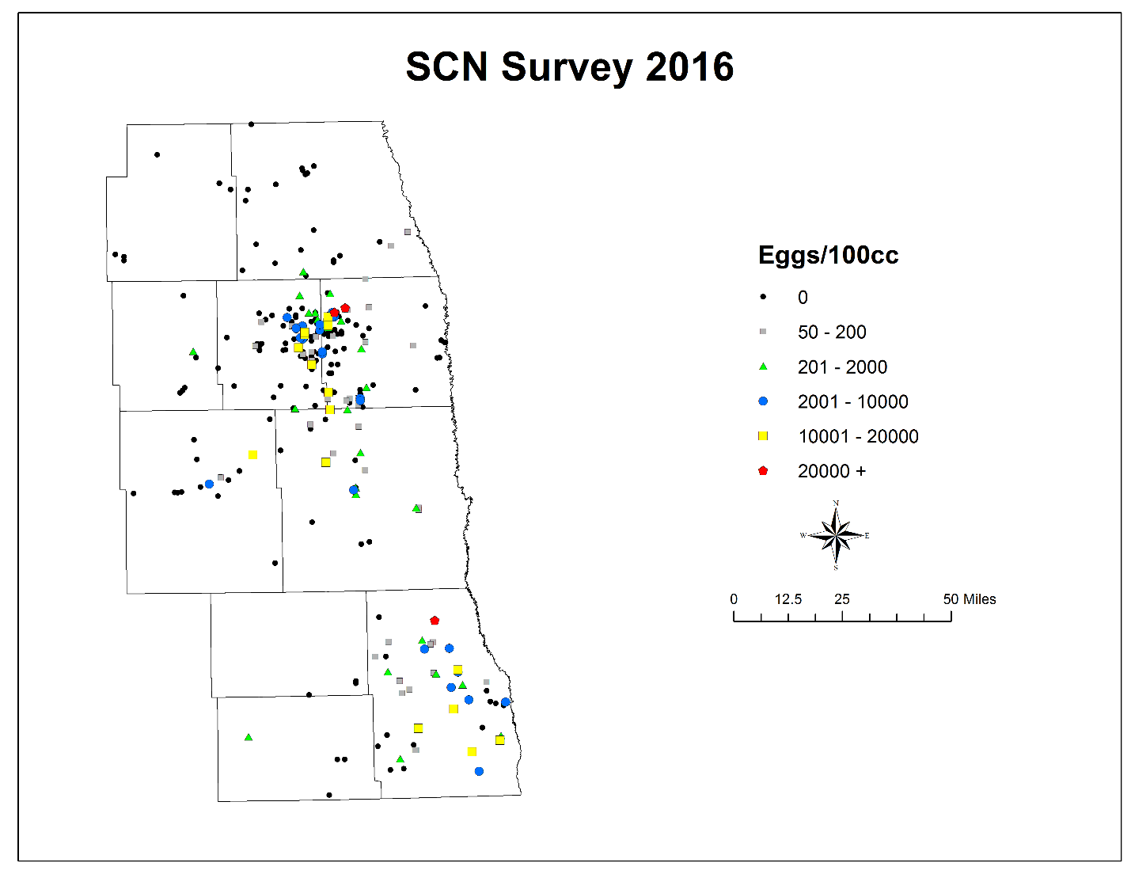

Figure 3. State wide distribution and egg levels of soybean cyst nematode in North Dakota received though the NDSC / NDSU sampling program from 2013 to 2016.

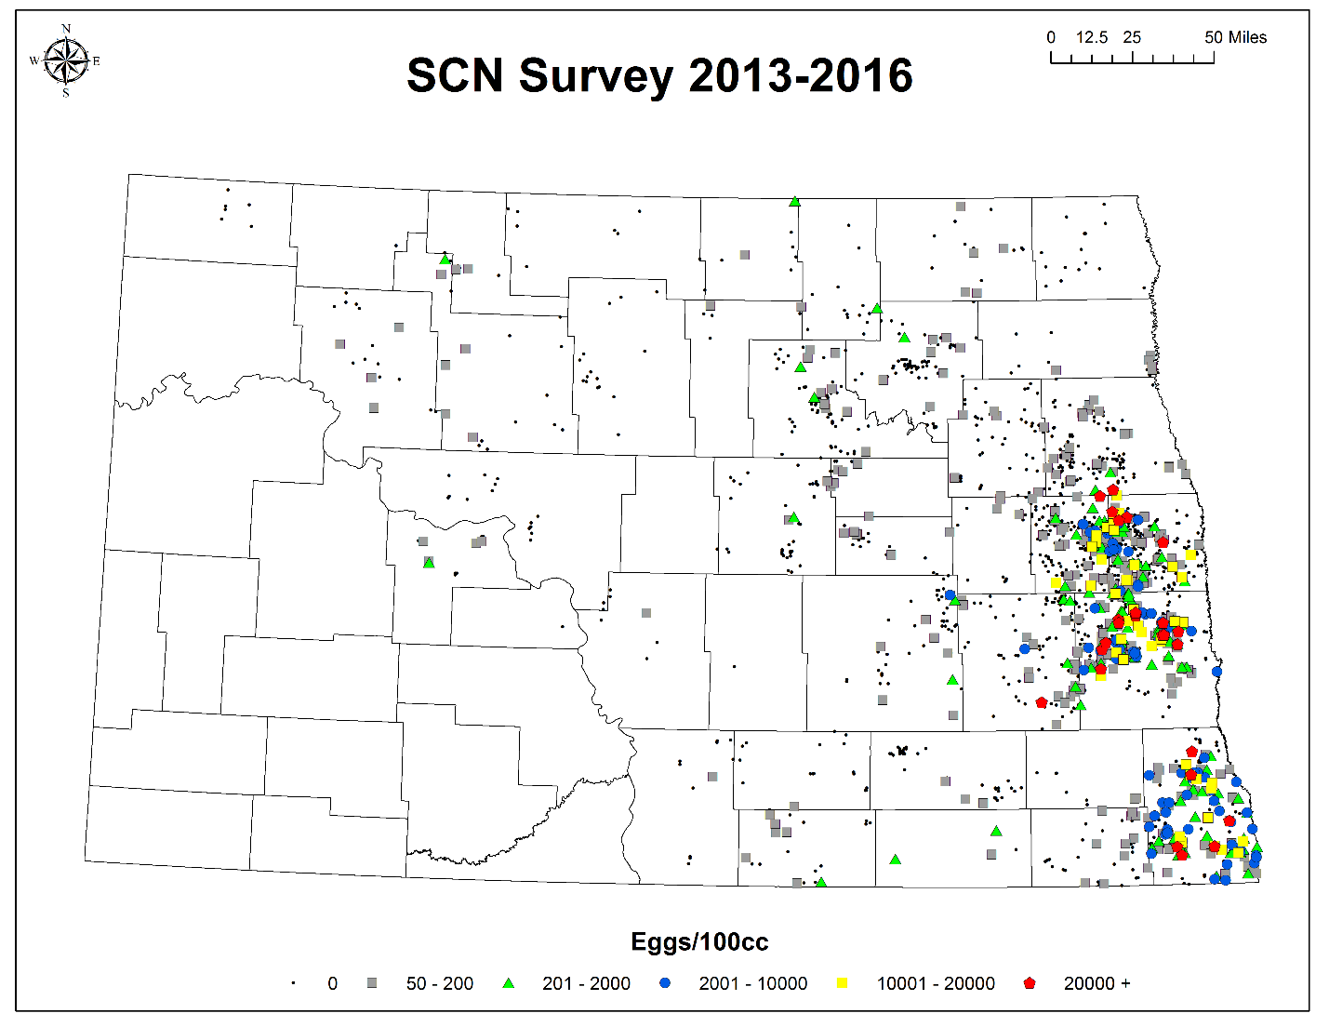

Figure 4. Regional distribution and egg levels of soybean cyst nematode in North Dakota received though the NDSC / NDSU sampling program from 2013 to 2016.

