2016 – 2017 Technical Report June 30, 2017

Sudden Death Syndrome Short Course

PI: Sam Markell, Ph.D.
Collaborator: Dean Malvick, Ph.D. (University of Minnesota)

What is the objective of this project?

Educate a critical mass of ND grower-educators about identification, diagnosis, and management of Sudden Death Syndrome; including crop consultants, county Extension agents, NDSC members and other agricultural professionals.

Why is this research is important to farmers?

Sudden Death Syndrome is a significant yield-limiting disease of soybean. The pathogen interacts with Soybean Cyst Nematode, and tends to ‘follow’ the movement of SCN. In 2011, Sudden Death Syndrome was confirmed in Ottertail county, MN; less than 100 miles from North Dakota. Similarly, Sudden Death Syndrome is widespread in Eastern South Dakota. It is possible that Sudden Death Syndrome will be a problem in North Dakota in the future.

Having a critical mass of grower-educators who know how to identify and manage Sudden Death Syndrome will be very important for early detection and management of this disease in North Dakota. A small number of critical professionals in agriculture will make management recommendations on 500,000 to 1 million acres of soybeans produced in the state. Providing an in-depth and hands-on training to this critical mass, who have the ability to act as first-responders, greatly increases the chances of early detection and active management of this disease.

How is this project conducted?

The Short Course was designed by Dr. Dean Malvick at the University of Minnesota and held on the morning of August 31st, 2016. Content included SDS biology, identification and management. Emphasis was placed on in-field identification.

Logistics were coordinated by Sam Markell and Aimee Thapa (NDSU Extension Administrative Assistant). Attendees were strategically selected based on ND geography and occupation; members of the NDSC, the NDSU Extension Service, Crop Consultants, Seed/Chemical Company professionals and one graduate student were included. All attendees arrived in Fargo on August 30th and traveled together to Mystic Lake Hotel and Casino for dinner and lodging. The short course began the next morning and concluded with a working lunch (Appendix 1). Attendees returned to the Fargo at approximately 5:00-6:00 pm.

What were the results?

Symptoms were excellent during the Short Course (Figures 1 and 2). Dr. Dean Malvick provided a very thorough overview of the disease, and included detailed content in specific areas of interest; primarily identification and management with genetics and seed treatments. Throughout the short-course, Dr. Markell and Kendall Nichols provided relevant commentary of local importance to North Dakota.

An evaluation of learning was done during the short course. The level of knowledge among the attendees was evaluated for six critical areas, including 1) the cause of SDS, 2) ability to identify SDS, 3) conditions that favor SDS, 4) how SDS can be managed, 5) how SDS impacts yield and 6) likelihood that SDS already occur in North Dakota (Figure 3). Attendees reported an increase in their knowledge level in each category. Complete survey results are presented in Appendix 2.

Figure 1. A range of severity of foliar symptoms of Sudden Death Syndrome observed during the Sudden Death Syndrome short-course.

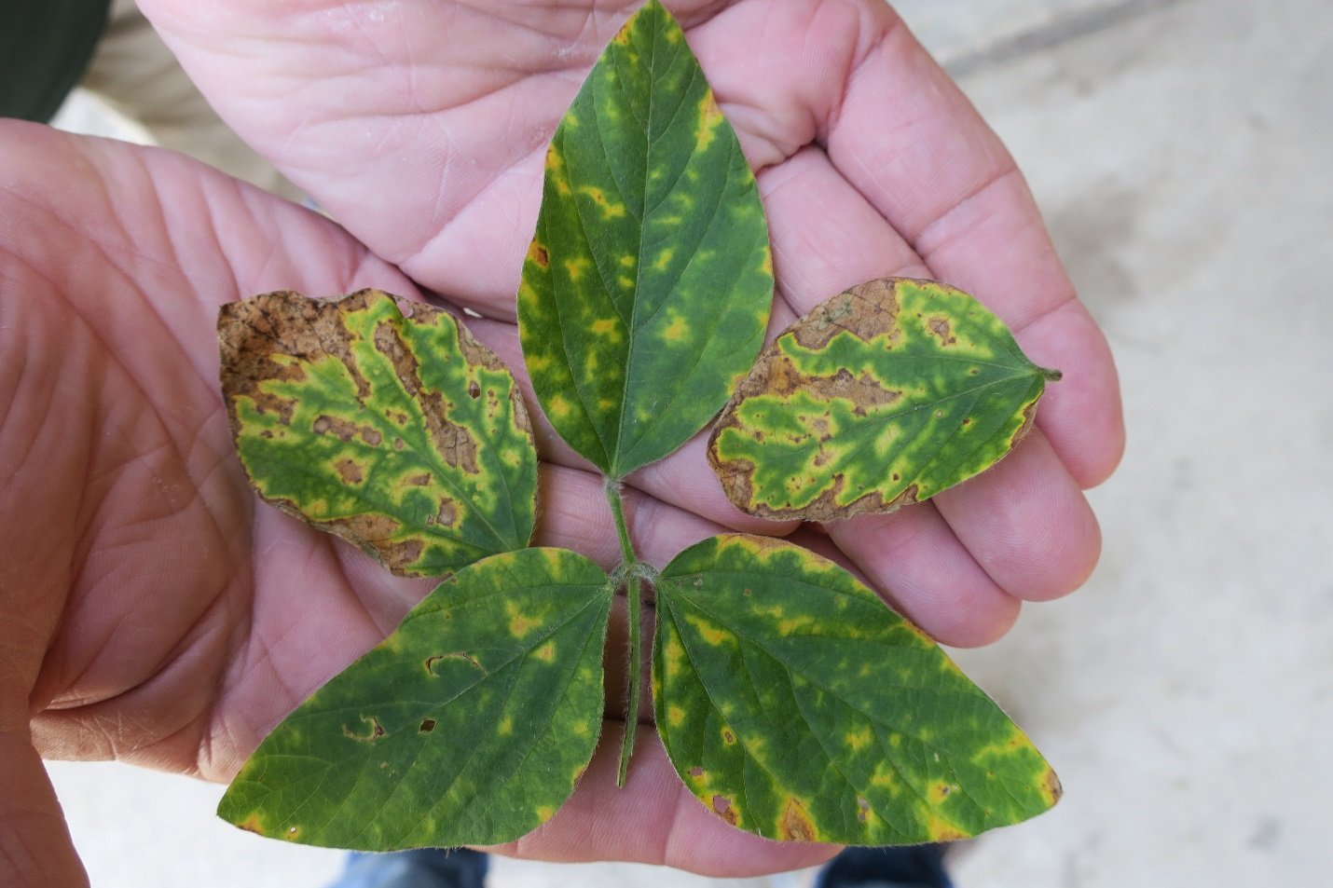

Figure 2. Dr. Dean Malvick describes management tools for Sudden Death Syndrome to North Dakota attendees. Note, severely infected SDS plot in foreground.

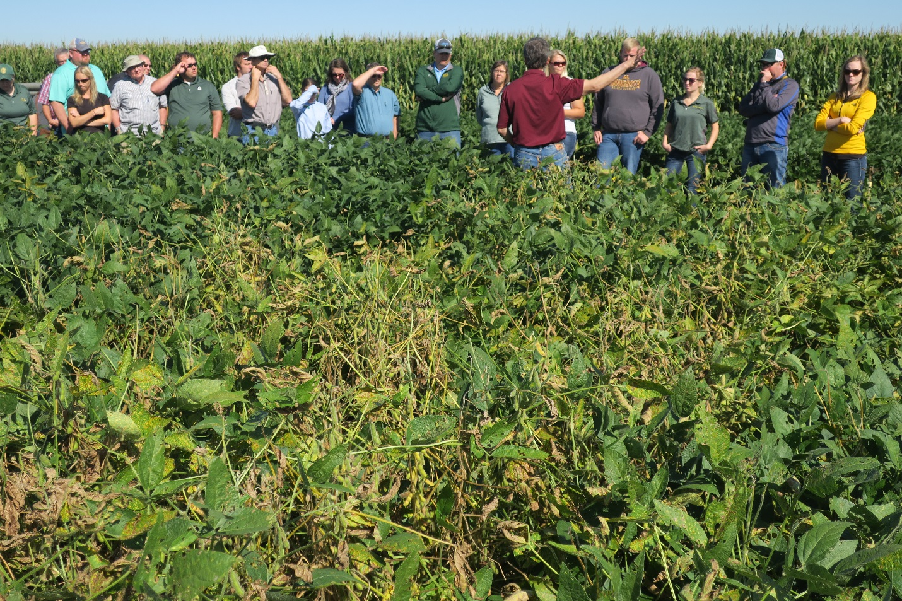

Figure 3. Knowledge level before and after attending the Sudden Death Syndrome Short-Course

Appendix 1. Sudden Death Syndrome Short-Course Agenda

Sudden Death Syndrome Tour Agenda – August 29th
August 30th
1:00-1:30 pm Arrive in Fargo.
Park in NW Fargodome Parking Lot F (see map on next page)
1:30 pm Depart for Mystic Lake Hotel & Casino.
We will take a 15 min break in Alexandria or Sauk Center
5:30 – 6:00 pm Arrive at Mystic Lake Hotel & Casino (www.mysticlake.com)
6:30 pm Supper (details below)

August 31st
6:00 - 7:45 am Breakfast on your own, checkout of hotel
7:45 - Load bus
8:00 – 8:30 am Depart Mystic Lake for Rosemount
8:30 – 8:45 am Arrive at U of MN Rosemount Research and Outreach Center
8:45 – 9:30 am SDS overview in Machine Shed: Coffee & Donuts will be provided
9:30 – 9:45 am Bus to research plots
9:45 – 11:15 am Field tour: Identification and Management
11:15 – 11:30 am Travel to Pizza Ranch
11:30- 1:00 pm Lunch at Pizza Ranch (15662 Pilot Knob Rd, Apple Valley, MN 55124)
1:00 pm Depart for Fargo, ND
5:00-6:00 pm Arrive in Fargodome parking lot.

Appendix 2. Sudden Death Syndrome Short-Course Evaluation Results
August 30-31, 2016

The Following Survey was given to attendees on the return trip. 31 attendees responded and mean data is presented for scaled numerical questions. Responses in blue represent knowledge level before attendance and responses in red represent knowledge level after attendance.

………………………………………………………………………………………………………………………………………………….

Please rate your level of knowledge on each statement before participation and after participation in the short-course. Rate your knowledge on the scale of 1 to 5, with 1 = low and 5 = high.

Area of Knowledge |  | Low |  | Med |  | High
- My understanding of the cause of SDS | Before Participation |  | 1.97
 | After Participation |  |  |  | 4.42
- My ability to identify SDS | Before Participation |  | 1.74
 | After Participation |  |  |  | 4.35
- My understanding of conditions that favor SDS | Before Participation |  | 1.77
 | After Participation |  |  |  | 4.48
- My understanding of how SDS can be managed | Before Participation |  | 1.65
 | After Participation |  |  |  | 4.35
- My understanding of how SDS can impact yield | Before Participation |  | 1.90
 | After Participation |  |  |  | 4.23
- The likelihood that SDS already occurs in North Dakota | Before Participation |  | 2.23
 | After Participation |  |  |  | 4.13

- I feel the short-course on Sudden Death Syndrome was worthwhile for me.

Not at all | Slightly | Somewhat | Significantly | Very much
1 | 2 | 3 | 4 | 5
4.81

- Do you anticipate using the knowledge you learned in this short-course? If so, how?

- Yes. I intend to scout field to aid in confirming the presence of SDS in ND
- Yes. education with producers and to personally scout for the disease in advance
- Yes - during Ext ed meetings
- Highlight symptoms in news release &amp; plot tours
- Yes - to help with grower ID &amp; management, even for those outside of North Dakota
- Yes, I plan to inform farmers/producers to keep an eye out for this. Using the information in a program during a winter meeting.
- Yes, Very helpful in my career to identify and manage
- I learned to identify a couple of other soybean diseases-brown stem rot &amp; bacterial blight, so I will be able to identify them as well as let Sam know if I see SDS. Also I know the management steps to take if I do see it.
- Yes - to create more awareness to producers and other consultants
- Absolutely, at next week's plot tour
- Hopefully. I will definitely be looking for the disease.
- Yes, use the abilitiy to identify to help growers/retailers manage
- Late season scouting
- I hope not, but probably. Like any other pathogen, it will eventually make its way to us.
- Yes, I found the info very useful. I am retired but still get questions.
- Yes, will be checking fields yet this fall to check leaves before maturity
- Yes. In making presentations &amp; informing growers before it gets in their fields.
- Yes, I will be sharing this info w/growers in my county
- Absolutely. Identifying in field, extending my knowledge of it to others
- I will feel more confident in field - identifying (for lab sending) susceptible samples
- Yes! As Prevention education to my producers on what it is, how it works, diagnosis, &amp; management strategies.
- Yes, to increase my ability to pick it out from Brown stem rot
- Scouting fields I monitor
- Yes. It will help in my line of work
- Educational
- Yes Visiting with farmers &amp; consultants
- Yes. Educate growers &amp; consultants and scout for it. Keep an eye out for new products, research &amp; varieties.

- What percent of the soybean fields that you advise/scout for growers would you believe will experience yield loss from Sudden Death Syndrome in the next 5 years?

0% 1-5% 6-10% 10-20% 21-30% 31-40% 41-50% >50%
Responses 1 6 12 4 2 0 1 1

- Please estimate the number of soybean acres that you advise/scout for growers.
- NA
- NA
- The number keeps increases. Don’t have exact # but I know a majority of the producers in the county grow them
- 40,000
- 2,500
- Approx 1,000-3,000
- 0
- 3,000,000
- 10,000
- Farm 2,500 acres
- None, retired
- 15,000
- 0
- 100,000
- N/A
- I’m an optimist! ))
- For 10. N/A
- 14,000
- 35,000
- 100,000
- 60,000
- 23,000
- N/A

- As a result of what you learned in this short-course, how much money do you think you could potentially save growers in the future (value of early identification, your preparedness for management, etc…)?

- Potentially save growers a 10-50% yield loss.
- $75,000
- $320,000
- Variable depending on environmental conditions &amp; if they follow management practices
- Based on different management strategies, I feel I could save them a substantial amount.
- 100,000 +
- very hard to pin down
- It Depends if they practice the right techniques provided . Should be considerable.
- Not enough information to answer at this time
- Millions!
- $47/A
- $20 to $50/Acre
- untold amounts
- thousands
- a lot :)
- N/A
- $100-200/Acre
- depending on its severity &amp; how fast it spreads, thosands
- lots
- $30-50.00/AC.
potentially more if disease get BAd
- $500,000
- Lots
- $30/Acre
- $10/Acre
- Tens of thousands +

