Project Number: |  | USB-1520-532-5662
Project Title: |  | Developing a Comprehensive Management Program for Foliar Diseases of Soybean
Organization: |  | Southern Illinois University
Principal Investigator Name: |  | Ahmad Fakhoury

Project Overview - What key activities were undertaken and what were the key accomplishments during the life of this project?
Rationale and Objectives - The main objective of this ongoing research is to develop cost-effective and sustainable management options for major foliar diseases of soybean. This will be accomplished by gaining a better understanding of the epidemiology of these diseases, identifying disease-resistant varieties, and assisting in the development of resistant germplasm.

Below is a summary of the key activities and accomplishments during the first two years of the project listed by performance measure, as cited in the proposal:

Objective 1 – Characterize Cercospora sojina (FLS pathogen) and Cercospora flagellaris population diversity and race structure

The genomes of C. sojina and C. flagellaris were sequenced. Isolates of C. sojina were collected from soybean fields with a high incidence of frogeye leaf spot in the Midwest (IL, IA, and MO) and the Midsouth (TN, LA, and AR). A collection of C. flagellaris was also built. Information from the sequences of both genomes are used to identify genetic markers that can be used to assess pathogen diversity, discover genes involved in pathogenesis, and determine the genetic basis of race structure. Two approaches were used to define race structure, population diversity, and mechanisms involved in CLB and FLS incidence and severity: a genomic approach and an approach based on reverse genetics. Initial analyses identified two genes thus far that are predicted to encode effectors, small secreted proteins that pathogens use to suppress host defenses. With this information, a rapid screen was designed utilizing next-generation DNA sequencing to define this locus in large populations of individuals. These loci were sequenced in large numbers of individuals of the same race to assess whether specific alleles are associated with specific races of the pathogen. Mapping data was also collected to identify genes associated with specific races.

To bait additional races of the pathogen out of natural populations, 1,200 soybean Pis were planted in Marianna, Arkansas in late July 2016. These Pis (all maturity group IV and V) represent non-domesticated and semi-domesticated lines that presumably are enriched in ancestral genetic material compared to modern soybeans. Additionally, each line has been fully genotyped by the USDA, and the genotyping data are publicly available. Alongside the non-domesticated soybean Pis, replicated plots of each soybean cultivar used as a differential in the current nomenclature system were planted. Highly resistant and susceptible Pis were identified, and populations of additional races of the pathogen were isolated.

Another focus has been to clarify the identity of Cercospora species that cause Cercospora leaf blight and purple seed stain. We performed Multi-locus sequencing on populations of the pathogen (previously thought to be exclusively C. kikuchii) from the U.S. and South America. At least five genetically diverse lineages were identified; work is ongoing to determine potential species boundaries. We have expanded the pathogen populations to include thorough coverage of the U.S., Brazil, Argentina, and South Korea to answer questions about potential movement of the pathogen on a global scale and to answer growers’ questions about exactly which pathogen is predominant in specific soybean-growing regions of the U.S.

Objective 2 – Manage Cercospora Leaf Blight of soybean with foliar applications of minor elements and develop a disease resistance screening protocol.

Cercospora leaf blight (CLB) continues to be a serious threat to soybean production and profitability in Louisiana and other Gulf South states. A high level of durable resistance to this disease has yet to be incorporated into commercial varieties, probably because the pathogen, Cercospora cf. flagellaris (formerly C. kikuchii), is extremely diverse and likely able to quickly overcome resistance genes. Producers are therefore dependent upon the use of fungicides to manage the disease.

It is well known that the pathogen produces a toxin, cercosporin, which is primarily responsible for symptom expression. We have been investigating nutritional factors that either promote or inhibit toxin production by the fungus with the objective of finding certain nutrients that could be applied to soybeans at a reasonable cost. Our efforts focused primarily on minor elements, including copper, zinc, iron, boron, manganese, aluminum and others. These studies were done by incorporating these minor elements into agar media and then growing the pathogen on these media and measuring fungal growth and toxin production. Iron and aluminum were very effective in completely inhibiting toxin production without necessarily affecting fungal growth. In addition, we recently showed that toxin production is enhanced with increasing iron concentrations until a critical concentration is reached at which point toxin production, and hence disease severity, plummet.

We investigated the use of commercial formulations of these minor elements and began testing products from Brandt Consolidated, a company with a proprietary formulation for enhanced uptake of minor elements following foliar applications. Briefly, ManniPlex Fe, when applied at R5, significantly reduced severity of CLB in field tests. The tests were expanded and repeated, and tissue analyses revealed that disease severity was reduced when tissue concentrations of iron exceeded 280 ppm. However, in a subsequent test, in spite of applying the same concentrations at R5, the highest tissue concentrations did not surpass 125 ppm, and disease suppression was not as dramatic as in previous years.

In 2016 these tests were expanded to other locations and included co-applications of fungicides with the iron formulations as well as applications at different growth stages. In addition, we initiated trials in two commercial fields in which the producers’ spray equipment was used. Disease development was negligible at one site, while disease severity was low at the other site. Positive effects were documented at both sites.

We are encouraged by our results to date in that results from our field studies and our laboratory experiments are closely aligned. However, results from our commercial field trials in 2016 have not been as promising. As of this writing, we do not yet have results from tissue analyses for these commercial trials. It is entirely possible that we did not reach the critical threshold for leaf tissue iron concentration (about 280 ppm) in these commercial field trials. We will have to conduct rate studies with commercial spray rigs.

We have pursued other studies related to iron nutrition. Briefly, we found that the purple leaf symptom, which is characteristic of CLB, is probably a plant defense reaction. Plants respond to oxidative stresses, such as ultraviolet irradiation, drought, and ozone damage, by producing secondary metabolites including anthocyanins, carotenoids and flavonoids, some of which are pigmented and may cause the CLB symptoms, while others function as antioxidants. The toxin produced by the pathogen is a strong oxidant, and we now have preliminary evidence that the plant responds to this toxin by activating its antioxidant defenses, which require iron for their synthesis.

Finally, we were successful in solubilizing cercosporin, the fungal toxin. We were then successful in conducting a proof-of-concept experiment in which we reproduced CLB symptoms by immersing cut petioles in solutions of the toxin. We are hopeful that this exciting new development will allow us to finally elucidate the biochemical mechanisms for disease development, which will then allow plant breeders to circumvent the need for inoculating whole plants with the pathogen. These inoculations, which have produced inconsistent results, have been a major impediment to selecting for disease resistance. In addition, these detached leaf assays may be useful in assessing varieties and breeding lines for disease resistance and could be used by breeders in their efforts to screen germplasm.

Objective 3 – Conduct extensive monitoring for fungicide-resistant strains of C. sojina, C. flagellaris, and S. glycines and develop and adapt fungicide application strategies accordingly.

A uniform fungicide field trial designed to evaluate the efficacy of fungicide products in managing frogeye leaf spot was initiated for the 2015 growing season. These “uniform” treatments were evaluated across several states.

The frogeye leaf spot severity and yield results are shown below for each location (Figs. 1 & 2).

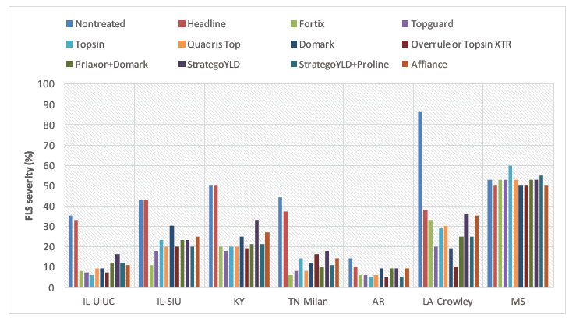
Figure 1 – Frogeye leaf spot severity (locations with at least 10% severity in non-treated control).

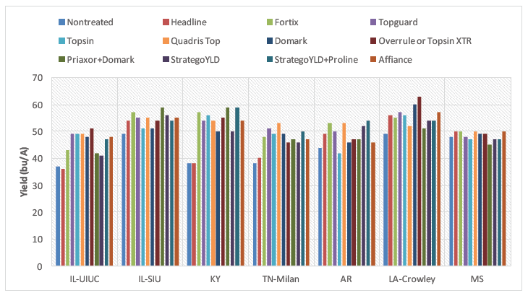
Figure 2 – Soybean yield (locations with at least 10% severity in non-treated control).

Strobilurin fungicide-resistant strains of C. sojina appeared to be prominent at all locations except Arkansas and Louisiana (Crowley) sites. Yield response with solo strobilurin fungicide (Headline) was generally low at locations with fungicide-resistant strains of C. sojina. The data also showed that frogeye leaf spot caused by strobilurin-resistant C. sojina can be controlled with other fungicide chemistries (triazoles, benzamidazoles, and SDHIs).

The uniform fungicide field trial was also conducted during the 2016 growing season.

At this time, yield data are not yet available from several of the locations. Figure 3 shows frogeye leaf spot data collected at the University of Kentucky field site. These results show that QoI-resistant strains are present in Princeton, KY, as the Headline (QoI fungicide) treatment was statistically similar to the nontreated control. Fungicide products that utilized active ingredients from chemistry classes other than the QoI fungicides, were effective in reducing frogeye leaf spot severity (Fig. 3).

Figure 3.
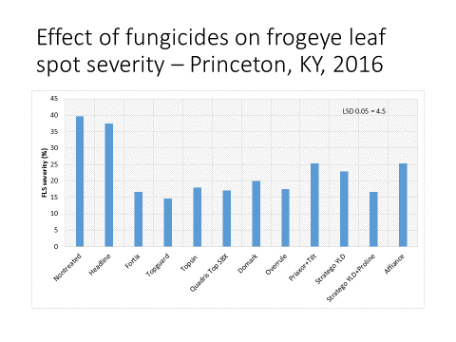

In 2015, the CLB Uniform Fungicide Trial was successfully executed in 8 locations, four had CLB. Treatment effects were observed in two locations (Hollier and Price) with multiple products at R3 and R5 and with Quadris Top applied at R3, respectively. Yield differences occurred in two locations (Rupe and Price). Combined data indicated that fungicides, particularly SDHIs or triazoles, were somewhat effective (non-significant) at reducing disease severity by 0 to 20% of the non-treated. Combined data from all locations indicated that fungicide type and timing did not significantly affect yield with mean percentages of the non-treated ranging from 2 to -5.4%.

The Uniform CLB Fungicide was repeated in 2016. The data from the 2016 season is still being analyzed at this time.

In 2013 and 2014, QoI-resistant strains of S. glycines (Septoria brown spot pathogen) were identified in Illinois. Work has continued in this area; the mutation responsible for QoI resistance in S. glycines was identified as the G143A mutation, a molecular assay was developed to identify the G143A mutation in S. glycines, a discriminatory dose assay was developed to identify S. glycines isolates that are resistant to QoI fungicides, leaf samples from KY and AL were obtained to help identify new locations in which QoI-resistant S. glycines are present (this work is on-going), and greenhouse and laboratory experiments designed to compare QoI-resistant and –sensitive S. glycines isolates are ongoing.

Objective 4 – Identify sources of resistance and develop resistant varieties and elite germplasm for C. sojina and C. flagellaris.

At SIU, 31 advanced breeding lines were evaluated with different genetic backgrounds for resistance to frog eye leaf spot (FLS) in two environments using two different field designs. All the lines were previously tested for yield and other important agronomic traits and showed a relatively high crop potential. The field evaluation allowed the identification of five lines that showed no disease traits and no differences compared with ‘Davis’ and ‘Kent’ that were used as controls. These lines will be introduced to regional yield trials in the following years and based on their performance, they might be released as new germplasm lines or varieties.

Crosses were performed between five Pis (PI398989, PI416943, PI424488A, PI494851, and PI92720) that are resistant to FLS with two ‘Saluki’ varieties (Saluki 4411 and Saluki 4916) that are susceptible in order to develop genetic populations. The collected F₁ seeds will be evaluated under greenhouse conditions in the following months.

A total of 94 recombinant inbred lines between Forrest and LS07-3131 (Resistant x Susceptible) were also evaluated for yield and various agronomic traits under field conditions. The same population will be screened for FLS resistance under greenhouse conditions in the following months. Plant materials were collected from each line to isolate DNA that will be used for SNP genotyping. Obtained phenotypic and genotypic data will be used to identify marker-trait associations for FLS resistance and other important traits.

A uniform variety trial for screening for resistance to Cercospora Leaf Blight (CLB) was planted at 15 locations in 7 states (AL, AR, LA, MO, MS, TN, TX). The trial consisted of 30 varieties and breeding lines planted in a randomized complete block with 2-row plots 20 ft. in length. The varieties and lines were rated for severity of CLB leaf bronzing and leaf blight symptoms. Incidence and severity of CLB petiole lesions was also rated. Ten entries had a low rating for severity of leaf bronzing and blight at Bossier City, LA. Six of the ten entries also rated low for incidence and severity of CLB petiole lesions. The trial will be harvested for yield and the incidence of purple seed stain will be recorded. Results from all trial locations will be compiled when the trials are completed.

In AR, fifty-six soybean breeding lines from Dr. Pengyin Chen’s program were screened in the field for their reactions to frogeye leafspot, Cercospora leaf blight, Phomopsis seed decay, and Cercospora seed decay. In 2014 and 2015, there were two late plantings of the test, in 2016 only one late planting. High levels of all four diseases occurred in both plantings in 2014. In 2015, frogeye leaf spot was lower, but still measurable in both plantings, but Cercospora leaf blight was only at measurable levels in the second planting. Seed infection levels were near 0 for both seed diseases in 2015 in both plantings. The 2016 data is still being compiled and analyzed. The five most consistently resistant lines to frogeye leaf spot and to Cercospora leaf blight are listed in Table 1 along with their parent lines. These results not only show which lines were the most consistently resistant to these diseases, but also show their parents. Research is continuing this winter to determine which parents may be the best sources of resistance to these diseases. Resistant and susceptible lines to Phomopsis seed decay and Cercospora seed decay were also identified.

Table 1. The five most resistant and two most susceptible soybean lines and their parents to frogeye leaf spot and to Cercospora leaf blight out of 28 late maturity group 4/early maturity group 5 and 28 late maturity group 5/early maturity group 6 soybean lines plated at the Southeast Research Station, Rohwer, AR in 2014and 2015.
Disease reaction Maturity Group Line Parent 1 Parent 2
Frogeye Resistant Lines
Late4/Early 5 R09-1589 5002T R01-4752
Late4/Early 5 R10-366R Ozark BC2F2 .
Late4/Early 5 R10-4892 5002T R01-3474F
Late4/Early 5 AG4632 . .
Late4/Early 5 R10-230 5002T R04-357
Frogeye Susceptible Lines
Late4/Early 5 R08-2797 DP 4748S KS 1599
Late4/Early 5 R09-4571 DP 4748S S01-9794

Frogeye Resistant Lines (0-3.0% Leaf area affected)
Late5/Early6 R11-2282 NCC04-734 RO1-327
Late5/Early6 UA5612 R97-1650 98601
Late5/Early6 R07-6614RR Lonoke Hutcheson
Late5/Early6 R10-230 5002T RO4-357
Late5/Early6 R10-1191 RO3-263 UA4805

Frogeye Susceptible Lines (20-30% Leaf area affected)
Late5/Early6 R07-7044 Lonoke NTCPR94-5157
Late5/Early6 Osage Hartz 5545 KS 4895

Cercospora Leaf Blight Resistant Lines (0.33 to 1.00% Leaf area affected)
Late4/Early 5 R11-927 5002T Osage
Late4/Early 5 AG 4933 . .
Late4/Early 5 UA 5213C R98-1523 98601
Late4/Early 5 AG4632 . .
Late4/Early 5 R09-5026 S00-9925-10 UA 4805
Cercospora Leaf Blight Susceptible Lines (15-27% Leaf area affected)
Late4/Early 5 R11-1617 R03-263 UA4805
Late4/Early 5 R11-89RY Osage RR2Y

Cercospora Leaf Blight Resistant Lines (0-2.0% Leaf area affected)
Late5/Early6 AG 5332 . .
Late5/Early6 R07-7044 Lonoke NTCPR 94-5157
Late5/Early6 R11-2517 R01-976 R03-946
Late5/Early6 R11-262 5002T R04-357
Late5/Early6 R10-197RY OzarkBC1F4 .

Cercospora Leaf Blight Susceptible Lines (20-38%Leaf area affected)
Late5/Early6 R11-1192 Osage R05-3239
Late5/Early6 R10-453RY R03-263 98601

Objective 5 – Determine the effect of Soybean Vein Necrosis Virus (SVNV) on yield.

To adequately address yield loss due to SVNV, we need to address several constraints. The largest of which deals with obtaining severe and uniform thrips infestations to measure yield differences in plots. During the 2015-16 fall/winter, we were successful in establishing methods to rear viruliferous soybean thrips and now have colonies of thrips with and without SVNV.

Field trials to study the effect of SVNV on yield. Two soybean cultivars (Merschman Kennedy 1436RR2 and 5N385 R2) were planted on 23 May 2016. Before releasing viruliferous thrips on June 17, leaves were collected to determine the occurrence of thrips and SVNV in thrips and in plant tissue. This pre-inoculation survey showed counts of thrips to be low, but were predominantly soybean thrips (Neohydatothrips variabilis; over 99%). The test for SVNV using mmune-blots showed that 100% of the sampled leaves were free of SVNV, while 15% of the thrips tested positive for SVNV indicating that the thrips in the field were infected with SVNV but the plant samples were SVNV-free at this time. The first release of growth chamber-reared viruliferous thrips occurred on June 17 when plants were in growth stage V3 by placing 12 thrips-infested plants (Williams 82) in half of the experimental units. Two weeks after this release, leaves and thrips were collected and tested for SVNV. Just after this sampling, insecticide treatments were initiated (2 July) on half of the experimental units. Both insecticide treatments and sample collections (plants and thrips) were continued periodically through July and August. Thrips were monitored by examining leaf samples under the microscope to identify thrips species including adults and immature individuals, and notes were recorded on visual symptoms of SVNV. Results showed higher (P < 0.05) SVNV scores on plants in plots where viruliferous thrips were released compared to plots sprayed with insecticides or those with no added viruliferous thrips. Immuno-blot analysis of leaves showed a greater (P < 0.05) incidence of SVNV in plots treated with viruliferous thrips. These trials have been harvested for yield. The data for these trials is being analyzed and summarized.

Effect of insecticide seed treatments on SVNV. Seeds of Illini 3590N, Merschman Kennedy 1436RR2, Power Plus 34T3, and 2R2801 treated with a neonicotinoid insecticide were planted on 23 May. The dates of viruliferous thrips release was similar to that of the yield plots except only 6 plants infested with viruliferous thrips were used for each experimental unit. Immuno-blots of leaves showed a lower (P < 0.05) incidence of SVNV infection in the Cruiser Maxx (thiamethoxam, fludioxonil and mefenoxam) treatment than the control. Although no differences were detected among cultivars using mmune-blots, visual SVNV scores indicated a difference (P < 0.05) among cultivars but not among the seed treatments. These trials have been harvested for yield. The data for these trials is being analyzed and summarized.

Impact of thrips at different soybean growth stages. Twenty-four tents in the field were used to evaluate six treatments: (i) no thrips added, (ii) non-viruliferous thrips added regularly, (iii) viruliferous thrips added at growth V3 followed by a few days with an insecticide, (iv) viruliferous thrips added at growth V3 without insecticide, (v) viruliferous thrips added at growth R3 followed by a few days with an insecticide, and (vi) viruliferous thrips added at growth R3 without insecticide (Fig. 4). The tents were removed from the plants. One last assessment was completed to evaluate the damage and SVNV symptoms.

Evaluation of soybean cultivars, breeding lines, and soybean plant introductions (PI) for SVNV resistance. Soybean entries (Field Illini 3590N, Hoffman H 451, Merschman Kennedy 1436RR2, Mycogen 5N385 R2, Power Plus 34T3, Stine 42RD02, Stone Seed Group 2R2801, Williams 82, Pis 171451, 417061, 229358, 417136, 423901-2, 518771, 572237, 604464, and soybean breeding lines with Rag1, Rag2 and Rag1/Rag2) were infested with viruliferous thrips in the growth chamber. Counts of adults and immature soybean thrips 2 weeks after infestation, the severity of soybean leaf damage by thrips, and SVNV incidence on unifoliolates and trifoliolates with and without thrips feeding were tested. Differences were observed in soybean entries for damage caused by thrips, and there were differences by entry in the occurrence of SVNV. The trial will be repeated during the next phase of the project.

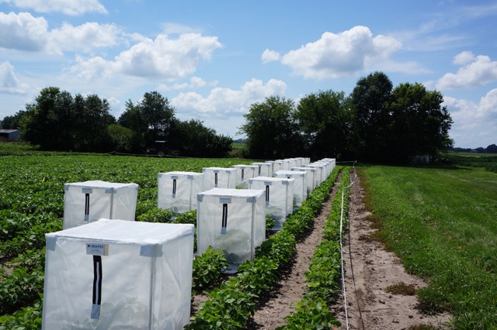

Fig. 4. Tents or cages of soybeans with and without viruliferous thrips.

Deliverables – List each deliverable and indicate whether or not it was supplied and if not supplied, please provide an explanation as to why.
This project includes both laboratory and field research aimed at understanding the occurrence and the impact of several soybean foliar pathogens on yield. Researchers used genomics, molecular biology, classical plant pathology, and plant breeding to address the stated objectives. Below are deliverables and their status in the second year of the project, listed by proposed objective:

OBJECTIVE 1 – Characterize Cercospora sojina (FLS pathogen) and Cercospora flagellaris population diversity and race structure:

We expect to complete the genotype-by-sequencing analyses on larger populations of C. sojina and C. flagellaris, and to identify candidate genes/genomic regions underlying race structure in C. sojina. The completion of the proposed work will result in the generation of genomic tools to study C. sojina and C. flagellaris, and in the identification of genes or gene variants unique to specific races of C. sojina and C. flagellaris. The information generated will help develop more efficient variety screening programs for breeders that rely more on the use of molecular markers. This will alleviate the current need in breeding programs for extensive phenotyping using plant differentials, which is very time consuming and labor intensive.

- The genomes of C. sojina and C. flagellaris were sequenced.
- New genomic tools were developed to study C. sojina and C. flagellaris.
- A large collection of C. sojina and C. flagellaris was built.
- Genetic markers were identified to identify genetic markers that can be used to assess pathogen diversity, discover genes involved in pathogenesis, and determine the genetic basis of race structure.
- Initial analyses identified two genes thus far that are predicted to encode effectors, small secreted proteins that pathogens use to suppress host defenses.
- A rapid screen was designed utilizing next-generation DNA sequencing to define this locus in large populations of individuals.
- Sequencing was performed on populations of the Cercospora leaf blight pathogen from the U.S. and South America. At least five genetically diverse lineages were identified; work is ongoing to determine potential species boundaries.

We expect the remaining deliverables to be supplied by the end of the project.

OBJECTIVE 2 – Management of Cercospora Leaf Blight of soybean with foliar applications of minor elements and development of a disease resistance screening protocol.

This research will ultimately lead to the delivery of recommendations for optimum tissue levels of iron and other minor elements to manage CLB. By the conclusion of the proposed experiments, we will be able to accurately identify iron and other minor element tissue concentrations associated with disease suppression. We will also be able to identify those compounds in soybean associated with anti-oxidant activity and disease resistance. Moreover, leaf culture protocols will be finalized and recommendations will be given to plant breeders.

- We have been investigating nutritional factors that either promote or inhibit cercosporin production by the fungus with the objective of finding certain nutrients that could be applied to soybeans at a reasonable cost. Iron and aluminum were very effective in completely inhibiting toxin production.
- We investigated the use of commercial formulations of these minor elements
- ManniPlex Fe, when applied at R5, significantly reduced severity of CLB in field tests.
- We were successful in solubilizing cercosporin, the fungal toxin.
- We were then successful in conducting a proof-of-concept experiment in which we reproduced CLB symptoms by immersing cut petioles in solutions of the toxin.
- These detached leaf assays may be useful in assessing varieties and breeding lines for disease resistance and could be used by breeders in their efforts to screen germplasm.

We expect the remaining deliverables to be supplied by the end of the project.

OBJECTIVE 3 – Conduct extensive monitoring for fungicide-resistant strains of C. sojina, and C. flagellaris, and Septoria glycines and develop and adapt fungicide application strategies accordingly.

By the end of the proposed research, an initial survey of strobilurin-fungicide-resistant strains of C. sojina, C. flagellaris, and S. glycines across the participating states will be completed. Furthermore, fungicide recommendations to manage C. sojina and C. flagellaris will be updated taking into consideration the distribution of fungicide- resistant strains.

- A uniform fungicide field trial designed to evaluate the efficacy of fungicide products in managing frogeye leaf spot was conducted in 2015 and 2016.
- Strobilurin fungicide-resistant strains of C. sojina appeared to be prominent at most locations.
- The data also showed that frogeye leaf spot caused by strobilurin-resistant C. sojina can be controlled with other fungicide chemistries.
- A CLB uniform fungicide trial was conducted in 2015 and 2016.
- Fungicides, particularly SDHIs or triazoles, are somewhat effective at reducing disease severity by 0 to 20% of the non-treated.
- The mutation responsible for QoI resistance in S. glycines was identified as the G143A mutation and a molecular assay was developed to identify the G143A mutation in S. glycines.

We expect the remaining deliverables to be supplied by the end of the project.

OBJECTIVE 4 – Identify sources of resistance and develop resistant varieties and elite germplasm for C. sojina and C. flagellaris:

A collection of commercial varieties and public lines (plant introductions and advanced breeding lines) will be screened in the greenhouse and in the in the field for resistance to frogeye leaf spot and to Cercospora leaf blight. Mapping populations will be developed. Advanced breeding lines with resistance to FLS will be introduced to multi-location yield trials to select those lines that combine resistance with high crop potential. An expanded multi-state regional field trial will evaluate an increased number of lines and varieties to identify lines with stable CLB resistance across locations. Crosses will be made with CLB resistant lines to incorporate resistance into elite lines and varieties. Mapping populations will be phenotyped and genotyped with SSR and SNP markers to map novel FLS resistance genes.

- Thirty-one advanced breeding lines were evaluated with different genetic backgrounds for resistance to frog eye leaf spot (FLS).
- Field evaluation allowed the identification of five lines that showed no disease traits and no differences compared with ‘Davis’ and ‘Kent’ that were used as controls.
- Crosses were performed between five Pis (PI398989, PI416943, PI424488A, PI494851, and PI92720) that are resistant to FLS with two ‘Saluki’ varieties (Saluki 4411 and Saluki 4916) that are susceptible in order to develop genetic populations.
- A uniform variety trial for screening for resistance to Cercospora Leaf Blight (CLB) was planted at 15 locations in 7 states (AL, AR, LA, MO, MS, TN, TX). The trial consisted of 30 varieties and breeding lines.
- Ten entries had a low rating for severity of leaf bronzing and blight at Bossier City, LA. Six of the ten entries also rated low for incidence and severity of CLB petiole lesions.
- In AR, fifty-six soybean breeding lines from Dr. Pengyin Chen’s program were screened in the field for their reactions to frogeye leafspot, Cercospora leaf blight, Phomopsis seed decay, and Cercospora seed decay.

OBJECTIVE 5 – Determine the effect of Soybean Vein Necrosis Virus (SVNV) on yield and evaluate soybean germplasm for resistance to thrips and SVNV.

The completion of this objective will benefit growers and crop advisors that are affected by SVNV, by being able to equate the level of severity of visual symptoms with potential yield loss and thus make more informed decisions about the need for control measures. In addition to providing an estimate of the effect of SVNV incidence on yield, we will be generating and publishing at least one report related to the evaluation of soybean germplasm for resistance to thrips and SVNV.

- We were successful in establishing methods to rear viruliferous soybean thrips and now have colonies of thrips with and without SVNV.
- Results from a series of assays showed higher (P < 0.05) SVNV scores on plants in plots where viruliferous thrips were released compared to plots sprayed with insecticides or those with no added viruliferous thrips.
- Immuno-blot analysis of leaves showed a greater (P < 0.05) incidence of SVNV in plots treated with viruliferous thrips.
- Seeds of Illini 3590N, Merschman Kennedy 1436RR2, Power Plus 34T3, and 2R2801 treated with a neonicotinoid insecticide were planted on 23 May. Immuno-blots of leaves showed a lower (P < 0.05) incidence of SVNV infection in the Cruiser Maxx (thiamethoxam, fludioxonil and mefenoxam) treatment than the control.
- Soybean entries (Field Illini 3590N, Hoffman H 451, Merschman Kennedy 1436RR2, Mycogen 5N385 R2, Power Plus 34T3, Stine 42RD02, Stone Seed Group 2R2801, Williams 82, Pis 171451, 417061, 229358, 417136, 423901-2, 518771, 572237, 604464, and soybean breeding lines with Rag1, Rag2 and Rag1/Rag2) were infested with viruliferous thrips in the growth chamber, and differences were observed in soybean entries for damage caused by thrips and there were differences by entry in the occurrence of SVNV.

We expect the remaining deliverables to be supplied by the end of the project.

 | Did this project meet the intended Key Performance Indicators (KPIs)? List each KPI and describe progress made (or not made) toward addressing it, including metrics where appropriate.
Following are the KPIs listed by proposed objective:

OBJECTIVE 1 – Characterize Cercospora sojina (FLS pathogen) and Cercospora flagellaris population diversity and race structure:
- By the end of the proposed research, plant pathologists will be able to better characterize the two Cercospora pathogen species.
- Breeders will have a race scheme by which to better match genetic sources of resistance to the diversity (pathogenicity) with each species.

OBJECTIVE 2 - Management of Cercospora Leaf Blight of soybean with foliar applications of minor elements and development of a disease resistance screening protocol.
- Growers will be provided with chemical control measures for C. flagellaris, which are currently lacking in the industry.
- Pathologists and field reps will benefit by a more precise disease rating scheme to assess disease severity.

OBJECTIVE 3 - Conduct extensive monitoring for fungicide-resistant strains of C. sojina, and C. flagellaris, and Septoria glycines and develop and adapt fungicide application strategies accordingly.
- Provide growers and crop advisors with tools to make more informed decisions on how to better manage the use of fungicides to control foliar diseases of soybean.
- Provide an updated map of the distribution of fungicide resistant isolates across the U.S.

OBJECTIVE 4 - Identify sources of resistance and develop resistant varieties and elite germplasm for C. sojina and C. flagellaris.
- Multi-state field and greenhouse screens will be conducted to identify sources of resistance to cercospora leaf blight and to frogeye leaf spot.

OBJECTIVE 5 - Determine the effect of Soybean Vein Necrosis Virus (SVNV) on yield and evaluate soybean germplasm for resistance to thrips and SVNV.
- Provide growers and crop advisors with a scheme to correlate the level of severity of visual SVNV symptoms with potential yield loss.

As shown in the previous sections, significant progress has been accomplished towards meeting the different KPIs by the end of the project.

What, if any, follow-on steps are required to capture benefits for all US soybean farmers? Describe in a few sentences how the results of this project will be or should be used.

By the end of the project, combined results from the performed experiments, screens, and trials will provide a robust dataset which will permit to provide solutions for these two important yield-limiting foliar diseases of soybean. The information could be used at county production meetings where it can be delivered directly to growers. The data will also be shared through publications, and presentations at professional meetings.

Continued cultivar and fungicide trials will benefit US soybean farmers by continuing to update and add to IPM strategies for foliar disease management in soybean. Specifically, more data on the epidemiology of the diseases and fungicide resistance will improve fungicide and application timing recommendations and save farmers money on input costs and protecting yield.

Describe any unforeseen events or circumstances that may have affected project timeline, costs, or deliverables.
Foliar diseases are dependent on environmental weather conditions that favor disease development. Given that the weather is unpredictable this is likely the most important unforeseen event that impacts foliar disease trials. However, continued support for such trials provide at least one or two years where data is collected and when combined with other PI’s data provide a deliverable that is more robust for the soybean producing state. Thus, though unforeseen, the multi PI approach was a good solution to provide some practical result from these trials

List any relevant performance metrics not captured in KPI’s.
None at this point.

