Final Report on the
Second SCN Coalition: Resistance Management and Awareness Campaign
12/31/17

Submitted by Dr. Sam Markell, PI (NDSU) to Dr. Ed Anderson, NCSRP
Co-PI’s include: Bond, D., Schroeder, N., Faghihi, J., Tylka, G., Bissonnette, K., Jardine, D., Bird, M., Naeve, S., Sweets, L., Giesler, L., Yan, G., Niblack, T., Byamukama, E., Conley, S., MacGuidwin, A., Bradley, C., Damicone, J., Tenuta, A., Young, H., and Mehl, H.

Organization of Report:
The development of the 2nd SCN Coalition is organized into seven different steps, of which steps three through seven have been active. To most clearly explain progress made during this period, milestones, time frame and key performance indicators are detailed by step (Table 1). Additional performance indicators for the National SCN Conference (Tables 2-3) and draft outputs of SCN Coalition activities (Appendix 1-5) are also included in this report.

Mission:
The Mission of the Second Soybean Cyst Nematode Coalition is to develop an SCN Resistance Management and Awareness Campaign to educate growers and industry on the reality of SCN resistance development, to slow the development of highly aggressive SCN populations and to minimize increasing levels of yield loss. This project will focus on the North Central states, but with early success and additional partners, will be expanded nationally and into Canada in 2018.

Objectives (Steps):
Step 1: SCN Grower Baseline Survey
Step 2: SCN Awareness and Education Meeting – Kick-starting the Second SCN Coalition
Step 3: National SCN Conference
Step 4: SCN Coalition Building and Development Meeting
Step 5: Develop an SCN Resistance Management and Awareness communication strategy
Step 6: Securing Buy-in from Industry Partners and Early Implementation
Step 7: Future Implementation of the Second SCN Coalition

Summary of Progress:
Prior to this project, Steps 1 and 2 were completed. The information generated by survey growers in 17 states (Step 1) was used as a guide to clearly identifying the SCN awareness problem and possible desired solutions. The SCN awareness and education meeting in 2015 (Step 2) was used as a springboard to outline a broad strategy that could lead to the Second SCN Coalition.

Since the beginning of this project, we have organized and completed the National SCN Conference in Coral Gables, FL (Step 3), held the SCN Coalition Development meeting in Coral Gables (Step 4), held the SCN Resistance Management and Awareness Communication Strategy meeting (Step 5), have secured a half-dozen prominent industry partners (Step 6) and are deep in the process of implementation (Step 7). Significant progress has been made in each step.

Step 3 (National SCN Conference) brought together academic, industry and grower’s to share SCN research results and needs. The conference was opened by a plenary speaker (Dr. Greg Tylka) who successfully provided a history and foundation knowledge to the attendees. The conference design consisted of three distinct sessions (succinctly; host, pathogen and management), each of them opened by a plenary speaker who is an expert in the session topic. Following each session, growers from North Central States (members of the NCSRP) were asked to provide feedback to the entire conference attendance. These conversations were a critical part of the conference. The National SCN Conference was closed by plenary speaker Dr. Ed Anderson (NCSRP), who successfully synthesized the information presented throughout the conference and laid out a vision that researchers and growers alike can follow as we move forward on management of SCN; cooperation among different groups, coordination among researchers and always keeping the growers in mind. The performance indicators included feedback from attendees using a post-meeting survey of National SCN Conference attendees. Results demonstrated that conference organizers accomplished the objectives of the meeting and that attendees viewed the meeting ‘above average’ to ‘much above average’ when compared to similar meetings they have attended (Tables 2 and 3).

Step 4 performance indicators included the diverse attendance at the SCN Coalition building and development meeting. Specifically, fourteen industry scientists representing nine companies, nine growers representing six North Central states, five research directors from five state soybean checkoff organizations, seven scientists representing seven Universities and five professionals representing National soybean checkoff and/or media attended the meeting.

Step 5 performance indicators included the drafts of talking points, messaging, and presentations that were developed following a two-day meeting to develop the messaging and communication strategy for the 2nd SCN Coalition. This includes talking points and strategy to build the coalition with industry partners.

Step 6 performance indicators include many prominent industry partners being committed to the SCN Coalition, namely; BASF, Bayer, Corn+Soybean Digest, Growmark, Monsanto, Syngenta and Winfield United. Pioneer has been contacted and we are hoping to interact with their leadership soon (the Dow/DuPont merger has impeded progress. In addition to specific visits to each of the companies (save Growmark), the SCN members of the SCN Coalition leadership met jointly with BASF, Bayer, Growmark, Syngenta and Winfield United at ASTA on December 8th, 2017. While not in the time frame of this current FY, a meeting to get these competitors in the same room as partners, immediately prior to the launch of the SCN Coalition, was considered a great success.

Step 7 performance indicators are numerous, diverse and not static. Implementation is dependent upon partnerships, financial support and leveraging, content development and implementation steps. We will address each indicator succinctly.
- Partnerships include BASF, Bayer, Growmark, Monsanto, Syngenta, Winfield United. Anticipated partner visits include Pioneer and 4-10 additional partners.
- Financial support and leveraging. The NCSRP money has been used to generate early successes for the SCN Coalition and leverage significant financial support from other entities.
  - The United Soybean Board funded a $275,000 proposal that is a perfect complimentary fit to the NCSRP support. This proposal will, 1) expand the SCN Coalition beyond the NCSRP member states, 2) dramatically improve the visibility at the launch, and 3) turn the SCN Coalition resource center into a robust, one-stop shop complete with state/region/partner specific information. Corn+Soybean Digest will be providing a multi-page layout to coincide with the launch at Commodity Classic.
  - Private partners have provided direct support in terms of travel, conference rooms, partner meetings, support of the National SCN Conference and more throughout this cycle, likely valued at $50,000-$100,000. Additionally, private partners have committed to in-kind advertising (logo use, advertising, media help, etc..) in the near future. While the financial value is very difficult to estimate, it is likely to exceed $500,000. Similarly, they will likely be contributing direct support after the SCN Coalition is launched.
  - Select QSSB’s will likely be providing complimentary direct support to state PI’s to help accomplish the objective and mission of the SCN Coalition into the future. While this number is unclear, we currently estimate the dollar figure submitted in proposals to the QSSB’s to exceed $750,000.
- Content Development. The first grower video (Ron Heck – IA), a national scientific training video (Greg Tylka – ISU), a Slim Jim (small fact sheet), multiple infographics, www.theSCNcoalition.com website, a logo/lockup and messaging materials have been drafted and/or completed (Appendix 1-7).
- Implementation Steps. The SCN Coalition will be launched at Commodity Classic in Anaheim, CA in late February this year. Events currently planned include a booth, ‘what’s new’ session, press conference and multiple cross-marketing opportunities with partners. Following the launch, a concerted effort to recruit more industry partners will be made, and additional PR events will follow.

Table 1. Objectives, description and milestones, timeline and key performance indications for the development of the 2nd SCN Coalition: Resistance Management and Awareness Campaign. Steps/Objectives active in this cycle are presented in black, non-active steps are presented in gray.

Step | Description and Milestones | When | Key Performance Indicator Summary
1 | SCN Grower Baseline Survey  Information on grower awareness, perception and information acquisition preference was generated from 1,096 growers in 17 states. | 2015 | Survey provided overwhelming evidence that a lack of awareness about SCN and the impending SCN crisis existed among growers.
2 | SCN Awareness and Education Meeting  A strategic planning meeting with University, industry and grower representatives was held to identify needs and develop strategies to manage the SCN crisis. The concept of a 2nd SCN Coalition was born and sub committees were developed to lead the effort; Proposal, Industry Outreach, Extension Outreach. | December 16th-18th, 2015 | Support for a large awareness campaign was voiced, and three sub-committees were formed to design a strategy to develop the 2nd SCN Coalition. The resulting strategy was financially supported by the North Central Soybean Research Program.
3 | National SCN Conference  A scientific conference brought together scientists from academia and industry, grower advisors and others to present and discuss research updates that have occurred since the last SCN Conference (2008). The implementation of the 2nd SCN Coalition will began at this meeting. | December 13th–15th, 2016 | A critical early step in coalition building was to bring together researchers to share updates. Follow-up surveys demonstrated the organizers of the National SCN Conference accomplished their stated goals and the conference was viewed as ‘above average’ to ‘much above average’ (Table 2-3).
4 | SCN Coalition Building and Development Meeting  A small gathering (roughly 30-36 people) of strategic partners (Industry, Growers, Academia) was held following the National SCN Conference. Feedback during the meeting was used as a foundation for developing the communication strategy | December 15th, 2016 | Interpretation of grower survey results (step 1), the strategic planning and mission development that occurred in step 2 and research results from step 3 were used to brainstorm how an SCN Coalition might be most successful to each group of partners. Results were a strong desire to push forward and establish messaging.
5 | Develop an SCN Resistance Management and Awareness Communication Strategy  The ideas put forth and discussed in the SCN Coalition Building and Developmental Meeting (Step 4) were refined and packaged into key messages and strategies. Key members of the three original committees (Sam Markell, Albert Tenuta, George Bird, Greg Tylka, Seth Naeve and Kaitlyn Bissonnette) gathered with MorganMyers (Laurie Steen and Max Wenck) at the office of Kurt Lawton (Corn Soybean Digest). | February 9th – 10th, 2017 | Drafts of talking points, messaging, and presentations were created. The draft messaging has been sent in a feedback loop among the SCN Coalition community in effort to ensure a reasonably high level of satisfaction and consensus among members.  Industry visits were discussed and scheduling with industry partners and the United Soybean Board were discussed.
6 | Securing Buy-in from Industry Partners and Early Implementation  In order to solicit and earn intellectual and financial buy-in from industry partners, key members will visit private partners. | Spring – Fall 2017 | Committed partners include BASF, Bayer, Corn+Soybean Digest, Growmark, Monsanto, Syngenta and Winfield United. USB support has also been secured.
7 | Future Implementation of the Second SCN Coalition  NCSRP funds have been leveraged to secure cash or in-kind financial support has been secured from USB and industry partners. This will support the launch, resource center, new partner visits and all supporting materials. | Fall 2017 –  Spring 2018 | Financial support secured. Launch set for Commodity Classic. Many resource materials drafted/developed (video, infographics, website, etc.) (Appendix 1-5).

Table 2. Attendee responses to a survey following the National SCN Conference. Attendees were asked to rate the program content, location and field trip when compared to similar meetings that have recently attended, using a 1-5 scale, where; 1 = much below average, 2 = below average, 3 = average, 4 = above average and 5 = much above average.

Category Rated | Number of Survey Responses | Mean
Program Content | 53 | 4.08
Location | 54 | 4.00
Field Trip | 26 | 4.31

Table 3. Attendee responses when asked if the three stated objectives of the 2016 SCN Conference were accomplished.

Did we accomplish the stated objectives? | Response (n)
 | Yes | No
‘Bring together academia and industry scientists, graduate students, crop advisors and the leaders of grower groups’ | 54 | 0
‘Share and discuss developments related to SCN’ | 54 | 0
‘Gather feedback and perspectives from growers’ | 54 | 0

Appendix 1. Message map of the SCN Coalition.
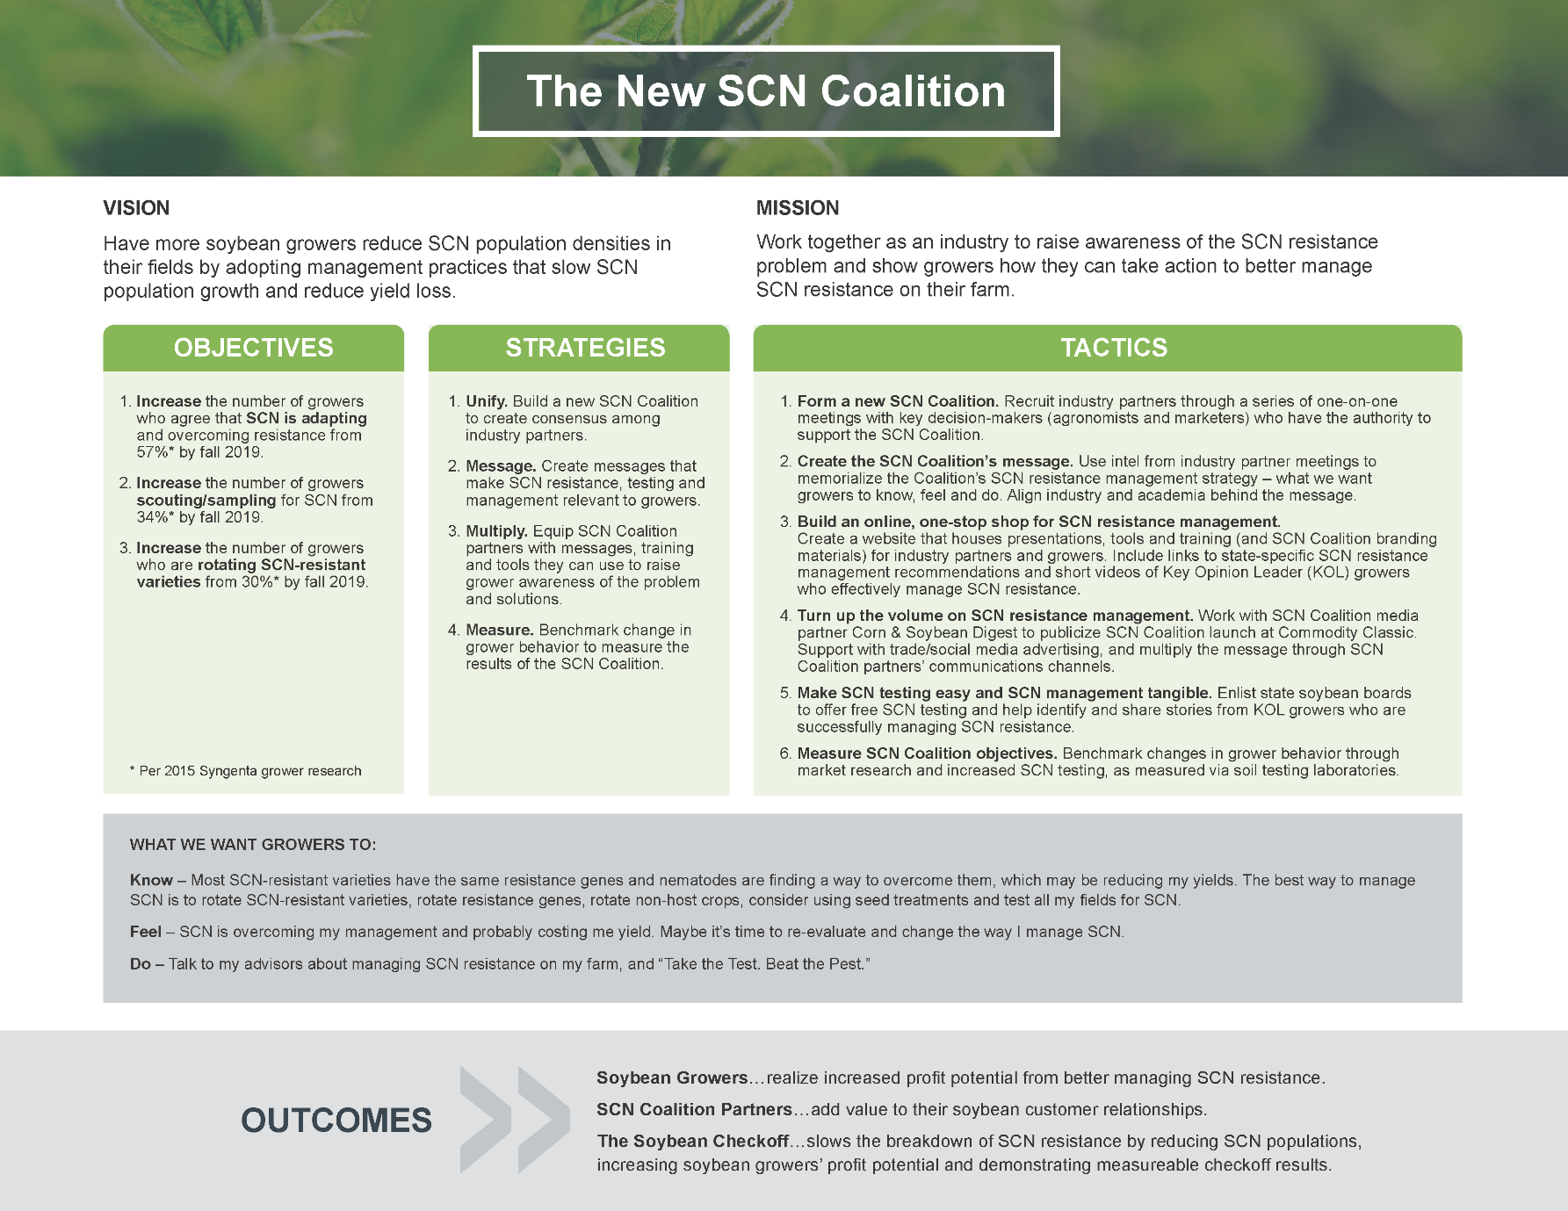

Appendix 2. Draft Slim Jim (front/back)
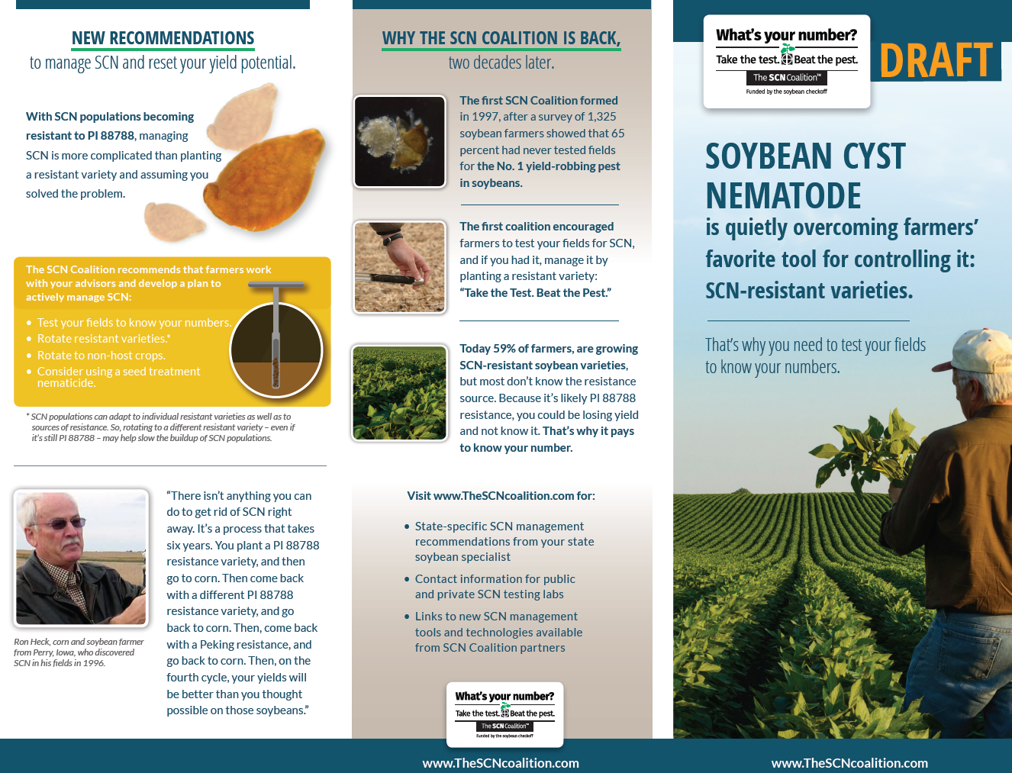

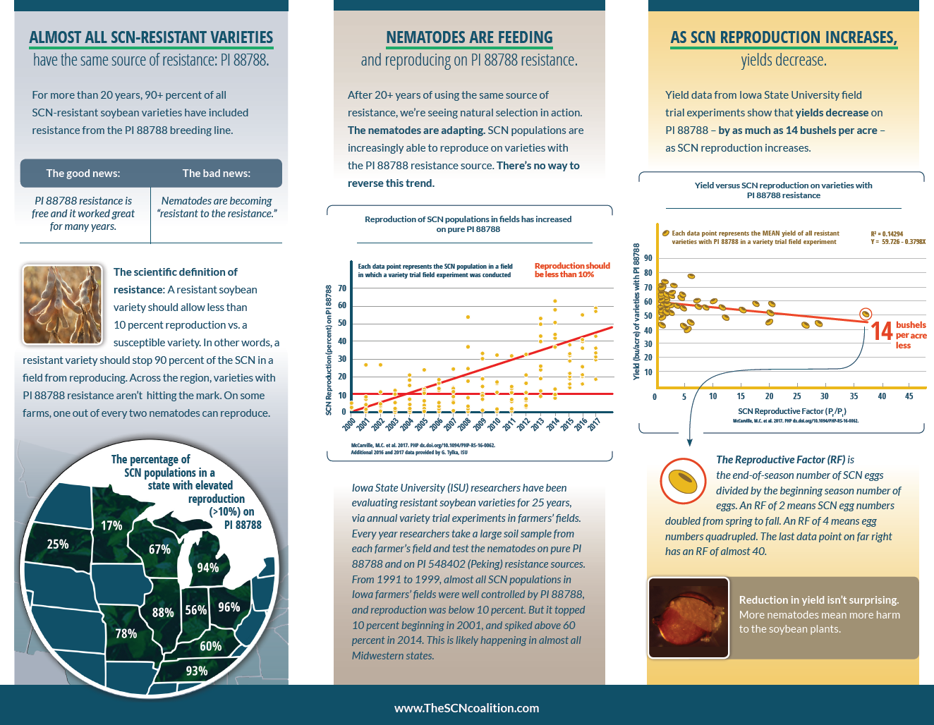

Appendix 3. Draft ‘where from’ infographic.
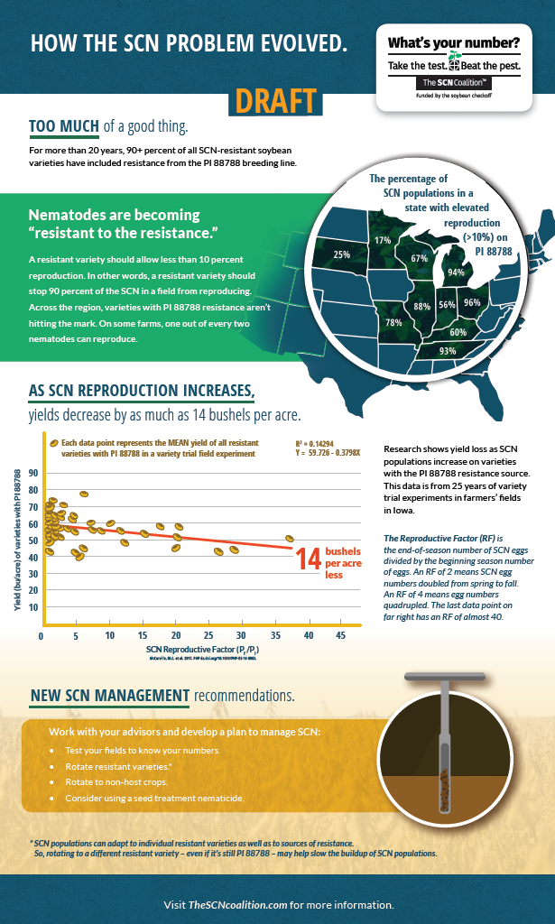

Appendix 3. Draft merchandising resource guide cover.
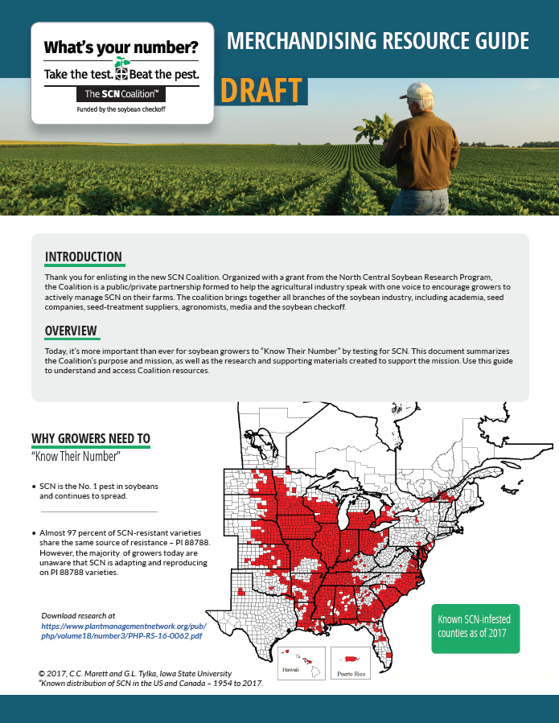

Appendix 4. Screen capture image of resource center under construction.
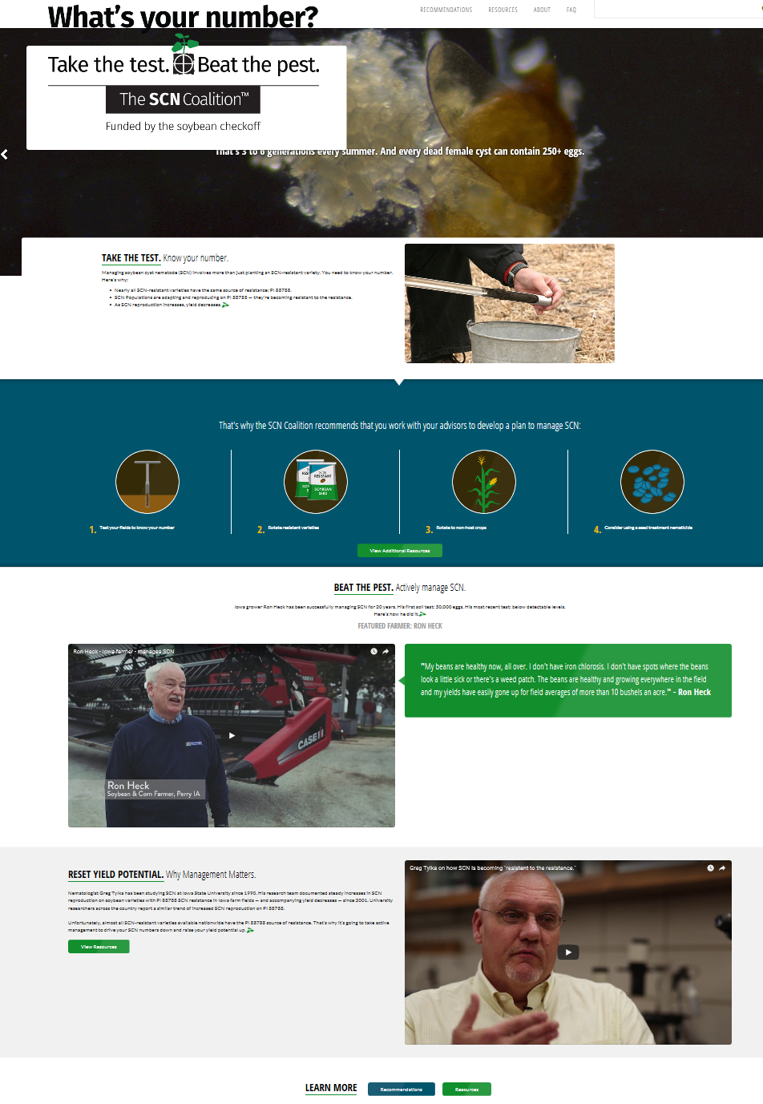

Appendix 5. Draft training module cover (76 total annotated slides).

