Kansas Soybean Commission
4th Quarter & Final Progress Report
February 28, 2017

Principal Investigators and Units: C. M. Smith, Dept. of Entomology, (785)-532-4700, Brian McCornack, Dept. of Entomology (785 532-4729, W. Schapaugh, Dept of Agronomy, (785) 532-7242, Jeff Whitworth, Dept. of Entomology, (785) 532-5656.

Project Title: Development of Genetic, Chemical and Population-Based Tactics to Manage Key Kansas Soybean Insect Pests

Amount of Funding: $64,060

Progress Report: December 1, 2016 – February 28, 2017

Completion Date : February 28, 2017

Objective 1. Create soybean plants resistant to soybean stem borer by inserting borer RNA into soybean plants to interfere (RNAi) with genes necessary for borer survival. Lina Aguirre, the PhD student conducting research on sub-objective 1, made substantial progress in FY 17. A laboratory stem borer colony was developed for experiments to test the effects of silencing Laccase2 (Lac2), a key cuticle gene in borer larvae. She designed ds (double-stranded) RNA and RT-qPCR primers with Lac2 fragments sequenced from soybean stem borer larval cDNA. She cloned ~380 bp fragments of D. texanus Lac2 and 16S-rRNA genes and synthesized Lac2 and GFP (green fluorescent protein)-dsRNA. These results allowed development of two sub-objectives. Sub-objective 1 is to verify gene silencing by RNAi in soybean stem borer larvae by silencing Lac2, and sub-objective 2 is to determine if silenced Lac2 or other beetle membrane proteins can be moved into soybean plants and expressed at levels sufficient to kill stem borer larvae and/or adult beetles. Fifth-instar colony larvae were injected with 1µg of Lac2 or GFP-dsRNA, kept at 27°C on artificial diet and assessed for changes in adult body characteristics and Lac2 or GFP expression. No significant changes in gene expression were found between Lac2 and GFP-dsRNA at either time point. In a follow-up replicated study, 95% of stem borer larvae injected with RNAi silenced Lac2 died as larvae or beetles. A few treated larvae have become adults, and those have atrophied wings, un-tanned cuticle, curled antennae, do not feed and eventually die. Additional replicated experiments are being conducted with RNAi injected larvae to verify results of this study. Sub-objective 2 experiments will be conducted in FY19. From January-March 2017, Ms. Aquirre underwent extensive training and tutoring in the use of Beocat, the high-performance computing cluster at Kansas State University. This training will be used to assess and analyze results of a study to be conducted in 2017 that will compare the gene expression patterns in D. texanus larvae fed soybean, sunflower and ragweed. This study is necessary to insure that Lac2 genes specifically from soybean are those used for RNAi silencing experiments in soybean plants.

Objective 2. Improve insecticide efficacy by using host plant developmental stages and other environmental cues or conditions to adjust timing of application. A primary focus of this objective is to examine the timing and placement of insecticide applications for controlling soybean stem borer adults and other key soybean pests in Kansas soybean fields. The efficacy of Prevathon and Stewart to Dectes texanus was tested over several acres in production fields in 2016. In the first field study, plants treated with Prevathon alone, or with Prevathon plus Stewart were compared to untreated control plants. The combinations of Prevathon and Stewart targeted different Dectes texanus growth stages and aimed to provide varied levels of residual control. In addition to larval counts, images at two 25’ and 150’ altitudes were captured over each field using an unmanned aircraft system (UAS). Currently, images from different altitudes are being analyzed to quantify insecticide treatment differences and evaluate the utility of UAS imagery to identify borer infestations prior to harvest, which includes methods to quantify lodging in untreated (Fig. 1A) and insecticide-treated (Fig. 1B) plots. Results from replicated cage and small-plot studies showed significant differences in mean vegetation indices between infested and non-infested treatments using established indices. In general, there are significant differences between sample dates as soybean plants mature through time for all vegetation indices tested.

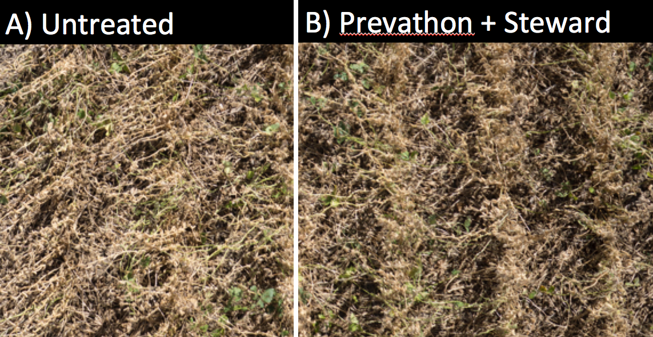
Figure 1. Images captured from small UAS over control or untreated (A) and insecticide treated (B) plots within a production field in Norway, KS during the 2016 growing season.

A second field study was used to develop a sampling strategy to evaluate the efficacy of site-specific insecticide applications. We identified growers in Riley and Republic Counties willing to participate and sampled 8 production fields throughout the summer using sweep net samples from each waypoint (n > 40 per field). Adults from each sample set were bagged, frozen and adults are currently being sexed in the lab. A graduate student will take over this project and model the value of site-specific management strategies and the value of reducing insecticide spray areas for managing D. texanus in soybean.

Objective 3. Expand web pages and other educational materials associated with soybean insect pests. Co-PI Whitworth and Dr. Holly Schwarting wrote the insect pest chapter for the just completed publication: Ciampitti, I. A. et al. 2016."Soybean Production Handbook.” KSRE. Sept., 2016. C449.Work is in progress to update the insect pest management information section for the Kansas Soybean Management 2017 publication.
https://www.bookstore.ksre.ksu.edu/pubs/MF3154.pdf.

