**Kansas Soybean Commission 4th Quarter report for FY2017**

**Principle investigators:** Krishna Jagadish, Raju Bheemanahalli and William Schapaugh

**Project Title**: “High-throughput Platform to Enhance Quality of Beans and Add Value to Kansas Soybean Breeding Program”

**Checkoff Organization:** Kansas Soybean Commission

**Categories:** Breeding & genetics

**NCSRP, USB, QSSB Project Code:** 1778

**Amount of funding:** $35,000.00

**Project Year:** 2017

**Department Head:** Gary Pierzynski

**Project Summary**

Soybean breeding programs are successful in increasing yield potential but progress in breeding for optimizing seed quality composition such as protein, oil, fatty acids, amino acids has not received similar attention. This is primarily because of the lack of a rapid screening tool to capture the complex tradeoffs between yield and quality parameters. Hence there is a real need to develop a simple, robust and high-throughput platform for quantifying quality parameters and the seed compositional changes in response to a range of environmental conditions. The major quality determining components i.e. amino acids, protein, oil and fatty acids compositions are often negatively impacted by harsh environmental conditions (high temperatures and low or erratic rainfall) during pod filling stage (Carrera et al., 2011 a, b). Enhancing the quality of the beans is emerging as a major priority that needs to be addressed, to obtain an edge in the domestic and international market. Till date, assessing the diversity in protein, oil, fatty acids, amino acids, and other quality composition in soybean grown in Kansas has not been systematically attempted. Thus, with the establishment of Near-infrared spectroscopy (NIRS)- a rapid and high-throughput tool in the Agronomy Department will strengthen Kansas soybean breeding program to develop beans with higher quality. Progress achieved in the project will increase additional income generation potential among Kansas growers.

**Project Objectives**

1. Develop and standardize a high-throughput approach to quantify genetic diversity in beans protein, amino acids, oil, oleic acid etc. from germplasm generated by the Kansas Soybean Breeding Program
2. Estimate the spatial and temporal impact of Kansas climatic variability on soybean quality with emphasis on essential amino acids, oleic acid etc.
3. Integrate the technology into Kansas soybean breeding program to enhance breeding efficiency towards developing high quality beans

**Project Deliverables**

1. Genetic variability in protein, amino acids, oil, oleic acid compositions of native, exotic and advanced soybeans breeding lines profiled
2. Location specific climatic impact on soybean seed quality quantified
3. A high throughput platform to determine trade-offs between yield and quality parameters established
4. NIRS spectral curves developed and standardized for supporting the soybean breeding program during and beyond the time-frame of the proposed project

**Progress of Work (4th Quarter report for FY2017)**

For the 4th quarter report, we mainly focused on our second and third objectives that focus on estimating the spatial impact of Kansas climatic variability on soybeans quality and integrating the NIRS technology into Kansas soybean breeding program to enhance breeding efficiency towards developing high quality beans.

Seeds used for the breeding experiment were obtained from Prof. Schapaugh and his team, and details on the experiments are listed in Table 01. The objective of the breeding experiment is to determine beans that produce 47.5%-48.5% (at 13% moisture) with highest possible percentage of oil.

Soybean Varietal Performance Test was carried out in 2017 by Prof. Schapaugh and his team, and data was used to determine the impact of location and local temperature (during the pod-filling stage) on yield, protein, and oil content of nine soybean genotypes grown across six locations. Also, data were used to see the correlations between yield, oil, and protein. Information on the local temperature variations during pod-filling stage (mid-July to mid-September) was obtained from the Kansas Mesonet (<http://mesonet.k-state.edu/>) and Global Historical Climate Network stations via RC-ACIS interface (<http://scacis.rcc-acis.org/>).

Further, seeds were obtained from Dr. Henry T. Nguyen and the team (University of Missouri). The objective of this project is to determine correlations of quantitative data of seed composition traits that are evaluated by NIRS and HLPC. Details on the seeds are listed in Table 02.

**NIRS scanning procedure**

Seeds of each entry and replicate were profiled for composition traits, mainly for oil and protein using Near Infra-Red Spectroscopy (DA 7250 NIR analyzer, Perten Instruments), along with moisture content on percent dry basis. NIR spectra of whole seeds were collected using either a small black rotating cup (volume of 125 mL) or a small plastic cup (volume of 50 mL), depending upon the amount of seeds available. Each sample was scanned for 6 seconds (15 spectra sec-1) with a wavelength ranging from 950 to 1650 nm (optical resolution ~7 nm).

Each seed set was scanned 4 times (2 repacks and 2 repeats).

**Results**

**Integrate the NIRS technology into Kansas soybean breeding program to enhance breeding efficiency**

Integrating the high throughput technology would enable quick identification and development of quality beans from KSU breeding program. Protein, oil, and moisture validation experiments showed the robustness of the existing calibration curves, developed by Perten Instruments (see previous quarter reports).

Prof. Schapaugh and the team use protein and oil data to ensure that the selections will produce the minimum 48% soybean meal protein with as high a percentage of oil as possible, and also to guarantee that some of the high protein selections meet the criteria for special purposes and food-use applications. Fig. 01 shows some of the genotypes with high protein that were identified through breeding programs. Also, some genotypes showed very high protein (>48.5 % soybean meal protein) along with high oil (Fig. 01). These genotypes will be used for future breeding programs.

**The spatial impact and Kansas climatic variables (temperature) on soybean quality**

Soybean Varietal Performance Test (2017)

Seed yield had a significant positive correlation with protein (Fig. 2a; r=0.29; p<0.0001) and negative correlation with oil (Fig. 2b; r=0.39; p<0.0001). Seed protein and oil showed a significant negative correlation (Fig. 2c; r=0.72; p<0.0001).

Seeds of nine common soybean genotypes (AG 3432, AG 4232, KS3618Ngr, KS4117Ns, MG 3.5, MG 3.9, MG 4.2, MG 4.5, and S14-9051R) from six different locations (Ottawa, Colby, Rossville_dry, Rossville_irri, Parsons, and Onaga) were analyzed for quality composition to determine the effect of the environment. The average maximum temperature, number of days exceeded the critical temperature, and precipitation data are listed in Table 03 (during the pod filling stage).

Significant effect of location was recorded for yield, protein, and oil indicating the influence of the environment (Fig.3). Lowest yield was observed in Parsons (Fig. 3b; 43.1 bushels acre-1) and highest was found in Rossville_dry (87.1 bushels acre-1). Soybean grown in Colby had the lowest oil (Fig. 3b; 19.5% dry basis) compared to all other locations which could be an effect of the relatively high temperature during pod-filling stage. Soybean grown in Rossville_dry had a significantly high protein (Fig. 3c; 41.2% dry basis) compared to Onega (39.1 % dry basis).

**On-going work:**

* Validation of oleic acid using wet chemical methods (extraction of fatty acids, followed by a titration)
* Validation of sucrose by HPLC
* Continuation of analysis of seeds from breeding experiments

**Final Project Results**

NIRS is a promising high-throughput platform that helps in selecting genotypes with high protein and oil for breeding programs.

**Benefit to soybean farmers**

Enhancement of soybean quality provided to Kansas soybean growers will provide newer opportunities to enhance their revenue in domestic and international market.

**Tables:**

Table 01: Details of the breeding experiments and the number of samples analyzed using NIRS to support ongoing breeding efforts

|  |  |  |  |
| --- | --- | --- | --- |
| **Year** | **Experiment** | **Details** | **No. of samples** |
| 2017 | Kansas Advance test (early and late maturity groups): KAE and KAL | 35 genotypes, 2 reps | 70 |
| 2017 | Kansas Performance Test (early and late maturity groups): KPE and KPL | 130 genotypes across 6 locations | 450 |
| 2017 | SA_Missouri drought | 74 genotypes, 3 reps,1 location (Salina) | 222 |
| 2017 | OT_ Missouri drought | 74 entries, 3 reps, 1 location (Ottawa) | 222 |
| 2017 | Soybean Varietal Performance Test: SVPT | 131 genotypes across 6 locations | 337 |
| 2016 | Whole genetic sequence: WGS3 | 200 entries, 2 reps, 2 locations (Manhattan and Salina) | 795 |
| 2016 | Whole genetic sequence: WGS4 | 254 entries, 2 reps, 2 locations (Manhattan and Salina) | 801 |
| 2016 | Whole genetic sequence: WGS5 | 90 entries, 2 reps, 1 location (Salina) | 178 |
| 2017 | Whole genetic sequence: WGS3 | 200 entries, 2 reps, 1 location (Salina) | 400 |
| 2017 | Whole genetic sequence: WGS4 | 254 entries, 2 reps, 1 location (Salina) | 500 |
| 2017 | Whole genetic sequence: WGS5 | 90 entries, 2 reps, 1 location (Salina) | 180 |

Table 02: Details of the study on correlations of quantitative data of seed composition traits

|  |  |  |  |
| --- | --- | --- | --- |
| **Year** | **Experiment** | **Details** | **No. of samples** |
| 2015 | Bradford Research and Education Center (BREC), University of Missouri | Bradford Research and Education Center, University of Missouri | 800 |
| 2016 | Delta Research Center (DC), University of Missouri | Delta Research Center, University of Missouri | 800 |

Table 03: Maximum average temperature and total precipitation during the pod filling stage of soybean, grown across six locations in 2017

|  |  |  |  |
| --- | --- | --- | --- |
| **Location** | **Maximum average temperature (°C)** | **Number of days exceeded 29.4 °C** | **Total precipitation**  **(mm)** |
| Parsons | 28.2 | 13 | 206.2 |
| Rossville_Dry | 28.1 | 15 | 104.9 |
| Rossville_Irr | 28.1 | 15 | 104.9 |
| Colby | 30.1 | 27 | 66 |
| Onaga | 28.8 | 18 | 61.5 |
| Ottawa | 28.4 | 14 | 211.3 |

**Figures:**

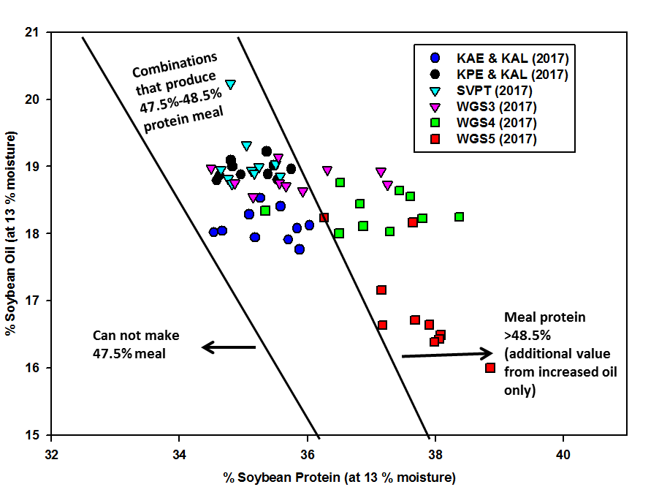

Figure 01: Genotypes capable of producing high soybean meal protein (47.5-48.5%). Black lines indicate the margins of combinations of soybean protein and oil that yield high soybean meal protein (47.5-48.5%) as calculated by the SPROC model. Adapted from Brumm and Hurburgh (2006).

a

b



c

Figure 02: Correlations between yield and protein (a), yield and oil (b), and protein and oil (c) in seeds from six different locations grown in Kansas.

a



b

c

Figure 03: Significant effect of location on yield (p<0.0001), oil (p<0.0001), protein (p=0.006) of nine common genotypes grown in six different locations in Kansas (2017)