Increasing Efficiency and Cost Effectiveness in Intensively Managed Soybean.
James H. Long Ph.D.
A report of activity during the first year of the project ending February 28, 2018.
Objective 1- Screening for Genetic potential
Varieties with varying response to charcoal rot were compared to determine their potential under both conventional (check) and intensive management. In addition 4 selections from Bill Schapaughs program were compared also. Results for 2017 indicate that entries with some tolerance to charcoal rot will perform well under intensive management.

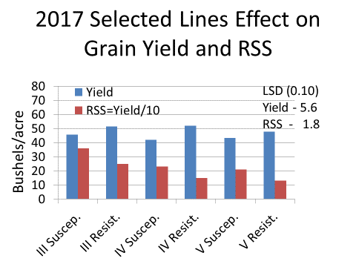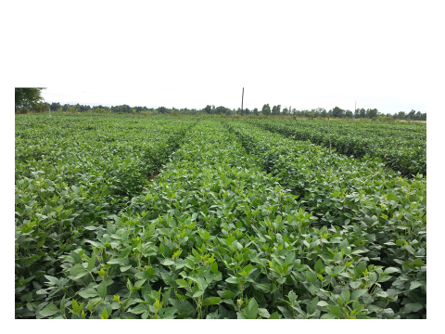

Objective 2 – BMP’s.
A second study to develop best management practices for predicting disease and insect problems and need for crop monitoring or treatment has been set up with insect traps and sentinel plots established in the field. Black light and sticky traps started picking up large numbers of Japanese beetle and soybean pod worm by June 17th. This was confirmed by field scouts especially in corn fields as well as soybean. This also includes weather data from time of planting to determine the effect of weather fronts, temperature and rainfall on insect and disease infestation in the soybean crop. Sentinel fields and plots were also established in 2017 and were scouted for both diseases and insects. In addition to the insects picked up through scouting and traps soybean diseases such as septoria and frogeye leafspot were picked up by mid-season. Insect control is one of the major needs in IPM of intensively managed soybean. There were certainly both insect and disease problems in 2017.

Objective 3 – PGR use on soybean
Another study was planted and treatments were applied to compare PGR use on soybean to enhance soybean growth and yield especially early in the season. Auxin or auxin like compounds were utilized to determine their effect on growth and yield. PGR had little effect on yield in 2017 although there are possible trends to increase root mass.
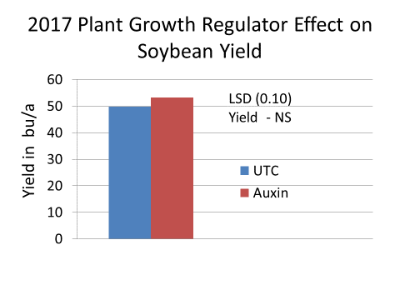
Objective 4. - Nitrogen Rates in High Yield Dryland and Irrigated Soybean.
As a part of the previous objectives study Nitrogen rates and times of application will be utilized throughout the growing season. Their effect on grain yield and quality as well as the agronomic characteristics such as lodging have been followed throughout the year. Some N rates have caused lodging of plants. Other plots receiving less N have not lodged.
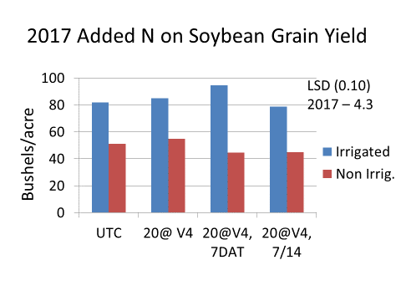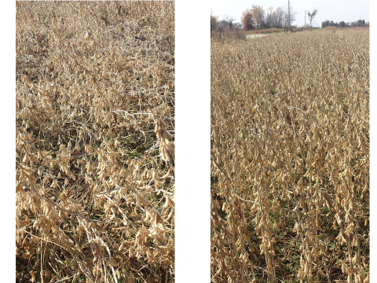

5. - Novel compounds
Treatments were compared in 2017 to compare novels compounds like sugar added to spray components to determine if there is an effect and what that effect might be.
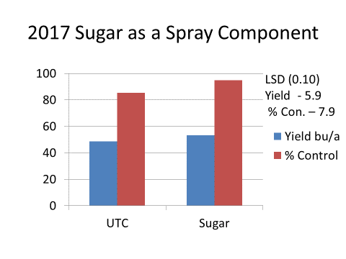
Objective 6. – Incorporation of Generic Compounds into a Cost Effective Package.
Plots were planted that compare untreated checks with generic and standard treatments. Comparisons of treatments will include critical stages of growth as well as specific insect and disease occurrence. Cost of treatment as well as effectiveness of treatments will be determined. Since there is a lot of information this will be the topic for a poster at the Soybean Expo in January. Generally, generic treatments do an adequate job under intensive management but new products such as Trivapro or Priaxor have better canopy management of disease.

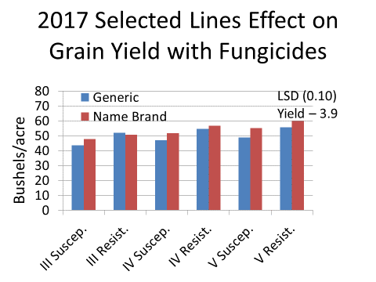

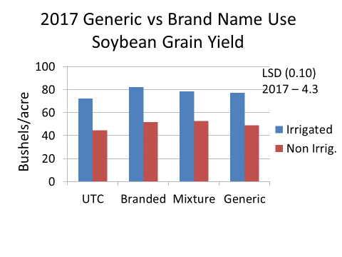
Objective 7. 3 D visuals for information delivery
Literature review and product evaluation have begun. This will pick up as information becomes available and audiences are identified. The development of and use of existing programs for data presentation will begin with first year results. The ultimate goal is to show season long effect of treatments on growth, disease development and insect infestation.

