Please use this form to clearly and concisely report on project progress. The information included should reflect quantifiable results that can be used to evaluate and measure project success. Comments should be limited to the designated boxes. Technical reports, no longer than 4 pages, may be attached to this summary report.
Project Number: | 1720-172-0128
Project Title: | Improved Management of Charcoal Rot
Organization: | USDA-ARS
Principal Investigator Name: | Tom Allen
Report Period: | FINAL report

Project Status: Completed, project review meeting 3/21/2018 in Memphis, TN
Objective 1: Provide and characterize new sources of resistance, incorporate into advanced germplasm that will be made available for incorporation into elite commercial varieties
Mengistu: Have evaluated a total of 77 conventional germplasm lines in MG IV and V, 14 advanced charcoal rot selections in MG II through MG V and 76 commercial lines in MG III, IV and V at the USDA research site located the West Tennessee Research and Education Center at Jackson, TN.
Deliverables:
- A total of 30 from conventional and commercial lines with moderate resistance have been identified.
- New plant selection within the conventional lines with high level of resistance have been identified.
- Released conventional soybean germplasm DT99-16864 with moderate resistance to charcoal rot.
- Released conventional soybean germplasm JTN-4307 with moderate resistance to charcoal rot.

Publication: Effect of charcoal rot on selected putative drought tolerant soybean
genotypes and yield. Crop Protection 105: 90-101.

Singh (ISU portion):
Screening of 465 soybean accessions from USDA germplasm collection has been completed and all data has been analyzed.
Field Experiment: Four hundred sixty-five soybean genotypes including 459 PI lines, four maturity checks (MN1410, LD02-4485, IA3023, and IA4005), one moderately resistant check (H3LER11017-00-0238, provided by Pioneer), and one susceptible check (H3LER11022-00-0037, provided by Pioneer), were grown near Muscatine, IA, in 1.52 m long single rows with 0.76 m row to row distance and 0.91 m alleyways. Maturity and disease checks were spaced every 100 and every 50 entries, respectively. Genotypes were arranged in a randomized complete block design (RCBD) with three replications. During field planting, the planter was calibrated to apply charcoal rot-infected sorghum seed in furrow with the soybean seed using a 4-row planter. Stem collection and charcoal rot ratings were based on the evaluation of root and stem severity rating. For each replication, five plants of each genotype were randomly harvested between the R7 and R8 growth stage from each row. Stem and top of the tap root portion of each plant was obtained by gently uprooting each plant and clearing it of the soil and other debris. Each plant stem was longitudinally split using a sharp knife and ratings were given on a scale of 1–5. The taproot of each plant and visually rating the intensity of discoloration as well as the microsclerotial load covering the vascular and cortical tissue. The ratings were on a scale of 1 to 5 where 1 = no discoloration and 5 = highly discolored. The scale for RSS was divided into four classifications (PARIS et al. 2006): resistant (values of 1), moderately resistant (values >1 and ≤2), moderately susceptible (values >2 and <3), and susceptible (values 3–5).
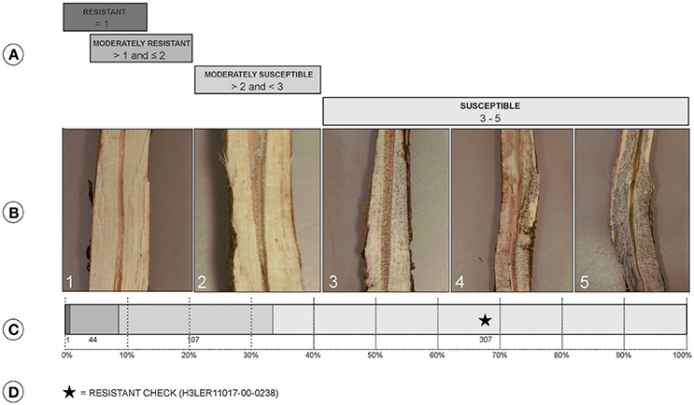
(A) Classes of charcoal rot resistance where resistant (values of 1), moderately resistant (values >1 and ≤2), moderately susceptible (values >2 and <3), and susceptible (values 3–5). (B) Split stem showing symptoms associated with the scores: 1, no microsclerotia visible in vascular tissue; 2, very few microsclerotia visible and vascular tissue is not discolored; 3, microsclerotia partially covering the vascular tissue and there is minimal discoloration; 4, numerous microsclerotia in the tissue and also visible under the outside epidermis, and discolored vascular tissue; 5, darkened vascular tissue due to high numbers of microsclerotia both inside and outside of the stem. (C) Distribution of the 459 PI lines and checks for resistance classification. (D) Class of location of the resistant check in accessions distribution.
Greenhouse Screening: A total of 463 soybean genotypes were evaluated including 459 PI lines and four checks, two resistant and two susceptible checks repeated twice per block. The genotypes were arranged in a randomized complete block design (RCBD) with four replications. Two plants of each genotype in cups made for an experimental unit in each block. Plants were grown in 0.24 L styrofoam cups, with holes in the bottom for drainage, filled with soilless mix (Sunshine Mix, LC1; Sun Gro Horticulture Inc., Agawam, MA) and topped with pellets of slow-release fertilizer (Osmocote Plus 19-9-12, 23 g per cup) spread over the surface of each cup. Seeds were over sown, three seeds per cup, in each pot and thinned to two plants 10 days post-emergence. All experiments were conducted in a greenhouse maintained at 30°C day and 22°C night temperatures, and the room was supplemented with high-pressure 400 W sodium lights to ensure the 16-h photo period. Plants were watered manually to avoid plant wilting. The cut-stem inoculation technique was used to classify genotypes for resistance (Twizeyimana et al., 2012). Ratings were based on the recorded measurements of lesion length. The details of measurements are provided in Pawlowski et al. (2015) with the modification that the length of cut-stem at the time of inoculation was 40 mm instead of 25 mm used in their publication. Measurements were taken the third day after inoculation (dai), and followed every 3 days, for a total of 5 ratings (3, 6, 9, 12, and 15 dai). The area under the disease progress curve (AUDPC) for each entry was calculated to estimate the disease resistance and select superior PI lines.
Major Findings: Table below shows the top 20 soybean PI accessions from the mini-core collection selected from maturity groups I–III for disease resistance from each experiment (field and greenhouse screening).
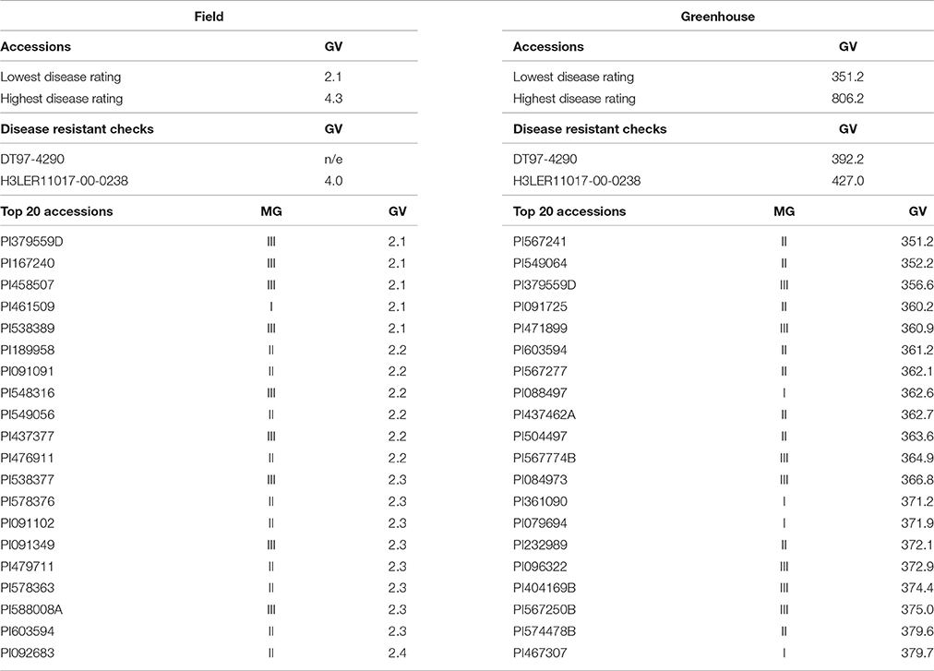
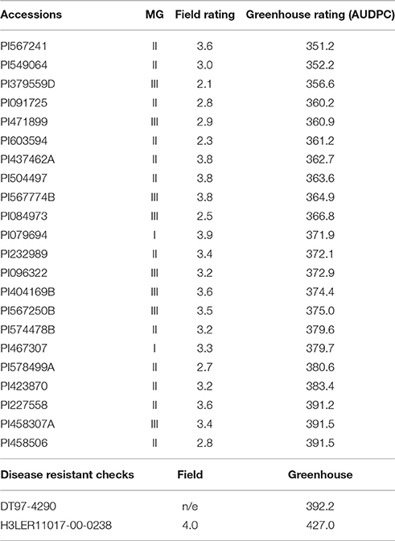
The field and greenhouse screening had a low but significant negative correlation (r_{fg} = −0.12). Among all the accessions selected for the field and the greenhouse, 22 (5%) were common between field and greenhouse experiments (Table on the left) showing good level of resistance in both screenings (field and greenhouse). Accessions PI379559D and PI603594 had the lowest RSS and AUDPC scores, respectively. Lack of correlation between field and greenhouse emphasizes the need for field based screening for more meaningful information generation.

We planted segregating (early generation) breeding populations in 2017 summer for single plant pulls in the charcoal rot disease nursery. This allowed for enrichment of alleles for charcoal rot resistance in breeding populations, created for this objective. From these space planted populations in specialized charcoal rot disease nursery, selected planted were harvested and stem-split for charcoal rot rating. Only plants that met the cut-off for tolerance were advanced and will be yield tested in progeny rows in 2018.
To summarize: in 2017, 5 F_{4:5} populations were grown near Ames (non charcoal rot disease nursery), and near Muscatine (charcoal rot specialized screening nursery) and single plants selected; 4 F_{2:3} populations were in generation advancement and selections (USA and Chile), while 10 new populations with charcoal rot resistant parent were created in 2017-18.
Overall, identified and selected accessions with better and novel charcoal rot tolerance than is currently available in commercial cultivars. Targeted crosses have been made to build a multiple disease resistance package with charcoal rot. These populations were in early generation testing in 2017, and in 2018 will be having first yield testing (progeny row) to continue developing elite soybean breeding lines with charcoal rot resistance. Although the project was not renewed, we will attempt to find other funding sources to complete charcoal rot screening in 2018 and or 2019.

Objective 2. Characterize the sources of CR resistance by providing markers for all breeders to more effectively incorporate CR resistance into commercial varieties
Mengistu: We have phenotyped one RIL population derived from DT97-4290 × ‘Saline.’. This same RIL population was evaluated in 2017 and ratings are complete. Evaluation was based on stem severity and colony forming unit determination. In addition, a RIL population derived from ‘Pharaoh’ × DT99-17483 was planted in 2017 for seed increase to be tested in 2018 for verification. The future plan in 2018 phenotyping contingent on funding availability. This approach offers the potential to confirm previously identified CR resistance QTL as well as the potential to identify new ones. Both susceptible parents have been shown in previous studies to be among the most susceptible to charcoal rot of all lines tested. The RILs have been genotyped using marker-trait association analysis. This will be repeated when all the RIL populations are all phenotyped. These data could provide information that can be used to fine map resistance loci and develop breeder friendly markers.

Additional RILS (Grover Shannon’s crosses), from two crosses (NCC05-1168 × PI79693 & LD07-4477 × PI567568A) were phenotyped using severity rating (1-5). Two additional RILS (NCC05-1168 × PI567568A & LD07-4477 × PI424565) were also planted in 2017 and phenotyping using severity rating is now complete. The resistant population identified will be advanced for further evaluation based on agronomic traits and ultimately release these lines as germplasms.

Deliverables:
- Fourteen moderately resistant lines and 1 highly resistant line have been identified from ‘NCC05-1168 × PI79693 & LD07-4477 × PI567568A’ RILs.
- Ten moderately resistant lines and 2 highly resistant lines have been identified from NCC05-1168 × PI567568A & LD07-4477 × PI424565 RILs.
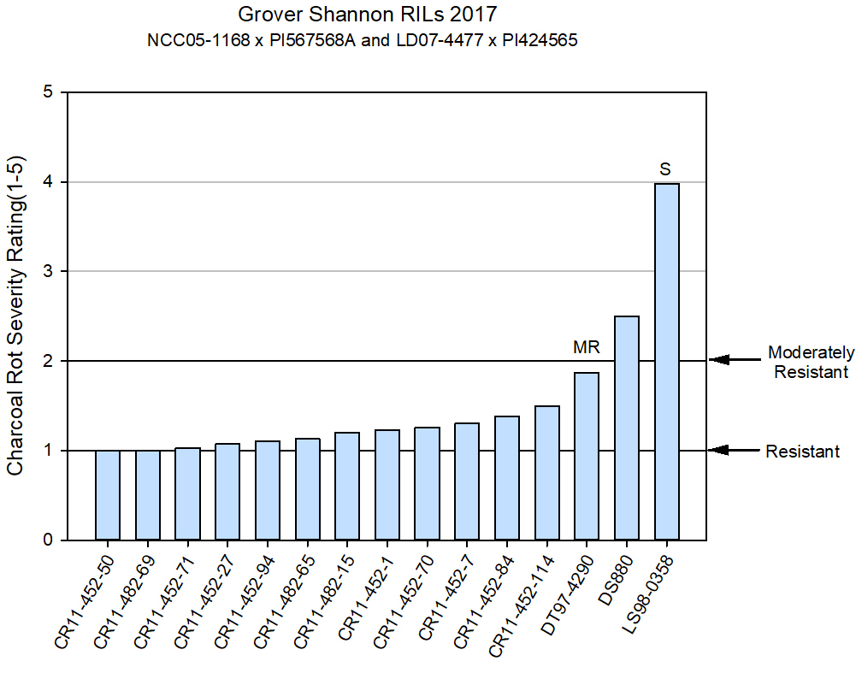
2a. Linkage Mapping:
Arti Singh Update:
Little information is available on the inheritance of charcoal rot resistance in soybean, however multiple germplasm screenings to identify sources of charcoal rot resistance in diverse backgrounds have been completed in the field and in controlled environments. Unfortunately, to date, no charcoal rot resistance QTL have been reported in soybean (Romero Luna et al. 2017). USB funded genome wide association study is the first such study of charcoal rot in the world (Coser et al. 2017). In non-soybean plant species, QTL markers found to be associated with resistance to Macrophomina phaseolina in common bean, have been reported but were of minor effects. Considering the current scenario with no genes or QTL reported for charcoal rot resistance and only moderately resistant germplasms sources identified, harnessing quantitative resistance may offer the most promising solution for developing charcoal rot resistant cultivars. However, the current lack of understanding of the genetic control of charcoal rot resistance and limited identified markers associated with charcoal rot resistance is detrimental to the breeding of improved varieties. Therefore, we complemented our genome wide study with QTL mapping to expand the information available on the genetic control of charcoal rot resistance in soybean in order to combat the current management challenges faced by farmers in response to charcoal rot infection.

The parents from the NAM population were screened for their response to charcoal rot infection using the cut-stem inoculation technique first outlined in Twizeyimana et al. 2012. Six replications of each of the 41 NAM parents and 3 check lines (Pharaoh, PI479719, and PI189958) were randomized within each replication and planted in the Agronomy greenhouse at Iowa State University in Ames, Iowa. Lesion lengths (exterior, interior, and dead tissue) caused by disease infection were measured to record the disease progression and resistance levels present among the diverse soybean parents in the NAM panel. After parental screening, three NAM populations were selected for further evaluation of their recombinant inbred lines. Selections were made based on a combination of highest observed level of resistance among the parents screened, standard deviation of lesion length measurements, and the maturity group of the parents favoring earlier maturity groups for evaluation of genotypes more suited for an Iowa growing environment. The NAM populations selected were NAM5 (IA 3023 x CLOJ-095-4-6) conferring the highest resistance response among the NAM parents, followed by NAM46 (IA 3023 x PI 507681B) and NAM23 (IA 3023 x U03-100612). However, NAM46 was later dropped due to issues in the RIL population during population development potentially due to an incorrect parent in the cross as explained in Song 2017 which was not published until after screening of the RIL populations.

The t-tests comparing a balanced data set of lesion lengths of plants with the single unifoliate node against the lesion lengths of plants with both a unifoliate and 1st trifoliate node show that the presence of the 1st trifoliate node significantly decreases the lesion lengths for all three lesion length measurements. Because this observational trend proved true, it was concluded that including the phenotypes from plants that had developed a trifoliate node in the 40 mm segment of stem above the unifoliate node would bias the data potentially resulting in errors in QTL mapping. Therefore, samples possessing the additional first trifoliate node were excluded from the phenotypic data set to decrease plant development interaction with the phenotype of disease progression during QTL mapping. The least square means (LS means) of the exterior, interior, and dead tissue lesion length phenotypes were then obtained in JMP® Pro 13.0.0 using only data from plant lesion length phenotypes with the single unifoliate node. Due to the absence of trifoliate node presence notes in NAM5 and the issues in population development in NAM46, only NAM23 was considered for the rest of the study and for QTL mapping.

Using the LOD significance thresholds determined by 1000 permutations, Inclusive Composite Interval Mapping (ICIM) detected 2 QTL on Gm15. The first QTL, qCR17-001, was identified in the region between SNP markers ss1235983775 – ss1235983766. The second QTL, qCR17-002, was detected nearby in the region between the SNP markers ss1235983585 – ss1235983580 and also explained 9.9% of the variation. Both QTL identified in these analyses were located on chromosome 15. Only interior lesion length and the relationship of the interior lesion length and the dead tissue length (LBD) resulted in QTL detection highlighting the importance of capturing the interior lesion length. Exterior lesion length and dead tissue lesion measurements did not result in locating associated QTL.

Table. Significant QTL, map position, and genetic contribution for charcoal rot resistance in soybean from the NAM23 mapping population (parentage: IA3023 x U03-100612) identified using Inclusive Composite Interval Mapping (ICIM).
QTL | Trait | Gm | Position | Marker/Marker interval | LOD* | PVE (%)* | Additive Effect*
qCR17-001 | ILL | 15 | 15.0 | ss1235983775 - ss1235983766 | 3.1 | 9.9 | -3.7
qCR17-002 | LBD | 15 | 30.0 | ss1235983585 - ss1235983580 | 3.2 | 9.9 | -3.7
LOD = Logarithm of odds
PVE% = Phenotypic variation explained by QTL at the current scanning position
Additive Effect = Estimated additive effect of QTL at the current scanning position

We did not identify any major effect QTL, which concurs with our genome wide study and suggests that breeding for charcoal rot will require phenotyping and genomic selection while marker assisted selection for major effect gene seems futile.

2b. Genome wide association and prediction:
AK Singh update:
Our genome wide association paper is now published and available online. Here is the paper abstract: Charcoal rot (CR) disease caused by Macrophomina phaseolina is responsible for significant yield losses in soybean production. Among the methods available for controlling this disease, breeding for resistance is the most promising. Progress in breeding efforts has been slow due to the insufficient information available on the genetic mechanisms related to resistance. Genome-wide association studies (GWAS) enable unraveling the genetic architecture of resistance and identification of causal genes. The aims of this study were to identify new sources of resistance to CR in a collection of 459 diverse plant introductions from the USDA Soybean Germplasm Core Collection using field and greenhouse screenings, and to conduct GWAS to identify candidate genes and associated molecular markers. New sources for CR resistance were identified from both field and greenhouse screening from maturity groups I, II, and III. Five significant single nucleotide polymorphism (SNP) and putative candidate genes related to abiotic and biotic stress responses are reported from the field screening; while greenhouse screening revealed eight loci associated with eight candidate gene families, all associated with functions controlling plant defense response. No overlap of markers or genes was observed between field and greenhouse screenings suggesting a complex molecular mechanism underlying resistance to CR in soybean with varied response to different environments; but our findings provide useful information for advancing breeding for CR resistance as well as the genetic mechanism of resistance.
Citation: Coser SM, RV Chowdareddy, J Zhang, DS Mueller, A Mengistu, K Wise, TW Allen, A Singh, AK Singh*. 2017. Genetic architecture of charcoal rot (Macrophomina phaseolina) resistance in soybean revealed using a diverse panel. Frontiers in Plant Science. 8:1626.
Genomic wide prediction (GWP) can be a useful tool to help breeders find sources of resistance for charcoal rot. Therefore, we conducted experiments to leverage GWP with the objective to select charcoal rot resistance sources in the entire USDA soybean germplasm collection composed up to 19 k accessions based on genomic estimated breeding value (GEBV), and also verify the genetic diversity between the most resistant sources based on continent/country of origin and maturity group. Greenhouse and a field experiments included 465 diverse PI lines from maturity grups I, II and III and that have been previously genotyped using 36,105 SNPs. These accessions were phenotyped for charcoal rot resistance. Accessions were selected based on their GEBV for charcoal rot and we verified their diversity by maturity group and country of origin. Genotypes from 31 countries were identified (for CR resistance) and China, United States, Indian, Japan and Vietnam together represented 92%. Of the selected accessions 65% belonged on maturity groups II, IV and V. Therefore, the genetic variability among the selected genotype for charcoal rot is considered large, turning possible to stablish crossing blocks between them and finding resistant genotypes in the progeny. With the GEBV information and our validation, we now have information on the entire USDA germplasm collection, which can be used for parental selection as well as selection of breeding lines. This information will be available through an open access publication.

Objective 3. Understand the effect of environmental variables on CR development during the season to design improved control measures
Mengistu: The emphasis will be to monitor all key environmental data to determine the timing and cause of ‘rapid incitement’ of symptoms within the plant. This is to find out if there is a vulnerable growth stage and/or certain environmental factors that spur this rapid development of symptoms. Measurements on soil water potential, leaf porometer reading that measures stomatal conductance, weather data (air temperature, humidity, soil and air temperatures and precipitation). A stress tolerance index was used to determine the relative impact of soil moisture stress (i.e. no irrigation) on 13 genotypes.

Deliverables:
Over the three years in both irrigated and non-irrigated environments, five genotypes were consistently rated as moderately resistant to CR (MRCR) and three genotypes were consistently rated as susceptible to CR (SCR), whereas the responses of the remaining five genotype’s varied between MRCR and SCR.
Regression analysis indicated that as CFUs at R7 increased, seed yield decreased, although the relationship was not significant in every year and irrigation environment.
- Across all years and irrigation environments, a pooled (global) slope indicated a yield loss of 11.5 kg ha⁻¹ for every 1,000 CFUs at R7.

Objective 4. Quantify the impact of production practices that minimize disease development. Farmer adoption of resistant varieties will depend on how varieties perform economically in comparison to susceptible varieties.
Allen and Wilkerson:
Trial 1 (small variety selection trial). To determine soybean yield losses as a result of charcoal rot, non-irrigated research plots containing a specific selection of commercial and conventional varieties with varying levels of susceptibility to charcoal rot (based on some observations made by Grover Shannon in 2014). Plot trials were conducted between 2015 and 2017. Plots consisted of four rows with two rows receiving charcoal rot inoculum so that comparisons could be made between two inoculated rows and two non-inoculated rows. Results from the specific trial suggest that variety selection is an important method to manage charcoal rot in field situations where the disease has been historically important. Moreover, from the three-year trial, variety tolerance can account for yield differences between 0.2 and 31.2 bu/A. As an average across the 26 entries that were planted each of three years a 4 bu/A yield difference was observed between non-inoculated and inoculated sub-plots suggesting that yield losses over time associated with charcoal rot could account for 4 bu/A depending on the variety planted in a field situation. Colony forming unit data also suggested differences between the varieties planted. On average, and across all varieties considered (differences between inoculated and non-inoculated subplots) suggest that cfu differences can account for a difference of 1.1% to 45.3%. A manuscript including the results of the repeated field trials has been planned and should be completed over the next year.

Trial 2 (entire variety trial). Non-irrigated research plots were established on June 28, 2017 using all of the soybean variety trial entries (n=192 separate entries) contained in the Mississippi State University Official Variety Trial (OVT) to assess tolerance across commercial varieties and within maturity groups. Plots consisted of four rows with two rows receiving charcoal rot inoculum so that comparisons could be made between two inoculated rows and two non-inoculated rows. Stand counts were collected shortly after emergence to make comparisons between inoculated and non-inoculated rows. Based on observations of stand counts up to an 18% difference in average stand was observed between inoculated and non-inoculated subplots. In addition, averages of yield determined that up to a 10% difference occurred between the inoculated and non-inoculated subplots, again suggesting that variety selection is one important method to aid in the management of charcoal rot in fields with a historical charcoal rot component.

Objective 5. Create cultivar differential set to characterize and classify isolate samples of the pathogen Macrophomina phaseolina according to their pathogenicity and by geographic origin
Mengistu:
Deliverables:
- Six soybean lines (one cultivar, two released as germplasm lines, and three breeding lines): DS-880, ‘Pharaoh,’ 6056-1-1-2-1, 6056-1-3-3-1, 6070-2-4-2, and DS97-94-9 have been identified for use as differentials. These six lines can be used as standard sets to improve consistency in pathotyping and breeding programs.
- Pathogen variability – 70 isolates from 14 geographical locations within the U.S. were screened for their virulence against six differential breeding lines. This is to standardize pathotypes to have consistency in breeding programs.
The figure below indicates the degree of variability detected when inoculated with six differential soybean lines.
Chilvers: Isolates (n=96) were observed to determine if the fungus involved was specifically Macrophomina phaseolina. A second Macrophomina sp. that has been reported to cause charcoal rot has been observed in Senegal so we sought to determine which species was actively involved in charcoal rot from those isolates in our collection. However, based on our phylogenetic analysis it appears that all of the isolates considered were in fact determined to be M. phaseolina and not the newly reported species. Research to consider the sensitivity of M. phaseolina to three different fungicide classes (dicarboxamides (FRAC Code 2), demethylation inhibitors (DMIs; FRAC Code 3) and succinate dehydrogenase inhibitors (SDHI; FRAC Code 7). Even though the products associated with seed treatment fungicides, based on each of the fungicide classes evaluated, the specific fungicides likely provide some overall benefit by reducing early-season infection as a result of M. phaseolina. In addition, and more so based on the differences between isolates originating in the northern U.S. as compared to those originating in the southern U.S. it appears that northern isolates have an adaptation that allows them to successful grow at cool temperatures. More importantly, differences in the specific temperature regime as related to isolate origin suggests that northern and southern germplasm should be screened with the appropriate isolate strains.

With regards to the virulence component of this specific objective, M. phaseolina isolates demonstrated varying levels of virulence. Most importantly, the varying levels of virulence indicated that the selection of Macrophomina isolates is an important first step in screening germplasm. Additional results from this research determined that Macrophomina effectors, which are small secreted molecules, were identified. The specific identification of effectors may provide tools to aid in the screening of germplasm.

Task 6. Create improved screening tools and measures to screen both broad sets of germplasm for discovery of CR resistance and also to screen CR resistance within elite commercial varieties, so that seed companies can more accurately and uniformly rate their varieties.
Mengistu: Evaluated twelve different inoculation methods in 2017-18 and have identified two that have a prospect for use in the future. However, these tests may need to be repeated to ascertain consistency as it relates to the field assessment method. See pictures below of some our promising inoculation methods:

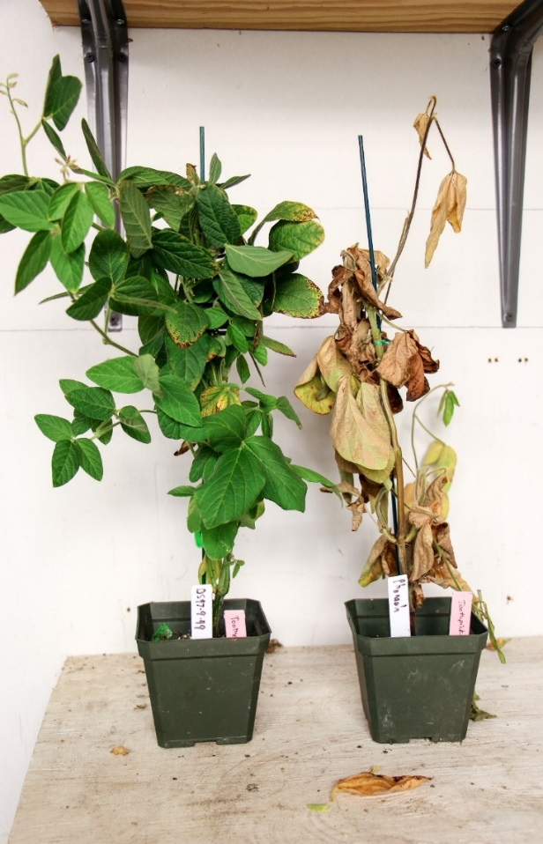
Mod Resistant
Susceptible
Planted 12/20/2017
Inoculated 2/22/2018

Objective 7. Provide stakeholders with updated research-based information on charcoal rot management in print, web-based, and video formats. Improve communication and partnerships with industry.
Wise/Mueller/Allen: Information on charcoal rot research was summarized and presented to stakeholders in the agricultural community. Extension summaries on charcoal rot research were released in summer of 2017 in press release form, and posted on the Soybean Research and Information Initiative (SRII), agriculture media outlets, and individual state Extension channels. A short YouTube video highlighting the process of breeding for charcoal rot resistance from Singh’s laboratory was released in fall of 2017 and promoted through Extension. Final summaries, developed for a farmer audience, will highlight the new breeding tools available for charcoal rot resistance, and new discoveries on our understanding of charcoal rot in both breeding and applied science. These communication pieces will be posted on SRII and promoted through agriculture media and other USB communication outlets.

Mueller: A video regarding breeding efforts to identify charcoal rot resistant varieties was created from the efforts by Dr. Danny Singh. The edits were recently completed and the video was uploaded to YouTube. The video can be observed at:

https://www.youtube.com/watch?v=xZBBBPczdwk&t=1s&index=6&list=PLyDHx-rmZpClxBQQWMesNaqDnQrvNpHvk

