Final Report for All Bioreactor Sites: October 2018

Preface
The original three-year proposal was supported by the Iowa Soybean Association for the first two years of the project, 2015 – 2017. Due to early termination of the project, it was not possible to fully document the benefits of monarch habitat establishment efforts; at least two growing seasons post-planting are needed to assess habitat establishment. The ISU College of Agriculture and Life Sciences provided the funding to complete 2018 (year three) data collection and data analysis over the three years of the project. The final data collection for 2018 was completed in August. This report qualitatively summarizes the results through 2018.

The objective of this project was to develop best management practices for converting existing non-native cool season grasslands to native pollinator/monarch habitat at bioreactor sites. Plot locations were sited at farms owned by Iowa Soybean Association members and site selection was facilitated with support from Iowa Soybean Association Staff, specifically Keegan Kult. The study included seven plots, all of which were grassland transitions (Appendix A). The approach for site preparation and planting generally complied with USDA-NRCS requirements for establishing pollinator habitat as of spring 2016. This approach utilized half a growing season to prepare a site for planting and, at the time, was an approach consistent with NRCS practices. In 2016 existing vegetation was mowed after August 1 and then sprayed with one or two applications of glyphosate in the fall, except one site where a grass selective herbicide was sprayed followed by an application of glyphosate. Sites were planted in fall (dormant season) of 2016.
Observations over the three years indicated that a half growing season of site preparation for a non-native cool season grassland to native habitat transition is insufficient site preparation to ensure native plant establishment. Relative establishment success of the plots is summarized in Appendix A. Photos of all plots for summer 2018 are included in Appendix B. Of the seven grassland transition sites in this study, one site (nie1) is promising, with a high density of native forbs (wildflowers) establishing and a relatively low density of problematic weeds. Two sites (van1, jon1) have a medium density of native forbs with incomplete establishment due to weed pressure or native grass competition. The remaining four plots (har1, van2, fis1, vos1) have poor or failed establishment. It appears the major factor limiting establishment at all seven sites is weed pressure.
Although native forb establishment was low overall, many forbs were observed. Relative forb density is summarized in Appendix C. It should be noted that a two year old planting (as ours is) will have higher densities of some species and lower densities of other species simply due to the natural pattern of the specific native species. Native species range from being ‘pioneer’ species that establish almost immediately to other ‘late successional’ species which may not be present at considerable densities until 5-10 years of prairie development. The application of this knowledge is that a balanced seed mix is desired. It would be shortsighted to suggest that a seed mix should contain far more of the species listed as ‘high density’ in year two post-planting. Native plant communities are dynamic and contain exceptional spatial and temporal variation. A good seed mix is a diverse seed mix. Overall, it appears native grass establishment is quite low. The only native grass consistently identified at the sites is canada wild rye and it is present at relatively low densities. Canada wild rye is a native cool season grass that is often present at high densities in a young establishing prairie so it is not surprising that it is easy to find but it should be present at higher densities than observed. Most native grasses are warm season grasses that grow vigorously in the summer. Native warm season grasses were observed at very low densities.
The most common non-native cool season grasses in the plots prior to intervention (prior to 2016) were smooth bromegrass, and reed canary grass. Herbicide applications were insufficient to suppress reed canary grass. 2018 Reed canary grass density is similar to that observed in the original plant community. Reed canary grass requires multiple years of herbicide applications to control. For many of the sites it appears smooth brome grass was greatly reduced with the herbicide treatment, although rarely was it completely eliminated. At a few sites the brome appears to have not died or been significantly reduced for reasons not known. Non-native grasses reduce the potential of successful native plant community establishment.
While herbicide applications in 2016 was successful in suppressing brome in several sites, opportunistic, sub-dominant species replaced the grass monocultures. Opportunistic, sub-dominant species that pose a threat to native plant establishment are often perennial and biennial broadleaf plants.
The most problematic opportunistic sub-dominant species (ordered roughly from highly problematic to somewhat problematic) include canada thistle, red clover, white clover, wild parsnip, musk thistle, yellow/white sweet clover, dandelion, plantain, Queen Anne’s lace, eastern daisy fleabane, curly dock, alfalfa, and bladder campion. Although some of these species are more problematic than others, a dense establishment of any single one or combination of these species (or likely any other highly competitive weed species) can result in nearly complete native plant establishment failure. Establishment of trees/shrubs has not yet occurred in most plots but may need to be managed in years to come.
Wild parsnip, and a few other weed species have formed monocultures in some areas of some of the plots. Yellow/white sweet clover is often present at low densities in most plots but can reach monoculture levels in some areas of some plots. Canada thistle, musk thistle, Queen Anne’s lace, eastern daisy fleabane, curly dock, and alfalfa have formed monocultures in a few plots. Musk thistle, wild parsnip, and Queen Anne’s lace are biennials so these can be reduced by mowing twice in a season or physically cutting down the plant below the root crown (2” below the soil surface). Mowing is not a preferred practice in the second season of a prairie establishment as it can damage native plants but it is necessary when problematic weeds are dominant. Only areas with problematic weeds should be mowed and whole plot mowing should be avoided. Canada thistle can be controlled using fall spot applications of Milestone herbicide.
. Annual weeds are very common in a young pollinator planting but are not a concern unless they have formed or are approaching monoculture levels. A prairie is a perennial system so annual weeds usually decline over time in prairie environments. Aggressive perennial or biennial weeds or reestablishing non- native cool season grasses are of greater concern because they can outcompete the native species.
Some sites show potential to develop into quality pollinator habitat but may require interventions. A possible intervention may be a late fall or very early spring glyphosate application after native plants have senesced. This approach is generally discouraged in years 1 and 2 post-planting as many native plants don’t senesce and the general native plant population is very low. The hope is that a late fall or very early spring glyphosate application would reduce weed pressure from primarily non-native cool season grasses but also potentially red clover, white clover, dandelions, and broadleaf plantain. However, this herbicide timing will not control weeds that typically only grow during the summer months such wild parsnip, sweet clover, or Queen Anne’s lace.
Conclusions and Recommendations
Three major factors must be considered and addressed before attempting to carry out a non-native cool season grass conversion at a bioreactor site: 1) current vegetation (all species) 2) weed seed bank/weed potential and 3) accumulated vegetation residue levels. These factors will play a critical role in determining relative percentage of overall native plant establishment and if not properly addressed will likely result in poor or failed establishment. It should also be noted that it is very difficult to know the weed seed bank/weed potential or the exact effects of site history. Based on guidance that has evolved since 2016, site preparation over two growing seasons is likely needed when executing a non-native cool season grass transition. This extended preparation completely kills the current vegetation, provides time to flush and kill multiple rounds of problematic weeds, depletes the weed seed bank/weed root stock, and provides flexibility to address any additional vegetation issues. The simplest method of thorough non-native grassland to native habitat site preparation is to grow herbicide resistant corn/soybeans for multiple years, ending on a soybean year but this is not an option on top of bioreactors as bioreactor management is incompatible with standard farming practices. Repeated herbicide applications is the desired site preparation approach for establishing native habitat on top of bioreactors.
If a grassland (which is not associated with a bioreactor) is to be converted to native habitat, corn/soybean transitions are always preferred over direct grassland transitions due to dramatic increases in native plant establishment. The previous statement is not an endorsement of removing corn/soybean acres from production (unless of course those acres are not economically productive). We strongly endorse the conversion of non-native grasslands to corn/soybeans for 2-3 years before establishing native habitat. Corn/soybean systems are annual systems with multiple disturbances each season (tillage, herbicides, harvest) and a highly competitive monoculture crop. Years of herbicides/tillage intentionally deplete the weed seed bank. Almost no perennial weeds are present in a corn/soybean field and only a select number of annual weeds can survive. Corn/soybean transitions are ideal because there is no existing vegetation to kill, the weed seed bank/weed potential is almost zero, and the remaining weeds are annual weeds which will not survive in the perennial system of a prairie.
A grassland (such as CRP ground in smooth bromegrass) is a perennial system with few or no disturbances. The lack of disturbances such as herbicides, tillage, and harvest allow the weed seed bank to grow unchecked and encourages establishment of highly competitive perennial/biennial weeds. When the dominant vegetation is killed or disturbed (i.e. the grass monoculture is sprayed with herbicides or the soil is moved for construction) the weed seed bank flushes and many of the weeds that flush are highly competitive perennial weeds. Transitioning from a non-native, low management perennial system (such as CRP in smooth brome) to a native perennial system requires years of preparation to kill the non-native vegetation and to deplete the weed seed bank/weed root stock. It is difficult to ensure the existing grassland vegetation has been killed and the weed seed bank/weed potential is under control. Successful transition from a non-native cool season grassland may not produce desirable results if executed in a single growing season.
All non-native cool season grasses should be completely eradicated before establishing native habitat. All non-native cool season grasses are most susceptible to herbicide applications in late fall after having been mowed in late summer. Quackgrass and reed canary grass are highly persistent grasses and require multiple seasons of herbicides to control. Quackgrass mostly spreads via aggressive rhizomes while reed canary grass is a prolific seed producer with seed that survives in the soil for 3+ years. Reed canary grass will likely re-establish from seed even if herbicides are applied for 2-3 years. If a site contains reed canary grass it is often most practical to pick another site in which to establish native vegetation instead of attempting to eradicate the reed canary grass. Smooth bromegrass control with a single late fall herbicide application is effective at significantly reducing smooth bromegrass in most situations but is highly variable and almost never results in eradication. Grass selective herbicides can provide temporary suppression of non-native cool season grasses but do not appear to be able to control these hardy non-native grasses. If a site contains native forbs and non-native grasses the decision needs to be made whether or not the forbs are present at adequate levels to warrant saving them. If the site contains enough forbs to justify saving, approaches such as grass selective herbicides or early spring/late fall glyphosate applications may be considered.
Opportunistic, sub-dominant species will quickly become dominant when a grass monoculture is weakened or removed. Opportunistic, sub-dominant species which pose a threat to native plant establishment are often perennial and biennial broadleaf plants. These plants will often establish at high densities in the growing season following non-native cool season grass control efforts.
The weed seed bank in a grassland (or minimally managed lawn) is phenomenal and contains a multitude of dormant/viable weed seed/weed root stock which is simply ‘waiting’ for a suppression of the dominant vegetation or a change in the growing environment. As soon as the dominant vegetation is removed, the next most dominant weeds strongly establish. A fall glyphosate application is often effective at significantly reducing the actively growing, dominant cool season grass but this eliminates the dominant grass and creates an ideal environment for dormant weed seed/weed root stock to establish. A single application or two applications of glyphosate in the fall is highly unlikely to provide adequate weed suppression or complete grass eradication when transitioning a grassland to native habitat. This is in large effect due to the plethora of opportunistic sub-dominant broadleaf weed species which establish in the growing season following grass control.
A listing of potential site preparation options for non-native cool season grassland transitions is included below. Options 1 and 2 are ideal if a site can be cropped but these options do not apply to bioreactor sites. Option 3 is the preferred method if cropping is not feasible. Option 4 may work in some cases but will not target non-native cool season grasses when they are most vulnerable. Option 5 will likely result in low or highly variable establishment success while option 6 will almost always be a failure.
There are two scenarios in which a landowner may find themselves if they wish to establish native habitat on top of a bioreactor.
- Bioreactor is being constructed
  - Wait until construction is complete and site has been graded to level
  - Follow option 3 or 4 from the list provided in Appendix D (mowing or burning is not necessary)
  - If a site was previously in corn/soybeans, potentially only 1-2 herbicide applications would be necessary prior to planting
- Bioreactor has already been constructed and site vegetation is dominated by non-native cool season grasses
  - Follow option 3 or 4 from the list provided in Appendix D
In summary, thorough site preparation over multiple years is often necessary when executing a non-native cool season grass transition as this allows time to completely kill the current vegetation, time to flush and kill multiple rounds of problematic weeds, depletion of the weed seed bank and weed root stock, and the ability to address any additional vegetation issues. There is no shortcut for transitioning non-native grasslands to high quality native pollinator/monarch habitat.

APPENDIX A: SITE INFORMATION
Site ID | Site Name | County | Relative Establishment Success
har1 | Haren | Hamilton | Poor
nie1 | Nielsen | Wright | Good
van1 | Van Diest 1 | Hamilton | Ok
van2 | Van Diest 2 | Hamilton | Poor
fis1 | Fisher | Wright | Failure
vos1 | Voss | Wright | Poor
jon1 | Jones | Wright | Ok

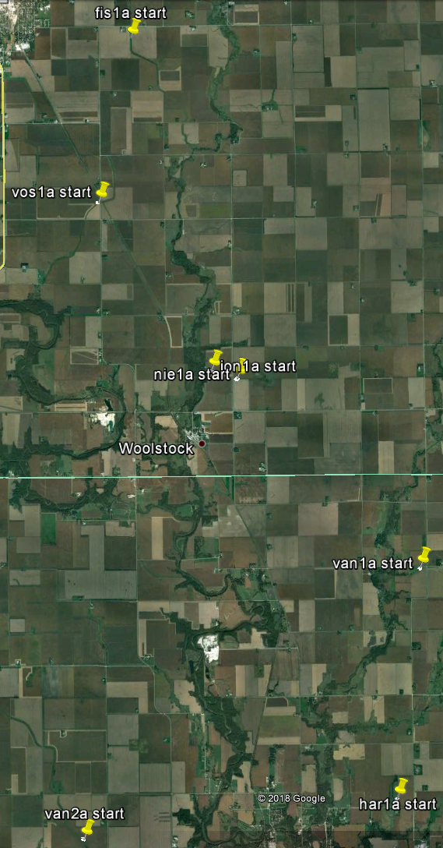
APPENDIX B 2018 SITE PHOTOS
Har1
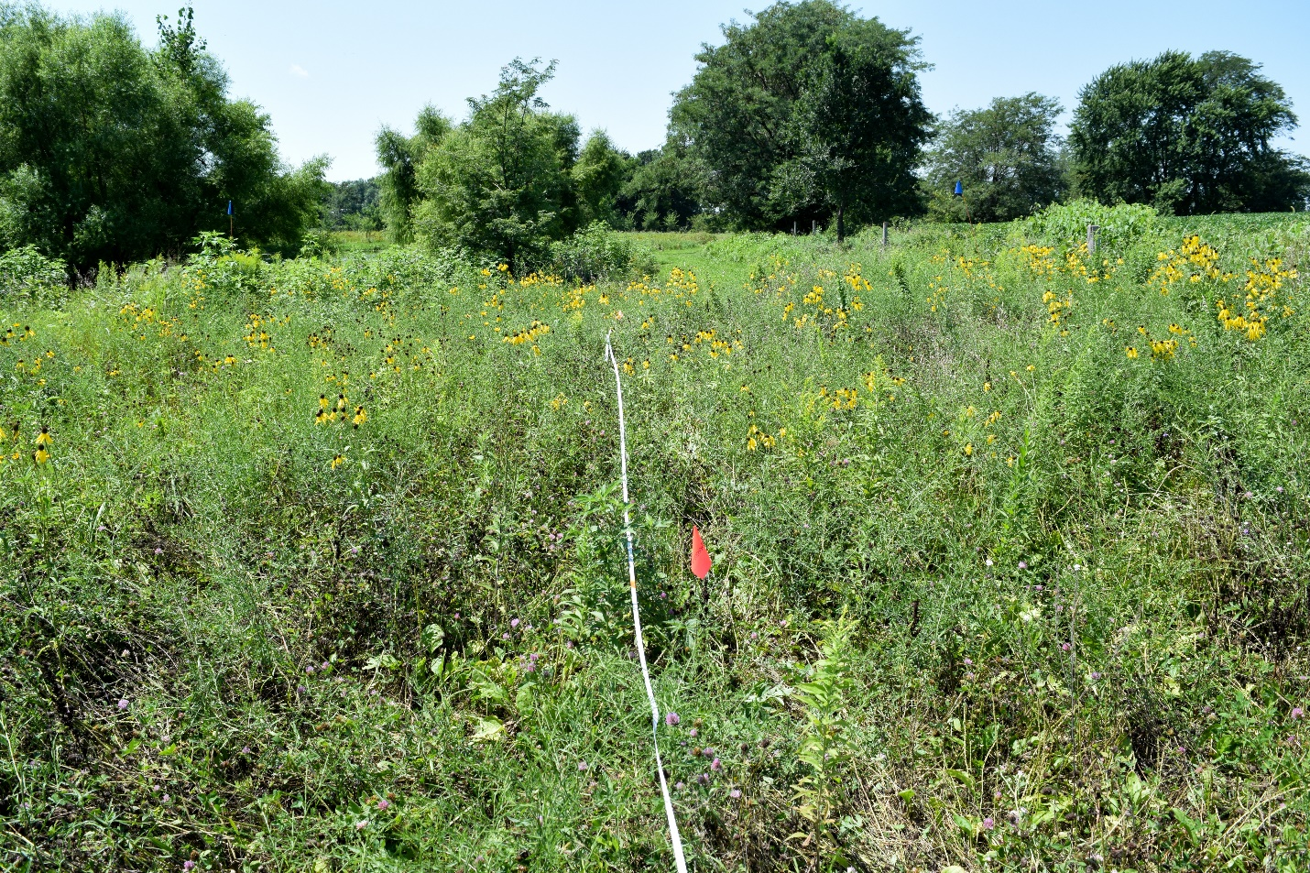

Nie1
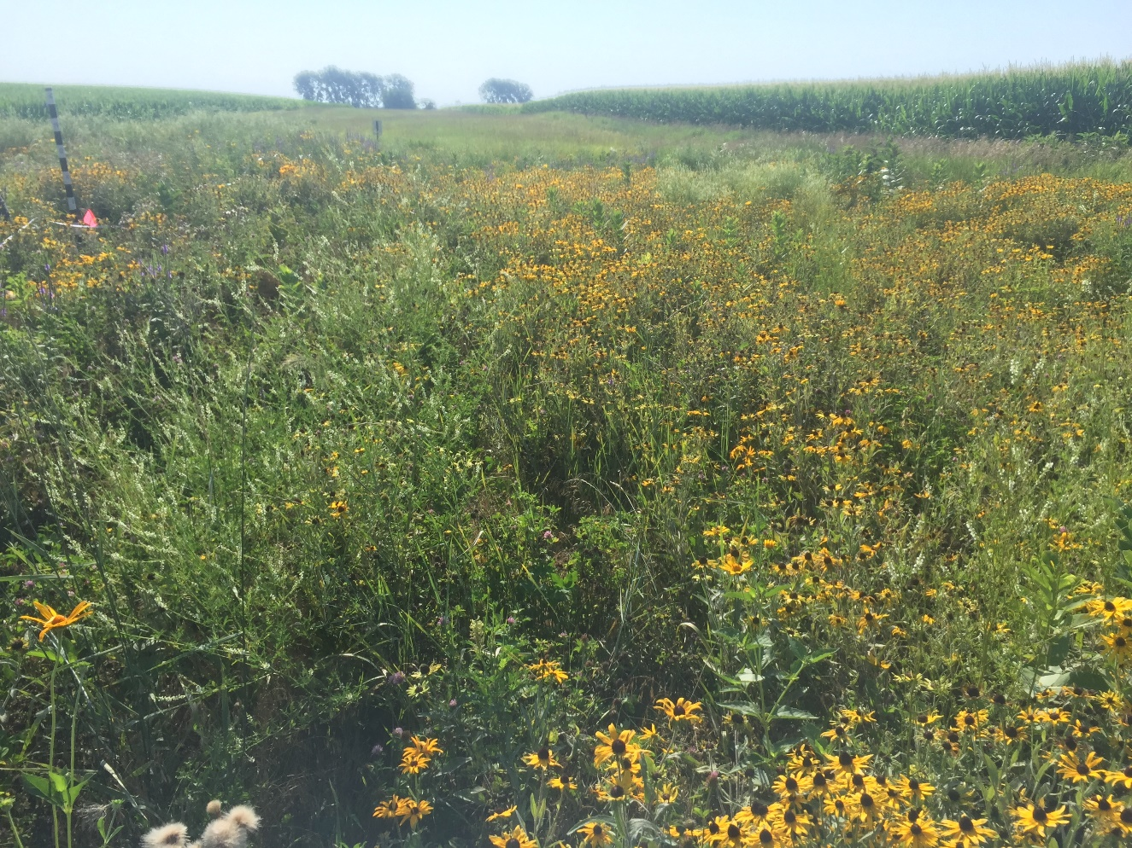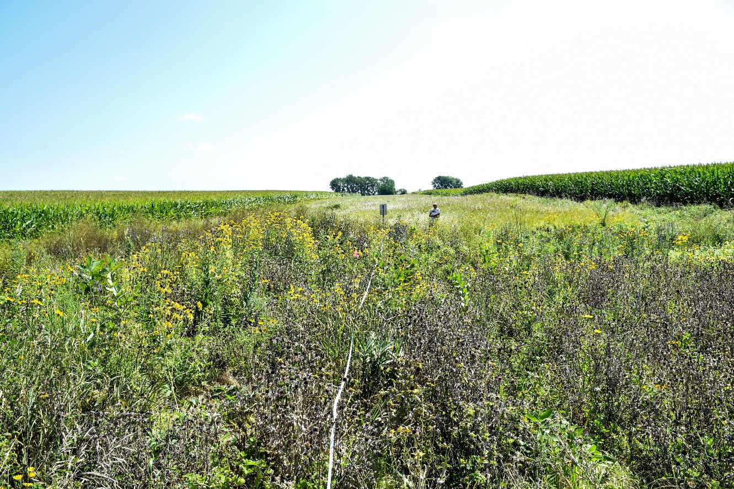
Van1
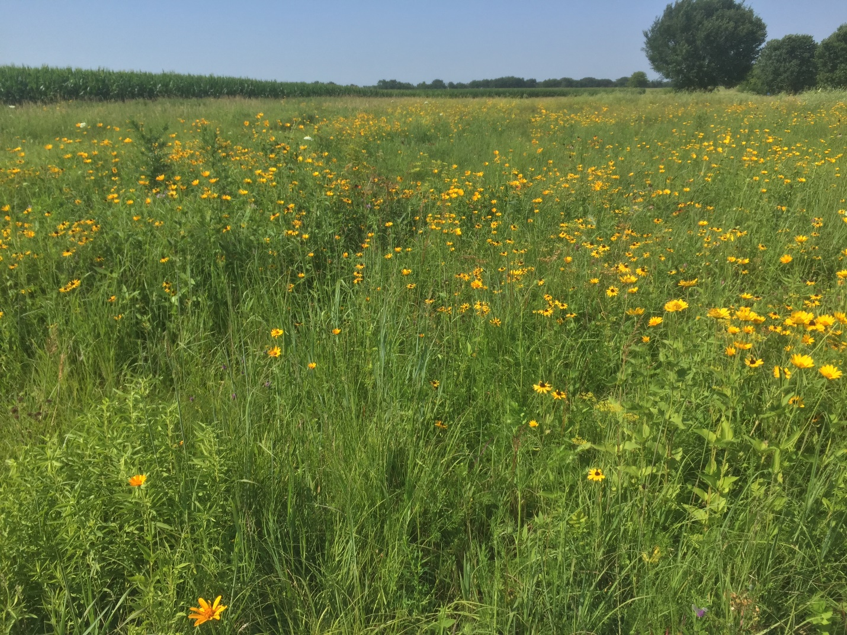
Van2
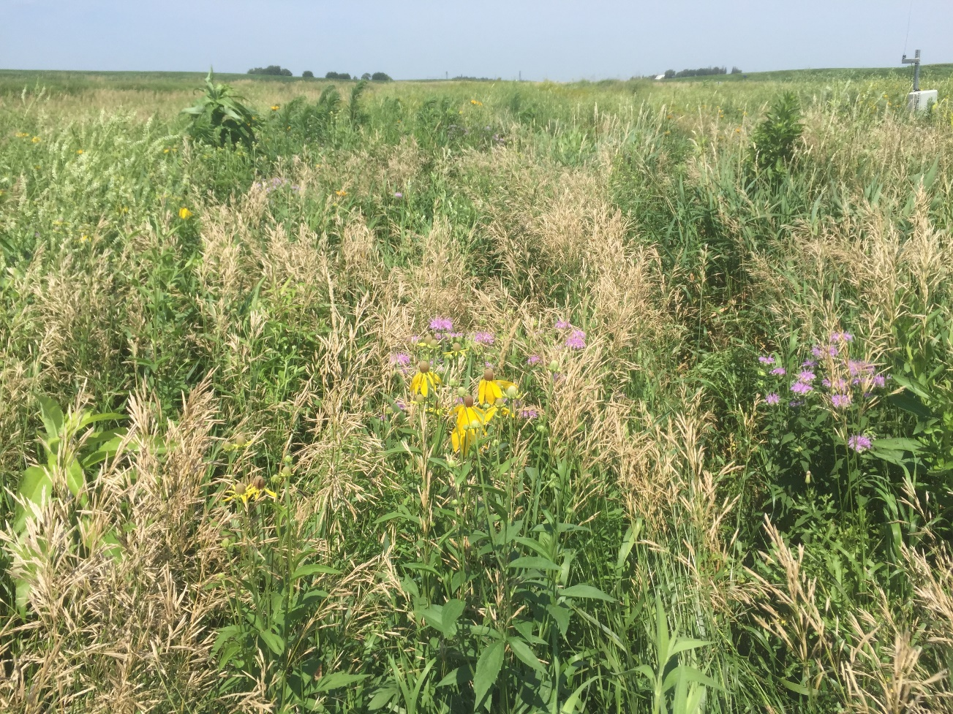
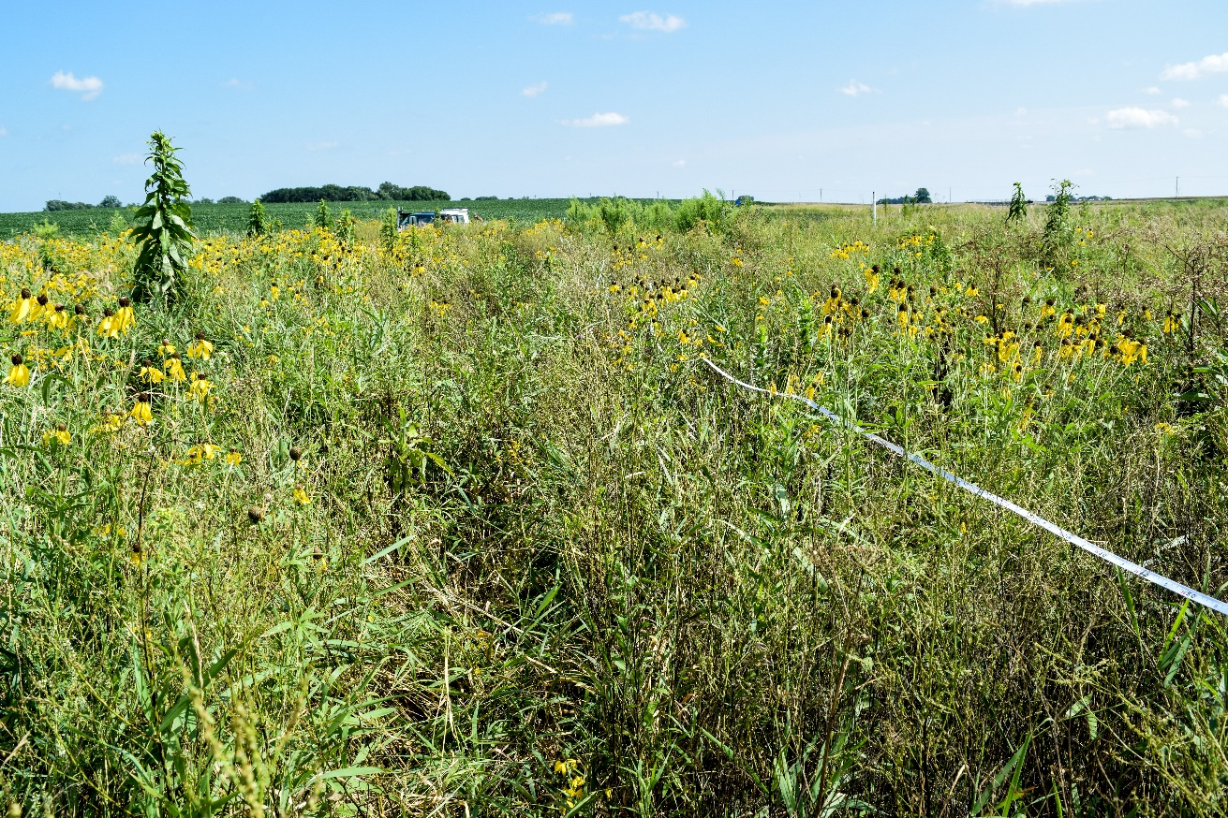
Fis1
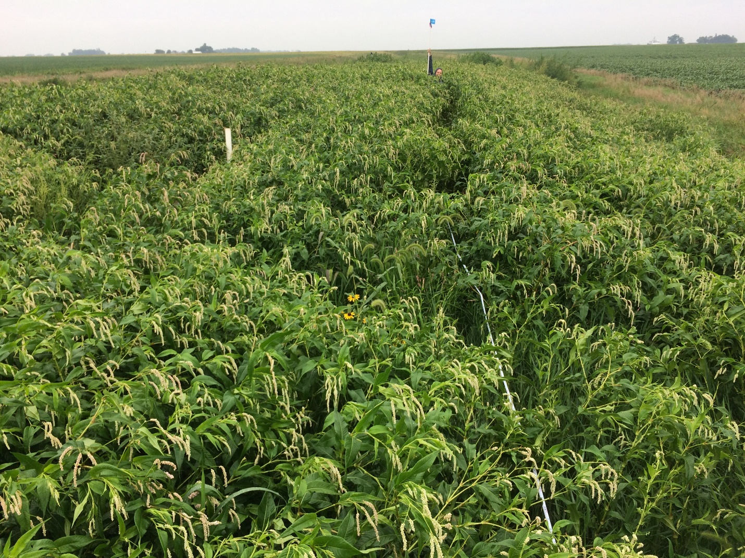
*Summer 2017 photo. Site was abandoned due to reed canary grass reestablishment and strong competition from smartweed. Cooperator did not mow site as scheduled.
Vos1
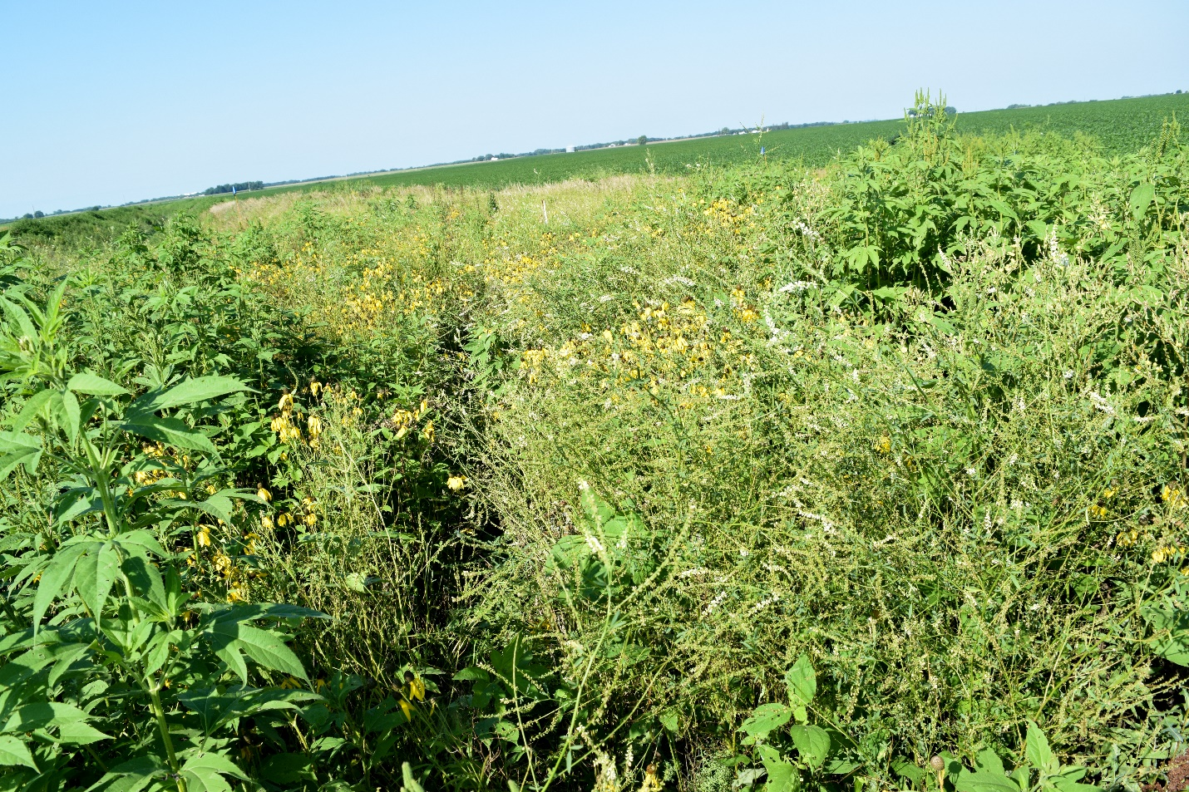

Jon1
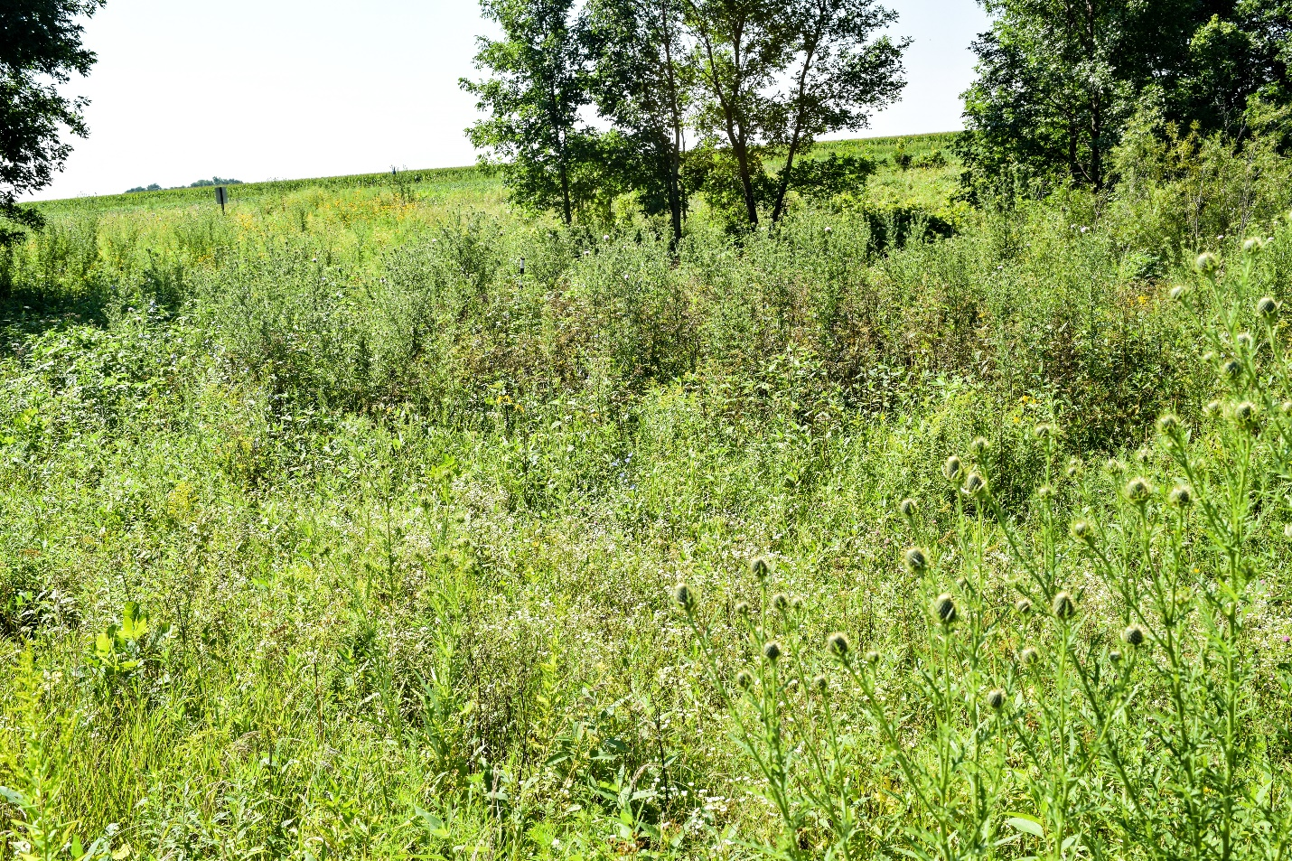

APPENDIX C: NATIVE FORB DENSITY
Planted native forb species density: Summer 2018 visual estimation
The use of density rankings in this list only refers to relative differences between planted native forb species densities. In this list, ‘density’ does not indicate overall establishment density of the planting. For example, gray headed coneflower was often the most dense native plant at all sites but the density was still far below acceptable establishment levels.
Density | Native Species
High | - Gray headed coneflower
 | - Wild bergamot
 | - Stiff goldenrod
 | - Ox eye sunflower
Medium | - New England aster
 | - Tall Boneset
 | - Foxglove beardtongue
 | - Black eyed susan
 | - White heath aster
 | - Blue vervain
 | - Hoary vervain
Low | - Pale purple coneflower
 | - Showy goldenrod
 | - Common milkweed
 | - Prairie cinquefoil
 | - Sawtooth sunflower
 | - Canada milkvetch
Rare | - White/purple prairie clover
 | - Swamp milkweed
Very Rare | - Butterfly milkweed
 | - Blazingstar
 | - Leadplant
 | - Virginia mountain mint
Not Yet Detected | - Showy tick trefoil
 | - Prairie coreopsis
 | - Great blue lobelia
 | - Prairie phlox
 | - Sky blue aster
 | - Ironweed
 | - Culver’s root

APPENDIX D: SITE PREPARATION
Non-native Cool Season Grassland Site Preparation Options: Best to Worst
- CROP – SOY, CORN, SOY
Mow summer, fall herbicide, soybeans, corn, soybeans, plant dormant
- CROP – SOY, SOY
Mow summer, fall herbicide, soybeans, soybeans, plant dormant
- HERBICIDES – 4 APPLICATIONS, 2 YEARS
Mow summer (*& bale), fall herbicide, (*dormant/early spring prescribed burn), 3 herbicide applications spring-fall, plant dormant
*bale or prescribed burn are residue removal options. Doing both may result in increased establishment but only one is necessary. In low residue grasslands (e.g. mowed/grazed grasslands) residue removal may not be necessary.
- HERBICIDES – 3 APPLICATIONS, 1 YEAR
Mow and bale in late summer/fall or dormant/early spring prescribed burn, 3 herbicide applications spring-fall, plant dormant
- HERBICIDES – 2 APPLICATIONS, ½ YEAR
Mow summer (*& bale), fall herbicide, (*dormant/early spring prescribed burn), spring herbicide, plant spring
  - *bale or prescribed burn are residue removal options. Doing both may result in increased establishment but only one is necessary. In low residue grasslands (e.g. mowed/grazed grasslands) residue removal may not be necessary.
- HERBICIDES – 1 APPLICATION, ¼ YEAR FAIL – NON OPTION
Mow summer, fall herbicide, plant dormant

