 | Project Number: | 1820-172-0122
 | Project Title: | Effects of the Introduction of Feed Grains into Mid-South Soybean Production Systems
 | Organization: | Mississippi State University
 | Principal Investigator Name: | Dr. Dan Reynolds
 | Project Status - What key activities were undertaken and what were the key accomplishments during the life of this project? Please use this field to clearly and concisely report on project progress. The information included should reflect quantifiable results (expand upon the KPIs) that can be used to evaluate and measure project success. Technical reports, no longer than 4 pages, may be included in this section.
This project was started in 2014 and 4 years of this study was completed by 2017. We completed 5th year in 2018 and it will be continued for one more year in 2019. A total of 12 rotations were included in this project, including different rotations of corn, soybean, sorghum, or wheat as well as continuous single crop rotations. Two rotations including grain sorghum were included in the study due to the potential of grain sorghum as a rotational crop on multiple soil types in the Mid-South. The 2-yr rotations including 1:1 Soybean/Corn and 1:1 Soybean/Sorghum completed their second cycle in 2017 and third cycle will be completed in the 2019 growing season. Three-year rotations (Irrigated 2:1 Soybean/Soybean/Corn and Irrigated 1:2 Soybean/Corn/Corn) completed only first rotation cycle in 2016 and second rotation cycle will be completed in 2019.
The data collected from this project included crop yields, soil nutrient analysis, and soil nematode population density. Economic analysis was also conducted on this collected yield data and utilizing input cost information from Mississippi State University’s Delta Planning Budgets. All crop rotations do not have each crop every year. Consequently, the yields were compared separately across crop rotation for each year and location. For 2018 yield data, because of wet soil conditions in last months, the harvesting was delayed and we are still in process of getting data from cooperators and analyzing it for results. Sorghum yields were reduced mostly at all locations by bird damage or by white sugarcane aphid and sorghum midge.
Results
Crop yields: The crop yields from 2014 are not included in this report as it was the first year of all rotations and no comparisons can be made for rotation effect in 2014. Data was averaged over residue management treatments due to absence of any interaction between crop rotations and residue management treatments. In general, the crop yields from the irrigated rotations were greater than their respective dryland rotations.
- Portageville, MO:
No significant differences were obtained for corn yields in Portageville, MO across crop rotations in 2015 and 2017 (Figure 1). In 2016, the irrigated continuous corn rotation had greater corn yield than the dryland continuous corn rotations. Soybean responded to irrigation application in 2015 and 2016 which resulted in higher yields from irrigated crop rotations compared to dryland crop rotation (Figure 2). Among dryland crop rotations in 2016 (third year of rotation), the 1:1 soybean/corn and 1:1 soybean/sorghum rotations resulted into 14-18 bu acre⁻¹ greater yield than the continuous soybean rotation. Sorghum yields are 9 bu/acre greater when it was grown in rotation with soybean as compared to continuous sorghum rotation in 2015 (Figure 2). Due to planting error in 2017, no sorghum yields were collected from the 1:1 soybean/sorghum rotation in 2017.
- Colt, AR
Corn and soybean yields responded to irrigation application in 2015. As a result, the irrigated crop rotations had higher yields than the dryland rotations. In 2016, the irrigated 2:1 Soybean/Corn rotation increased corn yield by 5 bu/acre than the 1:2 Soybean/Corn rotation. The soybean yield was increased by 3 bu/acre when soybean followed corn (1:1 Soybean/Corn) compared to rotation where soybean followed sorghum (1:1 Soybean/Sorghum) under dryland production conditions. However, none of these rotations yielded greater than the dryland continuous soybean rotation. There was only small difference of 2 bu/acre for sorghum yields between the rotations 1:1 soybean/sorghum and continuous sorghum in 2015 (Figure 3). However, growing sorghum in rotation with soybean increased sorghum yield by 10 bu/acre compared to continuous sorghum rotation in 2017.
- Newport, AR
Similar to Colt, AR, the irrigated 2:1 Soybean/Corn rotation increased corn yield by 6 bu/acre than the 1:2 Soybean/Corn rotation in 2016. Soybean yields responded to irrigation application in 2015 and 2016. As a result, the irrigated crop rotations had higher soybean yields than the dryland rotations. There was difference of 4 and 2 bu/acre for sorghum yields between the rotations 1:1 soybean/sorghum and continuous sorghum in 2015 and 2017, respectively (Figure 3).
- Stoneville, MS
Only differences obtained for corn grain yields in 2015 and 2016 was due to irrigation, with irrigated crop rotations having higher yields than the dryland rotations (Figure 1). Soybean yields also responded to irrigation in all years of this study. Irrigated rotations had higher soybean yields than the dryland rotations (Figure 3). In 2015, 1:1 Soybean/sorghum rotation reduced sorghum yields by 11 bu/acre as compared to continuous sorghum rotation (Figure 3). However, the sorghum yield was increased by 12 bu/acre, when sorghum was rotated with soybean as compared to continuous sorghum rotation in the year 2017 when 2 complete cycles of 1:1 soybean/sorghum rotation was completed.
- St. Joseph, LA
The irrigated 1:1 Soybean/Corn rotation had 32 and 11 bu/acre greater corn yield than the irrigated continuous corn rotation in 2015 and 2017, respectively (Figure 1). No significant differences were found for corn yields in 2016 among crop rotations. During the first years of this study, the soybean yields showed no differences between the crop rotations. However, the soybean following corn had 2 bu/acre greater yield than the soybean following soybean under irrigated conditions (Figure 3). At this location, 1:1 soybean/sorghum rotation significantly increased sorghum yield by 38 and 5 bu/acre compared to continuous sorghum rotation in 2015 and 2017, respectively (Figure 3).
- College Station, TX
The irrigated 1:1 Soybean/Corn rotation had 40 and 13 bu/acre greater corn yield than the irrigated continuous corn rotation in 2015 and 2017, respectively (Figure 1). Also, 1:2 Soybean/Corn rotation resulted into 32 bu/acre greater yield than irrigated continuous corn rotation in 2016. Corn plants suffered from soil waterlogging in 2016 and consequently, corn yields were low compared to previous years. However, no such benefit of crop rotation compared to continuous rotation was obtained under dryland conditions. In 2017, the dryland crop rotations had higher corn grain yields than irrigated crop rotations. Similar to other locations, there was only little difference of 3 bu/acre in sorghum yields between the rotations 1:1 soybean/sorghum and continuous rotation in 2015 (Figure 3).
Soybean yields were affected by dicamba drift in 2014. In 2015, excessive rainfall in the spring delayed planting and plant development which pushed flowering and seed development as much as 2 weeks back and into the hottest part of July and August that reduced soybean yields significantly. In 2016, excessive rainfall during period of 3-weeks caused rotting of seed in the pod which resulted into extremely low soybean yields. Wet soil conditions and hurricane Harvey in August this year caused complete yield loss for soybean crop. The plots had 18” of standing in plots due to 20” of rain from hurricane Harvey. Soybean plants had pods, but mostly they were flat, seedless and whatever seed was there is rooted due to wet conditions.

Soil nutrient concentrations: Among irrigated rotations, rotation SS had higher soil P concentration than all three-year rotations including 2:1 soybean/corn, 1:2 soybeans/corn, corn/wheat/soybean, and corn/soybean/wheat at Stoneville, MS (Figure 4A). However, no differences were found between the dryland crop rotations for soil P concentration at Stoneville, MS. Rotation continuous corn had higher soil K concentration than all other rotations under both irrigated and dryland conditions, except for corn/wheat/soybean under irrigated conditions (Figure 4B).Among irrigated rotations, 2:1 soybean/corn and 1:2 soybean/corn rotations had lower soil S concentration than rotations including continuous corn, Corn/Wheat/Soybeans, and Corn/Soybean/Wheat (Figure 4C). Growing soybean in rotation with corn (1:1 SC) resulted into lower soil S concentration than rotating soybean with sorghum (1:1 SM) under dryland conditions. However, rotation SS also had lower soil S concentration then the rotation MM under dryland conditions (Figure 4C). Variation in soil nutrient concentrations in response to crop rotations depends on nutrient requirement and removal by different crops and their interactions with climatic conditions, soil properties and crop management. Soybean (22 g K kg⁻¹) and wheat (5 g K kg⁻¹) have higher K requirement than corn and sorghum (4 g K kg⁻¹), which resulted into lower soil K concentrations with rotation including these crops. Similarly, P requirement of soybean is greater (6 g P kg⁻¹ grains) than corn or sorghum (3 g P kg-1) and wheat (4 g P kg⁻¹). Difference in post-harvest soil nutrient concentrations due to different crop rotations suggest that nutrient management for 2- or 3-year rotations would be different from continuous crop rotations. Long term crop rotations might be needed to observe more consistent changes in soil chemical properties and developing nutrient management plans for different crop rotations.

Soil total carbon and total nitrogen content: Total carbon was only affected by crop rotation in Colt, AR, and by interaction of crop rotation and residue management in Portageville, MO. Rotation dryland continuous sorghum had 0.09% higher total carbon than the 2:1 soybean/corn rotation in Colt, AR (Figure 5). Among dryland rotations in Portageville, MO, continuous sorghum and 1:1 Soybean/Sorghum had more total nitrogen than the continuous corn rotation by 0.02% (Figure 5). Dryland continuous sorghum also had more total N than dryland continuous corn, continuous soybean and 1:1 Soybean/Corn in Portageville, MO (Figure 5). In Newport, AR, the irrigated continuous soybean had more total nitrogen than the 2:1 soybean/corn rotation, 1:1 soybean/sorghum and corn/soybean/wheat rotation by 0.26%, 0.01% and 0.01%, respectively (Figure 5). Many studies have reported changes in soil carbon due to crop rotations (McConkey et al., 2003; Fu et al., 2017). Total carbon and total nitrogen response to crop rotations vary among different study locations, possible due to differences in climatic conditions, soil properties and crop management.
Economic Analysis: Economic analysis is conducted for only Stoneville, MS location. Since, not all field inputs information and their cost is available from cooperators or from Mississippi State University Budgets, therefore the economic analysis is not yet finalized for other locations.

Net returns were calculated by subtracting total specified cost from gross revenue. Gross revenue was calculated by multiplying crop yields with crop prices obtained from USDA-NASS for Mississippi state. The total specified cost per acre were obtained from the Mississippi State University Budgets for delta region prepared by the Department of Agricultural Economics (Budget report 2015, 2016, 2017). The total specified cost included costs for all field operations and crop inputs used.

After 2 complete cycles of 2-yr rotations, the 1:1 Soybean/Corn rotation provided same net returns as obtained from the continuous corn and continuous soybean rotation under irrigated conditions (Table 1). Under dryland conditions, the 1:1 Soybean/Corn rotation provided $537 and $419 higher net return than the continuous soybean and 1:1 Soybean/Sorghum rotations in Stoneville, MS. The 3-yr rotation 1:2 Soybean/Corn provided similar net returns as obtained from continuous corn or soybean rotations. However, the 2:1 Soybean/Corn rotation had $465 and $270 less net returns than the irrigated continuous corn and continuous soybean rotations, respectively (Table 2).

The total net returns from dryland 1:1 Soybean/sorghum rotation after 1 complete cycle (2014, 2015) in 2015 was $17 and $328 per acre greater compared to the dryland continuous soybean and continuous sorghum rotations, respectively (Table 1). The total net returns from dryland 1:1 Soybean/sorghum rotation after 2 complete cycle (2014-2017) in 2014 was $118 and $699 per acre greater compared to the dryland continuous soybean and continuous sorghum rotations, respectively. No net returns were calculated for sorghum in 2014 season because of complete stand failure due to combination of sorghum midge and white sugarcane aphid. Consequently, the 2-yr and 4-yr total net returns for dryland continuous sorghum rotation were low compared to other two rotations.
 | Did this project meet the intended Key Performance Indicators (KPIs)? List each KPI and describe progress made (or not made) toward addressing it, including metrics where appropriate.
- At least 30% of soybean growers in the Mid-South region adopt crop rotations and residue management practices identified in this study to increase soybean yield and profitability. Surveys on current rotational practices, as well as intentions about future rotations will be administered to soybean producers at major annual year-end meetings such as the Row Crop Short Course that also provides quantitative feedback on effect of the recommendations have on yield and profitability among the farmers participating.
- Tracking rotational practices yearly over the course of the study will allow for assessment of changes in practices as a result of this research and allow Extension specialists and industry tech reps to advise growers as to the best management practices regarding rotation, fertilizer application, and residue management including in relation to disease and pest (SCN) pressure.
Dr. John Orlowski was PI of this project for 2017-2018 season and he was also soybean extension specialist for MS delta region. Dr. Orlowski left his job/position in January 2018, because of which we were not able to present this research results at the annual short row crop course. However, the results from this study has been shared extensively with farmers at multiple grower meetings, or extension county meetings by Dr. Bobby Golden in 2018. Dr. John Orlowski also presented these results at various meeting in last few years. The cooperators from the other states have also presented the results from their location at various grower meetings and field days. In addition, these research results are also presented annually at the ASA-CSSA-SSSA conferences from 2015 onwards.

List of grower meeting, field, and technical presentations provided by Dr. Bobby Golden where he presented research results from this rotation trial:
1. Hamilton Production Meeting – Soil fertility update for 2018; Hamilton, MS (July 10, 2018)
2. Leflore County Production Meeting – Managing your fertilizer dollar; Greenwood, MS (March 26, 2018)
3. Sunflower County Production Meeting – Managing your fertilizer dollar; Indianola, MS (March 26, 2018)
4. Noxubee Co. Production Meeting – Nutrient uptake in cotton and corn; Macon, MS (Feb 5, 2018)
5. Monroe Co. Production Meeting – Nutrient related issues in soybean and corn; Aberdeen, MS (Jan 16, 2018)
6. Tunica Co. Production Meeting – Rice and soybean agronomics for 2018; Tunica, MS (Jan 10, 2018)
7. Raymond Production Meeting – Corn and soybean agronomics for 2018; Raymond, MS (Jan 9, 2018)
8. Canton Production Meeting – Corn and soybean agronomics for 2018; Canton, MS (Jan 9, 2018)
9. Vicksburg Production Meeting – Corn and soybean agronomics for 2018; Vicksburg, MS (Jan 8, 2018)
10. Greenpoint Ag Ag Summit – How to soil test and sustainable fertilization for maximum net return. Memphis, TN (July 18-19, 2018)
11. Farm Bureau YFR – Controversial issues in Mid-South Agriculture. Stoneville, MS (July 13, 2018)
12. Thad Cochran Leadership Group – Controversial issues in Agriculture. Stoneville, MS (June 19, 2018)
13. MSU Scout School – Know your nutrient deficiencies and how to address them. Verona, MS (May 29, 2018)
14. Farm Bureau YFR Conf. – How to best use fertilizer recommendations for net return. Biloxi, MS (Feb 23-24, 2018)
15. MS Ag Consultants Assoc – Making the most out of your fertilizer dollar. Starkville, MS (Feb 6-7, 2018)

Presentations at the ASA-CSSA-SSSA annual conference by Dr. Gurpreet Kaur:
- Kaur, G., J.M. Orlowski, B.R. Golden, D. Reynolds, W.J. Ross, G. Stevens, T. Irby, J. Copes, C.B. Neely, M. Rhine, D.L. Hathcoat and R.W. Schnell. 2018. Effects of crop rotation on soil chemical properties in the mid-south US. ASA-CSSA Annual Meeting, Baltimore, MD. 4-7 November.
- Kaur, G., J.M. Orlowski, B.R. Golden, W.J. Ross, G. Stevens, T. Irby, J. Copes, C.B. Neely, M. Rhine, D.L. Hathcoat and R.W. Schnell. 2017. Effects of crop rotation on soil chemical properties in the mid-south US. ASA-CSSA-SSSA Annual Meeting, Tampa, FL. 22-25 October. Available online: https://scisoc.confex.com/scisoc/2017am/webprogram/Paper106220.html
- Kaur, G., L. Falconer, J.M. Orlowski, B.R. Golden, W.J. Ross, G. Stevens, T. Irby, J. Copes, C.B. Neely, M. Rhine, D.L. Hathcoat, and R.W. Schnell. 2017. Crop rotation effects on corn and soybean yields and economic returns in the mid-south United States. ASA-CSSA-SSSA Annual Meeting, Tampa, FL. 22-25 October. Available online: https://scisoc.confex.com/scisoc/2017am/webprogram/Paper105901.html
 | Expected Outputs/Deliverables - List each deliverable identified in the project, indicate whether or not it was supplied and if not supplied, please provide an explanation as to why.
- One manuscript will be submitted on economic returns from various rotational systems for Mid-South soybean production systems.
We did not yet receive all the information about the field inputs used in the study from scientists from all locations and this results in delay in completing a manuscript for economic analysis. One reason for not getting all information about the inputs from other locations is change of PIs for this project during the last few years. Therefore, we decided to write a manuscript with yields and economic analysis for locations where all needed information is available. Currently, the manuscript is not yet submitted, but we hope to do submit it by early next year once all the researchers involved in this project review that manuscript. In addition, we will have another manuscript on soil chemical properties as affected by the crop rotation in the mid-south US.
- State specific rotational guides will be prepared and readied for publications by Extension for use by farmers.
We have presented the rotation trial results at various extension meeting throughout the state as well as published extension articles in DREC annual report book. Additionally, we have not seen a consistent effects of crop rotation at each individual location, which limit us to create rotation guide since crop yields are highly sensitive to environmental conditions during the growing season and it takes time for a rotation to stabilize over time and to show beneficial effects as compared to continuous single crop rotations. Therefore, once we get data from 2019 growing season, we will put together an extension article for each state based on research results from this trial.
- Soil test data will be examined to evaluate the effect of residue management and crop rotation of retention of soil nutrients.
The soil samples from 2017 post-harvest soil sampling events have been analyzed by the soil testing lab and soil samples have been collected this year for nutrient analysis. Some of the results is provided in the section above.

Describe any unforeseen events or circumstances that may have affected project timeline, costs, or deliverables (if applicable.)
The principle investigators have been changed multiple times during this project. Within the Mississippi State University, the lead PI for the grain rotation project was Dr. Bobby Golden in 2014 and 2015, then Dr. John Orlowski was the lead PI in 2016 and 2017 and at present, Dr. Dan Reynolds is currently the PI for this project. The subcontractors at the Louisiana State University were also changed twice or thrice during the duration of this project from 2014 onwards. Recent changes in PIs delayed/changed the outputs/deliverables to be produced from this project. However, we are currently working on manuscripts and we will be submitting few manuscripts on the rotation effects in mid-south US by early next year.

What, if any, follow-up steps are required to capture benefits for all US soybean farmers? Describe in a few sentences how the results of this project will be or should be used.

Some beneficial effect of crop rotations compared to continuous rotations had been found at some locations. However, no consistent results observed through all locations and years for rotations effects possible due to differences in soil properties, climatic conditions, and crop management. We only have data for 2 complete cycles of 2-yr rotations (1:1 soybean/corn and 1:1 soybean/sorghum) and 1 complete cycle of three rotations (2:1 or 1:2 soybean/corn). We have started seeing beneficial effects of crop rotations mostly at all locations by fourth year (2017) of this study. Therefore, the major follows up step for this project is the continuation of the project for multiple rotational cycles for next 3 to 6 years to provide strong conclusions about the impact of crop rotations in the mid-south US. More data is needed to confirm the long-term effects of crop rotation on yields and soil properties.
List any relevant performance metrics not captured in KPI’s.

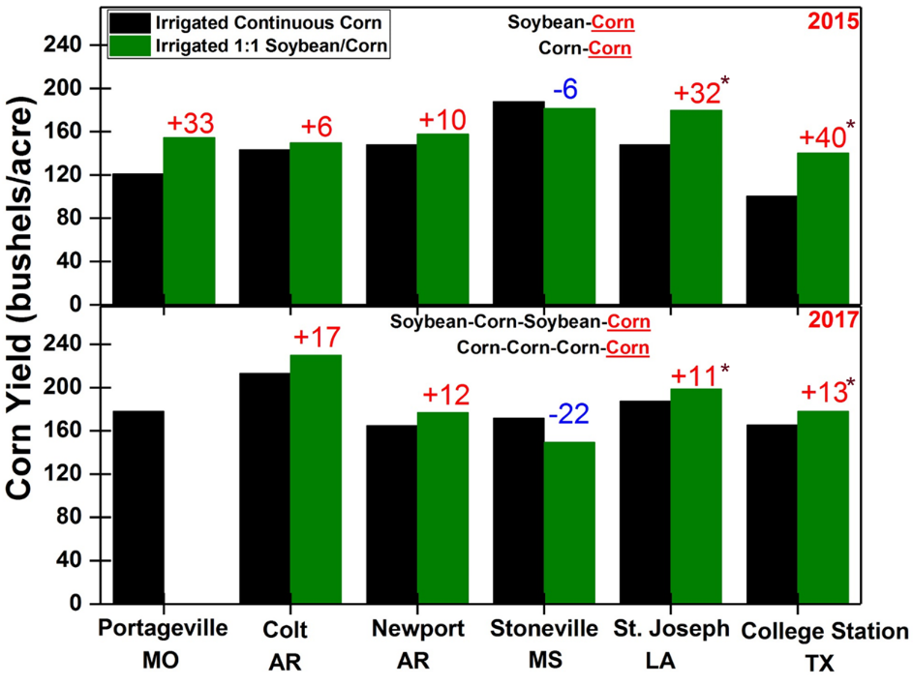
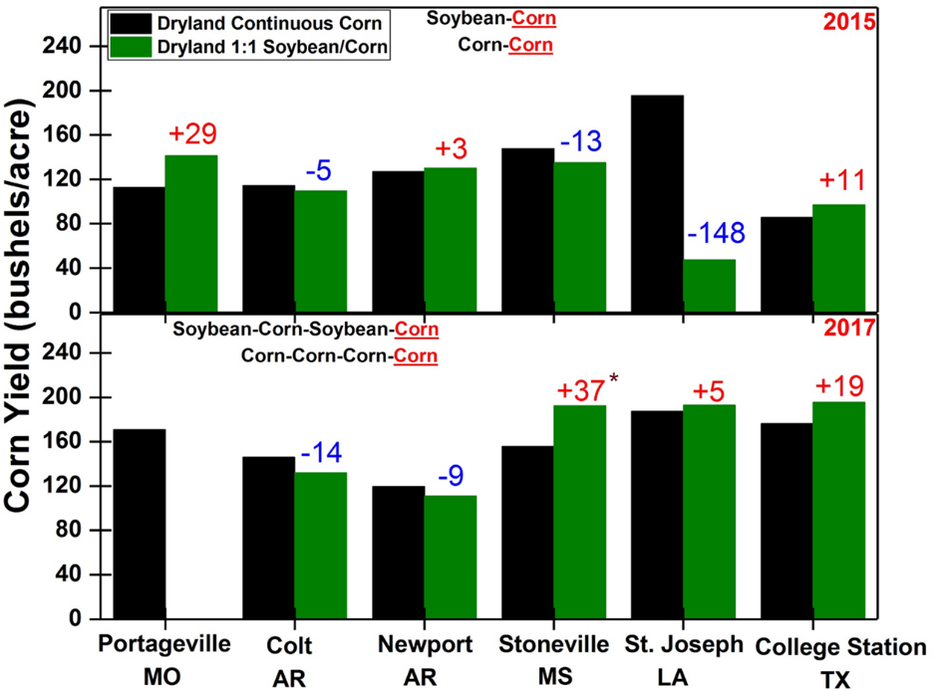
Figure 1. Comparison of corn grain yield between the 1:1 corn-soybean rotation and continuous corn rotation under irrigated and dryland conditions at different locations in this study.

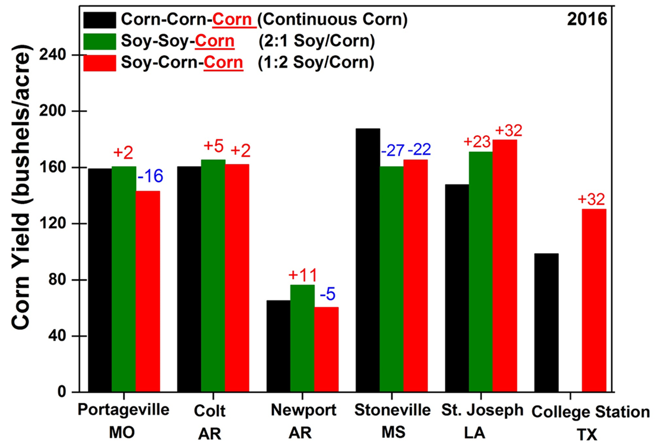
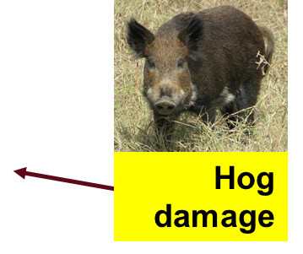
Figure 2. Comparison of corn grain yield between continuous corn rotation and 3-yr rotations including 2:1 Soy/corn and 1:2 soy/corn rotations under irrigated conditions at different locations of this study.

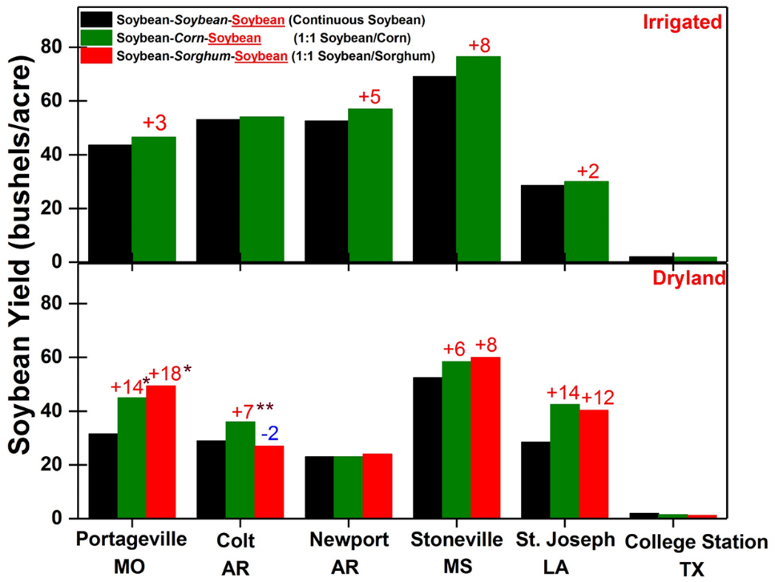
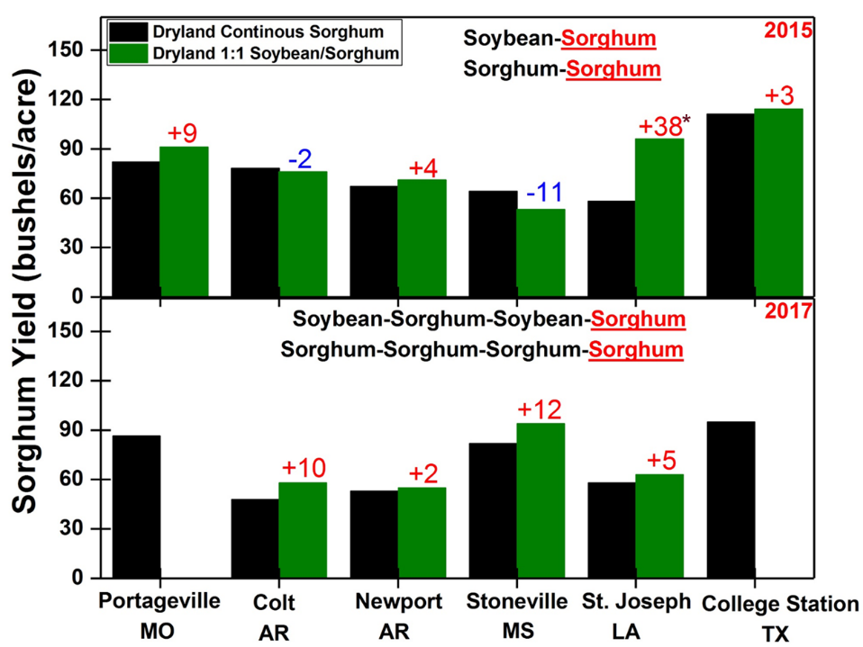
Figure 3. Comparison of Soybean and sorghum grain yield between 1:1 corn-soybean or soybean/sorghum rotation and continuous corn rotation under irrigated and dryland conditions at different locations in this study.

Table 1. Net returns of different crop rotation in Stoneville, MS.
Crop Rotation | Years of rotation |  |  |  | Total Net Returns
 | 1st | 2nd | 3rd | 4th | 2 yrs | 4 yrs
 | (2014) | (2015) | (2016) | (2017) | (2014, 2015) | (2014 to 2017)
 | ----------------------------------------------------$ Acre⁻¹---------------------------------
Irrigated Continuous Corn | 516 | 291 | 238 | 194 | 807a* | 1239a
Irrigated Continuous Soybean | 379 | 70 | 401 | 258 | 448c | 1107ab
Irrigated 1:1 Soybean/Corn | 387 | 262 | 472 | 109 | 649ab | 1230a
Dryland Continuous Corn | 566 | 222 | 100 | 215 | 788a | 1103ab
Dryland Continuous Soybean | 390 | -2 | 322 | 62 | 388c | 772c
Dryland 1:1 Soybean/Corn | 401 | 169 | 387 | 352 | 570bc | 1309a
Dryland 1:1 Soybean-Sorghum | 377 | 28 | 391 | 94 | 405c | 890bc
Dryland Continuous Sorghum | - | 77 | 61 | 53 | 77d | 191d
*Means within a column followed by the same letter are not significantly different at P ≤ 0.05.

Table 2. Net returns of 3-yr crop rotations as compared to continuous crop rotation in Stoneville, MS.
Crop Rotation | Years of rotation |  |  | Total Net Returns
 | 1st | 2nd | 3rd | 3 yrs
 | (2014) | (2015) | (2016)
 | -----------------------------------------$ Acre⁻¹-----------------------------------------
Irrigated Continuous Corn | 516 | 291 | 238 | 1044a*
Irrigated Continuous Soybean | 379 | 70 | 401 | 849ab
Irrigated 2:1 Soybean/Corn | 380 | 65 | 133 | 579c
Irrigated 1:2 Soybean/Corn | 393 | 285 | 155 | 834abc
Dryland Continuous Corn | 566 | 222 | 100 | 888ab
Dryland Continuous Soybean | 390 | -2 | 322 | 710bc
*Means within a column followed by the same letter are not significantly different at P ≤ 0.05.

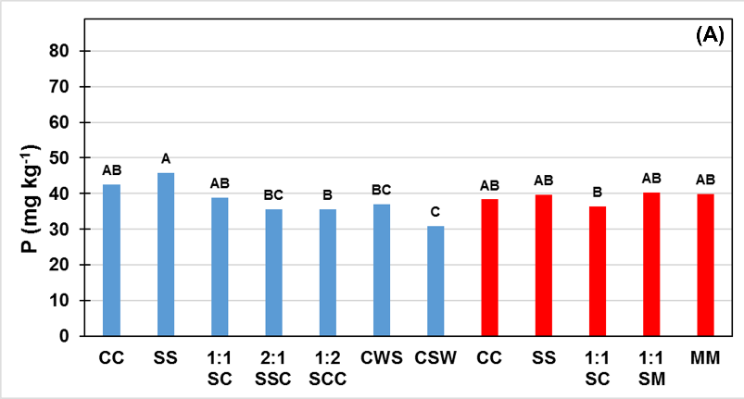
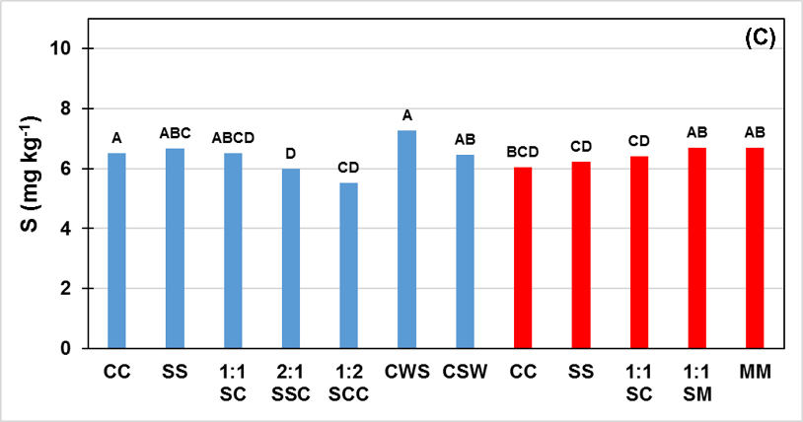
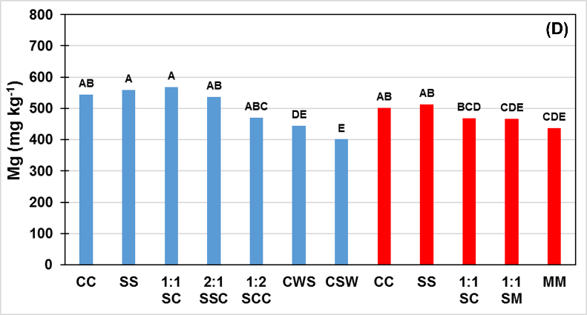
Figure 4. Mehlich-3 phosphorus, P (A), sulfur, S (C) and Magnesium, Mg (D) concentrations in soil samples collected after crop harvest in Stoneville, MS. Similar letters on bars indicate no significant differences between crop rotations at p<0.05 according to Tukey-Kramer test. Red bars are for dryland rotations and blue bars are for irrigated crop rotations.

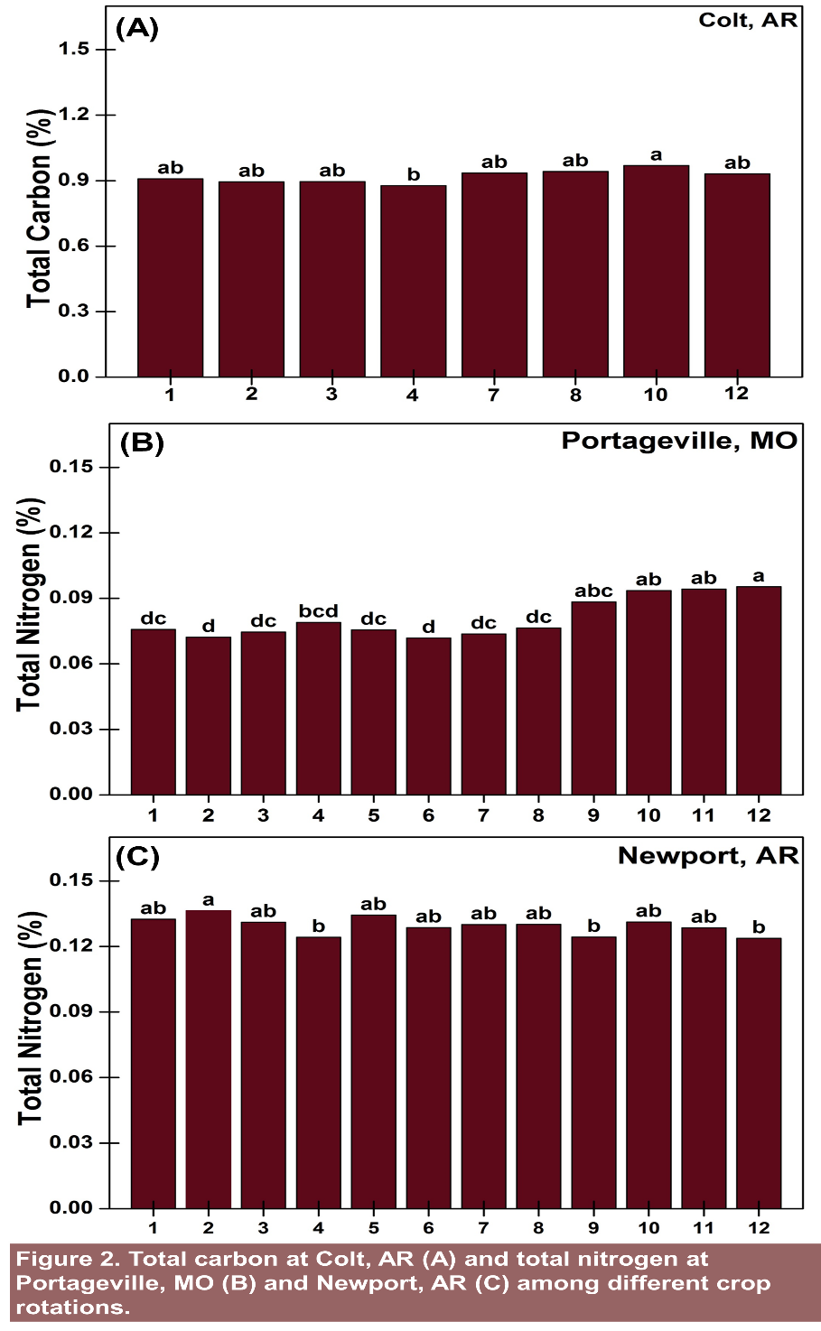
Figure 5. Total carbon at Colt, AR (A) and total nitrogen at Portageville, MO (B) and Newport, AR (C) among different crop rotations.

