Annual report

Project Number: | USB1820-172-0117
Project Title: | Evaluation of the joint effect of Arabidopsis PSS30 and soybean GmDS1 genes in providing SCN and SDS resistance in soybean
Organization: | Iowa State University, Department of Agronomy
Principal Investigator Name: | Madan K. Bhattacharyya
Report Period: | October 1, 2017 to October 30, 2018
Project Status: Active starting October 1, 2017
The goal of this project is to evaluate the joint or combined effect of the two plant genes in improving the SCN and SDS resistance in a single soybean line. The two genes use distinct mechanisms to confer SCN and SDS resistance. We hypothesize that since the resistance mechanisms encoded by PSS30, GmDS1 and rhg1-b are distinct, their roles in SCN resistance are complementary, and together they will provide soybean a more stable and enhanced SCN resistance.
Two objectives have been proposed to accomplish in this project are:
Objective 1. Determine the responses of transgenic soybean lines carrying single PSS30 and GmDS1 genes to a set of diverse SCN isolates.
Objective 2. Develop soybean lines to carry both PSS30 and GmDS1 genes through crossing and molecular selection for the two genes.
The progresses made in this quarter are presented below by objectives.
Objective 1. Determine the responses of transgenic soybean lines carrying single PSS30 and GmDS1 genes to a set of diverse SCN isolates.
Lines selected for each of the two genes are: 35S-PSS30.16.2-2 and Prom2-PSS30-232-7 for PSS30; Prom2-DS1-24 and Prom3-DS1-12. In Iowa State University, earlier we screened the lines against a putative SCN HG Type 2.5.7 (race 5) population and we observed significantly reduced number of SCN cysts among the transgenic lines carrying either of the genes. We have collaborated with Arelli Lab to determine if the transgenic lines show enhanced SCN resistance against additional SCN populations available in that lab. We presented preliminary responses of the transgenic lines to SCN HG Type 1.2.5.7 (race 2) in an early quarterly report. The responses of the lines against the race 5 are also known; the transgenic soybean lines did not show any big reduction in SCN cyst numbers, a measure of SCN resistance, in response to either race.
Objective 2. Develop soybean lines to carry both PSS30 and GmDS1 genes through crossing and molecular selection for the two genes.
Crosses 1 to 4 between lines carrying PSS30 and GmDS1 genes that were conducted in the Hinds Research Farm, Iowa State University in July 2017 generated F₁ presented in Table 1. Other crosses 5 to 8 conducted at the same time were made between these two transgenic lines to the SCN susceptible IA2050 line (Table 1) to determine if these genes can function in another genetic background. One-hundred and sixty-four seeds were harvested and planted in a growth chamber.
- Screening and selection of heterozygous plants
Molecular analysis of the 168 putative F₁ plants using DNA polymerase chain termination reaction (PCR) revealed 68 true F₁ plants (Figure 1).
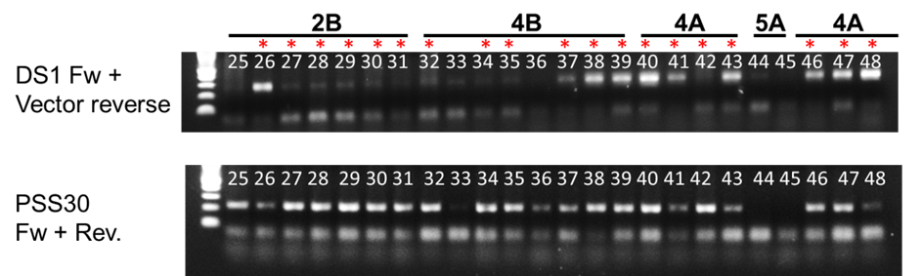
Figure 1. PCR analysis of F₁ plants. Top panel, GmDS1 transgene and lower panel, PSS30 transgene from the same plant. Numbers are categories of crosses shown in Table 1. A and B are reciprocal crosses. White numbers are different plants. Red stars are heterozygous plants showing the amplification of both PSS30 and GmDS1 transgenes.

Table 1. Number of F₁ from crosses between PSS30 and GmDS1 lines and that of PSS30 and GmDS1 lines individually with IA2050
Cross ID | Female | Male | Number of true  heterozygous plants
1A | Prom2-DS1-24 | 35S-Pss30-16.1 | 13
1B | 35S-Pss30-16.1 | Prom2-DS1-24
2A | Prom2-DS1-24 | Prpm2-Pss30-7 | 13
2B | Prom2-Pss30-7 | Prom2-DS1-24
3A | Prom3-DS1-12 | 35S-Pss30-16.1 | 4
3B | 35S-Pss30-16.1 | Prom3-DS1-12
4A | Prom3-DS1-12 | Prom2-Pss30-7 | 17
4B | Prom2-DS1-24 | 35S-Pss30-16.1
5A | Prom2-DS1-24 | IA2050 | 2
5B | IA2050 | Prom2-DS1-24
6A | Prom3-DS1-12 | IA2050 | 3
6B | IA2050 | Prom3-DS1-12
7A | 35S-Pss30-16.1 | IA2050 | 9
7B | IA2050 | 35S-Pss30-16.1
8A | Prom2-Pss30-7 | IA2050 | 7

In total, we identified 68 true F₁ plants that were grown in the Agronomy greenhouse.
- Early maturation of F₁s carrying the 35S-Pss30 transgene

We observed early maturation of the F₁s carrying the 35S-Pss30 transgene.
While the crosses 2 and 4 (Prom2-Pss30 X GmDS1 lines) were only flowering (Figure 2, right photo), the F₁ plants generated from the crosses 1 and 3 (crosses 1A/1B) were already setting pods.

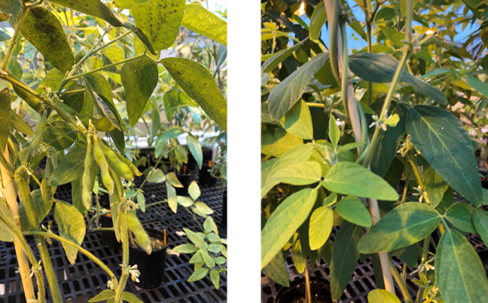
Figure 2. Status of F₁ heterozygotes plants from crosses between Pss30 and GmDS1 lines.
Left panel, 35S-Pss30 x GmDS1 lines (crosses 1A/1B); right panel Prom2-Pss30 X GmDS1 lines (crosses 2A/2B or 4A/4B).

In these crosses, 35S-Pss30 transgene induced early seed setting (Figure 2, left photo). The lines carrying the 35S-Pss30 transgene matured at least 3-4 week earlier as compared to the other transgenic lines and nontransgenic Williams 82 line.
- Loss of tolerance to spider mites among the F₁s carrying the 35S-Pss30 transgene
Another phenotype uncovered was the reduced tolerance of the F₁ plants carrying 35S-PSS30 transgene to spider mites.
This resistance observed previously in GmDS1 lines was suppressed when the GmDS1 lines were crossed with the 35S-Pss30 lines. This susceptible phenotype was not seen in the heterozygotes F₁s generated from crosses of Prom2-Pss30 with GmDS1 lines (Figure 3).
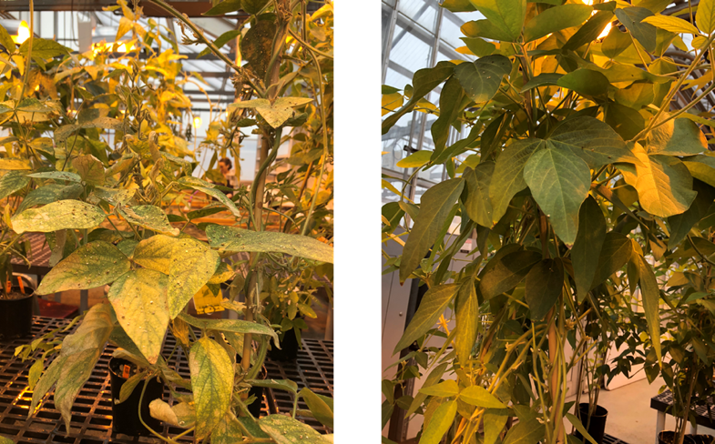

Figure 3. Phenotype of F₁ heterozygotes created from the crosses between 35S-Pss30 and GmDS1 lines. Left panel, heterozygotes for the 35S-Pss30 and GmDS1 genes (crosses 3A/3B) were very susceptible to spider mites. Right panel, heterozygotes for Prom2-Pss30 and GmDS1 transgenes were resistant to spider mites.
Cross ID | Female | Male | Status
1A | Prom2-DS1-24 | 35S-Pss30-16.1 | F₃ seeds have been harvested from 12 individual plants grown in the field and will be analyzed to identify homozygotes.
1B | 35S-Pss30-16.1 | Prom2-DS1-24
2A | Prom2-DS1-24 | Prpm2-Pss30-7 | F₃ seeds have been harvested from 12 individual plants grown in the field and will be analyzed to identify homozygotes.
2B | Prom2-Pss30-7 | Prom2-DS1-24
3A | Prom3-DS1-12 | 35S-Pss30-16.1 | All F₂ seeds from four F₁ heterozygous  plants have been harvested from the greenhouse. These seeds will be planted in the greenhouse to get the F₂ populations.
3B | 35S-Pss30-16.1 | Prom3-DS1-12
4A | Prom3-DS1-12 | Prom2-Pss30-7 | F₃ seeds have been harvested from 12 individual plants grown in the field and will be analyzed to identify homozygotes..
4B | Prom2-Pss30-7 | Prom3-DS1-12
5A | Prom2-DS1-24 | IA2050 | F₃ seeds have been harvested from 30 individual plants grown in the field and will be analyzed to identify homozygotes.
5B | IA2050 | Prom2-DS1-24
6A | Prom3-DS1-12 | IA2050 | F₃ seeds have been harvested from 35 individual plants grown in the field and will be analyzed to identify homozygotes.
6B | IA2050 | Prom3-DS1-12
7A | 35S-Pss30-16.1 | IA2050 | F₃ seeds have been harvested from 30 individual plants grown in the field and will be analyzed to identify homozygotes.
7B | IA2050 | 35S-Pss30-16.1
8A | Prom2-Pss30-7 | IA2050 | F₃ seeds have been harvested from 30 individual plants grown in the field and will be analyzed to identify homozygotes.
8B | IA2050 | Prom2-Pss30-7
Table 2. Status of the F₂ generated from crosses between Pss30- and GmDS1-transgenic lines or from crosses of Pss30- or GmDS1-transgenic lines with IA2050.

- F₂ heterozygotes were grown in the field
Next, F₂ seeds were harvested from the greenhouse grown F₁ plants and planted in a growth chamber prior to planting in the field located in the Horticulture Research Station, Iowa State University. Batches of seedlings were transplanted in the field as soon as they were ready for planting.
The desirable F₂ plants developed from crosses of the two classes of transgenic soybean lines with IA2050 as the other parent were selected by spraying the basta herbicide and grown to maturity. We have been able to grow in the field the F₂ plants of all but two crosses, 3A and 3B (Table 1; 3A and 3B, reciprocal crosses between Prom3-DS1-12 and 35S-Pss30-16.1 plants). The F₂ seeds of these two crosses have been harvested from the greenhouse and will be planted in the greenhouse in order to obtain the F₂ generation.

For crosses 1, 2, and 4, we have harvested 12 individual F₂ plants from the field that will be further analyzed in order to identify homozygotes (Table 2). We also have the F₁ seeds from greenhouse as back up.
For crosses 3A and 3B, the F₂ seeds have been harvested from the greenhouse and will be planted to get the F₂ generation.
For crosses 5A, 5B, 6A and 6B (between GmDS1 and IA2050 lines), and 7A, 7B, 8A, and 8B (between PSS30 and IA2050 lines), basta resistant F₂ plants have been harvested, at least 30 individual plants for each category. These seeds of these plants will be planted to identify homozygotes and will be investigated for responses to SCN.

Did this project meet the intended Key Performance Indicators (KPIs)? List each KPI and describe progress made (or not made) toward addressing it, including metrics where appropriate.
The following are Key Performance Indicators (KPIs) listed in the proposal. The KPIs were proposed based on completion of the project in a 2-year period.

- We will know if either or both of PSS30 and GmDS1 genes confer broad-spectrum resistance to all three SCN isolates included in this study. Results of this study are expected to be published in a peer reviewed journal article by September 30, 2018.
Response: We have completed the evaluation of the lines for two sets of SCN races in Arelli Lab. Unfortunately, none of the lines showed any enhanced SCN resistance against the SCN isolates included in that study and therefore no publication will be feasible.
- Seeds of six homozygous lines for six combinations of three PSS30 and two GmDS1 gene fusions will be available by October 31, 2018.
Response: We have harvested seeds of the F₂ lines from the field and will be available to determine if the two genes together further enhance the SDS resistance.

- The lines will be released to seed companies and public breeders to use in their breeding programs after evaluation for SCN, SDS and soybean aphids by September 30, 2019, if the proposal is renewed in 2018.
Response: This KPI was proposed for 2019.

Expected Outputs/Deliverables - List each deliverable identified in the project, indicate whether or not it was supplied and if not supplied, please provide an explanation as to why.
- We will know if the individual gene confers resistance to all three SCN isolates.
Response: It is known that the lines did not show any desirable SCN resistance to two SCN isolates tested.

- We will be able to develop six homozygous lines for six combinations of three PSS30 and two GmDS1 gene fusions with three and two promoters, respectively.
Response: We have sufficient seeds to go to the next step if we get funded in future ((Table 1 & 2). The genotypes generated in this project will be tested for possible enhanced SDS resistance.

- We will learn if the two genes together can improve SCN and SDS resistance significantly among the homozygous transgenic Williams 82 lines as compared to their respective parental lines containing single genes (either PSS30 or GmDS1).
Response: This deliverable was anticipated at the end of Year 2 (2019) of this project.

- A combination of PSS30 and GmDS1 genes is expected to be used in commercial soybean lines carrying rgh1-b or other SCN resistance genes as well as SDS resistance genes.
Response: This deliverable was anticipated at the end of year 2 (2019) of this project and if the two genes showed enhanced broad-spectrum SCN resistance.

Describe any unforeseen events or circumstances that may have affected project timeline, costs, or deliverables (if applicable.)
One of the crosses involving Prom3-DS1-12 and 35S-Pss30-16.1 parents got delayed in maturation because of the spider mite infestation (Figure 3). The plants were recovered following control of the spider mites. However, the flowering and pod formation processes were delayed. We will be growing the F₂ populations in the greenhouse to get homozygous lines.

What, if any, follow-up steps are required to capture benefits for all US soybean farmers? Describe in a few sentences how the results of this project will be or should be used.

Although surprisingly the lines did not show any SCN resistance, they are SDS resistant and will be evaluated to determine if they can enhance SDS resistance.
List any relevant performance metrics not captured in KPI’s.
Not that I can think of.

