Technical Report
Maximizing Soil Warming and Health under Different Tillage Practices in a Corn-Soybean Rotation
Dr. Aaron Daigh, NDSU Soil Science Dept., Principle Investigator
Jodi DeJong-Hughes, UMN Extension,
Dr. Abbey Wick, NDSU Soil Science Dept.

Introduction
Advantages to a reduction in tillage can include improved aggregation and water infiltration, reduced soil loss, and increased organic matter content and biological populations and diversity in the soil. However, concern about yield reductions due to cool and wet soil conditions may limit adoption of reduced-tillage systems for corn-soybean rotations on the poorly-drained soils that dominate much of North Dakota and Minnesota. Soil tillage benefits crop production by decreasing soil density and aerating the soil. Both of which benefit germination and root development. However, different tillage practices vary in how aggressive they disturb the soil and where the disturbance occurs. Therefore, different tillage practices differ in how they accomplishes this decrease in soil density and enhanced aeration. Ultimately, this translates into how a soil warms up and dries down in the spring months during and after soil thaw. Tillage practices allow an increased rate of soil warming due to: (1) lowering soil moisture content and reducing solid-soil particle contact points, which otherwise would conduct greater quantities of heat deep into the soil profile away from the seedbed and (2) decreasing soil residue cover allowing mineral soil to absorb greater quantities of solar radiation. Since tillage type varies in how they decrease soil density, the rate of soil warming is expected to vary with tillage type.
Therefore, we started a multi-state effort in late 2014, involving North Dakota and Minnesota, to address the following producer questions:
- What are the benefits of using chisel plow, vertical tillage, strip till with shank, and strip till with coulters on clayey, loamy, and sandy soils when I have concerns about warm up and dry out in the spring?
- How do I manage residue in each type of tillage system?
- Can I achieve the same yields under all these tillage options?
- Are there differences in yields for these tillage strategies on subsurface drained soils compared to naturally drained soils?
- How do different tillage practices influence soil health in Red River Valley soils?
- How does my choice in tillage practice affect the bottom line of my farming operation?
We currently have limited information pertaining to these important questions that are key to understanding how to build soil health and what tillage management practices to recommend for the different soil types.
Goals/Objectives
The ultimate goal of this project is to improve yields while at the same time building soil health. We evaluate which tillage approach (chisel plow, vertical tillage, strip till with shank, and strip till with coulters) maximizes early-season soil warming and crop yields while at the same time improving soil health on subsurface drained and naturally drained soils in the Red River Valley where growing degree units are a primary consideration for soil management selection.
The objectives of this research are to:
- Monitor soil warming and water contents under chisel plow, vertical tillage, strip till with shank, and strip till with coulters on various soil series with a range in texture
- Evaluate soil health parameters and crop emergence and yields, and
- Transfer the information to producers in several formats, including but not limited to, inclusion in field days, winter programming, videos and circulars.
This report delivers data and information from the 2017 growing season and ongoing work in the 2018 growing season. Information focuses on soil temperatures, water contents, biological properties and crop yields.
Methods
Four on-farm locations are included in the ongoing study. Each site is under a corn-soybean rotation and rotates each year. At each site, the chisel plow, vertical tillage, strip till with shank, and strip till with coulter systems are demonstrated in a replicated design (three replicates at each on-farm location). In the fall of 2016, the chisel plow, strip till with shank, and a first pass with the vertical till was performed. In the spring of 2017, the chisel plowed plots were field cultivated, the strip till with coulter, and a second pass with the vertical till was performed in their appropriate plots. Due to fall rains and an early winter, few of the tillage treatments were applied in the fall of 2017. Therefore, spring application of the tillage treatments were made for nearly all treatments at all farms. This situation demonstrates the difficult logistics producers face in the region with applying timely soil and residue management practices.
Soil monitoring for temperature, moisture, thermal properties, water retention, bulk density, crop residue cover, microbial properties (a suite of enzyme essays and phospholipid fatty acid analysis for soil microbial community structures) and chemical properties (macro- and micro-nutrients, organic matter, carbon concentrations) were performed, whereas plant monitoring included population counts, plant height, growth stage and grain yields. All plots were planted to either soybean or corn each year.
All tillage operations were completed using full-sized equipment in plots of 40 feet wide that extent the full length of the field (~1800 feet long). This allows us to get an accurate representation of these tillage practices so that producers will be able to visualize the implementation of each practice on their own farm.
The four on-farm locations have the following soil series: Fargo silty clay, Lakepark clay loam, Barnes-Buse loams, Delamere fine sandy loam, and Wyndmere fine sandy loam. These soil series cover over 67 million acres of prime farmland in the Northern Great Plains regions (Table 1).
Findings
During 2017, the chisel plow and within-plant-row zones of both strip-tills had the driest and warmest soil conditions followed by the between-plant-row zones of the strip-tills and then the vertical till had the wettest and coolest soil conditions (Figure 1). Soil biological communities and microbial stresses appeared to be relatively stable over time (Figure 1); further analysis will confirm with there are any detectable variations due to weather inputs and potential differences in response lag times.

No differences were observed in soybean’s time to emergence, stand counts, or yields (Table 2). However, tile drainage appeared to have substantially larger influence on soybean yields than tillage or soil salinity level. For instance, crop yields varied 3.9 bu/ac on average among tillage management practices, regardless of the soil salinity levels or drainage management. Similarly, crop yields varied 3.9 bu/ac on average among soil salinity levels, regardless of the tillage management practices or drainage management. In contrast, crop yields varied by 7.5 bu/ac based on weather fields were tile drained, regardless of the tillage management practices or soil salinity levels. Additionally, no differences were observed in corn’s stand counts, plant heights, or yields (Table 3).
Ongoing work
Soil temperatures and water contents will continue to be monitored near-continuously (every 30 minutes) throughout the 2018 crop. Crop yields, soil aggregates, infiltration rates, penetration resistance, chemical properties and microbial properties will be measured in the fall of 2018.
We are currently looking at temporal data from 2017 and is also being continued throughout 2018 on soil microbial community and their activities. This will allow us to evaluate effects on the below ground biology of these tillage plots. These analyses will provide us insights to shifts and temporal dynamics of AM fungi, total fungi, anaerobes, eukaryotes, gram positive bacteria, gram negative bacteria, and actinomycetes as well as the ratios of fungi:bacteria, protozoa:bacteria, gram+:gram-, saturated:unsaturated fatty acids, and cyclopropanes (indicator of stressful conditions for microbial populations). These sampling and data analyzes will continue through 2018 and will be finalized during the winter months of early 2019.
Education and Outreach
Over 50 publications, videos, media interviews, and news articles on this project.
Over 40 presentations at winter meetings, summer field days, conferences, extension workshops, etc., with >3,700 participants:
The Conservation Technology Information Center (CTIC) hosted 8th national tour, MN (2015)
MN Ag Expo (2015)
BWSR Annual Training Conference in Brainerd, MN (2015)
MN Association of Professional Soil Scientists annual mtg in St. Cloud (2015)
Barriers to Bushels at 5 locations in MN (Flom, TRF, FF, Willmar, Madison)
NRCS Soil Health Field Tour in Stearns Co., MN (2015)
Soil Health Field Tour near Foley, MN (2015)
Soil Health and Research Update Field Day in Barney, ND (2015)
MN Ag Services small group mtg in Granite Falls, MN (2015)
UMN Tillage, Technology, and Residue Field Day, Madison, MN (2015)
Soil Health Field Day at SWROC Lamberton, MN (2015)
State of Water Conference Alexandria, MN (2016)
Prairie Grains Conference, Grand Forks, ND (2016)
Conservation Tillage Conference, Fargo and Willmar (2015 and 2016)
Cavalier Co. Tillage Workshop ND (2016)
NDSU UMN Soil Health Bus Tour, Wahpeton, ND (2016)
Soil Health Tour and Tillage Expo, Landgon, ND (2016)
ETS Strip Till Field Day, Buffalo Lake, MN (2016)
Lake Wilson Field Day, MN (2016)
2016 Certified Crop Adviser Update, Paynesville, MN (2016)
Soil Science Society of America, Phoenix, AZ (2016)
Coteau des Prairies Annual Meeting, ND (2016)
Ridgewater Community College Willmar, MN. Two classes of Corn/Soybean Production. (2016)
MVTL Soil Lab Annual Mtg. New Ulm, MN (2016)
Soil Science Society of America, Tampa, FL (2017)
Commodity Classics. Tillage Panel of Experts. San Antonio, TX, (2017)
Sterling Equipment. Granite Falls (2017)
Ridgewater Community College Ag Days. Willmar, MN (2017)
SWCD Soil Health Field Day. Pipestone Co, MN (2017)
UMN Soil Health Field Day. Morris, MN (2017)
UMN Strip Till Expo. Fergus Falls, MN (2017)
UMN Soil Health and Tillage Field Day. Rushmore, MN (2017)
BWSR Staff Training. Brainard, MN (2017)
Conservation Tillage Conference. Willmar, MN (2017)
Technical Planning Workshop for ND, SD, & MN Cooperative Soil Survey, Fargo, ND (2017)
County Soil Health Workshop, Wyndmere, ND (2017)
Manitoba Pulse and Soybean Growers “Getting it Right”, Canada (2017)
Best of the Best in Soybean and Wheat Research, Moorhead, MN (2017)
Soil and Soil/Water Training Workshop. Fargo, ND (2018)
AGVISE Laboratories Soil Fertility Seminar Series – Hankinson, ND (2018)
AGVISE Laboratories Soil Fertility Seminar Series – Granite Falls, MN (2018)
Publications:
DeJong-Hughes, J. and A.L.M. Daigh. 2017. Upper Midwest Tillage Guide, University of Minnesota Extension Service and North Dakota State University. 4 chapters available online at http://www.extension.umn.edu/agriculture/soils/tillage/
Daigh A.L.M. and J. DeJong-Hughes. 2017. Fluffy Soil Syndrome: When tilled soil does not settle. Journal of Soil and Water Conservation 72(1):10A-14A
Videos:
Three extension videos were made in 2015 for producers and the general public and continue to be made available on the UMN Soil Health website www.extension.umn.edu/agriculture/soils and the NDSU Soil Health website https://www.youtube.com/watch?v=_-8gAfTYktg and https://www.youtube.com/watch?v=9XywM4AMExM These videos have received over 9,700 views from around the world. From the Tillage and Technology Field Day we have received over 37,000 views from around the world https://www.youtube.com/watch?v=SWvjsa5_k-E
Abbey Wick and Jodi DeJong-Hughes Tweeted pictures throughout the season and have a following of over 6,400 people.

Table 1. Soil series among the on-farm locations, their taxonomy, and geographical extent in the Northern Great Plains region (NRCS Web Soil Survey data).
Soil Series | Taxonomy | Texture | Geographical extent (acres) | Counties Present
Fargo Clay | Fine, Smectitic, Frigid Typic Epiaquerts | Silty Clay | 9,469,740 | 36
Lakepark | Fine-loamy, mixed, superactive, frigid Cumulic Endoaquolls | Clay Loam | 415,940 | 7
Barnes | Fine-loamy, mixed, superactive, frigid Calcic Hapludolls | Loam | 37,596,920 | 60
Buse | Fine-loamy, mixed, superactive, frigid Typic Calciudolls | Loam | 16,830,560 | 57
Wyndmere | Coarse-loamy, mixed, superactive, frigid Aeric Calciaquolls | Fine Sandy Loam | 2,500,410 | 32
Delamere | Coarse-loamy, mixed, superactive, frigid Typic Endoaquolls | Fine Sandy Loam | 505,940 | 22
Total |  |  | 67,319,510

Table 2. Crop Responses among Tillage Operations. Mooreton, ND – a various combinations of tile drained, naturally drained, saline, and non-saline Fargo Silty Clay
Tillage Operation | 2017 Soybean Yields (bu/ac)
 | Saline  & Tiled | Non-saline & Tiled | Saline | Non-saline
Chisel Plow | 38.3 a | 42.6 a | 30.6 a | 36.7 a
Strip Tillage with Shank | 41.4 a | 43.7 a | 35.2 a | 36.7 a
Strip Tillage with Coulter | 38.3 a | 40.3 a | 30.6 a | 35.1 a
Vertical Tillage | 39.3 a | 43.9 a | 28.6 a | 34.6 a
Average | 39.3 | 42.6 | 31.2 | 35.8
§ Different letters in a column are significantly different

Table 3. Crop Responses among Tillage Operations. Fergus Falls, MN – a spot-drained Lakepark Clay Loam and Barnes/Buse Complex Loam; Barney, ND – a undrained Delamere and Wyndmere Fine Sandy Loam
Tillage Operation | 2017 Corn Yields (bu/ac)
 | Fergus Falls, MN | Barney, ND
Chisel Plow | 190.6 a | 198.4 a
Strip Tillage with Shank | 184.9 a | 191.9 a
Strip Tillage with Coulter | 188.7 a | 201.3 a
Vertical Tillage | 183.9 a | 199.3 a
Average | 187.0 | 197.7
§ Different letters in a column are significantly different

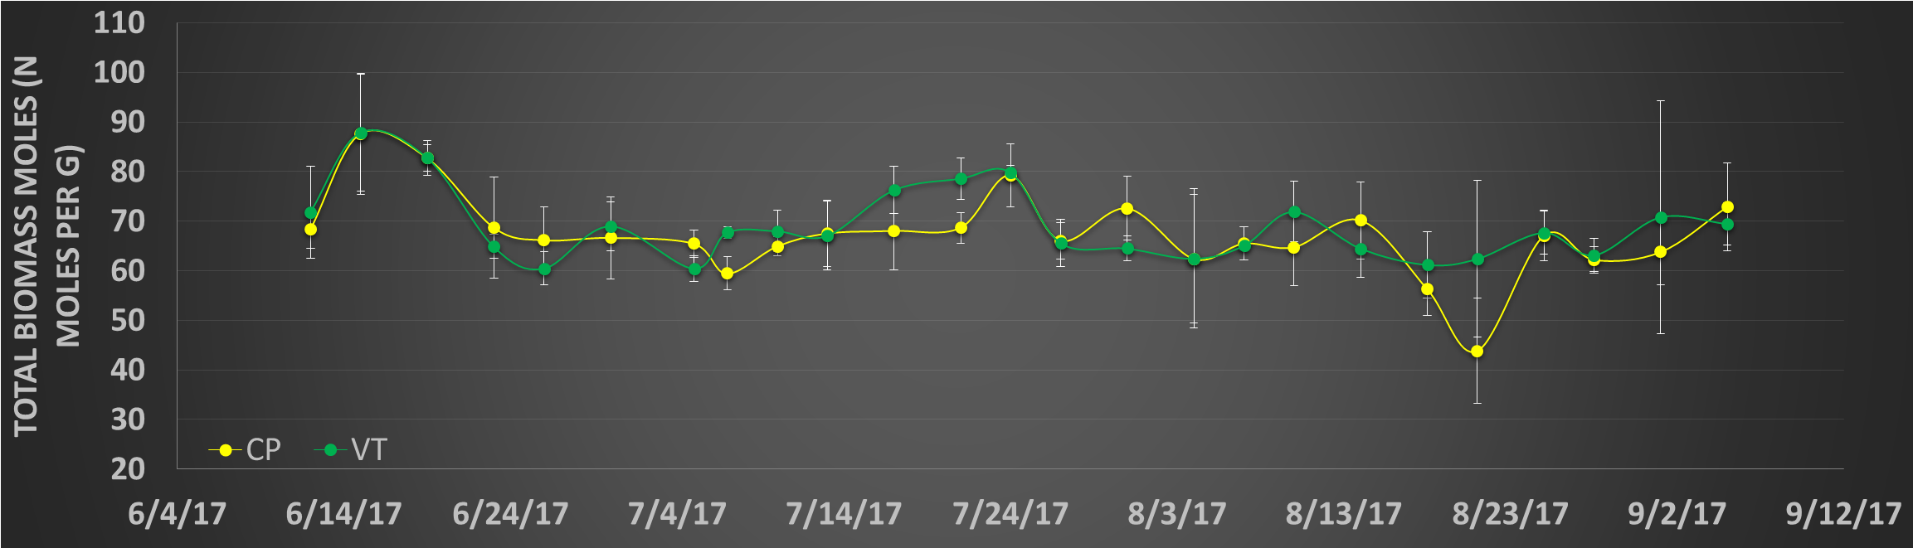
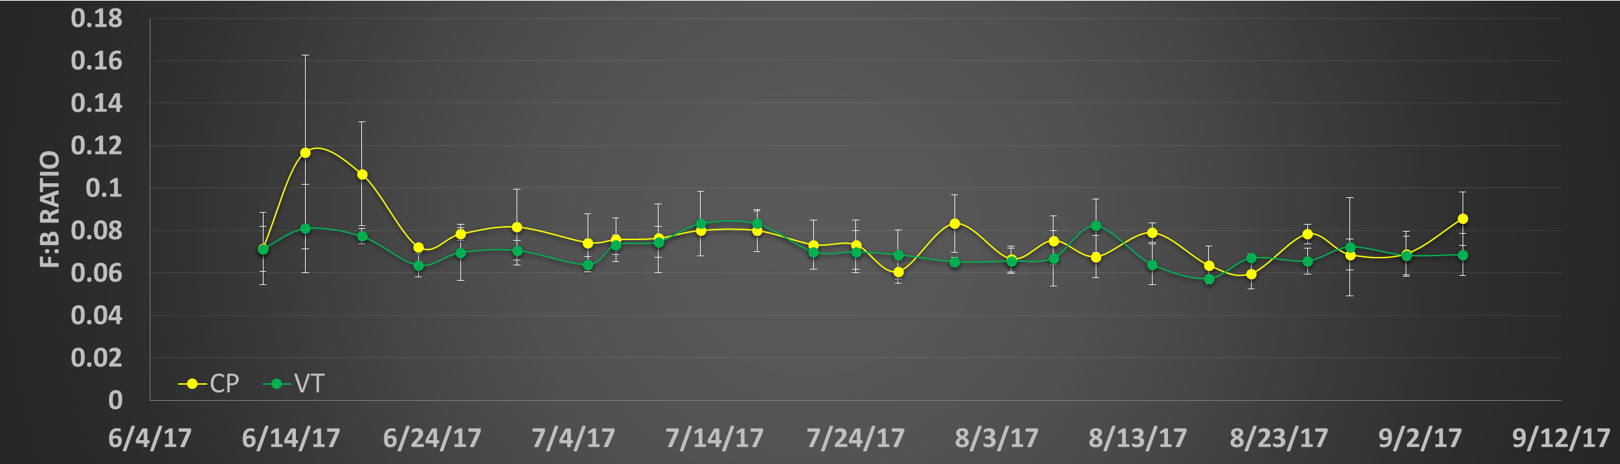
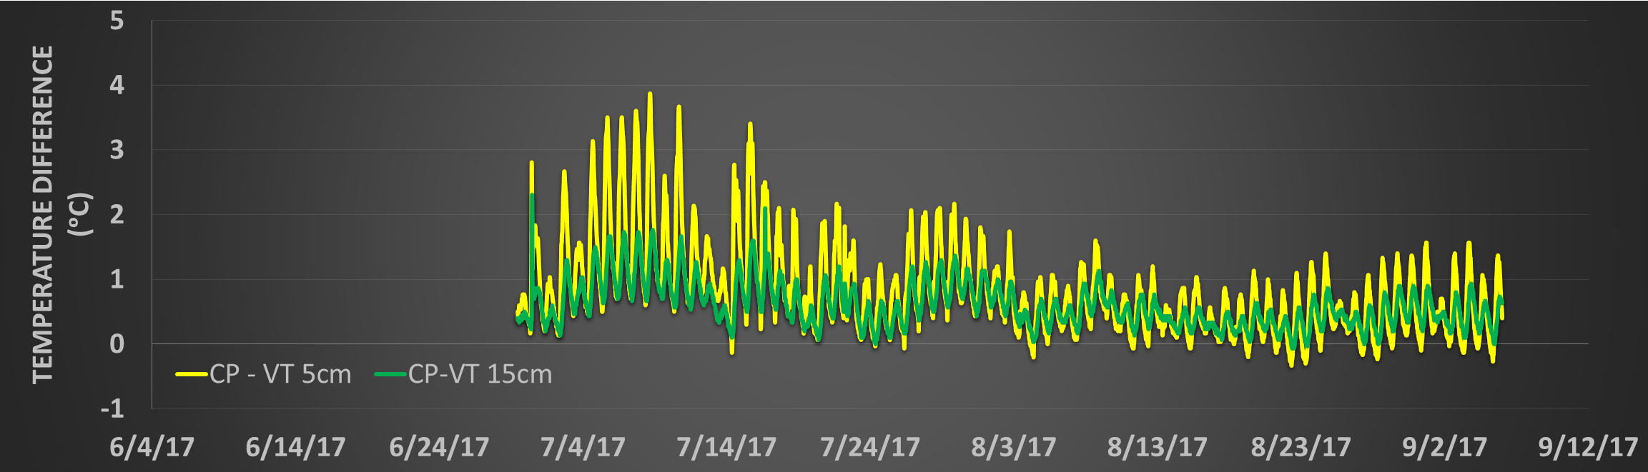
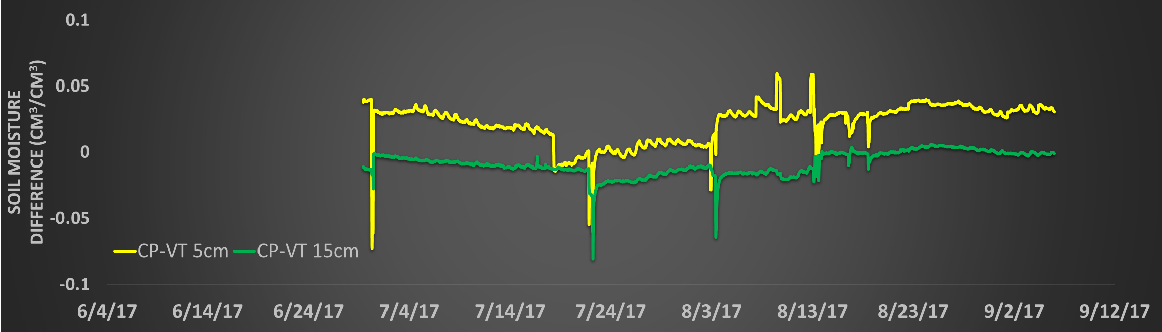
Figure 1. Microbial biomass, fungi to bacteria ratios, soil temperature difference between tillage treatments, soil moisture difference between tillage treatments in soybean field at farm near Mooreton, ND.

