Managing salinity with cover crops: a whole system response

Caley Gasch, Abbey Wick, Jason Harmon, Tom DeSutter

School of Natural Resource Sciences, North Dakota State University

Summary:

We initiated a research project in FY 2017/2018, supported by the North Dakota Soybean Council, to investigate the use of cereal rye (Secale cereal) in managing soil salinity. In this first year, we established research sites on four cooperating farms that experience reduced crop production in saline areas (located in Nelson, Grand Forks, and Stutsman counties). During the 2017 growing season, two of the farms were planted to soybeans, and we established replicated research plots within each field across saline and non-saline conditions. In September, we interseeded cereal rye treatment strips in each field, providing the opportunity to observe risks and benefits associated with incorporating cereal rye into the soybean-corn rotation. We conducted baseline soil, plant, and insect sampling in the summer and fall of 2017. During the 2018 growing season, soybeans are being grown on the two fields that hosted corn in 2017, to complete the first soybean-corn rotation. This project will continue for three more years, where we will continue monitoring these sites and documenting changes in soil properties (including water use, fertility, salts, and soil health), crop yield, cover crop effects, and beneficial and pest insects.

Background:
Soil salinity impacts approximately 13% of the land area in North Dakota, and saline patches reduce yield and profit. Researchers and farmers benefit from a better understanding of the nature and limitations of saline soils, as well as effective strategies to manage salts. Furthermore, cover crop use and interest is on the rise in North Dakota, yet we have a lot to learn about risks and benefits associating with using cover crops in soybean.

In 2017, we initiated a study, jointly funded by the ND Soybean and Corn Councils, to assess the use of cereal rye (Secale cereal) in managing soil salinity. This work was motivated by previous work, also funded by corn and soybean checkoff dollars, which revised threshold salinity values for corn and soybean¹ and demonstrated elevated insect pest pressures on salt-stressed corn and soybean plants². Because soil salinity continues to be a persistent problem across North Dakota, we initiated a project to evaluate the use of cereal rye cover crops as a tool for managing soil water and therefore reducing salinity. Cover crop interest and use is increasing³, and while cereal rye provides a number of soil health and weed management benefits⁴, we anticipate that there are also risks and challenges associated with its use (see Figure 1). Ultimately, our goal is to understand the uses and limitations of cereal rye in soybean rotations, particularly as a tool for managing soil water, maximizing soil cover, and therefore reducing effects of salinity⁵. We are also particularly interested in understanding how both beneficial and pest soil organisms and insects are affected by salinity and cereal rye.
Figure 1. Potential risks and benefits of cereal rye in soybean-corn rotations

Objectives:
Objective 1: Measure the benefits and risks of using a cereal rye cover crop in a soybean-corn rotation to determine its potential for salinity management and building soil health. We are using a whole-system approach to measure soil, crop, weed, and insect responses to the salts and the cover crop. These field-scale experiments compare cover crop and no cover crop treatments across a gradient of saline soils, replicated across four farms, and spanning two rotation cycles to capture variability in responses across different soil types and climates.

Objective 2: We directly provide information to ND soybean farmers about the challenges of farming on saline soils, the use of cereal rye in managing salinity, potential benefits and risks of using cereal rye, and guidance in where, when, and how to effectively use cereal rye as a salinity management tool. We deliver this information to farmers through the NDSU Soil Health extension program, with videos, fact sheets, field days, and online media. We also incorporate salinity education and management information into café talk programs.

Research Approach:
During the first year of the project, we accomplished the following:
- Formed cooperative agreements with four farmers, on four working farms that hosted saline patches. These field sites are located in Aneta, Northwood, and Jamestown, North Dakota.
- In the spring of 2017 and prior to planting, we Veris mapped and ground-truthed each field to locate four replicated sets of plots that span saline and non-saline areas (see Figure 2).
- The Aneta and Northwood sites were planted to corn and the two Jamestown sites were planted to soybean.
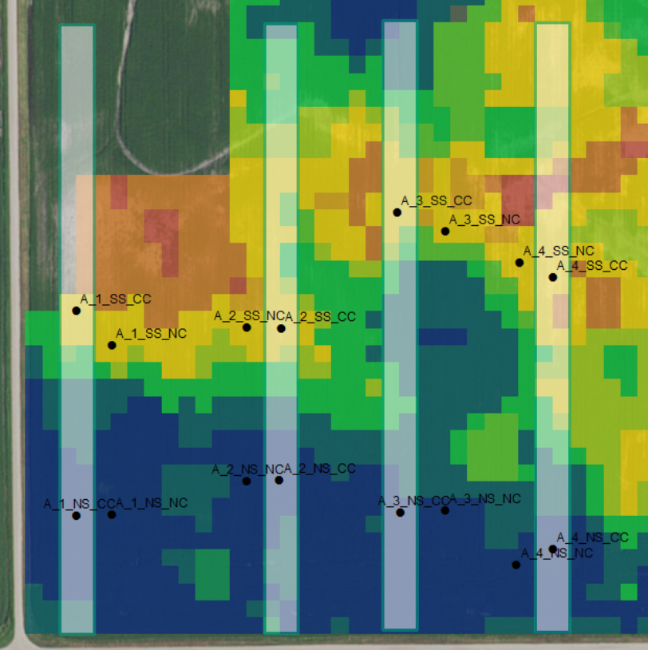
Figure 2. Veris map of the Aneta field site, with warm colors indicating higher salinity. Cover crop treatments are indicated by gray strips, and small points are plot locations.
- We installed weather stations at each of the four sites. The weather stations collect frequent readings of air temperature, precipitation, wind direction and speed, relative humidity, and solar intensity.
- Mid-season, we interseeded treatment strips of cereal rye into growing corn (July 7; see Figure 3) and soybeans (September 1) and immediately began sampling soil water content (0-6” and 6-12”) every other week. Once the cereal rye began to grow, we collected data on cover crop and weed biomass production each month.
- Mid-season, we sampled soil microbial and insect communities, to examine baseline differences between soil and insect communities in saline and non-saline soils.
- Post-harvest soil sampling (to 4’ depth) to describe soil texture, salt distributions, fertility, and soil health.
- Collected cash crop yield and cover crop and weed biomass production.
- This research and the field sites in Jamestown (soybean sites in 2017) will be featured in the 2018 Soil Health Bus Tour.

Results and Interpretation

We were not expecting to see any differences in the cover crop treatment in the first year, and we did not observe any differences in soil properties between cover crop and no cover crop plots, so these results focus on the differences between saline and non-saline plots across the four farms.

Saline soils often occur in landscape depressions that accumulate water (and whatever is dissolved in water, including salts and nutrients), and we observed that saline soils contained more water content throughout the season and beyond harvest. The cover crop did not necessarily reduce the water content at any time. Crop yields were generally lower in saline soils, while cover crop and weed biomass were variable across salinity conditions.

In terms of soil properties, we observed that large aggregates and aggregate stabilities were generally lower in the saline soils. We expect that the addition of the cover crop will improve soil structure in future years. Saline soils occasionally had higher nutrient (nitrogen and phosphorus) and organic (total organic and active carbon) contents. We think this is because there is less plant growth to take up nutrients, which may be accumulating in those areas if they’re dissolved in water. Microbial properties were extremely variable. We’ll be examining these properties in much greater detail in the future years of the project, including a complete analysis of microbial, nematode, earthworm, and insect (soil and canopy) communities.

Conclusion and Future Directions

The initiation of this project in 2017 was a success, and the established field design and baseline data that we compiled have set the foundation for future years of data collection and observation. Our initial results have confirmed that saline soils have different soil and insect characteristics beyond salt chemistry, and we will continue to investigate specific hydrologic and community differences. These differences may have implications for pest management or be barriers to improving crop productivity in saline soils. There is also a great need to understand the uses and limitations, and risks and benefits, of cereal rye in North Dakota cropping systems, and its potential for improving soil health in saline areas. This research will allow us to build knowledge in all of these areas, using a whole system soil – plant – insect approach that will be directly relevant to ND soybean farmers.

References
¹ Butcher, KR. 2016. Biological Response to Sulfate Salinity in Richland County, North Dakota. Thesis. North Dakota State University, Fargo, ND.
² Eichele-Nelson, JL, et al., 2017. The effects of salinity on the herbivorous crop pest Tetranychus urticae (Trombidiformes: Tetranychidae) on soybean and corn. Environmental Entomology, doi: 10.1093/ee/nvx103

³ SARE (Sustainable Agriculture Research and Education). 2017. Annual Cover Crop Survey 2015-2016. Avaialble online: http://www.sare.org/Learning-Center/Topic-Rooms/Cover-Crops/Cover-Crop-Surveys

⁴ Snapp, SS, et al., 2005. Evaluating cover crops for benefits, costs and performance within cropping system niches, Agronomy Journal, 97: 322-332.

⁵ Franzen, D, 2013. Managing Saline Soils in North Dakota. NDSU Extension Service, SF1087.

⁶ Liu, A, et al., 2005. Effects of cover crops on soil aggregate stability, total organic carbon, and polysaccharides. Soil Science Society of America Journal, 69:2041-2048.

⁷ Schulz, M, et al., 2013. Benzoxazinoids in rye allelopathy – from discovery to application in sustainable weed control and organic farming. Journal of Chemical Ecology, 39: 154-174.

⁸ Koch, RL, et al., 2015. On-farm evaluation of a fall-seeded rye cover crop for suppression of soybean aphid (Hemiptera: Aphididae) on soybean. Agricultural and Forest Entomology, 17: 239-246.

⁹ Koch, RL, et al., 2012. Response of soybean insects to an Autumn-seeded rye cover crop. Environmental Entomology, 41: 750-760.

¹⁰ Bakker, MG, et al., 2016. The potential for cereal rye cover crops to host corn seedling pathogens. Phytopathology, 106: 591-601.

¹¹ Dunbar, MW, et al., 2016. Increased risk of insect injury to corn following rye cover crop. Journal of Economic Entomology, 109: 1691-1697.

