Project Title: Road Performance Testing and Promotion of Soy-Based Dust Control
Principal Investigator: James A. Bahr, North Dakota State University

Situation Statement
Road dust is a common problem in the rural United States as well as in mining areas and can lead to health issues to those living and working in these dusty environments. At the same time, the rapidly growing biodiesel industry is faced with a glut of crude glycerol that is expensive to purify and expensive to dispose of. Over $400 million is spent annually in the US alone on dust control. The most common dust control agents in use today are the chloride salts of calcium and magnesium due to their low cost and ease of application. However, there is a growing concern with the use of these salts as they accumulate in the environment and are corrosive to vehicles and infrastructure. They have already been banned in parts of the US as a result of these issues and an effective chloride replacement is highly desired. Our goal is to create a drop in replacement for the chlorides so that existing equipment can be utilized for its application.
With previous funding from the ND Soybean Council, we have developed a successful road dust suppression agent derived from waste glycerol and soybean oil. Continued funding of this research has enabled us to advance our efforts from laboratory testing to large scale gravel road testing. The best candidate of soy based dust control agent developed at NDSU was produced in large quantities (1,200 gallons) sufficient enough for application to a gravel road surface for performance testing and durability measurements. Our material was tested against calcium chloride and an untreated control section of the same roadway. The data collected from this research has allowed NDSU to gauge the performance of this new material and pursue additional investment dollars for further testing and commercialization of the technology with the ultimate goal of creating a new market for soy-based products.
Our road test began on June 8, 2017 when we applied our dust control agent to a 600 ft. x 30 ft. wide section of Cass County 22 (East end of the Prosper road) as the last effort on our FY2017 grant from the NDSBC. Fortunately, with a follow on award from the NDSBC, we were able to continue the observation and analysis of this road test section throughout the summer, fall and winter of 2017-2018. In addition to monitoring the road test, we also presented our findings to state and local DoT agencies and attended regional conferences/trade shows related to road maintenance/safety and agricultural products. In addition, we were able to utilize the positive results from the road test to pursue funding opportunities from other agencies to work on manufacturing issues and perform additional road testing.

Goals/Objectives
Funding from the ND Soybean Council (NDSC) has made it possible for us to continue to monitor the dust control performance of our road test for the entire summer, fall and winter of 2017-2018. We also shared our findings at regional conferences/trade shows related to road maintenance/safety and agricultural products. In addition, we were able to utilize the complete results from the road test to promote the soy based dust control material to state and county agencies. The NDSBC funds were leveraged with a grant from the ND Department of Commerce that enabled us to expand our test area, pursue patent protection, perform a market analysis on the technology and begin commercialization activities. The proposed tasks intended to meet these goals are listed below.
- Monitor the dust control performance throughout the summer, fall and winter

- Measure the aggregate loss (loss-of-fines) for treated and untreated sections of road

- Communicate our results at trade shows and conferences

- Promote the technology to state and local DoT personnel

- Visit with potential material suppliers and manufacturers

Description of the Research Conducted:

The following section gives the background on how this technology was developed. The generalized approach to the synthesis of our soy based dust control agent is depicted in figure 1 and consists of a reaction between glycerol and soy biodiesel that generates a mixture of mono, di and triglycerides with some residual glycerol. The mono and diglycerides allow the product to form a stable emulsion in water while the unsaturated double bonds present in the fatty soybean oil chains allow the material to crosslink during curing. This crosslinking action forms larger continuous networks that bind to the fine dust particles and form a stable insoluble material that resists re-emulsification due to rainfall and the mechanical action of vehicle traffic. The hydroxyl groups (-OH) located on the mono and diglycerides as well as the residual glycerol attract and retain moisture from the air which further aids in the sequestration of the road dust particles.
The crosslinking action of the double bonds is depicted in figure 2 between two monoglyceride molecules. In reality, this crosslinking occurs between all three of the glycerides resulting in the joining of several glycerides into one very large and extended molecular structure similar to that of a polymeric system that is assembled from individual monomers. One characteristic of this system is that even after the curing process, the end product remains a soft non-hardening semi solid. This is important as the treated road must remain pliable and not harden since a hardened surface layer on a gravel road is prone to brittle failure, cracking and the removal of large chunks ultimately ending in failure of the road surface. In addition, a hardened road surface is undesirable from a maintenance perspective as it cannot be graded and reshaped without grinding and milling of the road surface.
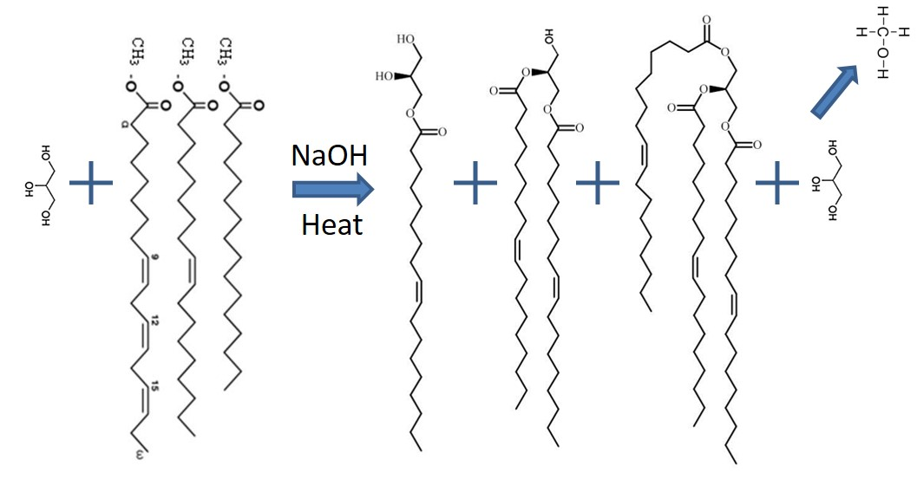
Figure 1 Generalized synthesis scheme to make glycerides from glycerol and biodiesel. This approach resulted in a mixture of mono, di and triglycerides with some residual glycerol. Methanol was stripped off in order to drive the reaction forward.

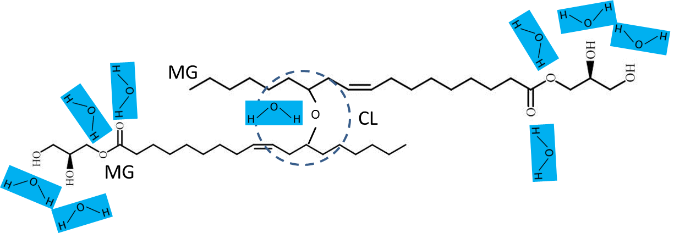
Figure 2 The fatty acid chains from the soybean oil will crosslink (CL) naturally between their unsaturated double bonds. Two cross-linked monoglycerides (MG) are depicted above but this crosslinking will also occur between di and triglycerides as well resulting in a larger network and higher molecular weight structure. The presence of hydroxyl groups (-OH) attract moisture from the air resulting in a dampness that aids in dust reduction.

Findings

Our findings are broken down below as a detailed discussion of the work performed in each individual task since this work was more of an applied research project than an investigation of a scientific hypothesis. After monitoring the performance of our soy-based dust control agent over the one year project period, we found the product controlled the dust very well, even on hot dry days, and continued to control dust the following spring. This indicates that our product experiences significant carryover into the following season, which will reduce the amount of material needed for dust control over a mulit-year span. The calcium chloride control section of the road experienced a steady decline in dust control performance over the season with little if any carry over into the following year.
In addition to monitoring the yearlong performance of the road test site, we submitted five more proposals focused on the further scale up of the manufacturing and expanded road testing. As of the writing of this report, two of the proposals were funded, one is pending and 2 were not funded this cycle. However, we plan to resubmit to these agencies next year based on the feedback from the reviewers.
Over the one year span of this project we were able to present our findings to various DoT agencies and make connections with many people in the industry. The general feedback from these individuals has been very positive with many requests to try the product themselves and to learn more about its use. The additional funding from the ND DoC has allowed us to expand these marketing efforts, pay for travel to conferences, and continue to promote the technology for another year. The detailed description of our findings are outlined below, task by task.

Task 1 Monitor the dust control performance throughout the summer, fall and winter

The primary objective of this project was to continue to monitor the performance of our soy-based dust control agent after the previous project had ended. The material was applied to the road in early June of 2017, less than a month before the end of the FY 2017 grant leaving little time to measure the performance. Also, the calcium chloride control section was not treated until July 2017, a month after the previous contract ended.
The location of the test road was 10 miles NW of NDSU on County Road 22 in Cass County ND starting at the intersection of Cass County Road 17. This road was recently reconstructed, prior to our testing, with an overlay of gravel and reclaimed asphalt pavement (RAP) with a commercial stabilizing agent added to firm up the base. Prior to treatment, the road surface was bladed to restore the crown and provide a uniform surface. The blading did create a center berm of course gravel that was lacking in finer aggregate and binders that lead to premature cracking as time went on. An aerial photo of the test road location is shown in figure 3.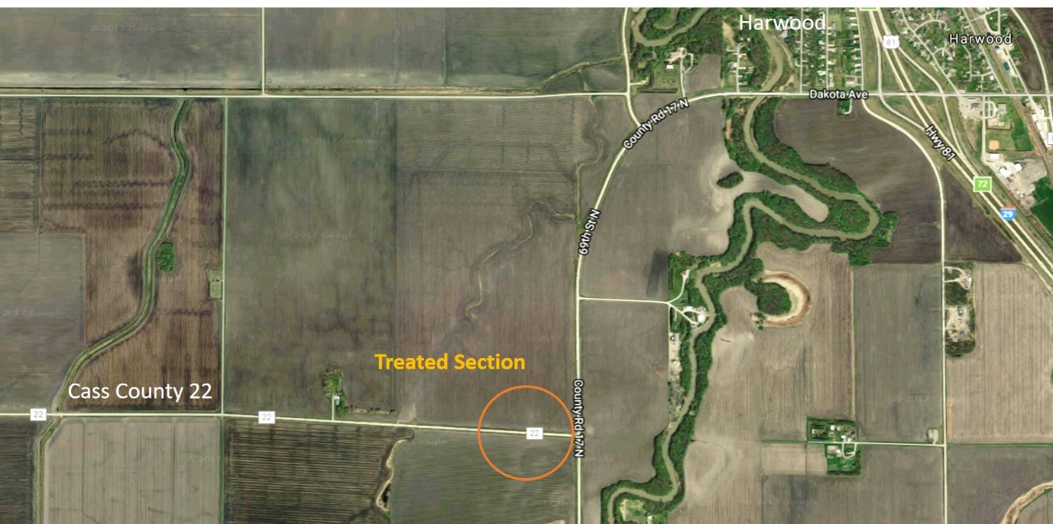
Figure 3 Aerial photo showing the location of the gravel test road used for this project. This highly travelled road services a grain elevator 5 miles to the west and is subject to heavy truck traffic. UGTI installed a traffic counter on this road and measured an average of 250 vehicles per day, 65 of which were trucks.
Dust control performance was measured using a custom dust collection device that we built to allow for real-time dust measurements of the test road. The sampling device features dual inlet ports with adjustable configuration to ensure that the samples are collected from the best location within the vehicle generated dust cloud. A suction blower draws a portion of the dust through the two inlet ports. This dust sample is then presented to the sampling port of the DustTrack IITM (laser particle counter) which is mounted in the rear of the vehicle. The advantage of this system over stationary dust collection methods is that we can measure the road dust on specific days of varying humidity and weather conditions in real-time without the need to maintain stationary devices that typically sample over longer periods of time and tend to average out the data over several weeks.
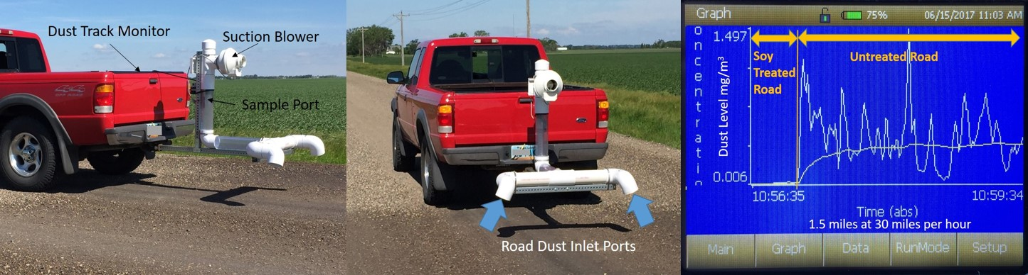
Figure 4 Vehicle mounted road dust sampling apparatus used to measure the real-time dust generated from vehicle traffic. The graph to the right is an example of the data output by the DustTrack IITM monitor in mg of dust per cubic meter. The device was driven over the various treated and untreated sections of the test road at 30 mph in both directions.
We made a total of 32 passes with the vehicle mounted dust meter on 7 different days. Each with a different temperature, humidity and wind condition. Therefore, it was essential for us to measure both the calcium treated section and the soy treated section on each test day as dust levels change with changes in the weather. Each session included at least 4 passes up and down the road with the average of all the readings being reported here. The data from a single pass is shown in figure 5 and represents a 1 mile section driven at 30 mph towards the west. The dust meter started measuring at time zero at which point the vehicle was accelerated to 30 mph causing a spike in the data at 00:18 seconds. This spike was excluded and only the values taken at a steady speed were included in the report.
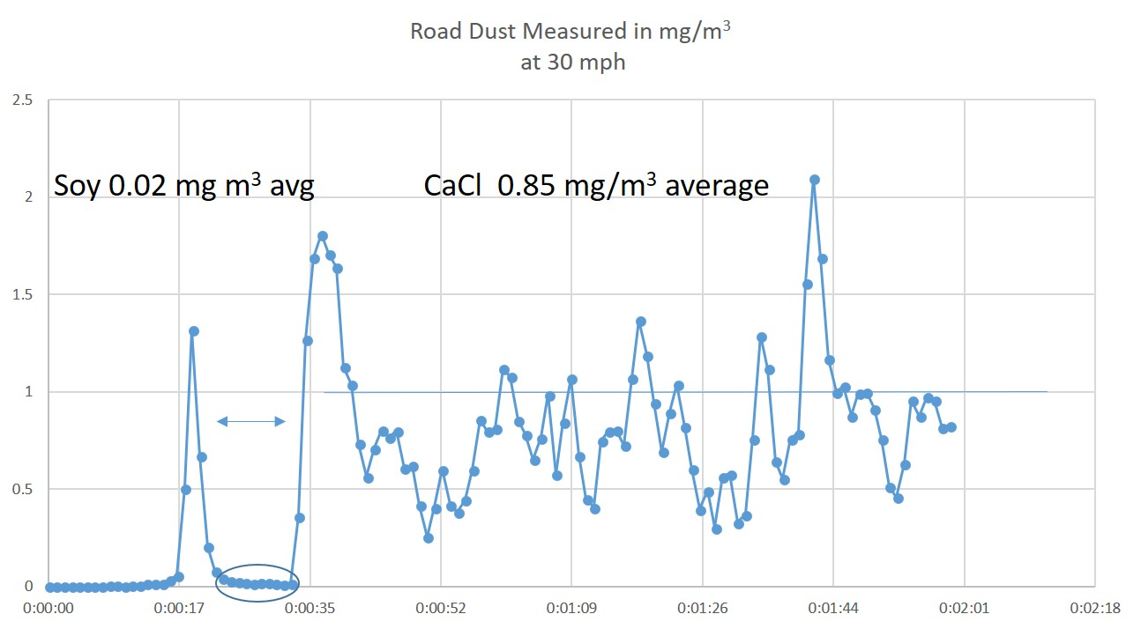
Figure 5 Typical data gathered from a single pass (1 mile) of the vehicle mounted dust measurement apparatus. The test vehicle was first driven over the soy treated road (00:25) followed by the much longer calcium chloride (CaCl) section (00:35 to 2:01). Several passes were made in both directions each day of testing and the results were averaged. A total of 32 measurements were made.
A summary of the dust collection data set, taken over the project period, is provided in the following graph and table. The data shows that the soy product was able to reduce the road dust generated by vehicle traffic to very low levels. Furthermore, the soy treated section retained its low dust quality through the winter months into the spring of the following year. The calcium chloride treat section had comparably low dust levels to begin with, but its ability to control dust gradually diminished until that section was as dusty as the untreated roadbed. This decrease in performance is why calcium chloride is typically applied twice in one season. These results were very encouraging and suggest that the soy-based product need only be applied once a year and perhaps applied at reduced rates year after year for the same section of road.

Figure 6 Road dust data measurements of the soy treated and calcium chloride sections of the same road for July-October 2017. The soy treated section remained relatively dust free throughout the summer and had a value of 0.14 mg/m³ the following spring while the calcium chloride dust values rose steadily throughout the summer. The starting, untreated dust value was 1.8 mg/m³.
The table below gives the same data as the graph above, but in a different format and includes the data from the following spring. There was substantial carry-over in dust control for the soy treated section from year one to year two but not for the calcium chloride.
 | 7/24/17 | 8/1/17 | 8/22/17 | 9/8/17 | 9/29/17 | 5/7/18
Calcium Chloride Treated Section | no data | 0.04 | 0.80 | 0.60 | 1.91 | 5.01
Soy Treated Section | 0.06 | 0.05 | 0.04 | 0.07 | 0.12 | 0.14
Untreated Section | 1.77 | no data | no data | no data | no data | no data

A photo record of the test road surface was collected throughout the year in order to document the stability of the RAP layer that formed in the top 20 mm of the roadbed. This layer resembled a common asphalt road surface and was firm and durable for the yearlong study. Due to the relatively thin nature of this RAP layer, it did experience some cracking and chip-out especially in areas that were comprised of loose, larger gravel that was deposited by the pretreat road grading operations. Similar cracking was observed in the calcium chloride section as well and may be due to the use of a base stabilizer in this gravel the year before. We will continue to study the RAP rejuvenating qualities in a controlled laboratory setting in the FY19 funded project from the NDSBC. The photo history is shown in figure 7.
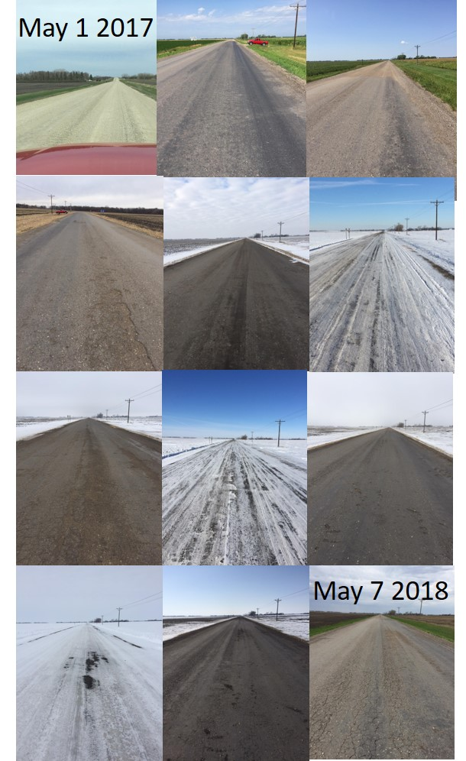
Figure 7 Photo collage of the road test site spanning one year. The bulk of the test section held up quite well, but areas that were loose gravel to begin with experinced moderate cracking and failure of the RAP layer. All of the photos above were taken of soy treated section.
Task 2 Measure the aggregate loss (loss-of-fines) for treated and untreated sections of road

A standard method used to analyze gravel road stability is the loss-of-fines measurement. This method entails isolating one square yard of the gravel road and sweeping all of the loose particles into a container. The sample is then brought back to the lab, placed in a series of sieves, and shaken until the sample has been separated out by particle size. Larger rocks collect in the top sieve (1/2 inch openings) and the smaller fines collect in the bottom (200 micron). Since it is the fine particles that generate the road dust and serve as the binder that holds the roadbed together, they are of the most interest. We feel that our soy based dust control agent can bind the fine particles and help to stabilize the road surface thereby reducing the maintenance costs of blading and re-graveling.
This project proposal was written 7 months before we applied the soy-based dust control agent to the test road and at that point, the loss of fines measurement seemed like an important piece of data to include in our comparison against the calcium chloride control. As it turned out, our material interacted with the RAP present in the gravel, plasticizing the asphalt, creating a firm road surface with all of the aggregate (and fines) bound by the rejuvenated asphalt. See photo below.

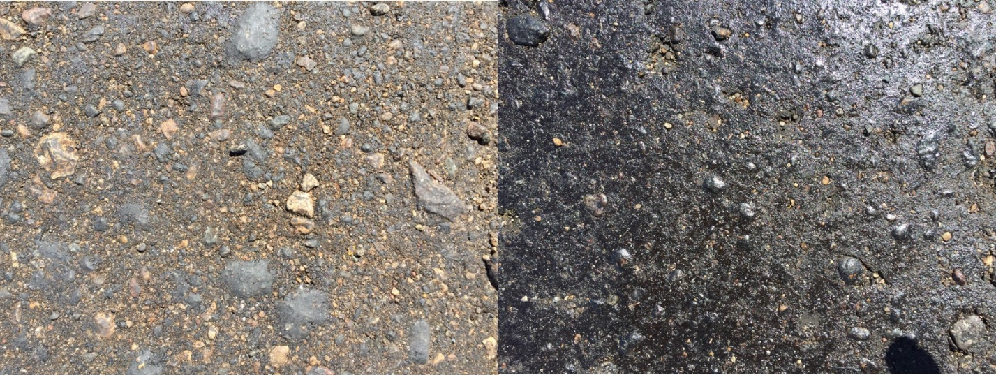
Figure 8 The photos above show the surface of the road a month after the application of the soy-based dust control agent. The asphalt-like surface created by the interaction of the soy material with the asphalt particles present in the gravel persisted for over a year.

This firm surface made it impossible for us to collect the loose gravel needed to perform the loss of fines measurements. Although unexpected, this was considered a positive result since the fine particles are obviously bound together and cannot migrate to the surface where they will be dispersed by rain and vehicle traffic. We will continue to study the ability of our soy-based dust control agent to rejuvenate asphalt in a follow-on project funded by the NDSBC in FY19. Once we were aware of this phenomenon, we filed for patent protection as a Continuation-in-Part to our original patent titled;
BIO-DERIVED COMPOSITION FOR dust control
Continuation in Part: Additional claims related to use as an asphalt rejuvenator and recycled asphalt binder/rejuvenator

Task 3 Communicate our results at trade shows and conferences

In addition to monitoring the performance of our road test throughout the year, we wanted to use this time to reach out to people in the industry to promote our product as well as make new contacts for future collaborations. The meetings attended were very useful in achieving this goal and resulted in new proposals, new contacts and potential partners going forward. Funds from our ND DoC Venture Grant were leveraged to support this activity. The trips made to support this effort are listed below.

In July of 2017, Mr Bahr attended the “Parade of Roads: Soy-Based Road/Bridge Sealants & Striping Field Day" in Hutchinson, MN sponsored by the Agricultural Utilization Research Institute (AURI). This was a great opportunity to meet with State and County DoT personnel who are interested and /or using soy-based road products. Several new contacts were made resulting in the generation of two new proposals geared towards the expanded testing of our material in Minnesota. Also, present at the meeting where Ag research personnel, Road treatment applicators, Road treatment manufacturers and local government officials. AURI is a strong promoter of soy based road treatments and regularly hosts meetings around this topic.

In Aug of 2017 Mr Bahr gave a presentation to the MN Soybean Research council in Mankato, MN to support a proposal focused on the further development and testing of the soy based dust control material. This opportunity arose from the discussions had with the attendees at the AURI conference in July.

In April of 2018, Mr Bahr attended the AURI New Uses Forum in Plymouth MN. This conference provided the opportunity to meet with a variety of people in agribusiness, academic research, entrepreneurship, investors and producers. New contacts were made as well as insight gained on the pathways to commercialization.

In April of 2018, Mr Bahr travelled to the National Association of County Engineers (NACE) annual meeting in Wisconsin. This meeting was unique in that it was primarily attended by the very people who will seek out and use products such as our soy-based dust control agent. One particular meeting was focused solely on the formation of a gravel roads maintenance committee. Other topics included the use of RAP in new construction and chip seal overlays. The contacts made at this conference will be valuable in the future as we work to test our material in more locations.

Task 4 Promote the technology to state and local DoT personnel

Working with Dale Heglund and the Upper Great Plains Transportation Institute (UGPTI) We were able to secure funding from the ND DoT TRIP (Transportation Innovations Program) to perform a second road test in FY19. The purpose of this second road test will be to optimize the application rate and determine the dust control performance on a standard gravel road (no RAP). The test road must qualify for federal aid funding, which limited the number of road sites for testing. Kevin Gorder, ND DoT, is working with us on this project and has identified an appropriate test road that will be available during the summer of 2019. This section of road will be a bypass route around a major construction site in Cassleton, ND. This award totals $65,734.

We submitted a proposal to the MN DoT LRRB (Local Road Research Program) and were invited to present it at their annual meeting in Golden Valley MN. In this proposal, we planned to perform a road test in Minnesota with the goal of optimizing the application rate and gaining data on the durability of the dust control product on a standard gravel road. Although the review board liked the concept, they were unable to fund the project this year. They suggested that we resubmit a proposal next year and include a partner that can provide matching funds.

Finally, we submitted a proposal to the United Soybean Board after our preproposal was chosen for advancement. The scope of this effort is focused on reducing the manufacturing costs through scale up with a chemical toller using crude starting materials. The resulting material quantities will be sufficient for us to perform 3-4 more road tests throughout the upper Midwest. If funded, this project will bring the technology closer to commercialization and introduce it to a broader market. The project will span 2 years and allow us to test the soy-based dust control agent on a variety of gravel types.

Task 5 Visit with potential material suppliers and manufacturers

Working with the NDSU Technology Transfer Office, we were able to perform a market analysis through Bird Dog Consulting to determine the best path to commercial success as well as to get a feel for how our product is perceived by people in the industry. This consultant was paid with funds from our ND DoC Venture Grant, but the results and contacts made, apply directly to the goals of this particular task. As a result of this effort we have had four companies express interest in our product and two of them engaged in licensing discussions with NDSU. Due to Non-disclosure agreements with these companies, they cannot be listed by name. The Tech Transfer Office at NDSU continues to foster relationships with potential partners/licensees. The table below lists the people who were contacted and the industries that they work in. Each individual filled out a multi-page questionnaire related to the use and production of the soy-based dust control agents. The results of these surveys are currently being compiled into a comprehensive marketing strategy.

Company | Expertise | Interviewee
AGP | Biodiesel / plant oil | Andy Wilson – Biodiesel Group
Agricultural Utilization Research Institute | Biodiesel / plant oil | Shannon Schecht – Executive Director  Harold Stanislawski – Project Development Director
Barry County Road Commission, Michigan | Dust control customer | Brad Lamberg – Managing Director
Cargill Industrial Oils | Biodiesel / plant oil | Brent Aufdembrink – Industrial Oils
Carroll County, MD | Dust control customer | Ted Sirko – Bureau Chief  Brian Tracey – Area Road Chief
Cass County, ND | Dust control customer | Blaine Laaveg – Highway superintendent
Glacier Dust Control | Dust control contractor | Don – Owner
Global Fuels | Biodiesel / plant oil | Robert Slavings – Plant Manager
Midwest Ag Group | Biodiesel / plant oil | Jeff Zueger – CEO
Minnesota DOT | Dust control customer | Ed Johnson – Road dust research
Minnesota Soybean Growers, Brewster Biodiesel | Biodiesel / plant oil | Scott Austin – Manager
Mountrail County, ND | Dust control customer | Jana Heberlie – County Engineer
North Dakota Soybean Growers | Biodiesel / plant oil | Nancy Johnson – Executive Director
Pennsylvania Dept of Agriculture | Dust control customer | Eric Chase – Product testing
Pottawattomie County Kansas | Dust control customer | Peter Clark – Public Works Director
Renewable Energy Group | Biodiesel / plant oil | Bernardo Daza – Corporate business development
Roskam – independent | Biodiesel / plant oil | Jeff Roskam
Unpaved Roads Institute | Dust control customer | Eli Cuelho – Research Engineer
Woodbury County Iowa | Dust control customer | Mark Nahra – County Engineer
Woody’s Dust Control | Dust control contractor | John Wood – Owner

Analyze soy-based material for environmental toxicity
Working with Professor Kirk Howatt of NDSU Weed Sciences, we designed a crop test matrix to evaluate the plant toxicity of the soy based dust control material in the event of road run off during application and wind-borne overspray that could reach adjacent crops. A total of 32 test plots were seeded with soybeans, wheat, oats, lentils, sunflower and canola half of which were used for pre-emergent toxicity testing with the remaining 16 plots treated for post emergent toxicity testing after the plants reached sufficient height to be sprayed. This project allowed us to continue to monitor the test plots for any signs of post emergent toxicity beyond the end date of the previous project that initiated the crop toxicity investigation.
The crop test matrix used is shown in the below. The dimensions of the 16 individual plots are 10x30 ft with a sprayed width of 7 ft. Each plot has 4 replicates and 4 of the plots were left unsprayed as controls. Although, the matrix is shown in systematic order, the actual pattern of test plots was randomized to minimize the effect of natural variations within the field site as a whole. Application rates for the post emergent trials were 0.10, 0.05 and 0.01 gal/yd². The post emergent test rates are lesser than the pre-emergent as they are intended to mimic wind carried overspray, which should be much less than the amount applied directly to the roadbed during treatment operations.

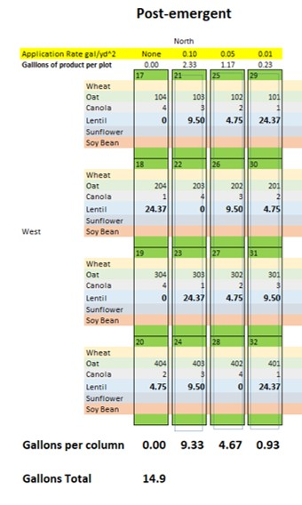
Figure 9 Crop toxicity test matrix used for post-emergent growth inhibition studies. Six different crop varieties were planted in rows perpendicular to the spray application of soy based dust control agent. A total of approximately 15 gallons of material was applied for the post-emergent toxicity study to 16 test plots each measuring 10x30ft.

The day of application to the test plots was hot and dry and these conditions persisted for several days after resulting in the product drying and clinging to the leaves without rain removal. The only sign of growth inhibition came from the heaviest application rate where the leaves where completely drenched with material. This heavy application rate was more representative of a direct application to plants, much more than would be carried to the plants due to wind drift. Even in this case, the plants did not die off but experienced a moderate level of leaf yellowing and damage. Overall, the pre and post emergent applications showed that the soy-based material has a very limited toxicity to the plants used in this study and can safely be applied without damage to the adjacent crops. The photo below shows the post emergent test plots several weeks after spray application.

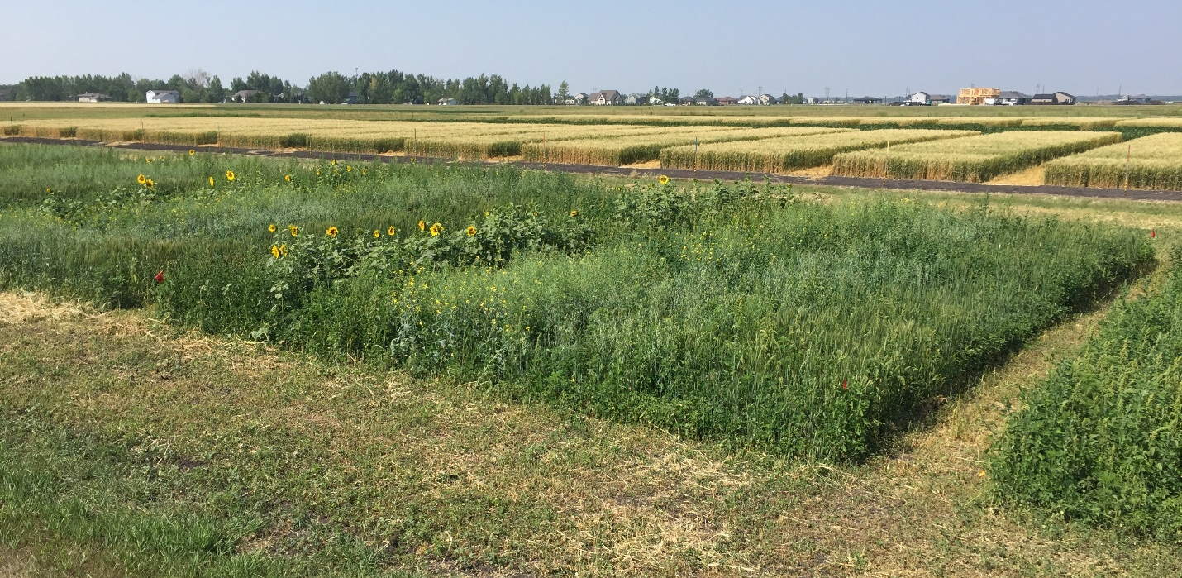
Figure 10 Photo of the test plots used for post-emergent toxicity testing taken one month after treatment with the soy-based dust control agent.

Conclusions:
This project allowed us to continue to monitor the performance of our road test and promote the technology while continuing our efforts to secure additional funding for the further development of the product. This “gap” funding resulted in two new funded projects based on the data gathered from our successful road test that will allow us to further demonstrate the performance and explore new uses for the material in the area of asphalt rejuvenation.
The dust collection data gathered over the year long study showed that our product was able to effectively control road dust for the entire dust season with substantial carry-over of the performance into the following year. The soy-based product out performed the calcium chloride control section and was not washed away by the rain as the calcium chloride was. We will perform a second road test of the material on a non-RAP road in Cass County in FY19 in order to verify the results of this study. This second road test will be funded by the ND DoT TRIP (Transportation Innovations Program).
We were able to promote the technology by attending key conferences related to; ag product utilization, bio-based road treatments, and a national conference for county engineers. Attendance at these conferences, along with the market research study, resulted in a large number of professional contacts. Many of these contacts expressed interest in the product with a desire to use it in their respective jurisdictions. The feedback from these individuals was very useful and helped us further refine the product to better meet their needs and increase the likelihood that they will use the product in the future. A few of these individuals expressed interest in participating in future studies as well as the further scale up of the manufacturing.
The crop toxicity testing that was started (but not finished) in the previous NDSBC funded project was concluded in this study. The results showed that the soy-based material was not toxic to the 6 crops used in the study when applied directly to the soil after seeding or when applied to the leaves a month after they emerged. This non-toxic quality combined with the resistance to rain induced run-off, indicate that the product is relatively safe for the environment. Even with repeated use, the biodegradable quality of the material will prevent it from accumulating over time.
Due to the interaction with the RAP present in the roadbed and the firm road surface that resulted, we were able to file an additional patent for the material as an asphalt rejuvenant and expand the potential use of the material beyond that of just dust control. This effect will be studied in more detail with a follow-on project funded by the NDSBC for FY19. Hopefully, the results of this work will lead to additional road testing as a RAP rejuvenating agent.
Even with the promising results obtained from this project, there is still a lot of work to be done to move this technology closer to a commercial product. The planned second road test for FY19 will help us determine the optimal application rate and gather more performance data that is needed in order to determine the cost of the material. This effort will help us answer the two main questions that individuals asked in the survey; How does the material perform in the field? and What is the cost of the material relative to existing technologies. A pending proposal to the USB will address the cost of large scale manufacturing from crude, low priced stating materials (if selected for funding). We would like to thank the NDSBC for funding this research!

