Technical Report
Soil and water management for soybean production under Fargo clay
Principal Investigators:
Dr. Amitava Chatterjee
Dr. Aaron Daigh
Department of Soil Sciences, NDSU, Fargo, ND
Significance:
Conservation tillage and water management are important factors affecting soybean yield along with soil health in Fargo clay soil that is high in smectitic clay (48.7%) that makes them poorly drained and sticky in nature. Subsurface drainage helps to remove excess soil moisture and provides opportunity to adopt conservation tillage practices such as strip and no tillage. Minimum tillage helps to maintain and enhance water movement through soil profile and increase the amount of drain flow. Higher disturbances under chisel plough during early spring can result into early nitrogen loss through subsurface drain before crop can use it. Deciding on subsurface drain depth and spacing also influences nutrient loss, closer drain spacing results in fast removal of excess water but also involves increased cost of installation. Wider drain spacing could reduce the cost but also significantly could reduce the yield due to prolonged water stress condition. Installation of control structures in subsurface drainage system provide an opportunity to control.
Objectives:
- Compare soybean yield (Bu/ac) under different tillage practices and drainage conditions
- Determine the effect of different subsurface drain spacing and depth combinations on soybean yield.
- Estimate the nutrient availability (lb/ac) as influenced by different subsurface drain spacing and depth combination.
Description of research conducted
A field trial was conducted for 2017 growing seasons (May to September) at Casselton, North Dakota (46°49'25.03"N, 97°13'5.70"W) on a Fargo silty clay soil (fine, smectitic, frigid typic epiaquerts). The experiment was conducted in Ron Holidays’s farm. Subsurface drain lines were installed in June 2013 and this is fourth growing season over four years. Basic soil properties are presented in Table 1.
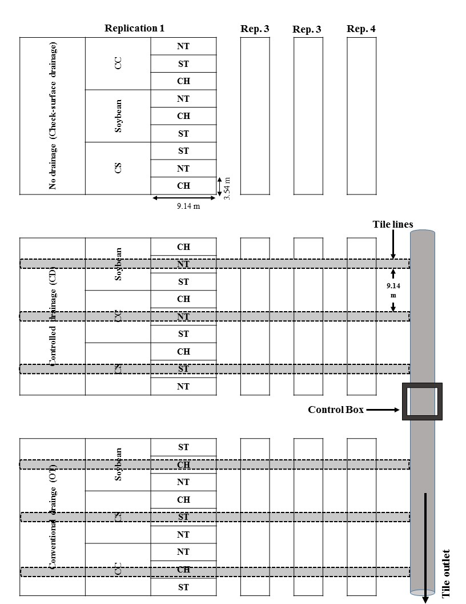
Experiment I: Tile drainage and tillage effect on soybean production
Soil Properties
pH | 6.4
EC (mmhos/cm) | 0.70
NO₃-N (lb/ac)-2 feet | 19
Olsen-P (ppm) | 48
K (ppm) | 470
Ca (ppm) | 4720
Mg (ppm) | 900
Na (ppm) | 14
CEC (Meq/100g) | 29.6
For this experiment, we followed strip-split-split design with four replication. Three drainage system (i) no drainage (check-surface drainage only), (ii) conventional drainage (OT), (iii) controlled drainage (CD) are placed as main plot and under each strip two rotation, (1) continuous corn and (2) corn-soybean and under each sub plot, three tillage practices, (i) chisel, (ii) strip-till and (iii) no-till as sub-sub plot randomized with four replication (Figure 1). Soybean are planted every year such that soybean is followed by corn. Controlled structure was set at one feet below soil surface during all growing season in dry period and 3 feet below soil surface at wet period. Three drainage systems are 30 feet apart. Plots are 30 feet long and 11 feet wide with 22-inch row spacing. Statistical analysis for will be based on split design with drainage as main-plot and tillage as sub-plot. We used split plot design for this experiment with four replication for analysis.
Table 1. Basic soil properties of the experimental site
Figure 1 Experimental layout for subsurface drainage and tillage.
Experiment II: Soybean production as influenced by subsurface drain depth and spacing
Three strips of corn, soybean and sugarbeet following corn-sugarbeet-soybean. Each strip have four pseudo-replication of six rows. Two tile lines were installed at three tile spacing of 30-, 40-, 50-feet at two depths, 3-feet and 4 feet at each level of tile spacing and along with 50 feet long plot of only control (undrained) (Figure 2).
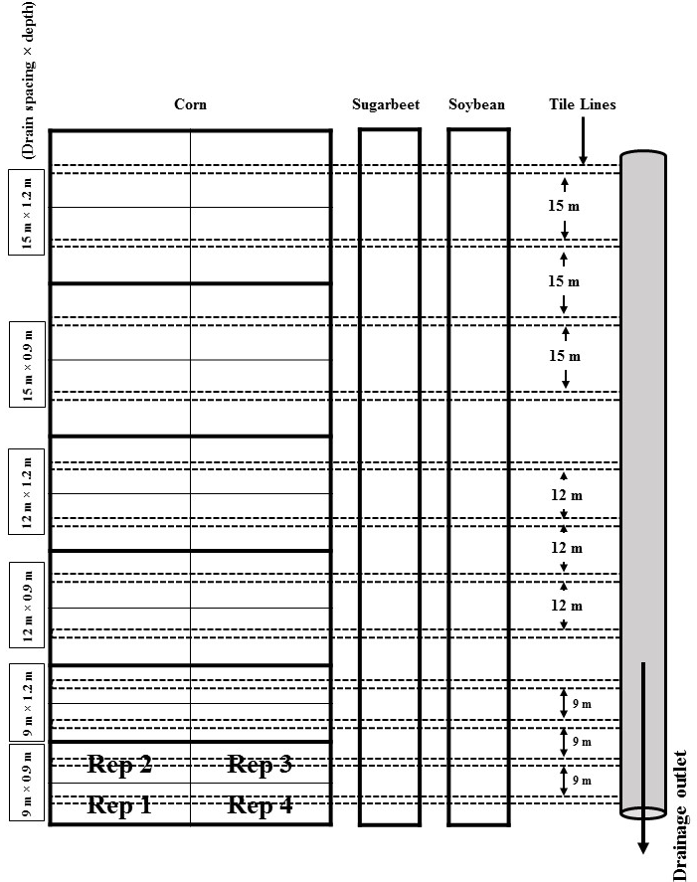
Statistical Analysis:
Figure 2 Experimental layout for subsurface drain spacing and depth.
Soybean yields and residual soil NO₃-N were analyzed using PROC GLM. Drainage and tillage were fixed effects; whereas, replication and replication × drainage were random effects. Analysis of variance (ANOVA) was used to test effects of drain spacing and depth on crop yields and residual soil nitrate using PROC ANOVA. Drainage spacing and depth were fixed effects and replicates were random. Fisher’s protected least square difference (LSD) at α = 0.05 was used to separate treatment means. All statistics were analyzed using Statistical Analysis System software (SAS, 2013)

Findings:
Soybean yield from first and second experiment are presented in Figure 3 and 4, respectively for 2017 growing season. No significant main plot effect (drainage) (p=0.2723) was observed for soybean yield, whereas, tillage (subplot) (p=0.0012) and interaction between drainage and tillage (0.0031) has significant effect on soybean yield (Figure 3). No drainage or check has recorded higher soybean yield (62.06 Bu/ac) followed by conventional subsurface (59.09 Bu/ac) and controlled drainage (58.66 Bu/ac). Chisel plough recorded highest soybean yield (62.92 Bu/ac) among three tillage practices. In interaction, Check×CH recorded highest soybean yield (66.73 Bu/ac) and lowest with conventional drainage×ST (57 Bu/ac). For experiment two, subsurface drain spacing (p=0.219) and depth (p=0.216) and interaction (p=0.3) have no significant effect on soybean yield (Figure 4). Subsurface drain spacing and depth (40-3 ft) recorded highest soybean yield (56.85 Bu/ac) followed by 30-4 ft (52.98 Bu/ac). The lowest yield (50.16 Bu/ac) was observed with 50-4 ft subsurface drain spacing and depth.
In soybean plots, only drainage had significant effect on residual soil NO₃-N during 2017 growing season. Highest residual soil NO₃-N was observed with OT (20.5 kg ha⁻¹) and lowest with no drainage (5.6 kg ha⁻¹). No difference in the residual soil nitrogen was observed under different subsurface drain spacing and depth combination.
Figure 2. Effect of drainage [surface-drained (Check), controlled drainage (CD) and conventional drainage (OT)] and tillage practices; chisel (CH), no-till (NT), and strip-till (ST) on soybean yield (Bu/ac) during 2017 growing season.

Figure 3. Effect of different subsurface drain spacing (30, 40 and 50 ft) and placement depth (3 and 4 ft) combinations on soybean yield during 2017 growing season.

Figure 4. Total soil inorganic N observed under different drain spacing depth and surface drainage (SD) after soybean harvest during 2017 growing season.

