Investigating the Feasibility of Artificial Pollination as a Herbicide-Resistant Weed Management Tool

Michael J. Christoffers
Department of Plant Sciences, North Dakota State University

Introduction
Artificial pollination is the human application of pollen by hand or mechanical means in order to supplement or replace natural pollination. In populations of outcrossing weeds with nuclear-encoded herbicide resistance, successful artificial pollination with herbicide-susceptible pollen might reduce resistance gene frequencies. Artificial pollination might also be used for the controlled introduction of engineered genes into weed populations to initiate self-propagating gene drives to reverse herbicide resistance. The practicality of such a system depends on several factors including reliable pollen sources, maintenance of pollen viability during storage and transport, application methods, and how much susceptible pollen is required to adequately compete with resistant pollen in the field. The current research project aimed to begin development of a biological system to test artificial pollination using rapid-cycling Brassica rapa L. To determine the likelihood that waterhemp pollen could be harvested and stored prior to use in an artificial pollination system, this project also studied the viability of waterhemp pollen after short-term storage.

Materials and Methods
Fertilization and viable seed in rapid-cycling Brassica rapa from pollen applied artificially as a liquid spray
Purple-stemmed and green-stemmed rapid-cycling Brassica rapa were grown separately under fluorescent lights at room temperature in a laboratory. Anthers were removed from green-stemmed plants prior to shedding pollen, and plants were covered with pollination bags to minimize the introduction of pollen from nearby plants.
Fresh pollen from purple-stemmed plants was placed in 66% relative humidity in the dark at room temperature for 16 hr. Pollen was then placed in a solution of 20% sucrose, 100 ppm boric acid, 100 ppm calcium nitrate tetrahydrate, 200 ppm magnesium sulfate heptahydrate, and 100 ppm potassium nitrate. The concentration of pollen varied among experiments, depending on the amount available. After removing pollination bags from green-stemmed plants, a small spray bottle was used to apply the pollen to flowers on green-stemmed plants from which anthers had been removed. Pollination bags were replaced after artificial pollination and plants were allowed to grow and set seed.
Mature seed was harvested from green-stemmed plants, grown, and seedling stem color was evaluated. Purple stems is a dominant trait, so purple-stemmed progeny from green-stemmed parent plants indicated successful artificial pollination. Green-stemmed progeny indicated pollination from nearby green-stemmed plants, most likely from new flowers developing after anther removal, or from self-pollination of parent plants by newly developed flowers inside pollination bags (unlikely due to self-incompatibility).
In some cases, for comparison, green-stemmed flowers were dipped into the pollen-containing solution, or pollen was brushed with a small paintbrush onto the flowers. Also in some cases, to test possible inhibition of fertilization by the spray solution, flowers were sprayed with solution alone prior to pollen being blown as a dust onto the flowers. When applied as a dust, a small puff of air was used to blow pollen off of a weigh paper and onto the flowers.

Waterhemp pollen viability after storage
Waterhemp was grown in a greenhouse and freshly dehisced pollen was collected from male plants. Pollen viability was initially assess by placing pollen grains in a liquid medium of 20% sucrose, 1 mM calcium chloride, and 0.1 mM boric acid at pH 5.5; or on the same medium but solidified with agar (0.8%). Pollen was then incubated at 30 C for 3 hr and observed under the microscope. Pollen with extended pollen tubes were considered viable.
Alternatives methods of testing pollen viability included incubating pollen in tetrazolium dye (MTT assay), or p-phenylenediamine dye. With both alternative methods, pollen was observed under a microscope and darkened pollen grains were considered viable.
For storage experiments, fresh pollen was collected and viability was assessed using p-phenylenediamine. Pollen subsamples were then placed at 22 C (room temperature), 4 C (refrigerator), or -20 C (freezer). After periods of 1 to 8 weeks, pollen samples were removed and viability was analyzed using p-phenylenediamine. Two replicates of 200 pollen grains each were evaluated.

Results and Discussion
Fertilization and viable seed in rapid-cycling Brassica rapa from pollen applied artificially as a liquid spray

Fifteen Brassica rapa pollination experiments were performed (Table 1). Nine experiments used pollen suspended in spray solution, while one used flowers dipped into pollen-containing solution, and one used a brush to apply dry pollen. In the other four experiments, pollen was blown onto flowers as a dust, twice with flower pre-treatment with spray solution and twice without pre-treatment.
Artificial pollination was not achieved in any spray application, as no purple progeny were observed. It is not clear why spray applications were not successful. It’s possible that spraying does not allow the pollen to stick to the stigma. Because the spray solution is known to stimulate pollen germination, it’s also possible that the pollen is not germinating down into the stigma, i.e., the direction of pollen tube growth may be disoriented.
To determine if the spray solution itself was inhibiting fertilization, we sprayed solution onto flowers before dusting with dry pollen. For comparison, pollen was also dusted onto flowers without pre-treatment. Purple-stemmed progeny were obtained, albeit inconsistently, under both conditions. This suggests that the spray solution itself is not inhibiting germination. Obtaining a purple-stemmed progeny plant by dipping into pollen solution also suggests that the solution is not inhibiting fertilization.
It is not clear why many of the experiments had high numbers of green-stemmed progeny. Anthers from green-stemmed flowers were removed and plants were protected with pollination bags. However, we observed that new flowers often developed within the pollination bags and some produced pollen. This is a possible explanation, but would require self-pollination. Brassica rapa is generally a self-incompatible species, so self-pollination seems unlikely. It’s also possible that pollen from unused neighboring green-stemmed plants was present in the area while target flowers were being emasculated or sprayed. However, this phenomenon was inconsistent, as several spray treatments did not produce any seeds.

Waterhemp pollen viability after storage
Waterhemp pollen did not successfully germinate in initial experiments. Alternative methods of determining pollen viability were evaluated, including tetrazolium dye (MTT assay), and p-phenylenediamine dye. Of these methods, p-phenylenediamine provided the clearest results and was used in subsequent experiments.
The initial storage experiment, performed at 4 C, gave surprising results (Figure 1). Pollen viability was initially 80% and dropped to 65% at 2 weeks. Unexpectedly, viability increased to 95% at 8 weeks. While it’s possible that viability counts were not accurate in this initial experiment, it’s also possible that dormant pollen was being counted as non-viable in the assay. Pollen is sometimes dormant when first shed, as a way to prevent premature pollen germination within anthers. However, this explanation will need more research to confirm.
In other experiments, pollen remained viable up to 2 weeks when stored at -20 C, 4 C, and 22 C (Figure 1). However, by 1 week, the viability of pollen stored at 22 C was significantly less (84.5%), than pollen stored at -20 C (94%) (Table 2). At 4 weeks, viability of pollen stored at 22 C dropped very low while pollen at 4 C or -20 C remained viable. This indicates that waterhemp pollen may potentially be collected and stored prior to artificial pollination experiments, provided that the pollen is stored at 4 C or below.

Conclusions
We performed artificial pollination experiments using rapid-cycling Brassica rapa, a plant that is often used for laboratory experiments in the plant sciences. Pollen from Brassica rapa with purple stems was suspended in a solution that is known to keep pollen alive, and then the solution was sprayed onto the flowers of Brassica rapa with green stems. We grew the resulting seed and checked for purple-stemmed plants, which would have indicated successful artificial pollination. We did not observe any purple-stemmed plants when pollen was sprayed, and only observed successful but inconsistent artificial pollination when flowers were dipped into the pollen-containing solution or dusted with dry pollen. This indicates that achieving artificial pollination using a pollen spray is difficult, and that dry pollen applications might have more potential.
If artificial pollination methods were improved and used in the field, herbicide-resistant waterhemp would be a likely target weed. We studied the ability of waterhemp pollen to be kept alive during storage at room temperature (22 C), in the refrigerator (4 C), and in the freezer (-20 C). We found that waterhemp pollen remained alive for up to 2 weeks in all conditions, but lost viability when stored at 22 C for at least 4 weeks. Pollen kept at 4 C or -20 C for 4 weeks remained alive. These results suggest that waterhemp pollen to be used for artificial pollination could be stored for at least a month in a refrigerator or freezer prior to use. However, this result needs to be confirmed on a larger scale.
Our results show both the difficulty and potential of artificial pollination. Further development of this potential tool for herbicide-resistant weed management is needed before this and other new technologies are useful in the field, and currently recommended herbicide-resistant weed management practices remain the most important strategies for soybean producers.

Table 1. Method of pollen application, amount of pollen (if determined), and progeny from artificial pollination experiments. Purple progeny carry the purple-stemmed trait contributed by the pollen donor, and represent successful artificial pollination. Green-stemmed progeny are the result of chance fertilization from other green-stemmed plants.
Progeny counts
Application Amount of Didn’t
method pollen Purple Green germinate Total
Spray 7.7 mg/ml 0 0 0 0
5.3 0 6 2 8
4.4 0 0 0 0
2.9 0 6 11 17
2.7 0 76 2 78
2.5 0 156 66 222
2.2 0 0 0 0
1.5 0 124 3 127
1.2 0 4 0 4
Dust 2.9 mg 8 1 0 9
- 0 14 0 14
Dust (with solution 4.8 mg 0 0 0 0
pre-treatment) - 6 0 1 7
Dip 3.3 mg/ml 1 1 0 2
Brush - 50 5 1 56

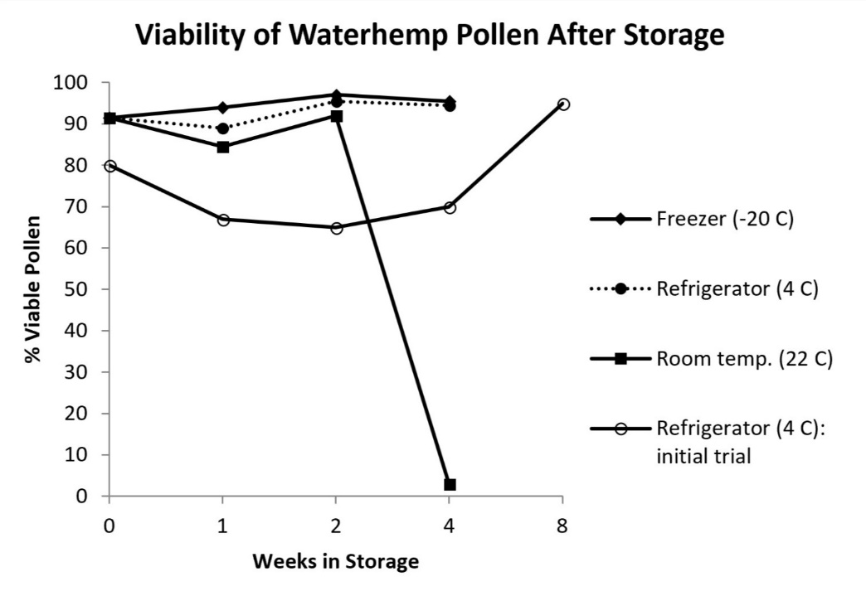
Figure 1. Percent viable waterhemp pollen after storage in different temperatures for different periods of time. All points are the average of two observations, except for the 4 C initial trial, and -20 C after 2 weeks.
Table 2. Percent viable waterhemp pollen after 1 or 4 weeks of storage at different temperatures. Within each column, values followed by the same letter are not significantly different (p > 0.05).
Percent viable pollen
after n weeks of storage
Storage conditions 1 4
Freezer (-20 C) 94.0 a 95.5 a
Refrigerator (4 C) 89.0 ab 94.5 a
Room temperature (22 C) 84.5 b 3.0 b

