Iron fertilizer evaluation and improvement
R. Jay Goos, Professor, Department of Soil Science, NDSU
Objectives: 1. To evaluate new iron fertilizers as they are introduced into the market. 2. To evaluate additives to FeEDDHA solutions that may reduce the short-term mobility of this fertilizer in soil, and thus improve its efficiency.
Summary of results: Objective 1: Eleven commercial iron fertilizers were evaluated for effectiveness in correcting IDC of soybeans grown in the greenhouse. One fertilizer (Marathon plus Greenboost) contained far less iron than was listed on the label, and this fertilizer was ineffective. The other ten fertilizers, containing FeEDDHA, FeEDDHSA, FeHBED, or mixtures of these compounds, were about equally effective in alleviating chlorosis in the first "crop" of about four weeks. However, the sources differed in effectiveness when a second "crop" of soybeans was grown. The study confirms our work of last year, which showed that "quality matters" when it comes to iron fertilizers, and that the higher-quality materials gave a longer-lasting response. It was estimated that farmers may need to apply 20-25% more of the lower-quality materials tested to equal the iron uptake of the best materials in the study. Objective 2: This research is still ongoing at the time of this writing. In the first experiment, experimental granular iron fertilizers were compared to FeEDDHA dissolved in water with regards to rate of movement through the soil. Over a 14-day leaching regimen, the differences between the leaching patterns of the materials were small. Granulation did not appear to slow down iron movement. In a second study, application of humates with FeEDDHA increased the amount of iron recovered, but adding humates to FeEDDHA did not slow leaching. In a third study, there was little difference in the rate of leaching fom FeEDDHA, FeEDDHSA, or FeHBED. However, in a fourth study, a polymer additive appeared to slow movement of FeEDDHA from the soil, and further studies are necessary to confirm these findings.

Methods, Objective 1
A greenhouse study was performed with six replications and twelve treatments. Treatments consisted of a control, and eleven iron fertilizers applied at a rate of 1 milligram of iron per pot. The fertilizers were applied according to the analysis on the label. The fertilizers are described in Table 1. The fertilizers were analyzed for water-soluble iron, and for "soil stable" iron, a test we developed. In the soil stability test, the soil is treated with a dilute solution of each fertilizer, and the amount remaining after a 7-day incubation period is deemed to be "soil stable." The theory is that the undesirable isomers and condensates will precipitate out during a 7-day incubation. The soybeans were grown in 2 liter, closed-bottom plastic pots, containing a mixture of 1 kg of white sand and 1 kg of an alkaline Glyndon soil collected near Hunter, ND. The site is known for producing severe IDC in soybeans. All pots, including the control, received basal fertilization with 67 mg of N as ammonium nitrate, 100 mg of P as K₂HPO₄, and 5 mg each of Zn, Cu, and Mn as sulfate salts. An inoculant suspension was also applied. The basal fertilizers and inoculant were applied to the sand in solution form, the sand mixed, and then mixed with the soil. Another 133 mg of N were applied to each pot after the plants emerged. Eight 'Mycogen 5072' soybean seeds were planted, and the pots thinned to four plants per pot after emergence. The pots were watered daily by weight to 15% water content. The relative chlorophyll contents of the first, second, and third trifoliolate leaflets were measured with a Minolta SPAD meter as they formed. After four weeks of growth, the plants were cut off at the seed-piece node, the tops rinsed in water, and dried at 65 C. The tops were weighed, ground to pass a 0.1 mm sieve, and analyzed for total iron by Agvise Labs. The contents of the pots were mixed, the remaining plant matter from the first crop (roots and lower stems) placed in the bottom of the pot, and the pots replanted to the same variety. After emergence, 200 mg of N as ammonium nitrate were added. Relative chlorophyll contents, dry matter production, and iron uptake were determined, as for the first crop.
Results, Objective 1
All of the iron fertilizers, except Marathon + Greenboost, alleviated IDC in the soybeans for the first crop (Figure 1). Relative chlorophyll (SPAD) readings were normal (non-chlorotic, values greater than 30) . Marathon + Greenboost was applied, assuming the percent iron on the label, 9%, but we found less than 0.5% water-soluble iron in the product.
We have learned over the years that growing a second 4-week "crop" is helpful in separating out differences in iron fertilizer product quality. The chlorophyll levels for the second crop are shown in Figure 2. None of the products produced non-chlorotic plants, as the greatest values were in the range of 14 SPAD units. However, there were significant differences between the various products. In general, those materials providing the highest rates of soil stable iron (Table 1), products like Iron Up, Soygreen, Soygreen Liquid, and Ferrale Evo, provided the greenest plants.
So, if iron fertilizers differ in quality, how do we adjust rates/prices accordingly? Table 2 estimates the fertilizer value of each product, relative to Soygreen, based on iron uptake by the plants. For example, the two FeEDDHSA products (Versa and Red Vigor) had lower % soil stable values (as EDDHSA is not as strong of a chelate for iron as EDDHA), and gave a lesser reponse to iron (Figure 2). It was estimated that Versa and Red Vigor gave 76 and 78% of the iron uptake response of Soygreen. This suggests that the rates of the lower-quality materials needs to be increased by perhaps 20-25% to give a similar iron availability as the best-quality materials in the study.
This experiment also allowed us to evaluate our "soil stability" test. Figure 3 shows the correlation between the rate of soil stable iron applied to the soil (Table 1), with the iron uptake by the soybean plants (Table 2). The soil stability test wasn't perfect, but was able to separate between the higher-quality materials and lower-quality materials. This test is important, as we don't have the equipment (HPLC) to analyze iron fertilizers for their various isomers and condensates.
Methods, Objective 2
Leaching studies were performed in ~8" columns (common greenhouse pots called 'conetainers'). In the bottom of each column was placed a glass marble, 12.5 mL of gravel, and 12.5 g of sand. Then the column was flushed with 20 mL of water, to remove any fines in the sand or gravel. Eighty grams of Glyndon soil was added, followed by 15 mL of water. The treatment was placed on the surface, 20 grams of soil added, followed by 12.5 mL of gravel. The column was covered with a plastic cup, and the treatment allowed to react with the soil for a week. Then, cups were placed under the columns, and 5 mL of 1 M HCl added to the cup. The cups were leached with 10 mL of water daily (about equivalent to 0.2" of water). Water began dripping from the cones after the fourth application of water. Then, daily, the contents of the cup were diluted to 500 mL, and a subsample taken. The cups were replaced underneath the column, and another 5 mL volume of acid added. The subsamples were analyzed for iron content by atomic absorption spectrophotometry. The rate of iron was approximately 2 mg per column.
The first experiment compared the movement of FeEDDHA (Soygreen) dissolved in water, versus five experimental granular chelate products, to determine if granulation might slow movement. The granular products were provided by industry and included FeEDDHA and FeEDDHSA-based products. The second experiment evaluated the effects of ammonium humate and potassium humate on movement. The third experiment compared the leaching rate of FeEDDHA, FeEDDHSA, and FeHBED. The fourth experiment compared two additives to FeEDDHA dissolved in water. One additive was an oil-based product believed to help chemical adhere to the soil, and the second was a polyacrylamide-based polymer which should help 'gel' the fertilizer.
Results, Objective 2
The effect of granulation of FeEDDHA or FeEDDHSA on the rate of leaching is shown in Figure 4. All products were FeEDDHA-based, except for Granule C which was FeEDDHSA-based. The basic shape of all of the curves was about the same, indicating that the soluble iron was moving through at about the same rate. Granule C had a much lower curve. Granule C was a FeEDDHSA-based granule, which tends to have more soil tie-up than FeEDDHA. Granule D was probably a lower-quality (lower ortho-ortho FeEDDHA product).
The effect of ammonium and potassium humate on the leaching of iron from the columns is shown in Figure 5. The iron product, Soygreen, was the same in all cases. Both the ammonium and potassium humate gave higher values for Fe leaching than FeEDDHA alone. Humates have weak chelation properties for iron, so perhaps the extra iron was from humate-complexed iron. Humates have been shown in Europe to improve the effect of FeEDDHA in correcting chlorosis, and perhaps further studies are warranted.
Figure 6 shows the rate of leaching from three different iron products. The curves are similarly-shaped, meaning that the rate of movement is about the same. The separation between the curves has to do with the quality of the chelates. FeEDDHSA does not have as high of a stability constant as FeEDDHA, and is more easily tied up by soil. The FeHBED product tested stated 9% Fe on the label, but our analyses (Marathon, Table 1) gave a lower value upon analysis.
Figure 7 shows the effect of two additives on rate of Fe leaching. The iron source was Soygreen in all cases. Additive 1, an oil-based product marketed to help pesticides adhere more strongly to soil, was ineffective in slowing down Fe movement. Additive 2, a gel-forming polymer additive, did appear to slow down movement, and a portion (almost a half of what was applied), did not move at all. This study is not completed as of the time of this writing. We will continue this work past the end of the contract, to confirm the effect of this polymer on the movement of iron from FeEDDHA.
The author thanks undergraduate students Hannah Ohm and Anne Dieter for their assistance with Objective 1 and Objective 2, respectively.

Table 1. Properties of the fertilizers studied.

 |  |  |  | Label | Water- | "Soil | Percent | Soil-Stable
Product | Distributor | Active ingredient | Phys. state | Fe content | Soluble Fe | Stable" Fe | "Soil Stable"⁺ | Fe rate
 |  |  |  | -------------------------- % -------------------------- |  |  |  | mg/pot
Ferrilene | Helena | FeEDDHA | Solid | 6.0 | 5.4 | 2.7 | 51 | 0.45
Iron Force | Winfield | FeEDDHA | Liquid | 2.2 | 1.9 | 0.8 | 42 | 0.37
Iron Up | Winfield | FeEDDHA | Solid | 6.0 | 6.1 | 4.4 | 73 | 0.74
Soygreen | West Central | FeEDDHA | Solid | 6.0 | 5.8 | 4.6 | 79 | 0.77
Soygreen | West Central | FeEDDHA | Liquid | 1.8 | 1.8 | 1.4 | 80 | 0.79
Versatile Iron Shield | Wilbur-Ellis | FeEDDHA | Liquid | 2.5 | 2.2 | 1.7 | 75 | 0.67
Ferrale EVO | Sipcam | FeEDDHA + FeHBED | Solid | 6.0 | 5.8 | 4.3 | 73 | 0.71
Red Vigor | Simplot | FeEDDHSA | Liquid | 2.0 | 1.6 | 0.7 | 45 | 0.35
Versa | Rosens | FeEDDHSA | Liquid | 1.8 | 1.5 | 0.6 | 38 | 0.32
Marathon | Maxsyst. Ag | FeHBED | Solid | 9.0 | 6.3 | 4.3 | 67 | 0.47
Marathon + Greenboost | Maxsyst. Ag | FeHBED | Liquid | 9.0 | 0.4 | 0.3 | 78 | 0.04
⁺Percent of water-soluble Fe that was soil stable (7-day incubation)

Table 2. Estimates of the fertilizer value of each product, relative to Soygreen (SG), based on increase iron uptake by soybean plants.

 | Fe uptake | Fe uptake | Fe uptake | Inc. over | Increase,
Product | first crop | second crop | sum | control | % of SG***
 | ---------------------- µg per pot ----------------------
Control | 186 | 40 | 226 | -- | --
Ferrilene | 444 | 76 | 521 | 294 | 80
Iron Force | 429 | 78 | 507 | 281 | 76
Iron Up | 487 | 89 | 576 | 350 | 95
Soygreen (SG) | 490 | 104 | 594 | 368 | 100
Soygreen Liquid | 463 | 101 | 564 | 338 | 92
Versatile Iron Shield | 474 | 82 | 556 | 330 | 90
Ferrale EVO | 449 | 105 | 554 | 328 | 89
Red Vigor | 433 | 75 | 508 | 281 | 76
Versa | 447 | 65 | 512 | 285 | 78
Iper Fer Marathon | 437 | 76 | 513 | 287 | 78
Iper Fer Marathon | 160 | 44 | 203 | -23 | ~ 0

Figure 1. Relative chlorophyll content of soybean plants, as affected by 11 different iron fertilizers. First crop.

Figure 2. Relative chlorophyll content of soybean plants, as affected by 11 different iron fertilizers. Second crop.

Figure 3. Relationship between the rate of "soil stable" iron applied, and iron uptake by soybean plants.

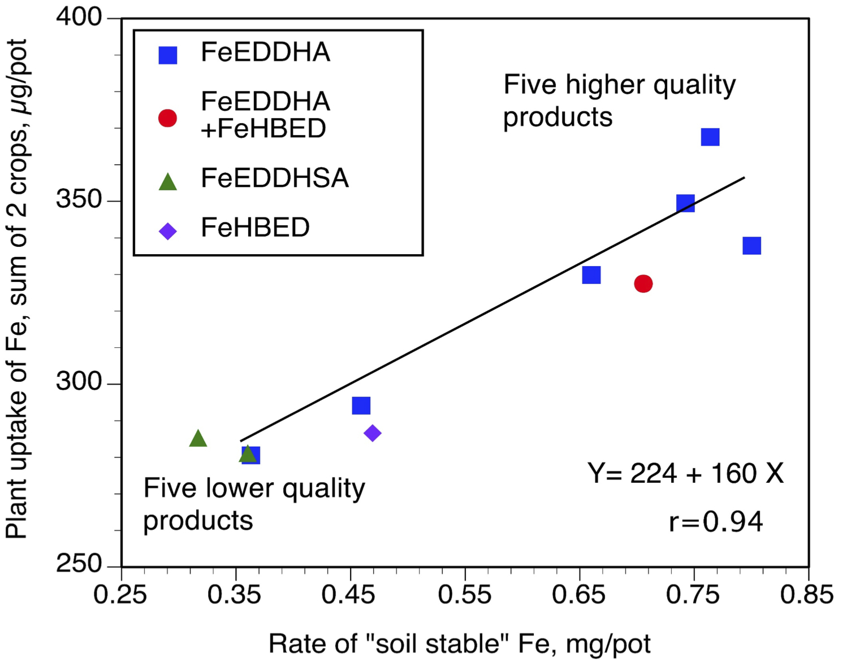

Figure 4. Leaching of different fertilizer iron products from soil columns. Soygreen was applied as a liquid, the other materials were experimental granules. Granule E was FeEDDHSA-based, the rest were FeEDDHA-based.

Figure 5. Effect of FeEDDHA, ammonium humate, and potassium humate on leaching of iron from soil columns.

Figure 6. Effect of iron source on leaching of iron from soil.

Figure 7. Effect of two additives on leaching of iron from soil columns.

