Final Technical Report
Impact of best water management on soil/water quality and soybean production
Xinhua Jia and Thomas Scherer
Department of Agricultural and Biosystems Engineering
North Dakota State University, Fargo, ND 58108
June 30, 2018
Situation statement
Above average precipitation and increased soil salinity on farmland caused delayed or prevented planting and harvesting the last two decades. Subsurface drainage (tile) installation has become a common practice to improve soil quality and crop production in the Red River Valley (RRV). With excess saline water removed from the top root zone, soybeans can grow in a healthier soil condition and produce a better yield. However, tile drainage water contains high dissolved salts and nutrients, which may pollute downstream surface water. Drainage water management (DWM) uses controlled drainage (CD) to manage drainage water flow and timing, and subirrigation (SI) to add water back into the field. Drainage water management can provide optimal soil moisture conditions for the crop and reduce the total amount of soil water and soluble salts/nutrients leaving the field in late spring after the soybeans are established. However, improper management of water, either too high or too low, can cause soil physical and chemical property changes, decrease soil/water quality, and reduce soybean yield. Through soil salinity and topographic mapping, and soil/water sampling, we can demonstrate the impact of DWM practices using six fields in the RRV.
Objectives
- To continuously evaluate water quality differences among different drainage water management (DWM) practices (surface drainage, tile drainage with gravity outlet, tile drainage with flow control, and subirrigation) using measureable parameters, including nutrients and salt contents in surface and subsurface outflow.
- To measure soil chemistry changes due to DWM and subirrigation (SI) practice via soil sampling and analysis around the tile drains.
- To assess the DWM and SI impacts on crop yield through soil salinity mapping.

Description of the research conducted
Six fields at two existing sites were used to study the impact of drainage water management on soil and water quality and crop production. The first site has two fields located near Fairmount, Richland County, ND. One field is surface drained with no tile drainage, and CD and SI are practiced in the other field. Soil quality is the major concern because of the poor subirrigation water quality with a SAR of 6 and electrical conductivity of 1.5 deci-siemens per meter (dS/m). Drainage outflow, subirrigation inflow, rainfall, snowfall, soil moisture and temperature profiles, relative humidity and air temperature, and water quality monitoring at the outlet are measured. Soil and water quality assessment due to CD and SI are evaluated, with intensive soil sampling and analysis and salinity mapping in the fall after harvest.
The second site is located in Clay County, MN and is divided into four fields. The four fields have similar soil types, but each with a different water management practice. One has no tile with only surface drainage, one has tile with no control on the outlet (conventional drainage), and the last two have drainage control structures plus the ability to subirrigate. Six pairs of 6-foot deep observation wells are installed in each field and the water table is measured continuously, even in the winter. Rainfall, snowfall, and snow equivalent water depth are measured in each field. Surface and subsurface runoff and subirrigation flow are also measured. Water quality is monitored at the outlet and in the drainage ditch for nutrient and salt load determination. During the growing season, soil moisture and water table are measured and used to guide the water management practices. At the end of the growing season, soil salinity, topographic, and crop yield maps are used to reveal the impact of DWM.
Results
This project, which centered on soil and water quality and crop yield responses due to different drainage water management, is an important component in a multi-state project funded by National Institute of Food and Agriculture, U.S. Department of Agriculture, under award number 2015-68007-23193, “Managing Water for Increased Resiliency of Drained Agricultural Landscapes” (http://transformingdrainage.org). With most of the results found in this report on the transforming drainage website, we will report the results related to the objectives of this project most important to ND soybean growers, e.g., the nutrient and salinity changes in soil and water as well as crop yield responses due to tile drainage, and drainage water management.

Nitrate nitrogen (NO₃-N) was measured in water samples from surface runoff, the tile outlets, controlled drainage outlets, and the legal surface drainage ditches, which represented a mixture of surface and subsurface flow from upstream. Figure 1 shows the NO₃-N measurements at the Clay County, MN site and Figure 2 shows the results at the Richland County, ND site.
Figure 1. Nitrate-Nitrogen concentrations from the drainage ditch upstream and downstream of the monitoring fields, and the control drainage structures of the control drained and controlled drained plus subirrigated fields at the Clay County, MN site in 2017.

From Figure 1, we can see clearly that the NO₃-N in the outlets were much higher than the NO₃-N in the surface drainage ditch (downstream and upstream), which was a mixture of surface and subsurface runoff flow. With the drainage control since the spring, however, none of the NO₃-N rich left the field into the surface water, but instead, it was used in the field for potential crop uptake. Subirrigation was applied in July 27 – September 8 for crop water consumption, and then in October 27 – November 1 for replenish of the soil profile at the Clay County site. Due to soil property difference, the NO₃-N at the outlets from the two fields were different in the spring time before July 1, 2017, but stayed the same after July 1.

Figure 2. Nitrate-Nitrogen concentration from the drainage ditch, upstream and downstream from the field, and two controlled drained plus subirrigated fields (Sump_west and Sump_east) at the Richland County, ND site in 2017.

Figure 2 indicates that NO₃-N was higher in spring/fall drainage mode, but during the subirrigation period in the summer, the NO₃-N was low. In 2017, subirrigation was applied in July 3 – August 12 for soybeans.

Ortho Phosphorus (P) is another important parameter affecting the surface water quality. Figure 3 shows the P monitoring at the Clay County, MN site and figure 4 shows the P at the Richland County, ND site.

Figure 3. Ortho phosphorus concentration in upstream and downstream ditches from the field, controlled drained, and controlled drained plus subirrigated fields at the Clay County, MN site in 2017.

The P results showed a similar pattern as the NO₃-N concentration, high in the field and low in the surface water. As with the NO₃-N concentrations, the P was held in the field due to controlled drainage, and water in the structure were residue flow or static water from the field. However, the P was different from the two fields though the management in 2017 were almost identical. Beside the soil difference, the topography is also different in the two fields, while the CD has high elevation and the SI has low elevation. The elevated higher P concentration in the downstream ditch water was not associated with drainage water from the field because the entire region was dry until early July. If using the 0.02 mg/L as the threshold for surface water quality, then both surface and subsurface flow exceeded the water quality standard for surface water.

Figure 4. Ortho-phosphorus concentration from the drainage ditch, upstream and downstream from the field, and two controlled drained plus subirrigated fields (Sump_west and Sump_east) at the Richland County, ND site in 2017.

The P concentrations were found similar to what was reported in Jia et al. (2012), higher during the subirrigation period, due to the P introduction from the groundwater. The findings indicate that the SI system provided P benefits to crop growth.

Salts in water samples were analyzed at the both MN and ND sites. Figure 5 and 6 show the electrical conductivity, a parameter representing total dissolved salts in a water sample from each site.
Figure 5. Electrical conductivity in upstream and downstream ditches from the field, controlled drained and controlled drained plus subirrigated fields at the Clay County, MN site in 2017.

Since the board was closed and drainage outflow was held in the field, the high salts in the CD and SI fields were not released from the field, and might not be potentially harmful to the crops (4 dS/m as the threshold). However, the EC in the two fields were highly different in the spring, indicating that the soil properties were different. The south part of the field released more salts from the field, than the central part of the field. After the SI was applied in the summer, the EC dropped in the south part of the field, either through leaching or dilution.

Figure 6. Electrical conductivity in upstream and downstream ditches from the field, and two controlled drained plus subirrigated fields (Sump_west and Sump_east) at the Richland County, ND site in 2017.

The EC level was much higher at the ND site than at the MN site. EC in the drainage outflow was 3.14 dS/m and in the surface ditch water was 4.2 dS/m. This indicated that without tile drainage, the field would have suffered from a high soil salinity and crop yield would be limited. However, in certain times of the year, the EC was above 6 dS/m, which would affect the crop growth due to salinity. This EC level was much higher than other years, as indicated by Dr. Kandel of Plant Sciences Department.

According to the landowner, before the tile drainage was installed, the lower quarter of the field was not worth planting. During the SI period in the summer, the EC was low because SI water has a lower EC. In the fall, when tile drainage was running again, the EC was higher than that in the summer, but lower than that in the spring, implying the mixture between drainage and irrigation water was beneficial. The high EC in the surface water indicated that there are more fields tile drained and the EC level was not affected by the single testing field. Also, the surface ditch water had less flow, which resulted in a higher EC.

Soil quality

Soil samples taken in the fall after harvesting from the top soil layer (0 -6 inch) and the bottom soil layer (6 – 18 inch) were analyzed for soil nutrient and salts concentrations. At the Clay County site, the soils were taken from the top, middle and bottom section of the fields along the drainage flow direction. At each location, the samples were also taken above the tile and in the middle of two tile lines to indicate the chemical differences due to different water management practices. The results are shown in Figure 7 for nitrate nitrogen, Figure 8 for phosphorus, and Figure 9 for electrical conductivity, respectively, for the Clay County, MN site.
Figure 7. Soil Nitrate-N concentrations at different sampling locations at the Clay County, MN site in fall 2017. UA = upper section of the field above the tile, UM = upper section of the field in the middle between two tiles, MA = middle section of the field above the tile, MM = middle section of the field in the middle between two tiles, BA = bottom section of the field above the tile, BM = bottom section of the field in the middle between two tiles in the undrained, free drained, control drained, and subirrigated fields. The white bars represent the top soil (0-6 inch) and the grey bars represent the bottom soil (6 – 18 inch).

Differences in NO₃-N were observed among the fields, with FD the highest at both the top (100.5 lb/ac) and the bottom (99.3 lb/ac) soil layers, and the CD field the lowest concentrations at 14.5 and 40 lb/ac for the top and the bottom soil layers, respectively. Within the same field, a higher NO₃-N difference was found between the top and the bottom soil layers in the CD and SI fields, while the UD and the FD fields had similar NO₃-N between the top and the bottom soil layers.

Figure 8. Soil phosphorus concentrations at different sampling locations at the Clay County, MN site in fall 2017. UA = upper section of the field above the tile, UM = upper section of the field in the middle between two tiles, MA = middle section of the field above the tile, MM = middle section of the field in the middle between two tiles, BA = bottom section of the field above the tile, BM = bottom section of the field in the middle between two tiles in the undrained, free drained, control drained, and subirrigated fields. The white bars represent the top soil (0-6 inch) and the grey bars represent the bottom soil (6 – 18 inch).

Similar to the NO₃-N difference, the P concentrations were the highest in FD field, with 29.8 and 13.2 mg/L for the top and bottom soil layers, respectively. It is obvious that the top soil had a higher P concentration than that the bottom soil regardless of the fields. P concentrations were the lowest in the CD field, similar to the NO₃-N concentrations in this field. In the CD and SI fields, while water from the upper section of the field to the bottom section of the field, the bottom of the fields showed a higher P concentrations than the upper part. However, the same pattern was not found for the NO₃-N concentrations.
Figure 9. Soil electrical conductivity at different sampling locations at the Clay County, MN site in fall 2017. UA = upper section of the field above the tile, UM = upper section of the field in the middle between two tiles, MA = middle section of the field above the tile, MM = middle section of the field in the middle between two tiles, BA = bottom section of the field above the tile, BM = bottom section of the field in the middle between two tiles in the undrained, free drained, control drained, and subirrigated fields. The white bars represent the top soil (0-6 inch) and the grey bars represent the bottom soil (6 – 18 inch).

The soil salinity level in the four fields were relatively the same even after tile drainage for six years. The top soil layer had a slightly higher salts concentration than the bottom layer. Overall, the soil salinity level was low and below the threshold of concern.

Top and bottom soil layer samples were randomly taken to test for NO₃-N, P, and EC at the Richland County, ND site in fall 2017. The results are shown in Figures 10 (NO₃-N), 11 (P), and 12 (EC), respectively,
Figure 10. Soil nitrate-nitrogen concentrations at eight quadrant sampling locations in the undrained field and subirrigated field at the Richland County, ND site in fall 2017. The white bars represent the top soil (0-6 inch) and the blue bars represent the bottom soil (6 – 18 inch).

The NO₃-N concentrations were similar between the undrained and tile drained + control drained + subirrigated fields, with the NO₃-N in the SI slightly lower than that in the UD field. However, the top soil had a consistently higher NO₃-N than that in the bottom soils, 97.75 lb/ac vs. 36 lb/ac in the SI field, and 107.75 lb/ac vs. 38.75 lb/ac in the UD field. A lower NO₃-N in the SI can be explained with more denitrification loss in the bottom layer. Denitrification was probably caused by the soil moisture difference between the top and the bottom soils since it occurred in both fields. These results were different from the findings at the Clay County site.

Figure 11. Soil phosphorus concentrations at eight quadrat sampling locations in the undrained, and subirrigated fields at the Richland County, ND site in fall 2017. The white bars represent the top soil (0-6 inch) and the blue bars represent the bottom soil (6 – 18 inch).

The P concentration in the tile drained + control drained + subirrigated field was higher than that in the undrained field. The top soil also had a higher P than that in the bottom soil. Though SI brings additional P to the field, when averaging the P levels for the entire field, the P concentrations in the UD and SI fields were about the same.

Figure 12. Soil electrical conductivity at eight quadrat sampling locations in the undrained, and subirrigated fields at the Richland County, ND site in fall 2017. The white bars represent the top soil (0-6 inch) and the blue bars represent the bottom soil (6 – 18 inch).

The EC level at the Richland County, ND site was much higher than that at the Clay County, MN site. Though the average values were about the same, the SI field had a higher EC (1.23 dS/m) than that in the UD field (0.82 dS/m), possibly due to enhanced evaporation from a slightly wetter soil in the SI field. These values were also higher than the EC values in 2016, 0.91 dS/m and 0.57 dS/m for the SI and UD fields, respectively. Compared to the MN site, the salt level at the ND site was higher.

Soil salinity is common and unique in the Red River Valley due to rich parent materials in the region. Tile drainage is probably the only effective way to reduce soil salinity and make the land farmable. Depending on the salts in the soil and water, sodic soils that with high exchangeable sodium can be different from saline soil. The SI water at the ND site has a sodium adsorption ratio (SAR) 6, which may potentially cause the soil to be more sodic with tile drainage. Therefore, a periodic soil sampling around the tile drains has been conducted since 2007. Figure 13 shows the soil analysis results at the ND site.

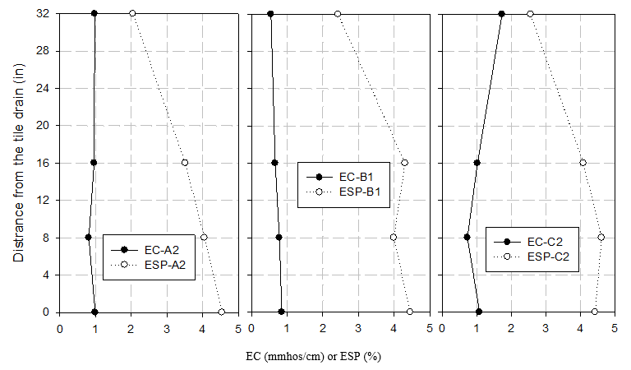
Figure 13. Soil electrical conductivity (EC) and sodium exchangeable percentage (ESP) at distance away from the tile drains at three locations (A2, B1, and C2) at the Richland County, ND site in 2017.

Due to insufficient soil samples, exchangeable sodium percentage (ESP), another parameter for sodic effect, was analyzed, while there was no enough soil samples for SAR analysis. As seen from Figure 13, for all three locations, the ESP s greater near the tile, and smaller away from the tile drain. This indicated a slight built-up of sodium near the tile due to the introduction of SI water. Among these three sites, C2 has been subirrigated longer than the other two sites and is the lowest elevation spot in the field. Instead of a higher ESP, however, the EC at the C2 location has increased at the distance away from the tile near the soil surface. This is different from the results in 2015, while the increase EC or salinity level might be caused by enhanced evaporation if maintaining a shallow water table at this location.

Figure 14 shows the soil chemical analysis around the tile drains at the Clay County, MN site.

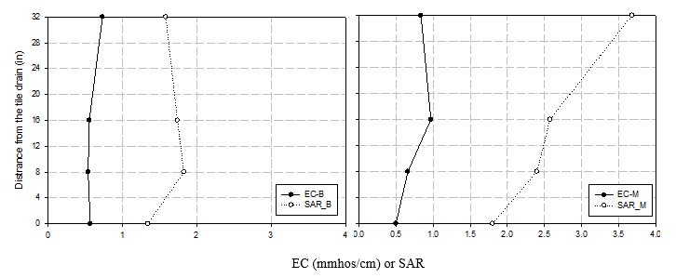
Figure 14. Soil electrical conductivity (EC) and sodium adsorption ratio (SAR) at distance away from the tile drain in the middle (M) and bottom (B) part of the subirrigated field at the Clay County, MN site in 2017.

The results at the MN site showed that due to soil property difference, the middle part of the field has an increasing sodicity, especially near the soil surface. The EC, however, stayed at a relative stable level. Continuous monitoring of SAR is needed at this location.

Soil salinity map is a visual way to show the spatial distribution of the soil salts. A soil salinity mapping up to 1 m soil depth was conducted using an EM38 electromagnetic device with soils samples taken to calibrate the readings. The results are shown in Figures 15 – 18.
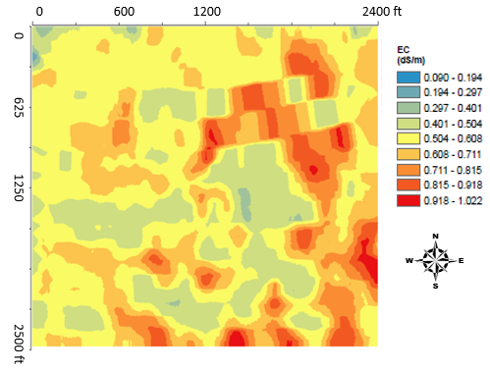
Figure 15. Soil salinity map for the control drained (south 1/3), and control drained plus subirrigated (middle 1/3) fields at the Clay County, MN site in fall 2017.
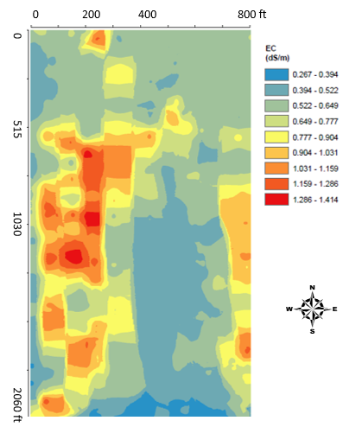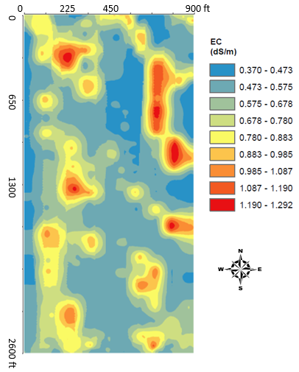
Figure 16. Soil salinity maps for the undrained (left) and free drained (right) fields at the Clay County, MN site in fall 2017.

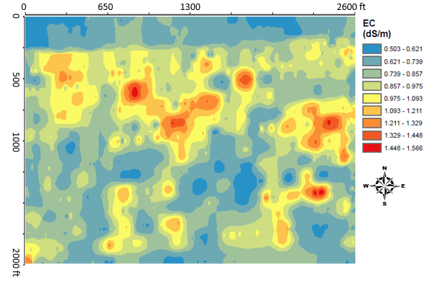
Figure 17. Soil salinity map for the control drained plus subirrigated field at the Richland County, ND site in fall 2016.

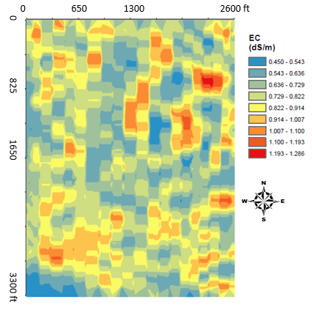
Figure 18. Soil salinity map for the undrained field at the Richland County, ND site in fall 2017.

From the salinity maps, we can see that the soil salinity was lower at the MN site, and higher at the ND site. However, the west side of the UD field had visual saline seeps as shown in the soil salinity map as well. For the fields at the MN site, this is the second time we conducted soil salinity maps, but for the ND site, we have done soil salinity maps three times since fall 2007. A clear trend of soil salinity decrease can be seen for the north half of the field since the tile drainage was installed in 2011. For the south half of the field, the soil salinity was stable around 1 dS/m, which is a good benefit derived from continuous tile drainage and subirrigation in the field. However, compared to the salinity map in 2016, the EC level was enhanced in 2017.

Crop yields in 2017 are listed in Table 1, with the county average yield for that crop listed in the table as well.

Table 1. Comparison of crop yields in 2017 for undrained (UD), conventional tile drained (FD), control drained (CD), and CD and subirrigated (SI) at the Clay County, MN and Richland County, ND sites.

Location | Practice | Crop type | Yield (bu/ac) | County Average Yield (bu/ac) | Difference (bu/ac) | Difference (%)
MN site | UD | Corn | 187 | 166 | 21.0 | 12.7
 | FD | Corn | 196 | 166 | 30.0 | 18.1
 | CD | Corn | 177 | 166 | 11.0 | 6.6
 | SI | Corn | 177 | 166 | 11.0 | 6.6
ND site | UD | Soybean | 50 | 41.3 | 8.7 | 3.4
 | SI | Soybean | 43 | 41.3 | 1.7 | 8.5

The SI field in Richland County, ND has been providing steady and consistent higher yield in the last five years and one of the most important reasons was the good understanding of how to manage the water. However, in 2016, due to a sump pump failure, a high water table was sustained for an extended time, the corn yield was slightly higher than the County average corn yield. In 2017, the soybean yield in the subirrigation field was much lower than the undrained field. This was a disappointment, however, we all learned again that a short duration of waterlogging created more damage to the crop than a long duration of drought conditions. Further investigations in the field reviewed that the low yields were caused by compaction and waterlogging stress in the east side of the field. High soil salinity spots were also found in some poor crop areas. A compacted clayey layer at 16-20 in depth was found in a very poor crop growing area. More field investigations are needed in order to help the landowner manage the crops in a better way.

