MOLECULAR QUANTIFICATION OF SOYBEAN CYST NEMATODES IN SOIL IN NORTH DAKOTA

TECHNICAL REPORT
NORTH DAKOTA SOYBEAN COUNCIL
June, 2018

Principal Investigator:
Dr. Guiping Yan, Dept. Plant Pathology, NDSU

The soybean cyst nematode (SCN) continues to be a major threat to soybean production in North Dakota (ND). It reduces crop yield by feeding on the plant root and thereby limiting nutrient and water absorption by the plant. However, other nematodes including sugar beet cyst nematode, clover cyst nematode and cereal cyst nematode may occur in ND fields. These nematodes are traditionally differentiated based on morphology by microscopy. However, distinction between SCN and these nematodes using the traditional identification methods is not only difficult and time-consuming but also requires high expertise in nematode taxonomy. Again, morphological characters are not adequate to reliably separate these nematodes. The primary goal of this project was to develop a molecular identification and quantification tool for SCN alternative to the traditional method. The specific objectives were to design highly specific real-time PCR primers to detect SCN in soil and to discriminate it from sugar beet cyst nematode and other nematode species that are known to occur or may occur in ND, and to Develop a real-time PCR assay to quantify SCN directly from DNA extracts of field soils and validate that assay using artificially inoculated and naturally infested soils.

In this project, we have been able to develop effective molecular assays capable of identifying and quantifying SCN and differentiating it from other closely related species such as sugar beet cyst nematode. This method is highly specific and sensitive compared to the traditional method of SCN quantification in soybean fields. This development will speed up SCN test results to growers and prevent false positive or false negative results. Sensitive and accurate detection and quantification of SCN are essential for recommending effective management measures against SCN.

Genomic regions of a nematode parasitism gene CLAVATA3 from SCN populations from ND were amplified and sequenced. The ND sequences, together with CLAVATA3 sequences of cyst nematodes at the GenBank, were used to design SCN-specific qPCR primers (SCNF: ACCATTTTGGTGGCCATGG, and SCNR: TCCAGCGGTGACAATTCTT) which showed high specificity to SCN (Figure 1). The specificity of the primers was also evaluated using seven isolates of SCN and 31 other nematode species. Varying numbers of SCN eggs or juveniles (0, 1, 4, 16, 64, 256) were inoculated into 0.25 g sterilized soil from which soil DNA was extracted using the Qiagen Power Soil DNA Isolation Kit and a standard curve relating threshold cycle and log values of nematode number was generated (y = -3.516x + 30.846; E = 92.5 %; R² = 0.99) as shown in Figure 2. The assay was validated by quantifying different SCN numbers artificially added to a sterilized soil (Figure 3).

The validated assay was used to estimate SCN numbers in 34 field soil samples from ND naturally infested with the nematode at varying levels; the identities of SCN in the field soils were confirmed by randomly sequencing of two genomic regions of 15 populations. For each soil sample, 400 g of soil was collected and divided in half for molecular quantification, and traditional egg extraction and microscopic enumeration (Table 1). We also designed another CLAVATA3 (CLE2F: CACCATTTTGGTGGCCATGG; CLE2R: GTCGCCAGGGAAGTGAAGAG) primer pair specific to both SCN and SBCN but are able to separate the two species simultaneously based on melt curve peak temperature (Figure 4). Finally, we found that different soil textural classes may have effects on quantification efficiency as soils with more clay content may inhibit qPCR amplification reflected in increased Cq values (Figure 5).

The outcome of this project has far reaching consequence in the management of this nematode. Currently, detection of SCN relies on the traditional method based on morphology which includes nematode extraction from soil and identification under microscope. Nematode extraction from soil is both time and labor intensive. Identification of SCN based on morphology can be extremely challenging due to highly variable morphology within species or a population. The SCN life stage (juveniles) commonly found in soil may lack important features for accurate identification. Moreover, other cyst-forming, non-SCN juveniles look just like SCN juveniles and are hard to separate under microscope. SCN identification using eggs or cyst is uncertain since nematode eggs and/cysts are highly similar. Consequently, using the traditional method, detection of SCN at low population density is hard, unreliable and could lead to false positive or false negative results.

The developed molecular assay provides a platform to detect SCN sensitively and directly from DNA extracts of field soil, which allows us to avoid time-consuming steps of nematode extraction and microscopic identification. The molecular assay is highly specific to SCN and will improve SCN detection efficiency in soybean fields in ND and help prevent false positive or negative detection results for soil samples submitted by growers. Further, there are other cyst nematodes that may be present in fields in ND. These include the sugar beet cyst nematode Heterodera schachtii, clover cyst nematode H. trifolii, cereal cyst nematode H. avenae, and Cactodera cyst nematode C. weissi and C. milleri. These nematodes are very similar to SCN in morphology and may be associated with weeds, grasses or other rotational crops used in SCN management. This assay provides a distinction method between SCN and these cyst nematodes for effective SCN management using crop rotation.

M Hs Hs Hs Hs Hg Hg Hg Hg C
165bp
500bp
Figure 1. PCR amplification using SCN-specific primers SCNF and SCNR. Hs = Heterodera schachtii (sugar beet cyst nematode), Hg = Heterodera glycines (soybean cyst nematode), C = water control, M = 100bp ladder.

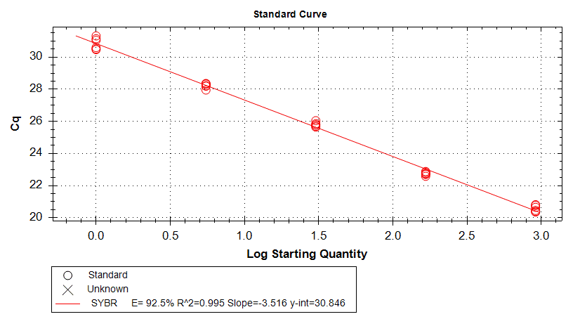

Figure 2. Standard curve showing linear relationship between log number of nematodes and threshold cycle (Cq) number.

#eggs/0.25 g of soil
qPCR estimates

Figure 3. Linear relationship between nematodes actually added to soil and qPCR (quantitative real-time PCR) estimates.

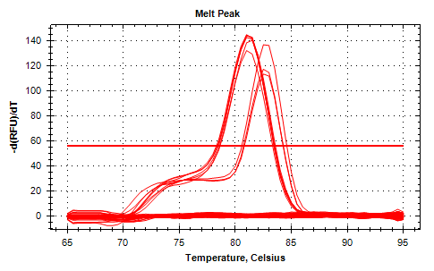
SCN
SBCNN
Figure 4. Distinguishing SCN (soybean cyst nematode) and SBCN (sugar beet cyst nematode) simultaneously using CLAVATA3 (CLE2F and CLE2R) primers. SCN DNA melts at 81.5 ⁰C whereas SBCN DNA melts at 83.5 ⁰C.

Figure 5. Effects of soil texture on quantification of SCN.

Table 1. Quantification of soybean cyst nematodes from field soils in ND using traditional and qPCR methods
Sample No. | Field Sample ID | Soil |  | Cyst |  | Total | Mean Cq value | qPCR estimate
 |  | J2 | Egg | J2 | Egg
1 | Y2 SCN 62 | 14 | - | - | 190 | 204 | 33.99 | 103
2 | Y2 SCN 2 W | 75 | - | 15 | 360 | 450 | 31.02 | 713
3 | Y2 SCN 59 | - | 70 | - | 900 | 970 | 30.00 | 1,390
4 | Y2 SCN 78 | 25 | - | - | - | 25 | 34.20 | 88
5 | Y2 SCN 2 | - | - | - | - | 0 | N/A | 0
6 | Y2 SCN 49 N | 13 | - | 225 | 1,275 | 1,513 | 30.85 | 1,392
7 | Y2 SCN 103 | 25 | - | 735 | 120 | 880 | 30.01 | 1,383
8 | Y2 SCN 55 | 20 | - | 75 | - | 95 | 32.77 | 227
9 | Y2 SCN 157 | - | - | 135 | 30 | 165 | 32.42 | 285
10 | Y2 SCN 95 | - | - | - | - | 0 | N/A | 0
11 | Y1 101 | 330 | - | - | 18,946 | 19,276 | 26.10 | 17,902
12 | Y2 SCN 52* | 30 | - | - | 5,200 | 5,230 | 29.23 | 2305
13 | Y2 SCN 81 | 30 | - | - | 2,680 | 2,710 | 29.93 | 1458
14 | Y2 SCN 48 N | 137 | - | 700 | 1,680 | 2,517 | 29.12 | 2,477
15 | Y2 SCN 79 N | - | - | - | - | 0 | N/A | 0
16 | Y2 SCN 63 | 175 | - | 3,850 | 45 | 4,070 | 29.01 | 2,662
17 | Y1 SCN 102 | 219 | - | - | 1,893 | 2,112 | 29.91 | 1,477
18 | Y2 SCN 69 | 25 | - | - | 15 | 40 | 33.41 | 149
19 | Y2 SCN 61 | 100 | - | 810 | 45 | 955 | 31.81 | 425
20 | Y2 SCN 38* | - | - | - | - | 0 | 34.44 | 76
21 | SCN 131 | 60 | - | - | - | 60 | 34.81 | 60
22 | SCN 53 | - | 22 | - | - | 22 | 34.81 | 60
23 | SCN 193 | 25 | - | - | - | 25 | 33.11 | 182
24 | SCN 46 | 13 | - | 15 | - | 28 | 34.88 | 57
25 | SCN 52 | - | 10 | 70 | - | 80 | 34.02 | 100
26 | SCN 139 E | - | - | - | - | 0 | N/A | 0
27 | SCN 95 | - | 30 | - | - | 30 | 34.78 | 60
28 | Y2 SCN 79 | 22 | 109 | - | 60 | 191 | 32.49 | 272
29 | SCN 244 | 388 | - | - | - | 388 | 32.98 | 197
30 | SCN 220 | - | 63 | - | - | 63 | 34.85 | 58
31 | SCN 50 | 60 | 75 | - | - | 135 | 33.74 | 140
32 | Y2 SCN 73 | 13 | - | - | - | 13 | 34.99 | 60
33 | Y2 SCN 55N | - | - | - | - | 0 | 34.52 | 83
34 | SCN 238 | - | - | - | - | 0 | 34.94 | 62
- Means nothing was recorded

