SCREENING COVER CROPS TO REDUCE SOYBEAN CYST NEMATODE IN INFESTED FIELDS

TECHNICAL REPORT

NORTH DAKOTA SOYBEAN COUNCIL
JUNE 2018

Dr. Guiping Yan, Principal Investigator, Dept. Plant Pathology, NDSU
Co-investigators: Dr. Marisol Berti, Dept. Plant Science, NDSU and Dr. Sam Markell, Dept. Plant Pathology, NDSU

Soybean cyst nematode (SCN), Heterodera glycines, is one of the most important pests of soybean production in North Dakota (ND). It is an endoparasitic nematode, which infects through soybean roots, causes colonization of roots and ultimately affects growth and development of the soybean crop. This nematode not only infects soybean, but also invades other leguminous crops and weed species, which play an important role in nematode survival and population increase in fields. Limited sources of resistance being utilized for developing resistant cultivars for managing this nematode cause the virulence changes in nematode populations, so integrated management strategy is necessary for sustainable management of this devastating soybean pest. Cover crops that are non-host to SCN and have the ability of reducing SCN population can be integrated in the management practice as an alternative means.

Previous studies have shown that cover crops could suppress plant-parasitic nematode populations such as root-knot nematode (Meloidogyne spp.), root lesion nematodes (Pratylenchus penetrans), sugar beet cyst nematode (Heterodera schachtii), and potato cyst nematode (Globodera spp.). Cover crops may also reduce SCN populations, by three ways such as non-host with encouraging SCN egg hatching, producing toxic biochemical compounds, and acting as a trap crop. In ND, commonly grown cover crops have not been tested for SCN and no information is available about the interaction between cover crops and SCN. The overall goal of this research is to sustainably manage SCN by utilizing cover crops as an alternative means. The specific objectives are to 1) screen common and potential cover crop species in ND for their hosting abilities to SCN; and 2) evaluate cover crops for reducing SCN numbers in infested fields.

Commonly grown and potential to be grown twenty-one cover crops and species in the Northern Great Plains were selected based on availability. Two SCN populations were collected from each field of Cass and Richland counties in ND. SCN populations were increased in the greenhouse by inoculating plants of susceptible soybean, Barnes. SCN white females (cysts) were collected for each SCN population and crushed to obtain eggs and juveniles. Eggs and juveniles were counted under the microscope, then used as inoculum for host range evaluation. Each of the cover crops and susceptible soybean cultivars were planted in a cone-tainer having about 100 cm³ of soil and inoculated with 2,000 eggs and juveniles of each SCN population, then kept in a growth chamber for 35 days at 27 °C (Figure 1). Experimental design was completely randomized design with 5 replications. After 35 days, plants were taken out from the growth chamber and SCN white females were extracted from soil and roots of each plant. Collected white cysts were counted under a microscope. The hosting ability of cover crops and species was determined by calculating a female index (FI = average number of females on a crop/average number of females on the soybean Barnes x 100). Female index of 10 or greater was considered as host for SCN, less than 10 considered as poor-host, and FI of 0 as non-host for SCN.

Out of the 21 cover crops tested for host status in the greenhouse conditions, 13 of the cover crops including annual ryegrass, camelina, carinata, cow pea, ethiopian cabbage, faba bean, foxtail millet, radish, rape dwarf essex, red clover, sweet clover, triticale, and winter rye did not support SCN reproduction (Table 1), suggesting non-hosts of SCN. Four cover crops showed very low reproduction for both SCN populations, with FI less than 10 but greater than 0 (FI = 2 in crimson clover cv. Dixie; FI = 2 and 6 in Turnip cv. Purple top; FI = 4 and 9 in hairy vetch; FI = 9 and 3 in forage pea cv. Arvika), suggesting as poor hosts. However, Austrian winter pea and field pea (Cooper) supported very low reproduction for the SCN population from soil 2W (FI = 3 in both crops) but did not support any SCN reproduction from soil 103, suggesting that they are non- or poor hosts of SCN. Two cover crops showed some reproduction with FI greater than 10 (FI = 13 in field pea cv. Aragorn for soil 2W; FI = 11 in turnip cv. Pointer for soil 103), indicating hosts for at least one of the SCN populations. In general, SCN reproduced much less in all the tested cultivars compared to the two susceptible checks (Table 1).

Ten cover crops (annual ryegrass, Austrian winter pea, carinata, faba bean, foxtail millet, radish, red clover, sweet clover, turnip and winter rye) and the susceptible soybean cultivar (Barnes) were selected for the microplot study (Figure 2), based on the results from the greenhouse experiments. Soil was collected from the same two fields in Cass and Richland counties. SCN population density of each soil was determined by extracting and counting nematodes. About 9-inch diameter plastic pots each holding 5 kg of soil were used for planting these crops in both the field soils. Standard seeding rate of each crop was used for determining number of plants per pot. Plants were kept in the greenhouse for two weeks for better establishment before they were moved to the microplot in natural field conditions. Experimental design was randomized complete block design with 5 replications.

For setting up the microplot, required holes were made in the field and plastic pots were buried with the top part about 5-8 cm high above the soil surface. The remaining surface of the field was covered with plastic mesh, called weed barrier, to prevent the weeds and contamination of the pots from surrounding soil. Regular watering and fertilization were applied in the pots as needed. After 75 days of planting, three soil cores were collected from each pot to determine the final population density. Reproductive factor was determined by dividing the final SCN population density by the initial population density in each pot. After soil sampling, plastic pots with crops were left as it was for winterkill then samples were collected again in the spring for determining the nematode population density and reproductive factor.

In soil 103, only carinata, Annual ryegrass, and Radish significantly (P < 0.0001) reduced (RF: from 0.3 to 0.4) the SCN population compared to the non-planted control and susceptible soybean (Figure 3). In soil 2W, all crops except Austrian winter pea, foxtail millet, and carinata significantly (P < 0. 0001) reduced (RF: from 0.4 to 0.6) the SCN population compared to the non-planted control and susceptible soybean. Among the cover crops tested, annual ryegrass and radish had the lowest average RF (≈ 0.4) for both SCN populations (Figure 3). Moreover, the spring sampling and counting of SCN population showed no much reduction in nematode population compared to the population before winterkill suggesting no effect of winterkill on population reduction. Annual ryegrass and radish greatly reduced SCN numbers by an average of 61% and 64%, respectively, for the two SCN populations.

Another set of cover crops will be screened for hosting and population reduction abilities for the two SCN populations in the greenhouse and microplot conditions. Cover crops, which are non-host with the greater population reduction abilities will be evaluated for understanding the mechanisms of population reduction and will be utilized for further field trials for developing SCN management strategy. The research findings will be useful to navigate the selection and use of cover crops for farmers for reducing SCN damage to increase soybean yield in ND.
Table 1. Reproduction of soybean cyst nematode in cover crops planted in artificially infested soil with 2,000 eggs and juveniles of each of the SCN populations (soil 103 and 2W).
 |  |  | No. of white females (cysts) per plant
Crop | Scientific name | Family | Soil 2W | Soil 103
Soybean (Barnes) | Glycine max | Leguiminosae | 260 | 122
Soybean (Sheyenne) | Glycine max | Leguiminosae | 205 | 135
Field pea (Aragorn) | Pisum sativum L. | Leguiminosae | 33 | 2
Forage pea (Arvika) | Pisum sativum L. | Leguiminosae | 24 | 4
Hairy vetch | Vicia villosa | Leguiminosae | 10 | 11
Turnip (Pointer) | Brassica rapa subsp. rapa | Brassicaceae | 10 | 13
Field pea (Cooper) | Pisum sativum L. | Leguiminosae | 9 | 0
Austrian winter pea | Pisum sativum subsp. arvense | Leguiminosae | 8 | 0
Turnip (Purple top) | Brassica rapa subsp. rapa | Brassicaceae | 5 | 7
Crimson clover (Dixie) | Trifolium incarnatum | Leguiminosae | 4 | 2
Annual ryegrass | Lolium multiflorum | Poaceae | 0 | 0
Camelina (Bison) | Camelina sativa | Brassicaceae | 0 | 0
Carinata | Brassica carinata | Brassicaceae | 0 | 0
Cow pea | Vigna unguiculata | Leguiminosae | 0 | 0
Ethiopian cabbage | Brassica oleracea | Brassicaceae | 0 | 0
Faba bean | Vicia faba | Fabaceae | 0 | 0
Foxtail millet (Siberian) | Setaria italica | Poaceae | 0 | 0
Radish (Daikon) | Raphanus sativus | Brassicaceae | 0 | 0
Rape dwarf essex | Brassica napus | Brassicaceae | 0 | 0
Red clover (Allington) | Trifolium pratens | Fabaceae | 0 | 0
Sweet clover | Melilotus albus | Fabaceae | 0 | 0
Triticale (Winter 336) | Triticale hexaploide Lart | Poaceae | 0 | 0
Winter rye (Dylan) | Secale cereale | Poaceae | 0 | 0

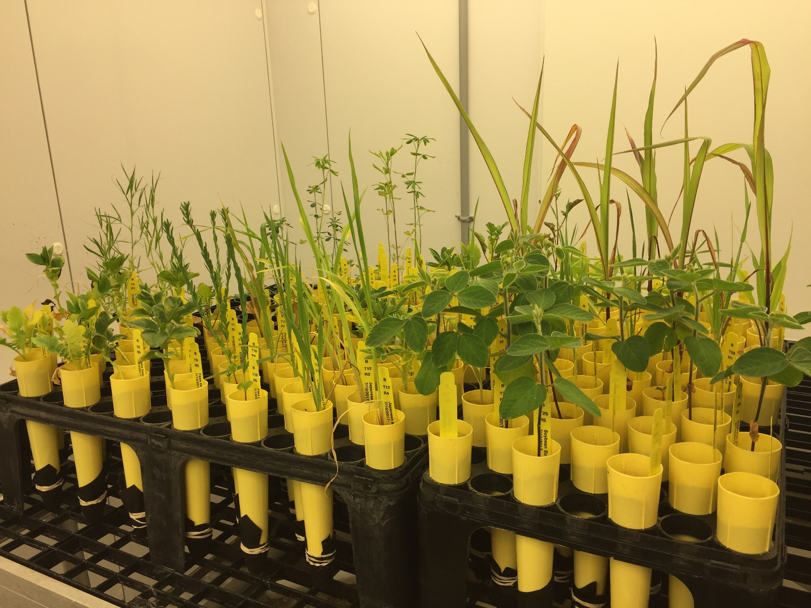
Figure 1. Cover crops grown in cone-tainers each containing 100 cm³ of autoclaved sandy soil inoculated with each SCN population and kept in a growth chamber at 27°C for SCN host range evaluation.

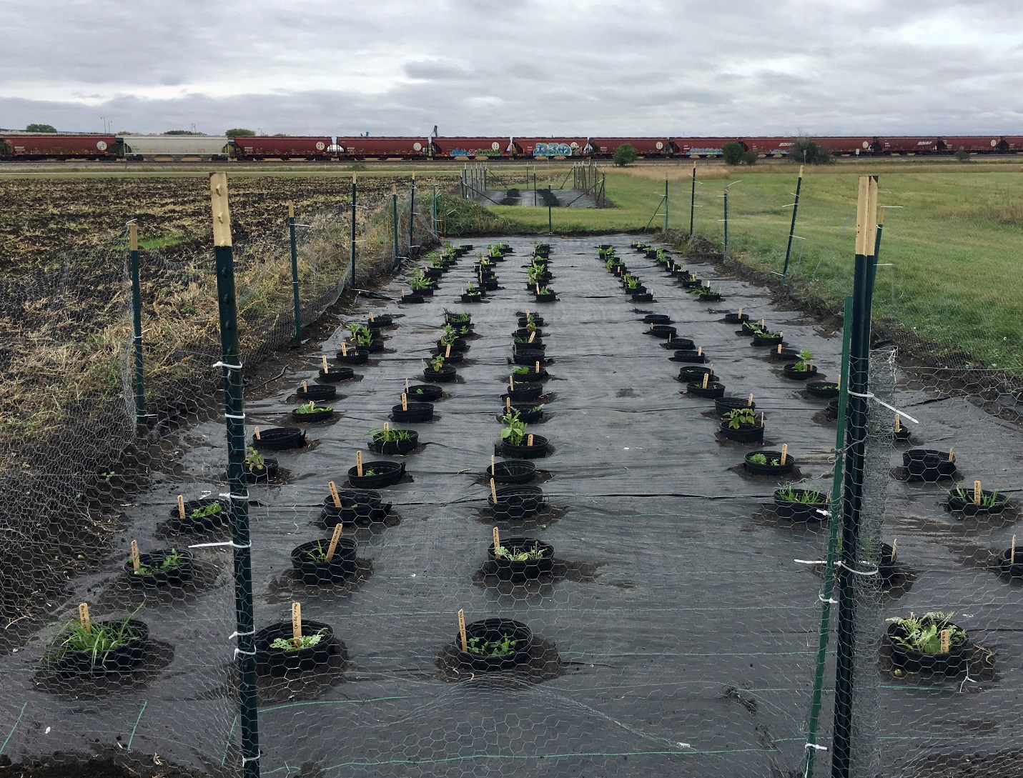

Figure 2. Cover crops grown in plastic pots each containing 5 kg of naturally infested soil in the microplot.

Figure 3. SCN population reduction by cover crops planted in the microplot with each of the two infested field soils (Soil 2W and 103) in natural conditions.

