EFFECT OF SOYBEAN CYST NEMATODE ON FUSARIUM
ROOT ROT OF SOYBEAN

TECHNICAL REPORT
NORTH DAKOTA SOYBEAN COUNCIL
JUNE, 2018

Dr. Berlin D. Nelson Jr., Principal investigator, Plant Pathology, NDSU
Dr. Hui Yan, Research Scientist, Plant Pathology, NDSU

Furarium root rot caused by F. solani and F. tricinctum are two common and serious root rot pathogens of soybean in North Dakota. Although Fusarium is common on soybean plants, it does not always cause yield losses. Healthy, well growing plants can produce new roots and compensate for the loss of decayed roots. Plants are more likely to suffer from Fusarium root rot when they are stressed by abiotic factors such as a lack of water or biotic factors such as other pathogens. Soybean cyst nematode (SCN) is now common in many soybean fields having been found in about 15 counties in the eastern part of North Dakota. SCN causes wounds as they penetrate the roots and they change the physiology of the root while feeding in the root. These effects of the nematodes could increase the damage caused by Fusarium root rot. The goal of this research is to determine if the interaction of soybean cyst nematode with Fusarium root rot results in greater damage to the plant. The emphasis will be on determining the relationship between SCN egg levels, inoculum levels of Fusarium and severity of root rot. To validate our hypothesis that SCN will increase the amount of root rot by these two Fusarium root pathogens, especially at moderate to low Fusarium inoculum levels, experiments in greenhouse and field conditions were conducted during 2016 and 2018. This is the final report of this project.

Two Fusarium species, F. solani (isolate 91-113-3) and F.tricinctum (isolate 91-1-8), were used in experiments. Barley grain served as fungal nutrient substrate of Fusarium spp. Different amounts of barley grain infested by the Fusarium pathogens were designated as Fusarium levels and amounts of nematode eggs were designated as SCN levels. In each experiment, susceptible soybean cultivar Barnes was planted in soil correspondingly infested with F. solani or F. tricinctum alone or in the presence of soybean cyst nematode. Plants with no Fusarium spp. and H.glycines served as a control. Experiments were repeated.

The pathogenicity of barley grain inoculum was conducted in greenhouse to determine lower inoculum levels of F. solani that would insure a moderate amount of disease, but allow sufficient root growth for development of SCN on the roots within a five week period. Seven different inoculum levels (number of infested barley grains from 10 to 200/ plant) were tested for effects on disease development. Disease was scored on a 0-6 scale with 0 = no disease and 6 = high disease. The results (Figure 1) demonstrated various levels of disease on tap roots associated with inoculum levels three weeks after inoculation. From this experiment, different levels of inoculum were used in the following experiments to determine the interaction of SCN with Fusarium root rot.

Figure 1. Effect of inoculum level of Fusarium solani on root rot severity of soybean at three weeks growth. The horizontal axis shows various levels of inoculum with 10F the lowest and 200F the highest level.

To determine the relationship between SCN and Fusarium, greenhouse experiments were conducted using various inoculum levels (SCN egg levels, inoculum levels of Fusarium spp.) with the plants growing in our plant growth system that uses a water bath to control rooting zone temperature to favor growth of SCN. Inoculum levels of 25 and 50 infested barley grains per plant and 500 and 5,000 SCN eggs per plant were tested with both species of Fusarium and two five week experiments were run. The trends between experiments were similar. In general, adding SCN resulted in lower plant growth characteristics and higher root rot severity, but not all differences between treatments were statistically significant (Table 1). In one experiment, the addition of SCN with F. solani significantly reduced plant height (Figure 2) and the number of plants with unifoliate leaves after one week, plus increased root rot severity at the lower inoculum level and 5,000 eggs/plant compared to F. solani alone. Similarly with F. tricinctum, in one experiment the addition of SCN resulted in a significant reduction in number of plants with unifoliate leaves at 1 week, plant height, dry weight, root length and root weight plus a significant increase in root rot severity, compared to F. tricinctum alone (Table 1, 2).

Table 1. Effects of Fusarium spp. with Heterodera glycines on plant growth of soybean and disease development five weeks after inoculation*.
Treatment | Plant height (cm) | Plant dry weight (g) | Root length (cm) | Root dry weight (g) | Disease severity (0-6)
Fusarium solani *
CK | 20.33 a | 1.19 a | 19.00 a | 0.25 a | 0.0 d
SCN5000 | 19.83 a | 1.20 a | 18.33 a | 0.24 a | 0.0 d
FS25 | 15.67 b | 0.59 b | 16.00 b* | 0.21 ab | 2.3 c
FS25+SCN5000 | 15.33 b | 0.54 b | 14.67 bc* | 0.18 bc | 4.0 b
FS50 | 15.5 b | 0.37 c | 13.91 cd* | 0.14 c | 4.0 b
FS50+SCN5000 | 13.91 c | 0.38 c | 12.67 d* | 0.13 c | 4.3 ab
Fusarium tricinctum
CK | 20.33 a | 1.19 a | 19.00 a | 0.25 a | 0.0 d
SCN5000 | 19.83 a | 1.20 a | 18.33 a | 0.24 a | 0.0 d
FT25 | 17.75 b | 0.51 b | 18.59 a | 0.16 b | 1.7 c**
FT25+SCN5000 | 17.67 b | 0.49 b | 15.50 b | 0.16 b | 2.5 bc**
FT50 | 16.67 bc* | 0.40 b | 15.33 b | 0.12 c | 3.5 b
FT50+SCN5000 | 15.33 c* | 0.26 c | 12.83 c | 0.07 d | 4.7 a
* Treatments of inoculum are 25 or 50 infested grains per plant. SCN 5000 = number of eggs per plant. CK denotes control. FS and FT denote isolates of F. saloni and F. tricinctum, respectively. SCN denotes H. glycines. FS+SCN and FT+SCN denote the combined inoculations of Fusarium spp. with H. glycines. Numbers followed by the same letters are not significantly different at alpha= 0.05. Letters followed by an asterisk indicate a significant difference at alpha=0.10.

Table 2. Effects of H. glycines and Fusarium spp. on plant growth of soybean at 1 week after inoculation of H. glycines.
Treatment | Plant length (cm) | Plants with unifoliate leaf (%) | Treatment | Plant length (cm) | Plants with unifoliate leaf (%)
Fusarium solani trial |  |  | Fusarium tricinctum trial
CK | 14.83 a | 100 a | CK | 16.00 ab | 100 a
SCN5000 | 13.33 ab | 100 a | SCN5000 | 16.33 a | 100 a
FS25 | 13.67 ab | 100 a | FT25 | 15.83 ab | 100 a
FS25+SCN5000 | 12.67 bcd | 100 a | FT25+SCN5000 | 14.33 ab | 66.5 ab
FS50 | 14.17 ab | 100 a | FT50 | 15.83 ab | 1000a
FS50+SCN5000 | 11.17 d | 33.5 bc | FT50+SCN5000 | 13.17 b | 33.5 bc

To validate the effect of H.glycines on Fusarium root rot observed in greenhouse experiments, a field experiment was conducted in 2017. Soil was infested with F. solani and F. tricinctum alone at 10 – 25 barley grains per 100 ml soil or in the presence of soybean cyst nematode at 5,000 – 10.000 eggs per plant. Plant height and weight, pod and seed weight, and disease severity on roots were recorded after harvest. Disease was scored on a 1-4 scale with 1 = no disease and 4 = high disease. Soybean cyst nematode at high and moderate egg levels significantly increased root rot caused by F. solani and F.tricinctum, and reduced plant growth and yield compared to Fusarium spp. alone. However, large variations in growth measurements in the field experiment resulted in statistically non-significant differences between treatments for these growth measurements, even though reductions associated with SCN were consistent (Table 3, notice shaded numbers).
Table 3. Means of plant growth, yield and disease evaluation at high levels of Heterodera glycines with Fusarium spp. under field conditionª
Treatment^{b} | plant length (cm) | whole plant weight (g) | pod weight (g) | seed weight (g) | basal lesion length (cm) | basal lesion severity 1-4^{c}
CK | 74.3 | 94.7 | 77.2 | 51.6 | 0 | 1.0 d
SCN5K | 68.5 | 59.5 | 49.9 | 33.3 | 0 | 1.0 d
SCN10K | 68.7 | 59.7 | 48.0 | 32.3 | 0 | 1.0 d
FS10 | 74.3 | 56.8 | 47.2 | 31.2 | 1.6 | 2.0 c
FS10+SCN5K | 72.3 | 50.8 | 42.7 | 27.4 | 2.6 | 3.0 ab
FS10+SCN 10K | 60.3 | 24.7 | 19.3 | 12.7 | 2.9 | 3.5 a
FS25 | 75.0 | 44.9 | 37.3 | 24.4 | 2.2 | 2.3 bc
FS25+SCN 5K | 52.6 | 33.6 | 27.2 | 17.2 | 2.8 | 2.4 bc
FS25+SCN 10K | 47.0 | 24.2 | 20.1 | 13.4 | 3.0 | 3.0 a(ab)
FT10 | 70.3 | 55.5 | 43.6 | 28.2 | 2.0 | 2.0 c
FT10+SCN 5K | 61.5 | 23.9 | 19.6 | 15.7 | 2.3 | 3.0 a(ab)
FT10+SCN 10K | 46.5 | 14.3 | 13.1 | 14.5 | 2.7 | 3.2 a
FT25 | 41.5 | 42.9 | 33.5 | 21.5 | 2.3 | 2.3 bc
FT25+SCN 5K | 42.5 | 18.9 | 17.4 | 14.0 | 3.8 | 3.0 a(ab)
FT25+SCN 10K | 52.5 | 15.6 | 13.6 | 12.0 | 4.0 | 3.0 a(ab)
ª Field microplot experiment was conducted in 2017, in which plants were planted in black tubes within 5 lbs pots .
^{b} CK denotes infestation. FS and FT denote isolates of F. saloni and F. tricinctum, respectively. SCN denotes H. glycines. FS+SCN and FT+SCN denote the combined inoculations of Fusarium spp. and H. glycines.
^{c} basal lesion severity were rated using a 1 to 4 scale, where 1 = health white yellow; 2 = brown; 3 = reddish brown; 4 = dark. Following letters stand for multiple comparison Tukey test, and the same letters are not significantly different. Letters outside parentheses stand for HSD at alpha = 0.10 level, while inside parentheses stand for HSD at alpha = 0.05 level.

Experiments on the interaction between SCN and high level of Fusarium pathogens were also conduction in greenhouse and field conditions from 2016 to 2017. Post emergence damping off was high in the greenhouse experiments which affected the number of plants where measurements could be made. No consistent effects of SCN were found on the surviving plants, although in one experiment the presence of Fusarium (both species) + SCN resulted in significantly shorter plants at various dates compared to Fusarium alone (Table 4). Also, in one experiment the addition of SCN with F. solani or F. tricinctum significantly reduced plant weight compared to the Fusarium alone. A major problem in these experiments was the high disease caused by Fusarium which resulted in poor plant growth which did not allow adequate development of SCN on some of the roots. Infection with Fusarium will often result in plants not unfurling the first trifoliate leaves and then the plant will not develop beyond that stage (Figure 2).

Table 4. Effect of Heterodera glycines and Fusarium spp. on soybean seedling emergence, plant growth and severity of root rot in greenhouse
Treatment | Seed emergence (%) | Plant height (cm) |  |  | Plant dry weight (g) | disease severity (scale 0-6)*
 | 6 days | 10 days | 20 days | 36 days | 36 days | 36 days
CK | 96.67 a | 9.93 a | 16.90 a | 25.55 a | 0.69 a | 0.00 b
FS100 | 93.33 a | 9.18 a | 13.95 b | 14.60 b | 0.28 b** | 5.90 a
FS100+SCN5000 | 90.00 a | 8.22 b | 13.89 b | 12.95 cd | 0.22 b** | 5.80 a
FT100 | 93.33 a | 7.80 bc | 13.90 b | 14.35 bc | 0.29 b | 6.00 a
FT100+SCN5000 | 100.00 a | 7.35 c | 11.75 c | 12.75 d | 0.18 c | 5.90 a
SCN5000 | 96.67 a | 9.67 a | 16.95 a | 23.2 a | 0.695 a | 0.00 b
* lesion severity were rated using a 0 to 6 scale, where 0 = novisible symptoms on roots, healthy roots; 1 = root lesion length on tap root <=2 cm; 2 = root leasion length on tap root >2 cm ; 3 = entire tap root is rotted; 4 = entire tap roots and <=50% of secondary roots are rotted; 5 = entire tap roots and >50% of secondary roots are rotted; 6 = dead plants with rotten roots, dried stems and leaves. Numbers followed by the same letters are not significantly different at alpha= 0.05. Letters followed by an asterisk indicate a significant difference at alpha=0.10.

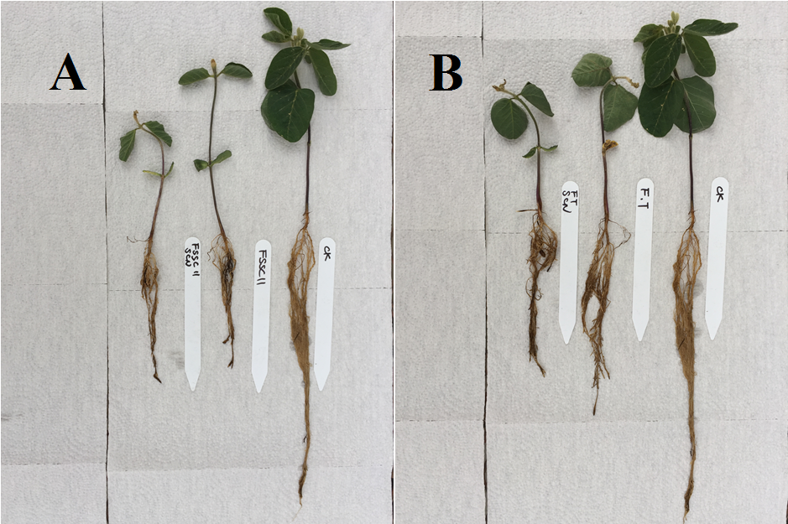
Figure 2. Soybean growth at V2 stage in greenhouse experiments. Plants of soybean infected with H. glycines and Fusarium root rot pathogens of F. solani (A) and F. tricinctum (B) compared with plants not infected. In both photos, ck denotes no infestation. FSSC 11 and FT denote infestation with isolates of F. solani and F. tricinctum, respectively. SCN denotes H. glycines. Each tube contained 200 ml of inoculum substrate with 200 infested barely seed evenly mixed into the soil. H. glycines was at 5000 eggs per tube; FSSC11 SCN and FT SCN denote the combined inoculations of Fusarium spp. and H. glycines.

Field experiments in 2016 and 2017 were conducted with high levels of Fusarium pathogens, 50 – 200 infested barley grains per 100 ml soil, and SCN eggs at 5,000 level per plants. Two year’s results shown a similar trend on plant growth and disease development. Most of the plants died or were dying within four weeks after planting due to post-emergence damping off caused by both Fusarium species and root rot on surviving plants was so severe that plants did not grow sufficiently to allow SCN to develop. No significant effects of soybean cyst nematode were detected when comparing plants inoculated by SCN and Fusarium pathogens to those inoculated with Fusarium pathogens alone (Table 5).

Table 5. Effects of high levels of Fusarium spp. with Heterodera glycines on plant growth of soybean and disease development in field experimentsª
Treatment^{b} | plant length (cm) | Plant weight (g)* | Root biomass (g) | Disease severity (0-6)^{c}
 | 2016
CK | 20.1 | 2.72 | 0.99 | 0 c(c)
SCN | 17 | 1.9 | 0.88 | 0 c(c)
FS200 | 9.6 | 0.53 | 0.42 | 4.0 b (b)
FS200+SCN5000 | 9.5 | 0.49 | 0.4 | 4.0 b (b)
FT200 | 8.1 | 0.25 | 0.13 | 5.0 a(a)
FT200+SCN5000 | 8.4 | 0.27 | 0.15 | 5.4 a(a)
 | 2017
CK | 17.5 | 1.05 | 0.69 | 0 b(c)
SCN | 17.3 | 0.94 | 0.61 | 0 b (c)
FS100 | 12.8 | 0.28 | 0.22 | 5.3 a(a)
FS100+SCN5000 | 11.7 | 0.2 | 0.22 | 5.3 a(a)
FS50 | 14 | 0.54 | 0.62 | 2.5 b (d)
FS50+SCN5000 | 12.2 | 0.48 | 0.51 | 2.8 b(bc)
FT100 | 12.8 | 0.3 | 0.36 | 5.0 a( a)
FT100+SCN5000 | 12.3 | 0.25 | 0.24 | 5.2 a(a)
FT50 | 15 | 0.4 | 0.62 | 4.5 a(ab)
FT50+SCN5000 | 13.3 | 0.4 | 0.44 | 4.5 a (ab)
ª Field microplot experiments were conducted in 2016 and 2017, in which plant were planted in black tubes within 5 lbs pots. Data were collected at 6wks after planting.
^{b} CK denotes infestation. FS and FT denote isolates of F. saloni and F. tricinctum, respectively. SCN denotes H. glycines. FS+SCN and FT+SCN denote the combined inoculations of Fusarium spp. and H. glycines. HSD stands for Tukey's Studentized Range Test.
^{c} basal lesion severity were rated using a 0 to 6 scale, where 0 = novisible symptoms on roots, healthy roots; 1 = root lesion length on tap root <=2 cm; 2 = root leasion length on tap root >2 cm ; 3 = entire tap root is rotted; 4 = entire tap roots and <=50% of secondary roots are rotted; 5 = entire tap roots and >50% of secondary roots are rotted; 6 = dead plants with rotten roots, dried stems and leaves. Following letters stand for multiple comparison Tukey test, and the same letters are not significantly different. Letters outside parentheses stand for HSD at alpha = 0.10 level, while inside parentheses stand for HSD at alpha = 0.05 level.

