Research and Extension Efforts at the Soil Health and Agriculture Research Extension (SHARE) Farm (year 6)
Dr. Abbey Wick, Extension Soil Health Specialist, NDSU Soil Science, Dept. 7680, P.O. Box 6050, Fargo, ND 58108; phone: 701-850-6458; fax: 701-231-7861; email: abbey.wick@ndsu.edu
Co-Investigators: Dr. Frank Casey, Director of the School of Natural Resource Sciences; Dr. David Ripplinger, Assistant Professor Agribusiness and Applied Economics; Dr. Caley Gasch, Assistant Professor of Soil Health.
Summary: The Soil Health program in North Dakota focuses on management options for salt-affected soils, effective use of conservation tillage and cover crops, evaluation of soil health and its relation to crop disease, pest pressures and economic parameters. All projects within this program are directly linked to the Soil Health and Agriculture Research Extension (SHARE) Farm in Mooreton, ND. This project was established in 2013 and has been funded exclusively with commodity dollars (corn, soybean and wheat) with the goal of conducting field-scale research and developing extension programming driven by farmer input. Table 1 shows some of the milestones reached at the SHARE Farm:

Timing | Milestone
Spring 2013 | Extensively soil sampled and established groundwater monitoring wells; weed and disease surveys
Fall 2014 | Installed tile drainage on northern half of the field;
 | Seeded cover crops to remediate tile installation disturbance
Summer 2015 | NDAWN station installed
Fall 2015 | Established field scale conservation tillage plots (with UMN and MN commodities)
Spring 2016 | Joined National Corn Growers Association Soil Health Partnership
Summer 2016 | Interseeded cover crops into corn
 | Convert a majority of the site to no-till
Fall 2016 | Crop response to salinity economic calculator available online
Winter 2017 | Commodity Classic NCGA Soil Health Partnership panel
Spring 2017 | Plant green - soybean into living cereal rye (first crop in no-till)
Summer 2017 | Fly on oat/radish cover crop into standing soybean
Winter 2018 | Commodity Classic ND Soil Health panel
Spring 2018 | Spring wheat crop seeded into no-till soils (second crop in no-till)
Table 1. Timeline for notable milestones reached at the SHARE Farm.

Objectives: Continued research and Extension efforts at the SHARE Farm: (1) demonstrate and evaluate field-scale, whole system strategies on saline and non-saline soils developed and guided with farmer-input, (2) evaluate the economics of alternative soil health improving strategies (for example tillage and cover cropping), (3) evaluate soil health testing and how it applies to our region and (4) transfer science-based knowledge to ND farmers using farmer-driven Extension approaches.
Benefits to ND Soybean Farmers:
- Field scale evaluation and demonstration of farming practices for salinity management and building soil health to improve soybean production
- Information is getting in the hands of farmers using creative extension programming consisting of field days, bus tours, workshops and Café Talks as well as digital methods of twitter, webpage and videos
- All aspects of the SHARE Farm research and extension is driven by farmer input – this is truly the “farmer’s project”

Results:
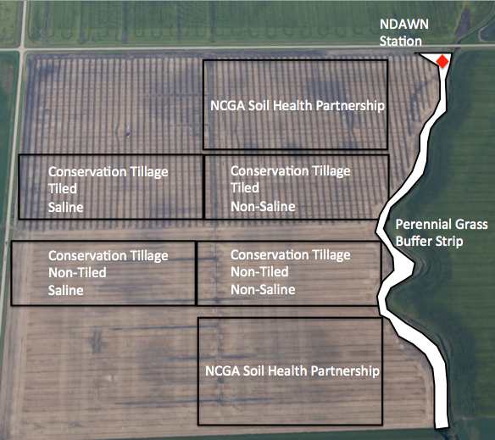
The SHARE Farm includes both research and Extension efforts – developing concepts that can be applied throughout the state and Extension programs that reach state-wide as well.
Research: A lot of activity is going on at the SHARE Farm – we continue to expand and be a platform for other research projects to be conducted (Figure 1 to left). We have sampled permanent monitoring locations across the field for soil conditions (salts, fertility and other soil health parameters) along with groundwater levels and quality. We have evaluated salt leaching rates through soils under a tile drainage scenario. We also we to participate in the conservation tillage study and in a five year evaluation with the NCGA Soil Health Partnership for cover crops over tiled and non-tiled ground as an approach to improve soil health. Both projects are summarized in pervious annual reports.

Extension: Extension programming through the SHARE Farm project continues to be strong. Since 2013, we have hosted numerous workshops, field days, a bus tour and large conferences. We have also expanded our outreach efforts nationally to include participating in a learning session with the NCGA Soil Health Partnership in 2017 (San Antonio, TX) and having our own learning session that was accepted and presented during the 2018 Commodity Classic in Anaheim, CA.

The SHARE Farm is considered a model program for Extension being highlighted in the Fall 2016 during the North Central Region Climate Hub Meeting, where Extension Directors from seven states visited the site to learn about how NDSU is working with commodity groups to reach farmers with timely information. The SHARE Farm was again highlighted in summer 2018 with a visit from the USDA NIFA liaisons for North Dakota. This private tour again highlighted partnerships and programs and was well received.

The most notable Extension program associated with the SHARE Farm is the Soil Health Café Talks. At the start of the Café Talks in 2014, we reached 41 individuals at three locations. From 2014 through 2018, we have successfully held Café Talks at 17 locations to reach 500 individuals with personalized, conversational information. Conversations are how a majority of farmers learn and gain the confidence to tailor management practices to use on their own farms.

Figure 2 shows the knowledge network maps developed from those attending the Café Talks. Green circles are NDSU Extension and Research personnel, blue are farmers, red are consultants, yellow indicate industry and grey are unknown affiliations. The size of the circle and the location within the diagram are important – the larger the circle and the closer the circle is towards the center of the diagram, the more important the individual’s role in the knowledge network. The café talks have created a super-highway for information transfer amongst individuals.

We continue to adjust how we get information in the farmer’s hands based on their feedback – this program is never stagnant!

Figure 2. Knowledge networks for the 2014 and 2014-2018 Soil Health Café Talks.
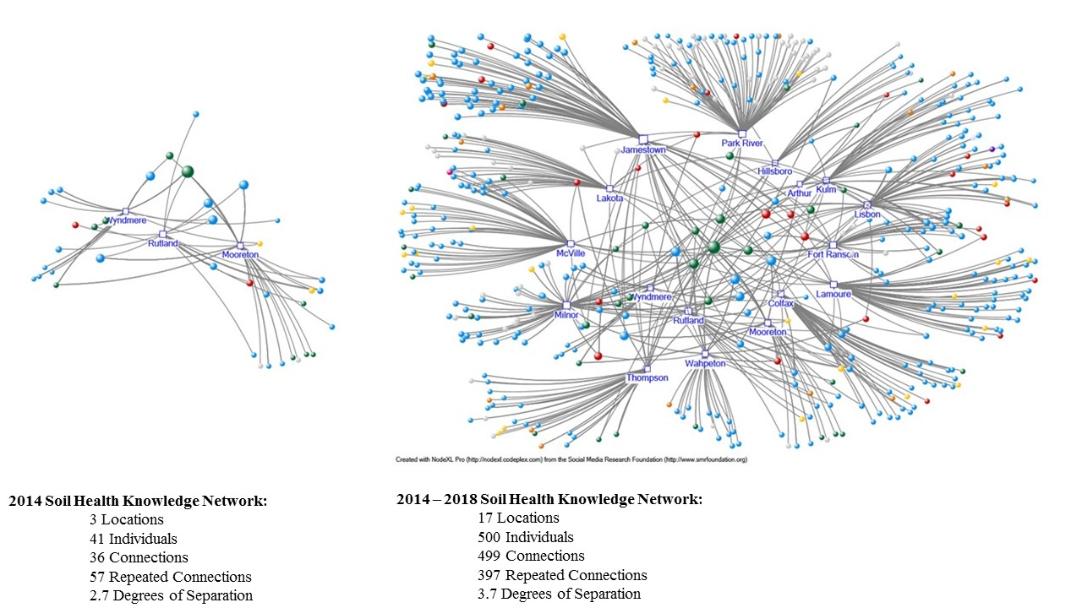

We have also utilized digital outlets for information transfer in the form of a website, YouTube and Twitter. Since 2013, we have produced 80 videos that have been posted on the NDSU Soil Health webpage (ndsu.edu/soilhealth). Those videos have received close to 82,000 views. A Twitter account was also established (@NDSUsoilhealth) in summer 2015. There are now over 4,900 followers who receive information almost daily on soil health from the NDSU program (5,294 tweets).

The AgWeek Soil Health Minute has been a popular way to transfer information to the general public. From Spring of 2017 to 2018, 19 television segments have been produced and 29 magazine article columns written.

Conclusions: As we move forward with our research and Extension efforts at the SHARE Farm, we will continue to listen to farmers and their needs. We will also expand our efforts to reach additional farmers with information related to soil health building practices.

