Evaluation of Soil Health Test to Determine Fertilizer Needs for Soybean in Kansas

Introduction
Recent interest in the biological components and soil health have led to the development of soil tests, such as the Haney H3A-4 (H3A4) soil test. The H3A4 extracting solution is comprised of a dilute mixture of weak organic acids (e.g. citric acid, malic acid, oxalic acid), and is intended to mimic the chemical behaviour of plant root exudates in soil. Some labs have begun offering this test to producers, however, correlation and calibration data is scarce. Phosphorus (P) and potassium (K) are two of the most common yield limiting nutrients in agricultural production. Fertilizer application is common practice to prevent P and K defficiency symptoms in crops. Application rates are typically based on soil concentration for P and K, as they are considered immobile in soil. If data exists to calibrate these tests to relative crop yield, then fertilizer application rates can be calculated based on the soil test value. Numerous soil tests for P and K have been developed over the years. The Mehlich-3 soil test has been one of the most common tests as it allows labs to take full advantage of modern technology (e.g. ICP spectroscopy) to measure the concentration of multiple nutrients from a single extraction. The goal of this study was to evaluate the use of soil health test for fertilizer recommendations and evaluate the relationship between the Haney H3A-4 (H3A4) and Mehlich-3 (M3) soil tests for P and K in Kansas soils.

Methods
Soil samples were collected from plots of field trials in soybean. Soil samples were categorized into two groups, “dry” and “wet” samples. Samples in the dry group were dried at ${40}^{∘}C$ and ground to pass a # 10 sieve (2 mm). Samples in the wet group were removed from the field and stored at $4^{∘}C$ until analysis. Wet samples were homogenized using a food processor prior to analysis, as conventional soil grinders are designed with dry soils in mind. After homogenization, samples were passed through a # 4 sieve (4.75 mm). Subsamples from the homogenized wet samples were dried at ${40}^{∘}C$ to determine moisture content relative to their counterparts in the dry group. These subsamples were assumed to be dry when the change in mass was less than 0.1 % of the initial mass (approximately 48 hours). The mass of soil used in soil tests was corrected for moisture content to prevent dilution issues during extraction of the wet samples. Phosphorus was determined with both colorimetry (Lachat QuickChem Series 2, 660 nm detector) and emission spectroscopy (ICP-OES). Potassium was determined using ICP-OES. Solution pH was measured from filtrate subsamples using a benchtop pH meter equipped with a refillable glass electrode. Soil pH was measured using an automate Skalar Robotics dual probe pH robot equipped with glass membrane electrodes.
Relationships between M3 and H3A4 soil test results were investigated using correlation and regression techniques, and evaluated at the 95% confidence level (a = 0.05). All statistical analyses were performed in R ver 3.5.2

Results
Mehlich-3 and H3A4 soil test P and K were positively correlated in the combined data (Figure 4). As expected, the pH buffering capacity of the M3 solution was clearly greater than that of H3A4 (Figure 1). The H3A4 solution consists of a dilute mixture of weak organic acids, and solution pH essentially followed the pH of the soil. In general, H3A soil test P and K were considerably lower than M3 soil test P and K. The relationship between M3 and H3A4 soil test P appears to be strongly influenced by soil pH and alkalinity (Figure 2). This is unsurprising given the differences in pH buffering capacity between the two solutions, and the important role pH plays in the solubility equilbria of most soil P minerals. The relationship between M3 and H3A4 soil test K also varied between sites, but was not well-explained by either soil pH or alkalinity. Differences between M3 and H3A4 soil test K are not surprising, given the different chemical nature of the two extracting solutions. Mehlich-3 contains ammonium (NH₄⁺) which has a similar ionic radius and valence to K⁺ cations, which allows it to displace K⁺ from the soil’s cation exchange complex. The H3A4 solution lacks the NH₄⁺, and is thought to provide a measure of soluble K pool, rather than exchangeable K. Differences in clay mineralogy, although unknown for these soils, may also help explain this variability, as it been shown to be an important factor affecting the solubility of soil K by other workers.

Conclusions
While Mehlich-3 and H3A4 soil test P and K appear to be positvely correlated, their relationship also appears to be variable. This means new calibration data will likely be required if H3A4 would be used for fertilizer recommendations.

Tables and Figures
Table 1. General site and soil test information. Soil test values are mean values for phosphorus (P) and potassium (K) extracted by Mehlich-3 (M3) or H3A-4 (H3A4) reported as soil ppm (mg/kg). Soil pH (1:1 water) is reported as the median of measurements from all soil samples from each site.
Site | County | Soil pH | M3-K | M3-P | H3A4-K | H3A4-P
1 | McPherson | 7.9 | 382 | 66 | 222 | 18
2 | Palen1 | 5.0 | 455 | 70 | 149 | 38
3 | Palen2 | 7.7 | 226 | 9 | 57 | NA
4 | Rossville | 6.6 | 199 | 12 | 116 | 11
5 | Scandia | 6.2 | 402 | 7 | 151 | 10

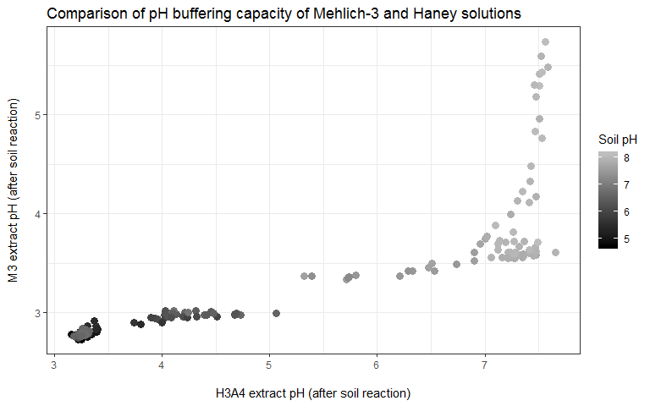
Figure 1. Measurements of filtrate solution pH suggest that the Mehlich-3 (M3) extract is buffered more strongly than the H3A-4 (H3A4) extract. Mehlich-3 pH remained at or below ~3 when soil pH was less than ~7.3. The pH of H3A4 filtrate is highly correlated to soil pH.

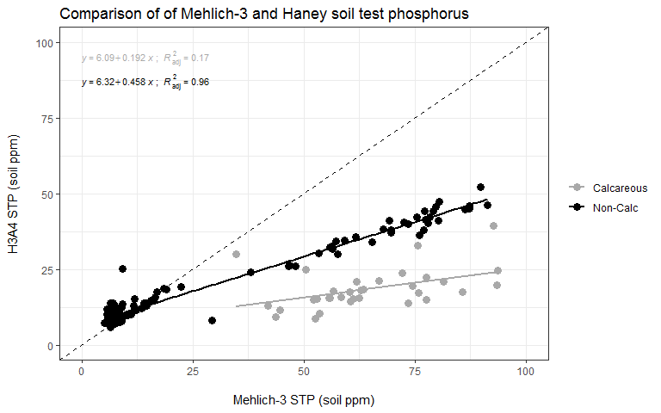
Figure 2. Comparison between Mehlich-3 (M3) and H3A-4 (H3A4) soil test phosphorus. The relationshp appears to be highly dependent on soil pH and alkalinity. The H3A4 test extracted much less P in calcareous soil than in non-calcareous soils.

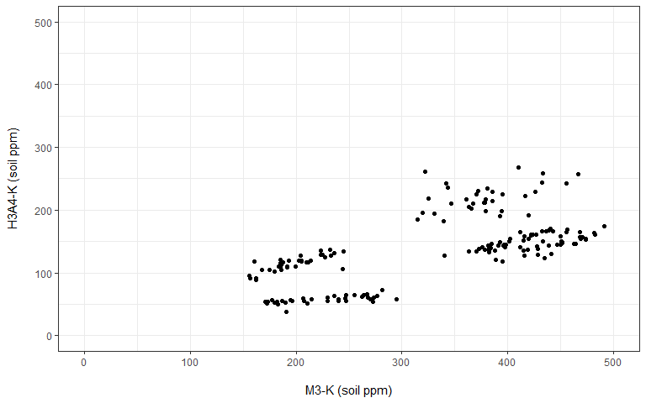
Figure 3. Comparison of Mehlich-3 (M3) and H3A-4 (H3A4) soil test potassium (STK). In general Mehlich-3 extracted far more soil K than H3A4, however the relationship is highly variable between locations. The causes for this discrepancy are not yet understood, but may be due to differences in clay mineralogy.
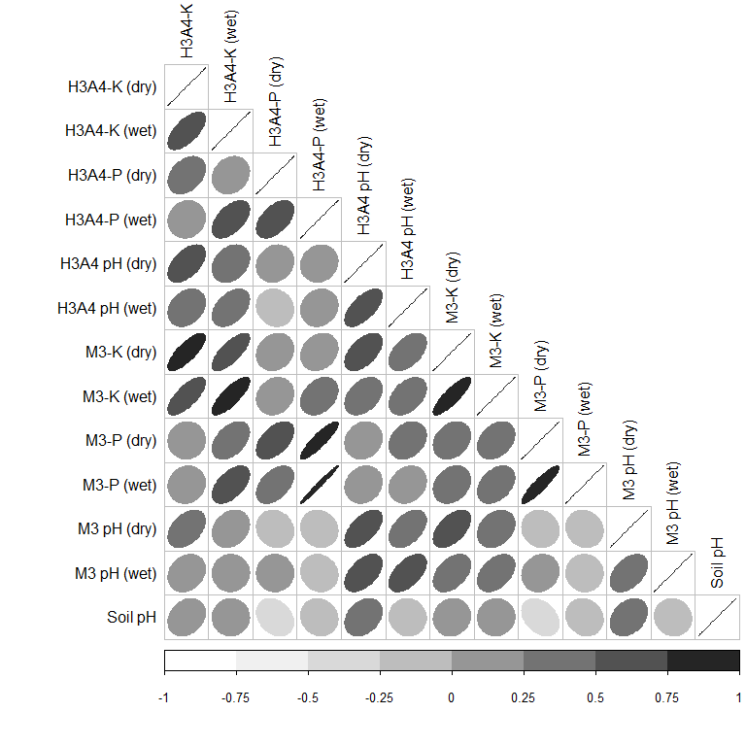
Figure 4. Correlation between soil pH, Mehlich-3 (M3) and H3A-4 (H3A4) soil test phosphorus (P) and potassium (K) from all sites combined. The direction and thickness of ellipses represents the sign and magnitude of the correlation coefficient between the parameters labeled by row and column. For example, thin ellipses trending up and towards the right represent strong and positive correlations.

