**OSC FY 2017 - 2018 – Final Report**

SOYBEAN RESEARCH: Genetic population structure of *Macrophomina phaseolina*, causal agent of charcoal rot on soybean.

The main goals of this study are to compare the population structure of *Macrophomina phaseolina* (causal agent of charcoal rot of soybean) isolates from: 1. fields in Ohio; 2. fields in South America; and 3. compare these very geographically distant populations for genetic relationships.

In order to select *M. phaseolina* isolates for the proposed population genetic study, we are conducting a physiological and pathogenicity assay. In addition to the geographic information, the physiological and pathogenicity assays will allow to add phenotypic information on the selected isolates for the population genetic study.

**PHYSIOLOGICAL ASSAY**

A total of 200 *M. phaseolina* isolates were used in the physiological study. Isolates were assigned a geographic region by slightly modifying the Ohio Agricultural Statistics Districts designations (Table 1). Isolates of *M. phaseolina* were obtained from soil collected throughout soybean and corn fields in Ohio (Fig. 1).

**Table 1.** Ohio regions, zone names, and number of isolates for each zone.

|  |  |  |
| --- | --- | --- |
| **Region** | **Zone Name** | **Isolates** |
| North | North East | 2 |
| North | North Central | 16 |
| North | North West | 48 |
| Central | Central Hills | 13 |
| Central | Central | 46 |
| Central | West Central | 42 |
| South | South East | 18 |
| South | South Central | 11 |
| South | South West | 4 |

Pure *M. phaseolina* isolates were used in the study. Each *M. phaseolina* isolate was grown in media and re-isolated until a pure isolate was obtained. Isolates were grown under different temperature (15, 20, 25, 30, 35 and 40 ºC) in potato dextrose agar (PDA). The experimental design was a randomized complete block design with three replications. The maximum and minimum diameter of each isolate (in mm) was recorded every 24 hours for 5 days. Subsequently, an averaged diameter for each day was obtained and the area under the growth progress curve (AUGPC) was estimated.

****

**Figure 1.** Approximate location of fields sampled in Ohio (Lopez-Nicora et al. 2016).

The isolates were grouped into three Ohio regions (North, Central and South). Isolate growth were compared between these regions for each of the five different temperature conditions. The null hypothesis was: there is no difference in averaged AUGPC between North, Central and South regions in Ohio under each temperature condition.

**Results**

Overall, larger variation in AUGPC between isolates was observed at lower temperature (15, 20, 25 and 40 ºC) than at temperatures consider optimal (30 – 35 ºC) for *M. phaseolina* growth (Fig. 2).

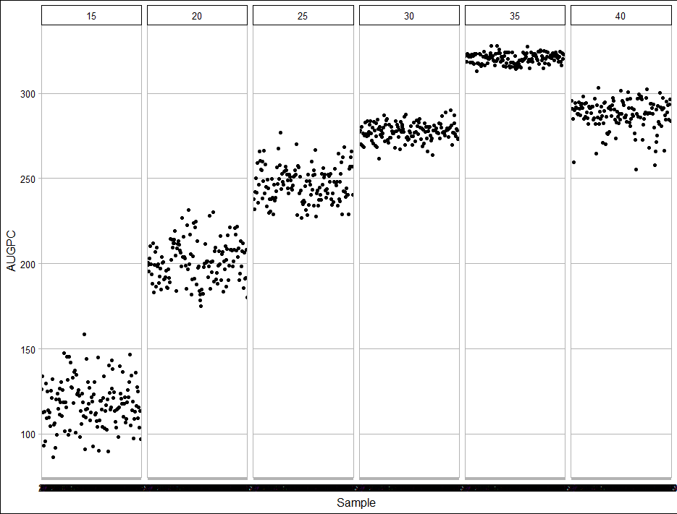

**Figure 2.** Area under the growth progress curve (AUGPC) of *Macrophomina phaseolina* isolates (n = 200) for each temperature conditions (15, 20, 25, 30, 35 and 40 ºC).

Geographic location for each isolate was obtained when soil samples were collected from soybean and corn fields throughout Ohio (Lopez-Nicora et al. 2016). *Macrophomina phaseolina* isolates, therefore, were grouped based on three geographic regions: North, Central or South. The variation in AUGPC between isolates observed at low temperatures (Fig. 2) can also be observed between isolates within geographic regions (Fig. 3A).



**Figure 3.** Boxplots of area under the growth progress curve (AUGPC) and isolates grouped by geographic region grown at 15, 20, 25, 30, 35, and 40 ºC (**A**). Bar graph comparing the growth of isolates from different regions at different temperatures (**B**).

The size of the boxplots for lower temperatures (15 to 25 ºC) are wide but similar between North, Central and South regions. As temperature increased to 30 and 35 ºC, the size of the boxplots get narrower, however, similar in size between regions (Fig. 3A).

Analysis of variance followed by *post hoc* multiple comparison revealed that at lower temperature (15 ºC), *M. phaseolina* isolates from North and Central regions grew significantly faster than isolates from South Ohio (Fig. 3B). As temperature increased and reached the fungus optimum growing temperature isolates from South Ohio grew similar to those from northern regions (Fig. 3B).

**PATHOGENICITY ASSAY**

A total of 200 *M. phaseolina* isolates were used in the pathogenicity study. Isolates were assigned a geographic region by slightly modifying the Ohio Agricultural Statistics Districts designations (Table 2). These isolates of *M. phaseolina* were obtained from soil collected throughout soybean and corn fields in Ohio (Fig. 1) and were the same used in the physiological study described above.

**Table 2.** Ohio regions, zone names, number of isolates, and averaged AUDPC for each zone.

|  |  |  |  |
| --- | --- | --- | --- |
| **Region** | **Zone Name** | **Isolates** | **AUDPC** |
| North | North East | 2 | 253.00 |
| North | North Central | 16 | 312.51 |
| North | North West | 48 | 277.66 |
| Central | Central Hills | 13 | 294.03 |
| Central | Central | 46 | 288.10 |
| Central | West Central | 42 | 272.24 |
| South | South East | 18 | 263.08 |
| South | South Central | 11 | 244.22 |
| South | South West | 4 | 237.83 |
| Positive Control | Mp007-PYR | 1 | 216.62 |
| Negative Control | PDA plug | 1 | 0 |

Pure *M. phaseolina* isolates were used in the study. A cut-stem inoculation technique was used to evaluate the pathogenicity and aggressiveness of *M. phaseolina* isolates. Briefly, stem apex was cut 25 mm above the unifoliate node and a PDA plug with actively growing *M. phaseolina* mycelia (or not in the case of the negative control) was set on top of the cut and covered with a pipette tip. Three days after tips were removed and length of the necrotic lesion from the top of the cut stem was measured every day for thirteen days.

Subsequently, thirteen days post inoculation the area under the disease progress curve (AUDPC) was obtained from each inoculated plant. The experimental design was a randomized complete block design with six replications with two plants per replication.

**Results**

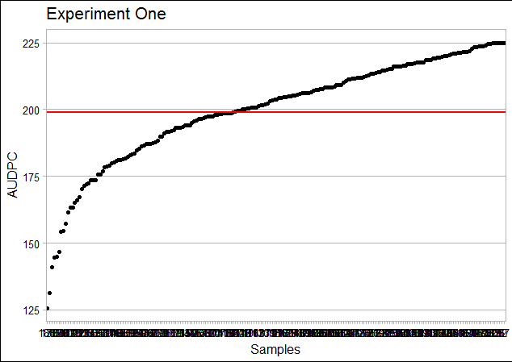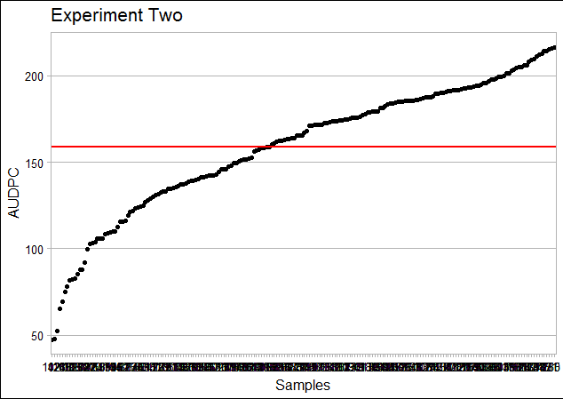*Macrophomina phaseolina* isolates from soil samples collected from soybean and corn fields in Ohio (Fig. 1) were all pathogenic to soybean. Moreover, *M. phaseolina* isolates displayed a significant variation in aggressiveness (Table 2, Figs. 4 and 5). *Macrophomina phaseolina* was never recovered from negative control and AUDPC was zero (Table 2, Fig 5).

**Figure 4.** Sorted area under the disease progress curve (AUDPC) for *M. phaseolina* isolates in Experiment One (left) and Two (right), respectively.

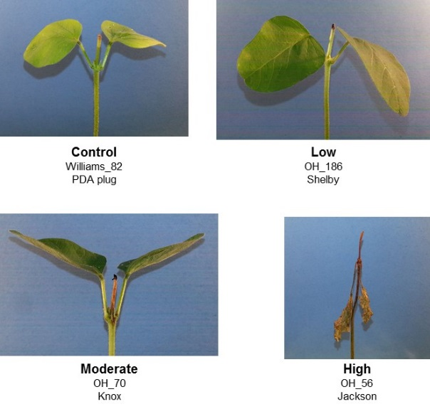

**Figure 5.** Examples of *M. phaseolina* low, moderate and high aggressiveness compared to control(right).

After results from the pathogenicity assay was completed (twice) for all isolates, analysis of variance was conducted to evaluate if there was a “Region” effect. Analysis of variance revealed that *M. phaseolina* isolates from North, Central, and South regions did not grow significantly different in infected soybean stem (Fig. 6).

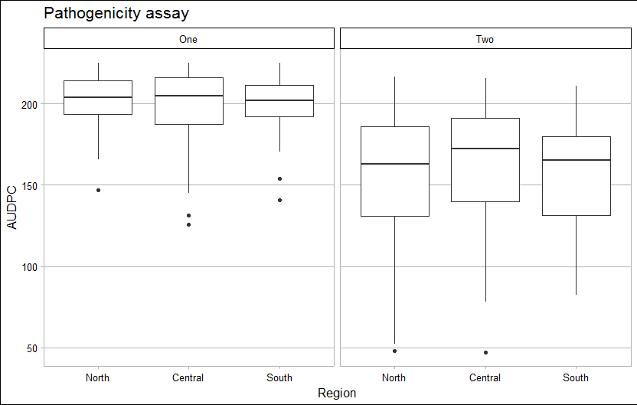

**Figure 6.** Box plots comparing the AUDPC of *M. phaseolina* isolates from different regions for Experiment One (left) and Two (right), respectively.

Sexton et al. (2016) detected significant difference in aggressiveness between *M. phaseolina* isolates from the north regions of U.S. compared to those from the south. Even though we detected significant differences in *M. phaseolina* aggressiveness from isolates in Ohio (Fig. 4); our results (Fig. 6) did not reveal that *M. phaseolina* isolates from Ohio differ in aggressiveness based on a particular region.

To further investigate how *M. phaseolina* isolates with different level of aggressiveness are spatially distributed throughout Ohio we conducted an inverse distance weighted interpolation on the AUDPC obtained from the pathogenicity assay results described above. This technique uses both the geographic information (i.e., GPS data) from each field where samples were retrieved and the aggressiveness information obtained from the pathogenicity assay.

Results from the inverse distance weighted interpolation suggests that *M. phaseolina* isolates tend to be spatially aggregated (Fig. 7). We observed that, based on AUDPC, *M. phaseolina* isolates cluster throughout Ohio resulting in areas with isolates more aggressive compare to other areas where aggregates of isolates tend to be less aggressive (Fig. 7). This aggregated characteristic can explain why the analysis of variance did not detect a “Regional” effect (i.e., North, Central, and South) on isolate aggressiveness.

C:\Users\lopez-nicora.1\Desktop\User Files\Desktop\OSU Documents\Classes\Spring 2018\Kowlett Seminar\Ohio - Macrophomina - AUDPC_Clusters.tif

**Figure 7.** Inverse distance weighted (IDW) interpolation of area under the disease progress curve (AUDPC) from *Macrophomina phaseolina* isolates (n = 200) in Ohio. Ten clusters based on k-means are represented in different colors for each sampling point.

Additionally, k-means cluster analysis was performed to identify, based on distance (i.e., latitude and longitude), ten clusters from where isolated with large phenotypic variation were selected for genotypic analysis.

**Phenotypic evaluation of *M. phaseolina* isolates from South America**

A physiological and pathogenicity assays (similar to those performed with the Ohio isolates to produce the phenotypic results presented in this report) were conducted on *M. phaseolina* isolates (n = 300) from South America. Data is now being compiled and analyzed to further compare with results obtained from assay with *M. phaseolina* isolates from Ohio.

**Genotypic analysis of *Macrophomina phaseolina***

Two types of genotypic analyses will be conducted:

1. Complete genomes sequence of twelve *M. phaseolina* isolates, which will be used in a comparative genomic study, and 2. Genotyping-by-sequence (GBS), which will be used to understand the genetic structure of *M. phaseolina* isolates from different locations.

*Selection of twelve isolates for genome sequence:*Based on the phenotypic data presented in this report, selection of isolates for genomic DNA extraction and genotypic analysis was conducted. Six isolates were selected based on their aggressiveness, adaptation to extreme temperatures (15 and 40 ºC), and phenotypic appearance of mycelia. Four isolates, differing in aggressiveness to soybean, were selected from north Ohio, one that differed in its ability to normally grow at 15 and 40 ºC was selected from south Ohio, and one that grow white mycelia and delay in turning dark as most *M. phaseolina* isolates do.

In addition, pure *M. phaseolina* isolates obtained from soybean plants demonstrating charcoal rot symptoms in South America have been shipped for genomic DNA extraction and further comparison with North America isolates in a population genetic study. These isolates were included in a pathogenicity assay as the one described above and the most aggressive isolate was selected to represent the South America isolate. Similar to how we selected the six isolated from Ohio, six isolates from South America were selected following the same criteria.

**Genomic DNA extraction**

To obtain enough fungal mycelia for DNA extraction, pure *M. phaseolina* isolates are grown in potato dextrose broth (PDB) for one day. Mycelia are strained and washed and subsequently flash frozen in liquid nitrogen. Frozen isolates are kept in -20 ºC freezer until they are freeze dried. DNA extraction protocol was optimized to obtain as much DNA as possible for GBS analysis and full genome sequence **(Fig. 8)**.

Pure genomic DNA of *M. phaseolina* have been sent to the Molecular and Cellular Imaging Center (MCIC) in Wooster to determine the set of enzymes we will use in the GBS study. Briefly, genomic DNA digested with different enzymes results in several (desirable in length) DNA fragments. These fragments will contain important information that we will use to understand the genetic structure of *M. phaseolina*. Selection of digestion enzymes for GBS is a very important step since all the data that will be analyzed will result from this selection.

C:\Users\lopez-nicora.1\Desktop\User Files\Desktop\OSU Documents\Classes\Autumn 2017\Mp - Genome\Emile\Mp - DNA - Genome Seq - Gel.tif

**Figure 8.** Pure genomic DNA of four *M. phaseolina* (three from Ohio and one from South America) isolates for genome sequencing and enzyme digestion assay for GBS.

***Macrophomina phaseolina* genome sequencing**

Even though all *M. phaseolina* isolates are pathogenic to soybean, significant variation in aggressiveness was observed. We also noticed that the spatial distribution of isolates with similar aggressiveness to soybean is aggregated. Therefore, a subset of isolates were selected based on phenotypic data presented in this study and sampling geographic location for further genotypic and population genetic analyses.

Two techniques were used to generate complete, high quality sequences of 12 geographically and phenotypically diverse M. phaseolina isolates that have the potential to span entire chromosomes. We begin the analysis of four out of the twelve genomes and we observed difference between isolates and between our isolates and the available *M. phaseolina* reference genome (from a Jute isolate from India) that can be retrieved online. As soon as we receive the results from the other eight genomes a comparative genomic analysis will be performed and a manuscript on these analyses will be written.

As stated in the proposal, in addition to generating these reference genomes, we will use genotype by sequencing techniques to explore the population genetic structure of 300 isolates collected from soybean fields in Ohio and South America. Once the data is fully analyzed, we will be able to undertake one of the largest-ever genome-wide population genetic analyses of a single fungal species. We expect to submit a manuscript (different from the comparative genomic one described above) by the end of this year.

**Presentations and Publications**

**Poster:**

* OARDC OSC Meeting – Poster presentation 2017
* International Congress of Plant Pathology (ICPP) / American Phytopathological Society (APS) – Annual Conference – Boston, MA 2018

**Oral presentation:**

* Kowlett Seminar – 2018

**Manuscripts:**

* Physiological and pathogenicity studies – Plant Disease or Plant Health Progress (to be submitted September/October 2018).
* Comparative genomic analysis – Phytopathology or Heredity (to be submitted end of 2018).
* Population genomic studies – Phytopathology or Ecology and Evolution or Heredity (to be submitted end of 2018).