Modification of insoluble dietary fiber in soybean residue okara to value-added soluble dietary fiber by enzyme-assisted microfluidization
Jiajia Rao, Assistant Professor, Department of Plant Sciences
1. Materials and methods: Viscozyme L, Celluclast 1.5L and Shearzyme from Novozymes company.
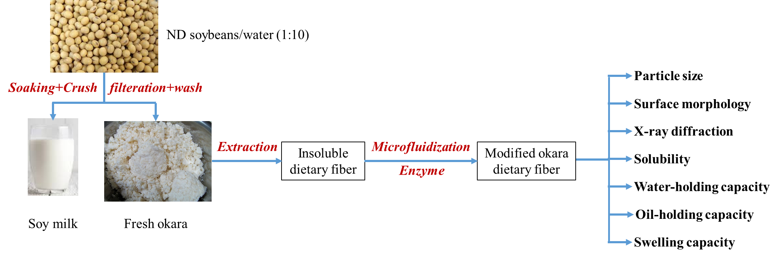
Figure 1: The flow chart of okara preparation modification
1.1 Milling of okara powder and size measurement: The dried okara powder (particle size: 740 µm) was subjected through sieves (250, 500 and 1000 µm) at certain grinding speed (8000, 12000 and 16000 rpm) to generate different particle size of okara powder. The size of the okara powders were determined by a Mastersizer 3000 integrated with powder analysis module (Malvern Instruments, Worcestershire, UK).
1.2 Thermal pre-treatment and enzyme treatment of okara: 2 g of okara samples were mixed with 200 ml water and autoclaved for 20 min (121 ℃). 200 ml Celluclast in citric acid buffer (1:1, pH 5.5) were then added to the thermal pre-treated okara samples and incubated in a water bath at 55 ℃ for 12 h with agitation.
1.3 Chemical composition analysis of all treatments: The sedimentation part of samples were collected. Total dietary fiber (TDF) including soluble dietary fiber (SDF) and insoluble dietary fiber (IDF) were tested using an automated Ankom TDF Dietary Fiber Analyzer (Ankom Technology Corp., Macedon, NY).
1.4 Structural characterization of treatments: The structural change of okara samples were characterized by using scanning electron microscopy (SEM) and X-ray diffraction (XRD)
1.5 Functionality of modified okara compared with raw okara: Water holding capacity, oil holding capacity and swelling capacity were measured.
2. Results
2.1. Particle size: The mean particle size of okara powder prepared by milling of different mesh size and milling speed are shown in Table 1. The okara samples with size of 390 and 147 µm as well as non-milling sample (740 µm) were selected for the following studies.
Table1. Mean particle size of okara samples under different milling conditions
Mesh size (µm) | Speed (rpm) | Particle size (µm)
1000 | 8000 | 554
 | 12000 | 469
 | 16000 | 388
500 | 8000 | 390
 | 12000 | 334
 | 16000 | 279
250 | 8000 | 254
 | 12000 | 177
 | 16000 | 147
2.2 Fiber content: The autoclave in conjunction with autoclave greatly converted the insoluble fiber to soluble fiber.
Table2. Fiber content of modified okara samples
Sample name | Particle size (µm) | Total dietary fiber (%) | Insoluble  Fiber (%) | Soluble fiber (%)
Non-treated | 147 | 73.9 | 69.3 | 4.7
 | 390 | 74.1 | 68.0 | 6.2
 | 740 | 73.9 | 65.7 | 8.1
autoclave | 147 | 69.2 | 64.6 | 4.5
 | 390 | 70.6 | 65.4 | 5.1
 | 740 | 70.7 | 64.3 | 6.4
Autoclave  enzyme | 147 | 30.3 | 25.3 | 5.0
 | 390 | 37.2 | 30.9 | 6.3
 | 740 | 47.4 | 39.4 | 8.0
2.3. Okara surface morphology: Morphologies of modified okara are presented in Fig. 1. SEM images showed that the morphology of non-treated sample (740 µm) was observed to be of compact regular surface structure. Autoclave pre-treated samples (740 µm) showed more disintegrated and irregular surface structure. Autoclave plus enzyme treated group showed the highest degree of structural disintegration, no significant difference was observed between particles.
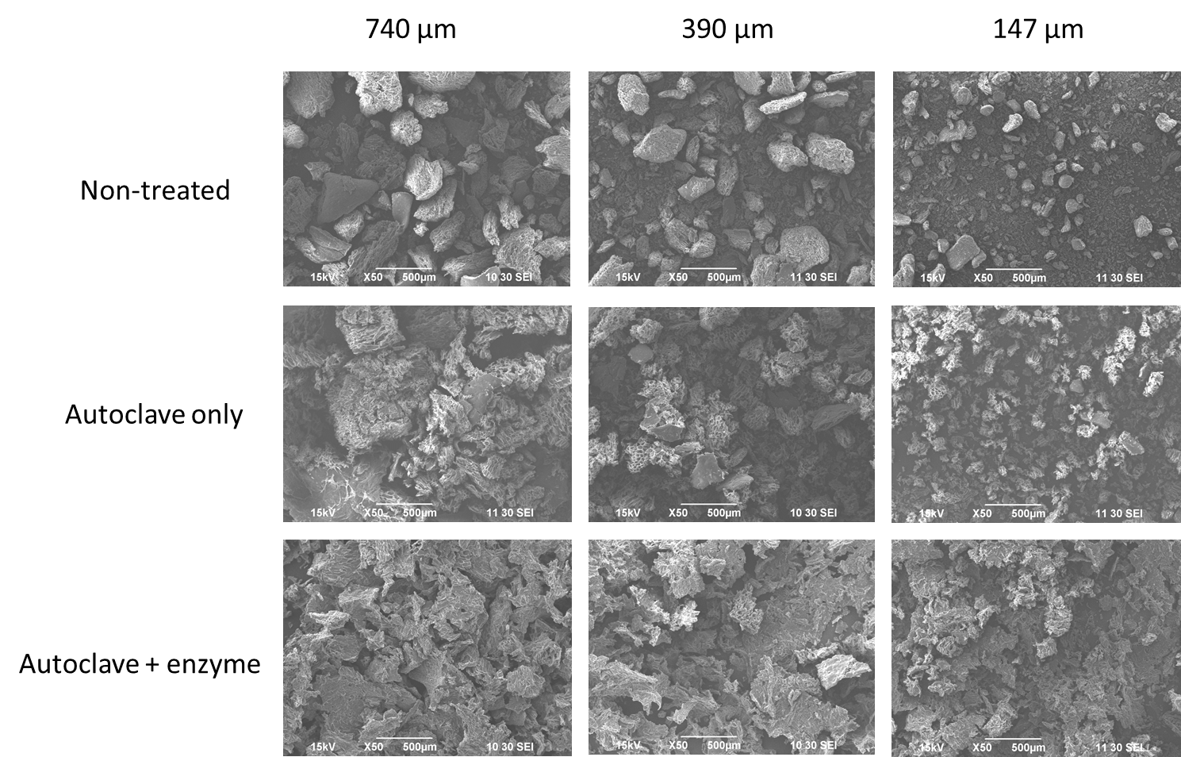
Figure 2. SEM image of okara samples
2.2 Crystalline and molecular structure: Crystalline order structure of okara under different treatment was analyzed using XRD and the obtained diffractograms are shown in Fig. 2. The distinct diffraction peaks were observed at 2θ angles of 22.5° and 34.5°, which represents typical crystalline cellulose I structure in both non-treated and autoclave-treated groups. Interestingly, the peak at 2θ angles of 34.5° was disappeared in autoclave plus enzyme treated group indicating that crystalline region was demolished by autoclave plus enzyme treatment.
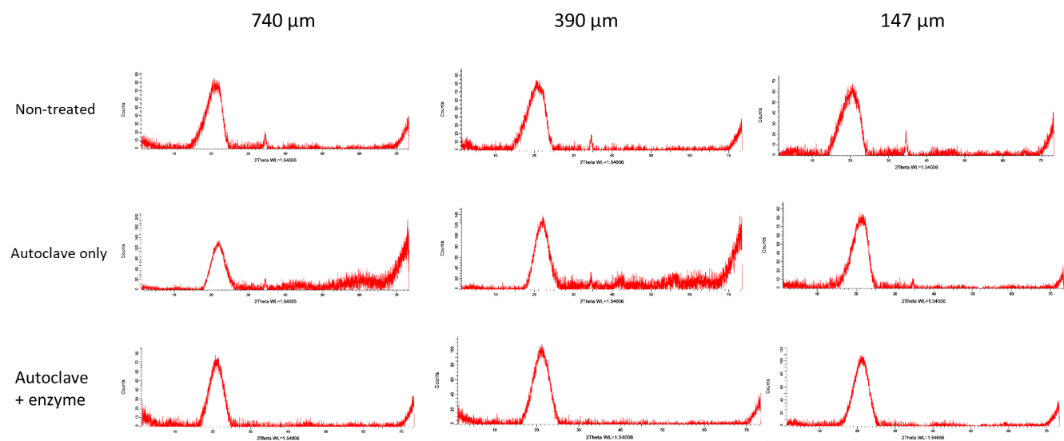
Figure 3. XRD histogram of modified okara
2.3 Functionality of modified okara: Generally, all treatments significantly increased the water holding capacity compared to the control (non-treatment) group. The enzyme + autoclave treatment showed highest water holding capacity for the okara of all the three particle size. The oil holding capacity and swelling capacity of okara showed similar trend as water holding capacity.
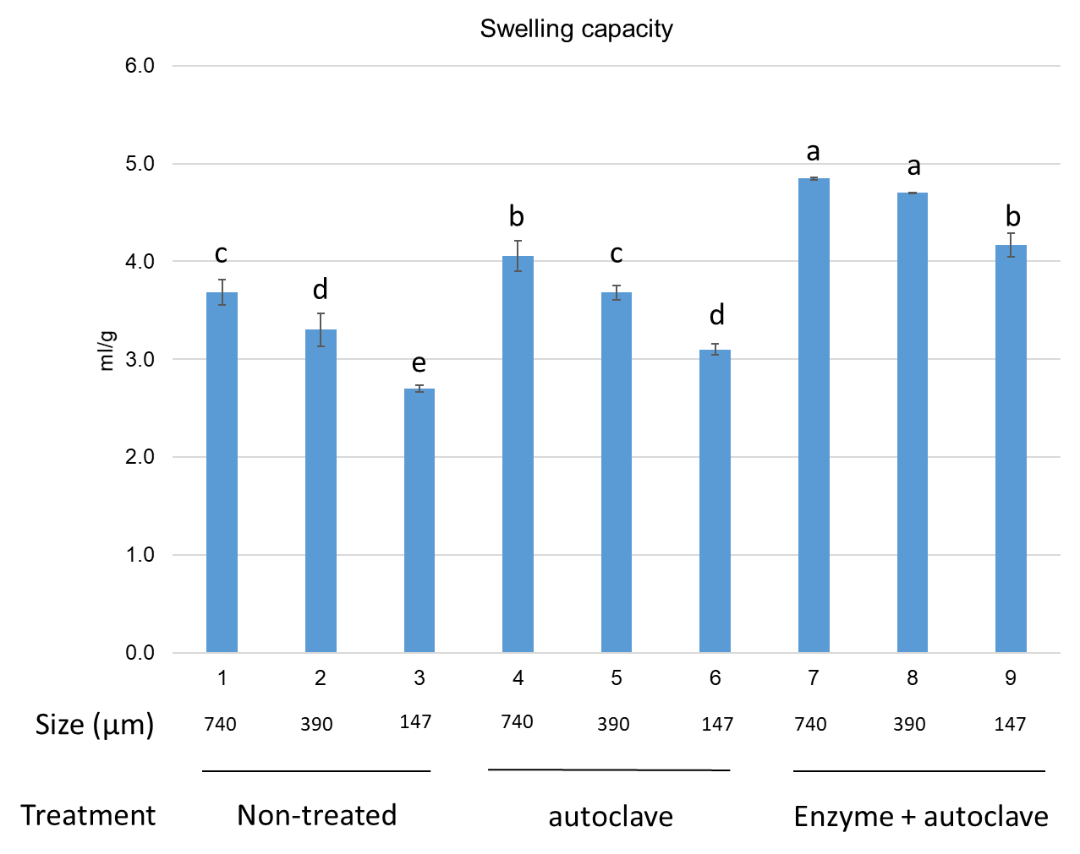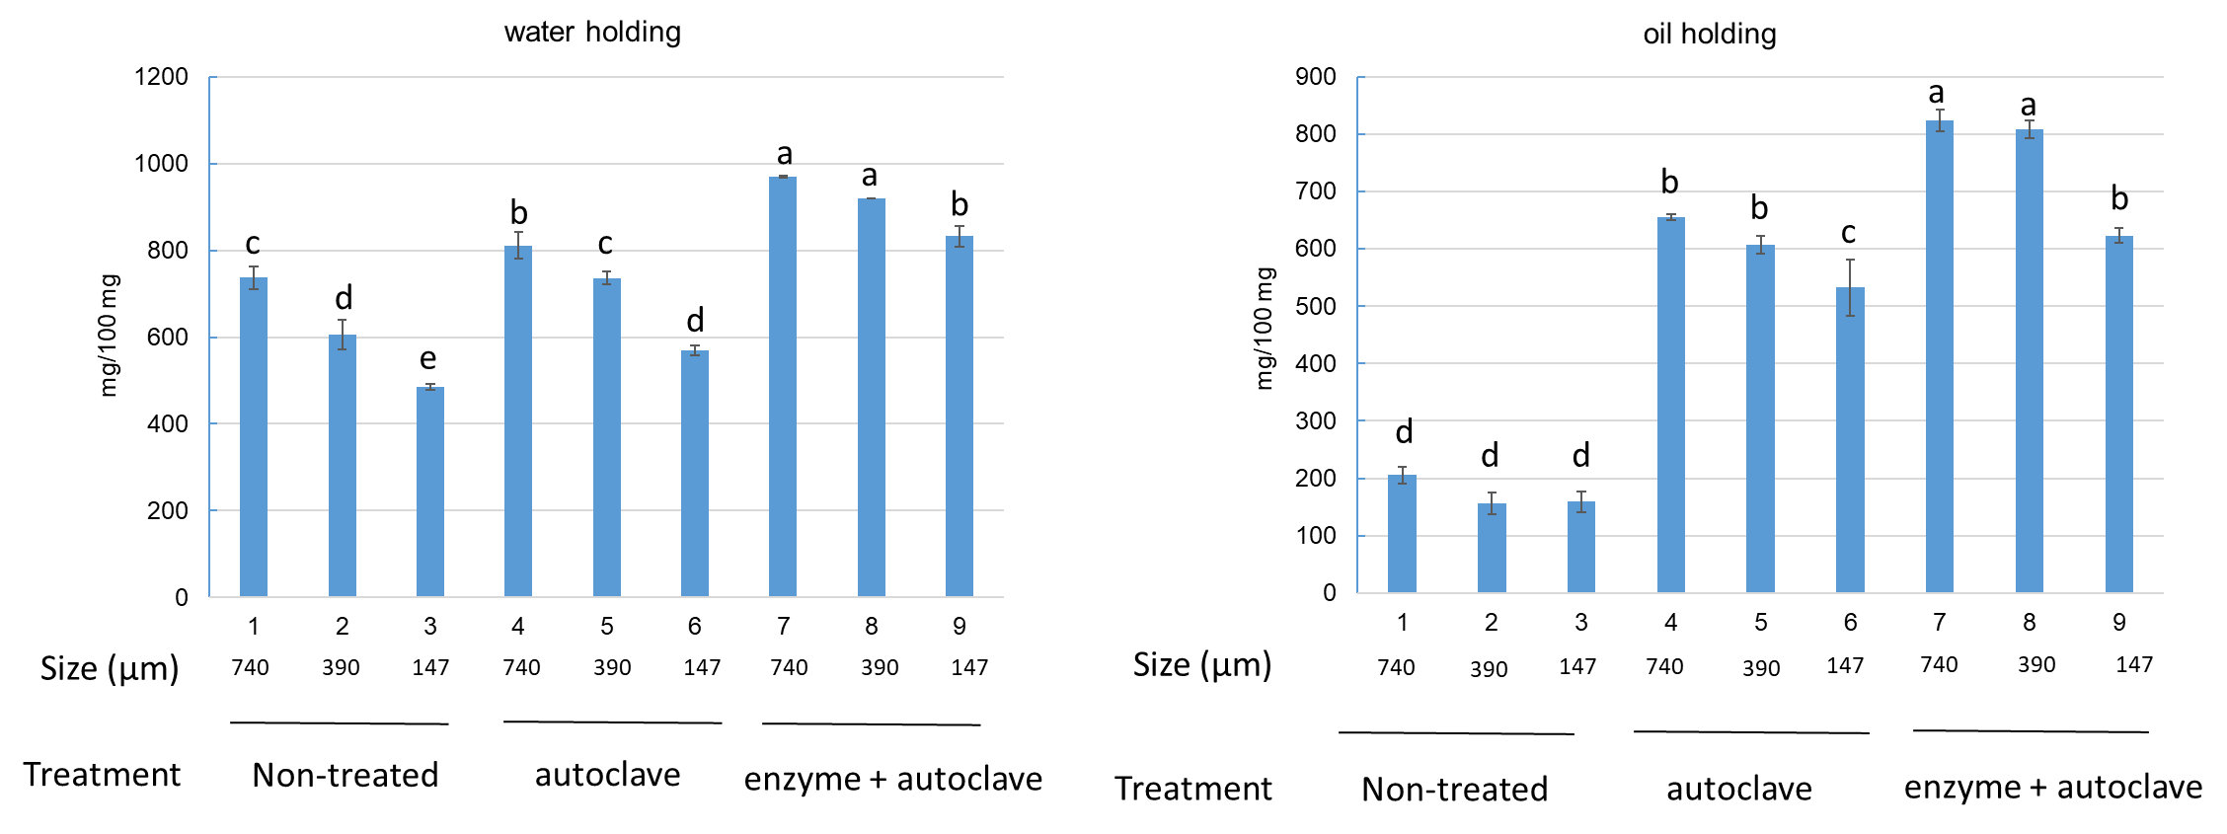
Figure 4. Functionality of modified okara

