Managing salinity with cover crops: A whole system response (year 2) [Part A]
Caley Gasch, Jason Harmon, Tom DeSutter, Abbey Wick
School of Natural Resource Sciences, North Dakota State University, Fargo, ND

North Dakota Soybean Council – FY2019 final report

Introduction
In 2018, we initiated a study, funded by the ND Soybean and Corn Councils, to assess the use of cereal rye (Secale cereal) in managing soil salinity. This work was motivated by previous work, also funded by corn and soybean checkoff dollars, which revised threshold salinity values for corn and soybean¹ and demonstrated elevated insect pest pressures on salt-stressed corn and soybean plants². Because soil salinity continues to be a persistent problem across North Dakota, we initiated a project to evaluate the use of cereal rye cover crops as a tool for managing soil water and therefore reducing salinity. Cover crop interest and use is increasing³, and while cereal rye provides a number of soil health and weed management benefits⁴, we anticipate that there are also risks and challenges associated with its use (see Figure 1). Ultimately, our goal is to understand the uses and limitations of cereal rye in soybean rotations, particularly as a tool for managing soil water, maximizing soil cover, and therefore reducing effects of salinity⁵. We are also particularly interested in understanding how both beneficial and pest soil organisms and insects are affected by salinity and cereal rye.
Figure 1. Potential risks and benefits of cereal rye in soybean-corn rotations
The project is ongoing, and we anticipate continued data collection for another year or two. The main objectives of this project are:

Objective 1: We will measure the benefits and risks of using a cereal rye cover crop in a soybean-corn rotation to determine its potential for salinity management and building soil health. We will use a whole-system approach to measure soil, crop, weed, and insect responses to the salts and the cover crop. These field-scale experiments will compare cover crop and no cover crop treatments across a gradient of saline soils, replicated across four farms, and spanning two rotation cycles to capture variability in responses across different soil types and climates.

Objective 2: We will directly provide information to ND soybean farmers about the challenges of farming on saline soils, the use of cereal rye in managing salinity, potential benefits and risks of using cereal rye, and guidance in where, when, and how to effectively use cereal rye as a salinity management tool. We will deliver this information to farmers through the NDSU Soil Health extension program, with videos, fact sheets, field days, and online media. We will also incorporate salinity education and management information into café talk programs.

Soil salinity effects approximately 13% of the land area in North Dakota, and saline patches reduce yield and profit. Researchers and farmers would benefit from a better understanding of the nature and limitations of saline soils, as well as effective strategies to manage salts. Furthermore, cover crop use and interest is on the rise in North Dakota, yet we have a lot to learn about risks and benefits of using cover crops in soybean. The research and extension efforts associated with this project will:
(1) provide ND specific information on risks and benefits of using cereal rye in a corn-soybean rotation (specifically in relation to salinity, water, weed, and insect management),
(2) demonstrate use of this practice across multiple soils and farm conditions (Stutsman, Grand Forks, and Nelson Counties), and
(3) provide opportunities to develop soil health extension programming for these areas.

Since FY2019 was the second year of the project, we present here some baseline data, describing our field sites and early observations in the field. We also have some soil and insect results that relate to specific, targeted, sub-objectives.

Methods
Field site description, farming system, baseline/routine data collection, and plot maintenance
In 2017, we formed cooperative agreements with four farmers, on four working farms that host saline patches. These field sites are located near Aneta, Northwood, and Jamestown, North Dakota. In the spring of 2018 and prior to planting, we Veris mapped and ground-truthed each field to locate four replicated sets of plots that span saline and non-saline areas (see Figure 2).

The Aneta and Northwood sites were planted to corn in 2017 and soybean in 2018, and the two Jamestown sites were planted to soybean in 2017 and corn in 2018. Mid-season, we broadcast treatment strips of cereal rye (40 lb/ac) into growing corn (early- to mid-July) and soybeans (September). The rye is terminated before, or around planting time the following spring. Thus, across each field, we have four replicates of plots with and without cover crop, and in either low saline soils (electrical conductivity (EC_{1:1}) < 1 dS/m), or moderately saline (EC_{1:1}= 2-4 dS/m).

In 2017, we installed weather stations at each of the four sites. The weather stations collect frequent readings of air temperature, precipitation, wind direction and speed, relative humidity, and solar intensity. We also sampled soil within each plot to a depth of 4 feet and analyzed the soil for general soil properties, including soil texture and structure, fertility, salinity, and soil health metrics (carbon pools).
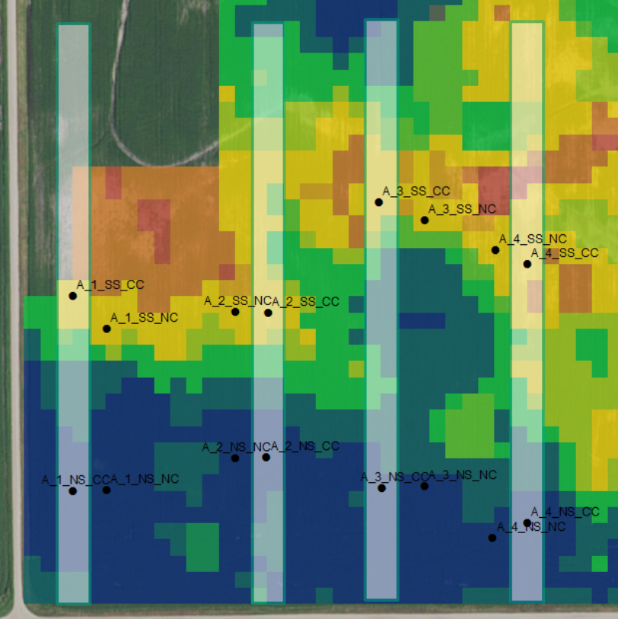
Figure 2. Veris map of the Aneta field site, with warm colors indicating higher salinity. Cover crop treatments are indicated by gray strips, and small points are plot locations.

Each year, as soon as cover crops are growing, we immediately begin sampling soil water content (0-6” and 6-12”) every other week. Once the cereal rye begins to grow, we collect data on cover crop and weed biomass production each month until a hard freeze. We resume these measurements in the spring upon thaw and until the cover crop is terminated.

In the fall of 2018, we sampled soil (0-6” and 6-24”) for routine analysis of fertility (nitrogen, phosphorous, and potassium), pH, EC, and soil organic matter (SOM). The routine sampling of the field sites allows us to monitor the plants and soils for any changes or differences, either due to salinity or the cereal rye.

Additional data collection
In addition to the routine monitoring of the plants and soil physical and chemical properties, we were also interested in monitoring and comparing the living communities in the plots (including soil organisms and insects). Under objective one, you will notice that we have been undertaking a broad approach to sampling soil properties, plants, and insects.

For the soil component of the project, we have two sub-objectives, which relate to the physical, chemical, and biological properties of the soil:
1.1 How do saline and non-saline soils differ?
In addition to the soil data collection that we’ve described in the previous section, we also measured soil microbial communities and decomposition activity within each plot in 2018. Soil microbes are responsible for transforming soil organic matter into plant-available nutrients, for forming beneficial relationships with plant roots (such as arbuscular mycorrhizal fungi (AMF)), and for transforming nutrients into different forms, which can either be used by plants, or lost through volatilization and leaching. We were curious if microbial abundance and activity would be affected by salt levels in the soil.

To measure this, we sampled soils in mid-season (late June – early August) 2018, when the crops are actively growing. Soils were either immediately processed for microbial biomass carbon (an indicator of total microbial abundance), or frozen and later processed by a commercial laboratory for microbial community structure (abundance of microbial groups, such as bacteria, fungi, AMF, and protozoans). We also measured a soil microbial food source, which we call “active carbon.” Generally, the more fertility (N, P, and K) and active carbon a soil contains, the more microbes it can support.

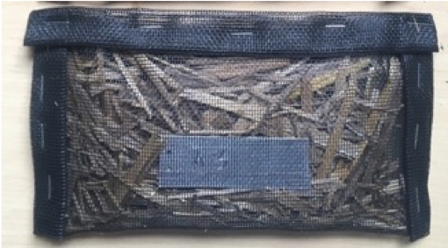
In addition to these measurements, we also deployed litter bags to measure decomposition rates on the soil surface. Litter bags are small screen pouches that are filled with a known quantity of residue, cereal rye biomass in our case. We secure the bags to the soil surface and allow them to decompose for one year. During that time, small arthropods, bacteria, and fungi will attack and degrade the residue, reducing the mass of the material in the pouch. After that time in the field, we recover the bags, clean, dry, and weigh the contents. Based on the mass loss of the residue, we can estimate biological decomposition activity within each plot.

  - Does cereal rye change any soil properties in the short-term?
Though we know that incorporating cereal rye as a cover crop provides many soil health-related benefits, we are also curious to track any changes in the soil (good or bad) in response to adding cereal rye into our fields. We are assessing this objective using the large soil dataset that has already been described in the sections above.

For the plant component, we have two sub-objectives:
  - What are the yields across salinity levels?
1.4 Does cereal rye influence yield?
We are interested to see if yields in our field sites are consistent with other regional reports of crop tolerance (or intolerance) to salt levels. We are also interested to see if the cover crop interfered with crop production, either by competing for soil resources (water, nutrients), or some other mechanism. To address these objectives, we hand-harvest the crop in each plot to estimate crop yield.

For the insect component, we have three sub-objectives:
1.5 Do our cover crops unintentionally increase damage from cutworms?
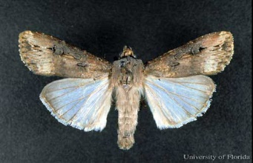
Cutworm is a general term used to describe a group of moths that can be significant pests on a variety of crops. As moths, their adult stage (right top) is fairly benign, but the larval stages (right below) can cause serious problems for crops.

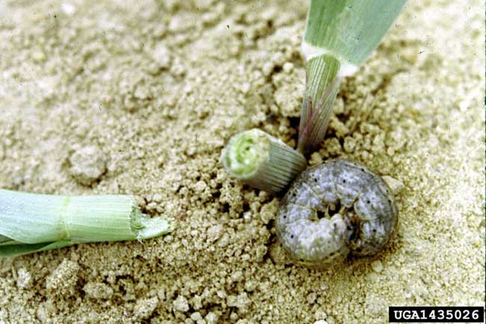
Cutworms can attack a huge variety of different crops in the Midwest. This includes field crops like corn and soybean as well as vegetables and other plants in home gardens. Which particular species of cutwork is prevalent and important changes with time of year and location, but the exact species does not always matter too much as an infested field often has multiple species of cutworms. Moreover, control measures that will be taken are usually the same for different cutworms.

That being said, there are some important differences between cutworms:
Overwintering. Some cutworm species lay their eggs in late Summer to Fall and overwinter in the soil. These cutworms might be influenced by our rye cover crop either in terms of adult moths choosing where to lay her eggs or in the juveniles being able to survive until next winter. Other species like the black cutworm, migrate from the south each year.

Damage. There are some differences in where and how cutworms can attack. Some cutworms climb up in to the vegetation and make holes and cause other damage to the plant. Others feed on the emerging plant in a way that will cut the plant off, thereby killing the entire plant.

Cutworms can be difficult to scout for because they are often hidden in soil during the day. Therefore, it is easiest to look for plant damage, quantify that, and then try to verify that the damage was caused by cutworms. To count and categorize plants, we placed a yard stick in the middle of each of our pre-established plots. These plots vary in their salinity and whether they were part of the rye cover crop. We then sampled four rows of plants, the two nearest of each side of the ruler, and counted the number of plants in those four rows for the length of the ruler, and classified each of those plants as undamaged, vegetation damage (significant), or cut off plants.

1.6 Do our cover crops influence other insects, particularly pests?
Previous research has indicated that cover crops can influence the abundance of both pest insects and beneficial insects on the focal crop. However, almost all of this research has been performed with cover crops that are present throughout the growing season and in systems, like organically grown crops, where insect densities are expected to be relatively high.
We focused our attention on soil-dwelling arthropods with the idea that their contact with the soil may result in the largest differences between plots with high and low salinity (and the potentially ameliorating cover crop). These samples are meant to better understand that community (see sub-objective 3) and to look for potential differences in beneficial and pest species.

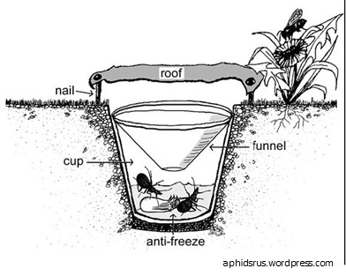
We took advantage of our pre-established plots across our four production fields. This allows us to sample in both crop types, across plots that vary in their salinity and presence of cover crops. Each plot had a center point and our pitfall traps were placed within 1m of those points. To establish traps a golf cup cutter was used to dig a hole in the soil and then two solo cups were placed in the hole to help keep the hole’s shape (bottom cup) or to collect insects (top cup). Before sampling began, we filled the cups half full with ethyl alcohol, which is a killing agent, an attractant, and helps keep specimens preserved. In addition, we placed a cover over the cup made of plywood and chicken wire that allowed insects and other arthropods to pass through but kept out any larger animals. All traps were kept in the field for two days, after which we collected them and took them back to the lab for processing and counting.

1.7 How does salinity (and cover crops) modify insects on the soil surface?
Our previous results indicate that soil salinity can have a large effect on arthropod performance and abundance. Moreover, we know that salinity is correlated with many other soil characteristics and can influence numerous other biotic groups in the soil. Part of our larger objective with this study is to look at organisms beyond just pests and beneficials and try to understand how soil salinity is influencing them and the food webs they are part of. This scientific question helps us better understand how the system works and how our management decisions influence the agroecosystem. The same insect samples described in the previous sub-objective were used to address this sub-objective.

Outreach & Education
Our second project objective focuses on communicating our findings to practitioners. In 2018, we achieved this in three ways:

- On July 26, 2018, the NDSU Soil Health bus tour (75 participants, primarily crop advisors and farmers) stopped at one of our field sites near Jamestown. At this location, we provided a summary of the research project, what we’ve observed so far, and discussed management options for managing saline soils.

- Both Dr. Gasch and Dr. DeSutter address salinity education and management in their course objectives. Dr. Gasch teaches Soil Ecology (SOIL 351, 20-35 students) and Dr. DeSutter teaches Soils and Land Use (SOIL 410/610, 40 students)—a large proportion of students in both classes will return to the farm or seek employment in crop advising or industry upon graduation. Topics include: the chemical nature and origin of salts, salinity versus sodicity, impacts of salinity of common ND and MN crops, impacts of salinity on soil organisms, economic changes in gross income due to salinity, and management options for salinity (tillage, cover crops, crop selection, tile and surface drainage).

- Dr. Wick incorporated education about salinity and cover crops in her winter café talk series. She held 12 café talks, with a total of 348 attendees. Cereal rye was discussed at all 12 café talks, and salinity was discussed at 10 café talks.

We are approaching a point in the project where we have more results to share, so we anticipate disseminating project-specific knowledge will increase during the next year. We will continue to provide education and outreach on the nature and management of saline soils.

