**Determining optimal planting date and soil temperature for enhanced growth and yield of soybean under no-till semi-arid condition**

**(A Technical Report – 2018/19)**

Gautam Pradhan*, Jerald Bergman, and James Staricka

NDSU Williston Research Extension Center, Williston, ND 58001

*Corresponding author: gautam.pradhan@ndsu.edu

**Situation statement**

Soybean acreage has been steadily increasing in North Dakota including in the western part of the state. Drought is one of the main abiotic stresses affecting soybean yield in the USA. In North Dakota, 99% of soybean is produced under dryland condition, and the western ND has exceptionally drier climate than the eastern part. It receives <15 inches of precipitation annually as compared to about 21 inches in the east, and average annual evapotranspiration is 5 inches higher than the east. There is a lack of a soybean production management guideline suitable for no-till dryland soybean producers of western ND. Planting date plays a significant role in field crop production including soybean. Early or late planting may decrease grain yield and quality of a crop due to increased biotic (insect, disease, weed, and bird incidence), and/or abiotic stress (frost, drought, and high temperature). There is a need for information on suitable soybean planting date and soil temperature for this part of the state.

**Objectives of the research project**

To determine suitable dryland soybean planting date and soil temperature for western North Dakota.

**Description of the research conducted**

A glyphosate resistant soybean variety was seeded at Williston Research Extension Center, Williston, ND on 3rd, 10th, 16th, and 25th of May, and 3rd, 9th, and 15th of June 2018 using a 7 rows no-till plot planter. Soil moisture and temperature data at 4 inches depth were continuously recorded from 04-26-2018 to 10-30-2018. Canopy temperature and normalized difference vegetation index (NDVI) were measured weekly with a FLIR® E60 Thermal Imaging camera and a modified NDVI Sony camera. The crop was harvested using a plot combine and biomass were collected four days before harvest.

**Findings**

This year, the trial received heavy rain, wind and hailstorms that damaged the crop and adversely affected yield (June 23: wind speed=46 mph, precipitation = 1.53”; June 28: wind speed = 61 mph, precipitation = 0.94”, hailstorm; July 9: wind speed = 48 mph, precipitation = 1.67”). Soybean emergence date and maximum soil temperature and moisture at 4” depth (averages of previous 4 days including emergence day) are given in Table 1.

There was a significant effect of seeding date on all the analyzed traits (Table 2 and Figures) except on the normalized difference vegetation index (NDVI) and canopy temperature (CT). On August 22, 2018, the average NDVI was 0.63 and the average CT was 32.4 °C. Soybean seeded on and after June 9 had higher plant stand than other seeding dates (Fig. 1). Soybean seeded on May 16th was 3 to 5 inches taller than other seeding dates; however, there was no difference between seeding dates of May 16th and May 25th for this trait. Soybean seeded on May 16th produced maximum above ground biomass than other seeding dates, and the statistical difference for this trait was evident between May 16th and late seeding dates (June 9th and 15th) only.





Soybean grains were significantly heavier when seeded on and after June 3rd (~119 g/ 1000 grain) as compared to May seeding. Soybean test weight was the highest for seeding date of May 16th as compared to others and a statistical difference was evident between May 16th and earliest (May 3rd) or latest (June 15th) seeding dates only. Soybean seeded on May 16th had a maximum grain yield of 17.8 bu/a, which was on an average 3.3 to 6.8 bushels more grain than other planting dates (Fig. 2). Soybean seeded on May 16th had maximum grain protein and it was significantly different than May 10th seeding date. In case of oil content, the earliest seeding date produced grains with the highest oil content than the latest seeding dates.

**Summary**

The growth, grain protein, test weight, and yield results showed that mid-May is suitable for seeding soybean under no-till dryland condition of Western North Dakota. The experiment will be repeated next year to validate the findings.

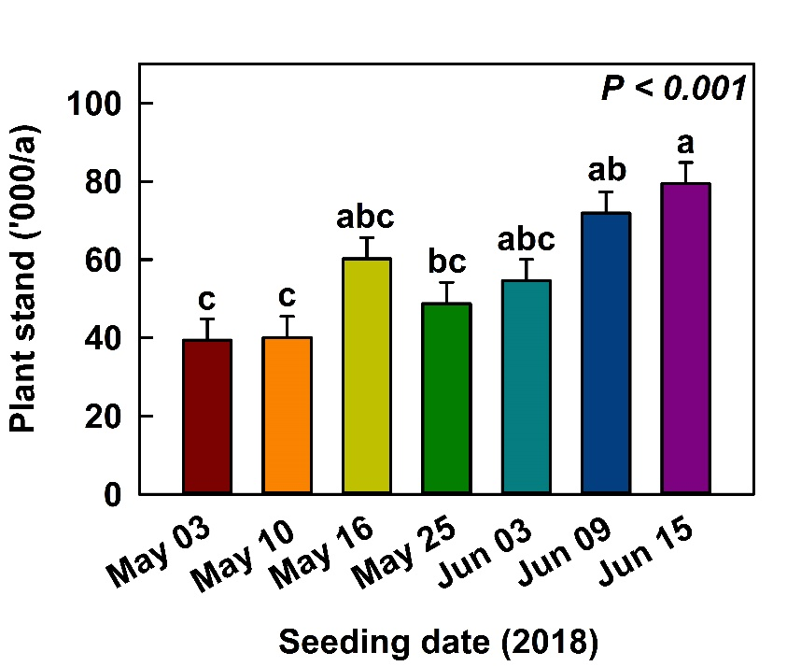

Figure 1. Soybean plant stand under different seeding date.

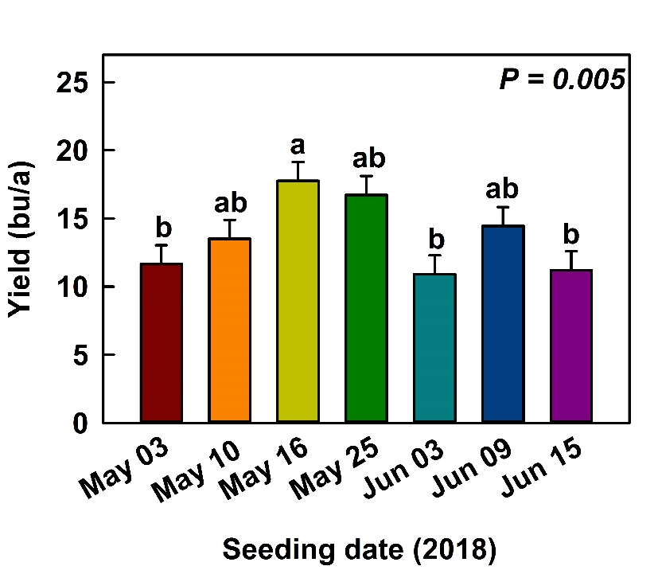

Figure 2. Soybean grain yield under different seeding date.

**Acknowledgements**

We would like to thank the North Dakota Soybean Council for financial support. Mention of trademark or proprietary product does not constitute a guarantee or warranty of the product by NDSU Williston Research Extension Center and does not imply its approval to the exclusion of other products which may also be suitable.