Technical Report 2018 - 2019 June 28, 2019
Soybean Cyst Nematode Sampling Program: 2018
PI: Sam Markell, Ph.D.
Co-PI’s Guiping Yan, Ph.D.
Collaborators: Berlin Nelson, Ph.D., and NDSU County Extension Agents
Why the Research is Important to ND Soybean Farmers:
Soybean cyst nematode is estimated to cause in excess of $1B in yield loss annual to U.S. soybeans. Since first reported in Richland County in 2003, the nematode has continued to spread throughout the North Dakota. Economic loss to North Dakota growers is expected to increase as the nematode is established in new fields and Counties in the state.
Management tools are available to growers, but early detection of SCN is critical to prevent yield loss. However, detection of SCN visually is difficult, and 15-30% yield loss is common before the appearance of any above ground symptoms. The most reliable way to detect SCN is to actively soil-sample areas where the nematode is most likely to be introduced into a field, before any symptoms are present.
To facilitate SCN sampling by growers, the NDSC and NDSU Extension developed a free-sampling program for growers in 2013. Since its creation, thousands of soil samples for SCN have been submitted in the state. The economic impact for every grower who proactively detects SCN before incurring yield loss is likely very high.
Objectives of the Research Conducted:
- Provide incentive for growers to sample for SCN by covering the cost of up to three SCN samples (pre-labeled bags) per grower on a first-come first-serve basis (up to 2,000 bags total). Bags are distributed through Extension County offices, my office, Research Director Nicholls office, at field days and by any other means appropriate.
- Creation of a SCN distribution map (limited resolution – no farms or growers can be identified) that can be used to determine how widespread SCN. This map was widely distributed in an effort to encourage growers to sample and/or manage SCN.
Description of the Research Conducted:
Soybean Cyst Nematode sample bags were obtained from Agvise in June 2018. Bags were labeled with distinct yellow tags containing funding and identification numbers. Bags and accompanying instruction/submission forms were distributed to every Extension County office in early August. The number of bags distributed was roughly proportional to acreage (i.e., Richland and Cass County received more bags than Divide or Williams County). Bags were also distributed though the NDSU Plant Pathology Department, the NDSC Research Directors office, field days, NDSU Research Extension Centers and any other means appropriate. To advertise the availability of the program, multiple radio interviews were delivered, NDSU Crop and Pest Reports were written and other advertising was done.
Soybean growers were asked to sample around the time of harvest (before or after) which is when SCN numbers are known to be highest. Growers submitted samples to Agvise directly, or though the NDSU County Extension offices. Upon receipt, Agvise processed the samples and sends results thought the U.S. mail back to the submitter. Dr. Markell received geographic data points and egg levels and construct a map of SCN egg levels and distribution in the state. No additional personal information about submitters was obtained or used.
Findings of the Research Conducted:
558 samples were received in the fall of 2018. Maps were created with SCN data from 2013 to 2018 (Figures 1 and 2). ‘Heat maps’ were created for the southeast and southcentral counties in North Dakota (Figure 3). While these are visually appealing, the should be viewed with a high-level caution, as SCN is very patchy; Many fields in areas indicating the presence of high egg counts will actually not have SCN, and some fields in areas without SCN eggs will be positive.

Maps were distributed widely throughout winter months, in both popular press and events. This included many NDSU sponsored or supported programs, including the Northern Corn and Soybean Expo. Feedback from growers and attendees indicated that the heat maps were much more impactful, and growers found them much easier to read and interpret than the original ‘dot’ maps.

Benefits/Recommendations to the North Dakota Soybean Farmers and Industry:
Early detection of SCN is critical to avoiding yield loss. Distribution of cost-free SCN sampling bags appears to have great buy-in among North Dakota growers. Additionally, secondary benefits of this program have occurred, including the increased talk among growers about SCN, many press interviews and importantly, a significant amount of positive press for the NDSC and its mission to serve the ND growers.
We continue to recommend that growers actively sample for SCN. For growers who have not detected SCN before, we recommend that they concentrate on areas in the field where SCN is most likely to first be introduced, such as field entrances and frequently flooded areas in fields. In fields where SCN is known to occur, we recommend that growers soil sample to determine if current management strategies are working (i.e. keeping egg levels low).
Acknowledgements:
We express our thanks to the many Extension agents, crop consultants and other agricultural professionals who helped distribute sample bags and sampling instructions, to Michaela Halvorson for map construction, to Agvise for sample processing, and finally to the North Dakota Soybean Council for support.

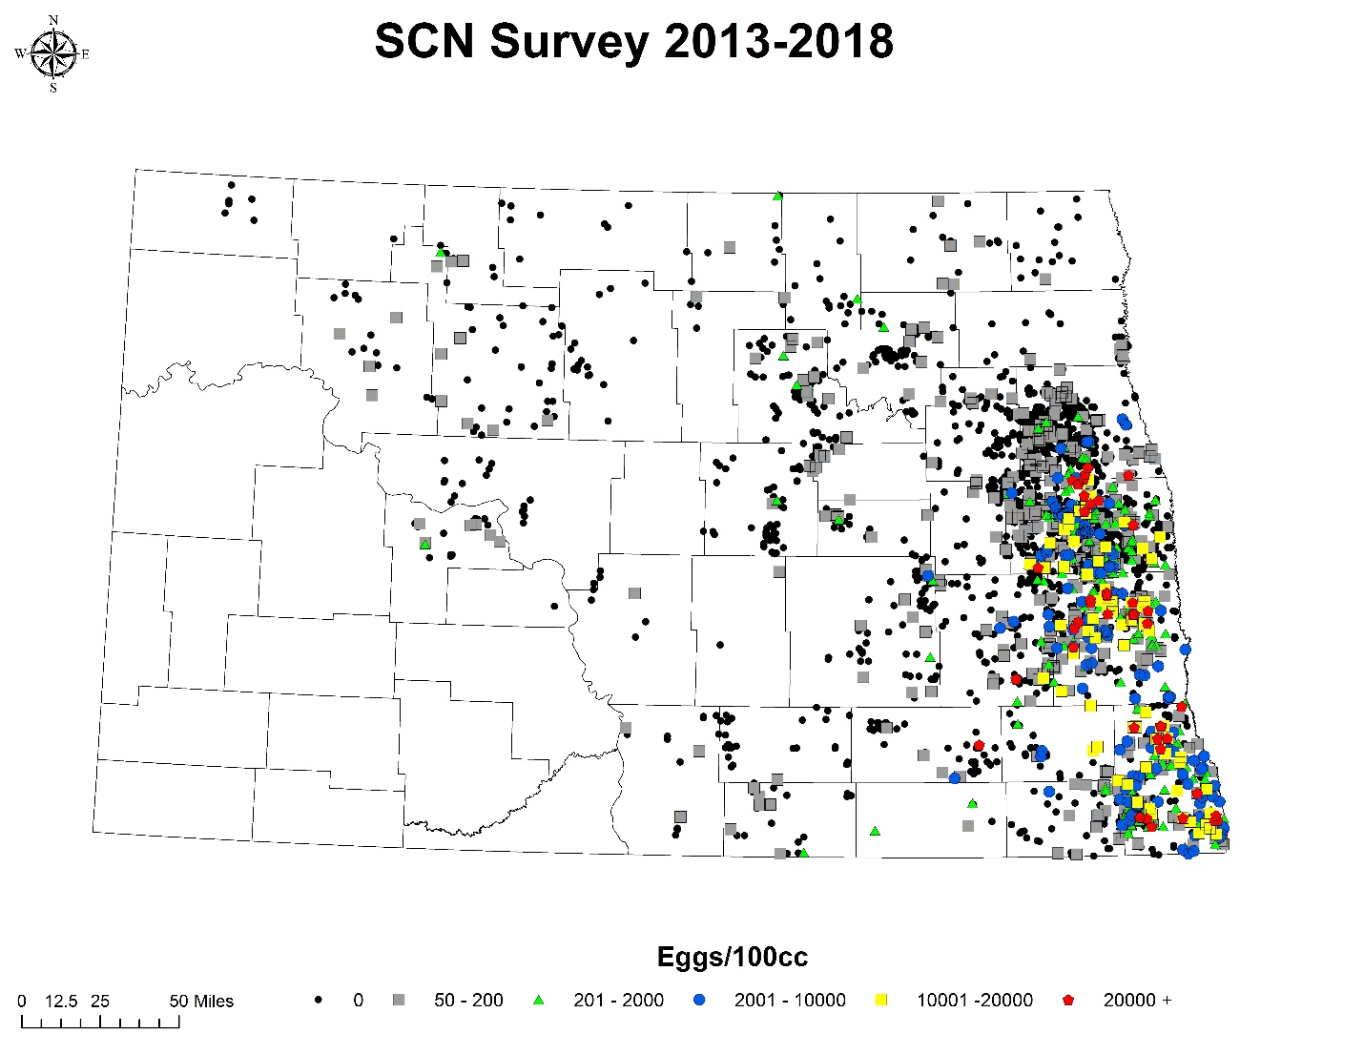Figure 1. State-wide distribution and egg level of soybean cyst nematode in North Dakota received though the NDSC / NDSU sampling program 2013-2018.

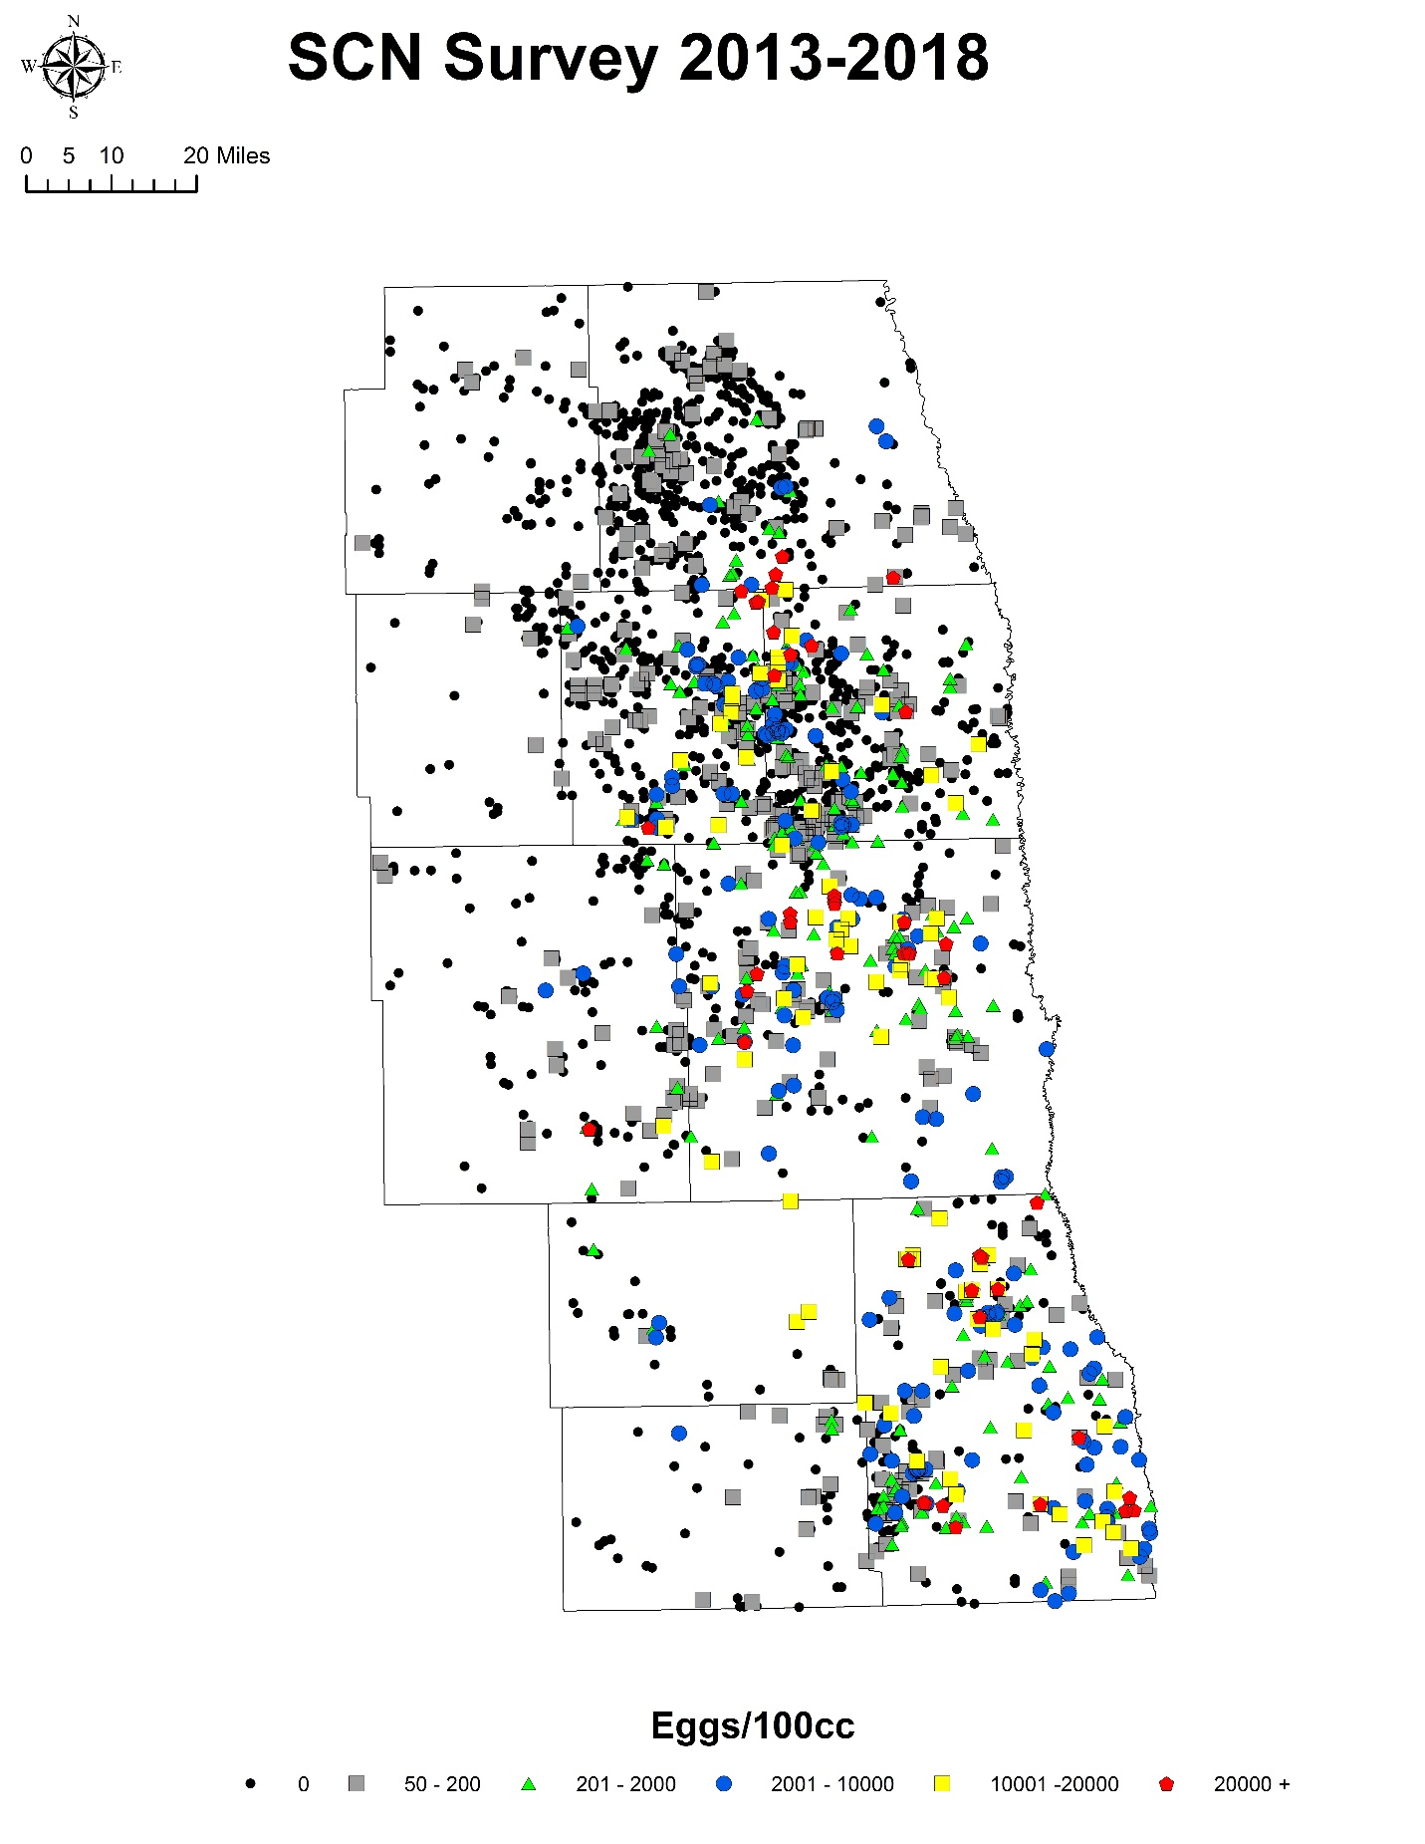Figure 2. Region-wide distribution and egg level of soybean cyst nematode in southeast North Dakota received though the NDSC / NDSU sampling program in 2013-2018.
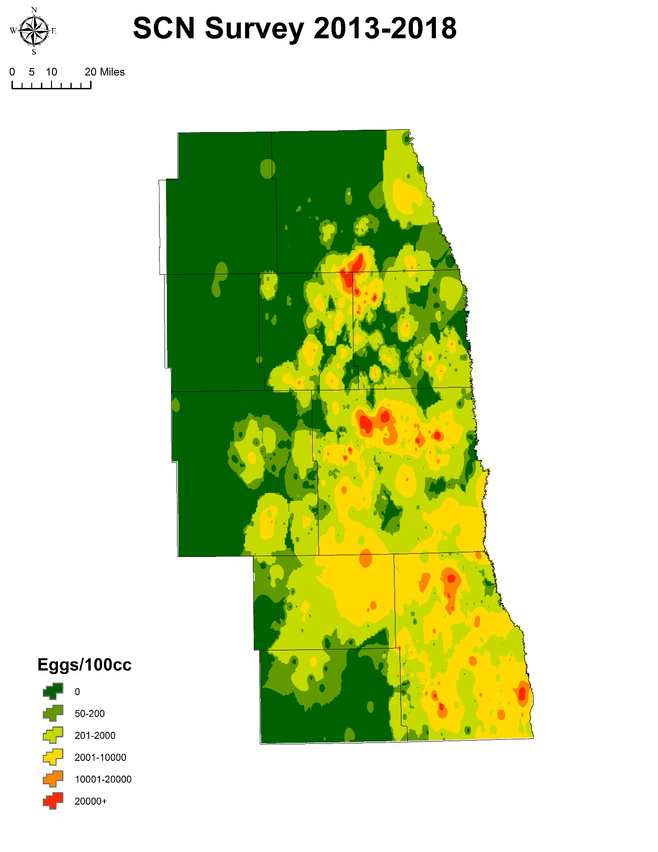Figure 3. Heat map of distribution and egg level of soybean cyst nematode in southeast North Dakota received though the NDSC / NDSU sampling program in 2013-2018.

