Technical Report

High-throughput methods for screening soybean varieties for resistance to iron deficiency chlorosis

R. Jay Goos, Professor, Department of Soil Science, NDSU

Summary

Iron deficiency chlorosis (IDC) persists as the most widespread nutrient deficiency in soybeans in North Dakota. Variety selection is the most effective, and cost-effective control measure. Field screening is the most common method of evaluation of varieties for resistance to IDC, but there still remains a need for a more rapid greenhouse/growth chamber method. The objective of this research was to develop a practical greenhouse screening protocol, which could be used to identify varieties with high levels of resistance. As the research progressed, it became evident that the method could be used to screen other cultural practices, such as seed treatments. The method consists of growing individual plants in "conetainer" pots in a 50:50 mix of white sand and chlorosis-producing soil. The degree of chlorosis can be adjusted by varying the composition of the sub-irrigation solution beneath each pot, and the amount of phosphorus applied to the soil. In the protocol developed, the sub-irrigation solution is 10 mmol sodium nitrate, and the soil:sand mixture is fertilized with 100 mg P per 2 kg of soil:sand mixture.

Introduction

Sadly, IDC remains as a widespread and destructive disorder of soybeans. Understanding of the problem has grown significantly over the past 20 years, but the problem is as destructive as ever. Variety selection remains as the most effective and cost-effective control measure, but selecting a resistant variety is not as easy as it seems. The commercial life-span of a variety is just a few years, and about the time farmers and agronomists identify a "go-to" variety for chlorosis-prone fields, the variety is no longer for sale. Also, the information given to farmers by some seed companies, about the chlorosis resistance of their varieties, is not helpful, as most companies are reluctant to give anything less than an "average" rating to a variety. NDSU conducts rigorous field evaluations of chlorosis resistance, but many companies don't participate. Thus there is a need for an alternative. The objective of this study was to develop a greenhouse method for screening varieties for resistance to IDC that could be performed researchers, seed companies, extension personnel, or even local agronomists or farmers with access to greenhouse or growth chamber facilities.

The Super-Cell Conetainer is an inexpensive and space-efficient system for growing plants that is an industry standard for greenhouse production (www.stuewe.com/products/rayleach.php). Conetainers have been used to screen clover lines for resistance to IDC. Scientists in Minnesota demonstrated that maintaining a free water surface 10 cm from the soil surface intensified chlorosis, and allowed for variety screening. This project combined these two methods into a screening method. Severity of chlorosis is intensified by factors such as levels of nitrate and bicarbonate in the soil solution, and phosphate in the soil, so these factors were studied. After a reasonable protocol was developed, the method was further tested by testing commercial varieties and experimental seed treatments.

Part 1. Development of the method

Methods, Study 1, nitrate rates

A Glyndon loam from Hunter, ND, was used for these experiments. The soil was taken from an area in a field that gives moderate to severe chlorosis every year soybeans are grown. The soil had a pH around 8, contained free calcium carbonate, but was not saline. The air-dried and sieved soil was weighed out in 1 kg lots. White sand (20/40 mesh) was weighed into 1 kg lots. Nutrients (P, Zn, Cu, Mn) were added to the sand at the rates of 100, 5, 5, and 5 mg, respectively, as potassium phosphate dibasic, and sulfate salts of the micronutrients. An inoculum suspension, representing about 0.1 g inoculum was also added to the sand. The sand was mixed, and then mixed with an equal mass of soil. Cotton balls were placed in the bottom of the pots, and the soil:sand mixture added to within about 5 cm from the surface. Water, 20 mL was added, and the pots covered, and allowed to incubate for a week. Then, two seeds were planted, and covered with about 2.5 cm of soil:sand mixture. The varieties were, in order of declining resistance to IDC: germplasm Iowa State A11, Traill, Glacier, and Stine 0480. In prior trials, Traill was found to have acceptable resistance to IDC, but still was responsive to additional control measures, such as heavier seeding rates and seed treatment with FeEDDHA.

After emergence, each pot was thinned to one plant per pot, and a cup placed beneath each cup that contained either 0, 2.5, 5, 7.5, or 10 mmol sodium nitrate. The cups were filled daily. The cup was placed so that the top of the water was about 10 cm below the soil surface. Measurements included the relative chlorophyll value of the first and second trifoliolate leaflets using a Minolta SPAD meter, and per-plant dry matter when the plants were cut off just above the seed piece. There were six replications.

Results, Study 1, nitrate rates

The results of the nitrate study are shown in Table 1, which is at the end of the document. At the lower nitrate rates (2.5 and 5 mmol), there was little chlorosis and little separation of the varieties. There was some separation at 7.5 mmol, but a dramatic separation at 10 mmol, and in the order expected. This is shown visually in Figure 1.

Methods, Study 2, nitrate and bicarbonate rates

Severity of IDC is known to be intensified by the presence of the bicarbonate ion in the soil solution. The experiment was run similarly as the first experiment, except that the sub-irrigation solutions contained 5, 7.5, and 10 mmol sodium nitrate by 0, 5, and 10 mmol sodium bicarbonate.

Results, Study 2, nitrate and bicarbonate rate

The results of this study are shown in Table 2. At a nitrate rate of 5 mmol, all of the varieties were reasonably green, and there was no intensification of the chlorosis by increasing bicarbonate rate. At the 7.5 and 10 mmol nitrate rate, there was also little intensification of the chlorosis by increasing bicarbonate rate. These results were surprising. No matter the nitrate or bicarbonate rate, the most resistant variety, A11, had the greatest level of chlorophyll, and greatest dry matter production. The variety Traill appeared to under-perform in this study, but it was noticed that many of the first and second trifoliolate leaflets were larger than for Glacier and Stine, but still chlorotic. So, it was decided to change the protocol with regards to growth. In the subsequent study, after measuring chlorophyll, the tops were cut up just below the intersection of the petiole of the first trifoliolate leaf and the main stem, and the fresh weight determined. That would allow for a better separation between leaves that were yellow, but still growing, and stunted leaves that were not.

Methods, Study 3, phosphate rates

The third study was run in a similar way as the first two studies. The sub-irrigation solution was 10 mmol sodium nitrate, and the amount of P added to the sand:soil mixture was 0, 25, 50, and 100 mg of P as potassium phosphate dibasic, per 2 kg of soil:sand mixture. Leaf chlorophyll was determined on the first and second trifoliolate leaflets, and the fresh weight of the plant tops was determined, cut off just beneath the intersection of the petiole of the first trifoliolate leaf and the main stem.

Results, Study 3, phosphate rates

The results of the third study are shown in Table 3. Chlorosis was intensified by adding phosphate to the soil, compared to the zero phosphorus rate. In general, the varieties separated themselves as expected, especially when looking at the column of fresh weight of the tops. As in Study 2, it was noticed that Traill may sometimes have reduced chlorophyll, but the leaflets are still growing and not going into necrosis.

Part 2. Application of the method

The method developed was used in three subsequent studies. One study evaluated varieties of interest to the Colfax Chlorosis Club. Another study examined seed-applied microbial inoculants and seed-applied Soygreen. And, another study examined seed-applied growth regulators and seed-applied Soygreen.

Methods, Study 4, variety evaluation.

Part of the outreach portion of this project is the Colfax Chlorosis Club. The Club meets twice a year, a winter meeting to discuss what worked (and what didn't work) the prior summer, and a summer field tour to look at various strip trials initiated by the farmer-members of the club. The agronomist at the Colfax Farmers Elevator sent in samples of varieties that were going to be offered for sale in 2019. These varieties were tested under the protocol developed (10 mmol sodium nitrate sub-irrigation solution, 100 mg of P per 2 kg batch of soil + sand).

Results, Study 4, variety evaluation.

The results of the variety evaluation are shown in Table 4. As expected, A11 and Traill out-performed most of the varieties entered. The two Libery Link varieties exhibited acceptable chlorosis resistance in this study, being in between A11 and Traill with regards to chlorophyll and top growth. This was in agreement with the general observations of the farmer members of the Chlorosis Club. However, none of the new Asgrow lines did as well as A11, Traill, or the Liberty Link varieties. One has to wonder if one of the reasons for the widespread chlorosis in 2019 is due to a lack of availability of varieties with high levels of IDC resistance.

Methods, Study 5, microbial inoculants

I was contacted by an industry agronomist who had observed that a co-application of Soygreen, plus an in-furrow biological treatment (Serenade, Bacillus subtilis), seemed to alleviate chlorosis better than the two treatments applied separately. This was easily evaluated, using this protocol. The experiment consisted of three inoculation treatments (Control, Serenade, another strain of Bacillus subtilis) by two seed-applied Soygreen treatments, minus and 1% on the seed (1 g/100 g of seed). The suceptible variety Stine 0480 was used.

Results, Study 5, microbial inoculants

The results of the study are shown in Table 5. The biological treatments did not improve chlorophyll level or growth, but the seed treatment with Soygreen did. The purpose of including this in this report is not because the results themselves are so important, but to show that the protocol developed is very helpful in screening treatments other than varieties, such as seed treatments.

Methods, Study 6, plant growth regulators and seed-applied Soygreen

This study evaluated the effects of two seed-applied growth regulators and seed applied Soygreen (1 g/100 g of seed) on the severity of IDC in a very susceptible variety, Stine 0480, using the protocol developed in this project. The growth regulators were chosen because prior work has shown that they stimulate chlorophyll production. The same seed lots used in the greenhouse study were given to Dr. Ted Helms, who entered them in his hill plot IDC studies in 2018.

Results, Study 6, plant growth regulators and seed-applied Soygreen

The results of this study are shown in Table 6. The combined effects of the growth regulator GR-1 along with seed-applied Soygreen were overwhelming. The control plants did not produce 1st trifoliolate leaflets (Figure 2a), as the growing points had died. However, with the combined treatment, the plants were in much better shape (Figure 2b). We will be continuing this work, starting in July of 2019, and will screen a series of seed treatment combinations of iron fertilizers and growth regulators. Hypothetically, seed treatment with FeEDDHA should work much better than it has in prior studies (see the two papers quoted earlier by Goos and Johnson). If a soybean seed that weighs 160 mg is treated with 1% by weight of Soygreen, that is about 100 ug of iron per seed. That should be enough iron to grow perfectly normal plants through about the 4th trifoliolate stage, but in the field and greenhouse, response is less. Perhaps by combining a seed treatment with FeEDDHA with a growth regulator that stimulates chlorophyll production, a better response will be obtained.

Other activities of this project

This project engages in other activities with the objective of reducing yield loss from IDC. The project leader is involved with public speaking to farmers and agronomists about IDC. The Colfax Chlorosis Club, and a farmer group in Mayville have been organized, to get farmers together to discuss what works, what doesn't work, and what needs to be tried. Lastly, the project leader does free testing for ag chemical distributors, seeking sources of iron to sell to their customers. The quality of iron fertilizers varies, and our "soil stability" test is performed on request, to help ag chemical distributors locate higher-quality products.

Table 1. Effect of nitrate concentration on the relative chlorophyll content (SPAD) of the first and second trifoliolate leaflets and dry matter production of four soybean varieties differing in resistance to IDC.

 |  |  |  |  | Dry
Nitrate | Variety | 1st-SPAD | 2nd-SPAD | Avg. SPAD | matter
mmol |  |  |  |  | g/plant
2.5 | A11 | 30.2 | 22.5 | 26.4 | 0.76
2.5 | TR | 27.8 | 26.7 | 27.3 | 0.71
2.5 | GL | 27.6 | 23.1 | 25.3 | 0.81
2.5 | ST | 28.2 | 22.6 | 25.4 | 0.71
5 | A11 | 30.7 | 28.3 | 29.5 | 0.78
5 | TR | 28.6 | 28.3 | 28.5 | 0.66
5 | GL | 29.5 | 26.5 | 28.0 | 0.89
5 | ST | 27.7 | 26.3 | 27.0 | 0.72
7.5 | A11 | 31.1 | 34.2 | 32.6 | 0.82
7.5 | TR | 26.6 | 31.2 | 28.9 | 0.67
7.5 | GL | 21.0 | 20.6 | 20.8 | 0.80
7.5 | ST | 21.5 | 23.7 | 22.6 | 0.89
10 | A11 | 25.7 | 24.4 | 25.1 | 0.76
10 | TR | 16.1 | 12.7 | 14.4 | 0.55
10 | GL | 6.8 | 0.0 | 3.4 | 0.57
10 | ST | 7.6 | 5.9 | 6.8 | 0.62
Sig of F | Nitrate | ** | ** | ** | *
 | Variety | ** | ** | ** | NS
 | Nit. x Var | ** | ** | ** | NS
 | SE | 2.5 | 3.2 | 2.5 | 0.08
*, **, significant at the 0.05 and 0.01 level respectively. NS=not significant. SE=standard error

Figure 1. Four soybean varieties illustrating different levels of resistance to IDC. Sub-irrigation solution was 10 mmol sodium nitrate. Varieties are shown from most resistant (right) to most susceptible (left).

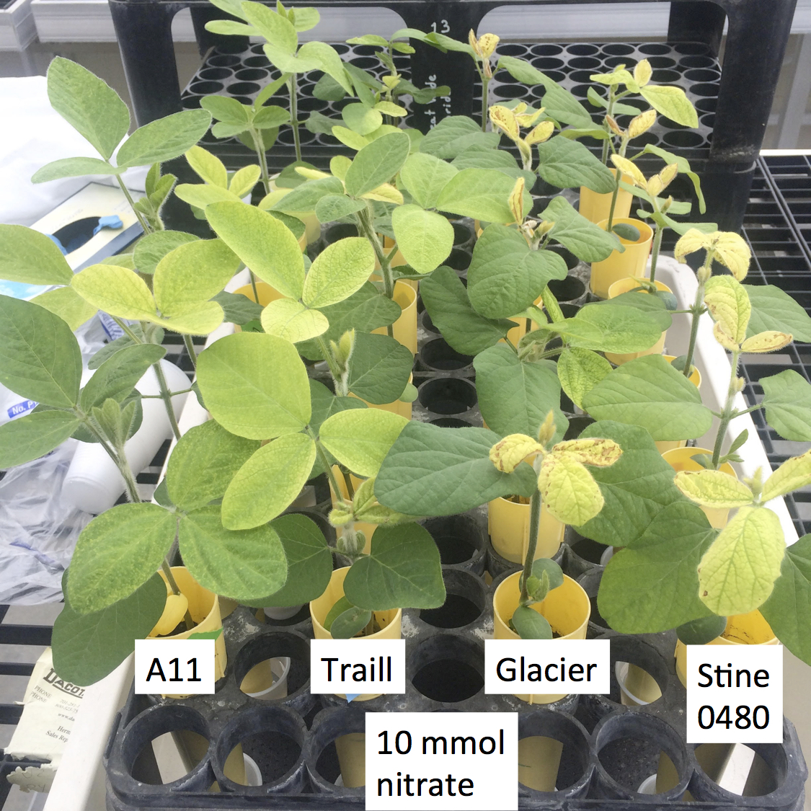

Table 2. Effect of nitrate and bicarbonate concentration on the relative chlorophyll content (SPAD) of the first and second trifoliolate leaflets and dry matter production of four soybean varieties differing in resistance to IDC.
Nitrate | Bicarb | Variety | 1st-SPAD | 2nd-SPAD | Avg. SPAD | Dry wt
mmol | mmol |  |  |  |  | g/plant
5 | 0 | A11 | 36.3 | 29.6 | 32.9 | 0.63
5 | 0 | TR | 30.8 | 32.3 | 31.5 | 0.58
5 | 0 | GL | 30.5 | 29.7 | 30.1 | 0.61
5 | 0 | ST | 21.4 | 24.7 | 23.0 | 0.48
5 | 5 | A11 | 35.9 | 28.9 | 32.4 | 0.69
5 | 5 | TR | 27.6 | 29.8 | 28.7 | 0.59
5 | 5 | GL | 31.7 | 28.1 | 29.9 | 0.69
5 | 5 | ST | 20.9 | 18.3 | 19.6 | 0.46
5 | 10 | A11 | 36.8 | 31.3 | 34.1 | 0.66
5 | 10 | TR | 31.2 | 31.2 | 31.2 | 0.60
5 | 10 | GL | 28.1 | 30.1 | 29.1 | 0.68
5 | 10 | ST | 27.5 | 29.5 | 28.5 | 0.53
7.5 | 0 | A11 | 33.2 | 30.2 | 31.7 | 0.64
7.5 | 0 | TR | 26.6 | 31.1 | 28.9 | 0.55
7.5 | 0 | GL | 26.5 | 31.8 | 29.1 | 0.62
7.5 | 0 | ST | 10.0 | 10.0 | 10.0 | 0.40
7.5 | 5 | A11 | 30.9 | 32.2 | 31.5 | 0.62
7.5 | 5 | TR | 20.8 | 13.7 | 17.2 | 0.47
7.5 | 5 | GL | 20.0 | 19.9 | 19.9 | 0.51
7.5 | 5 | ST | 5.6 | 4.9 | 5.2 | 0.33
7.5 | 10 | A11 | 33.7 | 32.6 | 33.2 | 0.68
7.5 | 10 | TR | 18.0 | 22.0 | 20.0 | 0.41
7.5 | 10 | GL | 21.5 | 25.2 | 23.4 | 0.60
7.5 | 10 | ST | 7.0 | 10.1 | 8.5 | 0.33
10 | 0 | A11 | 28.6 | 27.3 | 27.9 | 0.67
10 | 0 | TR | 5.2 | 0.8 | 3.0 | 0.37
10 | 0 | GL | 13.6 | 8.8 | 11.2 | 0.46
10 | 0 | ST | 1.1 | 0.0 | 0.6 | 0.33
10 | 5 | A11 | 21.2 | 18.5 | 19.8 | 0.56
10 | 5 | TR | 6.7 | 0.0 | 3.4 | 0.35
10 | 5 | GL | 5.9 | 2.6 | 4.2 | 0.41
10 | 5 | ST | 0.8 | 0.0 | 0.4 | 0.33
10 | 10 | A11 | 21.5 | 15.1 | 18.3 | 0.54
10 | 10 | TR | 6.4 | 2.8 | 4.6 | 0.38
10 | 10 | GL | 1.3 | 2.9 | 2.1 | 0.35
10 | 10 | ST | 0.8 | 0.0 | 0.4 | 0.31
 | Sig of F | Nitrate | ** | ** | ** | **
 |  | Bicarb. | * | ** | ** | NS
 |  | Variety | ** | ** | ** | **
 |  | Nitr. x Bicarb. | NS | NS | NS | *
 |  | Nitr. x Var. | ** | ** | ** | **
 |  | Bicarb x Var. | NS | NS | NS | NS
 |  | SE | 3.0 | 3.6 | 3.0 | 0.04
*, **, significant at the 0.05 and 0.01 level respectively. NS=not significant. SE=standard error

Table 3. Effect of phosphate rate on development of IDC by four soybean varieties.

P rate | Var | 1st-SPAD | 2nd-SPAD | Avg. SPAD | FW
mg |  |  |  |  | g/plant
0 | A11 | 30.7 | 25.1 | 27.9 | 1.61
0 | TR | 26.7 | 23.3 | 25.0 | 1.48
0 | GL | 21.2 | 19.0 | 20.1 | 1.30
0 | ST | 12.9 | 8.1 | 10.5 | 1.17
25 | A11 | 25.9 | 27.6 | 26.7 | 1.82
25 | TR | 10.5 | 7.8 | 9.2 | 1.41
25 | GL | 2.6 | 1.9 | 2.2 | 0.76
25 | ST | 1.7 | 0.4 | 1.1 | 0.69
50 | A11 | 30.6 | 27.7 | 29.2 | 1.78
50 | TR | 8.6 | 3.7 | 6.1 | 1.28
50 | GL | 2.3 | 0.9 | 1.6 | 0.67
50 | ST | 1.8 | 0.0 | 0.9 | 0.68
100 | A11 | 18.9 | 15.9 | 17.4 | 1.68
100 | TR | 5.1 | 4.5 | 4.8 | 1.42
100 | GL | 1.8 | 0.0 | 0.9 | 0.60
100 | ST | 0.8 | 0.0 | 0.4 | 0.46
Sig. of F | P rate | ** | ** | ** | **
 | Variety | ** | ** | ** | **
 | P x Var. | * | ** | ** | **
 | SE | 2.5 | 2.7 | 2.4 | 0.12
*, **, significant at the 0.05 and 0.01 level respectively. NS=not significant. SE=standard error

Table 4. A test run of screening soybean varieties for resistance to IDC in the greenhouse.

Variety | 1st-SPAD | 2nd-SPAD | Avg. SPAD | FW
 |  |  |  | g/plant
A11 | 23.9 | 13.4 | 18.6 | 1.31
Integra 30808 | 19.5 | 9.8 | 14.7 | 1.08
Integra 30607 | 13.1 | 8.0 | 10.6 | 1.05
Traill | 12.6 | 5.6 | 9.1 | 1.10
Asgrow 06X8 | 9.7 | 2.1 | 5.9 | 0.54
Asgrow 14X8 | 9.3 | 2.5 | 5.9 | 0.73
Asgrow 05X9 | 9.3 | 2.0 | 5.6 | 0.68
Asgrow 05X8 | 8.9 | 2.1 | 5.5 | 0.79
Asgrow 06X7 | 8.2 | 1.4 | 4.8 | 0.64
Stine 0480 | 3.0 | 0.4 | 1.7 | 0.67
Asgrow 11X8 | 1.5 | 0.0 | 0.7 | 0.32
Sig. of F, Variety | ** | ** | ** | **
SE | 2.5 | 1.9 | 2.0 | 0.12
Varieties in green font were in the resistance range exhibited by All and Traill. Varieties in orange font were less resistant than Traill.
**, significant at the 0.01 level. NS=not significant. SE=standard error

Table 5. Effect of seed inoculation with two Bacillus subtilis inoculants and seed treatment with Soygreen on severity of IDC in soybean.

Inoc.† | Soygreen | 1st-SPAD | 2nd-SPAD | Avg. SPAD | Fresh-wt
No | No | 10.6 | 9.0 | 9.8 | 1.76
No | Yes | 23.8 | 15.4 | 19.6 | 2.27
Product #1 | No | 7.1 | 4.7 | 5.9 | 1.20
Product #1 | Yes | 17.9 | 12.9 | 15.4 | 2.20
Product #2 | No | 8.1 | 6.4 | 7.2 | 1.58
Product #2 | Yes | 22.2 | 17.8 | 20.0 | 2.31
Sig. of F | Inoc. | NS | NS | NS | NS
 | Soygreen | ** | ** | ** | **
 | Inoc. x SG | * | + | * | *
 | SE | 1.8 | 1.9 | 1.2 | 0.10
† Product 1, Serenade by Bayer; Product 2, Bacillus subtilis isolated from natto.
+, *, **, significant at the 0.10, 0.05 and 0.01 level respectively. NS=not significant. SE=standard error

Table 6. Effect of seed-applied growth regulators and seed-applied Soygreen on severity of IDC in soybean in the greenhouse and in the field.

Growth | Soygreen | Greenhouse |  | Colfax | Colfax | Erie | Erie
reg. | seed trt. | 1st SPAD | DM | 1st rating | 2nd rating | 1st rating | 2nd rating
 |  |  | g
None | No | 0.3 | 0.5 | 3.0 | 2.6 | 3.0 | 3.5
GR-1 | No | 12.0 | 0.5 | 2.9 | 2.5 | 2.3 | 3.1
GR-2 | No | 7.5 | 0.4 | 2.9 | 2.6 | 2.1 | 3.1
None | Yes | 3.7 | 0.9 | 3.0 | 2.8 | 2.1 | 2.8
GR-1 | Yes | 25.5 | 1.2 | 2.4 | 2.1 | 1.5 | 2.9
GR-2 | Yes | 19.1 | 1.1 | 2.8 | 2.5 | 1.8 | 2.8
Sig. of F
 | Growth reg. | ** | NS | NS | NS | ** | NS
 | Soygreen | ** | ** | NS | NS | ** | **
 | GR x SG | * | NS | NS | NS | * | NS
 | SE | 1.9 | 0.17 | 0.2 | 0.2 | 0.1 | 0.1
Data from Colfax and Erie, courtesy of Dr. Ted Helms.
*, **, significant at the 0.05 and 0.01 level respectively. NS=not significant. SE=standard error

Figure 2. Effect of a seed-applied growth regulator and seed-applied Soygreen on the severity of IDC of a very susceptible variety.

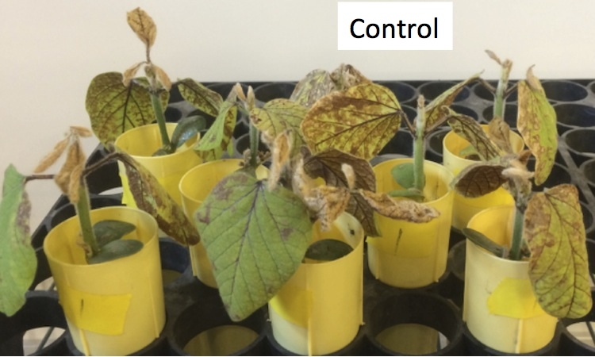

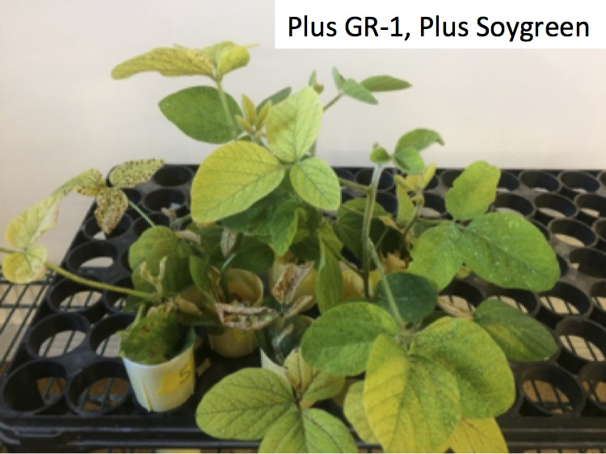

Gildersleeve and Ocumpaugh. 1989. Crop Science 29:949-951.
Fairbanks, Orf, Inskeep, and Bloom. 1987. Crop Science 27:953-957.
Goos and Johnson. 2000. Agronomy Journal 92:1135-1139; Goos and Johnson. 2001. Journal of Plant Nutrition 24:1255-1268.
Inskeep and Bloom. 1986. Soil Science Society of America Journal. 50:946-952.

