Technical Report

Determining Rye Safety to Soybeans with Soil Moisture Status

Mike Ostlie, Szilvia Yuja, Jasper Teboh, Greg Endres, Steve Zwinger, Paulo Flores, and Ezra Aberle

**Research Conducted**

In 2018 a trial was conducted to measure soil moisture differences between plots with rye that was terminated at different points within a rye/soybean relay system. After rye green-up, rye termination treatments were imposed weekly for 7 weeks. Soil moisture was measured weekly through rye anthesis and every 2 weeks thereafter. A hydroprobe was used to measure water content in 1 foot increments down to 4 feet. Soybeans were planted at the rye boot stage. Winter rye was established in Sept of 2017. Soybean emergence, rye growth stages, plant height, and rye and soybean grain yield and quality were other variables measured.

Treatments consisted of a fallow check (to calculate deficit), a rye-only check, a soybean-only check and a no termination (double-crop) check, along with 7 termination dates in-between, beginning in late April and running through early June. This trial was arranged as an RCBD with 4 replicates. This was the first year of the experiment with a goal of a 3-4 year study. The treatments were designed to be able to differentiate soil moisture differences with the rye removing more moisture as it advanced in growth stage.

This research was the focus of several workshops in summer 2018 including the Advanced Crop Advisor’s Workshop and CREC Fall Row Crop Tour, as well as an internal training workshop among researchers. Data were prepared for the CREC annual report and Wild World of Weeds Workshop and distributed on Twitter.

**Why the Research is Important to ND Soybean Farmers**

Winter rye is growing in popularity as a cover crop prior to soybeans. However, past research at the CREC has documented instances of rye growth reducing soybean yields under dry conditions. During wet seasons the soybeans can be planted ‘green’ (but terminated soon after) into the rye with little change in soybean yield. Other years, rye needs to be terminated several weeks prior to soybean planting to prevent soybean yield reduction. In some instances we saw complete crop failure from terminations occurring after soybean planting and near rye anthesis. This project aims to develop a set of guidelines for rye termination timing so that producers can predict when their soybean crop may be at risk from the rye.

Rye has become an important sustainability tool for soybean growers in the Northern Great Plains. It has excellent winter survival and grows late in the fall and early in the spring. It can be planted almost any time before ground freeze in the fall (though earlier is better). Rye provides soybean farmers with 1) reduced weed pressure, 2) a firm seedbed (which is important for saline areas), 3) reduced wind and water erosion, 4) potential livestock grazing/haying. #3 is probably the key reason to consider rye as it not only reduces erosion but also encourages reduced tillage.

**Final Findings of the Research**

Water use patterns were fairly consistent with expectations. Peak rye water use occurred around anthesis, while soybean peak water use peaked in mid-August (Figure 1). Rye that was terminated at or before soybean planting had similar soil moisture as soybean-only plots. Rye continued to use water for approximately 7 days after each termination (our measurements were only once every 7 days). Even though there was a spike in rye water use when terminated 1 week after soybean planting, the soil moisture status improved enough that soybean yield was not affected. Only further delaying termination (or not terminating) removed enough water to reduce soybean yields. Terminating rye at anthesis reduced soybean yields by approximately 10 bu/a in 2018 (Table 1). At this point we measured a 1.5” water deficit in the top two feet of soil. Our preliminary conclusion is that 1.5” deficit may be the trigger point where soybean yields will be affected, at least in medium textured soils.

Early and late soybean planting dates were included, with rye terminated 2 weeks prior to planting. This added to a longer database from previous trials that has demonstrated no negative impact on soybean yield when rye is terminated 2 weeks prior to planting. This is regardless of soybean planting date. The only statistical yield reductions in this study were when rye was not terminated or when rye was terminated at anthesis (after soybean planting). These are also two of the three treatments that differed in water deficit from the soybean-only check, confirming the water dependency of this relationship. The third treatment that differed is the termination 1 week after planting (mentioned above). This line corrected back toward the mean due to timely precipitation. Without timely rain that deficit would have remained or widened, to behave more similar to other treatments that affected yield.

One of the reasons that this system works is due to the completely separate peak water uses. While rye peak water use is in June (and decreasing rapidly to 0 by early July), soybeans didn’t start using water until early to mid-July. Areas with higher precipitation ae likely able to plant green more often due to the reduced water deficit and lack of water-use competition between the two crops.

**Benefits/Recommendations to North Dakota Soybean Farmers and Industry**

We are continuing to evaluate how water deficit will impact soybean yields over multiple years. Based on this and past research, the safest approach is to terminate rye two weeks prior to planting, which is also consistent with insurance guidelines. We are currently working to build a prediction tool that can be used to determine soybean yield risk from rye to assist with termination timing. The tool will be built using NDAWN data and previously researched GDD models developed for rye and soybean so that local weather data can be used to determine soybean crop safety. If safety can be assured, this practice could be adopted on a large percent of soybean acres in North Dakota.

Figure 1. Soil moisture deficit (compared to fallow) throughout the growing season for a subset of the treatments in our study.

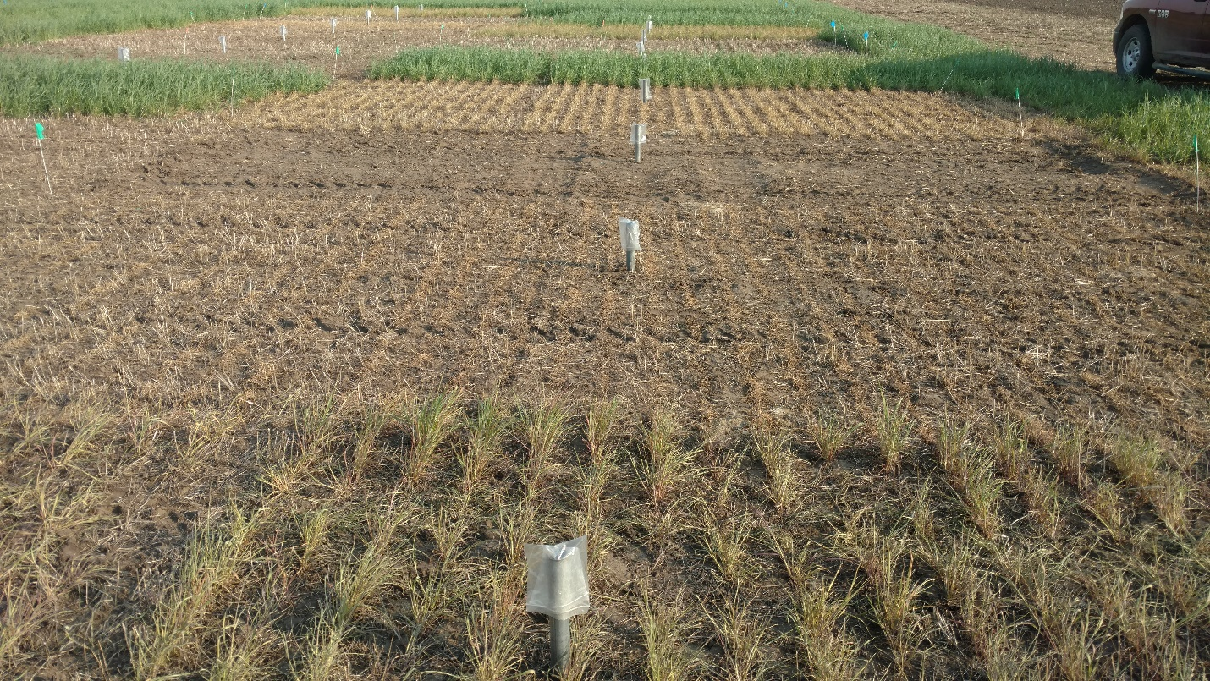

Figure 2. An overview of different rye termination dates as viewed at the time of soybean planting. The pipes are access tubes for measuring water content at different depths.

Table 1. soybean yield as affected by rye termination date. Termination 1 was April 20 and termination occurred in 1 week increments with termination 7 being rye anthesis.

