Technical Report

Multi Applications of Dicamba on Non-dicamba Tolerant Soybeans: Impact on Seed Yield and Quality, and the Effectiveness of a UAS to Assess Dicamba Damage

Mike Ostlie, Paulo Flores, and Kirk Howatt

**Research Conducted**

In 2018 a herbicide drift study was conducted to test the impact that microrates of dicamba have on soybean performance, including sensor-based data, on conventional soybeans. Dicamba rates used in the study were 0.014, 0.14, and 1.4 oz/a (Clarity rate equivalent). Glyphosate was included in some treatments paired with the dicamba rate structure at 0.025, 0.25, and 2.5 oz/a (Powermax rate equivalent). Applications were made at R1, when soybeans are particularly sensitive to injury. To test prolonged exposure, sequential treatments were tested to compare R1 **vs** R1 + R2 **vs** R1 + R2 + R3 exposures of the middle dicamba rate. Leaf tissue samples were collected and analyzed for dicamba residues 10 days after application.

Spectral data were also collect to test different methods for visualizing the extent of dicamba injury in a field. Visual and infrared images were collected and compared to ground-based injury evaluation 10, 20, 30, and 40 days after application. Images were analyzed with four different vegetation indices; NDVI, GNDVI, NDRE, and ExGr. The trial was organized as an RCBD with four replicates. Other data collected include plant height, maturity date, yield and quality. Harvested seed were also tested for germination and vigor.

These data were prepared for presentations at the Wild World of Weeds Workshop and Western Society of Weed Science. These data were also published in the CREC Annual Report and on Twitter (@agronomizeNDSU).

**Why the Research is Important to ND Soybean Farmers**

Since the release of dicamba tolerant soybeans, many fields have been affected by growth regulator symptoms, and the trait has since faced heavy regulatory scrutiny. This project was created to track the extent of damage from injury to yield, determine if symptoms can be measured accurately through remote sensing, test the validity of plant tissue tests in confirming dicamba application, and identify any changes to subsequent seed viability.

While dicamba symptoms readily affected fields in 2017 and 2018, it is less clear how much yields were impacted as a result of the injury. In many cases injury appeared with little to no observed yield loss, but not true in other instances. In other parts of the country, dicamba injury appears to cause yield loss more often than in the Upper Great Plains. Local data is needed to educate North Dakota producers on the realistic yield and quality expectations once visual symptoms are observed.

**Final Findings of the Research**

Regarding sequential exposures: Plants receiving a single or multiple applications responded the same to dicamba for the duration of the growing season (Table 1). The middle rate of dicamba caused substantial leaf cupping and plant height reduction, however, it had the same yield as the check (Table 2). Even though our yield potential was heavily reduced due to drought, the same trends have been observed previous seasons. Seeds harvested from sequentially-treated plants did not differ in germination, though there was reduced seedling vigor from three applications of dicamba. If sequential applications began earlier in the soybean lifecycle, it is unclear if the results would be the same.

Varying application rates of dicamba with or without glyphosate had a stepwise response to a number of variables (Table 3). Visual injury, plant height, and grain protein and oil changed with increasing doses. Only the highest rate of dicamba, with and without glyphosate, reduced yield. That same rate also caused an extreme delay in plant maturity. In fact, the plants only matured due to frost. This was also consistent with previous years. Also note that adding glyphosate to dicamba increased the amount of injury compared to dicamba alone at the highest rate. This would be important to particle drift cases, but with volatility drift, only dicamba portion is likely to move. Leaf tissue tests also showed a step-wise pattern when dicamba dose increased (Table 4), including increased concentration when glyphosate was added. However, it is important to note that the numbers received from the leaf tissue test do not translate well across environments (see recommendations below). Even though grain yields were quite low as a result of high dicamba doses the germination of seed that made it to maturity was no different from the check. In a realistic scenario, the plants treated with a high rate of dicamba would not be harvested due to the delayed maturity and low yield potential, and the likely need of a desiccant.

Vegetation indices were analyzed by comparison to visual injury (Figure 1) or yield (Figure 2) 20 days after herbicide application. In both cases yield and injury correlated very strongly with remote sensing techniques. The relationship between visual symptoms and analyzed imagery was so strong that they could be interchangeable. Among the indices used, NDVI, NDRE, and GNDVI all generated nearly identical relationships to yield and injury, again making any one of them suitable to use for this application. The Excess Green (ExGr) index had a consistently lower correlation, however, the relationships were still good. In fact, it is most likely that ExGr would be adopted by most growers/consultants due to cost. ExGr can be analyzed from any color image, meaning that low cost UAVs could be used to gather the data. The previous three indices require sensors that capture infrared bands which are more expensive and lower resolution.

**Benefits/Recommendations to North Dakota Soybean Farmers and Industry**

Dicamba symptoms on soybeans are an eyesore. However, often times the appearance of symptoms did not lead to a decline in soybean yield. Up to 25% leaf injury to the plants did not reduce yields (see photos). One of the keys was the even with that degree of injury, the growing points remained healthy. The plants were still shorter, but continued to grow and produce more leaves, buds, and subsequently pods. The highest tested dose caused severe stunting and no new growth until late in the season. The new growth on these plants generally occurred from auxiliary buds on the lower part of the plant. Seed harvested from affected plants generally had higher protein (probably due to less yield) but no loss in germination was observed.

Based on past experience with leaf tissue tests, it is important that samples are collected properly. Generally, more dicamba can be detected in plants treated with a higher dose, but the amount that is needed to cause injury can not be predicted. In some cases we’ve seen low levels of dicamba residue (20 ppb) cause severe injury. The only way to determine if dicamba is present in the leaf tissue is to have a check comparison (with several samples of each) and look for a higher amount in the dicamba affected area. This lessens the value of a tissue test. As such, visual symptoms should be the primary indicator of dicamba injury to soybeans. Tissue tests should only be used as supporting evidence to determine if it is indeed the agent causing observed symptoms. Visual injury was way more predictive of a yield response than tissue tests.

Aerial imagery appears to be a suitable method for measuring dicamba injury extent. Good relationships exist between several vegetation indices and visual symptoms or yield. While great relationships exist with infrared-based sensors, color images are likely sufficient to gather the needed information. With a color image, the Excess Green index can be used with good relationships to soybean response. This means, for example, that a Phantom 4 Pro with a 20 MP camera (a standard setup) should be sufficient to quantify the area affected and extent of dicamba injury.

Table 1. Comparison of visual injury symptoms of single vs multiple exposures of soybean to dicamba.



Table 2. Yield and plant response comparison of single vs multiple dicamba exposures.



Table 3. Dose response of glyphosate and dicamba on soybeans.



Table 4. Soybean leaf residue analysis for dicamba and subsequent germination of harvested seeds.



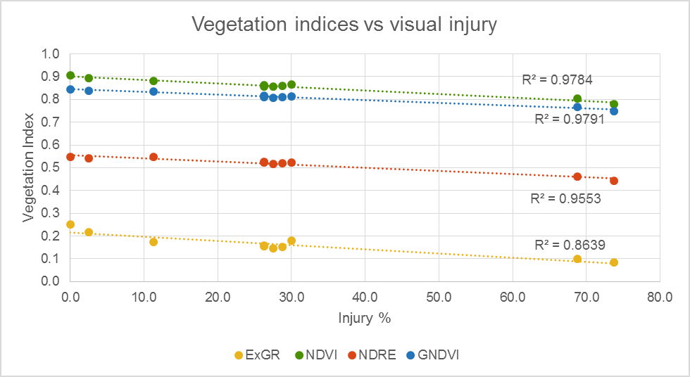

Figure 1. Visual injury caused by different treatment combinations compared to four vegetation indices.

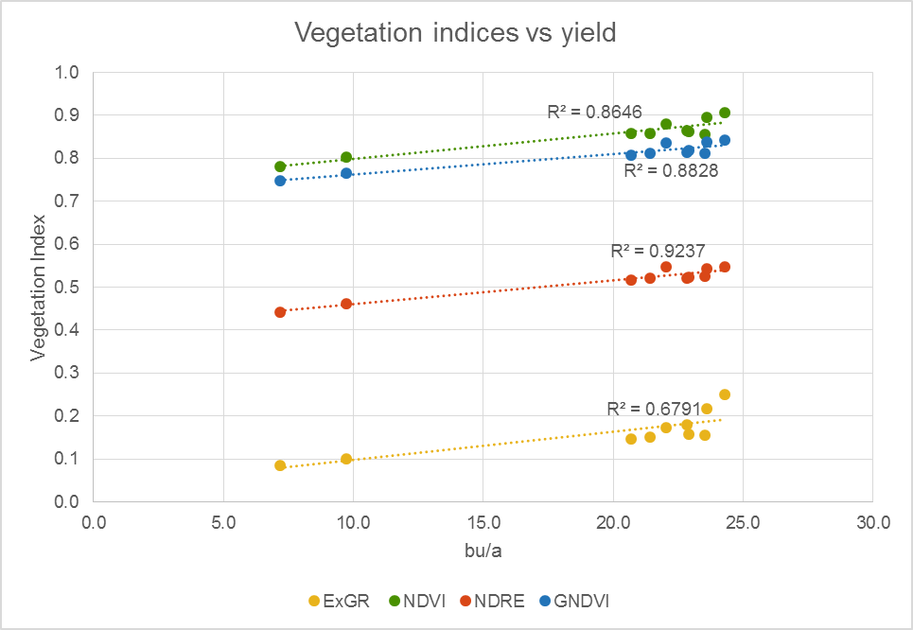

Figure 2. Soybean yield versus vegetation indices collected 20 days after dicamba application.

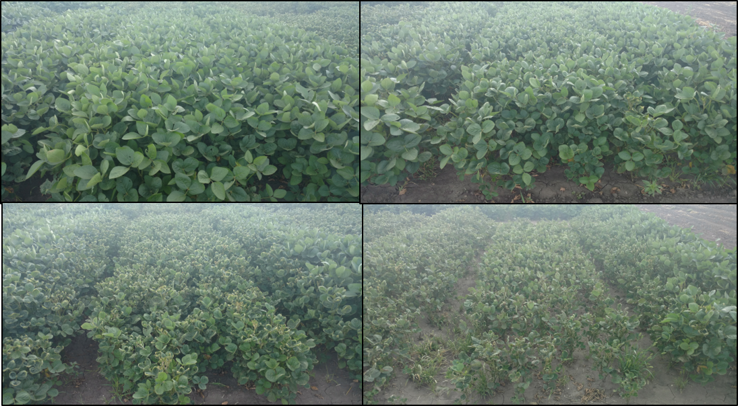

Figure 1. comparison of dicamba injury symptoms in soybeans with the check (UL), low rate (UR), middle (LL), and high rate (LR).