Determining thresholds for profitable use of fungicides to control white mold in soybeans
Technical Report

Principal investigator:
Michael Wunsch, Ph.D. / Plant Pathologist, NDSU Carrington Research Extension Center
PO Box 219 / 663 Hwy. 281 N. / Carrington, ND 58421-0219
701.652.2951 office / 701.652.2055 fax / michael.wunsch@ndsu.edu

Co-investigator:
Kelly Cooper / Agronomist, NDSU Robert Titus Research Farm, Oakes, ND

Introduction
Assessing expected economic returns to fungicide applications is critical for making profit-maximizing disease management decisions in soybeans and requires an understanding of the likely disease severity at the end of the season and the anticipated impact of the disease on soybean yield and quality.
The economic return to applying fungicides targeting white mold in soybeans is expected to be highest when a relatively long-maturity soybean variety is grown and when conditions become favorable for white mold disease development early during the bloom period, but gaps in our knowledge make it difficult to rigorously evaluate when no fungicide applications, a single fungicide application or two fungicide applications targeting white mold are most likely to be profit-maximizing.
Most white mold infections are initiated when ascospores of Sclerotinia sclerotiorum, the fungal pathogen that causes white mold, infect senesced blossoms. Research conducted in Iowa (Yang et al. 1999) and Illinois (Hoffman et al. 2002) has shown that white mold is typically more severe in longer-maturity soybeans than in shorter-maturity soybeans; longer-maturity soybeans have a longer bloom period, which provides a longer length of time for infections to occur. However, the impact of soybean maturity on the profitability of fungicides is unknown. For every 10 percent increase in white mold incidence in soybeans, yield losses of 3.2 to 6.3 bu/ac have been reported in Iowa (Yang et al. 1999), and yield losses of 2.8 to 4.9 bu/ac have been reported in Illinois (Hoffman et al. 1998). This range of yield loss is too broad to be useful as a decision-making metric; for soybeans at $9/bu and a total fungicide application cost of $27/acre ($20 fungicide plus $7 application), this range translates into a threshold for profitably applying a fungicide that is between approximately 10% and 25% expected end-of-season incidence of white mold. The limited number of varieties assessed for white mold yield loss in these studies precluded an assessment of whether the magnitude of white-mold associated yield loss may be correlated with soybean maturity.
The impact of diseases on crop yield and quality is generally highest when the causal pathogen infects early in crop growth (Madden and Nutter 1995, Madden et al. 2000, Perry et al. 2000, Xue et al. 1997, Zhou et al. 1999) before significant grain development occurs, and preliminary research conducted in Carrington, ND in 2015 suggests that the timing of white mold infection may have a strong influence on both white mold severity and soybean yield loss. Intensive irrigation favoring white mold was applied during early versus late bloom across a replicate study. When intensive irrigation commenced at the R2 growth stage, white mold incidence at the end of the season was 48% where no fungicide was applied, and every 10% increase in Sclerotinia incidence was associated with a 3.6 bu/ac reduction in soybean yield. When intensive irrigation commenced at the late R4/early R5 growth stage, white mold incidence was 18% at the end of the season, and every 10% increase in Sclerotinia incidence was associated with a 1.4 bu/ac reduction in soybean yield.
The objective of this study was to quantify the impact of soybean maturity and the impact of the timing of conditions favorable for white mold on white mold severity and soybean yield loss with the goal of developing rigorous guidelines for when fungicide applications targeting white mold are likely to be profitable. Field trials were conducted under overhead irrigation in Carrington and Oakes, ND with soybean varieties representing the full range of soybean maturities grown in North Dakota.

Methods
Field studies will be established at the NDSU Carrington Research Extension Center and at the NDSU Robert Titus Research Farm south of Oakes at sites with overhead irrigation capabilities and a previous history of white mold.
To evaluate the impact of soybean maturity on susceptibility to white mold and white-mold associated soybean yield loss, 38 varieties from 0.05 to 1.0 maturity were evaluated in Carrington and 25 varieties from 0.1 to 1.3 maturity were evaluated in Oakes. The studies were established as completely randomized split-plot designs with four replicates (Oakes) or three replicates (Carrington) with soybean variety as the main factor and fungicide treatment as the sub-factor. Three fungicide treatments were evaluated on each soybean variety: Non-treated, 5.5 oz/ac Endura (70% boscalid by weight; BASF Corp.) applied at the late R1 to early R2 growth stage, and 5.5 oz/ac Endura applied at late R1/early R2 and 10 to 12 days later. Fungicides were applied at 40 psi in a spray volume of 15 gal/ac using a CO₂-pressured 100-inch hand-held boom equipped with six equally spaced TeeJet (Spraying Systems Company; Springfield, IL) XR110015 nozzles.
To evaluate the impact of the timing of conditions favorable for white mold on disease development and soybean yield loss, a field study was conducted in Carrington in which three irrigation treatments were randomized: intensive irrigation favoring white mold applied from July 3 (early R2 growth stage) through July 23 (R3 growth stage); intensive irrigation favoring white mold applied from July 24 (R3 growth stage) through August 13 (R6 growth stage); and dryland. Experimental design was a completely randomized split-split plot with four replicates and with irrigation timing as the main factor, soybean variety as the sub-factor, and fungicide treatment as the sub-sub factor. Four soybean varieties of 0.6 to 0.9 maturity were evaluated, and three fungicide treatments (non-treated, 5.5 oz/ac Endura at R2, and 5.5 oz/ac Endura at R2 plus 10 days later) were tested.
In all studies, soybeans were seeded at 165,000 pure live seeds/ac in plots 25 feet long and 5 feet wide (center-on-center) containing four rows, each 14 inches apart, and agronomics were conducted in accordance to accepted best practices. Sclerotinia incidence, severity, and severity index were assessed at the R3, R5, R6, and R8 growth stages (irrigation study) or shortly before maturity (variety studies) by individually evaluating every plant in the middle two rows of each plot (variety studies) or 50 plants per plot (irrigation study) for white mold severity. Individual plants were assessed for white mold severity using a 0 to 100% scale in the irrigation study and using a 0 to 4 scale in the variety studies, where 0 = 0%, 1 = 1-25%, 2 = 26-50%, 3 =51-75%, 4 = 76-100% of the plant impacted by white mold. Plant tissue was considered to be impacted by Sclerotinia stem rot if it exhibited symptoms of Sclerotinia and/or bore poorly filled or unfilled pods caused by one or more Sclerotinia lesions that girdled stem tissue below the pods. In the variety studies, an average of 222 plants per plot and 264 plants per plot was assessed in Oakes and Carrington, respectively.
Data were analyzed in SAS 9.4 (SAS Institute, Cary, NC), with model assumptions evaluated prior to analysis. The disease reduction and yield response to applying fungicides was assessed, and the impact of soybean maturity and the timing of white mold disease development on soybean yield loss was calculated for each soybean variety (variety study) and for each soybean variety within each irrigation timing (irrigation study) using regression analysis.

Results
Relationship between soybean maturity and susceptibility to white mold
A strong, statistically significant (P < 0.001) correlation between soybean maturity and susceptibility to white mold was observed across soybean varieties evaluated in Carrington (Figure 1) and in Oakes (Figure 2), with susceptibility to white mold generally increasing as soybean maturity lengthened. In Carrington but not in Oakes (Figures 3 and 4), a modest but statistically significant correlation (P < 0.01) between soybean maturity and white mold-associated yield loss was observed, with the average yield loss associated with every 10 percent incidence of white mold increasing from approximately 3 bu/ac to 6 bu/ac as soybean maturity increased from 00.5 to 1.0.
Relationship between soybean maturity and the profitability of fungicide applications targeting white mold
The profitability and yield response conferred by a single application of the fungicide Endura (5.5 oz/ac) made at the late R1 to early R2 growth stage was relatively consistent across the full range of soybean maturities evaluated in Carrington and Oakes (Figures 5 and 6). Applying fungicides once was profitable approximately one-third to one-half of the time at a soybean price of $8/bu and approximately one-half to two-thirds of the time at a soybean price of $10/bu.
In soybeans under white mold pressure, the profitability of making two sequential applications of the fungicide Endura (5.5 oz/ac applied at the late R1 to early R2 growth stage and again 10 to 12 days later) increased with soybean maturity (Figures 7 and 8). Under heavy white mold pressure in Carrington, applying fungicides twice was profitable at a soybean price of $8/bu in 20% of the 00-maturity varieties and nearly 90% of the 0.6- to 1.0-maturity varieties evaluated. Under more moderate white mold pressure in Oakes, applying fungicides twice was profitable at a soybean price of $8/bu in 27% of the 0.1- to 0.5-maturity varieties evaluated and in 50 to 60% of the 0.6- to 1.3-maturity varieties evaluated.
Impact of white mold infection timing on disease incidence and soybean yield loss
Early white mold disease development (significant disease development between the R2 and R5 growth stage) versus delayed white mold disease development (R3 to R6 growth stage) was successfully facilitated through the application of intensive supplemental irrigation for 3 weeks during full bloom (R2 to R3 growth stage) versus 3 weeks during early to mid-pod fill (late R3 to early R6 growth stage (Figure 9).
Early disease development was associated with increased white mold disease pressure (Figure 10) and higher white mold-associated yield losses (Figure 11), and fungicide applications targeting white mold (Endura, 5.5 oz/ac, applied at late R1 to early R2) were profitable only when conditions favored white mold infection during full bloom (R2 and R3 growth stages).

Results and Discussion
This study suggests that fungicides are most likely to be profitable when cool, wet weather favorable for white mold occurs during the R2 and R3 growth stages and less likely to be profitable when cool, wet weather favorable for white mold does not develop until the late R3 growth stage or later. The study also suggests that when cool, wet weather favorable for white mold occurs during the R2 and R3 growth stages, a single fungicide application targeting white mold may often be sufficient in 00-maturity and low 0-maturity soybeans (≤ 0.5 maturity). When white mold pressure is relatively high, the study suggests that a single fungicide application may be overwhelmed by disease in soybeans with maturity ratings > 0.5, resulting in two sequential fungicide applications being more profitable than a single application.
The performance of a single fungicide application could likely be improved by applying fungicides with coarser spray droplets at a slightly more advanced growth stage. Fungicide applications were made in 15 gal/ac at 40 psi with Spraying Systems TeeJet XR110015 flat-fan nozzles, a pressure and nozzle combination emitting a droplet spectrum with predominately fine droplets. These application methods are consistent with standard practices in academic white mold research, but preliminary findings from fungicide droplet size studies being conducted concurrently with this study suggest that applications made with medium spray droplets (if the canopy is open) or coarse droplets (if the canopy is at or near closure) are likely to improve fungicide performance. In Carrington, fungicides were also applied 0 to 2 days after 90% of soybeans had reached the R1 growth stage, and previously completed multi-location field trials suggest that delaying applications until 80 to 100% of plants are at the R2 growth stage is likely to improve disease control. In follow-up research being conducted in 2019 in Carrington and Oakes, application methods and application timing has been adjusted accordingly.

Literature cited:
Hoffman et al. 1998. Plant Disease 82:826-829.
Hoffman et al. 2002. Plant Disease 86:971-980.
Madden and Nutter 1995. Canadian Journal of Plant Pathology 17:124-137.
Madden et al. 2000. Phytopathology 90:788-800.
Perry et al. 2000. Phytopathology 90:1043-1048.
Xue et al. 1997. Canadian Journal of Plant Science 77: 685–689.
Yang et al. 1999. Plant Disease 83:456-461.
Zhou et al.. 1999. European Journal of Plant Pathology 105: 715–728.

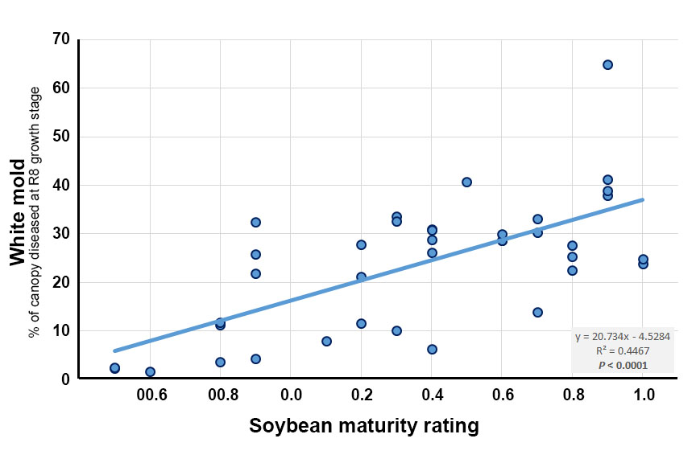
Figure 1. Relationship between soybean maturity rating and percent of the canopy impacted by white mold (white mold severity index) across 38 soybean varieties evaluated in a replicated field study; Carrington, ND (2018).

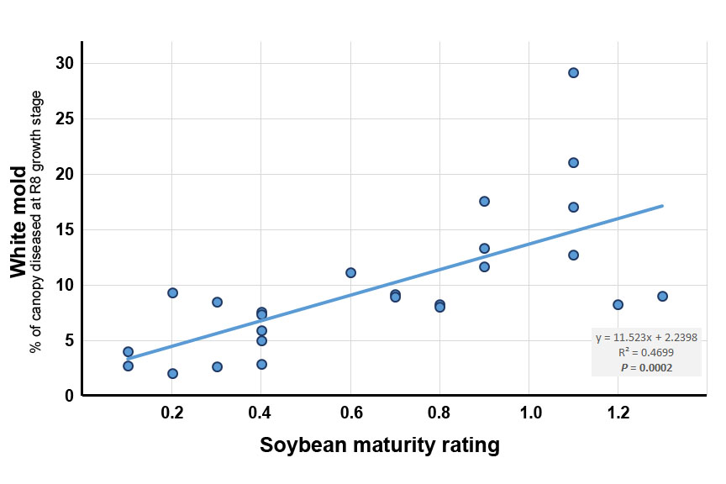
Figure 2. Relationship between soybean maturity rating and percent of the canopy impacted by white mold (white mold severity index) across 25 soybean varieties evaluated in a replicated field study; Oakes, ND (2018).

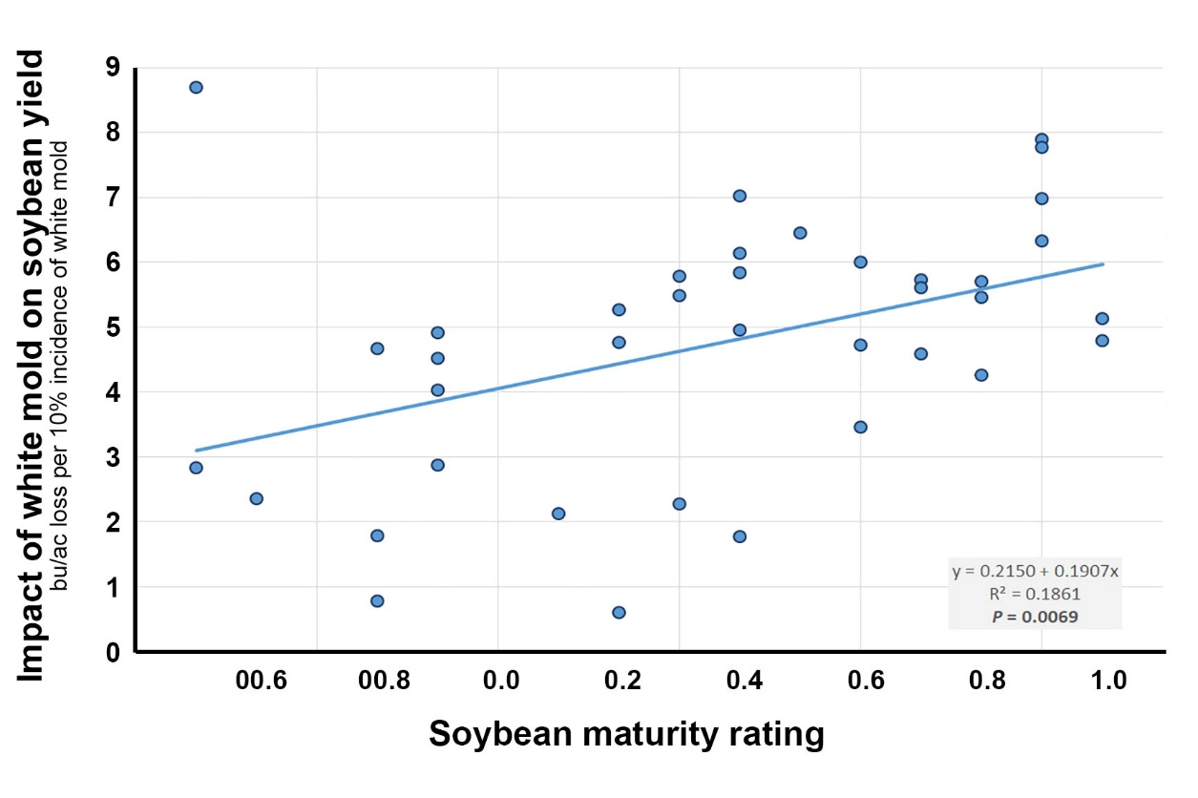
Figure 3. Relationship between soybean maturity rating and white-mold associated yield loss across 38 soybean varieties evaluated in a replicated field study; Carrington, ND (2018).

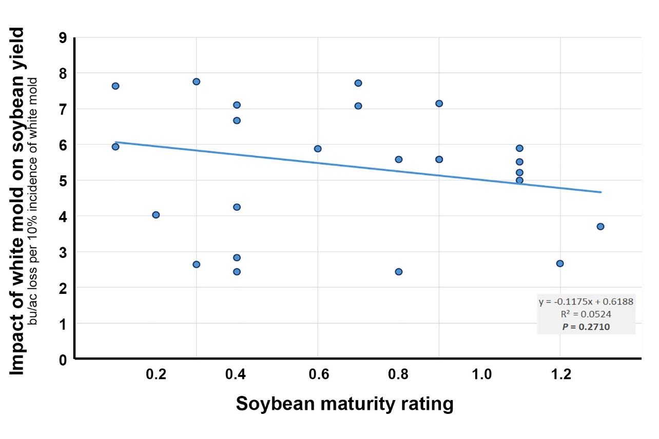
Figure 4. Relationship between soybean maturity rating and white-mold associated yield loss across 25 soybean varieties evaluated in a replicated field study; Oakes, ND (2018).
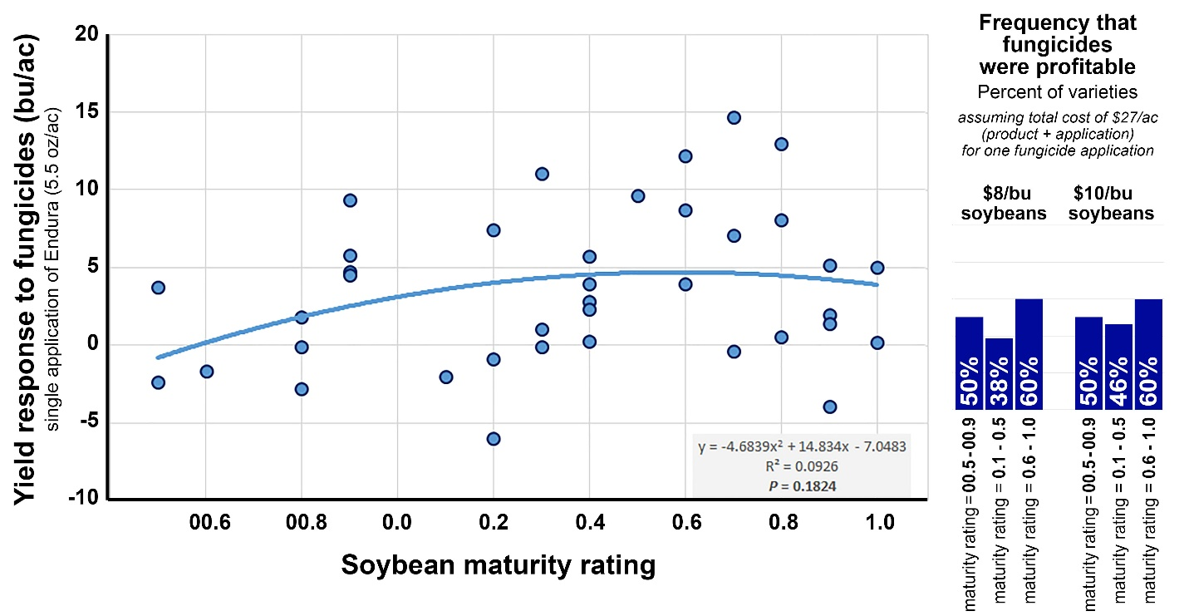
Figure 5. Yield response and profitability of 5.5 oz/ac Endura applied at the late R1 to early R2 growth stage to 38 soybean varieties in a replicated field study; Carrington, ND (2018). Each data point represents the yield response of one soybean variety.

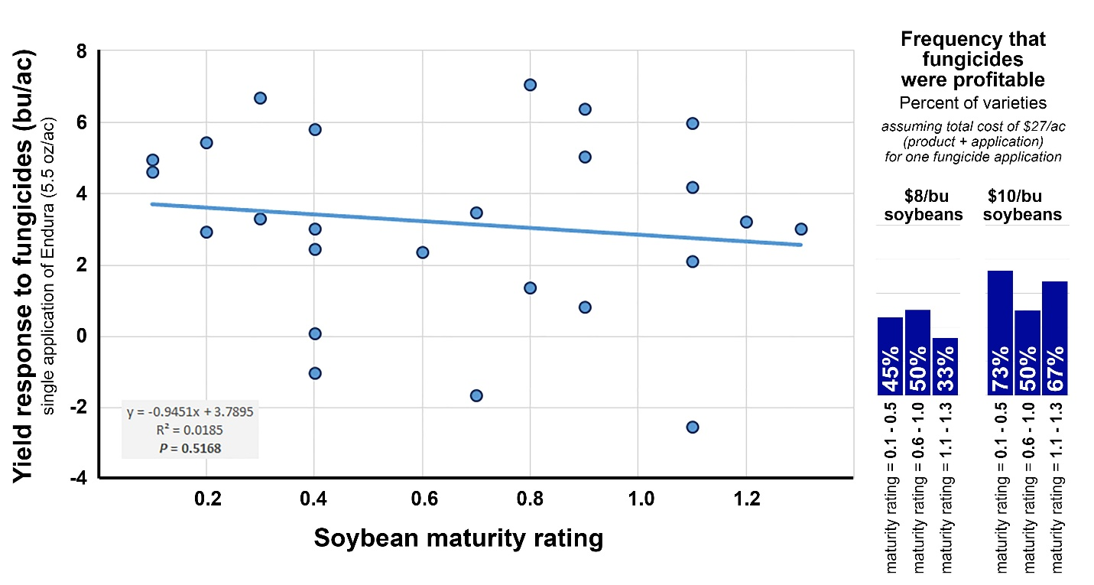

Figure 6. Yield response and profitability of 5.5 oz/ac Endura applied at the late R1 to early R2 growth stage to 25 soybean varieties in a replicated field study; Oakes, ND (2018). Each data point represents the yield response of one soybean variety.

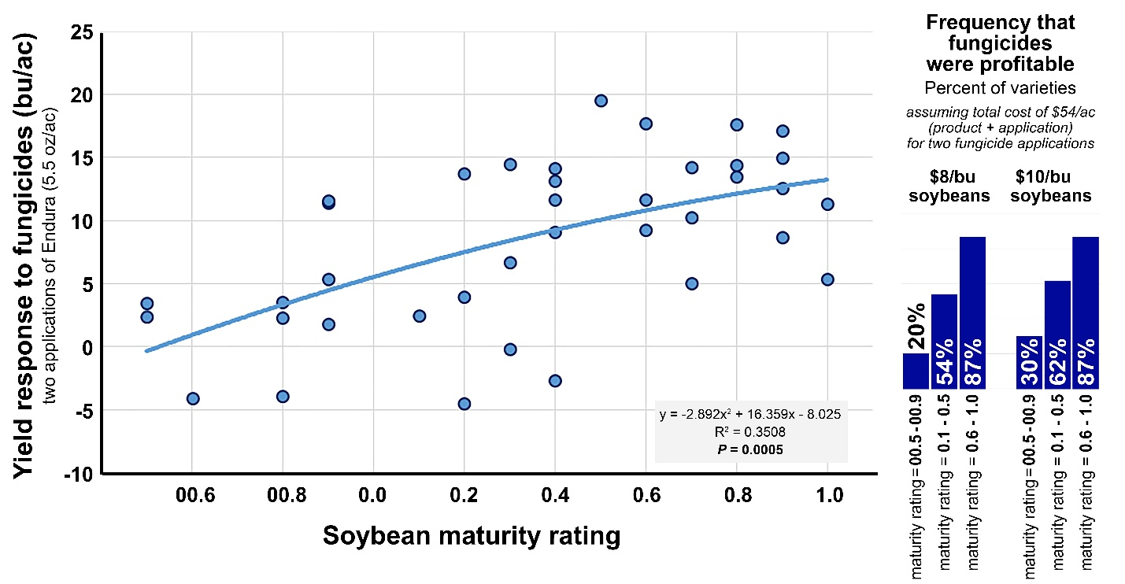
Figure 7. Yield response and profitability of 5.5 oz/ac Endura applied at the late R1 to early R2 growth stage and 10 to 12 days later to 38 soybean varieties in a replicated field study; Carrington, ND (2018). Each data point represents the yield response of one soybean variety.

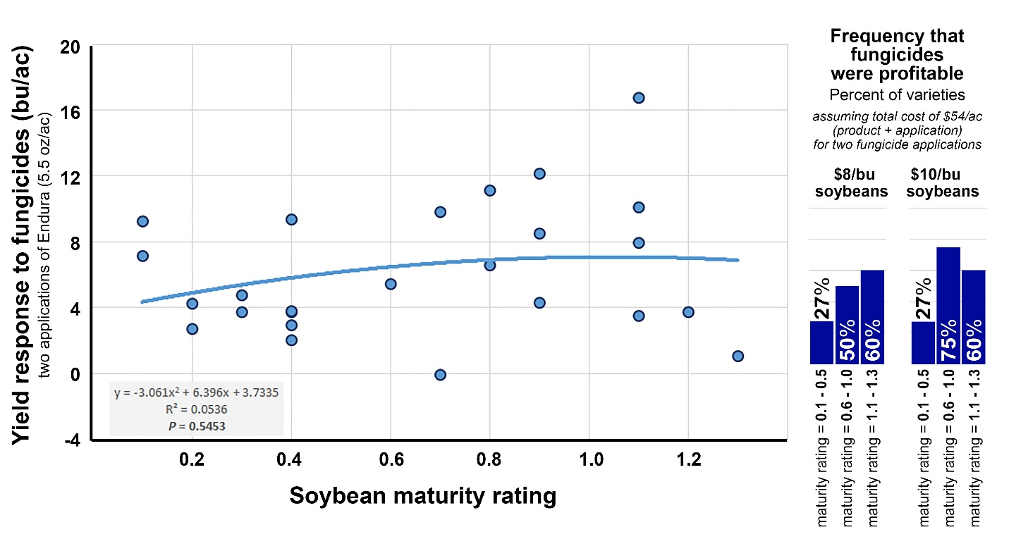

Figure 8. Yield response and profitability of 5.5 oz/ac Endura applied at the late R1 to early R2 growth stage and 10 to 12 days later to 25 soybean varieties in a replicated field study; Oakes, ND (2018). Each data point represents the yield response of one soybean variety.

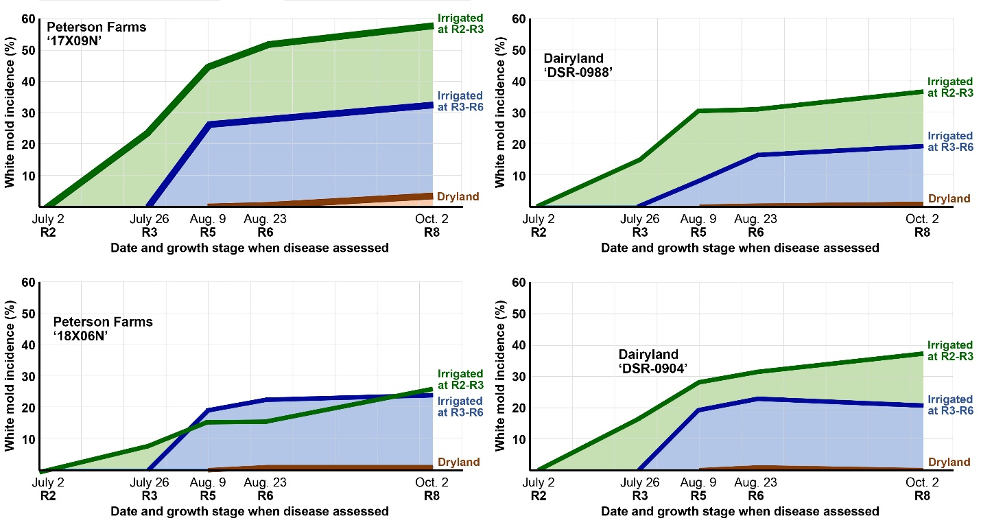
Figure 9. Impact of intensive irrigation applied July 3 to July 23 at the R2 to R3 growth stage versus July 24 to August 13 at the R3 to R6 growth stage on white mold disease progression in a replicated study conducted with four soybean varieties; Carrington, ND (2018).

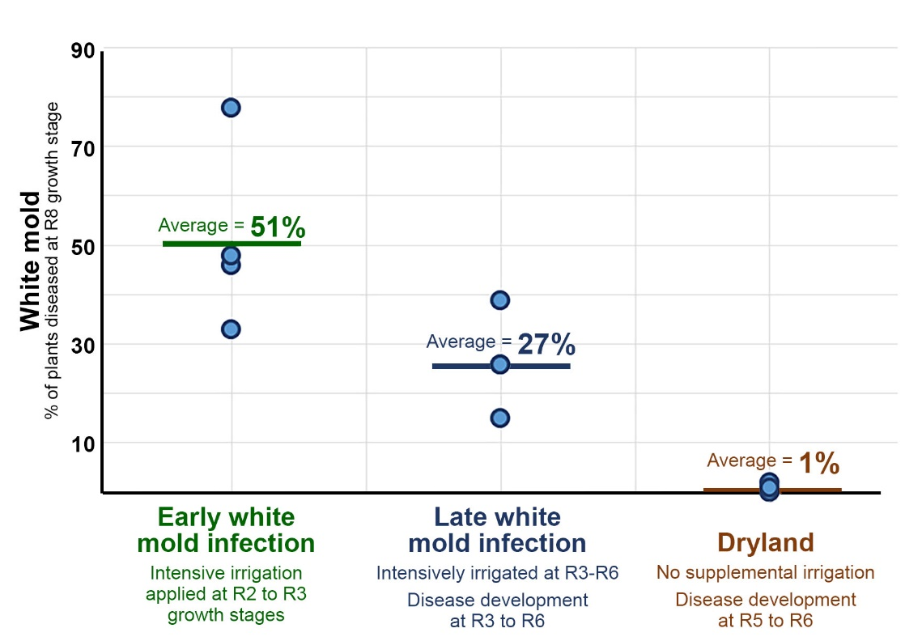
Figure 10. Relationship between white mold infection timing and white mold incidence in four soybean varieties evaluated in a replicated field study; Carrington, ND (2018). Each data point represents the white mold incidence observed in one of four 0.6- to 0.9- maturity varieties without the use of foliar fungicides.
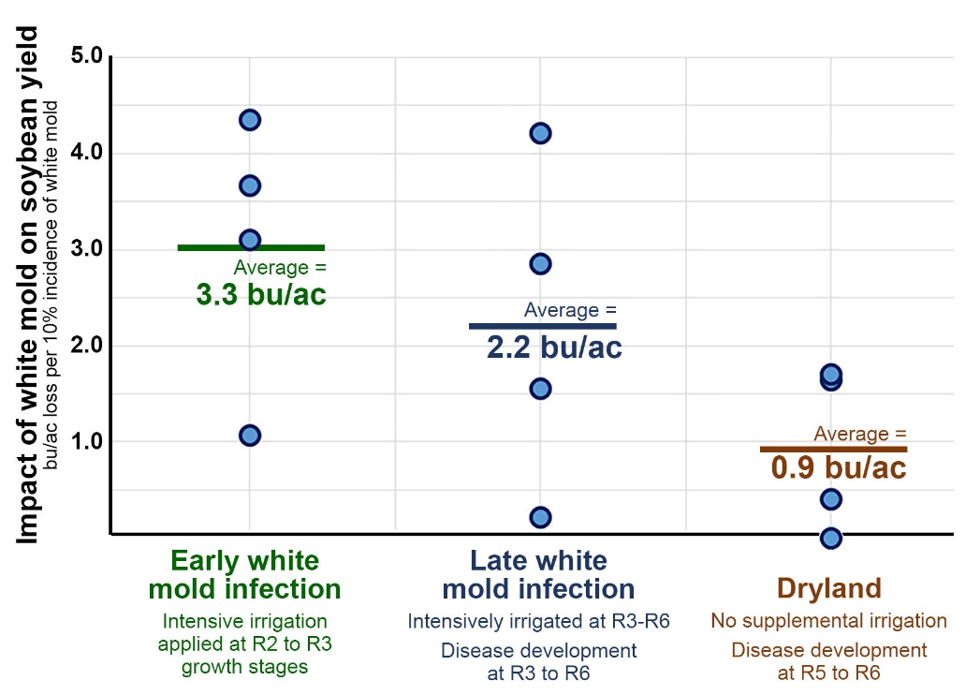
Figure 11. Relationship between white mold infection timing and white mold-associated yield loss in four soybean varieties evaluated in a replicated field study; Carrington, ND (2018). Each data point represents the impact of a 10% increase in white mold incidence on soybean yield (bu/ac) observed in one of four 0.6- to 0.9- maturity varieties.
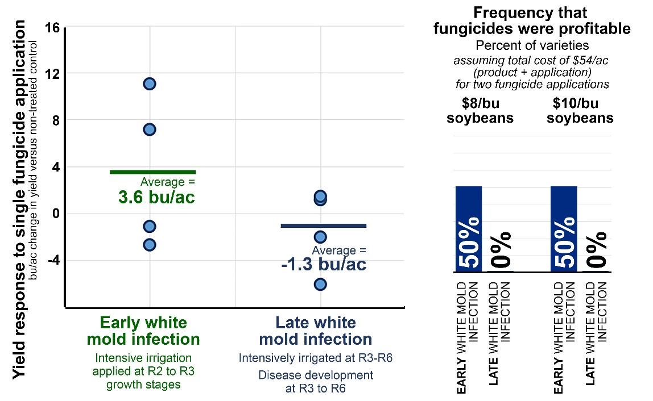
Figure 12. Relationship between white mold infection timing and the profitability of a single fungicide application targeting white mold (Endura, 5.5 oz/ac) across four 0.6- to 0.9-maturity soybean varieties evaluated in a replicated field study; Carrington, ND (2018). Each data point represents the change in soybean yield (bu/ac) between plots receiving one fungicide application versus no fungicide application.

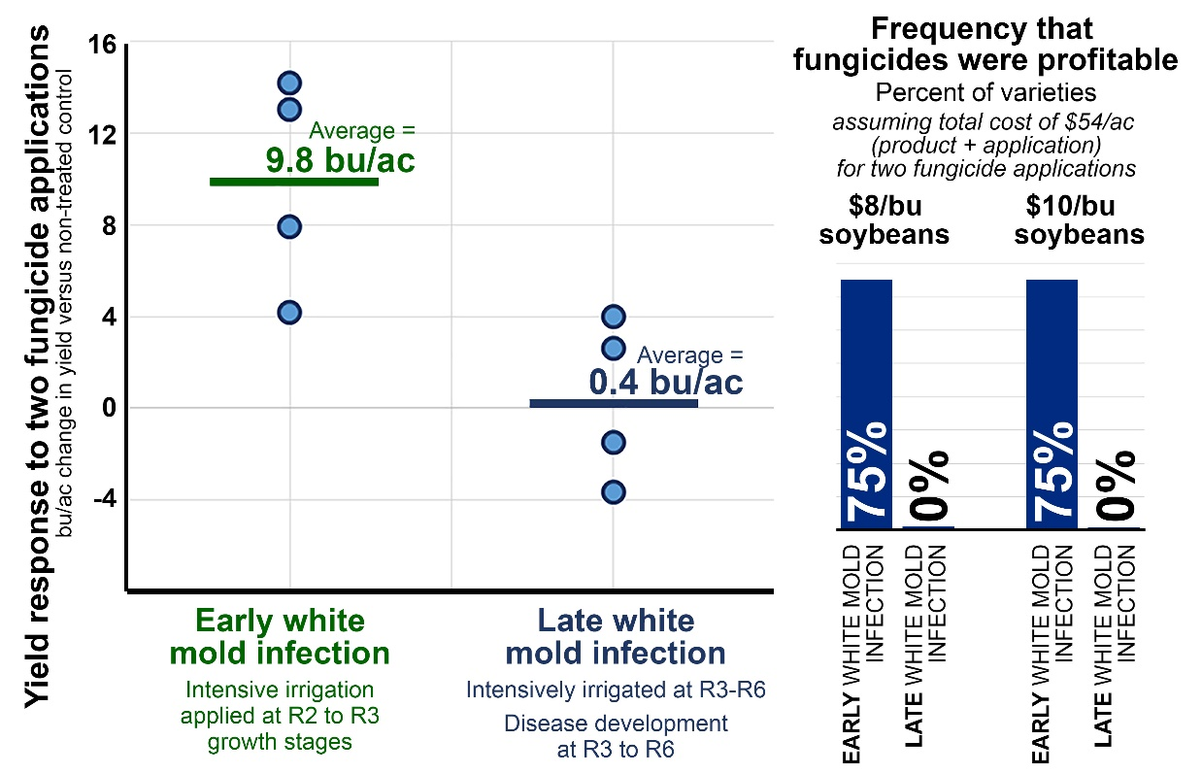
Figure 13. Relationship between white mold infection timing and the profitability of a two sequential fungicide applications targeting white mold (Endura, 5.5 oz/ac applied 10 to 12 days apart) across four 0.6- to 0.9-maturity soybean varieties evaluated in a replicated field study; Carrington, ND (2018). Each data point represents the change in soybean yield (bu/ac) between plots receiving two fungicide applications versus no fungicide application.

