ND Soybean Council FY2019 Final Report

Project Title: Soy Based Asphalt Rejuvenants

Investigators: James A. Bahr (Senior Research Engineer NDSU RCA), Dr. Ying Huang (Associate Professor NDSU Civil Engineering), Mu'ath Al-Tarawneh (Ph. D. Candidate)

Date: June 30, 2019

Objectives of the Research

The purpose of this research was to perform a systematic study of the observed reclaimed asphalt pavement (RAP) rejuvenating properties that the soy-based dust control agent exhibited during our earlier field trials. The RAP binder experiments were conducted at the asphalt research lab within the NDSU Civil Engineering Department by Mu’ath Al-Tarawneh under the direction of Dr. Ying Huang. The knowledge gained from these experiments allows us to better understand the rejuvenating properties of the soy-based dust control agent and provide a starting point for a future field trial where the RAP is premixed with the soy-based agent and applied to a test section of road.

Description of Work/Findings
Synthesis of soy-based dust control material:
Early on in the project we synthesiszed the soy-based dust control material that would be used to to treat the RAP binder. The generalized synthesis scheme is shown below and involves the reaction of soy biodiesel (or soybean oil) with glycerol in the presence of a catalyst. The resulting product is a mixture of mono, di, and triglycerides as well as some residual glycerol.
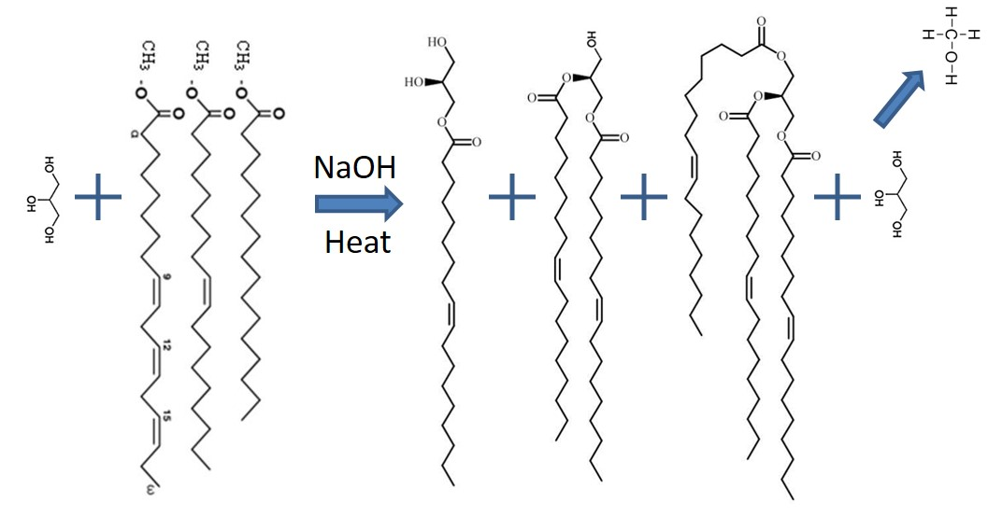
Figure 1 Generalized synthesis scheme to make glycerides from glycerol and biodiesel. This approach resulted in a mixture of mono, di and triglycerides with some residual glycerol. Methanol was stripped off in order to drive the reaction forward.

Rejuvenated Binder Solution Extraction from RAP:
Rejuvenated binder was extracted from RAP obtained from a local supplier using a centrifuge as shown in Figure 2 (left) following ASTM standard D2172/D2172M-17 Test Method A with toluene as a solvent. The representative sample with 1kg was weighed and placed inside the centrifuge bowl as shown in Figure 2 (middle). 200 mL of toluene solvent were added to the sample. The bowl was fixed into the centrifuge, covered with a filter, and the lid was secured then the centrifuge revolution began. Effluent solution was directed by tubing from the discharge port of the evaporator to a canister. Increasing speed gradually, the sample was rotated until there was no more effluent solution. The cover and lid were removed and 200 mL of toluene solvent were added. This process was repeated until the effluent solution had a very light straw color and the RAP was significantly lighter in color as shown in Figure 2 (right). This generally took 1400-1800 mL of toluene solvent. The extraction resulted in a toluene-binder solution which needed to be evaporated to get the actual rejuvenated binder.

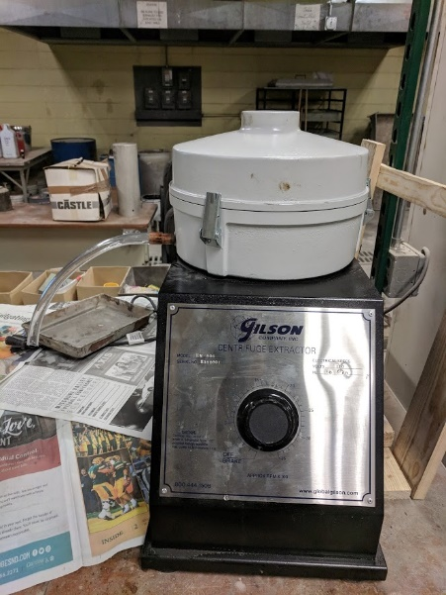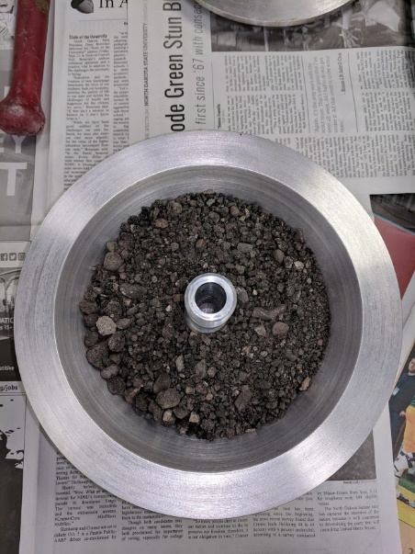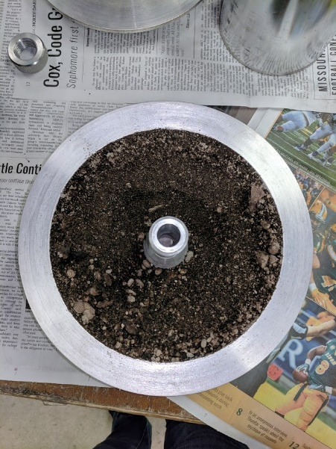
Figure 2 Centrifuge used for extraction (left), RAP samples before binder extraction (middle), and RAP samples after binder extraction (right)
Binder Evaporation from Solution:
Two of the extracted Toluene-binder solution samples were subjected to a rotary evaporator as shown in Figure 3 (left) to remove the Toluene solvent. Both individual samples had an initial mass of 999.7g. The toluene solvent was evaporated to get the lone binder using a rotary evaporator following ASTM standard D5404/D5404M. 200 mL of the toluene-binder solution were added to a round bottom flask which was fixed to an evaporator. Under the flask was a bath of oil, heated to 140 ºC. The flask was lowered into the hot oil bath and rotated throughout the extraction. A second round bottom flask was fixed to the evaporator for the purpose of collecting the toluene. Cold water was circulated through a coil in the evaporator. Vacuum pressure was applied and toluene was extracted from the solution. Once it appeared that no more toluene was being extracted from the sample (roughly 15 minutes), another 200 mL of solution was added to the round bottom flask. This process was repeated until the entire toluene-binder solution for that sample was evaporated. The extracted toluene was disposed of and the original round bottom flask only contained rejuvenated binder.

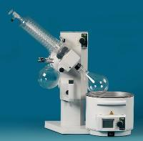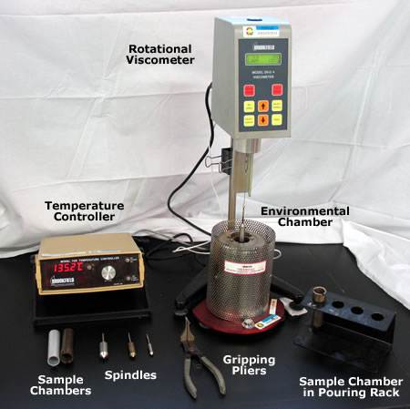
Figure 3 Rotary evaporator used for evaporation (left) and rotational viscometer (RV) used for testing (right)

Viscosity Test using Rotational Viscometer (RV):
The viscosity property of the rejuvenated binders was analyzed using a rotational viscometer (RV) as shown in Figure 4 (right) following ASTM standard D4402. The rotational viscometer was heated to a 135 ºC and the binder was heated until it could be poured. The binder was poured into the rotational viscometer. The sample was rotated at a speed of 10 rpm, after which the sample was removed from the rotational viscometer and placed in a falling needle viscometer. The needle was dropped into the sample three times for three different viscosity readings which were averaged. This process was repeated at 135 ºC and 20 rpm, 165 ºC and 10 rpm, and 165 ºC and 20 rpm.

Figure 4, shows the viscosity results for five samples with different percentage of soy agent to the weight of the rejuvenated binder including 0%, 5%, 10%, 15%, and 20%. From Figure 4, it can be concluded that adding more soy agent will decrease the viscosity of the binder significantly, especially when adding more than 5% soy-agent .

Figure 4 RV results for a rejuvenated binder with different percentage of the soy-agent.

Dynamic Shear Rheometer (DSR) Test:
The DSR test is a very precise and advanced test used in Superpave systems. During the DSR test, through the software, we can test the property of the binder at different rates, frequencies of the loading, and different temperatures (we can even set temperature to change during one test).

The DSR test is used to:
a. Determine the rheological properties of the asphalt binder at different temperatures and different conditions (Tank, RTFO residue, PAV residue); and
b. Give us information about the stiffness of the binder and how it would behave in various conditions and how this behavior is related to each aspect of its properties (viscosity or elasticity) by determining the phase angle.
The DSR test in this study is performed based on ASTM P246 – “Determining the Rheological Properties of Asphalt Binder for Specification Purposes Using a Dynamic Shear Rheometer (DSR)”. This test was done at different stages to investigate the properties of the binder under various conditions and different soy-agent weight percentage (5%, 10%, 15%, and 20%) and to test the stiffness resistance of the asphalt binder to deformation under loading.

As shown in Figure 5, the DSR test required the following apparatus:
- Dynamic Shear Rheometer (DSR)
- Temperature controller
- Loading device (air cylinder was used to feed the DSR to load the samples)
- Test plates (25mm for Tank and RTFO residue and 8 mm for PAV)
- Control and data acquisition system
- Misc. items, such as specimen mold, specimen trimmer

For every DSR test, the binder (hot enough to be fluid) should first be poured into the plastic molds (silicon rubber) and set aside to cool down to stiffen. During this time the machine should be readied for the installment of the specimen. This entails; turning on the air cylinder (it provides the pressure required by the machine to load specimen), setting the type of loading and temperature, zeroing the plates, and setting the gap size. The 25 mm diameter plates are used with a gap size of 1mm +/- 0.05mm. After putting the sample on the top, by using the software the gap between the two plates was set and the asphalt sample was squeezed between the plates. By using a heated trimming tool, the excess asphalt was removed from the perimeter of the upper and lower plates and the test was started. The test was done at 58 degrees at three frequencies of 1rad/s, 10 rad/s and 100 rad/sec. Table 1, shows the results from the DSR test with 5% soy agent at 58 °C.

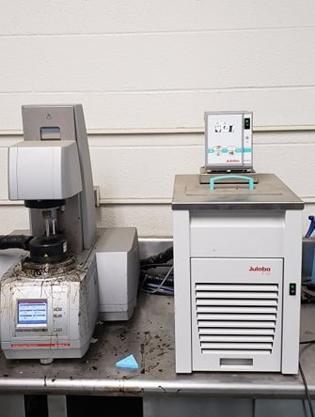
Figure 5 DSR instrument.

Table 1. DSR results for 5% soy-agent at 58 °C.

Time | Temp | Shear Stress | Shear Strain | Frequency | G* | Phase angle
[min] | [°C] | [kPa] | [%] | [rad/s] | [kPa] | [°]
1 | 57.99 | 0.01325 | 12.02 | 1 | 0.11 | 89.17
1.8 | 57.99 | 0.01244 | 12 | 1 | 0.104 | 89.16
2.5 | 57.98 | 0.01196 | 12 | 1 | 0.1 | 89.17
3.3 | 57.98 | 0.01165 | 12 | 1 | 0.097 | 89.16
4 | 57.98 | 0.01143 | 12 | 1 | 0.095 | 89.21
4.8 | 57.98 | 0.01127 | 12 | 1 | 0.094 | 89.22
5.5 | 57.98 | 0.01116 | 12 | 1 | 0.093 | 89.22
6.3 | 57.99 | 0.01107 | 12 | 1 | 0.092 | 89.22
7 | 57.99 | 0.011 | 12 | 1 | 0.092 | 89.22
7.8 | 57.99 | 0.01094 | 12 | 1 | 0.091 | 89.22
8 | 57.99 | 0.10559 | 12 | 10 | 0.88 | 87.4
8.1 | 57.99 | 0.10547 | 12 | 10 | 0.879 | 87.4
8.3 | 57.99 | 0.10534 | 12 | 10 | 0.878 | 87.4
8.5 | 57.99 | 0.10523 | 12 | 10 | 0.877 | 87.4
8.6 | 57.99 | 0.10512 | 12 | 10 | 0.876 | 87.4
8.8 | 57.99 | 0.10502 | 12 | 10 | 0.875 | 87.4
9 | 57.99 | 0.10493 | 12 | 10 | 0.874 | 87.4
9.1 | 57.98 | 0.10484 | 12 | 10 | 0.874 | 87.4
9.3 | 57.98 | 0.10476 | 12 | 10 | 0.873 | 87.4
9.5 | 57.99 | 0.88349 | 11.95 | 100 | 7.394 | 82.31

In order to investigate the effect of the soy-agent on the stiffness of the binder, all complex modulus results from all percentages are compared with the original binder, as shown in Figure 6. From this data, it can be seen that the stiffness resistance of the binder is significantly decreased by adding the soy-agent, by adding 5%, the G* is decreased by 65 % compared with original binder G*. Also, it is obvious that adding more agent will keep decreasing G*, but in a less significant way. Adding more than 15% soy-agent would significantly reduce the complex modulus when compared to 5%. Since the soy-agent cannot increase the strength of the binder, the binder with more agent has less resistance to shear.

Figure 6 DSR results for binder with different percentage of the soy-agent.

Compressive Strength Test:
In order to test the effect of the soy-agent on the compressive strength of the asphalt mixture, a typical 5% binder alsphalt concrete mixture was prepared in the lab. The samples were made using AASHTO T 312 – “Preparing and Determining the Density of Hot-Mix Asphalt Specimens by Means of the Superpave Gyratory Compactor”.
To make samples for compressive strength test, a Superpave Gyratory compactor is used to compact the mixture, as shown in Figure 7. The process involved batching the aggregates, mixing in the proper amount of binder, conditioning the prepared mixture, heating the mixture to compaction temperature and compacting the specimens. The apparatus used consisted of the following main parts:
- Superpave Gyratory Compactor
- Specimen molds
- Thermometer
- Balance
- Oven
The following steps were followed when preparing the mixture for the specimens:
a) The appropriate amounts of the required aggregate size fractions were weighed and combined in a small drum to the proper batch weight. The batch weight of the specimens was 4700 - 5200 grams of the height of 115 ± 5 mm.
b) The heated aggregate sample was placed in the mixing drum of a mixer and thoroughly mixed dry. The heated binder was weighed and added to the drum with mixing starting immediately. The temperature of the sample aggregate was controled to maintain the proper compaction range for the binder used.
c) The compaction mold and base plate were placed in an oven to preheat them to the required compaction temperature. Compaction were conducted for a period of 30 to 45 minutes.
d) When the mixture had attained the compaction temperature, the gyration counter was set to zero, and the desired number of gyrations was set to 220 to stop.
e) The mixture was brought to the proper compaction temperature. Before placing the mixture in the gyratory compactor, a paper disk was placed at the top of the plate and another at the top of the mixture. An angle of gyration of 1.25º was applied and then preceded with compaction.
f) After compaction, a fan was directed towards the top of the mold in the compactor. The molded specimens were extruded until flush with the top of the mold; plate and paper were removed and left to cool for 5 to 10 minutes. The mold and the base plate were then placed on a flat surface and inverted to remove the plate and the paper and the specimen was marked. The specimen was then cooled with a fan until the measured temperature with the non-contact digital infrared thermometer was 77 ± 9°F.

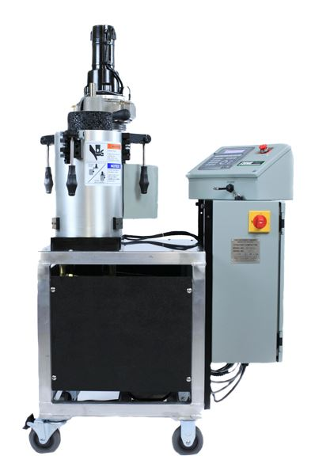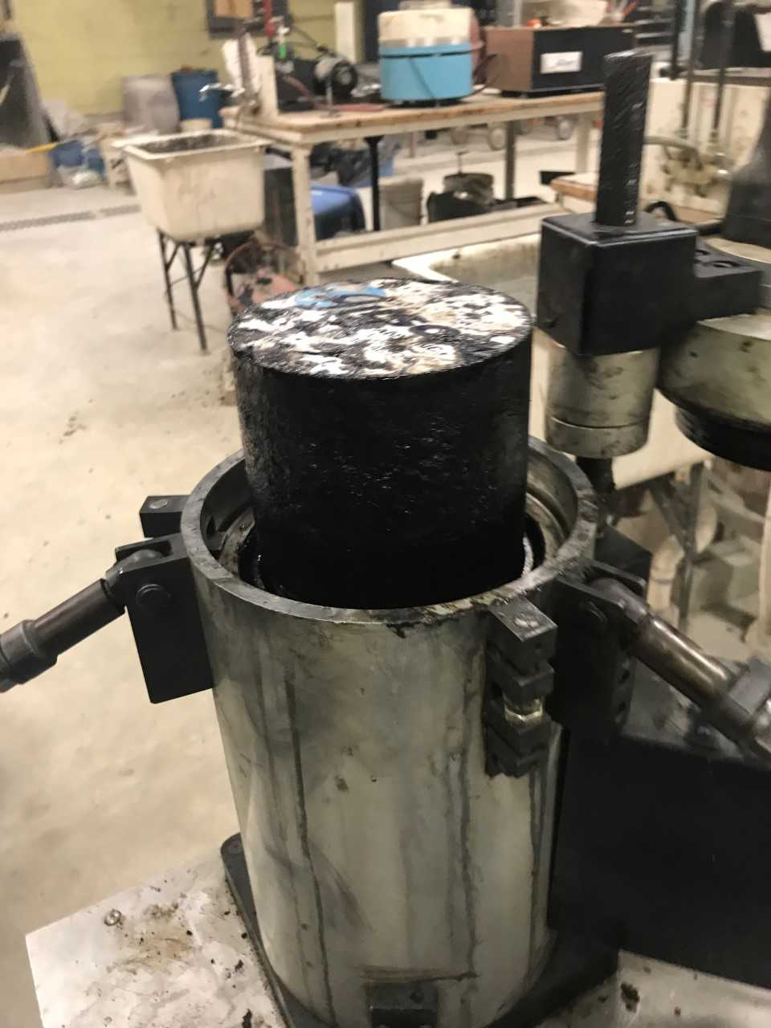
Figure 7 Superpave Gyratory Compactor.

Five alsphalt mixture samples were made based on the above procedure for four different soy-agent weight percentage (5%, 10%, 15%, and 20%). After that, the samples were tested using a compression testing machine, as sown in Figure 8 (a). Since the hot mixed alsphalt (HMA) samples are not brittle like the concrete, the samples keep squeezing under the applied load, but the failure point regards as the partial failure, as shown in Figure 8(b). Table 2 and Figure 9 show the compressive strength at partial failure. From Figure 9, it can be concluded that although the soy-agent has no significant reduction on the compressive strength of the asphalt mixtures, adding 10% of soy-agent would increase the compressive strength and adding more than 10% of soy-agent (for instance, 15%) would have a potential to decrease the compressive strength by 18%.

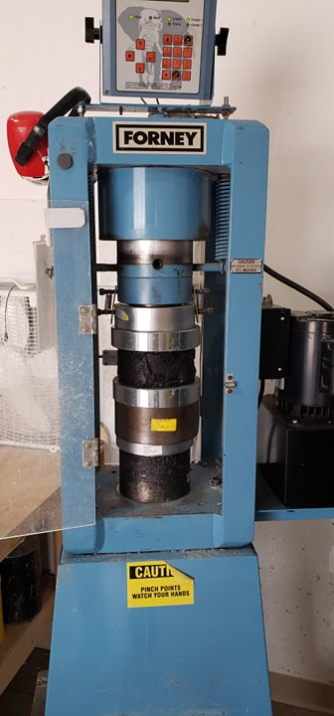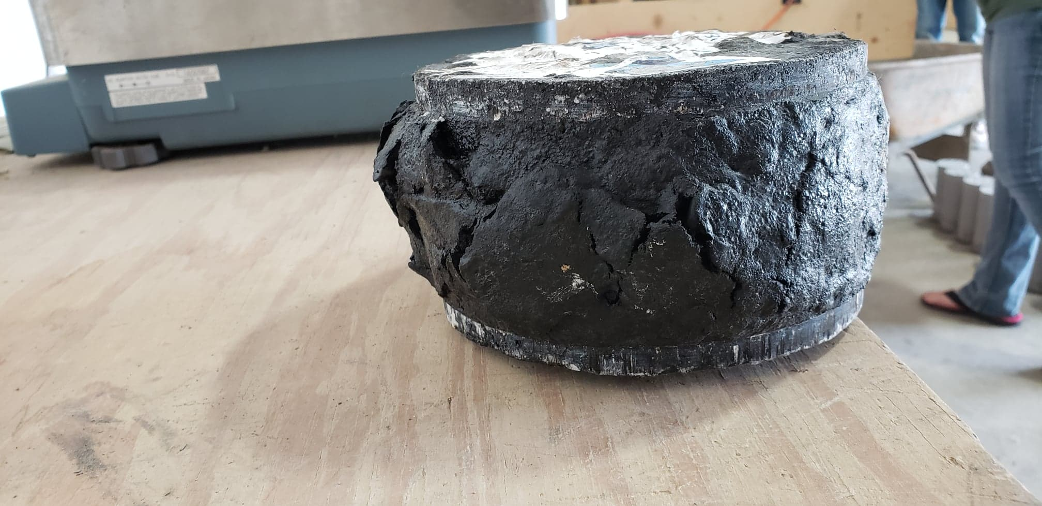
Figure 8 (a) Compressive strength tesing instrument, (b) Sample after the test.

Table 2. Compressive strength results summary.

Soy (%) | Diameter (in) | Height (in) | Load (kib) | Strength (ksi)
0 | 5.95 | 4.04 | 7.38 | 0.2656
5 | 5.95 | 3.97 | 7.41 | 0.2666
10 | 5.96 | 4.76 | 7.83 | 0.2808
15 | 5.97 | 4.67 | 6.125 | 0.2189
20 | 5.94 | 4.2 | 7.32 | 0.2643

Figure 9 Compressive strength results for different soy-agent percentage.

Differential Scanning Calorimeter (DSC) Test:
The physicochemical aspects of rejuvenation was evaluated by a differential scanning calorimeter (DSC). All DSC analyses were performed using a TA Instruments DSC Q1000 instrument (TA Instruments, New Castle, DE) with refrigerated cooling. Samples were sealed in air in hermetic aluminum pans (Tzero low-mass pans). Sample weights ranged from 3 to 10 mg. Samples were equilibrated at 165 °C for 5 min and then cooled to − 90 °C at 2 °C/min with a ± 0.5 °C, 80 s modulation. The samples were then heated at 2 °C/min with a ±0.5 °C, 80 s period modulation to 165 °C. Oxidation was not expected to be extreme under these conditions, and all samples were treated consistently to enable comparisons between them. In this study, the reversing heat capacity curves from heating and cooling cycles were comparable. Figure 10 shows the DSC Q1000 instrument and the procedure of preparing the test samples.

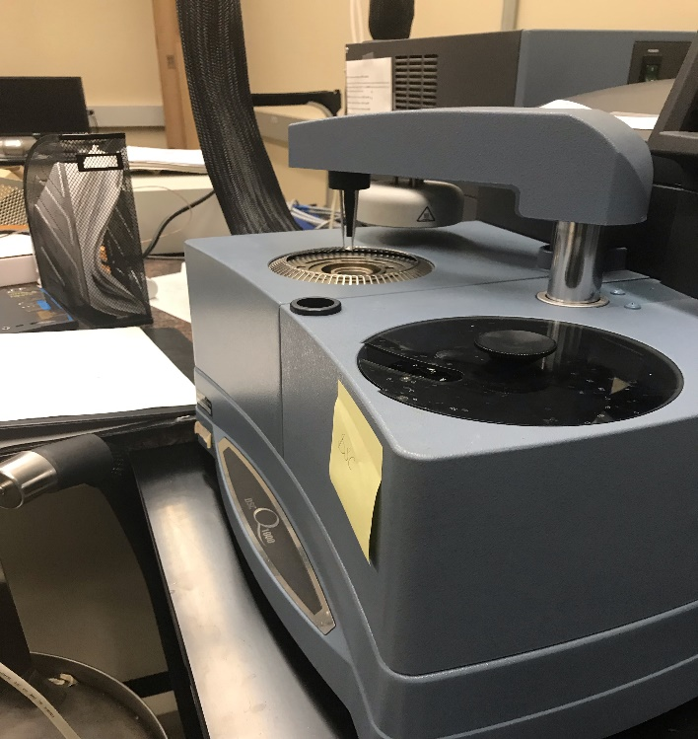
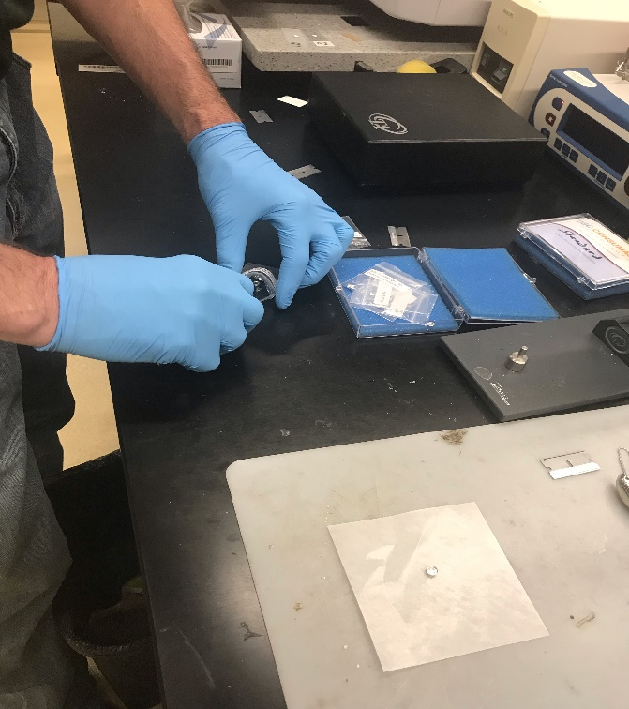
Figure 10 DSC Q1000 instrument and the procedure of preparing the test samples.

The DSC analysis software (Universal Analysis 2000 v4.5a, TA Instruments, New Castle, DE) was used to determine glass transition temperature (temperature range where the material changes from a hard, rigid or “glassy” state to a more compliant or “rubbery” state) by inflection, Tg(I), and the transition high-temperature limit (Tg(end)) for four samples with different percentage of soy-agent at 0%, 5%, 10%, and 20% by weight to binder, as shown in Figures 11, 12, 13, and 14 respectively. As shown from Figures 11 to 14, the soy-agent helps to solidify the binder at much lower temperatures as compared to asphalt binder, which means that the soy-agent is effective in restoring the temperature, thus, the binder will be more flexible and effective at a lower temperature. Also, it can be seen that 5% soy-agent does not affect the Tg(end) to much from changing from 18.7 °C to 16.48 °C, but by adding 10% of the soy agent the Tg(end) is decreased by 150% compared with the original binder, after that for 20% the Tg (end) just decreased by 1.5°C. So, we can consider the 10% percentage of soy-agent is enough to restore the cold temperature properties.
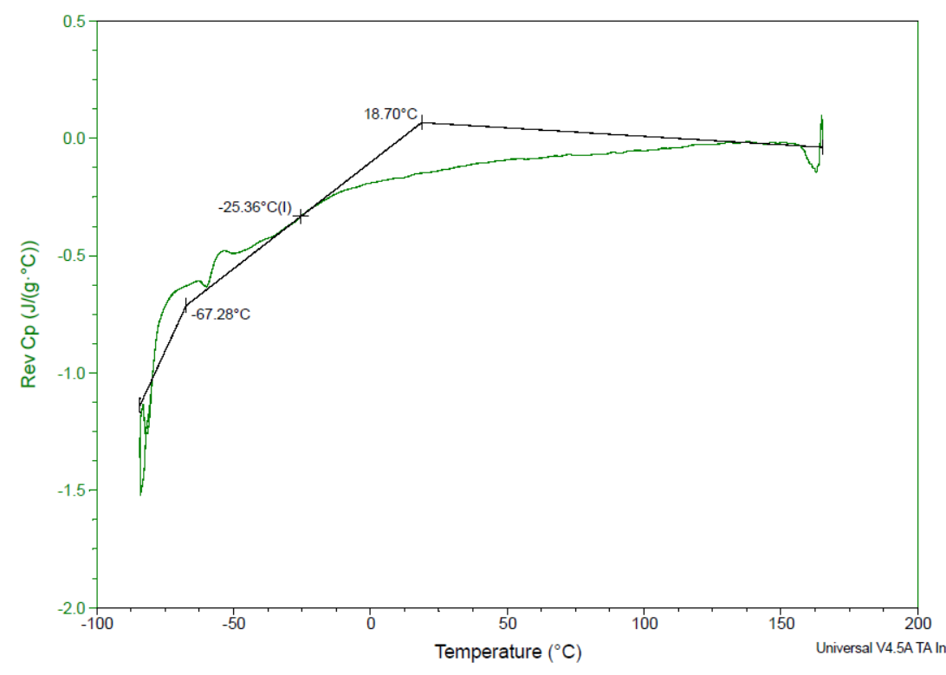
Figure 11 DSC results at 0% soy-agent.
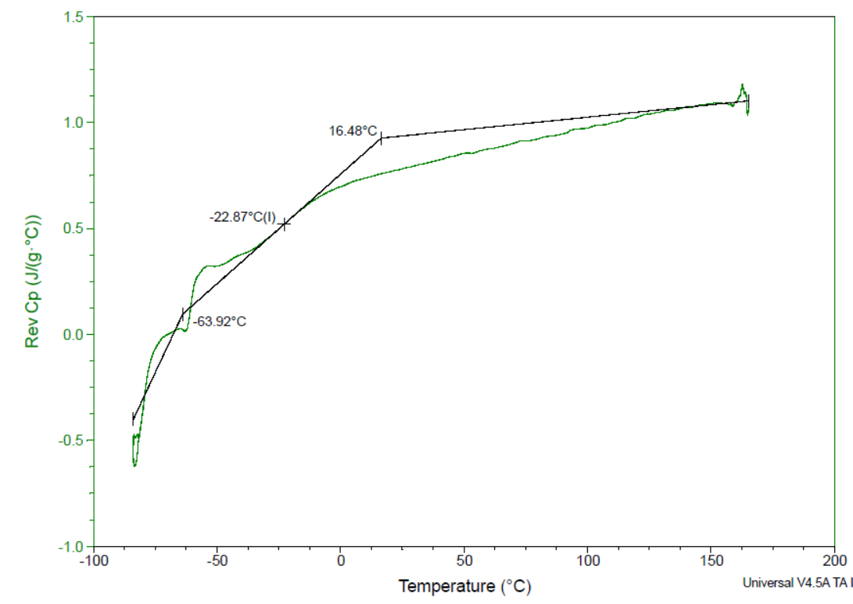
Figure 12 DSC results at 5% soy-agent.

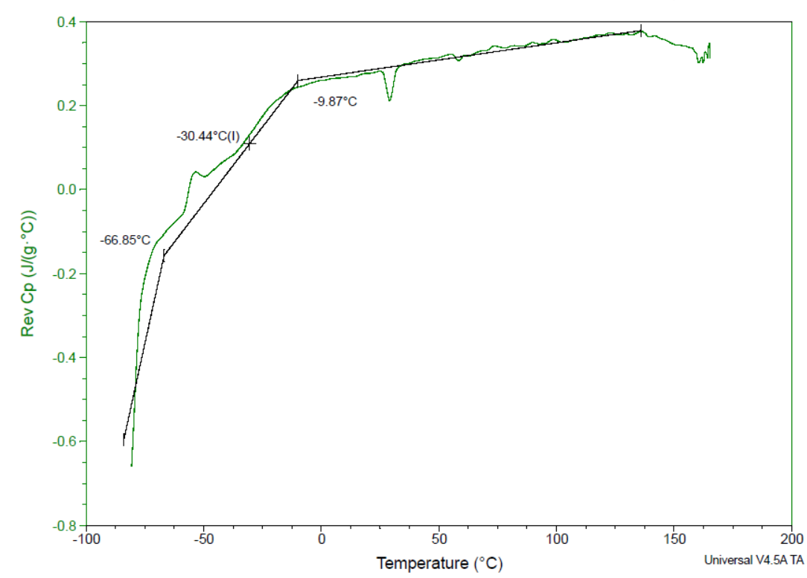
Figure 13 DSC results at 10% soy-agent.

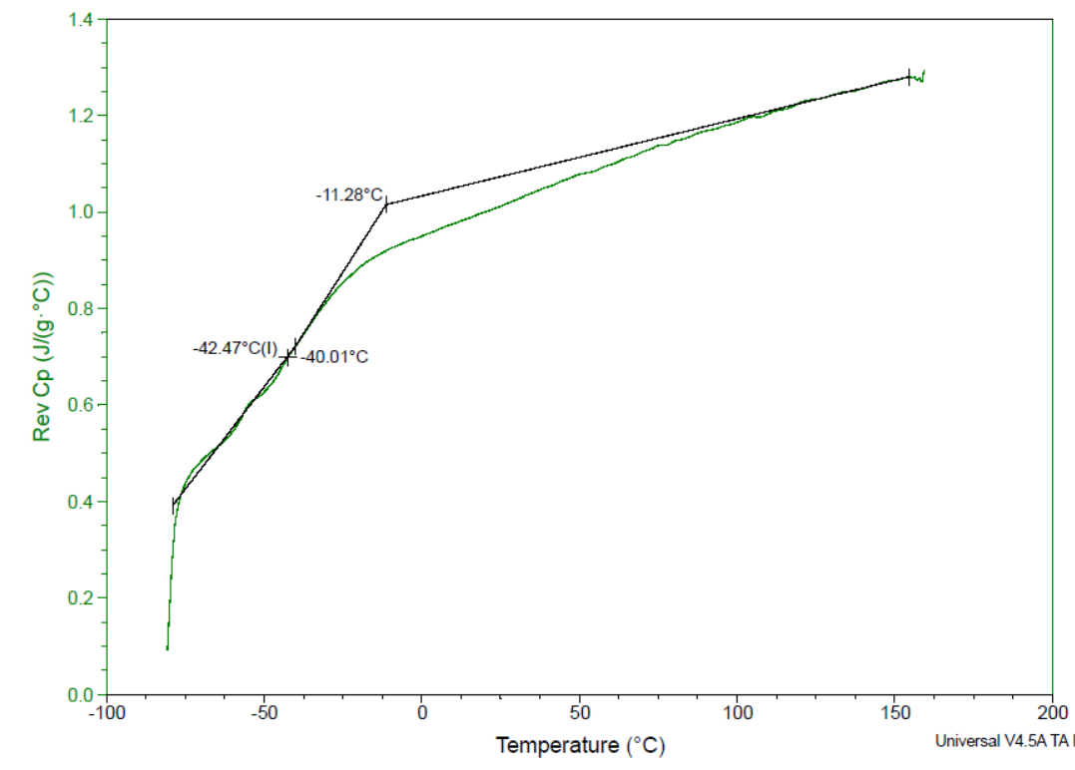
Figure 14 DSC results at 20% soy-agent.
Conclusions
a) The VR test results show that with more than 5% soy-agent by weight to binder, the viscosity of the binder decreases significantly.
b) The DSR test results show that the stiffness resistance of the binder is significantly decreased by adding the soy-agent and adding more agent will further decrease the complex modulus, G*. Adding soy-agent more than 15% would significantly reduce the complex modulus when compared to 5% to 15%.
c) The compressive strength test results indicate that the soy-agent does not show significant reduction on the compressive strength of the asphalt mixtures. Adding 10% of soy-agent would even increase the compressive strength. However, 15% or more of the soy-agent would have a potential to decrease the compressive strength by 18%.
d) The DSC test results illustrate that the soy-agent can help solidify the binder at lower temperatures, resulting in an effective addition to aged alsphalt binder that restores flexibility to the binder at lower temperatures. Adding 10% percentage of soy-agent is the best to restore the cold temperature properties when compare with 5% and 20% of soy-agent.
Based on all the analysis results above, a 10% addition of our soy-agent to aged RAP binder by weight is the optimal percentage of soy-agent for improving the property of the rejuvenated alsphalt binder. Based on these findings, we can now plan for future testing where large quantities of RAP are treated with our soy-based dust control agent, rolled out onto a roadbed, and subjected to real-world traffic.

