North Dakota Soybean Council
Identification of Pyrethroid Resistant Soybean Aphids and Use of Drones for Insect Scouting
Technical Report – June 30, 2019

Investigators:
Dr. Janet J. Knodel, Professor and Extension Entomologist, Dept. Plant Pathology, NDSU
Patrick Beauzay, IPM State Coordinator and Research Specialist, Dept. Plant Pathology
John Nowatzki, Dept. of Agricultural and Biosystems Engineering, NDSU

Cooperators:
Brian Otteson, Director, NDSU Agronomy Seed Farm, Casselton, ND
Dr. Robert Koch, Soybean Entomologist, University of Minnesota
Grower cooperators – Jared Hagert, Dale Flesberg

Situation
Insect resistance to pesticides is a worldwide problem. The United Nations Environmental Program has listed pesticide resistance as the third most serious threat to global agriculture behind soil erosion and water pollution (Pimentel 2005). In the United States, annual losses due to pesticide resistance are estimated at $1.4 billion (Oerke 2005). Resistance influences pesticide application costs and crop yields, affecting the level and stability of farm income (Knight and Norton 1989). Several pyrethroid and organophosphate insecticides are commonly used as foliar applications to manage soybean aphids, and insecticides continue to be the primary control strategy throughout the Upper Midwest (Hodgson et al. 2012). Soybean aphids could develop resistance to these chemistries. Based on the 2012 pesticide survey in ND (Zollinger et al. 2014), the top four insecticides used for insect control in soybeans included:
- Pyrethroids: lambda-cyhalothrin (Warrior and generics ); bifenthrin (Brigade and generics); esfenvalerate (Asana XL)
- Organophosphates: chlorpyrifos (Lorsban and generics).
In Minnesota and Iowa, Hanson et al. (2017) found that soybean aphid populations sampled from 2015 to 2016 had resistance ratios up to 40-fold for pyrethroids (i.e., bifenthrin and lambda-cyhalothrin). As a result of these findings, the goal of this research was to survey for populations of soybean aphids in eastern ND that may be developing insecticide resistance using a standardized laboratory bioassay, and to determine the best pest management strategies for insecticide resistant soybean aphids.

Objectives
1) To determine the level of pyrethroid insecticide resistance in populations of soybean aphids in North Dakota and where pyrethroid resistance exists in the major soybean producing counties of North Dakota.
2) To determine which insecticides and mode of actions are the best management tools for pyrethroid resistant soybean aphids.
3) To determine the feasibility of using drones to scout for soybean aphids and other insect pests of soybean.

Materials and Methods

Objective 1: Screening populations of soybean aphids for insecticide resistance.
Due to the low populations of soybean aphids in North Dakota in 2018, a single population of soybean aphids was collected from only one soybean field located near Emerado in Grand Forks County. See Results and Discussion section for details.
A standard experimental procedure called the ‘diagnostic dose glass-vial bioassay’ was utilized to test for resistance to lambda-cyhalothrin and bifenthrin. Each assay consisted of three replications of three insecticide concentrations in 20-ml glass vials that were coated internally with a solution of technical grade insecticide diluted in acetone at concentrations expected to provide 99% mortality(LC99), twice the concentration expected to provide 99% mortality (2 x LC99), and an acetone control.
We assessed the mortality of 10 wingless (apterous) adult soybean aphids per vial after 4 hours and 24 hours of exposure to the inner surfaces of the vials.
Aphid Collection: Infested plants were collected as aphid populations are increasing. Cut whole plants at soil level and assay immediately or preserve plants in a chilled cooler for up to 24 hours prior to assay.
Aphid Transfer to petri dishes: Wingless adult aphids were gently transferred with a paint brush into Petri dishes containing a piece of filter paper dampened with deionized water. This initial transfer served to narrow the transfer window into vials allowing all aphids to enter all vials at approximately the same time, and provide a visual assessment of aphid health.
Aphid transfer from petri dishes to vials: Aphids were visually assessed for any injury from the initial transfer and all injured or otherwise unacceptable aphids were removed. While wearing nitrile gloves, 10 healthy wingless adult aphids were transferred into each treatment vial. A specially designated paint brush was used for each chemical to avoid contamination. Aphids were transferred into all control vials first (Reps 1, 2, and 3), then LC99 vials (Reps 1, 2, and 3), and lastly 2xLC99 vials (Reps 1, 2, and 3) to avoid contamination from a higher concentration. Once infested, vials were kept upright and tightly capped in a tray and placed in a growth chamber at 25ºC, 70% relative humidity and a 16:8 (L:D) h photoperiod for the duration of the assay.
Mortality Assessment: Mortality of aphids in vials were assessed at 4 and 24 hours as:
1) Live: Healthy aphids have a tendency to climb up the walls of the vial and are typically found circling the walls of the vial.
2) Moribund: Aphids showing a lack of coordinated movement, unable to right themselves, or unable to climb the walls of the vial after 10 seconds will be considered moribund.
3) Dead: Aphids showing no movement will be considered dead.
The number and condition of any aphid nymphs produced at 4 and 24 hrs also were recorded.

Objective 2: Insecticide Study.
Soybeans were planted at three locations with a history of pyrethroid resistant soybean aphids in eastern ND: May 21 at Casselton, May 24 at Harwood, and May 26 at Emerado. Research plots were monitored weekly for soybean aphid populations from June through August. However, due to the low populations of soybean aphids in research plots, we were not able to conduct our insecticide efficacy study for evaluating 16 different products for control of pyrethroid resistant soybean aphids. We plan to repeat this study in 2019. See Results and Discussion section for details.

Objective 3: Testing drones for insect scouting in soybean fields.
Drone scouting could improve field scouting efficiency and aid in rapid detection of economic populations of soybean aphids. The drone with the autonomous probe needed for this objective was not available from the company in 2018. We were initially told that it would be available for 2018; however, the company had some unexpected problems.

Results and Discussion

Objective 1: Screening populations of soybean aphids for insecticide resistance.
Soybean aphid populations were extremely low in 2018 and never reached the economic threshold (E.T.) of an average of 250 aphids per plant, 80% of the plants and increasing population levels. The ND IPM Survey Program documented that no soybean aphids were observed in 82% of the 544 soybean fields surveyed in 2018. The percent of plants infested with soybean aphids in fields was also low with an average of 17% of plants infested and ranged from 1 to 100% of plants infested (see maps below). The higher percentage of plants infested with soybean aphids in fields were observed later in the season (August) and mainly in Cass and Richland Counties. The average number of aphids per plant was only 3 aphids per plant and ranged from 1 to 59 aphids per plant. Soybean aphids never reached the E.T. level in any of the fields in 2018. This was good news for soybean growers and helped reduced their inputs.

In spite of the low populations of soybean aphids in 2018, we were able to collect a small population from Emerado in Grand Forks County. In cooperation with the University of Minnesota (Dr. Koch), these aphids were reared in the laboratory to obtain enough soybean aphids to conduct the glass-vial bioassays for bifenthrin and lambda-cyhalothrin resistance. Results indicated that these soybean aphids were highly susceptible to both insecticides as all aphids were dead at the 4-hour mortality assessment. In contrast, soybean aphid populations tested from Emerado in 2017 were found to be resistant to bifenthrin only. This suggests that the pyrethroid resistant soybean aphids are mobile and may have migrated from other resistant areas in 2017, such as south central Minnesota where the resistance first occurred in 2015. Since pyrethroid resistant soybean aphids can vary by year and locations, screening more populations of soybean aphids in ND is key to determine their presence or absence, and their resistance status. These findings will be essential for soybean growers, so they can wisely decide which insecticide to use when soybean aphid populations are economic (above the E.T. level).

Multistate Activities. At the 2018 ESA, ESC and ESCB Joint Annual meeting (in Vancouver, B.C. on Nov. 11-14, 2018), soybean entomologists including Dr. Knodel received the ESA Plant-Insect Ecosystems IPM Team Award for their outstanding contributions to IPM through teamwork. This award was sponsored by Corteva Agriscience and acknowledges the excellent IPM team efforts for the soybean aphid resistance-monitoring project in Minnesota, Iowa, North Dakota, South Dakota and Manitoba. In addition, a poster entitled A diagnostic-concentration, glass-vial bioassay for the rapid monitoring of soybean aphid (Aphis glycines) susceptibility to pyrethroid insecticides was presented by James Menger, entomology graduate student, of University of Minnesota. The NDSC was acknowledged in the poster for their support in ND. For your information, a pdf of Menger’s poster was emailed to Ken Nichols along in the Mid-year Report to NDSC.
In addition, a cooperative peer-reviewed paper was published in the 2018 Journal of IPM in this issue:
Koch, R.L., E.W. Hodgson, J.J. Knodel, A.J. Varenhorst and B.D. Potter. 2018. Management of insecticide-resistant soybean aphids in the Upper Midwest of the United States. J. IPM 9(1):23; 1-7. https://doi.org/10.1093/jipm/pmy014

Objective 2: Foliar insecticide trial.
Due to the low populations of soybean aphids in research plots, we were not able to conduct our insecticide efficacy study for evaluating 16 different products for control of pyrethroid resistant soybean aphids. We plan to repeat this study in 2019.

Objective 3: Testing drones for insect scouting in soybean fields.
Drones could improve field scouting efficiency and aid in detecting economic populations of soybean aphids more rapidly than by traditional scouting. The drone with the autonomous probe needed for this objective was not available from the company in 2018. We were initially told that it would be available for 2018; however, the company had some unexpected problems. We plan to repeat this study in 2019.

Outputs:
Research Posters / Presentations related to this project:
Posters:
Menger, J., R. Koch, I. MacRae, J. Knodel, B. Potter, P. Glogoza, E. Hodgson, A. Varenhorst, A. Chirumamilla and J. Gavloski. 2018. A diagnostic-concentration, glass-vial bioassay for the rapid monitoring of soybean aphid (Aphis glycines) susceptibility to pyrethroid insecticides. 2018 ESA, ESC and ESBC Joint Annual Meeting, Vancouver, B.C., Canada, Nov. 11-14, 2018.

Presentations:
Prochaska, T.J., J. Knodel, P. Beauzay, L. Lubenow, A. Chirumamilla and S. Lahman. 2018. Extending Knowledge, Changing Lives: Insecticide Resistance to Soybean Aphid in North Dakota. 2018 ESA, ESC and ESBC Joint Annual Meeting, Vancouver, B.C., Canada, Nov. 11-14, 2018.

Meetings:
Information on the results of this research project was disseminated through the Crop & Pest Report, and a series of extension and commodity meetings. Some examples are listed below:
- Northern Corn & Soybean Expo, Fargo, ND – Feb. 12, 2019. Total audience = >800 people.
- Insecticides Updates for 2019; and Soybean Aphid Control and Pyrethroid Resistance, NDSU / UM Commercial Pesticide Applicator Training, Fargo, ND - Nov. 28, 2018. Total audience = 353 people.
- Field Scouting for Insect Pests of Field Crops, Field tour at NDSU campus, ND State College of Science and Bismarck State College, Fargo, ND – July 20, 2018. Total audience = 80 people.
- Update on Soybean Aphid and Other Crop Pests, NDSU Agronomy Seed Farm Field Tour, Casselton, ND - July 16, 2018. Total audience = 75.

Extension Publications:
Knodel, J.J., P. Beauzay, M. Boetel, T.J. Prochaska and L. Lubenow. 2018. 2019 North Dakota Field Crop Insect Management Guide. NDSU Ext. Serv., E-1143 (Revised).
Knodel, J.J., P.B. Beauzay, A. Friskop and S. Markell. 2018. IPM Basics Integrated Pest Management in North Dakota Agriculture PP863 (revised). NDSU Extension, Fargo, ND.
Koch, R., E. Hodgson, J. Knodel and A. Varenhorst. 2018. Management of Insecticide-resistant Soybean Aphids E1878. Multistate publication with University of Minnesota Extension, Iowa State University Extension and Outreach, NDSU Extension and SDSU Extension.
Knodel, J.J. 2018. New Multi-State Entomology Publications - Management of Insecticide-Resistant Soybean Aphids E1878. NDSU Crop and Pest Report #2 (May 10, 2018).
Knodel, J.J. and A. Friskop. 2018. IPM Survey Underway. NDSU Crop and Pest Report #5 (May 31, 2018).
Knodel, J.J. 2018. Blister Beetles in Soybeans. 2018. NDSU Crop and Pest Report #9 (June 28, 2018).
Knodel, J.J. 2018. Aphids are Here! 2018. NDSU Crop and Pest Report #9 (June 28, 2018).
Knodel, J.J. 2018. Soybean Aphids Low. 2018. NDSU Crop and Pest Report #11 (July 12, 2018).
Knodel, J.J. 2018. Red-headed Flea Beetle in Soybeans and Corn. 2018. NDSU Crop and Pest Report #12 (July 19, 2018).
Knodel, J.J. 2018. Soybean Aphids Continued Low. 2018. NDSU Crop and Pest Report #12 (July 19, 2018).
Knodel, J.J. 2018. Soybean Aphid Numbers Continued Low. 2018. NDSU Crop and Pest Report #13 (July 26, 2018).
Knodel, J.J. 2018. Soybean Aphids Increasing Slowly. 2018. NDSU Crop and Pest Report #14 (August 2, 2018).
Knodel, J.J. 2018. Scout for Spider Mites in Beans. 2018. NDSU Crop and Pest Report #15 (August 16, 2018).
Knodel, J.J. 2018. Soybean Aphids Still Low. 2018. NDSU Crop and Pest Report #15 (August 16, 2018).
Knodel, J.J. 2018. Grasshoppers on the Move!. 2018. NDSU Crop and Pest Report #15 (August 16, 2018).
Knodel, J.J. 2018. Chlorpyrifos Update. NDSU Crop and Pest Report #16 (August 30, 2018).
Knodel, J.J. 2018. New Soybean Gall Midge Found in Other States. NDSU Crop and Pest Report #16 (August 30, 2018).
Knodel, J.J. 2018. 2018 IPM Survey Results - Soybean and Sunflower Insect Pests. NDSU Crop and Pest Report #17 (September 13, 2018).
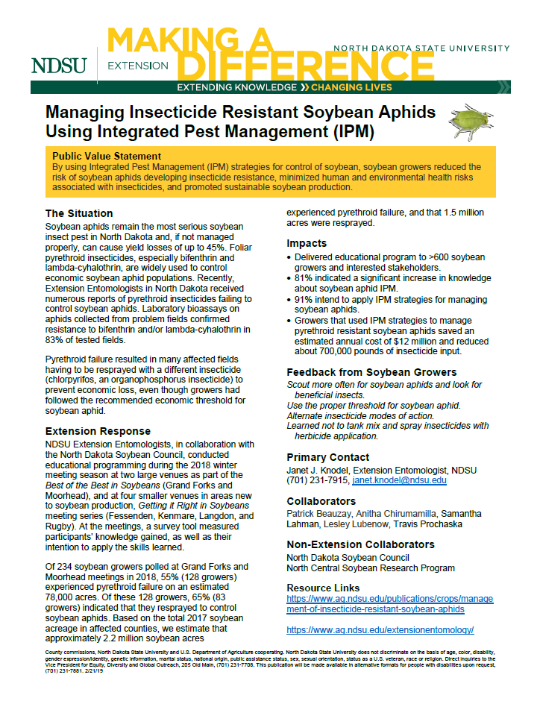
An Extension Impact Statement was prepared titled Managing Insecticide Resistant Soybean Aphids Using Integrated Pest Management (IPM) for the state legislators in 2019. Here’s the Public Value Statement: By using Integrated Pest Management (IPM) strategies for control of soybean, soybean growers reduced the risk of soybean aphids developing insecticide resistance, minimized human and environmental health risks associated with insecticides, and promoted sustainable soybean production. It is available on the NDSU Extension website at: https://www.ag.ndsu.edu/impactstatements/impact-statements/2019-impact-statements/19state-knodel-cm2.pdf/view

