Technical Report June 2019

Project Title: Preceding and Interseeding Cover Crops into Standing Soybean to Reduce Soybean Cyst Nematode Population

Principal Investigator: Marisol Berti
Co- Investigator: Guiping Yan
Research Specialist: Alan Peterson

- RESEARCH GOALS
In a previous study funded by the Soybean Council the interseeding of cover crops into standing soybean [Glycine max (L.) Merr.] was studied. Results indicated that winter Austrian pea (Pisum sativum L.) and cereal rye (Secale cereale L.) can be established under the canopy of soybean providing soil cover after soybean is harvested. The research goal of this proposal is to preseed and interseed cover crops to reduce soybean cyst nematode (SCN) (Heterodera glycines) population.

- RESEARCH OBJECTIVE
The objective is to determine the effect of preceding and interseeding cover crops into soybean on soybean yield, cover crop establishment, nematode population reduction, and potential negative effects to soybean quality.

- METHODOLOGY

Field establishment and experimental design
The research was conducted at two North Dakota State University experimental stations, Casselton, ND (46.9005 N, -97.2112 W) and Prosper, ND, (47.003′N, -97.116 W). Soil samples were taken for soybean cyst nematode assay at both locations the spring before soybean were planted and in the fall before soybean harvest (4 September) and cover crops biomass sampling.

The experimental design was a randomized complete block design (RCBD) with a split-plot arrangement with four replicates. The main plot was the soybean variety (SCN-susceptible and SCN-resistant). The subplots were three cover crops: winter camelina [Camelina sativa (L.) Crantz] cv. Joelle, brown mustard (Brassica juncea L.), Mighty Mustard™ cv. Kodiak, and crambe (Crambe abyssinica L.) cv. Westhope, planted before soybean or interseeded at V6 stage. A check plot (no cover crop) of each variety was included. Soybean cultivars were Pioneer P10t91R (glyphosate tolerant and SCN-resistant MG 1.0) and Pioneer 90Y80 (glyphosate tolerant and SCN-susceptible, MG 0.8). Soybean planting date was 16 May at both locations, with a row spacing of 30 inches. The target plant population of soybean was 432,100 plants ha⁻¹. Camelina and crambe seeding rate was 6 lbs/acre and for brown mustard 10 lbs/acre. Cover crops were seeded before soybean on 4 May and 8 May in Prosper and Casselton, respectively. Cover crops biomass was harvested on 5 June and then crops were terminated. Cover crops were interseeded on 2 July at both locations. Two rows of cover crops separated 6 inches were planted in the center row between the two soybean rows. Cover crops were not terminated.
Sampling and Analysis
Soybean plant height was recorded at physiological maturity or R8 before harvest. Soybean grain yield was harvested with a plot combine, on 18 and 24 October in Prosper and Casselton, respectively. Cover crop biomass for interseeded cover crops were collected on 17 and 23 October at Prosper and Casselton, respectively. Biomass samples were collected by hand clipping 2-ft² from each cover crop twin row growing between the 2-center soybean rows. All above ground biomass were collected. Biomass samples were dried at 70°C until a constant weight.
Soybean cyst nematode sampling: Soil samples were collected from each field plot before planting, after harvesting, and in the following spring to determine the initial nematode population densities and final nematode population densities. Cysts were extracted from each sample and then crushed to release the eggs. The eggs were collected and counted under a microscope. The nematode population was expressed as the number of eggs in 100 cm³ of soil.

Statistical Analysis
Statistical analysis was conducted using standard procedure for a RCBD with a split-plot arrangement. Each location and year combination were defined as an environment and were considered a random effect. Soybean variety and cover crop treatment were considered fixed effects. Analysis of variance and mean comparison were conducted using SAS procedures GLM and MIXED; mean separation was performed using LSD at P < 0.05. A covariance analysis using SCN-egg counts in plots before seeding the cover crops (initial SCN-eggs) was conducted. Yield and quality means reported from Prosper location are least squares means corrected by the initial SCN-egg numbers in each plot. Final SCN-egg extraction and counting for Casselton location are underway.

- RESULTS
The results of the first year indicate cover crops did not reduce soybean yield, and plant height, at both locations (Prosper and Casselton) (Tables 1 and 4). Interaction between cover crop treatments and soybean varieties was not significant. In Prosper, soybean yield in the susceptible variety, averaged across all cover crop treatments, was about half of that of the resistant variety (Table 1). Similarly, the susceptible soybean was shorter than the resistant variety. In Casselton, both varieties yield and plant height were similar but significantly lower than in Prosper (Table 4). The experiment in Casselton was very dry and weed control was delayed at the beginning of the season, which were probably two of the causes of low yield in both varieties. In addition, the initial SCN egg numbers in Casselton were lower than in Prosper.
Biomass for the interseeded cover crops was similar among cover crops at both locations. The biomass yield in the resistant variety was less than in the susceptible variety at both locations, indicating the resistant soybean competed with the cover crops suppressing their growth. The susceptible variety was affected by the SCN which allowed the interseeded cover crop to grow much more than in the resistant variety (Figure 1). This amount of biomass from the cover crop will hinder harvest in the susceptible variety. Thus using interseeded crops in a susceptible variety may not be a good solution unless is terminated with herbicides. Termination time will be tested in 2019 experiment.
Soybean crude protein and oil content were not different among cover crops or soybean varieties at Prosper (Table 2). In Casselton, soybean oil content was significantly lower in the resistant variety compared with the susceptible variety. Also, treatments with, pre-seeded mustard and interseeded crambe at V6 had greater crude protein and oil content, respectively, than the treatment without cover crops (Table 5).
In Prosper, SCN egg numbers increased in the susceptible variety in all treatments except in the treatment with camelina interseeded at V6, which reduced the SCN egg numbers in 32%. In the resistant variety, SCN eggs numbers decreased or stayed about the same in all treatments regardless of the initial SCN egg count. Although not significant, crambe and brown mustard interseeded at V6 had the lowest final egg population in the resistant variety, which may indicate these cover crops are providing an additional SCN-reduction to the resistant variety (Table 3). However, further research will be needed to assess this.
In the spring of 2019, all plots were sampled again on 24 May. The SCN population increased from fall to spring in the susceptible variety averaged across all cover crops treatments, but decreased in the resistant variety. The SCN populations were significantly different between the susceptible and resistant varieties (Table 3). The susceptible variety had three times more SCN eggs than the resistant variety across all treatments. There were no differences among treatments.
In 2018, in Casselton, the initial and final SCN egg counts were much lower than in Prosper and not significant for any treatment. However, the clear effect of the resistant variety on reducing SCN population observed in Prosper was not observed in Casselton. The populations stayed about the same. Although there were no significant differences due to the uneven distribution of SCN in the soil, the increase in number of eggs in the check treatment was much greater than for the plots with interseeded cover crops.
It is clear that none of the cover crop treatments was able to overcome the SCN reproduction ability in the susceptible variety. A check treatment with only cover crop (no soybean) and a fallow treatment without any crop would be needed to estimate if the presence of the susceptible soybean is responsible for the increase in SCN egg numbers. Winter camelina and brown mustard are non-hosts of SCN so they should not increase the population of SCN if they are planted alone.

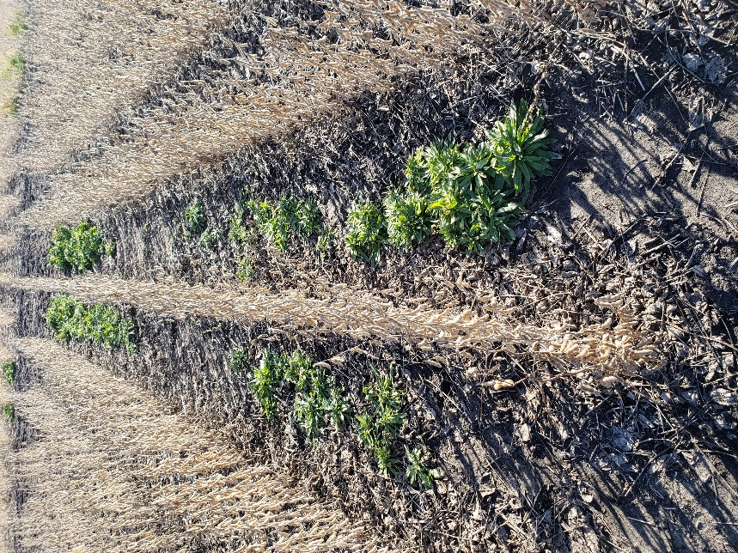

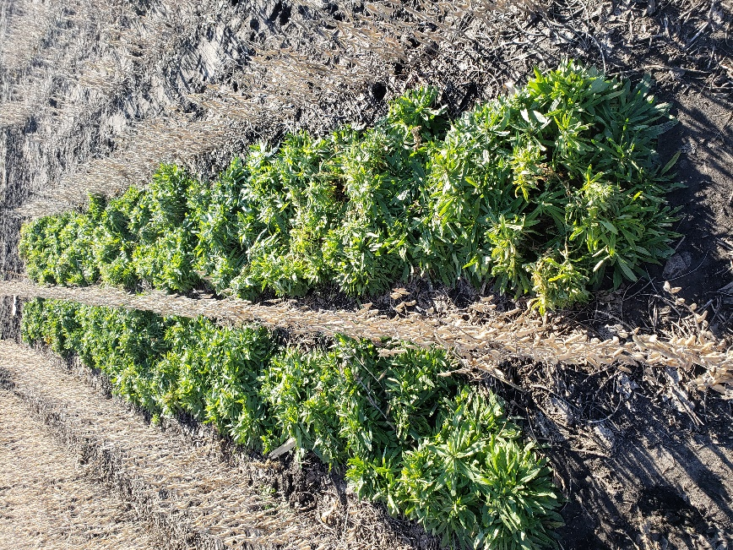
Figure 1. Camelina interseeded at V6 stage of soybean in the susceptible variety (left) and resistant variety (right) in Prosper, ND. (17 October 2018)
Table 1. Soybean grain yield and plant height and cover crops dry matter biomass yield for the susceptible and resistant varieties and three cover crops (CC) planted before soybean or interseeded at V6 stage in Prosper, ND.
 | Susceptible |  |  | Resistant
Cover crop treatment | Soybean yield | Plant height | CC biomass yield | Soybean yield | Plant height | CC biomass yield
 | Bu/acre | inches | lbs/acre | Bu/ acre | inches | lbs/acre
Camelina- pre | 25.1 | 20.3 | 107 | 48.6 | 25.3 | 1084
Camelina-V6 | 27.4 | 21.6 | 5428 | 47.2 | 27.0 | 3351
Crambe- pre | 28.4 | 23.5 | 29 | 51.4 | 26.5 | 351
Crambe- V6 | 29.8 | 22.8 | 5485 | 52.2 | 26.5 | 1299
Mustard- pre | 28.8 | 23.0 | 0 | 48.3 | 26.5 | 178
Mustard-V6 | 22.2 | 22.2 | 5827 | 50.1 | 26.3 | 1288
Check | 30.3 | 22.5 | - | 48.1 | 26.3 | -
LSD (0.05) | NS | NS | 4104 | NS | NS | 1041
Mean variety | 27.4b | 22.6b | 2774a | 49.4a | 26.1a | 868b
Different small case letters indicate significant difference (P ≤0.05) between susceptible and resistant variety for the same parameter evaluated.

Table 2. Soybean crude protein (CP) and oil content for the susceptible and resistant varieties and three cover crops (CC) planted before soybean or interseeded at V6 stage in Prosper, ND.
 |  | Susceptible |  | Resistant
Cover crop treatment | CP | Oil | CP | Oil
 | % | % | % | %
Camelina- pre | 34.9 | 19.9 | 34.9 | 19.4
Camelina-V6 | 34.4 | 19.7 | 34.3 | 20.1
Crambe- pre | 34.6 | 20.0 | 34.1 | 19.6
Crambe- V6 | 34.4 | 20.0 | 34.6 | 19.7
Mustard- pre | 34.7 | 20.1 | 34.7 | 19.5
Mustard-V6 | 33.9 | 20.1 | 34.5 | 19.6
Check | 34.7 | 19.9 | 34.6 | 19.7
LSD (0.05) | NS | NS | NS | NS
Mean variety | 34.5a | 20.1a | 34.5a | 19.6a
Different small case letters indicate significant difference (P ≤0.05) between susceptible and resistant variety for the same parameter evaluated.

Table 3. Initial (I), in the fall (F), and in spring 2019 (Sp) SCN-egg counts for the susceptible and resistant varieties and three cover crops (CC) planted before soybean or interseeded at V6 stage in Prosper, ND.

 | Susceptible |  |  | Resistant
Cover crop treatment | SCN-eggs (I) | SCN-eggs (F) | SCN-eggs (Sp) | SCN-eggs (I) | SCN-eggs (F) | SCN-eggs ( Sp)
 | no./100cm³ |  | ----no./100cm³----
Camelina- pre | 6148 | 9343 | 7190 | 7189 | 1459 | 2200
Camelina-V6 | 6756 | 4590 | 8352 | 2445 | 1438 | 1005
Crambe- pre | 2070 | 9026 | 8900 | 4200 | 1660 | 1030
Crambe- V6 | 3678 | 6350 | 7410 | 3975 | 871 | 940
Mustard- pre | 2192 | 2572 | 5960 | 1177 | 1658 | 410
Mustard-V6 | 4170 | 7124 | 5410 | 1516 | 765 | 2590
Check | 1211 | 5644 | 8270 | 7598 | 1921 | 765
LSD (0.05) | NS | NS | NS | NS | NS | NS
Mean variety | 4229a | 6378a | 7356a | 4355a | 1509b | 1277b
Different small case letters indicate significant difference (P ≤0.05) between susceptible and resistant variety for the same parameter evaluate.

Table 4. Soybean grain yield and plant height and cover crops dry matter biomass yield for the susceptible and resistant varieties and three cover crops (CC) planted before soybean or interseeded at V6 stage in Casselton, ND.
 | Susceptible |  |  | Resistant
Cover crop treatment | Soybean yield | Plant height | CC biomass yield | Soybean yield | Plant height | CC biomass yield
 | Bu/acre | inches | lbs/acre | Bu/ acre | inches | lbs/acre
Camelina- pre | 22.7 | 19.8 | 623 | 32.9 | 20.5 | 481
Camelina-V6 | 28.5 | 20.8 | 1579 | 31.4 | 20.8 | 1412
Crambe- pre | 29.3 | 20.8 | 364 | 31.4 | 19.8 | 344
Crambe- V6 | 29.1 | 21.3 | 2591 | 34.3 | 22.3 | 1323
Mustard- pre | 24.3 | 18.2 | 558 | 28.7 | 18.0 | 567
Mustard-V6 | 28.8 | 23.2 | 3817 | 30.0 | 22.0 | 3147
Check | 26.8 | 21.2 | - | 35.2 | 22.0 | -
LSD (0.05) | NS | NS | 854 | NS | NS | 990
Mean variety | 27.2a | 20.8a | 1588a | 31.9a | 20.8a | 1195a
Different small case letters indicate significant difference (P ≤0.05) between susceptible and resistant variety for the same parameter evaluated.

Table 5. Soybean crude protein (CP) and oil content for the susceptible and resistant varieties and three cover crops (CC) planted before soybean or interseeded at V6 stage in Prosper, ND.

 |  | Susceptible |  | Resistant
Cover crop treatment | CP | Oil | CP | Oil
 | % | % | % | %
Camelina- pre | 32.8 | 19.9 | 32.8 | 19.7
Camelina-V6 | 31.9 | 20.3 | 32.7 | 20.0
Crambe- pre | 32.1 | 20.1 | 32.8 | 19.9
Crambe- V6 | 31.5 | 20.5 | 31.8 | 20.5
Mustard- pre | 32.0 | 20.5 | 33.4 | 20.2
Mustard-V6 | 31.2 | 20.5 | 31.6 | 20.2
Check | 32.2 | 20.3 | 32.3 | 19.9
LSD (0.05) | NS | NS | 0.8 | 0.3
Mean variety | 32.0a | 20.3a | 32.5a | 19.9b
Different small case letters indicate significant difference (P ≤0.05) between susceptible and resistant variety for the same parameter evaluated.

Table 6. Soybean crude protein (CP) and oil content and initial (I) and final (F) SCN-egg counts for the susceptible and resistant varieties and three cover crops (CC) planted before soybean or interseeded at V6 stage in Casselton, ND.
 | Susceptible |  |  | Resistant
Cover crop treatment | SCN-eggs (I) | SCN-eggs (F) | SCN-eggs (Sp) | SCN-eggs (I) | SCN-eggs (F) | SCN-eggs ( Sp)
 | no./100cm³ |  | ----no./100cm³----
Camelina- pre | 710 | 755 |  | 1612 | 2077
Camelina-V6 | 326 | 1369 |  | 1310 | 945
Crambe- pre | 398 | 870 |  | 2246 | 1348
Crambe- V6 | 683 | 2580 |  | 1630 | 612
Mustard- pre | 862 | 330 |  | 1540 | 1170
Mustard-V6 | 710 | 1636 |  | 1544 | 980
Check | 942 | 4230 |  | 845 | 775
LSD (0.05) | NS | NS |  | NS | NS
Mean variety | 662a | 1681a |  | 1532a | 1130a
Different small case letters indicate significant difference (P ≤0.05) between susceptible and resistant variety for the same parameter evaluated.

- CONCLUSIONS

Preceding or interseeded cover crops did not significantly decreases SCN population. The preceding treatments did not grow big enough to have any influence in SCN. In the interseeded cover crops at V6 stage of soybean, although not significant, camelina interseeded at V6 stage of soybean was able to reduce SCN population in 32% at one location.
The uneven distribution of the SCN population in the soil made it very difficult to detect significant differences and replicate the positive results observed in greenhouse studies with camelina and mustard. The ability of SCN to reproduce in the susceptible variety is such that no cover crop can overcome the exponential increase in SCN population. The resistant variety clearly reduced the SCN populations in Prosper across all cover crop treatments, although the resistant variety in Casselton still showed symptoms of SCN and seed yield averaged 32 bu/acre while in Prosper the resistant variety averaged yield was 49 bu/acre. Ongoing analysis will determine if Casselton has a different SCN HG type than Prosper, which could explain the breaking of the resistance at this location.
In spite of the lack of reduction of SCN observed in the study, we believe non-host cover crops interseeded into soybean have the potential to be an additional tool to manage SCN population increases while using a resistant variety. The study will be repeated in 2019 to evaluate camelina and mustard interseeded into soybean.

- PUBLICATIONS, PROCEEDINGS AND CONFERENCE PRESENTATIONS

Peer-reviewed publications
Acharya, K., G. Yan, and M.T. Berti. 2019. Can camelina, crambe, and brown mustard reduce soybean cyst nematode populations? Ind. Crops. Prod. (Submitted)
Peterson, A., D. Samarappuli, and M.T. Berti. 2019. Intersowing cover crops into standing soybean in the US Upper Midwest. Agronomy 9: 264 http://dx.doi.org/10.3390/agronomy9050264 (This publication was funded by ND soybean council in 2016)
Proceedings publications
Berti, M.T., G. Yan, D. Samarappuli, A. Peterson, A. Wittenberg, and J.V. Anderson. 2019. Potential benefits to the environment by integrating winter camelina in current cropping systems of the northern Great Plains of the USA. In European Biomass Conference and Exhibition. 27-30 May 2019, Lisbon, Portugal. Available at http://www.etaflorence.it/proceedings/index.asp (verified 10 June 2019).

Conference presentations, symposiums, abstracts and reports
Berti, M.T. 2019. Cover crops North Dakota report. Midwest Cover Crops Annual Conference. Springfield, IL. 20-21 February 2019.
Berti, M.T. 2019. Interseeding, nutrient cycling, alfalfa-corn intercropping, and winter camelina studies. Annual Coordinated Agricultural Program (CAP) project. Fargo, ND, 26-27 March, 2019.

