EVALUATION OF SOYBEAN CULTIVARS FOR RESISTANCE TO A NEW ROOT-LESION NEMATODE SPECIES IN NORTH DAKOTA

TECHNICAL REPORT

NORTH DAKOTA SOYBEAN COUNCIL
June, 2019

Dr. Guiping Yan, Principal Investigator, Dept. Plant Pathology, NDSU

Root-lesion (Pratylenchus spp.) nematodes are one of the more destructive groups of plant-parasitic nematodes worldwide. This soil borne pathogen has a wide host range, which includes soybean plants. Root-lesion nematodes, along with soybean cyst nematode, lance nematode and root-knot nematode are considered highly aggressive on soybeans and can cause significant yield suppression. Like soybean cyst nematode (SCN), root-lesion nematode are also endoparasitic, but do not have a sedentary life stage. Therefore these migratory endoparasitic nematodes can move in and out of root systems and occupy either soil or root habitats during their entire life cycle. Upon hatching these nematodes can feed on epidermal cells while occupying the rhizosphere of soil, or completely enter into plant roots to feed on cortical cells.

In North Dakota, during 2015 and 2016, soil surveys of different soybean fields were conducted to determine the prevalence and distribution of plant-parasitic nematode in these fields. During the surveys six soil samples were collected from a soybean field in Richland County. After extracting nematodes from these samples, it was evident that root-lesion nematodes were present in all of these samples with a population density ranging from 125 to 2,000 per kg of soil. Morphological measurement of adult males and females and DNA sequencing of two genomic regions revealed that this nematode differs from other known species of root lesion nematodes in both morphology and DNA sequences, allowing us to conclude that this is a new species that has never been reported in literature previously. To confirm soybean is a host of this new species, a greenhouse study was conducted. In this study, infested soil samples were planted with the soybean cultivar Barnes, which is highly susceptible to soybean cyst nematode. The results of this study indicated that the new root lesion nematode infects and reproduces well on the cultivar Barnes. However, the resistance reactions of other soybean cultivars (except Barnes) to this nematode and its impact on soybean growth and yield are still unknown. Therefore, the objective of this research were to 1) evaluate twenty cultivars in North Dakota to determine the levels of resistance to this new root-lesion nematode species detected in ND and 2) determine the habitat of this new root-lesion nematode species for each cultivar by comparing the numbers of nematodes present in roots and in soil.

To achieve these objectives, bulk soil samples were collected from the field infested with the new root-lesion nematode species in Richland County. Soil samples were then thoroughly mixed together into a composite sample to ensure even distribution of nematode population. Nematodes were then extracted from three subsamples to determine the initial population density. Twenty different cultivars were selected for cultivar resistance screening. As comparison, two control were selected, which included the cultivar Barnes as a positive control and unplanted control as a negative control. Among the 20 cultivars, ten were obtained from Northstar Genetics (cultivars: NS 0081NR2, NS 1911NR2, NS 0651NR2, NS 61493NXR2, NS 62002NXR2, NS 60083NXR2, NS 2013NLL, NS 1742NLL, NS 1291NLL, and INT 51449NRZX), four from Syngenta (S03-G9, S07-Q4X, S06-Q9 and S12-R3) and one from each of Channel (0616R2X), Hefty Seed (H09X7), Integra Seed (20915N), Legacy Seed (LS-1335NRR2X), Proseed (41-10), and Thunder Seed (3408RR2YN). After pre-germinating each of these seeds in a petri dish, the seeds were planted in large cone-tainers containing soil (approximately 500g of soil) naturally infested with the new root-lesion nematode species. Each cultivar was planted in five replicates. The Plants were then grown in a growth chamber for 15 weeks at 22 °C (Figure 1). During harvest, the above-soil part of each plant was cut off, and soil and roots were collected into plastic bags and kept in cold storage until nematode extraction. During nematode extraction the roots were cut into 1 to 2 cm pieces and mixed thoroughly with the soil; nematodes were then extracted from 200 grams of the mixture (roots + soil) using the Whitehead tray method. After identifying nematodes and quantifying the final nematode density using a light microscope, the average reproductive factor for each cultivar was determined by dividing the final population by the initial population density.

To confirm our results from the first experiment, the entire experiment was repeated with the same seed lots. During this second iteration bulk soil samples were again collected from the field infested with the new root-lesion nematode species and initial population density was determined from three sub-samples. The experimental protocol used in the first experiment was also followed in the second experiment. However, during the second iteration of the experiment, due to technical difficulties (insect infestation of growth chamber) the plants were grown in a greenhouse room at 22°C for 15 weeks in five replicates. To ascertain the habitat preference of this new root-lesion nematode species the experiment was repeated for a third time with the same cultivars in five replicates at 22°C for nine weeks. In the first two iterations of the experiments, it became evident that it is extremely difficult to separate and obtain intact root system from soil. Thus, the third iteration of the experiment was conducted by planting in small cone-trainers containing approximately 170 grams of naturally infested soil and harvested earlier. After harvest each individual cone-trainer was gently emptied into a 3 liter jug containing water; as a result, the soil were easily dislodged from roots without much fragmentation of roots. The root system of each plant was then washed and cut into 1-cm pieces, from which nematodes were extracted using Whitehead tray method. The remaining soil in the water jug was then assayed using centrifugal sugar floatation method. After identifying and quantifying the final nematode population in root and in soil using a light microscope, nematode population densities of root-lesion nematode in soil and in roots were combined for each cultivar to determine the average reproductive factor (RF).

The average reproductive factor of each cultivar was then compared with the mean reproductive factor of the susceptible check (mean number of root-lesion nematode produced on a tested soybean cultivar/ mean number of root-lesion nematode in a susceptible check x 100 %). Since a susceptible check is not yet established for the new root lesion nematode species, the cultivar with the highest reproductive factor in all three iterations of the experiment was used as the susceptible check. The percentage of root-lesion nematode produced by each cultivar compared to the susceptible check was then qualitatively classified as resistant (mean RF ≤ 25% of the susceptible check), moderately resistant (26% to 50 %), moderately susceptible (51% to 75%) and susceptible (≥ 76%).

The results from first, second and third iteration of the experiments were similar and comparable. Although final population density and nematode reproductive factor for each cultivar varied between the iterations of the experiment, similar trends were evident for all three experiments. The final nematode population densities in these cultivars varied from 1,529 (Cultivar: 3408RR2YN) to 5,345 (NS 1911NR2) in the first iteration of the experiment (Table 1) with a reproductive factor of 1.0 and 3.4, respectively (Table 2). Similarly, the final population densities in the second experiment varied from 1,785 (3408RR2YN) to 13,612 (NS 1911NR2) with a reproductive factor of 0.7 and 5.1, respectively. In the third experiment the final population densities varied from 1,857 (NS 0651NR2) to 6,998 (20915N) with a reproductive factor of 1.0 and 3.6, respectively. Although the cultivar 20915N did not have the highest reproduction of the new root-lesion nematode in the first and second iteration of the experiment, it was the third highest when it comes to reproduction of the new root lesion nematode in the second iteration of the experiment. Cultivar NS 1911NR2 along with cultivar 20915N, S07-Q4X, and NS 62002NXR2 had the same reproductive factor of 3.6 in the third iteration of the experiment. Cultivar NS 1911NR2 has the highest reproductive factor across three experiments.

The positive control had an average population density of 3,076, 6,813, and 5,195 nematodes per kg of soil with a reproductive factor of 2.0, 2.6 and 2.7 in the first, second and third iteration of the experiments, respectively. On the other hand, the negative control had an average population density of 1,114, 871 and 682 nematodes per kg of soil with a reproductive factor of 0.7, 0.3 and 0.4 in the first, second and third iteration of the experiments, respectively. The cultivars S07-Q4X, S12-R3, NS 0081NR2, NS 1911NR2, NS 62002NXR2, NS 60083NXR2 and INT 51449NRZX had a reproductive factor above 2 in all three experiments whereas the cultivars 0616R2X, 20915N, LS-1335NRR2X and 41-10 had a reproductive factor above 2 in second and third experiments.

When analyzing the root versus soil habitat preference of the new root-lesion nematode, it became evident that considerable variations occurred even between the replicates of the same cultivar. This indicates that a constant scaling factor cannot be used to account for the ratio of soil vs root habitat preference of the new root lesion nematode. Our results did indicate a significant proportion of the new root lesion nematode population resided in roots (Table 3). In fact, in majority of the cultivars, above or close to 50% of the root-lesion nematodes were recovered and quantified from the root habitat (Table 3). Thus, it is of paramount importance to assay both roots and soil when determining the total population of the new root-lesion nematode in a sample.

Since the cultivar NS 1911NR2 had the highest reproductive factor in all three experiments, it was used as a susceptible check for resistance rating classification. According to our results, all cultivars did not have the same resistance reactions in all three experiments, however the resistance reactions for most of the cultivars did not vary significantly between the iterations of the experiment. For example, in the first and second iterations of the experiment the cultivar 0616R2X was moderately susceptible, while in the third iteration of the experiment this cultivar was susceptible. Similarly, NS 0651NR2 was moderately resistant in the first and third experiments, while being resistant in the second experiment. The slight variation in resistance ratings between iterations of the experiment could be attributed to different concentrations of initial inoculum, time of the year the experiment was conducted on as well as period of time for which nematodes were allowed to propagate on host for each iteration of the experiment.

Similar to the cultivar NS 1911NR2, the cultivar NS 60083NXR2 was also susceptible in all three experiments. The cultivars S12-R3, NS 0081NR2, NS 1291NLL and Barnes were moderately susceptible in all three experiments. These susceptible cultivars can also be used in future studies to culture the new root lesion nematode species and increase its population for soybean growth and yield evaluation studies against this species. The cultivars S06-Q9 and NS 61493NXR2 were moderately resistant across all three experiments. The reproductive factor for each cultivar was also averaged across all three iterations of the experiment and compared with the average RF of the susceptible check NS 1911NR2, which was then used to determine average resistance rating for each cultivar across all the experiments. According to the average reproductive factor of three experiments, the cultivar 0651NR2 was resistant to the new species of root lesion nematode. These results also indicated seven (H09X7, 3408RR2YN, S03-G9, S06-Q9, NS 61493NXR2, NS 2013NLL and NS 1742NLL) out of the 21 cultivars were moderately resistant. Ten cultivars (0616R2X, 20915N, LS-1335NRR2X, 41-10, S12-R3, NS 0081NR2, NS 62002NXR2, NS 1291NLL, INT 51449NRZX and Barnes) were moderately susceptible, and three cultivars (S07-Q4X, NS 1911NR2 and NS 60083NXR2) were susceptible (Figure 2).

These results provides us an insight into the virulence of the new root-lesion nematode species identified in ND against commercial soybean cultivars. However, further research is necessary to assess the performance of these cultivars against the new root-lesion nematode species under field conditions. Such research findings are very important with practical application since growers can use these results to identify the best performing resistant cultivars to minimize yield loss.

Table 1: Final population densities of the new root-lesion nematode species on soybean cultivars assayed in three greenhouse experiments.

Cultivars | Company | Maturity Group | Final Population Density per kg of Soil
 |  |  | 1st Iteration | 2nd Iteration | 3rd Iteration
0616R2X | Channel | 0.6 | 3,064 | 6,871 | 5,859
H09X7 | Hefty | 0.9 | 2,800 | 2,180 | 4,475
20915N | Integra | 0.9 | 1,894 | 9,620 | 6,998
LS-1335NRR2X | Legacy | 1.3 | 3,000 | 7,535 | 5,619
41-10 | Proseed | 1.1 | 2,844 | 6,390 | 4,985
3408RR2YN | Thunder seed | 0.8 | 1,529 | 1,785 | 3,206
S03-G9 | Syngenta | 0.3 | 2,502 | 4,696 | 4,302
S07-Q4X | Syngenta | 0.7 | 4,545 | 7,726 | 6,966
S06-Q9 | Syngenta | 0.6 | 2,593 | 5,170 | 3,178
S12-R3 | Syngenta | 1.2 | 3,245 | 6,995 | 4,235
NS 0081NR2 | Northstar Genetics | 0.8 | 3,313 | 7,041 | 4,869
NS 1911NR2 | Northstar Genetics | 1.9 | 5,345 | 13,612 | 6,947
NS 0651NR2 | Northstar Genetics | 0.6 | 1,594 | 2,500 | 1,857
NS 61493NXR2 | Northstar Genetics | 1.4 | 2,498 | 4,053 | 2,338
NS 62002NXR2 | Northstar Genetics | 2.0 | 3,863 | 7,770 | 6,941
NS 60083NXR2 | Northstar Genetics | 0.8 | 4,948 | 11,724 | 6,398
NS 2013NLL | Northstar Genetics | 2.0 | 2,920 | 3,657 | 3,997
NS 1742NLL | Northstar Genetics | 1.7 | 2,068 | 4,120 | 4,129
NS 1291NLL | Northstar Genetics | 1.2 | 3,030 | 7,682 | 3,718
INT 51449NRZX | Peking | - | 3,855 | 6,481 | 5,407
Barnes | T.C. Helms | 0.3 | 3,076 | 6,813 | 5,195
Unplanted |  |  | 1,114 | 871 | 682
** Initial population density for the first iteration of the experiment was 1,575 root-lesion nematodes per kg of soil. Initial population density for the second iteration of the experiment was 2,650 nematodes per kg of soil. Initial population density of the third iteration of the experiment was 1,952.

Table 2: Reproductive factor of the new root-lesion nematode species on each of soybean cultivars evaluated in three greenhouse experiments.

 |  |  | Reproductive Factor
Cultivars used | Company | Maturity Group | 1st Iteration | 2nd Iteration | 3rd Iteration
0616R2X | Channel | 0.6 | 2.0 | 2.6 | 3.0
H09X7 | Hefty | 0.9 | 1.8 | 0.8 | 2.3
20915N | Integra | 0.9 | 1.2 | 3.6 | 3.6
LS-1335NRR2X | Legacy | 1.3 | 1.9 | 2.8 | 2.9
41-10 | Proseed | 1.1 | 1.8 | 2.4 | 2.6
3408RR2YN | Thunder seed | 0.8 | 1.0 | 0.7 | 1.6
S03-G9 | Syngenta | 0.3 | 1.6 | 1.8 | 2.2
S07-Q4X | Syngenta | 0.7 | 2.9 | 2.9 | 3.6
S06-Q9 | Syngenta | 0.6 | 1.7 | 2.0 | 1.6
S12-R3 | Syngenta | 1.2 | 2.1 | 2.6 | 2.2
NS 0081NR2 | Northstar Genetics | 0.8 | 2.1 | 2.7 | 2.5
NS 1911NR2 | Northstar Genetics | 1.9 | 3.4 | 5.1 | 3.6
NS 0651NR2 | Northstar Genetics | 0.6 | 1.0 | 0.9 | 1.0
NS 61493NXR2 | Northstar Genetics | 1.4 | 1.6 | 1.5 | 1.2
NS 62002NXR2 | Northstar Genetics | 2 | 2.5 | 2.9 | 3.6
NS 60083NXR2 | Northstar Genetics | 0.8 | 3.1 | 4.4 | 3.3
NS 2013NLL | Northstar Genetics | 2 | 1.9 | 1.4 | 2.1
NS 1742NLL | Northstar Genetics | 1.7 | 1.3 | 1.6 | 2.1
NS 1291NLL | Northstar Genetics | 1.2 | 1.9 | 2.9 | 1.9
INT 51449NRZX | Peking | - | 2.5 | 2.5 | 2.8
Barnes | T.C. Helms | 0.3 | 2.0 | 2.6 | 2.7
Unplanted |  |  | 0.7 | 0.3 | 0.4
**Final population density was obtained by averaging five replicates of each of the cultivars.
Reproductive factor was determined by dividing the final nematode population density by the initial population density.

Table 3: Soil versus root habitat preference of the new root-lesion nematode species identified in North Dakota.
 |  | Number in Soil | Proportion in Soil (%) | Number in Roots | Proportion in Roots (%)
Cultivar | Company
0616R2X | Channel | 2,053 | 35 | 3,806 | 65
H09X7 | Hefty | 2,746 | 61 | 1,729 | 39
20915N | Integra | 4,019 | 57 | 2,979 | 43
LS-1335NRR2X | Legacy | 2,274 | 40 | 3,345 | 60
41-10 | Proseed | 3,147 | 63 | 1,838 | 37
3408RR2YN | Thunder seed | 1,689 | 53 | 1,518 | 47
S03-G9 | Syngenta | 2,244 | 52 | 2,059 | 48
S07-Q4X | Syngenta | 1,884 | 27 | 5,082 | 73
S06-Q9 | Syngenta | 1,535 | 48 | 1,642 | 52
S12-R3 | Syngenta | 1,518 | 36 | 2,718 | 64
NS 0081NR2 | Northstar Genetics | 2,164 | 44 | 2,706 | 56
NS 1911NR2 | Northstar Genetics | 2,584 | 37 | 4,364 | 63
NS 0651NR2 | Northstar Genetics | 904 | 49 | 953 | 51
NS 61493NXR2 | Northstar Genetics | 1,367 | 58 | 971 | 42
NS 62002NXR2 | Northstar Genetics | 3,184 | 46 | 3,758 | 54
NS 60083NXR2 | Northstar Genetics | 4,660 | 73 | 1,738 | 27
NS 2013NLL | Northstar Genetics | 1,741 | 44 | 2,255 | 56
NS 1742NLL | Northstar Genetics | 1,456 | 35 | 2,673 | 65
NS 1291NLL | Northstar Genetics | 1,706 | 46 | 2,012 | 54
INT 51449NRZX | Peking | 2,894 | 54 | 2,513 | 46
Barnes | T.C. Helms | 2,328 | 45 | 2,867 | 55
**In the third iteration of the experiment, nematodes were extracted from soil and root separately using centrifugal sugar floatation method and Whiteheadtray method, respectively.

Table 4: Resistance ranking of each cultivar for each iteration of the experiments for evaluation of resistance to the new root-lesion nematode species detected in North Dakota.

 |  | Resistance Ranking
Cultivars used | Company | 1st Iteration | 2nd Iteration | 3rd Iteration
0616R2X | Channel | MS | MS | S
H09X7 | Hefty | MS | R | MS
20915N | Integra | MR | MS | S
LS-1335NRR2X | Legacy | MS | MS | S
41-10 | Proseed | MS | MR | MS
3408RR2YN | Thunder seed | MR | R | MR
S03-G9 | Syngenta | MR | MR | MS
S07-Q4X | Syngenta | S | MS | S
S06-Q9 | Syngenta | MR | MR | MR
S12-R3 | Syngenta | MS | MS | MS
NS 0081NR2 | Northstar Genetics | MS | MS | MS
NS 1911NR2 | Northstar Genetics | S | S | S
NS 0651NR2 | Northstar Genetics | MR | R | MR
NS 61493NXR2 | Northstar Genetics | MR | MR | MR
NS 62002NXR2 | Northstar Genetics | MS | MS | S
NS 60083NXR2 | Northstar Genetics | S | S | S
NS 2013NLL | Northstar Genetics | MS | MR | MS
NS 1742NLL | Northstar Genetics | MR | MR | MS
NS 1291NLL | Northstar Genetics | MS | MS | MS
INT 51449NRZX | Peking | MS | MR | S
Barnes | T.C. Helms | MS | MS | MS
**The percentage of root-lesion nematode produced by each cultivar compared to the susceptible check, NS 1911NR2, was qualitatively classified as resistant (mean RF ≤ 25% of the susceptible check), moderately resistant (26% to 50 %), moderately susceptible (51% to 75%) and susceptible (≥ 76%).

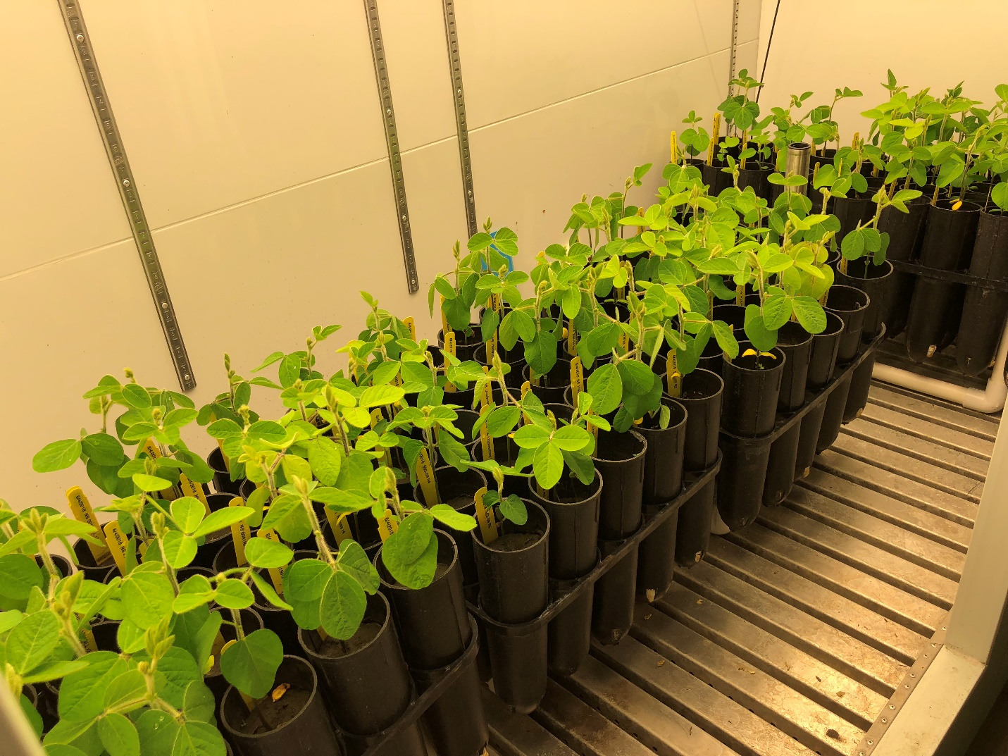

Figure 1. Soybean plants grown in a growth chamber maintained at 22 °C for resistance evaluation to the new root-lesion nematode species identified in North Dakota.

Figure 2. Classification of resistance responses of soybean cultivars to the new root lesion nematode species detected in North Dakota.

