SCREENING COVER CROPS FOR MANAGING SOYBEAN CYST NEMATODE AND OTHER NEMATODES IN INFESTED SOILS

TECHNICAL REPORT

NORTH DAKOTA SOYBEAN COUNCIL
JUNE 2019

Dr. Guiping Yan, Principal Investigator, Dept. Plant Pathology, NDSU
Co-investigators: Dr. Marisol Berti, Dept. Plant Science, NDSU and Dr. Sam Markell, Dept. Plant Pathology, NDSU

Soybean cyst nematode (SCN), Heterodera glycines, is one of the most important pests of soybean production in North Dakota (ND). It is an endoparasitic nematode, which infects soybean roots, causes colonization of roots and ultimately affects growth and yield of the soybean crop. This nematode not only infects soybean, but also invades other leguminous crops and weed species, which play an important role in nematode survival and population increase in fields. Limited sources of resistance that have been utilized for developing resistant cultivars for managing this nematode cause the virulence changes in nematode populations, so integrated management strategy is necessary for sustainable management of this devastating soybean pest. Cover crops that are non-hosts to SCN and have the ability to reduce SCN population can be integrated in the management practice as an alternative means.
Previous studies have shown that cover crops could suppress plant-parasitic nematode populations such as root-knot nematode (Meloidogyne spp.), root-lesion nematodes (Pratylenchus penetrans), sugar beet cyst nematode (Heterodera schachtii), and potato cyst nematode (Globodera spp.). Cover crops may reduce SCN populations by three ways, such as non-host with encouraging SCN egg hatching, producing toxic biochemical compounds, and acting as a trap crop. In ND, some cover crops that are being used or could be used have not been tested for SCN, and limited information is available about the interaction between cover crops and SCN. The overall goal of this research is to sustainably manage SCN by utilizing cover crops as an alternative means. The specific objectives of this research project were to 1) screen twenty entries of cover crops for hosting ability to SCN in controlled greenhouse conditions; and 2) evaluate ten cover crops for their effects on reducing SCN and vermiform plant-parasitic nematodes in infested soils in external environment (microplot).
A total of 26 entries of crops were tested in this study. These entries include cover crops that are commonly grown or has the potential to be grown in the region, as well as wheat and corn that are common rotational crops of soybean. Two susceptible soybean cultivars were also selected and tested in this study (Table 1). Two SCN populations were collected from two fields in Cass and Richland counties in ND. SCN populations were increased in a growth chamber under controlled environmental conditions by inoculating plants of susceptible soybean cultivar, Barnes. Soybean cyst nematode white females (cysts) were collected for each SCN population and crushed to obtain eggs and juveniles. Eggs and juveniles were counted under a microscope, then used as inoculum for host range evaluation. Each of the crops and susceptible soybean cultivars was planted in a cone-tainer having about 100 cm³ of soil and inoculated with 2,000 eggs and juveniles of each SCN population, then kept in the growth chamber for 35 days at 27 °C (Figure 1). Experimental design was a completely randomized design (CRD) with 4 replications. After 35 days of growth, plants were taken out from the growth chamber and SCN white females were extracted from soil and roots of each plant. Collected white females were counted under a microscope. The hosting ability of cover crops and species was determined by comparing number of white females produced in each of the cover crops with the susceptible soybean cultivar Barnes.
Ten cover crops (alfalfa, chickling vetch, daikon radish, faba bean (Petite), flax, oilseed radishes (Concorde, Control, and Image), sunhemp, white mustard) and the susceptible soybean check Barnes were selected for the microplot study (Figure 2), based on the results from the host range experiments. Soil was collected from the same two fields in Cass and Richland counties. SCN population density of each soil was determined by extracting and counting nematodes. About 9-inch diameter plastic pots each holding 5 kg of soil were used for planting these cover crops in both field soils. Standard seeding rate of each crop was used for determining number of plants per pot. Plants were kept in the greenhouse for two weeks for better establishment before they were moved to the microplot in natural field conditions. Experimental design was a randomized complete block design (RCBD) with 5 replications.
For setting up the microplot, required holes were made in the field and plastic pots were buried with the top part about 5-8 cm high above the soil surface. The remaining surface of the field was covered with plastic mesh (weed barrier) to prevent the weeds and contamination of the pots from surrounding soil. Regular watering and fertilization were applied in the pots as needed. After 75 days of planting, three soil cores were collected from each pot to determine the final population density. Reproductive factor (RF) was determined by dividing the final SCN population density by the initial population density in each pot. Out of two soils (103 and 2W), only soil 103 was infested with other plant-parasitic nematodes before planting. For that soil, sugar floatation method was used to extract the vermiform nematodes and reproductive factor was calculated for each nematode population. The RF was calculated by dividing the final nematode population density by the initial population density.
Out of the twenty-four crops and species tested for host range in the greenhouse conditions, 21 entries including alfalfa, balansa clover, berseem clover, winter camelina, faba beans (Petite and CNS), flax, forage oat, forage pea, Japanese millet, brown mustard, white mustard, daikon radish, oilseed radishes (Image, Concorde, and Control), pennycress, sunnhemp, white proso millet, corn, and wheat did not support any SCN reproduction (Table 1), suggesting non-hosts. Two crops chickling vetch and crambe showed limited SCN reproduction with numbers of white females ranging from 3 to 32, suggesting poor hosts. Lupine showed considerable reproduction (no. of white females: 55 to 73) suggesting a suitable host, when compared to the susceptible soybean cultivars (122 to 260) (Table 1).
In both soils 103 and 2W, all the tested crops significantly (P < 0.05) reduced the SCN populations compared with the susceptible soybean check Barnes. All the crops except sunnhemp reduced the SCN populations when compared with the non-planted control (fallow) but the differences were not statistically significant (Figure 3). Among the crops, white mustard, oilseed radish (Concorde, Control), and faba bean (Petite) were more effective than others, with average RF ranging from 0.24 to 0.27 and population reduction by 73% to 76%. Root-lesion, spiral, and stunt nematodes were found to be present in soil 103, but none of the crops showed a significant reduction (P > 0.05) of these vermiform plant-parasitic nematode populations in this infested soil (Figure 4).
The results of interaction of cover crops and SCN from repeated experiments have been summarized and presented in two manuscripts that were submitted to two journals (Industrial Crops and Products, Plant Disease) for publication. The experiment with the same crop entries used in this study will be repeated in 2019. Cover crops that are non-hosts with the greater population reduction ability will be recommended to farmers for SCN management. The effective cover crops also need to be evaluated for understanding the mechanisms of SCN population reduction and for further field trials to develop an integrated SCN management strategy. The research findings are useful to navigate the selection and use of cover crops for farmers for reducing SCN damage to increase soybean yield in ND.

Table 1. Reproduction of soybean cyst nematode in cover crops planted in artificially infested soil with 2,000 eggs and juveniles of each of the SCN populations (soil 103 and 2W).
 |  |  | No. of white females per plant
Crop | Scientific Name | Family | Soil 2W | Soil 103
Soybean Susceptible: Barnes | Glycine max | Leguiminosae | 260 | 122
Soybean Susceptible: Sheyenne | Glycine max | Leguiminosae | 205 | 135
Lupine (White) | Lupinus albus L. | Fabaceae | 73 | 55
Chickling Vetch (Pulse) | Vicia villosa | Fabaceae | 32 | 8
Crambe (BelAnn) | Crambe abyssinica | Brassicaceae | 3 | 3
Pennycress (VNS) | Thlaspi arvense | Brassicaceae | 0 | 0
White Proso Millet (VNS) | Panicum miliaceum | Poaceae | 0 | 0
Wheat (Glenn) | Triticum aestivum L. | Poaceae | 0 | 0
Forage oat (CNS) | Avena sativa L. | Poaceae | 0 | 0
Forage pea (Arvika) | Pisum sativum L. | Fabaceae | 0 | 0
Corn (DKC44-13) | Zea mays L. | Poaceae | 0 | 0
Brown mustard (Kodiak) | Brassica juncea L. | Brassicaceae | 0 | 0
Alfalfa (Bullseye) | Medicago sativa L. | Fabaceae | 0 | 0
Oilseed radish (Control) | Raphanus sativus L. | Brassicaceae | 0 | 0
Flax (Carter) | Linum usitatissimum L. | Linaceae | 0 | 0
White Mustard (Master) | Sinapis alba L. | Brassicaceae | 0 | 0
Japanese millet (CNS) | Echinochloa esculenta L. | Poaceae | 0 | 0
Radish Daikon (Eco-Till) | Raphanus sativus L. | Brassicaceae | 0 | 0
Faba bean (Petite) | Vicia faba Roth | Fabaceae | 0 | 0
Winter camelina (Joelle) | Camelina sativa (L.) Crantz | Brassicaceae | 0 | 0
Oilseed radish (Concorde) | Raphanus sativus L. | Brassicaceae | 0 | 0
Faba bean 1 (CNS) | Vicia faba Roth | Fabaceae | 0 | 0
Berseem clover (CNS) | Trifolium alexandrinum L. | Fabaceae | 0 | 0
Balansa clover (CNS) | Trifolium michelianum Savi | Fabaceae | 0 | 0
Oilseed radish (Image) | Raphanus sativus L. | Brassicaceae | 0 | 0
Sunnhemp (CNS) | Crotolara juncea L. | Fabaceae | 0 | 0
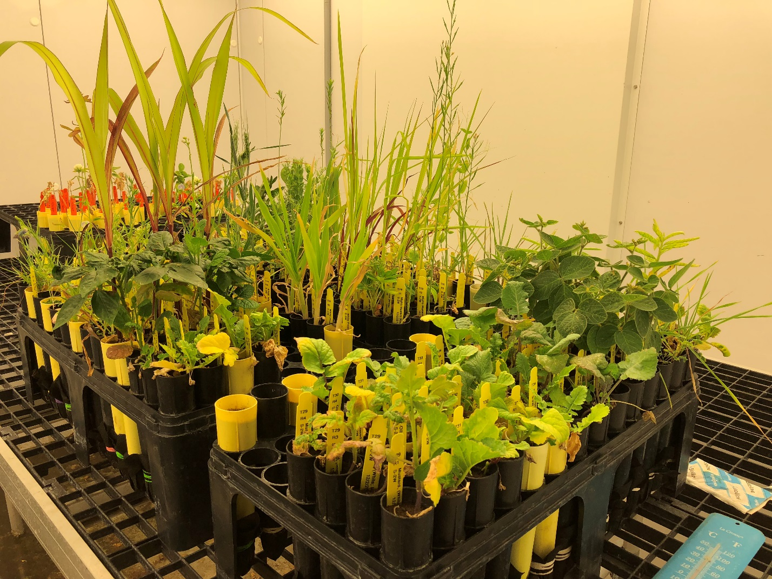
Figure 1. Cover crops grown in cone-tainers each containing 100 cm³ of autoclaved sandy soil inoculated with each of the SCN populations and kept in a growth chamber at 27°C for SCN host range evaluation.

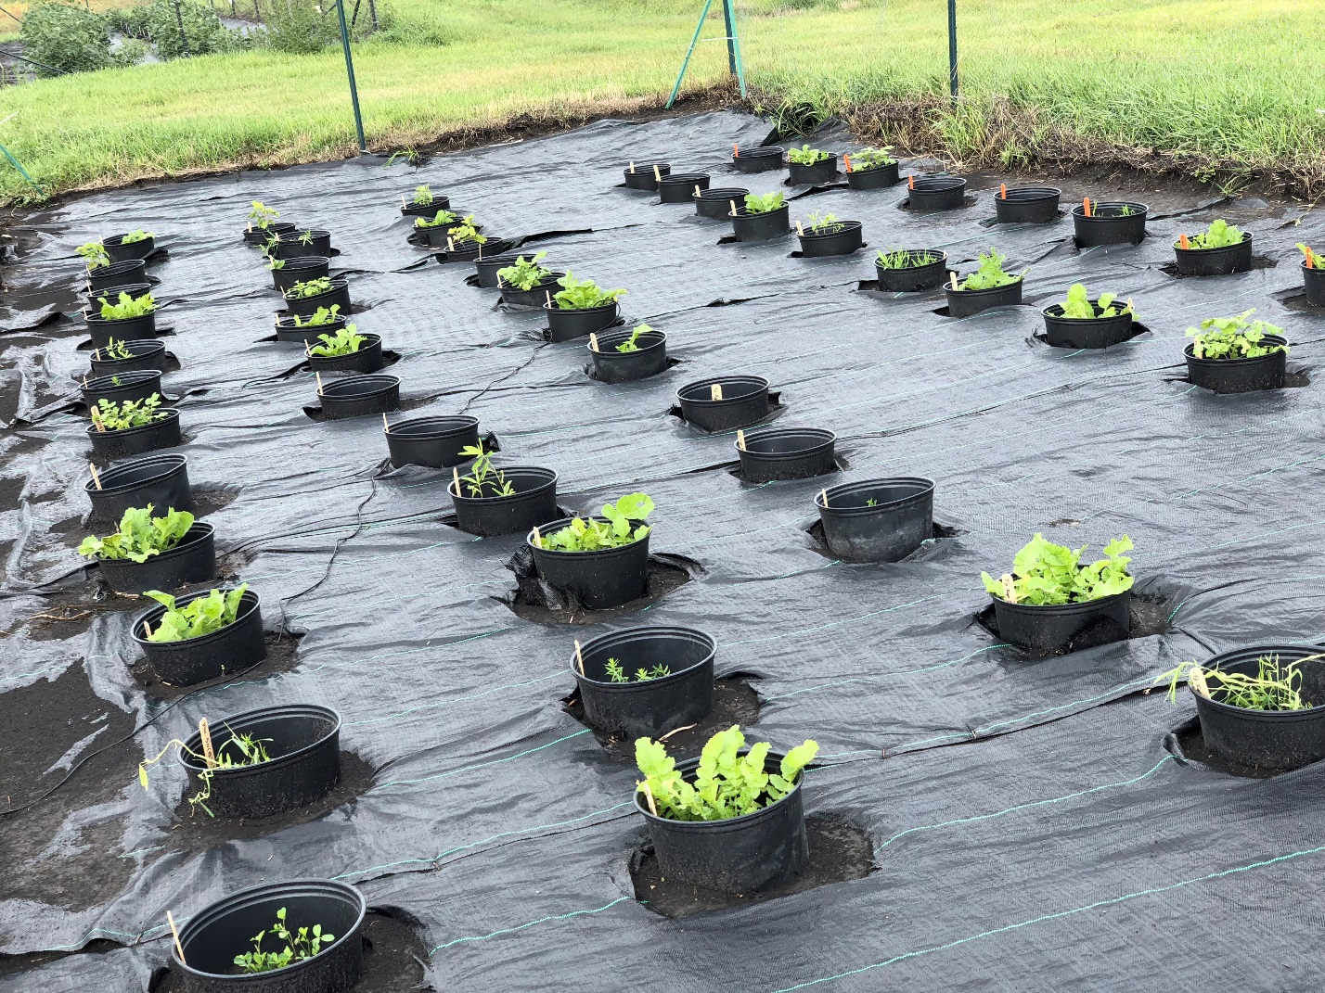
Figure 2. Cover crops grown in plastic pots each containing 5 kg of naturally infested soil in the microplot.

Figure 3. SCN population reduction by cover crops planted in the microplot with each of the two infested field soils (Soil 2W and 103) in outdoor natural conditions.

Figure 4. Reproductive factors of vermiform plant-parasitic nematodes (root-lesion, spiral and stunt nematodes) on cover crops tested in the microplot with infested field soil (Soil 103) in outdoor natural conditions.

