Maximizing Yield and Quality of Mid Atlantic Soybean Production with Soil Sulfur Management
Final Report – March 2018

Ray Weil
Dept. of Environmental Science and Technology
University of Maryland, College Park, MD

Experiments completed in 2018
- Field experiments were conducted at the Central Maryland Research and Education Center (CMREC) at Beltsville on two double crop soybean fields and two full season soybean fields.
  - All fields were conducted as randomized complete block trial with four treatments (1) Epsom sprayed at a rate of 77 lbs/acre at first flower, (2) gypsum broadcast at a rate of 500 lbs/acre at planting, (3) combined gypsum and Epsom, and (4) control.
  - Soil samples were collected around planting time from each control plot at 3 different depths (0-10 cm, 10 – 20cm or bottom of A, and 20 cm or bottom of A – 30 cm)
  - Seed samples were collected by hand and yield measurements were collected from the combine.
- Three different soil tests were evaluated to determine which would most effectively predict crop response to applied S.
  - Soil samples from several test sites in 2017 (138 samples) were used for the experiment.
  - 0.01M Calcium chloride, 500 ppm calcium phosphate and Mehlich 3 extractants were used to extract soil S and then were sent to Penn State University for ICP analysis
Preliminary Results
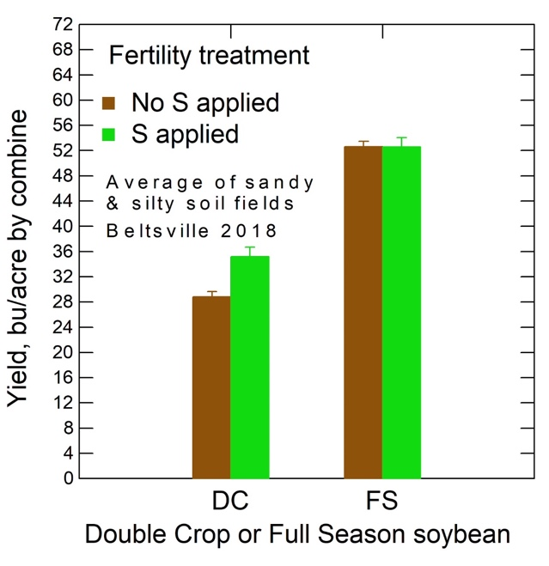

Figure 1. Yield results from 2018 Beltsville experimental fields. with extremely wet early season and very dry mid-season, only double crop soybeans responded to S at Beltsville (4 bu/acre or 14% increase)

- In November 2018 we presented a paper to the American Society of Agronomy that we believe was the first report of substantially improved protein quality on soybean achieved by sulfur fertilization (Weil and Notto, 2018).
- We also presented the following preliminary results from 2018 soil test evaluations at the November 2018 American Society of Agronomy meeting.

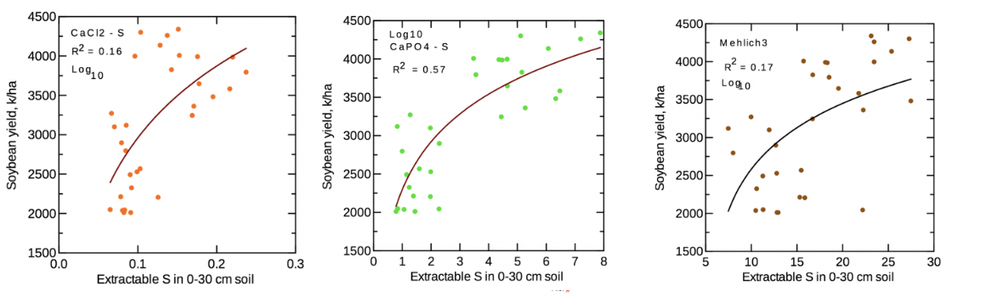
Critical Level
Figure 2. Extractable S in the top 30 cm of the soil vs. soybean yield in bu/ac in 138 samples from research sites at CMREC Beltsville and on farm collaborator fields. Results show the strongest correlation with the calcium phosphate extraction with the critical level for that extraction being around 3-4 ppm extractable S as determined by ICP analysis.

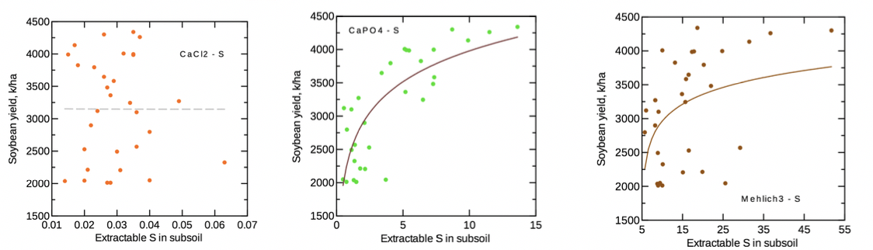
Critical Level
Figure 3. Extractable S in the subsoil (bottom of A – 30 cm) vs. soybean yield in bu/ac in 138 samples from research sites at CMREC Beltsville and on farm collaborator fields. Results show the strongest correlation with the calcium phosphate extraction with the critical level for that extraction being around 3-4 ppm extractable S as determined by ICP analysis.
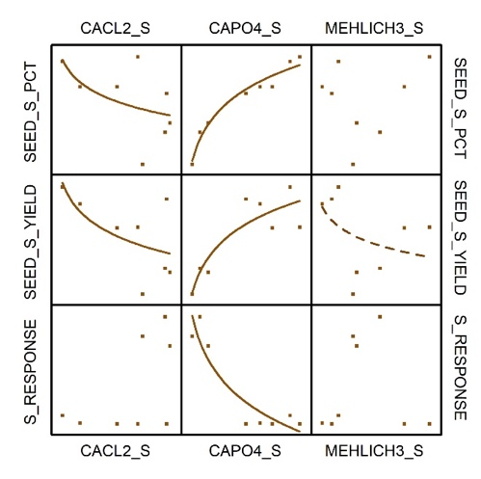

Figure 3. With a limited number of sites analyzed for yield response and S response, the 500 ppm calcium phosphate extraction was the only extraction that trended in the expected direction.

